Supplementary information
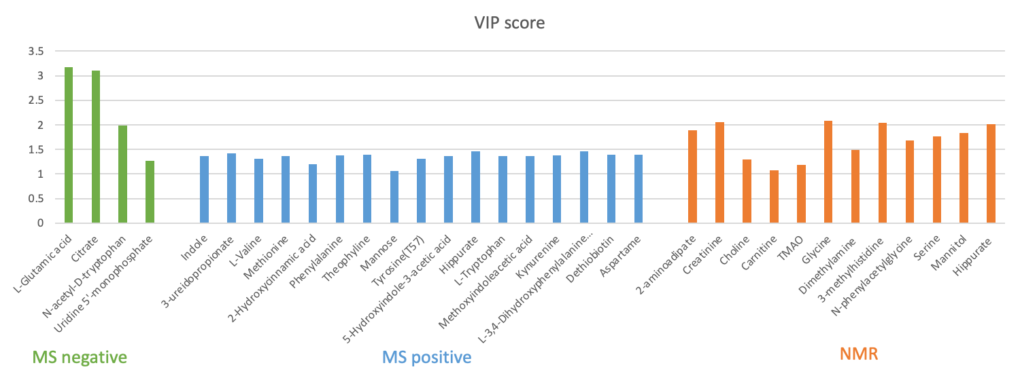
Supplementary Fig 1 VIP score plot for all the selected metabolites from each platform. Only VIP with a value higher than 1 were selected in this study.
Supplementary Fig 2 Density plot of the selected features through the 3 different platforms
Feature | Progressor (N=13) | Stable (N=43) | Total (N=56)
NMR
2-aminoadipate | 2.676 ±0.627 | 2.284 ±1.488 | 2.375 ±1.343
Creatinine | 12.526 ±2.970 | 10.866 ±4.245 | 11.252 ±4.023
Choline | 1.592 ±0.948 | 1.128 ±0.477 | 1.236 ±0.639
Carnitine | 1.227 ±1.121 | 1.389 ±2.463 | 1.352 ±2.217
TMAO | 2.736 ±0.915 | 4.360 ±3.396 | 3.983 ±3.077
Glycine | 2.399 ±1.015 | 1.645 ±0.739 | 1.820 ±0.863
Dimethylamine | 3.149 ±1.048 | 2.396 ±0.880 | 2.571 ±0.966
3-methylhistidine | 2.390 ±0.337 | 2.004 ±0.484 | 2.093 ±0.480
n-phenylacetylglycine | 1.384 ±0.265 | 1.718 ±0.607 | 1.640 ±0.563
Serine | 3.206 ±1.345 | 2.534 ±1.171 | 2.690 ±1.234
Mannitol | 1.234 ±0.241 | 1.572 ±0.618 | 1.493 ±0.570
Hippurate | 4.111 ±1.448 | 3.006 ±1.164 | 3.263 ±1.309
MS positive
Indole | 3007948.143 ±4020130.954 | 5912618.387 ±4778595.460 | 5238319.938 ±4742892.857
3-ureidopropionate | 1511282.267 ±1930064.818 | 2731153.727 ±2391076.487 | 2447969.281 ±2334252.683
L-Valine | 318621.742 ±471571.525 | 847558.225 ±1037341.034 | 724769.399 ±959701.736
Methionine | 3794064.106 ±3622019.528 | 6562016.958 ±4566353.000 | 5919456.474 ±4491757.037
2-Hydroxycinnamic acid | 63158613.753 ±56092615.143 | 110007507.445 ±80183581.202 | 99131871.409 ±77424526.776
Phenylalanine | 19457582.840 ±18845276.231 | 51953112.271 ±46399439.848 | 44409507.225 ±43739852.415
Mannose | 7304546.210 ±10472477.306 | 21526331.777 ±26210831.537 | 18224845.842 ±24192176.204
Tyrosine(T57) | 9804527.157 ±8936202.382 | 30510065.522 ±33161730.355 | 25703422.687 ±30577835.458
5-Hydroxyindole-3-acetic acid | 201624.919 ±370912.282 | 657745.413 ±977473.673 | 551860.299 ±892970.078
Hippurate | 11165079.226 ±18187221.371 | 21798822.325 ±21759782.426 | 19330274.820 ±21313481.634
L-Tryptophan | 17614678.273 ±16501031.717 | 59402529.032 ±74511314.560 | 49701777.963 ±67941121.916
Methoxyindoleacetic acid | 613626.296 ±1002104.911 | 1179711.720 ±1287996.045 | 1048299.032 ±1242611.589
Kynurenine | 3165247.490 ±4505509.019 | 9442486.643 ±11978706.454 | 7985270.411 ±11007009.472
L-3,4-Dihydroxyphenylalanine methyl ester hydrochloride | 317852.836 ±439547.732 | 569142.362 ±532193.722 | 510807.293 ±519517.779
Dethiobiotin | 900451.351 ±1107200.720 | 6067050.034 ±7507852.198 | 4867661.054 ±6939506.062
MS negative
L-Glutamic acid | -0.716 ±1.403 | 0.216 ±1.202 | -0.000 ±1.300
Citrate | -0.384 ±1.240 | 0.116 ±0.968 | 0.000 ±1.047
N-acetyl-D-tryptophan | 0.804 ±0.264 | -0.243 ±1.291 | -0.000 ±1.220
Uridine 5'-monophosphate | 0.250 ±0.802 | -0.075 ±0.415 | 0.000 ±0.539
Supplementary Table 1: Intensity of the 31 quantified metabolites through NMR and MS (positive and negative modes) with mean ± standard deviation values reported for all the 56 urinary samples divided by groups.

Drug | Frequency | Percentage (%) | Drug type
Mycophenolate mofetil | 56 | 100 | Immunosuppressant
Sulfamethoxazole | 49 | 87.5 | Antibiotic
Prednisone acetate | 46 | 82.1 | Anti-inflammatory, immunosuppressant, antineoplastic, and vasoconstrictor
Valganciclovir | 42 | 75 | Antiviral
Tacrolimus | 36 | 64.2 | Immunosuppressant
Supplementary Table 2:Frequency table of drugs taken by at least 60% of the patients. In the table for each drug frequency, percentage of total patient and the type of drug are reported.

