This supporting document provides supplementary information to “The relationship between morphological awareness and reading comprehension among Chinese children: Testing of cross-grade paths”. It includes: (1) information on variable definitions; (2) additional details on data processing and analysis.

1. Variable definitions
Compound awareness, homophone awareness, and homograph awareness are three facets of Chinese morphological awareness (MA). It has been found that Chinese MA facets are related to reading comprehension directly or indirectly through the pathways of vocabulary knowledge, character recognition, and lexical inference ability. In this study, these variables were defined as follows:
(1) Compound awareness (CA)
Compound awareness is the most fundamental facet of Chinese MA, referring to the capacity to analyze the combination of morphemes and the resultant formation of vocabulary (Liu & McBride-Chang, 2010).
(2) Homophone awareness (HMPA)
Homophone awareness refers to the ability to comprehend that morphemes of identical pronunciation may have different meanings (Li et al., 2002).
(3) Homograph awareness (HMGA)
Homograph awareness is another facet of Chinese MA at the morpheme level, which refers to the capacity to discern the different meanings of a single written character within given words (Xie et al., 2019).
(4) Vocabulary knowledge (VK)
Vocabulary knowledge is a rich and multifaceted construct (Koda, 2005; Schmitt, 2010). This multidimensional construct is closely linked to vocabulary breadth and vocabulary depth (Anderson & Freebody, 1981).
(5) Character recognition (CR)
In Chinese, character recognition often refers to the same ability of word decoding or word reading in English (Pang & Son, 2024; Zhao et al., 2019).
(6) Lexical inference ability (LEXI)
Lexical inference ability refers to the capacity to make “informed guesses as to the meaning of a word in the light of all available linguistic cues in combination with the learner’s general knowledge of the world, her awareness of the co-text and her relevant linguistic knowledge” (Haastrup, 1991, p. 40).
(7) Reading comprehension (RC)
Reading comprehension has been defined as “the process of simultaneously extracting and constructing meaning through interaction and involvement with written language” (Snow, 2002, p. 11).

2. Data processing and analysis
We performed data processing, descriptive statistics, and Pearson correlational analyses using SPSS Statistics (version 30.0). All test items were scored dichotomously (0 = incorrect, 1 = correct). The total score for each test was calculated by adding up the total number of correct items. There was no data transformation. Based on the literature review, we developed a full path model and two alternative models for hypothesis testing. We conducted path analysis and constructed preferred models for each grade using SPSS Amos (version 29) and an online diagramming tool (https://www.drawio.com).
By testing the goodness-of-fit measures, we identified four grade-appropriate path diagrams. Since the hypothesized models did not have satisfactory model fit across all grades, several non-significant pathways were removed for model trimming and specification. The path model diagrams and corresponding model codes (Amos syntax) are presented below for each grade.
Figure 1 Path Model (CA) of Grade 2
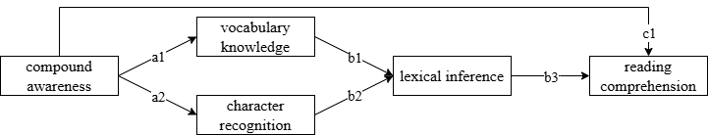
ind1=p.a1*p.b1
ind2=p.b1*p.b3
ind3=p.a1*p.b1*p.b3
ind4=p.a2*p.b2
ind5=p.b2*p.b3
ind6=p.a2*p.b2*p.b3
stda1=e.StandardizedDirectEffect(VK,CA)
stda2=e.StandardizedDirectEffect(CR,CA)
stdb1=e.StandardizedDirectEffect(LEXI,VK)
stdb2=e.StandardizedDirectEffect(LEXI,CR)
stdb3=e.StandardizedDirectEffect(RC,LEXI)
stdc1=e.StandardizedDirectEffect(RC,CA)
stdind1=stda1*stdb1
stdind2=stdb1*stdb3
stdind3=stda1*stdb1*stdb3
stdind4=stda2*stdb2
stdind5=stdb2*stdb3
stdind6=stda2*stdb2*stdb3
Note. CA: compound awareness; VK: vocabulary knowledge; CR: character recognition; LEXI: lexical inference; RC: reading comprehension
Figure 2-1 Path Model (HMPA) of Grade 4
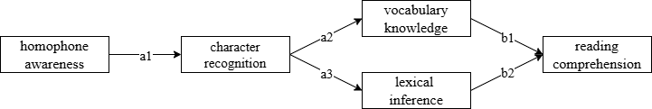
ind1=p.a1*p.a2
ind2=p.a2*p.b1
ind3=p.a1*p.a2*p.b1
ind4=p.a1*p.a3
ind5=p.a3*p.b2
ind6=p.a1*p.b3*p.b2
ind7=p.a1*p.a3*p.b2
stda1=e.StandardizedDirectEffect(CR,HMPA)
stda2=e.StandardizedDirectEffect(VK,CR)
stda3=e.StandardizedDirectEffect(LEXI,CR)
stdb1=e.StandardizedDirectEffect(RC,VK)
stdb2=e.StandardizedDirectEffect(RC,LEXI)
stdind1=stda1*stda2
stdind2=stda2*stdb1
stdind3=stda1*stda2*stdb1
stdind4=stda1*stda3
stdind5=stda3*stdb2
stdind6=stda1*stda3*stdb2
Note. HMPA: homophone awareness; VK: vocabulary knowledge; CR: character recognition; LEXI: lexical inference; RC: reading comprehension
Figure 2-2 Path Model (HMGA) of Grade 4
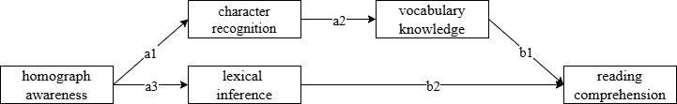
ind1=p.a1*p.a2
ind2=p.a2*p.b1
ind3=p.a1*p.a2*p.b1
ind4=p.a3*p.b2
stda1=e.StandardizedDirectEffect(CR,HMGA)
stda2=e.StandardizedDirectEffect(VK,CR)
stda3=e.StandardizedDirectEffect(LEXI,HMGA)
stdb1=e.StandardizedDirectEffect(RC,VK)
stdb2=e.StandardizedDirectEffect(RC,LEXI)
stdind1=stda1*stda2
stdind2=stda2*stdb1
stdind3=stda1*stda2*stdb1
stdind4=stda3*stdb2
Note. HMGA: homograph awareness; VK: vocabulary knowledge; CR: character recognition; LEXI: lexical inference; RC: reading comprehension
Figure 3 Path Model (HMPA) of Grade 6
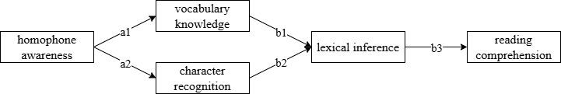
ind1=p.a1*p.b1
ind2=p.b1*p.b3
ind3=p.a1*p.b1*p.b3
ind4=p.a2*p.b2
ind5=p.b2*p.b3
ind6=p.a2*p.b2*p.b3
stda1=e.StandardizedDirectEffect(VK,HMPA)
stda2=e.StandardizedDirectEffect(CR,HMPA)
stdb1=e.StandardizedDirectEffect(LEXI,VK)
stdb2=e.StandardizedDirectEffect(LEXI,CR)
stdb3=e.StandardizedDirectEffect(RC,LEXI)
stdind1=stda1*stdb1
stdind2=stdb1*stdb3
stdind3=stda1*stdb1*stdb3
stdind4=stda2*stdb2
stdind5=stdb2*stdb3
stdind6=stda2*stdb2*stdb3
Note. HMPA: homophone awareness; VK: vocabulary knowledge; CR: character recognition; LEXI: lexical inference; RC: reading comprehension

We hope that this supporting material provides valuable information and supplementary data that will enhance the editorial and review process, facilitating a thorough evaluation of our manuscript.

