Appendix

Appendix 1: Attributes and Levels Used in the DCE
Attribute Description | Levels
Device Control Mode:  The patient's ability to initiate movement or be assisted by the exoskeleton. | - Active: The patient initiates and controls the movements, and the exoskeleton provides passive support.  - Semi-passive: The device partially initiates the movement, sharing motor effort with the patient.  - Passive: The exoskeleton fully guides the movement without active contribution from the patient.
Comfort of Use:  Overall feeling of the patient during use (pressure, support, potential discomfort). | - Low: Wearing the device is perceived as uncomfortable, possibly causing pressure points or discomfort.  - High: Wearing the device is considered comfortable, with good adaptation to the patient’s morphology.
Degrees of Freedom (DoF):  The device’s capacity to mobilize several leg joints (hip, knee, ankle). | - Limited: Only one or two joints are mobilized by the exoskeleton.  - Extended: Most or all major leg joints are mobilized in a coordinated way.
Feedback (Information provided to the patient):  Information given to the patient during the session about effort or progress. | - Basic information: Basic messages or visual signals about movement execution.  - Detailed information: Personalized and real-time data (graphs, voice feedback, performance analysis).
Price (Monthly Out-of-Pocket Cost for the Patient):  The estimated financial contribution in euros to use the device. | - €0  - €50  - €100

Appendix 2: An example of a choice scenario
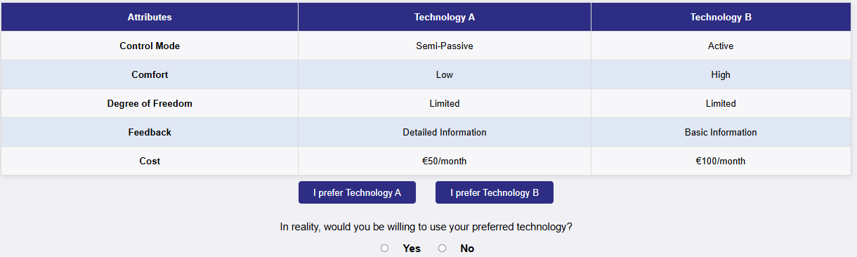

Appendix 3: Design Correlation Matrix

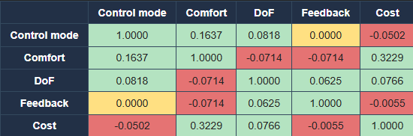

Appendix 4: Balance of Levels in the Experimental Design
Attributes and Levels | Number of Occurrences (%)
Mode:
Passive | 10 (31.24)
Semi-passive | 11 (34.38)
Active | 11 (34.38)
Comfort:
Low | 16 (50)
High | 16 (50)
Degrees of Freedom (DoF):
Limited | 16 (50)
Increased | 16 (50)
Feedback:
Basic | 16 (50)
Detailed | 16 (50)
Cost (out-of-pocket):
€0 / month (fully covered) | 11 (34.38)
€50 / month | 11 (34.38)
€100 / month | 10 (31.24)

Appendix 5: Respondents Excluded from the Modelling
ID | Block | Scenario 1 | Scenario 3 | Scenario 9 | Inconsistency
3 | A | A | B | B | Inconsistency Block A: 1 ≠ 9
27 | A | B | A | A | Inconsistency Block A: 1 ≠ 9
44 | B | A | A | B | Inconsistency Block B: 3 ≠ 9
49 | A | A | A | B | Inconsistency Block A: 1 ≠ 9
52 | B | A | A | B | Inconsistency Block B: 3 ≠ 9

Appendix 6: Summary of Respondents' Understanding, Opinions, and Attribute Consideration
Variable | Category | Frequency (n) | Percentage (%)
Understanding | I didn't understand anything. | 2 | 3.45
 | I didn't understand some of the questions | 2 | 3.45
 | I understood all the questions well | 93.10 | 93.10
Opinion | No opinion | 6 | 10.34
 | Quite easy | 30 | 51.72
 | Very easy | 15 | 25.86
 | quite difficult | 5 | 8.62
 | Very difficult | 2 | 3.45
Attribute Considered | Of a single attribute | 7 | 12.07
 | Of all the attributes | 23 | 39.66
 | Of some attributes | 28 | 48.28
Exhaustiveness | No opinion | 8 | 13.79
 | I somewhat agree | 43 | 74.14
 | Completely agree | 5 | 8.62
 | Disagree | 2 | 3.45

Appendix 7: Variation in Choice Probabilities Based on Changes in Attribute Levels
( $△p)$ | Formula | Value
$$△p_{Cost (0-50)}$$ | $$p_{Cost=50€}-p_{Cost=0€}=$$ | -0.59
$$△p_{Cost (0-100)}$$ | $$p_{Cost=100€}-p_{Cost=0€}$$ | -0.87
$$△p_{Mode (Active-Passive)}$$ | $$p_{Mode=Passive}-p_{Mode=Active}$$ | -0.31
$$p_{Mode (Active-Semi passive)}$$ | $$p_{Mode=semi Passive}-p_{Mode=Active}$$ | 0.20
$$△p_{DoF(Limited-Improved)}$$ | $${ p}_{DoF=Improved}-{ p}_{DoF=Limited}$$ | 0.34

