Terahertz Driven Ultrafast Energy Dissipation in Aqueous Ionic Solutions
Vasileios Balos^{1,*}, Naveen Kumar Kaliannan², Hossam Elgabarty^{2,*}, Martin Wolf¹, Thomas D. Kühne², Mohsen Sajadi^{1,2,*}

¹Fritz Haber Institute of the Max-Planck Society, Berlin, Germany
²Department of Chemistry, University of Paderborn, Paderborn, Germany

Fig. S1. Equilibrium dielectric loss (Imε) and incoherent Raman spectra of water.¹ Two Debye processes and two vibrations (network stretch vibrations and single-molecule hindered rotation, libration) are typically sufficient to fit the dielectric spectrum of water.¹ The Raman spectrum of water lacks the first Debye process,¹ but the H-bond bending vibration (red line) gains a significant amplitude. The spectra of the excitation THz fields at ~1 is indicated by the cyan dashed areas. a.u., arbitrary units.

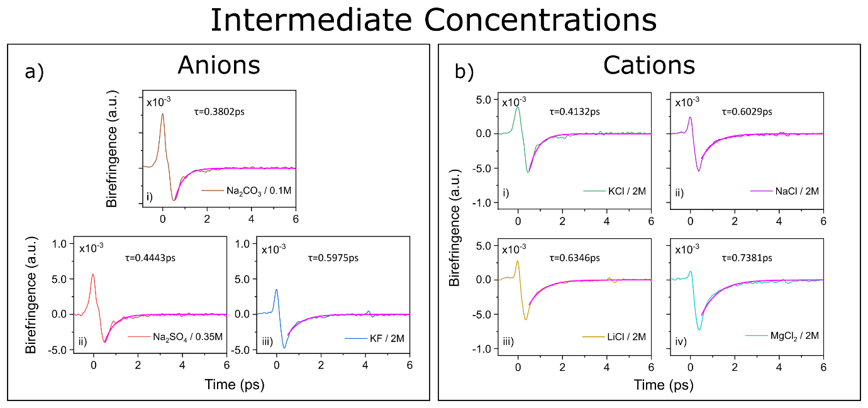
Fig. S2. Transient optical birefringence of intermediate salt concentrations of a) strong anions and b) strong cations. The tail (above 0.5ps) is fitted with a single exponential function and the resulting fitted curve is shown in each figure (magenta line). The time constants returned from the fitting routine are mentioned in each figure. Note that each time trace has been normalized to the value of the corresponding water amplitude in the day of measurement, to avoid errors from the THz power fluctuations.

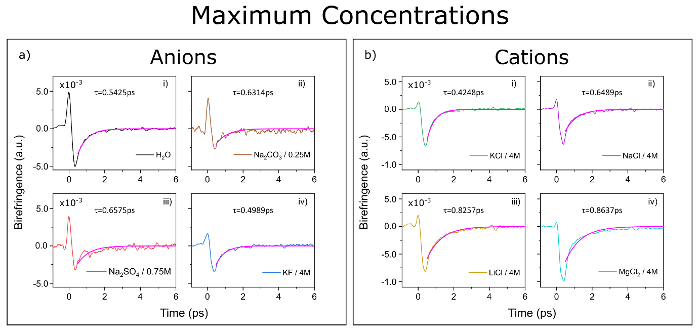
Fig. S3. Transient optical birefringence of maximum salt concentrations of a) strong anions and b) strong cations. The tail (above 0.5ps) is fitted with a single exponential function and the resulting fitted curve is shown in each figure (magenta line). The time constants returned from the fitting routine are mentioned in each figure. Note that each time trace has been normalized to the value of the corresponding water amplitude in the day of measurement, to avoid errors from the THz power fluctuations.

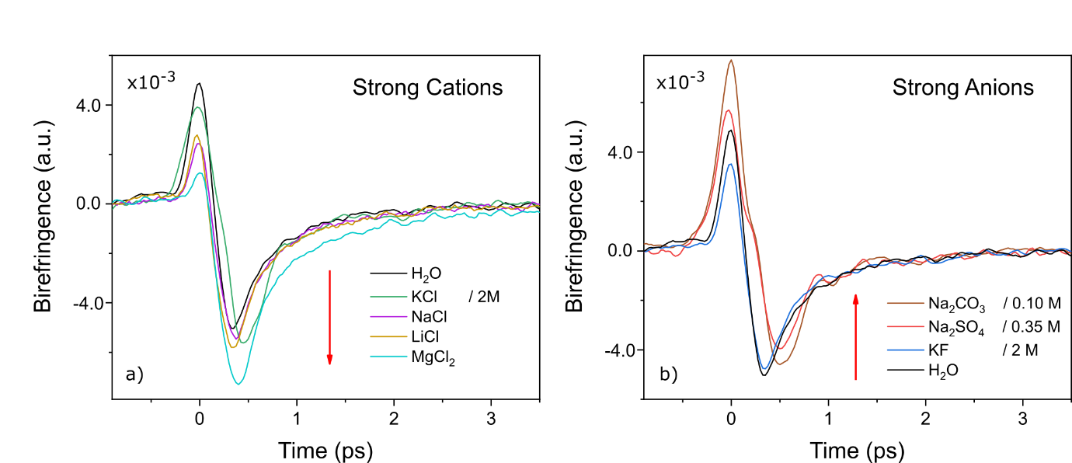
Figure S4. Transient optical birefringence of intermediate concentrations (values stated at the legend) of: a) strong cations: KCl (green line), NaCl (purple line), LiCl (orange line), MgCl₂ (cyan line) and b) strong anions: KF (blue line), Na₂SO₄ (red line), Na₂CO₃ (brown line), compared to pure liquid water (black line). The amplitude of the TKE signal drastically changes in the presence of highly charged electrolytes and the change is ion specific. The red arrows indicate the increase in the SCD of the ions. Note that each time trace has been normalized to the value of the corresponding water amplitude in the day of measurement, to avoid errors from the THz power fluctuations.

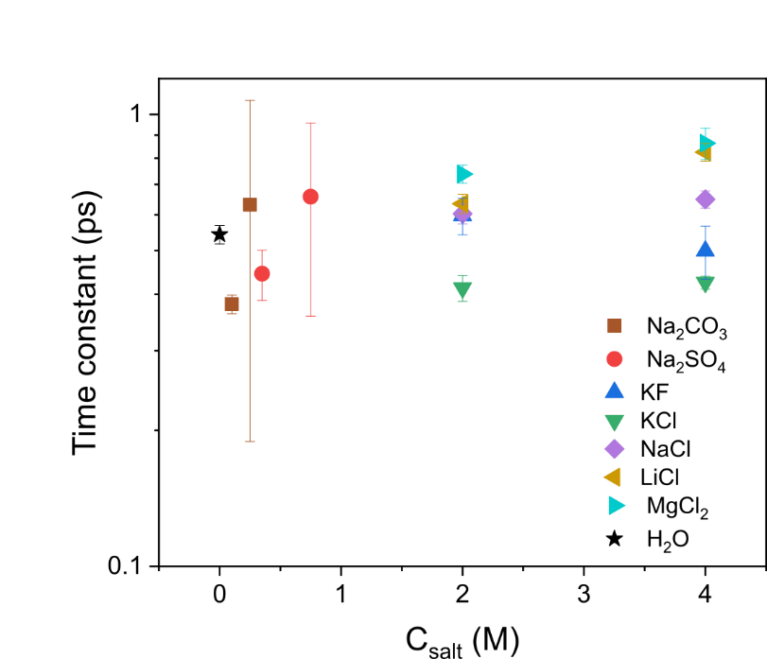
Fig. S5. Time constant values of Na₂CO₃ (brown squares), Na₂SO₄ (red circles), KF (blue up-triangles), KCl (green down-triangles), NaCl (purple diamond), LiCl (orange left-triangles), MgCl₂ (cyan right-triangles) and H₂O (black star), returned from the fitting of the tail (above 0.5ps) of the TKE signal with a single exponential function, versus salt concentration. Error bars correspond to the individual coefficient of determination (R²) of each fit.
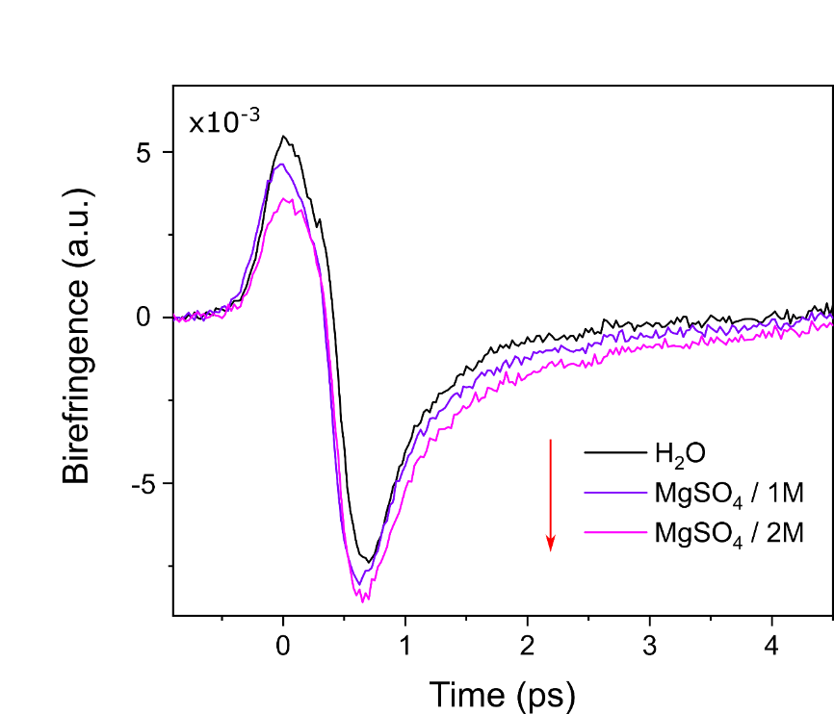
Fig. S6. Transient optical birefringence of aqueous MgSO₄ solutions at 1M (light purple line) and 2M (pink line) concentrations, compared with liquid water (black line). Note that increasing salt concentration (red arrow) leads to a subtle increase in the TKE signal (negative lobe), compared to that of liquid water.
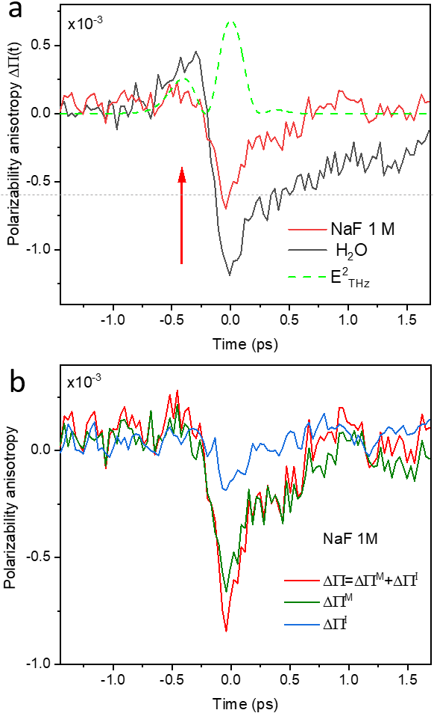

Fig. S7. Transient optical birefringence of aqueous MgSO₄ solutions at 1M (light purple line) and 2M (pink line) concentrations, compared with liquid water (black line). Note that increasing salt concentration (red arrow) leads to a subtle increase in the TKE signal (negative lobe), compared to that of liquid water.
Fig. S8. Transient optical biref. of aq. MgCl₂ solutions at 1M, 2M, and 4M concentrations, using simple point charge (non-polarizable) force field MD simulations. For each concentration the plot is an average of 250000 trajectories. The simulation box setup was the same as with the polarizable FFMD, the SPC water model² was used together with Amber parameters for ions.^{3–5}
Molecular Dynamics simulations.
Polarizable force field MD: We performed polarizable force field molecular dynamics simulations on three different aqueous systems: pure liquid water (as reference), MgCl₂ (1M, 2M and 4M) and Na₂SO₄ (1M). Table I lists the details of the simulated systems. Simulations were performed under fully periodic boundary conditions and a time step of 0.4 fs. Initial configurations were uniformly sampled from equilibrated canonical ensemble MD simulations. All simulations were initially performed under the microcanonical ensemble, and then a THz electric field pulse identical to the one used in our experiment was applied in the x-direction after 0.1 ps. In order to improve the signal-to-noise ratio we have used a pulse amplitude that is eight times stronger than the experimental one.
Simulations were performed using the TINKER software^{6,7} using double precision floating point precision. The velocity-verlet algorithm was employed to time-propagate the positions and velocities of atoms. The amoeba force field parameter set ‘amoebanuc17’ was used.^{8–11} For the sulphate ion, the parameters were taken from ref.¹² A buffered 14-7 potential¹³ was used to include the effects of short-range repulsion-dispersion interaction. Short-range interactions were truncated at 9 Å, whereas the smooth particle mesh Ewald¹⁴ was employed to treat the long-range electrostatic interactions. The mutual induced dipoles were computed using the conjugate gradients method^{15,16} with a tolerance of 0.00001 Debye. For inclusion of the external electric field E in energy and force calculations in TINKER, we have introduced the electric force term $F=k_{1}qE$ and induced dipole term $μ=k_{2}αE$. The constants $k_{1}$ = 1185.85 and $k_{2}$ = 3.567 give the forces and dipoles in kcal per angstrom per mol and Å², when the electric field E and polarizability $α$ are in atomic unit and Å³. The existing implementation of conjugate gradients minimization in TINKER was utilized to compute the mutual induced dipoles that produce the local field at each molecule.
The time-dependent polarizability anisotropy results reported in this work were averaged over 25000 trajectories. For all our analyses involving hydrogen bonds, we have used a standard hydrogen bond definition (O-O distance < 3.5 Å and an hydrogen bond angle < 30 Degree).¹⁷
Table I: Simulated systems with their concentration, proportion and box length. PFFMD=polarizable force field MD. The number of simulated trajectories of each solution is given between brackets.
Ionic solution | Concentration (mol/L) | No of ions | No of H₂O | Cubic box side length in angstrom | MD type [no of trajectories]
Liquid water | - | - | 128 | 15.6404 | PFFMD [25000]
Na₂SO₄ | 1 | 2 | 125 | 15.56 | PFFMD [25000]
MgCl₂ | 1 | 3 | 191 | 17.9772 | PFFMD [25000]
MgCl₂ | 2 | 5 | 133 | 16.099 | PFFMD [25000]
MgCl₂ | 4 | 19 | 236 | 19.9629 | PFFMD [25000]

Ab initio MD: To study the hydrogen bond strength between water molecules in ionic solutions, we performed ab initio molecular dynamics (AIMD) simulations under field free conditions, for pure liquid water (as reference), and for MgCl₂ (2M), Na₂SO₄ (1M) and MgSO₄ (2M). The systems were first equilibrated for 40 ps in the canonical ensemble, followed by a 50 ps microcanonical ensemble production run. The Ab initio MD simulations were conducted using the Quickstep module of the CP2K software.¹⁸ Throughout, the energies and forces were computed using the mixed Gaussian-plane waves (GPW) approach,¹⁹ with the Kohn–Sham orbitals represented by an accurate triple-ζ basis set with two sets of polarization functions (TZV2P).²⁰ Plane-waves with a cutoff of 400 Ry were used to represent the charge density, whereas the core electrons were described by the Goedecker-Teter-Hutter (GTH) pseudopotentials.^{21,22} The BLYP exchange-correlation functional was used together with a damped interatomic potential for dispersion interactions (Grimme-D3).²³ Simulations were conducted using a time step of 0.4 fs.
The average hydrogen bond strengths shown in this work were obtained by performing ALMO-EDA for 500 AIMD snapshots uniformly sampled from the 50 ps production trajectories. The technical details behind ALMO are described elsewhere.²⁴ All ALMO-EDA calculations in this work were performed using the ALMO-EDA implementation in CP2K program¹⁸ with same settings as described in our AIMD simulations.
Calculation of polarizability anisotropy
The polarizability anisotropy was calculated from the ensemble-averaged difference between the xx-component of the polarizability tensor, and the average of the remaining two diagonal components, yy and zz (laboratory reference frame, with the x-axis being defined by the THz electric field):
$$△α=α_{xx}-\left[\frac{α_{yy}+α_{zz}}{2}\right]$$
The total polarizability of each component can be calculated by summing the permanent ($α^{perm}$) and induced ($α^{ind}$) polarizabilites of all the molecules in the system:
$$α_{total}=\sum_{i=1}^{n}{\left(α_{i}^{perm}+α_{i}^{ind}\right)}$$
where $n$ is the total number of molecules.
The induced polarizability of each molecule is computed by an extended dipole-induced dipole (DID) mechanism in a self-consistent field (SCF) manner.²⁵ The model is „extended“ by the inclusion of both the first and the second hyperpolarizabilities. The SCF equation for first and second hyperpolarizability enhanced DID mechanism is given by the following expression:
$$α_{i}^{ind}=α_{i}^{perm}\sum_{j!=i}^{n}{T_{ij}}\left(α_{j}^{perm}+α_{j}^{ind}\right)+β_{i}\vec{E_{i}}+\frac{γ_{i}{\vec{E_{i}}}^{2}}{2}$$
where $T_{ij}=3\vec{r_{ij}}{\vec{r_{ij}^{T}}}/{r_{ij}^{5}}-I/{r_{ij}^{3}}$ is the standard dipole-dipole interaction tensor between molecules $i$ and $j$, ${\vec{r}}_{ij}$ and $r_{ij}$ are the distance vector and norm distance from molecule i to j, I is a 3 $×$ 3 unit tensor, $β_{i}$ and $γ_{i}$ are the first and second hyperpolarizability tensors of molecule i, which are calculated in gas phase conditions using our parameters in Table II. $\vec{E_{i}}$ is the local electric field vector at molecule i created only by all the surrounding molecules (i.e. the permanent ionic charges and the permanent and induced dipoles of all entities, but excluding the external THz field) within a 7.5 Å distance from the center of mass of the molecule. We have verified the validity of this cutoff by replicating the simulation box in all directions and increasing the cutoff distance to 15 Å, which only gave a negligible change in anisotropy. The SCF equation is solved iteratively until the solution reaches the tolerance of 0.000001 Å³.

The induced dipole moment of each molecule was obtained using the preconditioned conjugate gradient (PCG) method^{15,16} with a convergence tolerance of 0.000001 Debye and with the following initial guess, residue and direction:
$$Initialguess:{\vec{μ}}_{i}^{ind,0}=α_{i}^{perm}\left[{\vec{E}}_{external}+\sum_{j!=i}^{n}{\frac{q.{\hat{r}}_{ij}}{r_{ij}^{2}}}-\sum_{j!=i}^{n}{\frac{1}{r_{ij}^{3}}}\left({\vec{μ_{j}}}^{perm}\right)+\sum_{j!=i}^{n}{\frac{3}{r_{ij}^{5}}}\left(\vec{r_{ij}}.\left({\vec{μ_{j}}}^{perm}\right)\right).\vec{r_{ij}}\right]$$
$$Initialresidue:{\vec{r}}_{i}^{0}=\sum_{j!=i}^{n}{T_{ij}}\left({\vec{μ}}_{j}^{ind,0}\right)$$
$$Initialdirection:{\vec{p}}_{i}^{0}=α_{i}^{perm}{\vec{r}}_{i}^{0}$$
where ${\hat{r}}_{ij}$ is the unit vector pointing from molecule $i$ to $j$, $q$ is the molecular charge and ${\vec{E}}_{external}$ is the externally applied field vector.
Parametrization of the dipole moments, polarizabilities, and hyperpolarizabilities.
The permanent dipole moment of the ions was set to zero, while for water, a gas phase dipole moment of 1.93 Debye was assigned along the molecular bisector. The ionic polarizability parameters from the Refs.^{26,27} were used to model the permanent polarizabilites of the ions. Whereas the permanent polarizabilites of water were calculated in the gas phase. All the employed parameters are listed in Table II.
The values of dipole moment and polarizability parameters of gas phase water reported in this work were parameterized using CP2K program,¹⁸ while the first and second hyperpolarizability parameters of gas phase water were parameterized using DALTON program.²⁸ For this parameterization, we used the same settings as described in our AIMD simulations.
Table II: Molecular dipole moment, polarizabilites, first and second order hyperpolarizabilites of the gas phase water. Note that in our molecular frame of a water molecule, the x-axis points along the vector joining the two hydrogen atoms (H-H vector), y-axis the vector of the water bisector and the z-axis to the vector perpendicular to both water bisector and H-H vector.
Properties | H₂O Parameters | Units
Dipole  $$μ_{y}$$  Polarizability  $$α_{xx}$$  $$α_{yy}$$  $$α_{zz}$$  First hyperpolarizability  $$β_{yyy}$$  $$β_{xxy}$$  $$β_{zzy}$$  Second hyperpolarizability  $$γ_{xxxx}$$  $$γ_{yyyy}$$  $$γ_{zzzz}$$  $$γ_{xxyy}$$  $$γ_{xxzz}$$  $$γ_{yyxx}$$  $$γ_{yyzz}$$  $$γ_{zzxx}$$  $$γ_{zzyy}$$ | 1.3725 (9.2713)  1.3725 (9.2713)  1.1580 (7.8224)  0.9127 (6.1653)  -0.5282 (-12.730)  -0.6824 (-16.445)  -0.2297 (-5.5365)  3.1351 (269.8054)  1.470 (126.5123)  0.09407 (8.096200)  2.1019 (180.8921)  1.0817 (93.09720)  2.1019 (180.8921)  0.4124 (35.49410)  1.0817 (93.09720)  0.4124 (35.49410) | Debye (atomic unit)  Å³ (atomic unit)  Å⁵ (atomic unit)  Å⁷ (atomic unit)

References
1. Fukasawa, T. et al. Relation between Dielectric and Low-Frequency Raman Spectra of Hydrogen-Bond Liquids. Phys. Rev. Lett. 95, 197802 (2005).
2. Berendsen, H. J. C., Grigera, J. R. & Straatsma, T. P. The missing term in effective pair potentials. J. Phys. Chem. 91, 6269–6271 (1987).
3. Cornell, W. D. et al. A Second Generation Force Field for the Simulation of Proteins, Nucleic Acids, and Organic Molecules. J. Am. Chem. Soc. 117, 5179–5197 (1995).
4. Kashefolgheta, S. & Vila Verde, A. Developing force fields when experimental data is sparse: AMBER/GAFF-compatible parameters for inorganic and alkyl oxoanions. Phys. Chem. Chem. Phys. 19, 20593–20607 (2017).
5. Kashefolgheta, S. & Vila Verde, A. Correction: Developing force fields when experimental data is sparse: AMBER/GAFF-compatible parameters for inorganic and alkyl oxoanions. Phys. Chem. Chem. Phys. 20, 28346–28347 (2018).
6. Rackers, J. A. et al. Tinker 8: Software Tools for Molecular Design. J. Chem. Theory Comput. 14, 5273–5289 (2018).
7. https://github.com/TinkerTools/Tinker.
8. Ponder, J. W. et al. Current status of the AMOEBA polarizable force field. J. Phys. Chem. B 114, 2549–2564 (2010).
9. Grossfield, A., Ren, P. & Ponder, J. W. Ion Solvation Thermodynamics from Simulation with a Polarizable Force Field. J. Am. Chem. Soc. 125, 15671–15682 (2003).
10. Ren, P. & Ponder, J. W. Polarizable Atomic Multipole Water Model for Molecular Mechanics Simulation. J. Phys. Chem. B 107, 5933–5947 (2003).
11. Shi, Y. et al. Polarizable atomic multipole-based AMOEBA force field for proteins. J. Chem. Theory Comput. 9, 4046–4063 (2013).
12. Lambrecht, D. S., Clark, G. N. I., Head-Gordon, T. & Head-Gordon, M. Exploring the rich energy landscape of sulfate-water clusters SO₄²⁻ (H₂O) n=3-7: An electronic structure approach. J. Phys. Chem. A 115, 11438–11454 (2011).
13. Halgren, T. A. Representation of van der Waals (vdW) Interactions in Molecular Mechanics Force Fields: Potential Form, Combination Rules, and vdW Parameters. 114, 7827–7843 (1992).
14. Essmann, U. et al. A smooth particle mesh Ewald method. J. Chem. Phys. 103, 8577–8593 (1995).
15. Aviat, F. et al. Truncated conjugate gradient: An optimal strategy for the analytical evaluation of the many-body polarization energy and forces in molecular simulations. J. Chem. Theory Comput. 13, 180–190 (2017).
16. Wang, W. & Skeel, R. D. Fast evaluation of polarizable forces. J. Chem. Phys. 123, (2005).
17. Luzar, A. & Chandler, D. Hydrogen-bond kinetics in liquid water. Nature 379, 55–57 (1996).
18. Kühne, T. D. et al. CP2K: An electronic structure and molecular dynamics software package -Quickstep: Efficient and accurate electronic structure calculations. J. Chem. Phys. 152, (2020).
19. Lippert, G., Hutter, J. & Parrinello, M. A hybrid Gaussian and plane wave density functional scheme. Mol. Phys. 92, 477–488 (1997).
20. VandeVondele, J. & Hutter, J. Gaussian basis sets for accurate calculations on molecular systems in gas and condensed phases. J. Chem. Phys. 127, (2007).
21. Goedecker, S. & Teter, M. Separable dual-space Gaussian pseudopotentials. Phys. Rev. B - Condens. Matter Mater. Phys. 54, 1703–1710 (1996).
22. Krack, M. Pseudopotentials for H to Kr optimized for gradient-corrected exchange-correlation functionals. Theor. Chem. Acc. 114, 145–152 (2005).
23. Grimme, S., Antony, J., Ehrlich, S. & Krieg, H. A consistent and accurate ab initio parametrization of density functional dispersion correction (DFT-D) for the 94 elements H-Pu. J. Chem. Phys. 132, (2010).
24. Khaliullin, R. Z., Cobar, E. A., Lochan, R. C., Bell, A. T. & Head-Gordon, M. Unravelling the origin of intermolecular interactions using absolutely localized molecular orbitals. J. Phys. Chem. A 111, 8753–8765 (2007).
25. Torii, H. Extended dipole-induced dipole mechanism for generating Raman and optical Kerr effect intensities of low-frequency dynamics in liquids. Chem. Phys. Lett. 353, 431–438 (2002).
26. Molina, J. J. et al. Ions in solutions: Determining their polarizabilities from first-principles. J. Chem. Phys. 134, 5–10 (2011).
27. Jungwirth, P., Curtis, J. E. & Tobias, D. J. Polarizability and aqueous solvation of the sulfate dianion. Chem. Phys. Lett. 367, 704–710 (2003).
28. Aidas, K. et al. The Dalton quantum chemistry program system. Wiley Interdiscip. Rev. Comput. Mol. Sci. 4, 269–284 (2014).

