Supporting Information
Phytochemical Profiling of Aloe koenenii leaf epidermis by UHPLC-PDA-MS/MS

Sven Zalewski^{1,#} , Flávio A. Carvalho^{1,#} , Luis V. S. Sacramento¹, Caio H. Perego¹, Eduardo J. Crevelin², Antônio E. M. Crotti², André G. Santos*¹

¹São Paulo State University (UNESP), School of Pharmaceutical Sciences, Department of Drugs and Medicines, Araraquara, São Paulo, Brazil
²University of São Paulo (USP), Faculty of Philosophy, Sciences and Letters, Department of Chemistry, Ribeirão Preto, São Paulo, Brazil

*Corresponding author, e-mail: andre.gonzaga@unesp.br
#These authors contributed equally to this work

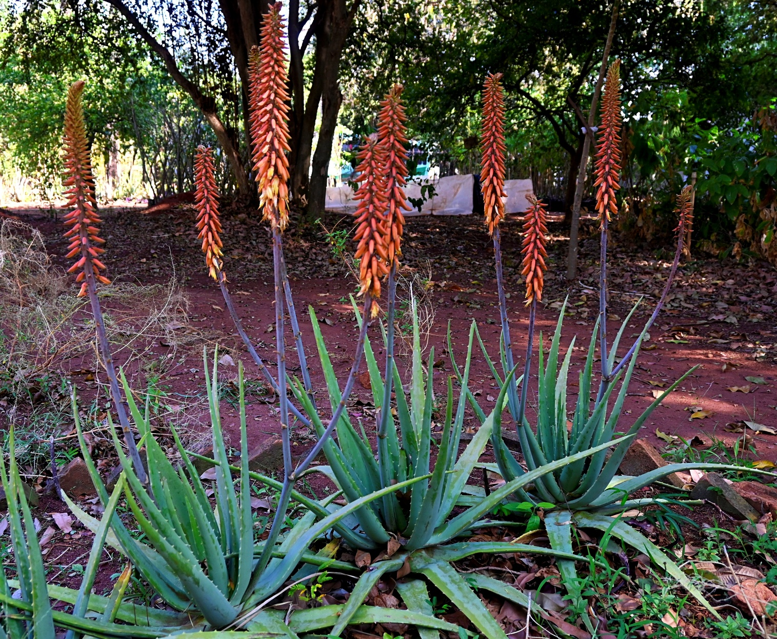
Figure S1. Aloe koenenii Lavranos & Kerstin Koch Lodé — cultivated plants in flower. Photo: Carolina Leidiádines de Sá Ferreira, 2025.

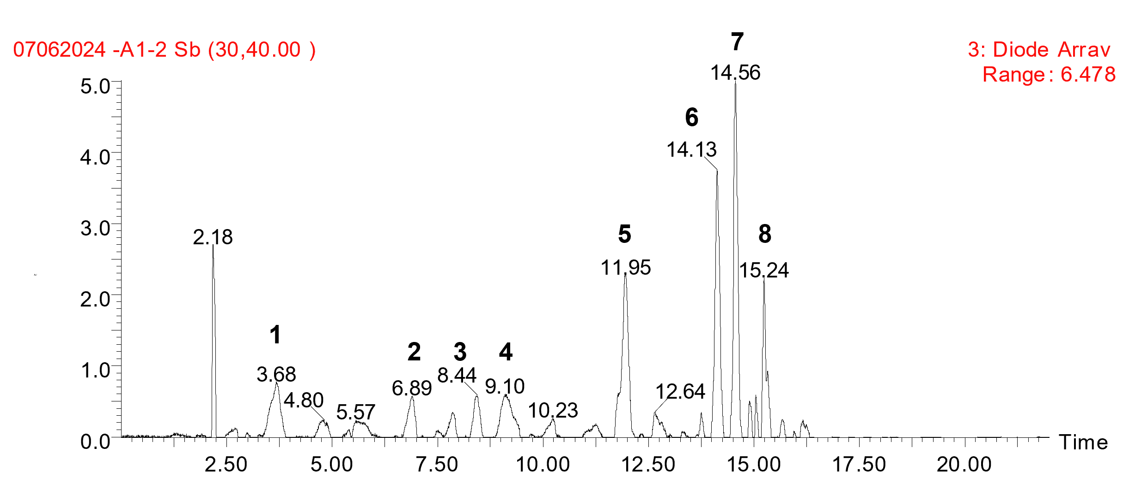
Figure S2. PDA chromatogram of the ethanolic crude extract of A. vera recorded in full-scan mode (200–700 nm).
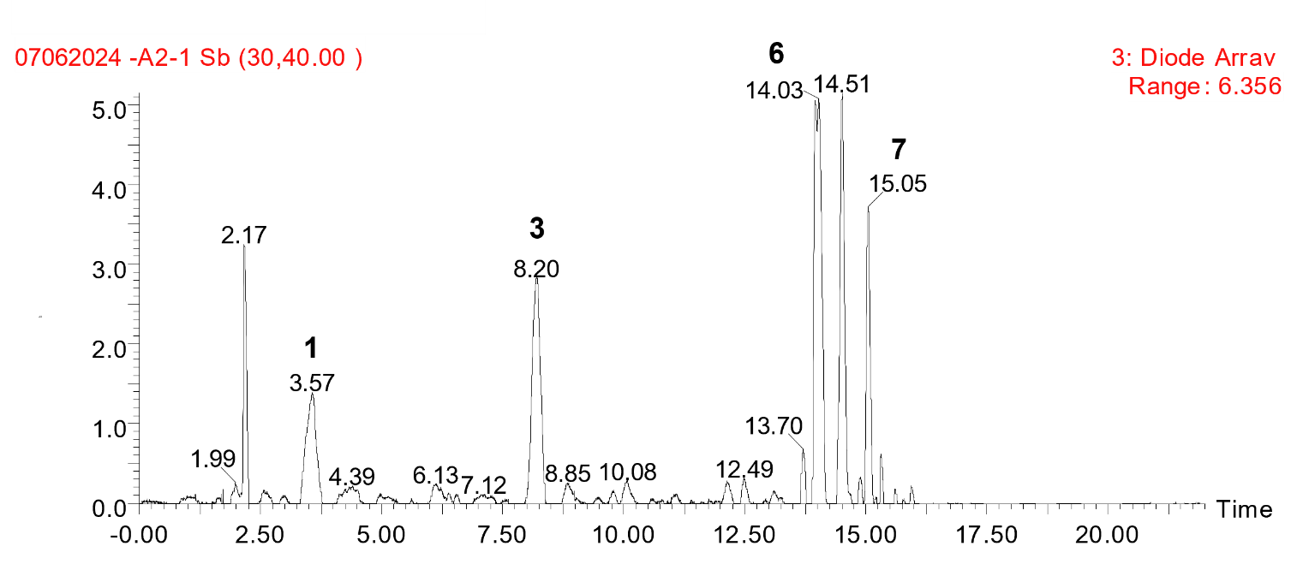
Figure S3. PDA chromatogram of the ethanolic crude extract of A. koenenii recorded in full-scan mode (200–700 nm).

Figure S4. Full-scan ESI(+)-MS chromatogram of the leaf ethanol extract of A. vera.

T
i
m
e
0
.
0
0
2
.
5
0
5
.
0
0
7
.
5
0
10
.
0
0
12
.
5
0
15
.
0
0
17
.
5
0
20
.
0
0
%
0
10
0
2
:
S
c
an
ES-
T
I
C
3
.
85e
9
14
.
5
5
14
.
1
1
2
.
0
7
11
.
9
4
8
.
4
0
3
.
6
8
4
.
8
2
6
.
89
5
.
5
7
9
.
1
0
10
.
2
6
12
.
6
3
15
.
2
2
16
.
4
7
17
.
4
8
1
2
3
4
Figure S5. Full-scan ESI(-)-MS chromatogram of the leaf ethanol extract of A. vera.

T
i
m
e
0
.
0
0
2
.
5
0
5
.
0
0
7
.
5
0
10
.
0
0
12
.
5
0
15
.
0
0
17
.
5
0
20
.
0
0
%
0
10
0
1
:
S
c
an
ES
+
T
I
C
1
.
78e1
0
2
.
1
3
14
.
13
8
.
1
6
3
.
2
1
3
.
4
4
4
.
3
4
7
.
0
2
8
.
8
7
12
.
1
6
10
.
0
4
14
.
5
6
15
.
24
16
.
5
0
6
7
Figure S6. Full-scan ESI(+)-MS chromatogram of the leaf ethanol extract of A. koenenni.

T
i
m
e
0
.
0
0
2
.
5
0
5
.
0
0
7
.
5
0
10
.
0
0
12
.
5
0
15
.
0
0
17
.
5
0
20
.
0
0
%
0
10
0
2
:
S
c
an
ES-
T
I
C
3
.
97e
9
2
.
1
3
10
.
0
5
12
.
4
8
14
.
56
16
.
4
0
17
.
4
8
3
.
68
1
8
.
40
3
1
4.
13
6
7
15
.
24
Figure S7. Full-scan ESI(-)-MS chromatogram of the leaf ethanol extract of A. koenenni.

Figure S8. Product ion spectrum of deprotonated aloesin (1) (m/z 393) (Ar, E_{lab} = 30 eV, QqQ).

Scheme S1. Formation of the product ions of m/z 303, 273, 245, and 231 of deprotonated aloesin (1) (m/z 393).

Figure S9. Product ion spectrum of deprotonated homonataloside B (2) (m/z 593) (Ar, E_{lab} = 30 eV, QqQ).

Scheme S2. Formation of the product ions of m/z 473, 431, 341, 311, 297, 282, and 269 of deprotonated homonataloside B (2) (m/z 593).

Figure S10. Product ion spectrum of deprotonated 7-hydroxy-8-O-methylaloin (3) (m/z 447) (Ar, E_{lab} = 30 eV, QqQ).

Scheme S3. Formation of the product ions of m/z 327, 312, and 284 of deprotonated 7-hydroxy-8-O-methylaloin (3) (m/z 447).

Figure S11. Product ion spectrum of deprotonated 7-hydroxyaloin A or B (4) (m/z 433) (Ar, E_{lab} = 30 eV, QqQ).

Scheme S4. Formation of the product ions of m/z 313 and 270 of deprotonated 7-hydroxyaloin A or B (4) (m/z 433).

Figure S12. Product ion spectrum of protonated isoaloeresin D or aloeresin D (5) (m/z 557) (Ar, E_{lab} = 30 eV, QqQ).

Scheme S5. Formation of the product ions of m/z 513, 437, 419, 393, 331, 291, 247, 205, and 147 of protonated isoaloeresin D or aloeresin D (5) (m/z 557).

Figure S13. Product ion spectrum of protonated aloin B (m/z 419) (6) (Ar, E_{lab} = 30 eV, QqQ).

Scheme S6. Formation of the product ions of m/z 401, 257, 239, and 211 of protonated aloin B (6) (m/z 419).

Figure S14. Product ion spectrum of protonated aloin A (7) (m/z 419) (Ar, E_{lab} = 30 eV, QqQ).

Scheme S7. Formation of the product ions of m/z 401, 257, 239 and 211 of protonated aloin A (7) (m/z 419).

