Supplemetary Materials
A: Floor Plan Drawing of EPS Made Model Building
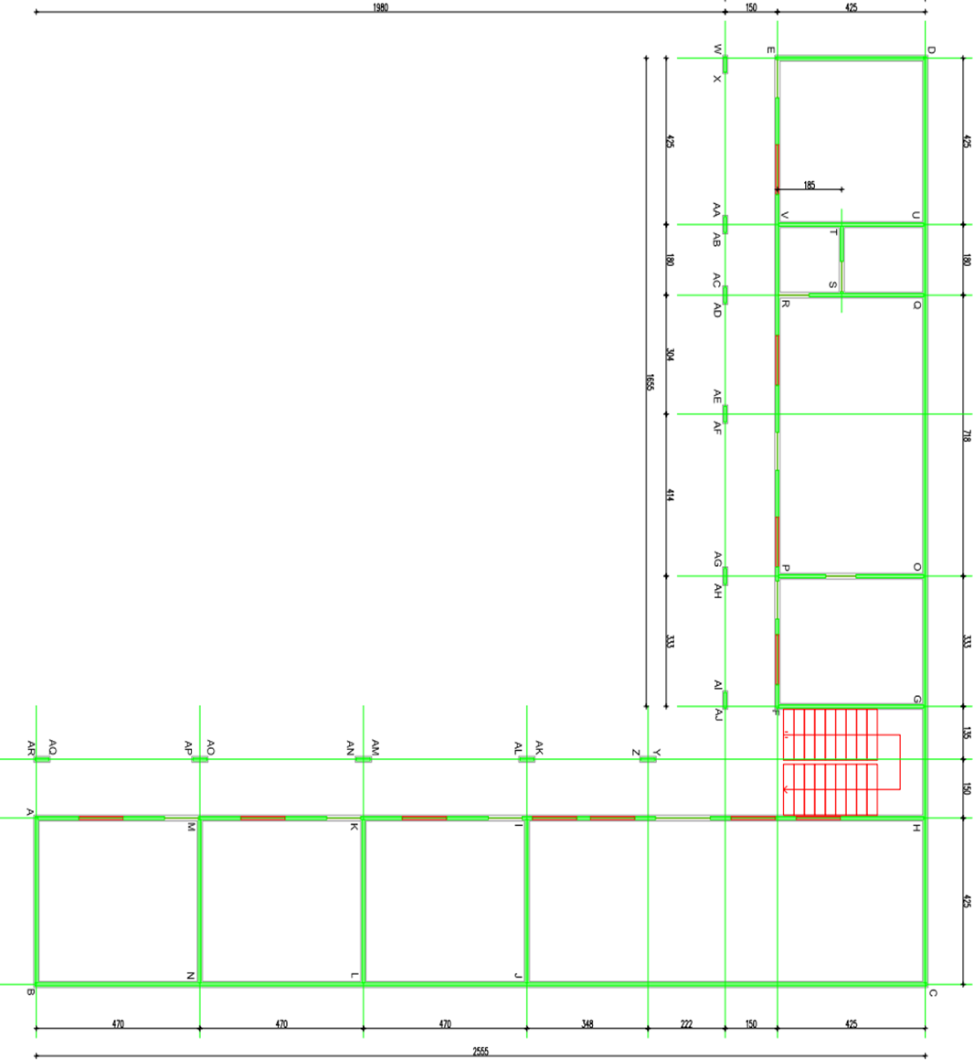

B: Roof Plan Drawing of EPS Made Model Building
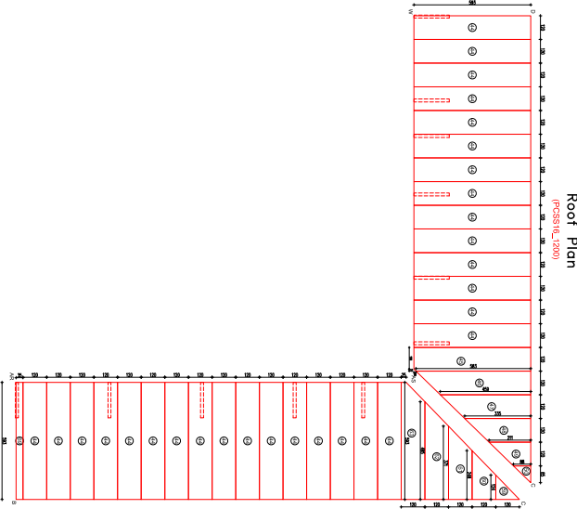

Roof plan

C: EPS Made Model Building Panels View

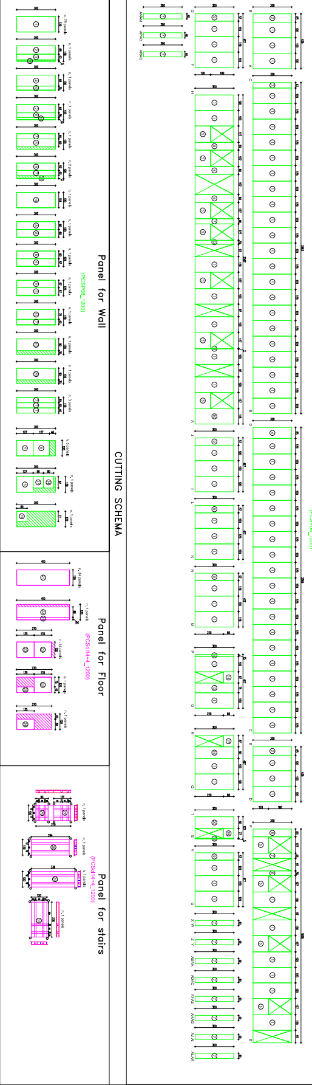

D: Results of a Monte Carlo Simulation

Time | Probability | Number iterations out of 500
79 | 0% | 0
80 | 0% | 0
81 | 0% | 0
82 | 0% | 0
83 | 0% | 0
84 | 0% | 0
85 | 0% | 0
86 | 0% | 0
87 | 0% | 0
88 | 0% | 0
89 | 0% | 0
90 | 0% | 0
91 | 0% | 0
92 | 0% | 0
93 | 0% | 0
94 | 0% | 0
95 | 0% | 0
96 | 0% | 0
97 | 0% | 0
98 | 0% | 0
99 | 1% | 5
100 | 1% | 6
101 | 3% | 13
102 | 4% | 20
103 | 6% | 29
104 | 8% | 39
105 | 10% | 49

106 | 12% | 60
107 | 17% | 84
108 | 22% | 110
109 | 28% | 142
110 | 35% | 177
111 | 41% | 207
112 | 48% | 242
113 | 55% | 273
114 | 62% | 311
115 | 66% | 332
116 | 72% | 358
117 | 76% | 382
118 | 82% | 408
119 | 86% | 429
120 | 89% | 445
121 | 91% | 456
122 | 93% | 467
123 | 96% | 479
124 | 96% | 482
125 | 98% | 489
126 | 99% | 493
127 | 99% | 496
128 | 99% | 497
129 | 100% | 499
130 | 100% | 499
131 | 100% | 500
132 | 100% | 500
133 | 100% | 500
134 | 100% | 500
135 | 100% | 500

136 | 100% | 500
137 | 100% | 500
138 | 100% | 500
139 | 100% | 500
140 | 100% | 500
141 | 100% | 500
142 | 100% | 500
143 | 100% | 500
144 | 100% | 500
145 | 100% | 500
146 | 100% | 500
147 | 100% | 500
148 | 100% | 500
149 | 100% | 500
150 | 100% | 500
151 | 100% | 500

E: Flexural Strength Test Result Sample Graphs
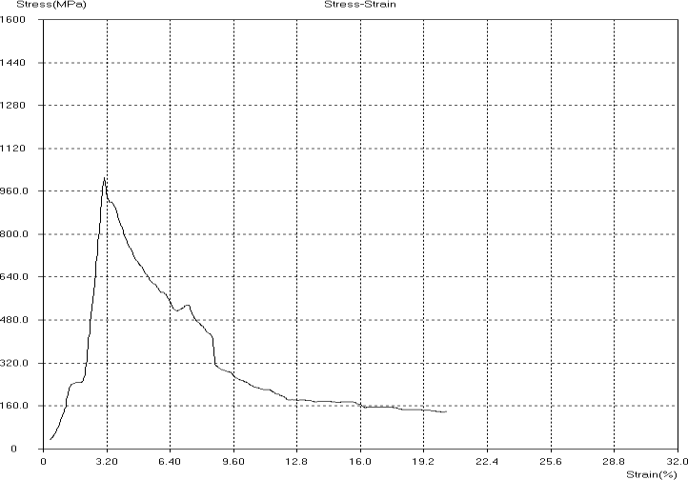
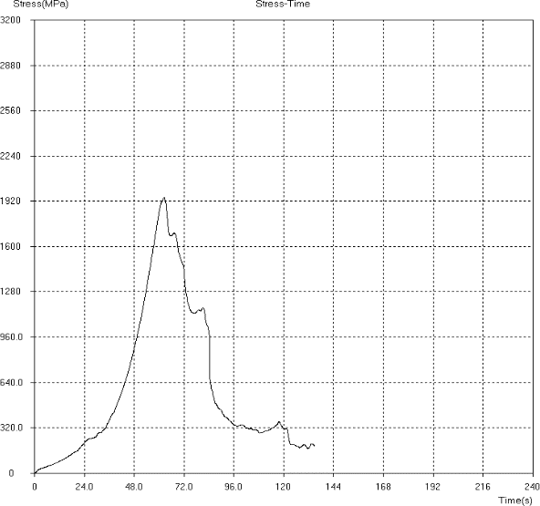
Stress –strain of 15kg/m³ density panel Stress –strain of 18kg/m³ density panel

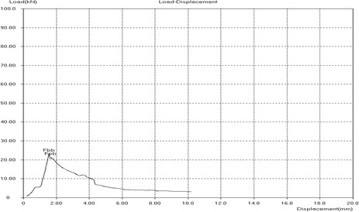
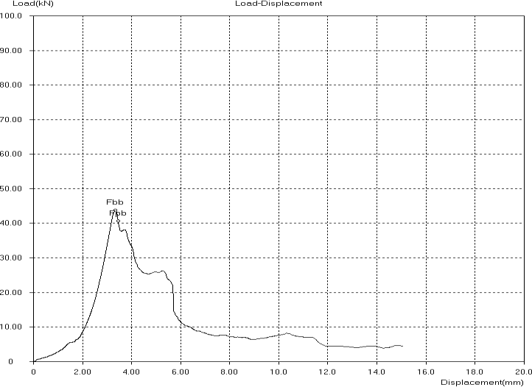
Load displacement of 15kg/m³ density Load displacement of 18kg/m³ density

F: Duration Estimation

Work item | Unit | Quanti- ty |  | Out- put per man /  day |  | Min. worker (max.dur ation ) |  | Aver. Workers (aver. duration  ) |  | Max. worker min. du- ration
1. Earth work and exca-  vation |  |  |  |  |  | 14.2 |  | 9.1 |  | 7.1
Site clearance | m2 | 372.46 |  | 10 |  | 4.1 |  | 2.7 |  | 2.1
Bulk excavation | m3 | 43.31 |  | 1.8 |  | 2.7 |  | 1.7 |  | 1.3
Pit excavation | m3 | 32.2 |  | 1.7 |  | 2.1 |  | 1.4 |  | 1.1
Trench excavation | m3 | 59.58 |  | 1.25 |  | 5.3 |  | 3.4 |  | 2.6
Output per crew
 | Unit | Qua ntity | Out- put per crew  / day |  | Min. worker (max.durat ion ) |  | Aver. Workers (aver. du- ration ) |  | Max.worker min.duration
1. Sub structure Con-  crete work |  |  |  |  | 28.6 |  | 24.0 |  | 17.3
Masonry work | m3 | 65.5 | 5 |  | 1.5 |  | 0.4 |  | 0.4
Pad concrete | m3 | 3.26 | 10 |  | 0.2 |  | 0.2 |  | 0.1
Foundation column con-  crete | m3 | 1.02 | 10 |  | 0.1 |  | 0.1 |  | 0.0
Grade beam concrete | m3 | 7.55 | 10 |  | 0.4 |  | 0.4 |  | 0.3

In 100 mm thick Ground  slab | m3 | 23.3 | 10 | 1.2 | 1.2 | 0.8
ø10 mm def bars for ground  slab mesh | kg | 1201  .51 | 100 | 4.0 | 3.0 | 3.0
ø12 mm def bars for pad  work | kg | 1123  .5 | 100 | 5.6 | 5.6 | 3.7
Pad formwork | m2 | 15.1  4 | 6 | 1.3 | 1.3 | 0.8
Foundation column form. | m2 | 32.2 | 5 | 3.2 | 3.2 | 2.1
Grade beam form work | m2 | 48.1  2 | 5 | 4.8 | 4.8 | 3.2
Hardcore | M2 | 232.  29 | 18 | 6.5 | 4.3 | 3.2
2. Super structure con-  crete |  |  |  | 47.7 | 38.1 | 29.5
Elevation column concrete | m3 | 3.12 | 6 | 0.3 | 0.2 | 0.1
Stair case concrete | m3 | 3.16 | 8 | 0.2 | 0.1 | 0.1
Intermediate beam concrete | m3 | 9.1 | 6 | 0.8 | 0.5 | 0.4
First floor 70mm thick con-  crete | m3 | 18.0  5 | 8 | 1.1 | 0.8 | 0.6
Top tie beam concrete | m3 | 4.92 | 6 | 0.4 | 0.3 | 0.2
elevation column form  work | m2 | 110.  4 | 3 | 9.2 | 12.3 | 9.2
Slab panel | m2 | 183.  07 | 5 | 9.2 | 6.1 | 4.6
Intermediate beam form  work | m2 | 63.8  4 | 3 | 10.6 | 7.1 | 5.3

In Staircase form work | m2 | 18.5 | 3.5 | 2.6 | 1.8 | 1.3
Top tie beams form works | m2 | 59.0  4 | 3 | 9.8 | 6.6 | 4.9
Reinforcement |  |  |  | 12.6 | 8.5 | 7.3
ø10 mm def bars for first  floor slab mesh | kg | 1201  .51 | 100 | 1.3 | 0.9 | 0.7
ø12 mm def bars for beams  and column | kg | 2556  .2 | 100 | 2.8 | 1.8 | 1.4
ø14 mm def bars for beams  and column | kg | 3604  .3 | 100 | 4.0 | 2.6 | 2.0
ø16 mm def bars for beams  and column | kg | 395.  51 | 100 | 0.4 | 0.3 | 0.2
3. Block work |  |  |  | 8.3 | 5.8 | 4.6
For external wall 20 cm  thick | m2 | 295.  2 | 10 | 5.9 | 4.9 | 3.3
For partion wall 10 cm  thick | m2 | 96 | 8 | 2.4 | 0.9 | 1.3
4. CARPENTRY &  JOINERY |  |  |  | 14.3 | 10.3 | 6.9
Upper & Lower eucalyptus members. Size Dia.10-  12cm | ml | 359.  63 | 37 | 1.9 | 1.6 | 1.1
Diagonal & vertical euca-  lyptus members size Dia.8- 10cm | ml | 291.  87 | 23 | 2.5 | 2.1 | 1.4
Purlin zigba 5*7 cm | ml | 750.  65 | 23 | 6.5 | 5.4 | 3.6
Agro-stone doors in different  sizes | no | 20.0  0 | 3 | 3.3 | 1.1 | 0.7

5. ROOFING | m2 |  |  | 5.0 | 4.0 | 2.9
G-28 Galvanized CIS roof-  ing. | m2 | 257.  93 | 40 | 2.1 | 1.6 | 1.3
Supply and fix G-28 Flash- ing(Copping) in flat metal sheet fix as shown detail  drawing dev't length 33cm | ml | 180.  50 | 16 | 2.3 | 1.9 | 1.3
Supply and fix G-28 flat sheet gutter dev't length 50cm as per the detail draw-  ing | ml | 38.0  5 | 30 | 0.3 | 0.2 | 0.1
Supply and fix G-28 flat  sheet Valley gutter dev't length 90 cm as per the de-  tail drawing | ml | 45.0  0 | 30 | 0.3 | 0.3 | 0.2
6. FINISHING WORK |  |  |  | 32.8 | 19.9 | 13.1
Three coats of plastering for  internal wall | m2 | 1189  .08 | 35 | 6.8 | 4.2 | 3.4
Two coats of plastering for  external wall ,columns &beams | m2 | 443.  98 | 35 | 4.2 | 2.5 | 1.6
Apply three coats of plastic  emulsion paint | m2 | 1189  .08 | 30 | 13.2 | 7.9 | 5.0
Ceramics floor finish | m2 | 257.  00 | 10 | 8.6 | 5.1 | 3.2
Total duration |  |  |  | 151 | 111 | 79

