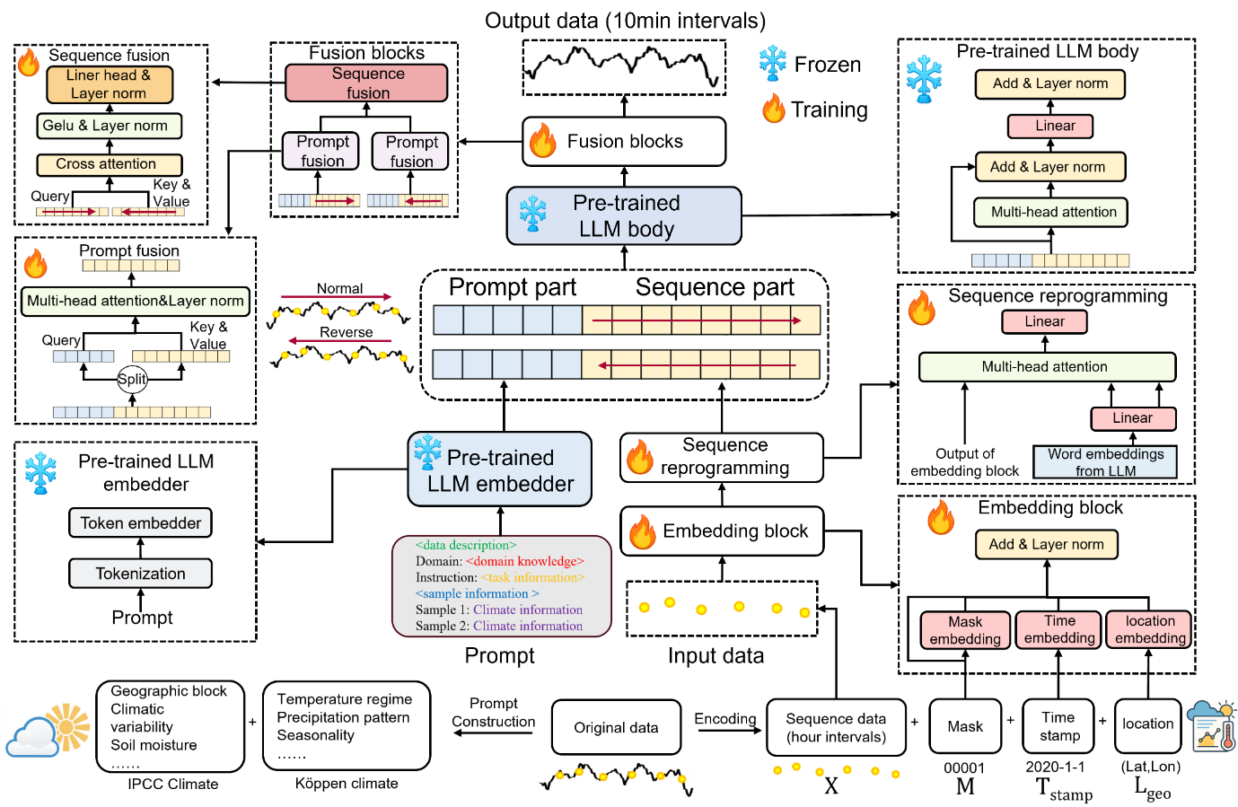
Extended Data Fig. 1 | Architecture of the climate-aware imputation LLM. In the figure, “normal” and “reverse” indicate that the sequence is duplicated into forward and backward orders.
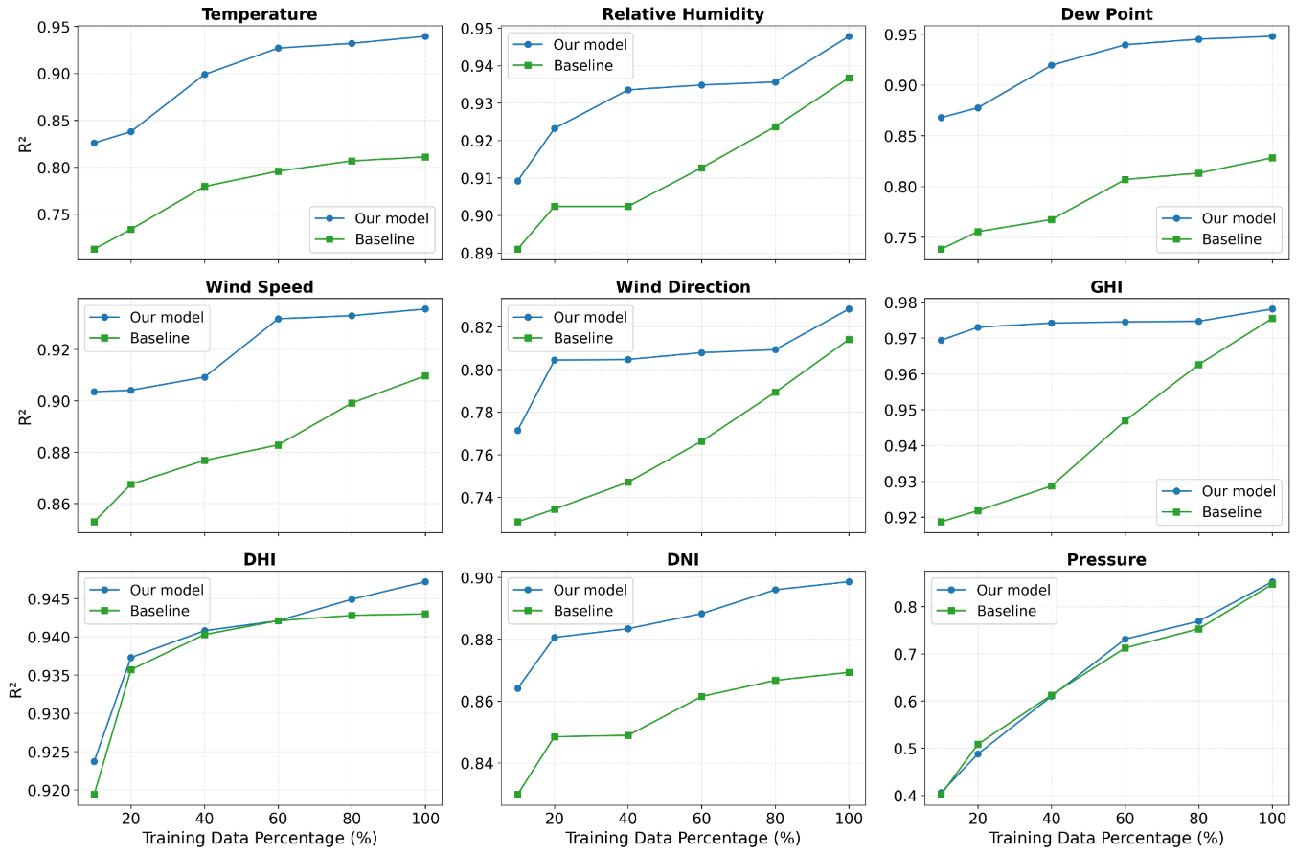
Extended Data Fig. 2 | Sensitivity of imputation performance to training data availability. Each panel reports the relative change in coefficient of determination (ΔR²) when varying the fraction of available training data, where ΔR² denotes the difference in R² scores between Climate-aware imputation LLM and the baseline model of TimeLLM. Details of performance gain per feature with increasing training data can be found in Supplementary Fig. 3.
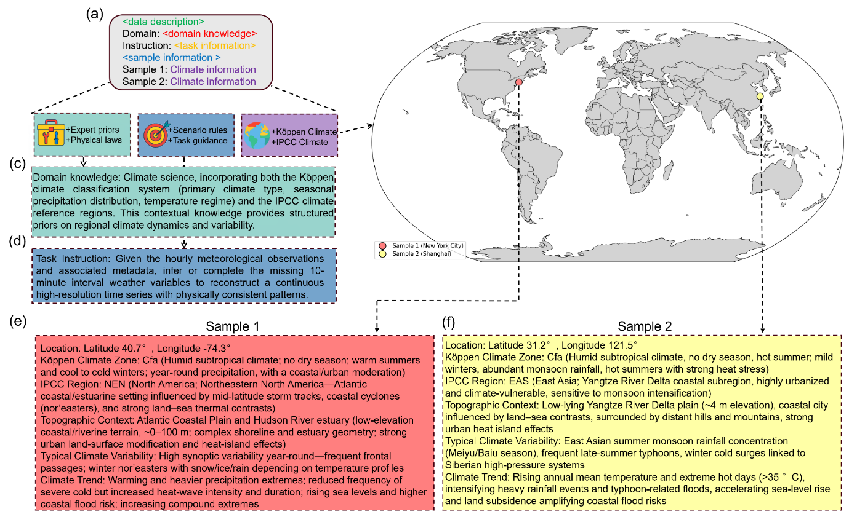
Extended Data Fig. 3 | The figure illustrates the design of structured prompts and input encoding. (a) Structure of a complete prompt. (b) Two representative cases: New York and Shanghai. (c) Example of domain knowledge encoding. (d) Example of task information encoding. (e) Climate information encoded for New York. (f) Climate information encoded for Shanghai.
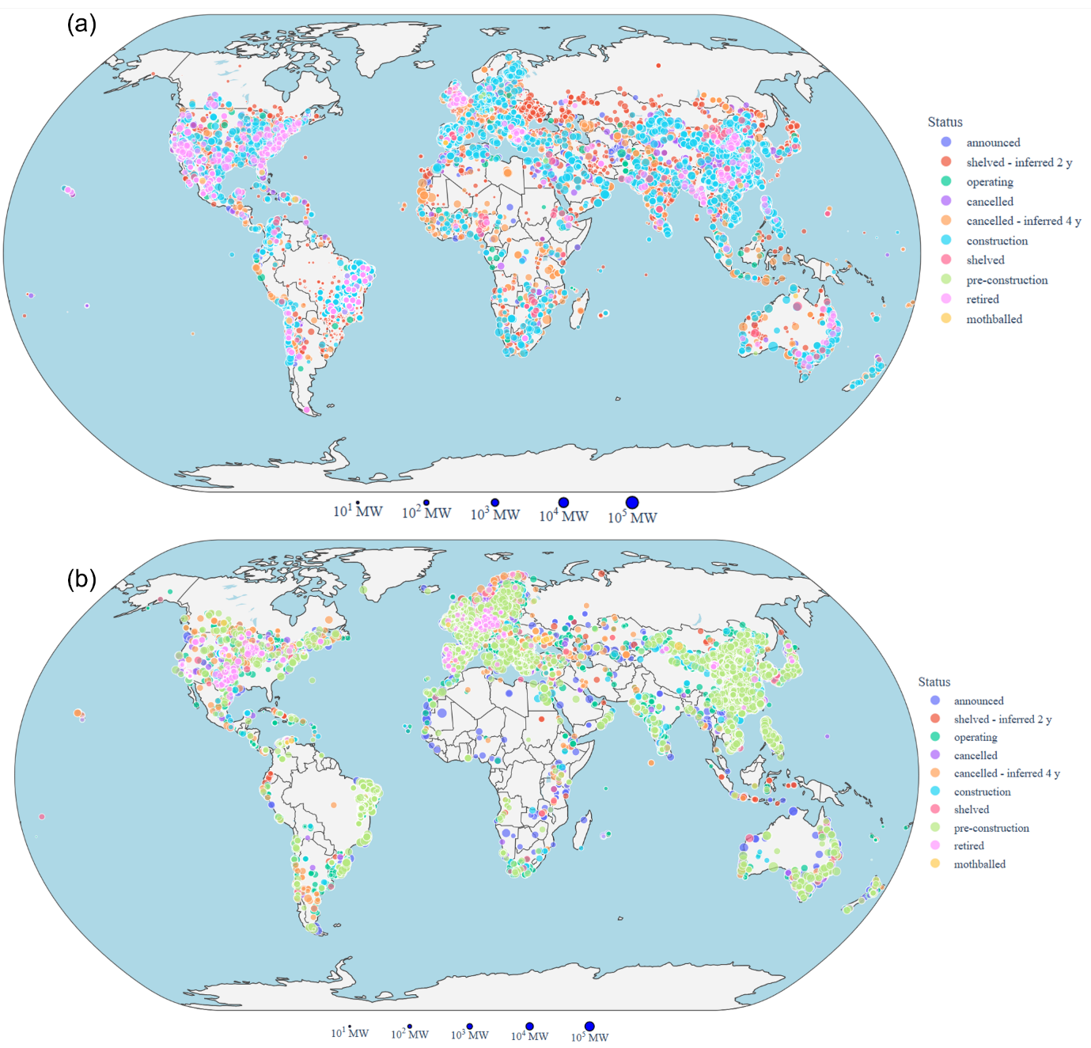
Extended Data Fig. 4 | Global infrastructure metadata used for downstream applications. (a) Solar photovoltaic projects from the Global Solar Power Tracker. (b) Wind power projects from the Global Wind Power Tracker. Both datasets are updated to February 2025.
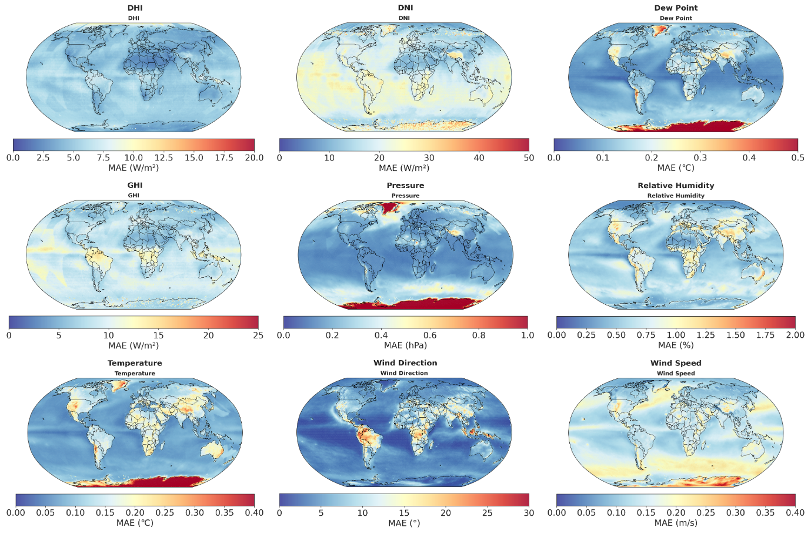
Extended Data Fig. 5 | Feature-wise absolute mean error (MAE) distributions of climate-aware imputation LLM imputations. Each panel reports the absolute deviation between reconstructed and true values, where MAE represents the average magnitude of errors irrespective of sign.
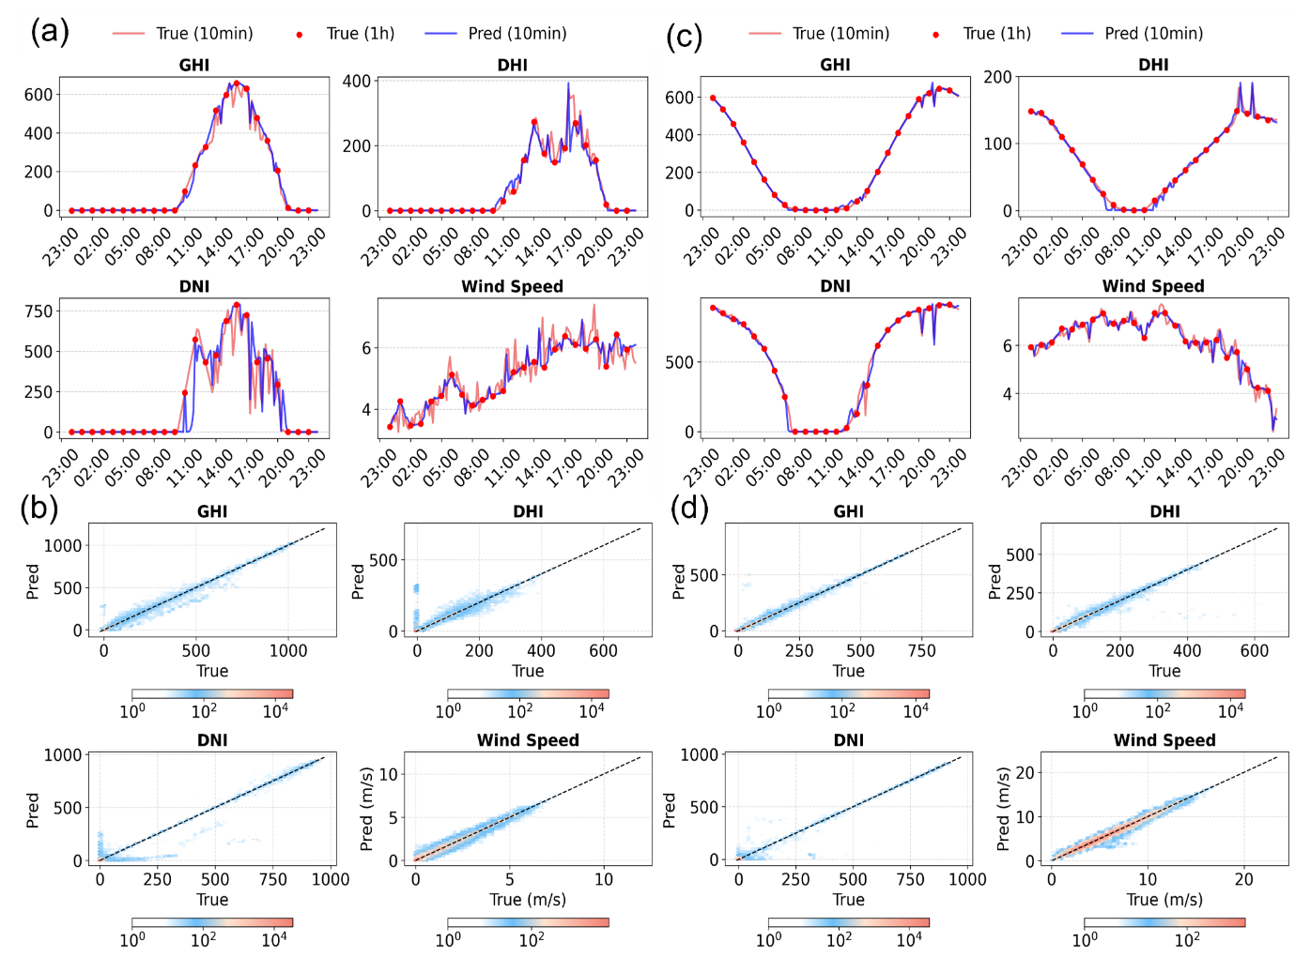
Extended Data Fig. 6 | Validation of climate-aware imputation LLM at two representative ground stations. Panels (a, c) and (b, d) present single-day and annual validations at the Bermuda and Barrow stations, respectively. (a, c) show the temporal evolution of GHI, DHI, DNI, and wind speed (red: ground truth; blue: model-filled values); (b, d) display scatter density plots between predictions and observations.

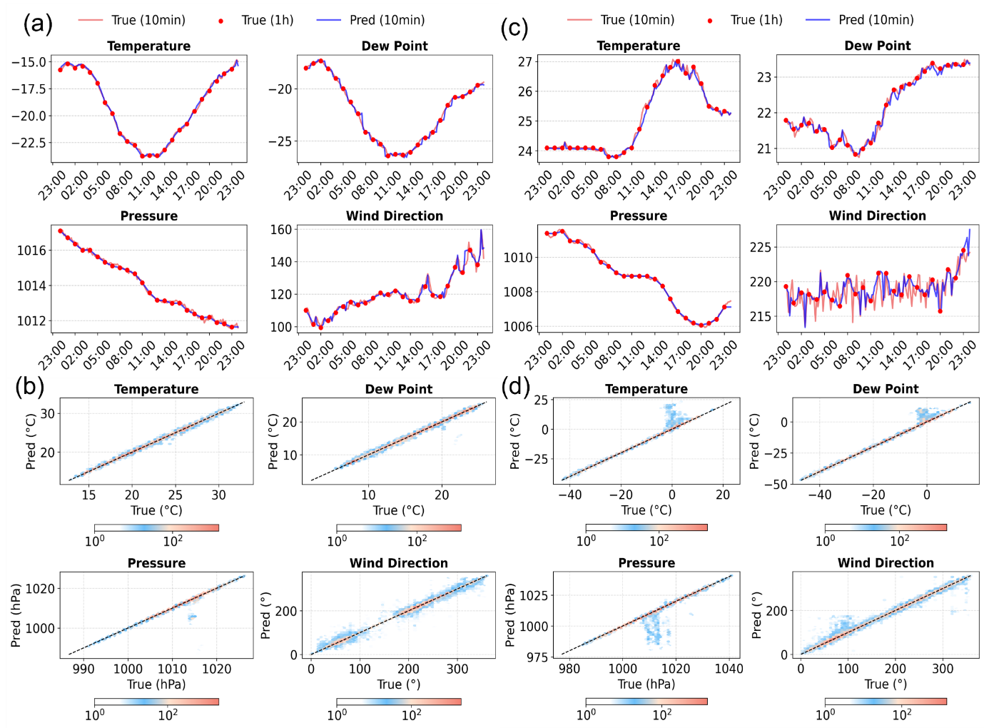
Extended Data Fig. 7 | Imputation results for secondary meteorological variables. Panels (a, c) and (b, d) show single-day and annual validations for secondary variables (temperature, dew point, pressure, and wind direction) at the Bermuda and Barrow stations, respectively.
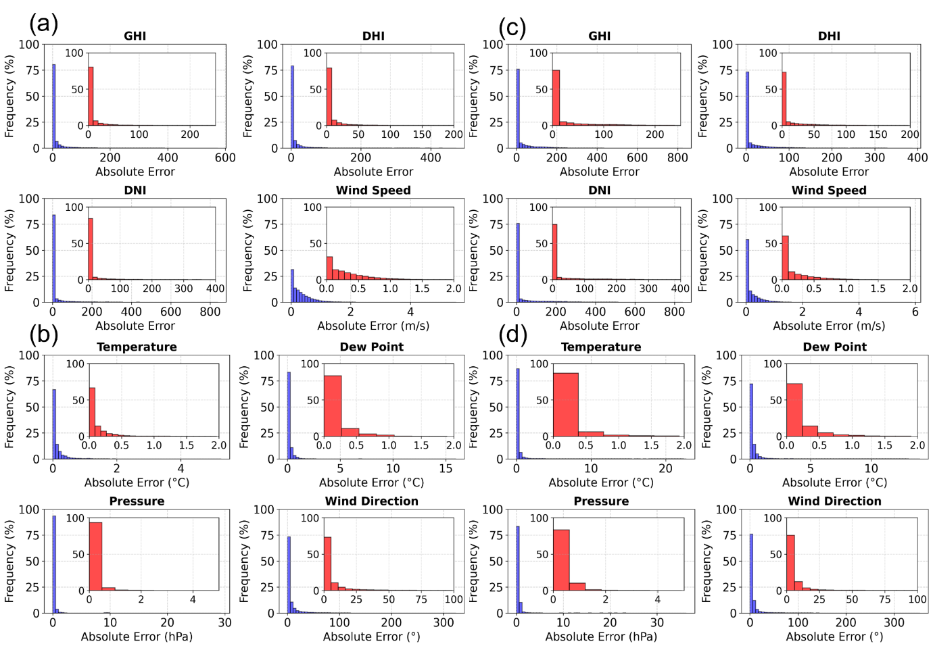
Extended Data Fig. 8 | Frequency distributions of absolute errors for meteorological features. Panels (a, b) correspond to Bermuda, while (c, d) correspond to Barrow. A higher concentration of histogram bars near zero indicates greater accuracy in the corresponding feature.
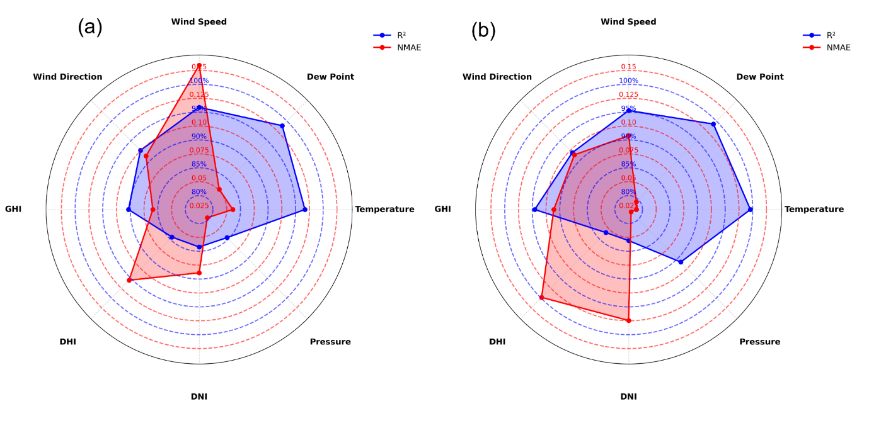
Extended Data Fig. 9 | Annual error metrics across meteorological features. Annual R² and NMAE values for Bermuda and Barrow are presented, highlighting differences in predictive performance across meteorological features.

