Data sources
We utilize meteorological data from two main sources and complement them with static geoclimatic priors. (i) Satellite-based high temporal resolution data. Ten-minute interval weather data are obtained from the National Solar Radiation Database (NSRDB), which is derived from the GOES constellation (for the Americas) and the Himawari-8 satellite (for East Asia and Oceania). In this study, we aggregate the original NSRDB fields onto a 1°×1° grid, yielding 8,342 grid cells that cover parts of the United States, Mexico, South America, Japan, and China. (ii) Reanalysis-based global data. To provide global coverage, we further collect hourly meteorological reanalysis data from the ERA5 family of reanalyses (ERA5 and ERA5-Land) produced by ECMWF for the Copernicus Climate Change Service, accessed via the Open-Meteo Historical Weather API. These data are sampled on a 1°×1° global analysis grid (64,800 grid cells) for the year 2020 and include wind-related variables, solar radiation, temperature, humidity, and pressure. They serve as the coarse-resolution input signals for our model and form the basis of our global validation benchmark. For time stamp of these data, we restrict the temporal scope to the year 2020, which serves as a representative meteorological year.
In addition, we compile two types of static geoclimatic priors as domain-knowledge inputs. The Köppen climate classification ^{[1]} encodes each location’s long-term climate regime (e.g., temperate, arid, tropical) with a hierarchical three-letter code, while the IPCC climate reference regions ^{[2]} provide spatial zoning for global climate analysis, summarizing geographical blocks, ecological homogeneity, climate variability patterns, and sensitivities to global warming. These regional descriptors are transformed into natural language and used to condition model inference via structured prompts.
The model takes as input multivariate meteorological sequences—temperature, pressure, humidity, radiation, and wind—from the ERA5-family reanalysis dataset on 64,800 global 1°×1° grid cells, together with structured prompts derived from Köppen classifications and IPCC reference regions. The output is a continuous 10-minute imputation of all variables. The proposed model fine-tunes only 1.9 % of the parameters of a frozen LLM backbone using 10-minute satellite data from NSRDB (GOES + Himawari-8), covering about 13 % of the global grids.

NSRDB data
The high-temporal-resolution supervision used in this work is derived from the National Solar Radiation Database (NSRDB) maintained by the National Renewable Energy Laboratory (NREL). The NSRDB provides a serially complete collection of solar irradiance and meteorological data constructed from surface observations, satellite retrievals and radiative transfer modelling ^{[3]}. The latest version of NSRDB is based primarily on geostationary satellite imagery (GOES over the Americas and Himawari-8 over East Asia and Oceania), combined with ancillary meteorological inputs, and has been extensively validated against ground-based measurements.
In this study, we use ten-minute NSRDB records for the year 2020, focusing on regions where satellite coverage and data quality are highest. We aggregate the original NSRDB native grid to a 1°×1° latitude–longitude grid by spatial averaging, resulting in 8,342 grid cells spanning the United States, Mexico, South America, Japan, and China. For each 1°×1° cell, we extract ten-minute time series of near-surface meteorological variables relevant to radiative and convective processes. All variables are converted to consistent physical units and quality-controlled using NSRDB flags before being used for model fine-tuning.
These NSRDB-based ten-minute sequences constitute the high-resolution ground-truth target for our imputation model.

ERA5-family reanalysis data
For global-scale validation and coarse-resolution input fields, we require an hourly meteorological dataset that (i) provides near-complete global coverage, (ii) is physically consistent across atmospheric and land–surface variables, and (iii) can be sampled efficiently at arbitrary latitude–longitude coordinates on a regular grid. To satisfy these requirements, we build our benchmark on the ERA5 family of reanalyses produced by the European Centre for Medium-Range Weather Forecasts (ECMWF) for the Copernicus Climate Change Service (C3S).
ERA5 is a full-observing-system global atmospheric reanalysis that combines a modern numerical weather prediction system with a wide range of historical in situ and satellite observations, providing hourly estimates of the atmosphere, land surface and ocean waves on a ~31 km (≈0.25°) grid from 1979 onwards ^{[4]}. ERA5-Land is a land-surface reanalysis generated by rerunning the land component of ERA5 at enhanced spatial resolution, yielding a state-of-the-art global dataset for land applications with improved representation of soil moisture, land surface temperature and land energy fluxes ^{[5]}. In the main text, we collectively refer to these products as the “ERA5-family reanalysis dataset”.
Rather than downloading and maintaining the full ERA5 and ERA5-Land archives, we access these reanalyses through the Open-Meteo Historical Weather API, which acts as a thin aggregation and interpolation layer over ECMWF and Copernicus products. Open-Meteo combines several ECMWF-based datasets—including ERA5 and ERA5-Land—into a unified historical weather service. According to the provider’s documentation, the default configuration for historical data seamlessly blends these sources on a native grid of order 9 km and uses reanalysis and high-resolution forecast fields to provide a spatially detailed, globally consistent time series for any requested coordinate. Conceptually, we treat Open-Meteo purely as an access and matching layer that exposes ERA5-family reanalysis fields at arbitrary locations, while all scientific attribution remains with the underlying Copernicus products.
In this study, we define a regular 1°×1° global analysis grid covering longitudes 180° W–180° E and latitudes 90° S–90° N. For each grid cell, we use its geographic centre as the target coordinate and query the Open-Meteo endpoint for the calendar year 2020. For every 1°×1° cell, the API returns an hourly time series of meteorological variables derived from the ERA5 / ERA5-Land family and associated ECMWF models. We request 2 m air temperature, relative humidity, 10 m wind speed and wind direction, surface (or mean sea-level) pressure, and surface shortwave radiation components (global horizontal irradiance, direct normal irradiance and diffuse horizontal irradiance). Internally, the Open-Meteo service maps each requested coordinate to the nearest model grid points on its ~9 km mesh and performs the required interpolation; the returned time series therefore represent ERA5-family reanalysis fields sampled at our 1°×1° analysis grid coordinates.
Using ERA5-family fields accessed through Open-Meteo offers two key advantages for our application. First, the ERA5 / ERA5-Land system provides a physically consistent, observation-constrained description of the coupled atmosphere–land system (Hersbach et al., 2020; Muñoz-Sabater et al., 2021), which is crucial for training and evaluating a model intended to generalize across diverse climate regimes. Second, the Historical Weather API operates on reanalysis models with native resolutions down to about 9 km, and its default Best match configuration seamlessly combines ECMWF IFS HRES, ERA5 and ERA5-Land fields before interpolating them to arbitrary coordinates. In this setup, Open-Meteo uses a terrain-optimised grid and preferentially selects land grid cells in complex regions, so that the effective reanalysis fields resolve coastlines and orography much more finely than a single 1° product. We then sample these finer-scale ERA5-family fields at the centres of our 1°×1° cells, which yields more realistic local meteorological signatures—particularly in mountainous and coastal regions—and improves the representativeness of the coarse-resolution inputs used for model training and global validation.
All data accessed via Open-Meteo are distributed under the Creative Commons Attribution 4.0 International (CC BY 4.0) licence ^{[6]}. In accordance with this licence, we acknowledge the Open-Meteo.com Weather API ^{[7]} as the access layer used in this study. The underlying reanalysis fields are produced by ECMWF for the Copernicus Climate Change Service; consequently, the global benchmark constructed here contains modified Copernicus Climate Change Service information (2020). In line with the C3S data policy, neither the European Commission nor ECMWF is responsible for any use that may be made of the Copernicus information or data contained in this work. Throughout the main text we therefore use the neutral term “ERA5-family reanalysis dataset” for this benchmark and refer the reader to the present section for full details on data provenance, access and licensing.

Forecast data
For the short-range forecast experiment and the associated PV energy simulations, we use a proprietary numerical weather prediction product: ECMWF operational medium-range forecasts produced ^{[8]} by the Integrated Forecasting System (IFS). The dataset consists of gridded short-range forecasts at hourly resolution from 00:00 UTC on 1 October 2025 to 00:00 UTC on 6 October 2025. For each target grid point, we extract four near-surface variables: 2 m air temperature, 10 m wind speed, dew point temperature, and global horizontal irradiance (GHI).
In the forecast experiment, both the data fields and the collocated ground stations are restricted to this 5-day window and are represented by a common six-variable feature set: air temperature, dew point temperature, 10 m wind speed, global horizontal irradiance (GHI), direct normal irradiance (DNI), diffuse horizontal irradiance (DHI).
For the forecast data, only temperature, dew point, wind speed and GHI are provided directly by the model. DNI and DHI are diagnosed from GHI and solar geometry using the pvlib Python library ^{[9]}. Specifically, we compute solar zenith and azimuth angles from latitude–longitude and time using pvlib’s solar position routines. GHI is then decomposed into DNI and DHI with pvlib’s irradiance decomposition and transposition models ^{[10]}. The resulting six-dimensional hourly feature vectors are used both as inputs to the 10-minute imputation model and as drivers for PV energy simulations.
For the short-range forecast experiment and associated PV and wind simulations, we use deterministic operational medium-range forecasts from the European Centre for Medium-Range Weather Forecasts (ECMWF). Due to licensing constraints, the raw data cannot be redistributed. However, the experimental setup is designed to be generic: our analysis focuses on the relative behavior of the imputation model, and the validation framework can be reproduced with any similar high-resolution forecast system that provides, at minimum, hourly 2 m temperature, dew point, 10 m wind speed, and GHI.

Station data
To complement the gridded NSRDB and ERA5-family products, we use high-quality point measurements from two NOAA Global Monitoring Laboratory (GML) Baseline/BSRN sites and seven SURFRAD core stations, all of which are part of international reference networks for surface radiation and meteorology ^{[11–13]}.
For the short-range forecast experiment (1–6 October 2025), we used observations from nine ground stations: two Baseline Surface Radiation Network (BSRN) sites ^{[11, 12]}—Bermuda (BER; 32.308°N, 64.765°W) and Barrow (BRW; 71.323°N, 156.611°W)—together with the seven core NOAA SURFRAD stations^{[13]}: Bondville, Illinois (BON); Table Mountain, Colorado (TBL); Desert Rock, Nevada (DRA); Fort Peck, Montana (FPK); Goodwin Creek, Mississippi (GWN); Penn State University, Pennsylvania (PSU); and Sioux Falls, South Dakota (SXF). The SURFRAD network was established to provide accurate, continuous, long-term measurements of the surface radiation budget across the United States for climate research and satellite validation ^{[13]}.
For each of these stations, we extract minute-average radiation and meteorological observations from the NOAA GML archives and aggregate them to hourly resolution over the period 00:00 UTC on 1 October 2025 to 00:00 UTC on 6 October 2025. From the available variables, we construct the same six-variable feature set used for the forecast data: air temperature, dew point temperature, wind speed, global horizontal irradiance (GHI), direct normal irradiance (DNI), diffuse horizontal irradiance (DHI).
In contrast to the forecast data, GHI, DNI and DHI at these ground sites are measured directly by precision radiometers as part of the BSRN and SURFRAD observing programmes ^{[11–13]}.
In addition to the short-range experiment, we construct a year-long benchmark using two NOAA GML Baseline/BSRN sites that sample contrasting climate regimes: (1) Bermuda (BER; 32.308°N, 64.765°W) – the Prospect Hill station, operated in collaboration with the Bermuda Institute of Ocean Sciences, forms part of the Baseline Surface Radiation Network and provides continuous in situ measurements of broadband solar radiation and standard meteorology in a subtropical maritime environment. (2) Barrow (BRW; 71.323°N, 156.611°W) – the Barrow Atmospheric Baseline Observatory, an Arctic coastal site, is a key node in the NOAA baseline network and BSRN, delivering long-term records of upward and downward shortwave and longwave irradiance, surface albedo and associated meteorological parameters for Arctic climate studies.
For both BER and BRW, we retrieve minute-average records for the entire calendar year 2020 and aggregate them to 10-minute resolution. From these records we construct an eight-variable feature set: global horizontal irradiance (GHI), diffuse horizontal irradiance (DHI), direct normal irradiance (DNI), surface pressure, dew point temperature, air temperature, wind speed, wind direction.
These eight measured quantities provide a comprehensive description of the local radiative–meteorological environment at two climatically distinct reference sites, and are used as high-quality “ground truth” for assessing the year-round performance of the imputation model at sub-hourly resolution.

Global infrastructure datasets
Global solar PV and wind power outputs were simulated using high-temporal-resolution irradiance and wind data, combined with global infrastructure metadata from the Global Solar Power Tracker (GSPT) ^{[14]} and the Global Wind Power Tracker (GWPT) ^{[15]}, both maintained by Global Energy Monitor (GEM) and updated to February 2025.
The Global Solar Power Tracker is a worldwide dataset of utility-scale solar photovoltaic (PV) and solar thermal facilities. It catalogs solar farm phases at the project level and includes all operating solar farm phases with capacities of at least 1 MW, as well as announced, pre-construction, construction and shelved projects with capacities greater than 20 MW. In this study, we extract all utility-scale PV projects from the February 2025 release and aggregate farm phases to the project scale where appropriate. After filtering and deduplication, the resulting portfolio comprises 74,945 utility-scale PV projects with a combined installed capacity of 3,284.6 GW, which are then driven by 10-minute and hourly meteorological inputs in parallel simulation runs.
The Global Wind Power Tracker is a worldwide dataset of utility-scale onshore and offshore wind facilities. It catalogs wind farm phases of 10 MW or greater, covering all development statuses (operating, announced, pre-construction, under construction, shelved, cancelled, mothballed and retired). For the purposes of this work, we use the February 2025 release of GWPT and restrict the analysis to utility-scale wind farm phases classified as operating (onshore and offshore). Phases belonging to the same wind farm are aggregated to construct plant-level time series, yielding a portfolio of 31,035 wind farms with a total installed capacity of 4,017.6 GW.
Both trackers provide plant-level metadata, including installed capacity, technology type, project status, geolocation, and commissioning year. We use the reported nameplate capacities and coordinates to collocate each project with the underlying meteorological grid, and treat all projects as fully available over the simulation period (i.e. without modeling unit-level forced outages). For all assets, solar and wind simulations are run in parallel with hourly and 10-minute forcing, and the resulting generation series are used to compute the Relative Generation Difference (RGD) and maximum RGD (MRGD) metrics described in the “Energy simulation experiments” section.

Large language model driven imputation framework

Data structuring
We begin by masking the high temporal resolution satellite time series to simulate the typical global availability of coarse hourly data. Specifically, we retain only the hourly (on-the-hour) entries, and mask all intermediate time steps with a placeholder value of -999, representing missing observations. During model preprocessing, these masked values are replaced with learnable input embeddings, enabling the model to distinguish observed from missing positions and focus on reconstructing the high temporal resolution structure. Each time series is associated with a single latitude-longitude grid point, and is grouped into fixed-length sequences. For sequences shorter than the target length (e.g., due to regional availability), we apply zero-padding to maintain shape consistency. To enhance numerical stability during training, all meteorological variables were preprocessed using standardization.

Prompt construction and input encoding
To enable LLM-based reconstruction at high temporal resolution without dense station supervision, we pair each sample with a three-part structured prompt and co-encode it with the masked meteorological time series. The prompt comprises Domain, Instruction, and Sample information. Domain and Instruction remain constant across the dataset, whereas Sample information is sample-specific. The Domain section distills expert priors and physical laws to provide structured constraints on regional climate dynamics and variability; its fixed text reads: “Climate science, incorporating both the Köppen climate classification system (primary climate type, seasonal precipitation distribution, temperature regime) and the IPCC climate reference regions. This contextual knowledge provides structured priors on regional climate dynamics and variability.” The Instruction section derives from scenario rules and task guidance, specifying that 10-minute gaps must be completed from hourly observations while preserving physical consistency; its fixed text reads: “Given the hourly meteorological observations and associated metadata, infer or complete the missing 10-minute interval weather variables to reconstruct a continuous high-resolution time series with physically consistent patterns.”
The Sample information injects location-specific climatic and geographic priors. It is derived from the official Köppen classification and IPCC climate reference regions, augmented with geolocation and a brief topographic context (e.g., coastal/inland, plateau/mountain/basin). To improve readability without redundancy, we prioritize the official definitions of Köppen and IPCC, and optionally append concise background phrases from Wikipedia; any overlap with the official definitions is removed, retaining only short expressions that convey key climatic traits (such as seasonal precipitation peaks, temperature regimes, monsoon/land–sea breeze signals, cloud seasonality, and storm-track exposure). The narrative follows a fixed order: location (lat–lon or standard toponym), Köppen code with a brief gloss, IPCC region with a brief gloss, and a compact topographic note. We enforce tight length control (a few sentences, tens of words) to respect context budgets, harmonize units and precision for auxiliary descriptors (elevation, coastal distance), and ensure consistency with reanalysis inputs. For missing or ambiguous fields, we apply hierarchical fallbacks: retain higher-level categories (Köppen/IPCC only) when terrain is unavailable, and use lat–lon plus macro-region phrasing when toponyms are ambiguous. To prevent leakage, Sample information never contains future observations or target values and does not contradict the provided inputs.
The complete prompt is written in natural language and encoded with the frozen LLM’s native tokenizer and embedding layer into a climate-aware textual embedding. This embedding is then aligned with time-series embeddings via Sequence Reprogramming and the Fusion Block, ensuring that prompt guidance persists at the sample level rather than acting as a one-off task descriptor. Extended Data Fig. 3 presents two representative cases (New York and Shanghai), illustrating the pruning and length-control pipeline from classification labels to readable text.
For each sample, the prompt is instantiated from a compact, sentence-level schema that preserves the Domain and Instruction fixed texts and then appends Sample information in a standardized order and style. Concretely, we write one to three short sentences that (i) identify the location (lat–lon or toponym) and state the Köppen code with a brief gloss plus the IPCC region label; (ii) summarize the topographic context with one clause (e.g., coastal/inland, mountain–plain transition, approximate elevation), avoiding redundant phrases that already appear in the Köppen/IPCC definitions; (iii) list the typical climate variability cues with 2–4 nouns or noun phrases (e.g., diurnal/seasonal contrasts, monsoon concentration, winter cold surges, summer convection/typhoons); and (iv) optionally add one clause on the recent climate tendencies when it strengthens interpretability (e.g., heat-extreme frequency, heavy-rain intensification, snowpack sensitivity), keeping wording neutral and avoiding policy or impact narratives. All numbers use harmonized units and coarse rounding; duplications between encyclopedic gloss and Köppen/IPCC text are pruned; and no future observations or target values are revealed.

Climate-aware imputation LLM for meteorological data imputation
The Climate-aware imputation LLM is developed to perform high temporal resolution meteorological imputation by learning to infer sub-hourly weather dynamics from globally available hourly observations, guided by region-specific climate priors encoded in natural language prompts. The model receives as input (i) coarse-resolution hourly meteorological sequences and (ii) prompt embeddings encoding domain knowledge, including Köppen climate classification, IPCC climate region, geolocation, and topographic context.
During supervised fine-tuning, we leverage high temporal resolution (10-minute interval) satellite observations from the National Solar Radiation Database (NSRDB), based on GOES and Himawari-8 satellite data. These are only available over specific regions such as the United States, Mexico, Japan, China, and parts of South America, covering approximately 13% of the global grid. To simulate real-world low-resolution conditions, only the on-the-hour observations are retained, while non-integer timestamps are masked with a placeholder value (-999). The model learns to reconstruct the masked values using the surrounding hourly data and structured prompt-based priors. The masked portions act as supervised labels, enabling climate-aware imputation LLM to capture local diurnal cycles, irradiance patterns, and wind variations.
For the remaining global regions, where no 10-minute ground truth exists, hourly meteorological sequences are obtained from the Open-Meteo reanalysis dataset and similarly augmented by inserting masked 10-minute intervals requiring inference. In this zero-shot imputation phase, climate-aware imputation LLM reconstructs the missing values based on the global prompt-conditioned knowledge and context patterns learned during training. This framework enables large-scale, physically consistent, and climate-aware generation of high temporal resolution meteorological data across the entire globe for the year 2020.

Climate-aware imputation LLM in framework

Embedding block and pre-trained LLM embedder
In the Climate-aware imputation LLM, it takes two types of inputs: (1) a multivariate meteorological time series with missing entries masked by a special value, and (2) a prompt constructed from domain-specific metadata derived from the sample’s geolocation, including Köppen and IPCC climate zone. These two modalities are jointly processed by our model to perform high-fidelity temporal imputation. Let the raw meteorological sequence be denoted as $X∈R^{T×N}$where $T$ is the number of timesteps and $N$ is the number of variables. We define a binary mask $M∈\{0,1\}^{T×N}$ such that:
$M_{t,n}=\left\{\begin{matrix}1, & ifX_{t,n}=-999 \\ 0, & otherwise\end{matrix}\right.$
To handle this dual input structure, we define the overall input as a tuple:
$I=\left(X,M,T_{stamp},L_{geo},P\right)$
where $T_{stamp}∈R^{T×d_{t}}$ is the timestamp sequence embedded using multi-layer MLP into hidden space, $L_{geo}∈R^{2}$represents the latitude and longitude, used for geographic encoding, $P$ is a prompt constructed from the sample’s domain context and climatic properties. The climate-aware imputation LLM processes these components via embedding block to Mask Embedding, Time Embedding, Location Embedding. For Mask Embedding, to explicitly encode the presence of missing values, we construct a learnable vector $v_{mask}∈R^{d}$ and define the embedded input $X_{mask}∈R^{T×N×d}$ as:
$X_{mask}=\left\{\begin{matrix}v_{mask}, & if M_{t,n}=1 \\ X, & otherwise\end{matrix}\right.$
We first map the raw meteorological sequence into the model hidden dimension $D$ via a shared linear projection:
$E_{input}=Linear_{input}(X_{mask})∈R^{T×N×D}$
$E_{masked}=MLP_{mask}\left(X_{mask}\right)$
For Time Embedding, Timestamp $T_{stamp}$is projected via MLP:
$E_{time}=MLP_{time}\left(T_{stamp}\right)∈R^{T×D}$
For Location Embedding, the geolocation vector $L_{geo}=(lat,lon)$ is encoded via:
$E_{location}=MLP_{loc}([sin(π⋅lat/180),cos(π⋅lat/180),sin(π⋅lon/180),cos(π⋅lon/180)])$
This embedding is broadcast to match $T×N×D$. As for prompt $P$, this string is tokenized and embedded via the frozen LLM's native tokenizer and embedding layer $E_{prompt}=Embed_{LLM}(P)$ in Pre-trained LLM embedder. Finally, it can compute the unified sequence embedding $E_{seq}$ by element-wise summation as output of Embedding block:
$E_{seq}=\left(E_{input}+E_{mask}+E_{time}+E_{location}\right)∈R^{T×N×D}$

Sequence reprogramming
In Sequence Reprogramming, $E_{seq}$ and Word Embeddings from LLM are inputs. To bridge the representational gap between continuous meteorological time series and the discrete token space of pre-trained language models, we design a Sequence Reprogramming mechanism. This block maps the embedded time series $E_{seq}$ into the LLM’s input representation space by referencing a set of learned textual semantics—text prototypes—drawn from the LLM’s native word embedding space.
Let the frozen pre-trained LLM define a vocabulary of size $V$, with a corresponding embedding matrix: $E_{word}∈R^{V×D}$. This matrix maps discrete tokens to their semantic vector representations. We linearly probe the embedding space $E_{proto}∈R^{V^{'}×D}\left(V^{'}≪V\right)$. Each prototype is a dense embedding vector that conceptually captures a phrase or semantic cue relevant to patterns in time series. The goal is to re-encode $E_{seq}∈R^{T⋅N×D}$ by aligning it with the semantic space spanned by $E_{proto}$. To achieve this, we apply multi-head cross-attention from the time series tokens (queries) to the text prototypes (keys and values). For each head $k=1,...,K$:
$Q_{k}=E_{seq}W_{k}^{Q},K_{k}=E_{proto}W_{k}^{K},V_{k}=E_{proto}W_{k}^{V}$
where $W_{k}^{Q},W_{k}^{K},W_{k}^{V}∈R^{D×d}$, and $d=D/K$is the per-head dimension. Then the cross-attention output for head $k$is:
$Z_{k}=Softmax\left(\frac{Q_{k}K_{k}^{⊤}}{\sqrt{d}}\right)V_{k}∈R^{T⋅N×d}$
Concatenating all heads yields:
$Z={Concat}_{k=1}^{K}Z_{k}∈R^{T⋅N×D}$
Finally, we apply a linear projection layer to refine the reprogrammed representation:
$X_{repr}=Linear(Z)∈R^{T⋅N×D}$
This reprogrammed sequence $X_{repr}$ encodes the original time series content in a language-aligned semantic space, while maintaining differentiability and allowing efficient training.

Pretrained LLM body
After obtaining the reprogrammed representation $X_{repr}$, we incorporate external domain knowledge and climate priors by concatenating it with the prompt embedding $E_{prompt}$ along the temporal dimension:
$X_{input}=Concat_{time}\left(E_{prompt},X_{repr}\right)∈R^{\left(L_{p}+T⋅N\right)×D}$
This fused sequence is then used as the input to the pre-trained LLM body, serving as the shared backbone of the climate-aware imputation LLM. Unlike forecasting tasks, which require only past context to predict future values, imputation tasks demand access to both historical and future information to infer missing entries in the middle of the sequence. However, standard LLMs use causal (autoregressive) attention masks, which prevent information from future tokens being accessed by earlier tokens—an inherent limitation for imputation tasks. To address this challenge without modifying the frozen LLM’s attention mechanism, we propose a simple yet effective strategy: bidirectional encoding, which involves processing both the original sequence and its reversed version independently through the LLM. We denote the forward and reversed versions of the fused input as forward input and reversed input:
$X_{input}^{fwd}=X_{input}$
$X_{input}^{rev}=Reverse_{time}\left(X_{input}\right)$
Both sequences are independently fed into the frozen pre-trained LLM body
$H^{fwd}=f_{LLM}\left(X_{input}^{fwd}\right)∈R^{\left(L_{p}+T⋅N\right)×D}$
$H^{rev}=f_{LLM}\left(X_{input}^{rev}\right)∈R^{\left(L_{p}+T⋅N\right)×D}$
Inside the pre-trained LLM body, both the original and reversed sequences are processed independently to overcome the causal masking limitation that prevents access to future context in standard autoregressive attention. This bidirectional encoding ensures that the model can incorporate information from both past and future intervals when reconstructing missing sub-hourly values. Importantly, the LLM body itself remains frozen, with only lightweight adaptation applied: 64.7 million trainable parameters (1.9% of total parameters) out of the 3.404 billion total in LLaMA-3.2 (3B) are updated, enabling efficient specialization to meteorological imputation tasks while preserving robust cross-climate generalization. The outputs of the forward and reversed passes are then fed into the Fusion Blocks, where a two-stage strategy integrates prompt and sequence information. A Prompt Fusion Block first refines the meteorological features by aligning them with prompt embeddings in each direction, while a Sequence Fusion Block subsequently cross-aligns the bidirectional outputs to enforce temporal consistency. The fused representation is finally projected back into the physical meteorological variable space, producing continuous 10-minute resolution imputations.

Fusion block
In the original Time-LLM design, the prompt embeddings were discarded after LLM processing, under the assumption that prompts serve only as shallow task descriptors. However, in the climate-aware imputation LLM, each input sequence is accompanied by a location-specific prompt that encodes domain knowledge, task goals, and climate context derived from the sample’s Köppen climate zone and IPCC region.
Unlike generic task prompts, these prompts carry meaningful, structured guidance tailored to the input. Therefore, merely using the prompt to guide internal attention within the LLM is insufficient. To capture deeper cross-modal alignment, we design a two-stage fusion mechanism that explicitly fuses prompt and time-series representations after LLM encoding, bypassing the limitations of unidirectional masked attention.
Let $H^{fwd}$and $H^{rev}$denote the outputs of the pre-trained LLM body for forward and reversed inputs respectively. We split each into two segments along the temporal axis:
$H_{prompt}^{fwd}=H^{fwd}\left[0:L_{p}\right],H_{prompt}^{rev}=H^{rev}\left[0:L_{p}\right]$
$H_{seq}^{fwd}=H^{fwd}\left[L_{p}:\right],H_{seq}^{rev}=H^{rev}\left[L_{p}:\right]$
where, $H_{prompt}^{fwd}$and $H_{prompt}^{rev}$ are prompt representations, while $H_{seq}^{fwd}$and $H_{seq}^{rev}$ are time-series representations. We then apply a Prompt Fusion Block to each direction independently. Take forward path as example, we use a multi-head attention where the prompt tokens attend to the sequence:
$Z_{fwd}=MultiHeadAttn\left(Q=H_{prompt}^{fwd},K=H_{seq}^{fwd},V=H_{seq}^{fwd}\right)$
$F_{fwd}=LayerNorm\left(Z_{fwd}+H_{prompt}^{fwd}\right)$
The outputs $F_{fwd}$ is the prompt-refined semantic encodings for forward direction. In this way, $F_{rev}$ is the prompt-refined semantic encodings for reverse direction. We now fuse the bidirectional prompt-refined outputs to produce the final imputation. We perform cross-attention between the two views:
$C=CrossAttn\left(Q=F_{fwd},K=F_{rev},V=F_{rev}\right)$
We aggregate the two representations and apply nonlinearity, layer normalization, and a final linear projection to produce the imputed output:
$F_{final}=GELU\left(C\right)$
$\hat{Y}=Linear\left(LayerNorm\left(F_{final}\right)\right)∈R^{T⋅N×1}$
Finally, it reshapes $\hat{Y}$ back to $R^{T⋅N}$ to match the original time series format.

Model parameters setup
We use LLaMA-3.2 as a frozen language backbone (hidden size 3072). Inputs and outputs share the same 9 variables: Temperature, Relative Humidity, Dew Point, Wind Speed, Wind Direction, GHI, DHI, DNI, and Pressure. The window length is 512, and the stride is 512. In standardization, for inputs $x$ and targets $x$, we compute per-variable mean $μ$ and standard deviation $σ$ on the training set, and apply formula to get standardization results $\hat{x}$:
$\hat{x}=\frac{x-μ}{σ}$
Standardization is kept for some evaluation (NMAE), or inverse-transformed for other evaluation (MAE/MSE/R²). In, masking and learning target, only on-the-hour samples (minute=0) are visible observations. All 10-minute steps between hours are targets to impute (mask=1). The loss is computed only on masked positions.
In placeholder marking and learnable replacement, at data loading, missing positions are marked as a placeholder. Inside the network, these placeholders are replaced by learnable fill parameters (per variable), together with a linear-interpolation branch as a prior. This design (i) lets the model explicitly separate observed vs. missing and learn good initial fills; (ii) combines a learned path with a simple prior for stable and faster training; and (iii) keeps mask usage consistent between forward and loss. The sequence is then added with in-year/in-day time embedding, spherical lat-lon embedding, and a mask embedding, followed by sequence reprogramming and prompt/sequence fusion, and projected back to the physical space for 10-minute reconstruction.
The main time-series channel dimension is 256 with 4 heads and dropout is 0.01. We use Adam with an initial learning rate 1×10⁻⁴. The scheduler is ReduceLROnPlateau (factor=0.9, patience=7, monitored on training loss). The loss is pointwise L1 and applied only where mask=1. We train with batch size=24 for 200 epochs, with early-stopping patience=50. We save weights each epoch and select the best checkpoint by the lowest validation L1.
Training is performed for up to 200 epochs with early stopping triggered if validation loss fails to improve for 50 consecutive epochs, and the checkpoint with the lowest validation loss is selected as the final model.
In comparison, other models are trained and evaluated under exactly the same global settings: (i) Data and windows: same split; window 512, stride 512. (ii) Standardization: the same per-variable procedure for inputs and targets (training-set statistics; formula above). (iii) Mask/targets: only on-the-hour steps are visible; all 10-minute steps are targets; loss only on targets. (iv) Optimization and selection: batch size=24, 200 epochs, same ReduceLROnPlateau and early-stopping=50; (v) best model chosen by lowest validation L1. For model-specific hyperparameters (e.g., Transformer depth/heads/width; DLinear decomposition and kernel length; TimesNet multi-period and kernel width; iTransformer projection and depth; TimeMixer depth and patch length; SAITS mask rate and loss weights; GPT4TS/TimeLLM instruction length and adapter width), we use a common validation-driven automated search (Grid search method). TimeLLM uses only a dataset-level instruction which same as prompt construction of proposed model. The final trained model is the one with the lowest validation loss, and we report setting parameter values in the Model Parameters Setup for reproducibility.

Energy simulation experiments
To evaluate the practical implications of high temporal resolution meteorological imputations, we developed an energy simulation experiment covering both solar photovoltaics (PV) and wind power. The framework translates meteorological inputs at 10-minute and hourly resolutions into project-level generation estimates, thereby enabling a controlled comparison of temporal resolution effects.
The solar PV simulation follows a three-stage procedure—(i) irradiance transposition, (ii) module temperature estimation, and (iii) efficiency and power calculation—building on prior global-scale PV modeling frameworks.
In plane-of-array (POA) irradiance, the total irradiance incident on the module plane is derived from the direct, diffuse, and global horizontal irradiance components, together with solar geometry:
$I_{POA}=f\left(I_{DNI},I_{DHI},I_{GHI},θ_{z},θ_{a},β,γ\right),$
where $θ_{z}$ and $θ_{a}$ are the solar zenith and azimuth angles, $β$ is the tilt angle, and $γ$ is the azimuth orientation. The transposition function $f\left(·\right)$ is implemented through the pvlib python.
In module temperature (Faiman model), the cell temperature is corrected for irradiance loading and convective cooling:
$T_{cell}=T_{air}+\frac{I_{POA}}{U_{0}+U_{1}v}$
where $T_{air}$ is the ambient air temperature,$v$ is wind speed, and $U_{0}$, $U_{1}$ are empirical Faiman coefficients. In relative efficiency and power (ADR model), the array efficiency is estimated with the Array Performance Degradation (ADR) model:
$η_{rel}=f_{ADR}\left(I_{POA},T_{cell}\right).$
The instantaneous power output then follows:
$P_{t}=P_{STC}⋅η_{rel}⋅\frac{I_{POA}}{1000}⋅η_{sys}$
where $P_{STC}$ is the rated capacity at standard test conditions and $η_{sys}$ is a system-level correction factor (e.g., inverter efficiency).
Wind Power Simulation
The wind power model follows established practices in global wind energy simulations, incorporating three sequential corrections—(i) vertical extrapolation of wind speed, (ii) air-density adjustment, and (iii) turbine power curves—consistent with prior large-scale wind power modeling studies.
In wind speed vertical extrapolation, observed wind speeds at 2–10 m height is extrapolated to the hub height of 100 m using the power-law profile:
$v(z)=v\left(z_{0}\right)⋅{\left(\frac{z}{z_{0}}\right)}^{α}$
where $z_{0}$ is the reference measurement height and $α$ is the wind shear exponent. The value of $α$ is selected from a Köppen–Geiger climate-specific lookup table.
In air density correction, air density is estimated from pressure and temperature using the ideal-gas law, with a barometric adjustment for the vertical offset between 2 m and 100 m:
$ρ(z)=\frac{p}{RT}⋅exp\left(-\frac{g∆z}{RT}\right)$
where $P$ is atmospheric pressure, $T$ is air temperature, $R$ is the specific gas constant, $g$ is gravitational acceleration, and $∆z$ is the height difference. The resulting${ p}_{100m}$ is used to scale power outputs.
In turbine power curve, for each turbine type, the power curve is defined as:
$P(v)=\left\{\begin{matrix}0, & v<v_{cut-in} or v>v_{cut-out} \\ P_{rated}⋅{\left(\frac{v}{v_{rated}}\right)}^{3}, & v_{cut-in}≤v<v_{rated} \\ P_{rated}, & v_{rated}≤v≤v_{cut-out}\end{matrix}\right.$
and corrected for non-standard density:
$P^{'}(v)=P(v)⋅\frac{ρ_{100m}}{ρ_{0}}$
where $ρ_{0}$=1.225 kg/m³. The total annual energy is then:
$E=\sum_{t}{P_{t}^{'}}⋅∆t$
with $∆t$ the meteorological sampling interval (10 min or 1 h).

Evaluation Metrics
In evaluation metrics, we report normalized mean absolute error (NMAE) in the standardized space, whereas mean absolute error (MAE), mean squared error (MSE), and the coefficient of determination (R²) are computed after inverse transformation to physical units.
In standardization, for each variable $v$, the standardized target and prediction are
${\tilde{y}}_{i}^{(v)}=\frac{y_{i}^{(v)}-μ_{v}}{σ_{v}} , {\tilde{\hat{y}}}_{i}^{(v)}=\frac{{\hat{y}}_{i}^{(v)}-μ_{v}}{σ_{v}}$
where $μ_{v}$and $σ_{v}$are the mean and standard deviation of variable $v$computed on the training set, and $i$indexes spatiotemporal evaluation points restricted to masked (imputed) positions $S_{v}$.
For NMAE:
${NMAE}_{v}=\frac{1}{∣S_{v}∣}\sum_{i∈S_{v}}{∣{\tilde{y}}_{i}^{(v)}-{\tilde{\hat{y}}}_{i}^{(v)}∣}=\frac{1}{∣S_{v}∣}\sum_{i∈S_{v}}{∣\frac{y_{i}^{(v)}-{\hat{y}}_{i}^{(v)}}{σ_{v}}∣}$
For MAE:
${MAE}_{v}=\frac{1}{∣S_{v}∣}\sum_{i∈S_{v}}{∣y_{i}^{(v)}-{\hat{y}}_{i}^{(v)}∣}$
For MSE:
${MSE}_{v}=\frac{1}{∣S_{v}∣}\sum_{i∈S_{v}}{{(y_{i}^{(v)}-{\hat{y}}_{i}^{(v)})}^{2}}$
For coefficient of determination:
$R_{v}^{2}=1-\frac{\sum_{i∈S_{v}}{{(y_{i}^{(v)}-{\hat{y}}_{i}^{(v)})}^{2}}}{\sum_{i∈S_{v}}{{(y_{i}^{(v)}-{\overset{ˉ}{y}}^{(v)})}^{2}}},{\overset{ˉ}{y}}^{(v)}=\frac{1}{∣S_{v}∣}\sum_{i∈S_{v}}{y_{i}^{(v)}}$
For averaging across variables, when an overall NMAE is reported (e.g., for color bars), we use the macro-average ${NMAE}_{\text{avg}}=\frac{1}{∣V∣}\sum_{v∈V}{{NMAE}_{v}}$over the set of variables $V$. MAE/MSE are reported per variable due to differing physical units.
For wind direction $θ$(degrees), residuals use the minimal angular difference
$r_{i}=angdiff⁡(θ_{i},{\hat{θ}}_{i})={wrap⁡}_{(-{180}^{∘}, {180}^{∘}]}(θ_{i}-{\hat{θ}}_{i})$
and the above MAE/MSE/R² formulas replace $\left(y_{i}^{\left(v\right)}-{\hat{y}}_{i}^{\left(v\right)}\right)$by $r_{i}$. Note: this yields MAE in degrees and ensures circular consistency.
Where, $y_{i}^{(v)},{\hat{y}}_{i}^{(v)}$are ground-truth and predicted values (physical units) at evaluation index $i$for variable $v$; ${\tilde{y}}_{i}^{(v)},{\tilde{\hat{y}}}_{i}^{(v)}$are their standardized counterparts; $S_{v}$is the set of masked/imputed positions used for evaluation; $∣S_{v}∣$is its cardinality; $μ_{v},σ_{v}$are the training-set mean and standard deviation; ${\overset{ˉ}{y}}^{(v)}$is the evaluation-set mean; $V$is the set of reported variables.

Supplementary References:
[1] Peel, M. C., Finlayson, B. L. & McMahon, T. A. Updated world map of the Köppen–Geiger climate classification. Hydrol. Earth Syst. Sci. 11, 1633–1644 (2007).
[2] Iturbide, M. et al. An update of IPCC climate reference regions for subcontinental analysis of climate model data: definition and aggregated datasets. Earth Syst. Sci. Data 12, 2959–2970 (2020).
[3] Sengupta, M. et al. The National Solar Radiation Data Base (NSRDB). Renewable and Sustainable Energy Reviews 89, 51–60 (2018).
[4] Hersbach, H. et al. The ERA5 global reanalysis. Quarterly Journal of the Royal Meteorological Society 146, 1999–2049 (2020).
[5] Muñoz-Sabater, J. et al. ERA5-Land: a state-of-the-art global reanalysis dataset for land applications. Earth System Science Data 13, 4349–4383 (2021).
[6] Zippenfenig, P. Open-Meteo.com Weather API [Computer software]. Zenodo (2023). doi: 10.5281/zenodo.7970649.
[7] Open-Meteo. Historical Weather API. Available at: https://open-meteo.com/en/docs/historical-weather-api.
[8] Molteni, F., Buizza, R., Palmer, T. N. & Petroliagis, T. The ECMWF ensemble prediction system: Methodology and validation. Q. J. R. Meteorol. Soc.122, 73–119 (1996).
[9] Holmgren, W. F., Hansen, C. W. & Mikofski, M. A. pvlib python: a python package for modeling solar energy systems. J. Open Source Softw. 3, 884 (2018).
[10] Reda, I. & Andreas, A. Solar Position Algorithm for Solar Radiation Applications. NREL Technical Report NREL/TP-560-34302 (2008).
[11] Ohmura, A. et al. Baseline Surface Radiation Network (BSRN/WCRP): New precision radiometry for climate research. Bull. Am. Meteorol. Soc. 79, 2115–2136 (1998).
[12] Driemel, A. et al. Baseline Surface Radiation Network (BSRN): Structure and data description (1992–2017). Earth Syst. Sci. Data 10, 1491–1501 (2018).
[13] Augustine, J. A., DeLuisi, J. J. & Long, C. N. SURFRAD—A National Surface Radiation Budget Network for Atmospheric Research. Bull. Am. Meteorol. Soc. 81, 2341–2357 (2000).
[14] Global Energy Monitor. Global Solar Power Tracker, February 2025 release. Global Energy Monitor, 2025.
[15] Global Energy Monitor. Global Wind Power Tracker, February 2025 release. Global Energy Monitor, 2025.
Supplementary Information Table 1 Overall performance comparison across models
model | Overall MAE | Overall MSE | Overall R2 | Overall NMAE
Transformer | 12.696±3.294 | 2433.011±1055.231 | 0.898±0.098 | 0.085±0.027
iTransformer | 12.529±2.623 | 2773.622±949.932 | 0.903±0.096 | 0.081±0.022
TimeMixer | 12.353±3.596 | 2715.134±1431.912 | 0.902±0.099 | 0.085±0.032
DLinear | 11.791±3.098 | 2316.347±984.963 | 0.906±0.097 | 0.078±0.025
SAITS | 11.708±3.406 | 2057.461±975.275 | 0.917±0.084 | 0.085±0.033
GPT4TS | 11.572±2.373 | 2355.525±833.164 | 0.911±0.092 | 0.074±0.022
TimesNet | 10.846±2.513 | 2197.734±886.224 | 0.913±0.093 | 0.071±0.021
TimeLLM | 10.716±2.436 | 2123.676±825.375 | 0.914±0.093 | 0.072±0.022
Our model | 6.089±1.916 | 1482.666±723.484 | 0.968±0.025 | 0.031±0.011
Note: This table reports the overall prediction performance for each model, summarized as MAE, MSE, R² and NMAE aggregated across all meteorological variables. Metrics are presented as MAE (mean absolute error), MSE (mean squared error), R² (coefficient of determination), and NMAE (normalized mean absolute error). The “Overall” columns summarize performance across all features, while the feature-specific columns correspond to individual meteorological variables: DHI (Diffuse Horizontal Irradiance), DNI (Direct Normal Irradiance), Dew Point (dew point temperature), GHI (Global Horizontal Irradiance), Pressure (atmospheric pressure), Relative Humidity, Temperature (air temperature), Wind Direction, and Wind Speed. All values are reported as mean ± standard deviation over the evaluation dataset.
Supplementary Information Table 2 Auxiliary metrics for each model and feature.
Measure | MAE
model | Overall MAE | DHI | DNI | Dew Point | GHI | Pressure | Rel. Hum. | Temp. | Wind Dir. | Wind Spd.
Transformer | 12.696±3.294 | 18.952±5.074 | 52.737±12.719 | 0.594±0.229 | 29.828±5.514 | 0.908±1.912 | 1.274±0.460 | 0.869±0.292 | 8.975±3.405 | 0.128±0.042
iTransformer | 12.529±2.623 | 18.037±4.451 | 53.052±9.192 | 0.618±0.231 | 30.539±5.037 | 0.893±1.731 | 1.237±0.337 | 0.625±0.192 | 7.626±2.396 | 0.136±0.038
TimeMixer | 12.353±3.596 | 17.427±4.325 | 51.379±13.879 | 0.801±0.465 | 30.156±8.522 | 0.891±1.863 | 1.338±0.568 | 0.852±0.484 | 8.180±2.197 | 0.151±0.064
DLinear | 11.791±3.098 | 17.466±4.800 | 48.699±11.801 | 0.537±0.218 | 27.975±5.430 | 0.915±1.986 | 1.253±0.430 | 0.698±0.306 | 8.459±2.871 | 0.121±0.040
SAITS | 11.708±3.406 | 16.298±4.444 | 47.284±13.250 | 0.718±0.411 | 27.296±6.164 | 0.897±1.956 | 1.626±0.707 | 0.698±0.414 | 10.370±3.220 | 0.189±0.091
GPT4TS | 11.572±2.373 | 16.615±3.677 | 48.179±8.160 | 0.525±0.269 | 29.468±4.489 | 0.905±1.848 | 1.265±0.418 | 0.555±0.241 | 6.507±2.216 | 0.126±0.043
TimesNet | 10.846±2.513 | 15.923±3.993 | 44.453±9.064 | 0.479±0.194 | 26.047±4.717 | 0.929±2.039 | 1.231±0.383 | 0.520±0.195 | 7.914±1.994 | 0.115±0.037
TimeLLM | 10.716±2.436 | 16.436±4.190 | 43.775±8.700 | 0.568±0.260 | 26.131±4.759 | 0.917±1.779 | 1.263±0.386 | 0.540±0.267 | 6.688±1.536 | 0.127±0.048
Our model | 6.089±1.916 | 11.016±3.566 | 27.727±8.049 | 0.093±0.052 | 14.689±4.557 | 0.299±0.587 | 0.407±0.187 | 0.047±0.039 | 0.497±0.203 | 0.025±0.007
Measure | MSE
model | Overall MSE | DHI | DNI | Dew Point | GHI | Pressure | Rel. Hum. | Temp. | Wind Dir. | Wind Spd.
iTransformer | 2773.622±949.932 | 1871.620±839.070 | 17804.666±5682.187 | 3.138±3.803 | 4755.581±1697.957 | 6.855±50.598 | 5.736±3.872 | 3.241±3.999 | 511.690±267.829 | 0.073±0.069
TimeMixer | 2715.134±1431.912 | 1896.052±893.923 | 17414.627±9004.538 | 3.656±4.300 | 4637.009±2666.433 | 7.557±73.231 | 6.508±5.346 | 3.984±4.684 | 466.730±234.659 | 0.085±0.094
Transformer | 2433.011±1055.231 | 2019.435±1101.182 | 14473.479±6094.208 | 3.129±3.910 | 4423.413±1678.991 | 7.817±66.028 | 6.197±5.128 | 3.840±4.117 | 959.716±543.440 | 0.072±0.077
GPT4TS | 2355.525±833.164 | 1835.796±786.677 | 14755.395±5060.393 | 2.979±3.840 | 4200.527±1382.525 | 7.545±58.077 | 5.903±4.094 | 3.121±4.027 | 388.394±198.772 | 0.069±0.069
DLinear | 2316.347±984.963 | 1892.429±983.344 | 14071.313±5709.680 | 3.000±3.816 | 4157.888±1583.933 | 8.280±80.491 | 5.956±4.643 | 3.446±4.044 | 704.747±494.643 | 0.068±0.071
TimesNet | 2197.734±886.224 | 1763.787±848.211 | 13672.422±5350.062 | 2.871±3.721 | 3883.816±1459.968 | 8.689±83.026 | 5.695±3.917 | 3.032±3.922 | 439.233±223.117 | 0.065±0.067
TimeLLM | 2123.676±825.375 | 1795.686±800.270 | 13091.027±4980.107 | 3.068±3.959 | 3856.710±1412.125 | 7.223±54.938 | 5.886±4.044 | 3.149±4.166 | 350.263±168.695 | 0.070±0.074
SAITS | 2057.461±975.275 | 1627.436±934.366 | 12775.879±5908.194 | 1.666±2.879 | 3655.615±1587.037 | 7.970±92.297 | 6.616±7.438 | 1.604±2.661 | 440.256±242.467 | 0.105±0.139
Our model | 1482.666±723.484 | 1380.142±718.074 | 9659.066±4584.977 | 0.055±0.123 | 2285.108±1172.305 | 1.157±15.637 | 0.672±0.593 | 0.033±0.132 | 17.755±19.512 | 0.002±0.003
Measure | R2
model | Overall R2 | DHI | DNI | Dew Point | GHI | Pressure | Rel. Hum. | Temp. | Wind Dir. | Wind Spd.
Transformer | 0.898±0.098 | 0.838±0.050 | 0.852±0.060 | 0.876±0.202 | 0.944±0.020 | 0.906±0.164 | 0.967±0.034 | 0.895±0.161 | 0.882±0.046 | 0.926±0.147
TimeMixer | 0.902±0.099 | 0.844±0.050 | 0.826±0.071 | 0.870±0.201 | 0.943±0.026 | 0.907±0.166 | 0.969±0.028 | 0.904±0.150 | 0.936±0.045 | 0.917±0.152
iTransformer | 0.903±0.096 | 0.846±0.048 | 0.816±0.066 | 0.882±0.197 | 0.940±0.020 | 0.905±0.167 | 0.969±0.030 | 0.914±0.151 | 0.934±0.032 | 0.919±0.156
DLinear | 0.906±0.097 | 0.846±0.051 | 0.856±0.060 | 0.883±0.197 | 0.947±0.020 | 0.905±0.168 | 0.968±0.033 | 0.907±0.155 | 0.911±0.050 | 0.929±0.143
GPT4TS | 0.911±0.092 | 0.846±0.051 | 0.848±0.057 | 0.884±0.196 | 0.947±0.017 | 0.908±0.163 | 0.969±0.029 | 0.919±0.143 | 0.949±0.027 | 0.926±0.145
TimesNet | 0.913±0.093 | 0.854±0.050 | 0.859±0.060 | 0.890±0.191 | 0.950±0.020 | 0.904±0.170 | 0.970±0.030 | 0.921±0.143 | 0.942±0.033 | 0.930±0.143
TimeLLM | 0.914±0.093 | 0.851±0.050 | 0.865±0.055 | 0.888±0.191 | 0.950±0.020 | 0.901±0.172 | 0.969±0.030 | 0.921±0.141 | 0.954±0.028 | 0.927±0.146
SAITS | 0.917±0.084 | 0.868±0.047 | 0.870±0.055 | 0.922±0.115 | 0.953±0.018 | 0.905±0.168 | 0.965±0.035 | 0.938±0.123 | 0.943±0.029 | 0.888±0.166
Our model | 0.968±0.025 | 0.886±0.047 | 0.900±0.051 | 0.988±0.003 | 0.971±0.015 | 0.967±0.086 | 0.987±0.004 | 0.989±0.003 | 0.988±0.002 | 0.984±0.014
Measure | NMAE
model | Overall NMAE | DHI | DNI | Dew Point | GHI | Pressure | Rel. Hum. | Temp. | Wind Dir. | Wind Spd.
SAITS | 0.086±0.033 | 0.142±0.039 | 0.146±0.041 | 0.057±0.033 | 0.093±0.021 | 0.011±0.025 | 0.074±0.032 | 0.055±0.033 | 0.105±0.033 | 0.081±0.039
TimeMixer | 0.085±0.032 | 0.152±0.038 | 0.159±0.043 | 0.063±0.037 | 0.103±0.029 | 0.011±0.023 | 0.061±0.026 | 0.067±0.038 | 0.083±0.022 | 0.065±0.027
Transformer | 0.084±0.027 | 0.166±0.044 | 0.163±0.039 | 0.047±0.018 | 0.102±0.019 | 0.011±0.024 | 0.058±0.021 | 0.069±0.023 | 0.091±0.035 | 0.055±0.018
iTransformer | 0.081±0.022 | 0.158±0.039 | 0.164±0.028 | 0.049±0.018 | 0.104±0.017 | 0.011±0.022 | 0.056±0.015 | 0.049±0.015 | 0.078±0.024 | 0.059±0.016
DLinear | 0.078±0.025 | 0.153±0.042 | 0.150±0.036 | 0.043±0.017 | 0.095±0.019 | 0.011±0.025 | 0.057±0.020 | 0.055±0.024 | 0.086±0.029 | 0.052±0.017
GPT4TS | 0.074±0.022 | 0.145±0.032 | 0.149±0.025 | 0.042±0.021 | 0.100±0.015 | 0.011±0.023 | 0.057±0.019 | 0.044±0.019 | 0.066±0.023 | 0.054±0.018
TimeLLM | 0.072±0.022 | 0.144±0.037 | 0.135±0.027 | 0.045±0.021 | 0.089±0.016 | 0.011±0.022 | 0.057±0.018 | 0.043±0.021 | 0.068±0.016 | 0.055±0.021
TimesNet | 0.071±0.021 | 0.139±0.035 | 0.137±0.028 | 0.038±0.015 | 0.089±0.016 | 0.012±0.026 | 0.056±0.017 | 0.041±0.015 | 0.080±0.020 | 0.050±0.016
Our model | 0.031±0.011 | 0.096±0.031 | 0.086±0.025 | 0.007±0.004 | 0.050±0.016 | 0.004±0.007 | 0.018±0.009 | 0.004±0.003 | 0.005±0.002 | 0.011±0.003
Note: This table complements Supplementary Table 1 by providing feature-level performance for MAE, MSE, R², and NMAE separately. All values are reported as mean ± standard deviation over the evaluation dataset.
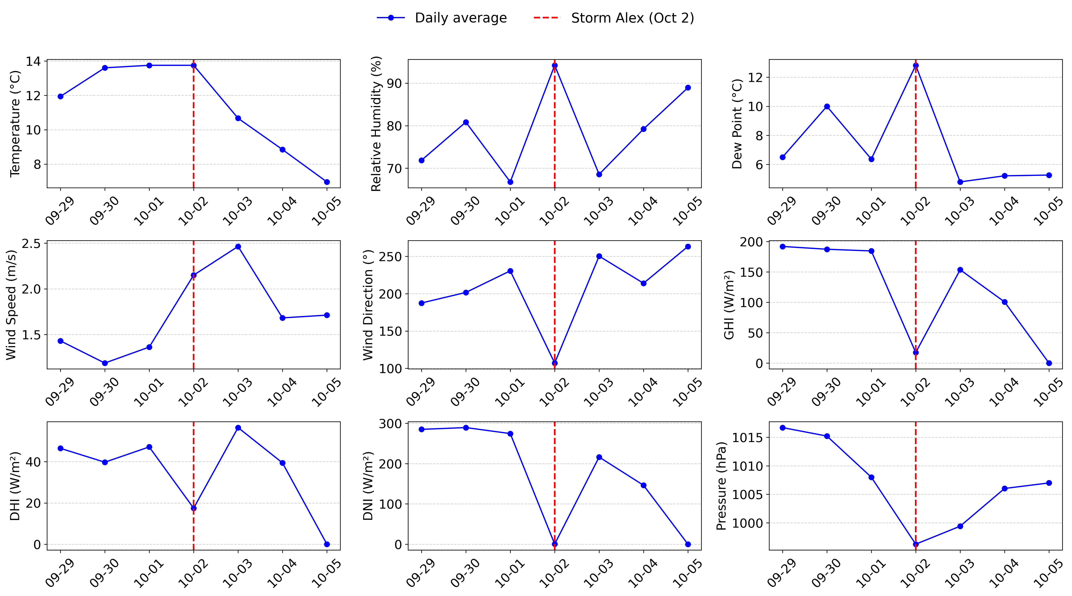
Supplementary Information Fig. 1 | Daily meteorological averages during the week of Mediterranean storm “Alex” (Saint-Martin-Vésubie, France, 26 September–2 October 2020). Panels show daily mean values of 9 variables: direct normal irradiance (DNI), diffuse horizontal irradiance (DHI), global horizontal irradiance (GHI), air temperature (°C), wind speed (m/s), relative humidity (%), dew point (°C), surface pressure (hPa), and wind direction (°).

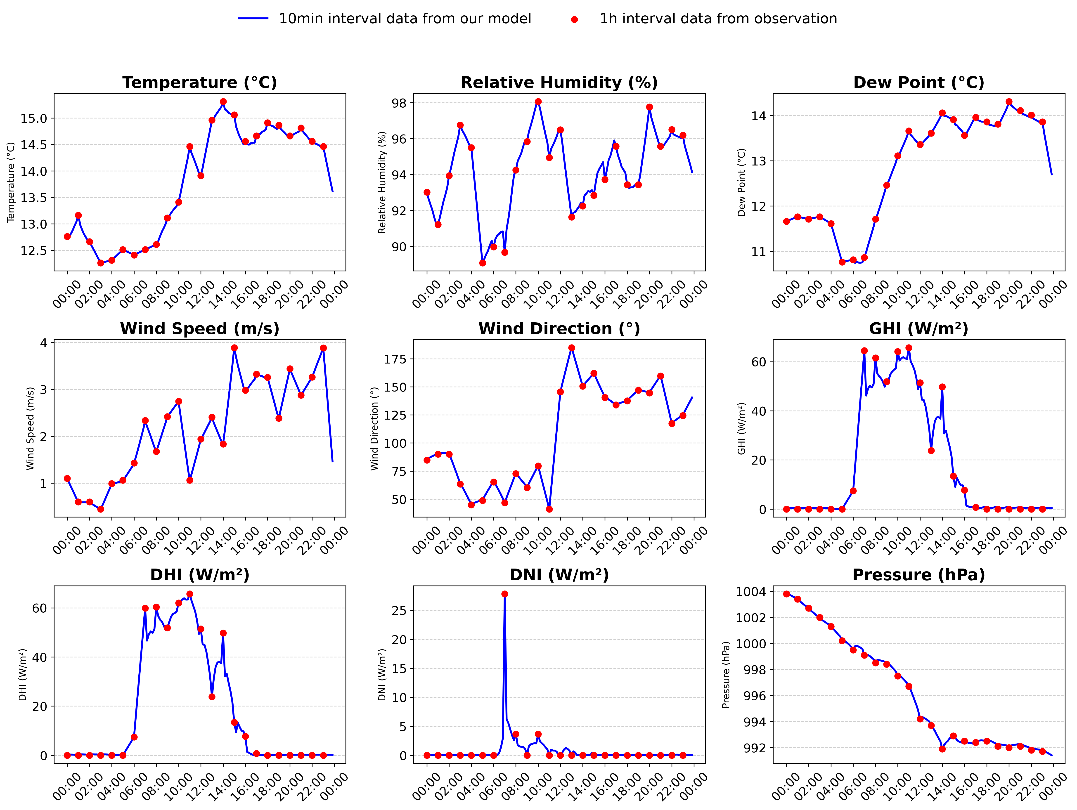
Supplementary Information Fig. 2 | Sub-hourly meteorological imputations on the storm day (Saint-Martin-Vésubie, France, 2 October 2020). Panels display reconstructed 10-minute fields of the same 9 variables (DNI, DHI, GHI, air temperature, wind speed, relative humidity, dew point, surface pressure, and wind direction), illustrating fine-scale temporal variability during the onset of the storm.
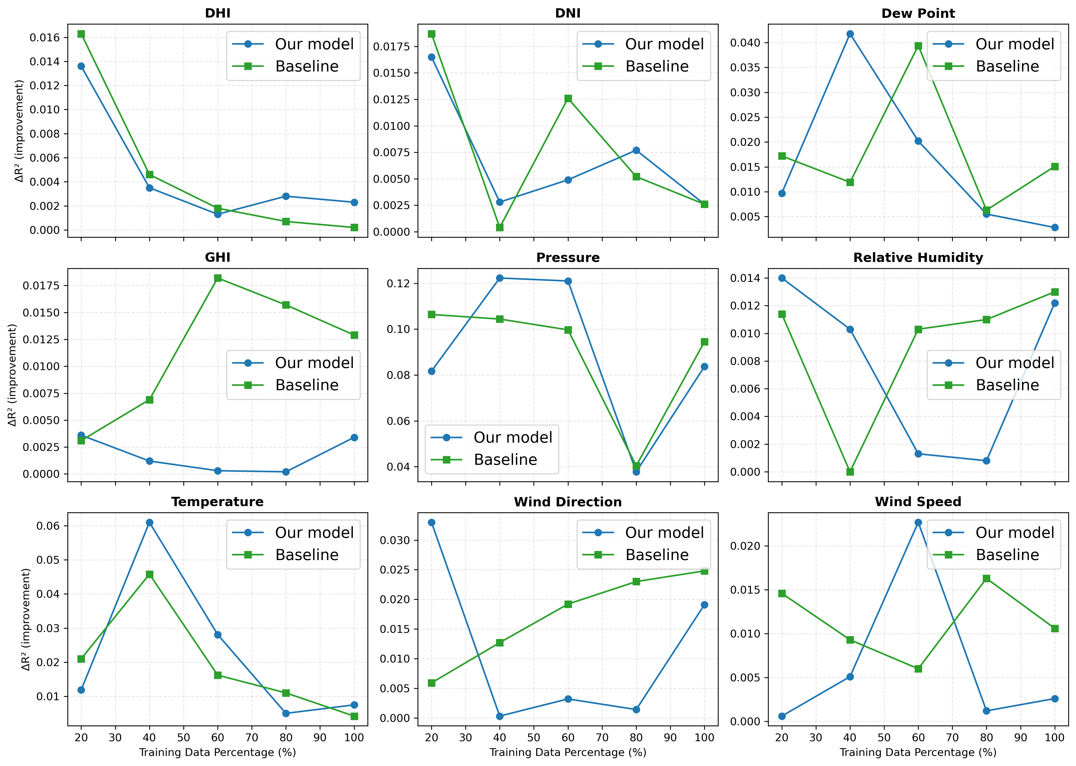
Supplementary Information Fig. 3 Performance Gain per Feature with Increasing Training Data.

