Supplementary Table 1. Predictors included in final prediction models for low 5-min Apgar scores.
Predictor | Definition | Coding
Antenatal care visits | Total number of antenatal visits made (regardless of the place of such visits) before admission for delivery. | Continuous (number of visits)
Antenatal haemorrhage | Vaginal bleeding at 28 weeks of gestation or later that is unrelated to labour and delivery. | Yes / No
Cardiac/renal disease | As marked on ANC card. | Yes / No
Diabetes mellitus or  gestational diabetes | Diabetes mellitus and/or gestational diabetes, as marked on ANC card | Yes / No
Gestational age | Best obstetric estimate of gestational age (in completed weeks) at delivery, based on an estimation from existing obstetrical data (preferred) or estimated by physical examination. | Continuous (weeks)
HIV | Status of mother at admission for delivery. | Positive / Negative / Unknown
Hypertensive disorders | As marked on ANC card. | Yes / No
Last pregnancy outcome* | Outcome of immediate previous pregnancy | Abortion or miscarriage / Stillbirth /  Neonatal death / Baby alive at 28 days
Malaria | As marked on ANC card. | Yes / No
Maternal age | Age of mother in completed years, recorded from hospital records or calculated from date of birth | Continuous (years)
Parity* | Number of previous deliveries (stillbirths and live births) excluding current delivery. Including both vaginal and c-section deliveries, excluding abortions or miscarriages. | Continuous (number of births)
Pre-labour membrane rupture | As marked on ANC card. | Yes / No
Previous C-section* | Previous caesarean section | Yes / No
Severe anaemia | Hb <7g/l. As marked on ANC card. | Yes / No
Syphilis | Status of mother at admission for delivery. | Positive / Negative / Unknown

ANC = Antenatal care. *Predictor only considered for the parous model.

Supplementary Table 2. TRIPOD Checklist: Prediction Model Development and Validation
Section/Topic | Item |  | Checklist Item | Page
Title and abstract
Title | 1 | D;V | Identify the study as developing and/or validating a multivariable prediction model, the target population, and the outcome to be predicted. | Section 1, Title page
Abstract | 2 | D;V | Provide a summary of objectives, study design, setting, participants, sample size, predictors, outcome, statistical analysis, results, and conclusions. | Section 2, Abstract
Introduction
Background and objectives | 3a | D;V | Explain the medical context (including whether diagnostic or prognostic) and rationale for developing or validating the multivariable prediction model, including references to existing models. | Section 3, Introduction
Background and objectives | 3b | D;V | Specify the objectives, including whether the study describes the development or validation of the model or both. | Section 3, Introduction
Methods
Source of data | 4a | D;V | Describe the study design or source of data (e.g., randomized trial, cohort, or registry data), separately for the development and validation data sets, if applicable. | Section 4, paragraph 1
Source of data | 4b | D;V | Specify the key study dates, including start of accrual; end of accrual; and, if applicable, end of follow-up. | Section 4, paragraph 1
Participants | 5a | D;V | Specify key elements of the study setting (e.g., primary care, secondary care, general population) including number and location of centres. | Section 4, paragraph 1
Participants | 5b | D;V | Describe eligibility criteria for participants. | Section 4, paragraph 2
Participants | 5c | D;V | Give details of treatments received, if relevant. | N/A
Outcome | 6a | D;V | Clearly define the outcome that is predicted by the prediction model, including how and when assessed. | Section 4, paragraph 3
Outcome | 6b | D;V | Report any actions to blind assessment of the outcome to be predicted. | N/A
Predictors | 7a | D;V | Clearly define all predictors used in developing or validating the multivariable prediction model, including how and when they were measured. | Supplementary materials
Predictors | 7b | D;V | Report any actions to blind assessment of predictors for the outcome and other predictors. | N/A
Sample size | 8 | D;V | Explain how the study size was arrived at. | Section 4, paragraph 2
Missing data | 9 | D;V | Describe how missing data were handled (e.g., complete-case analysis, single imputation, multiple imputation) with details of any imputation method. | Section 4, paragraph 5
Statistical analysis methods | 10a | D | Describe how predictors were handled in the analyses. | Section 4, paragraph 4
Statistical analysis methods | 10b | D | Specify type of model, all model-building procedures (including any predictor selection), and method for internal validation. | Section 4, paragraph 5
Statistical analysis methods | 10c | V | For validation, describe how the predictions were calculated. | Supplementary materials
Statistical analysis methods | 10d | D;V | Specify all measures used to assess model performance and, if relevant, to compare multiple models. | Section 4, paragraph 6
Statistical analysis methods | 10e | V | Describe any model updating (e.g., recalibration) arising from the validation, if done. | Section 4, paragraph 5
Risk groups | 11 | D;V | Provide details on how risk groups were created, if done. | N/A
Development vs. validation | 12 | V | For validation, identify any differences from the development data in setting, eligibility criteria, outcome, and predictors. | Section 4, paragraph 6
Results
Participants | 13a | D;V | Describe the flow of participants through the study, including the number of participants with and without the outcome and, if applicable, a summary of the follow-up time. A diagram may be helpful. | Section 4, paragraph 2  Section 5, paragraph 1
Participants | 13b | D;V | Describe the characteristics of the participants (basic demographics, clinical features, available predictors), including the number of participants with missing data for predictors and outcome. | Section 5, paragraph 1
Participants | 13c | V | For validation, show a comparison with the development data of the distribution of important variables (demographics, predictors and outcome). | N/A
Model development | 14a | D | Specify the number of participants and outcome events in each analysis. | Section 5, paragraph 1
Model development | 14b | D | If done, report the unadjusted association between each candidate predictor and outcome. | N/A
Model specification | 15a | D | Present the full prediction model to allow predictions for individuals (i.e., all regression coefficients, and model intercept or baseline survival at a given time point). | Supplementary materials
Model specification | 15b | D | Explain how to the use the prediction model. | Supplementary materials
Model performance | 16 | D;V | Report performance measures (with CIs) for the prediction model. | Section 5, paragraphs 2-3
Model-updating | 17 | V | If done, report the results from any model updating (i.e., model specification, model performance). | Supplementary materials
Discussion
Limitations | 18 | D;V | Discuss any limitations of the study (such as nonrepresentative sample, few events per predictor, missing data). | Section 6, paragraphs 2-6
Interpretation | 19a | V | For validation, discuss the results with reference to performance in the development data, and any other validation data. | N/A
Interpretation | 19b | D;V | Give an overall interpretation of the results, considering objectives, limitations, results from similar studies, and other relevant evidence. | Section 6, paragraph 7
Implications | 20 | D;V | Discuss the potential clinical use of the model and implications for future research. | Section 6, paragraph 7
Other information
Supplementary information | 21 | D;V | Provide information about the availability of supplementary resources, such as study protocol, Web calculator, and data sets. | Section 4, paragraph 1
Funding | 22 | D;V | Give the source of funding and the role of the funders for the present study. | Section 1, Title page  Section 2, Abstract

Supplementary Table 3. Comparison of model performance after optimism-adjustment for nulliparous and parous participants across the control group, intervention group, and the full study population.

 | C-statistic | E:O ratio | Calibration slope | Calibration-in-the-large
Nulliparous model
Full study population | 0.662 | 0.990 | 0.983 | 0.003
Control group | 0.676 | 0.993 | 0.974 | -0.001
Intervention group | 0.655 | 1.005 | 0.975 | 0.003
Parous model
Full study population | 0.732 | 0.993 | 0.994 | -0.001
Control group | 0.742 | 1.007 | 0.989 | 0.001
Intervention group | 0.729 | 0.993 | 0.992 | 0.001

Supplementary Figure 1. Optimism-adjusted calibration plot for prediction model for low 5-minute Apgar scores in nulliparous mothers (n=50,106) with additional predictors: birth weight and foetal presentation.

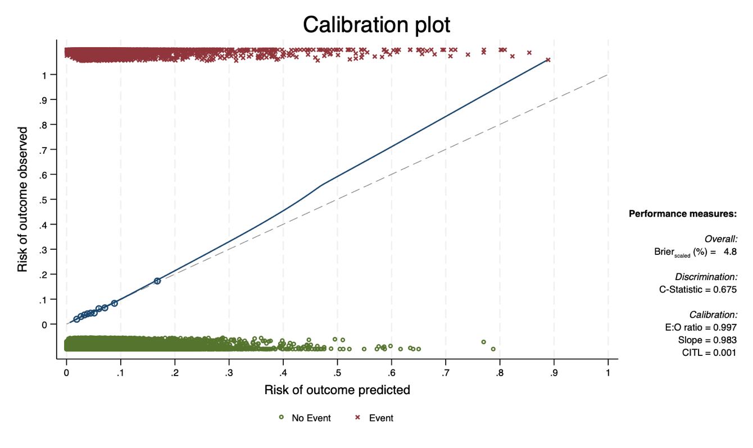

Supplementary Table 4. Coefficients of nulliparous model with additional predictors: birth weight and foetal presentation before and after internal validation.
Predictor |  |  | Coefficient (β) | Odds ratio | Optimism-adjusted  Coefficient* (β) | (95% Confidence Interval)
Maternal age |  |  | −0.012 | 0.988 | −0.012 | (−0.023, | −0.001)
Gestational age |  |  | −0.057 | 0.944 | −0.056 | (−0.075, | −0.038)
Antenatal care visits |  |  | −0.039 | 0.962 | −0.039 | (−0.062, | −0.015)
Antepartum haemorrhage |  |  | 1.634 | 5.125 | 1.606 | (1.329, | 1.884)
Pre-labour membrane rupture |  |  | −0.127 | 0.881 | −0.125 | (−0.339, | 0.090)
Hypertensive disorders |  |  | 0.267 | 1.306 | 0.263 | (0.132, | 0.394)
Cardiac/renal diseases |  |  | −0.147 | 0.863 | −0.144 | (−0.980, | 0.691)
Diabetes mellitus or gestational diabetes |  |  | −0.619 | 0.538 | −0.608 | (−1.286, | 0.070)
Syphilis Reference: Negative
Positive |  |  | 0.510 | 1.666 | 0.502 | (−0.032, | 1.036)
Unknown |  |  | 0.234 | 1.263 | 0.230 | (0.143, | 0.317)
HIV Reference: Negative
Positive |  |  | −0.139 | 0.870 | −0.137 | (−0.490, | 0.217)
Unknown |  |  | 0.180 | 1.197 | 0.177 | (0.054, | 0.299)
Malaria |  |  | 0.248 | 1.282 | 0.244 | (-0.035, | 0.523)
Severe anaemia |  |  | 0.789 | 2.202 | 0.776 | (0.469, | 1.083)
Foetal presentation Reference: Negative
Breech |  |  | 0.758 | 2.134 | 0.745 | (0.569, | 0.921)
Transverse |  |  | 1.131 | 3.097 | 1.111 | (0.428, | 1.795)
Birth weight |  |  | -0.001 | 0.999 | -0.001 | (-0.001, | 0.001)
Country Reference: Tanzania
Benin |  |  | 1.237 | 3.445 | 1.216 | (1.050, | 1.382)
Malawi |  |  | 0.397 | 1.487 | 0.390 | (0.229, | 0.550)
Uganda |  |  | 1.067 | 2.905 | 1.049 | (0.885, | 1.212)
Model intercept (β₀₎ |  |  | 0.505 |  | 0.453 | (0.415, | 0.491)

Supplementary Figure 2. Optimism-adjusted calibration plot for prediction model for low 5-minute Apgar scores in parous mothers (n=74,270) with additional predictors: birth weight and foetal presentation.

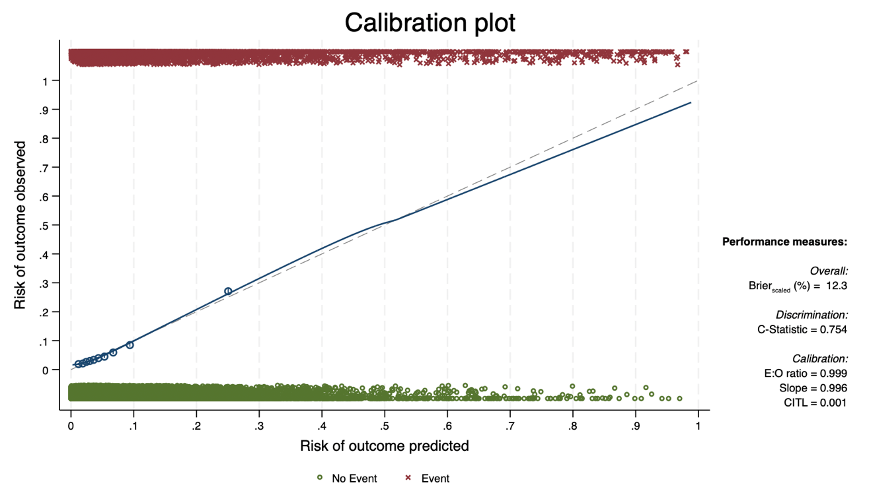

Supplementary Table 5. Coefficients of parous model with additional predictors: birth weight and foetal presentation. before and after internal validation.
Predictor |  | Coefficient (β) | Odds ratio | Optimism-adjusted  coefficient (β) |  | (95% Confidence Interval)
Maternal age |  | −0.010 | 0.990 | −0.010 | (−0.017, |  | −0.003)
Gestational age |  | −0.088 | 0.916 | −0.088 | (−0.103, |  | −0.072)
Antenatal care visits |  | −0.100 | 0.905 | −0.099 | (−0.120, |  | −0.079)
Parity |  | 0.126 | 1.134 | 0.125 | (0.101, |  | 0.150)
Antepartum haemorrhage |  | 1.878 | 6.541 | 1.871 | (1.714, |  | 2.027)
Pre-labour membrane rupture |  | −0.267 | 0.765 | −0.266 | (−0.431, |  | −0.102)
Hypertensive disorders |  | 0.344 | 1.411 | 0.343 | (0.233, |  | 0.452)
Cardiac/renal diseases |  | −0.037 | 0.964 | −0.037 | (−0.575, |  | 0.501)
Diabetes mellitus or gestational diabetes |  | 0.065 | 1.067 | 0.065 | (−0.336, |  | 0.466)
Syphilis
Reference: Negative
Positive |  | 0.553 | 1.738 | 0.551 | (0.165, |  | 0.936)
Unknown |  | 0.171 | 1.186 | 0.170 | (0.095, |  | 0.245)
HIV
Reference: Negative
Positive |  | −0.320 | 0.726 | −0.319 | (−0.515, |  | −0.122)
Unknown |  | 0.174 | 1.190 | 0.174 | (0.068, |  | 0.280)
Malaria |  | −0.003 | 0.997 | −0.003 | (−0.310, |  | 0.304)
Severe anaemia |  | 0.907 | 2.478 | 0.904 | (0.674, |  | 1.134)
Previous caesarean section |  | −0.456 | 0.634 | −0.454 | (−0.539, |  | −0.370)
Last pregnancy outcome
Reference: Baby alive at 28 days
Abortion/miscarriage |  | 0.096 | 1.101 | 0.096 | (−0.020, |  | 0.212)
Stillbirth |  | 0.443 | 1.557 | 0.441 | (0.248, |  | 0.634)
Neonatal death |  | 0.214 | 1.239 | 0.213 | (−0.027, |  | 0.454)
Foetal presentation
Reference: Negative
Breech |  | 0.951 | 2.588 | 0.947 | (0.828, |  | 1.066)
Transverse |  | 1.009 | 2.743 | 1.005 | (0.661, |  | 1.350)
Birth weight |  | −0.001 | 0.999 | −0.001 | (−0.001, |  | −0.001)
Country
Reference: Tanzania
Benin |  | 1.208 | 3.347 | 1.203 | (1.069, |  | 1.337)
Malawi |  | 0.226 | 1.253 | 0.225 | (0.084, |  | 0.365)
Uganda |  | 0.949 | 2.584 | 0.945 | (0.808, |  | 1.083)
Model intercept (β₀₎ |  | 2.317 |  | 2.299 | (2.267, |  | 2.331)

Supplementary Table 6. Country- and hospital-specific characteristics of 124,376 mothers giving birth at 16 hospitals in Benin, Malawi, Tanzania and Uganda between July 2021 and December 2023.
Country | Benin |  |  |  |  | Malawi |  |  |  |  | Tanzania |  |  |  |  | Uganda
% |  |  |  |  | 19.4 |  |  |  |  | 36.1 |  |  |  |  | 16.8 |  |  |  |  | 27.7
Hospital | 1 | 2 | 3 | 4 |  | 5 | 6 | 7 | 8 |  | 9 | 10 | 11 | 12 |  | 13 | 14 | 15 | 16
n | 4481 | 12211 | 4460 | 3006 |  | 14444 | 13098 | 9434 | 7828 |  | 3240 | 8745 | 4949 | 4000 |  | 11727 | 2039 | 14856 | 5858
% | 3.6 | 9.8 | 3.6 | 2.4 |  | 11.6 | 10.5 | 7.6 | 6.3 |  | 2.6 | 7.0 | 4.0 | 3.2 |  | 9.4 | 1.6 | 11.9 | 4.7
Characteristics
Low 5-minute Apgar score | 9.0 | 14.3 | 10.8 | 3.9 | 11.4 | 5.1 | 3.0 | 4.8 | 4.2 | 4.3 | 4.8 | 2.6 | 1.5 | 1.4 | 2.4 | 8.5 | 14.4 | 7.5 | 3.9 | 7.6
Maternal age  (years) | 26  (22-31) | 25  (21-30) | 29  (24-33) | 28  (24-32) | 26  (22-31) | 22  (19-28) | 22  (19-28) | 21  (19-26) | 22  (19-28) | 22  (19-28) | 27  (22-33) | 24  (20-31) | 25  (20-31) | 25  (20-32) | 25  (20-32) | 25  (21-30) | 25  (21-30) | 24  (20-29) | 23  (20-28) | 24  (20-29)
Antenatal care visits | 5  (3-6) | 4  (3-5) | 5  (4-6) | 4  (3-6) | 5  (3-6) | 4  (3-5) | 4  (3-4) | 3  (2-4) | 3  (3-4) | 4  (3-5) | 5  (4-6) | 5  (4-6) | 5  (4-6) | 6  (5-7) | 5  (4-6) | 4  (3-5) | 4  (3-5) | 4  (3-5) | 3  (3-4) | 4  (3-5)
Gestational age  (weeks) | 39  (38-40) | 38  (37-40) | 38  (37-39) | 39  (37-40) | 39  (37-40) | 38  (37-39) | 38  (37-38) | 38  (37-38) | 38  (37-38) | 38  (37-38) | 39  (38-39) | 40  (38-40) | 39  (37-40) | 39  (38-40) | 39  (38-40) | 39  (38-40) | 38  (38-39) | 38  (38-39) | 39  (38-40) | 38  (38-40)
HIV positive | 1.9 | 0.7 | 2.4 | 1.0 | 1.3 | 3.6 | 4.8 | 1.8 | 2.1 | 3.3 | 2.7 | 3.6 | 2.9 | 1.8 | 3.0 | 3.9 | 3.9 | 3.0 | 2.1 | 3.2
Severe anaemia | 1.0 | 1.3 | 6.3 | 0.8 | 2.1 | 0.1 | 0.1 | 0.0 | 0.3 | 0.1 | 1.3 | 0.6 | 0.1 | 0.2 | 0.5 | 0.4 | 1.1 | 0.4 | 0.4 | 0.4
Referral | 62.8 | 63.9 | 36.4 | 30.1 | 54.4 | 32.1 | 5.1 | 31.2 | 20.5 | 22.0 | 19.5 | 1.4 | 5.6 | 3.5 | 5.6 | 11.9 | 44.1 | 20.3 | 13.7 | 17.7
Antepartum haemorrhage | 1.1 | 1.5 | 4.9 | 0.6 | 1.9 | 0.4 | 0.3 | 0.1 | 0.8 | 0.4 | 1.5 | 0.4 | 0.3 | 0.3 | 0.5 | 1.6 | 3.6 | 1.0 | 0.9 | 1.3
Foetal heartbeat at admission | 95.4 | 91.0 | 93.8 | 93.3 | 92.6 | 91.0 | 98.3 | 96.2 | 97.1 | 95.3 | 96.3 | 98.7 | 97.2 | 99.0 | 98.0 | 93.5 | 81.7 | 97.4 | 95.7 | 94.8
Categorical variables are presented as percentages and continuous variables as medians with interquartile ranges (IQR).

