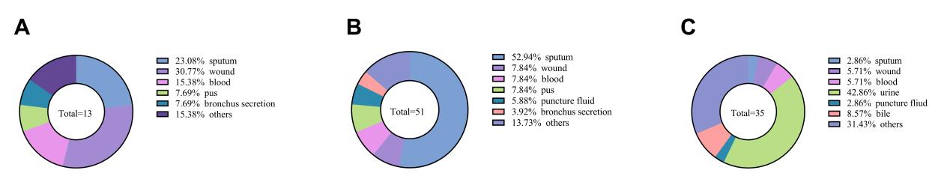
Figure S1. The sample type of clinical MSSA, MRSA and E. faecalis isolates.
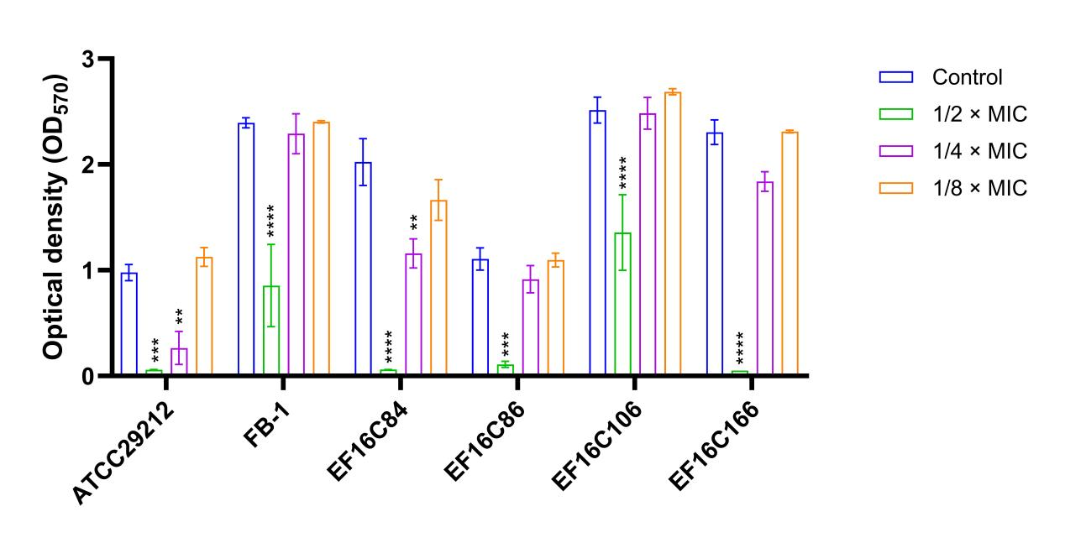
Figure S2. Antibiofilm activity of MLS0315771 against E. faecium. E. faecium isolates were tested for the inhibitory effect of MLS0315771 on the biofilm formation under different concentrations (1/8 ×, 1/4 ×, 1/2 × MIC).

Table S1. The MIC distribution of MLS0315771 against LZD-resistant and intermediate E. faecalis.

Bacteria species | Clinical isolates | MLS0315771 MIC (μM) | LZD (μg/mL)
Standard strain | ATCC29212 | 12.5 (3.42 μg/mL) | 2
Standard strain | OG1RF | 12.5 | 2
LZD resistant  E. faecalis | FB-1 | 6.25 (1.71 μg/mL) | 8
LZD resistant  E. faecalis | JXY | 12.5 | 8
LZD resistant  E. faecalis | JB-2 | 6.25 | 8
LZD resistant  E. faecalis | R3-LZD | 6.25 | 8
LZD resistant  E. faecalis | TYY | 6.25 | 8
LZD resistant  E. faecalis | EF16C3 | 6.25 | 16
LZD resistant  E. faecalis | EF16C30 | 3.125 (0.86 μg/mL) | 8
LZD resistant  E. faecalis | EF16C102 | 3.125 | 8
LZD resistant  E. faecalis | EF16C272 | 6.25 | 8
LZD resistant  E. faecalis | EF16C299 | 6.25 | 8
LZD resistant  E. faecalis | EF16C340 | 12.5 | 8
LZD resistant  E. faecalis | EF16C348 | 12.5 | 8
LZD resistant  E. faecalis | EF16C359 | 3.125 | 8
LZD resistant  E. faecalis | EF16C360 | 3.125 | 8
LZD intermediate  E. faecalis | EF16C108 | 3.125 | 4
LZD intermediate  E. faecalis | EF16C112 | 6.25 | 4
LZD intermediate  E. faecalis | EF16C166 | 12.5 | 4
LZD intermediate  E. faecalis | EF16C289 | 12.5 | 4
LZD intermediate  E. faecalis | EF16C352 | 6.25 | 4

Table S3. The MIC distribution of membrane phospholipids against S. aureus.

MIC (μg/mL) | PC | PE | PG | CL
CHS101 | >128 | >128 | >128 | >128
YUSA145 | >128 | >128 | >128 | >128

Table S4. The MIC distribution of MLS0315771 against S. aureus after exogenously supplementing membrane phospholipids.

MLS0315771 MIC (μM) |  | PC (μg/ml) |  | PE (μg/ml) |  | PG (μg/ml) |  | CL (μg/ml)
 |  | 64 | 16 | 64 | 16 | 64 | 16 | 64 | 16
CHS101 | 6.25 | 12.5 | 12.5 | 12.5 | 6.25 | 6.25 | 6.25 | 12.5 | 6.25
YUSA145 | 12.5 | 12.5 | 12.5 | 12.5 | 12.5 | 12.5 | 12.5 | 12.5 | 12.5

Table S5. The MIC distribution of MLS0315771 against WT and ΔClpx S. aureus.

Isolates | MIC (μM)
SA113 | 6.25
SA113 ΔClpx clone 1 | 12.5
SA113 ΔClpx clone 2 | 12.5
SA113 ΔClpx clone 3 | 12.5
SA113 ΔClpx clone 4 | 12.5
SA113 ΔClpx clone 5 | 12.5
SA113 ΔClpx clone 6 | 12.5

