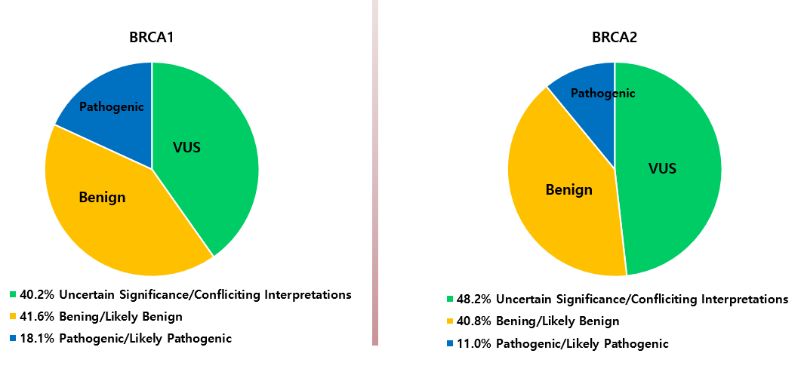Supplement Figure 1. Pie charts representing the percentages of BRCA1/2 variants of clinical significance.
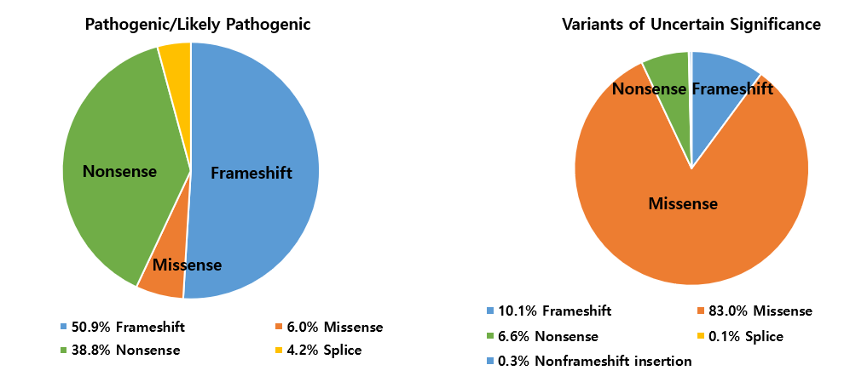
Supplement Figure 2. Pie charts representing the percentages of BRCA2 mutation into pathogenic/likely pathogenic (left) and VUS (right)
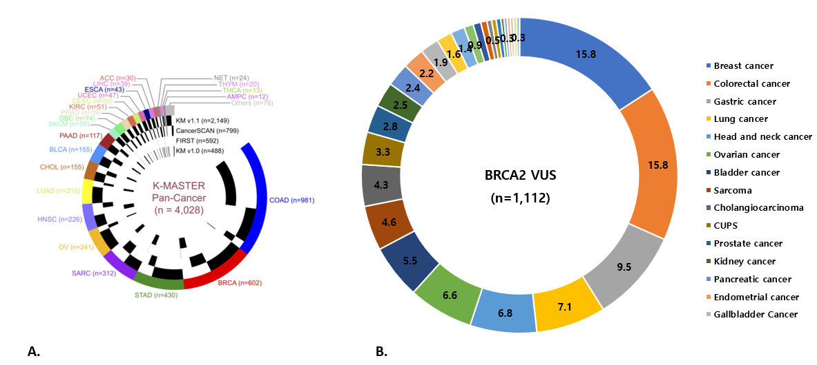

Supplement Figure 3. Tumor Types in the K-MASTER Cohort and BRCA2 VUS Mutants.
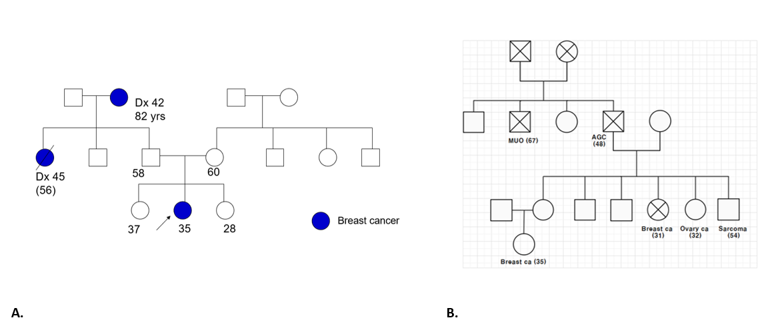
Supplement Figure 4. Pedigree of BRACA2 VUS

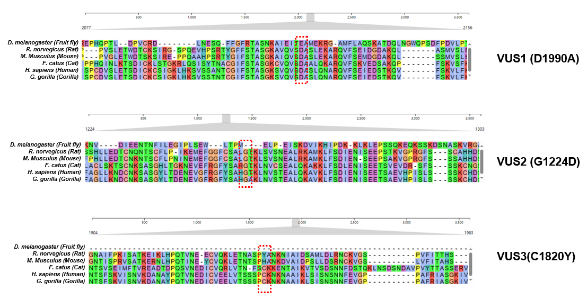 Supplement Figure 5. . Multiple Sequence Alignment of BRCA2 VUS among Species

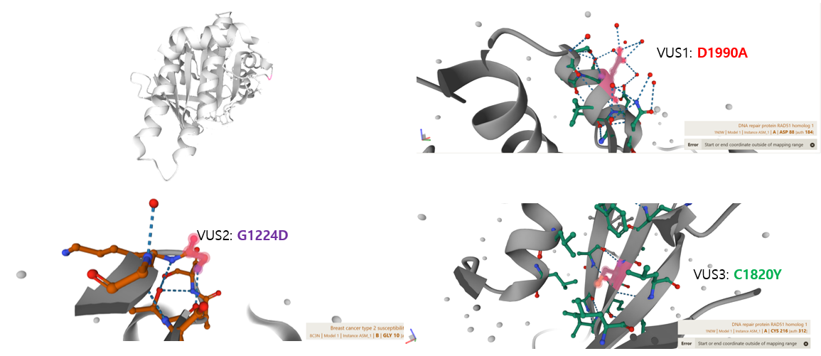Supplement Figure 6. Protein 3D Structure Analysis for BRCA2 VUS

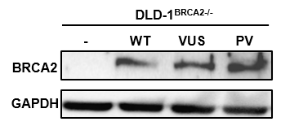
Supplement Figure 7. BRCA2 Protein Expression in DLD-1 BRCA2 Knockout Cells Transfected with WT, VUS, and PV BRCA2 Plasmid

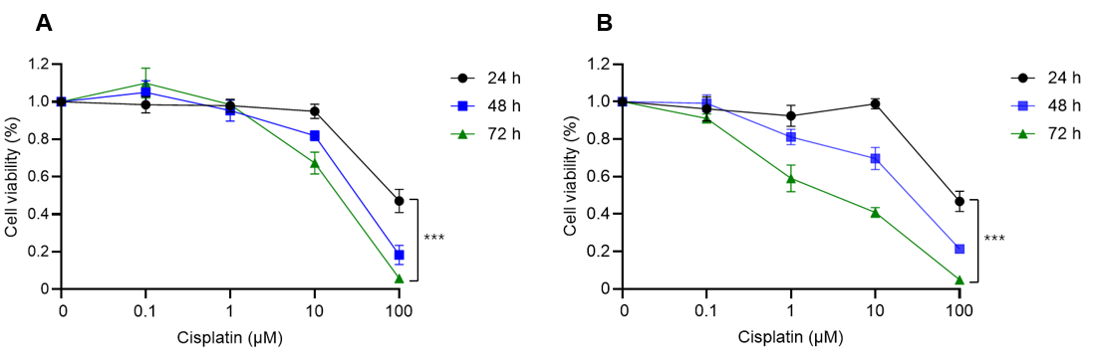

Supplement Figure 8. DNA Damage and Recovery Model: Cell viability of BRCA2 WT (A) and KO (B) cells after cisplatin treatment. Marks represent the mean cell viability (%) of triplicates, and error bars represent SD. ***p < 0.001, two-way ANOVA.

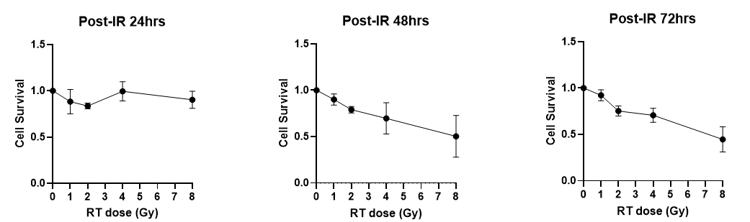
Supplement Figure 9. Cell Survival Following Ionizing Radiation (IR) in BRCA2 WT Cells

