Table S.1 Distribution of the SBR cycle phases over the 12-hour (in minutes).
- SBR1 cycle distribution in stage S-I
 | Feast phase (6 h) |  |  |  |  |  |  |  | Famine phase (6 h)
Aeration
UCO addition
Withdrawn
Nutrients and Nitrogen addition
Time (min) | 3 | 87 |  | 3 | 87 |  | 3 | 177 | 5 | 4 | 351

- SBR1 cycle distribution in stages S-II and S-III
 | Feast phase (6 h) |  | Famine phase (6 h)
Aeration
UCO addition
Withdrawn
Nutrients and Nitrogen addition
Time (min) | 9 | 351 | 5 | 4 | 351

- SBR2 cycle distribution
 | Feast phase (5 h/6 h) |  |  |  | Famine phase (7 h/6 h)
Aeration
UCO addition
Withdrawn
Nutrients addition
Nitrogen addition
Time (min) | 5 | 4 | 4 | 287/347 | 1 | 419/359

Table S.2 Characteristics of the raw UCO fed as the organic carbon source.
Parameter | Value
Density (g/L) | 867.85 ± 33.3
tCOD (g/g) | 2.63 ± 0.29
Biodegradability (%) ¹ | 58.47 ± 2.2
Elemental composition (%) ²
C | 76.15 ± 1.90
H | 12.26 ± 0.49
O | 11.13 ± 1.55
N | 0.19 ± 0.09
S | -
Fatty acid profile (%) ³ | 93.84 ± 2.34
C-12:0 (Lauric) | < 0.01
C-14:0 (Myristic) | 0.14
C-15:0 (Pentadecanoic) | < 0.01
C-16:0 (Palmitic) | 7.67
C-16:1 (Palmitoleic) | 0.26
C-17:0 (Margaric) | 0.06
C-17:1 (Margaroleic) | 0.05
C-18:0 (Stearic) | 3.91
C-18:1 (Oleic) | 37.08
C-18:2 (Linoleic) | 49.14
C-20:0 (Arachidic) | 0.27
C-18:3 (Linolenic) | 0.20
C-20:1 (Eicosenoic) | 0.21
C-22:0 (Behenico | 0.78
C-22:1 (Erucic) | < 0.01
C-24:0 (Lignoceric) | 0.24
Others | < 0.01
Trans Oleic (t-C18:1) | 0.09
Trans Linoleic + Trans Linolenic (t- C18:2 + t-C18:3) | 0.25
¹ Oxygen uptake rate test with the respirometer BM-T Plus 151,204 Surcis, Spain.
² Elemental analyser (FlashSmart, Thermo Fisher Scientific, US) by means of a thermal conductivity detector (university internal service).
³ Gas chromatography in the Instituto de la Grasa (Sevilla, Spain). ISO 12966-2:2011 & ISO 12966-4:2015.
tCOD: total chemical oxygen demand.

(a)
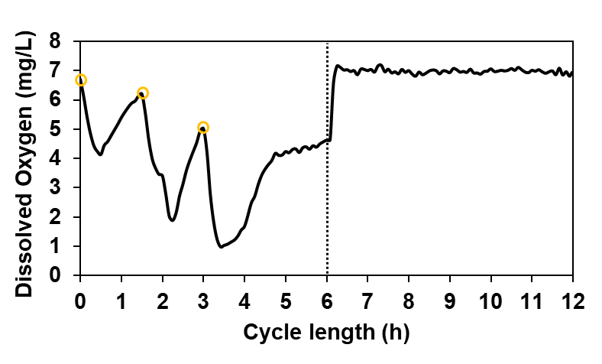
(b)
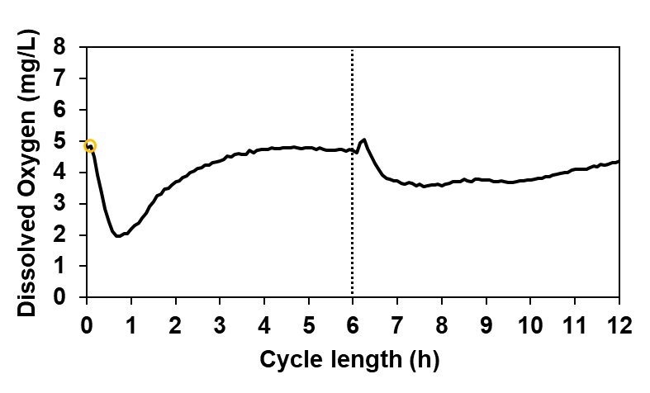
Fig. S.1 Oxygen consumption through two different cycles: (a) three-pulse cycle (day 126); (b) single-pulse cycle (day 225). The moment of the UCO pulses addition () and the separation between the feast and famine phase (⁞) are indicated in the image.

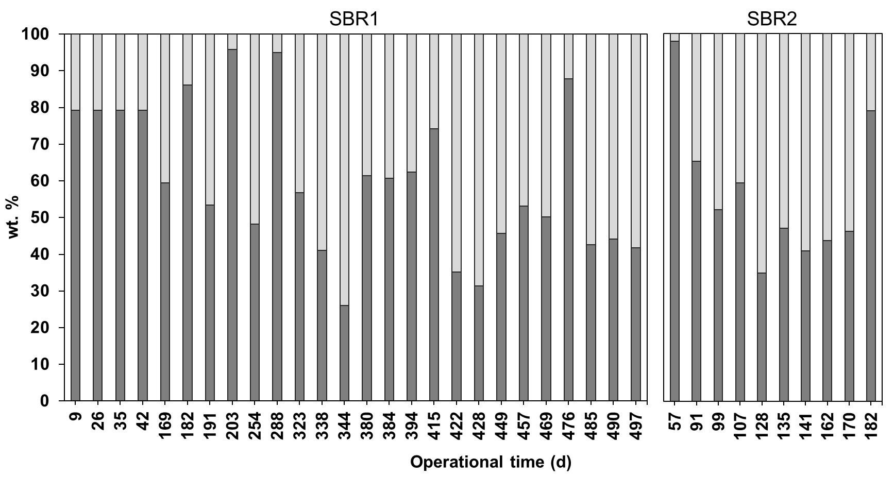Fig. S.2 PHBV monomer composition in wt. % with respect to the total biopolymer in SBR1 and SBR2 during the operation period: 3HB (■) and 3HV (■).

