Supplementary information for “Formation of nanoscale vacuum films governing thermal resistance in amorphous ice”

Yizhi Liu^{1,9}, Tobias Eklund^{1,2,3,9},
Aigerim Karina⁴, Svenja Hövelmann^{5,6}, Robert Bauer⁷, Seonju You⁸, Claudia Goy⁷,
Nele N. Striker⁷, Alexander Gierke^{3,7}, Kenneth Hess¹, Kai Schlage⁷, Lars Bocklage⁷, Fernando Ardana Lamas³, Hao Wang³, Yifeng Jiang³, Yohei Uemara³, Chris Milne³, Kyung Hwan Kim⁸, Bridget Murphy^{5,6}, Felix Lehmkühler⁷, Peter Zalden³, Katrin Amann-Winkel^{1,2,*}

1 Max Planck Institute for Polymer Research, Ackermannweg 10, 55128 Mainz, Germany
2 Institut für Physik, Johannes Gutenberg-Universität Mainz, 55099 Mainz, Germany
3 European XFEL, Holzkoppel 4, Schenefeld 22869, Germany
4 Department of Chemical Physics, Fysikum, Stockholm University, 10691 Stockholm, Sweden
5 Institute of Experimental and Applied Physics, Kiel University, Leibnizstraße 19, 24118 Kiel, Germany
6 Ruprecht Haensel Laboratory, Deutsches Elektronen-Synchrotron DESY, Notkestraße 85, 22607 Hamburg, Germany
7 Deutsches Elektronen-Synchrotron DESY, Notkestraße 85, 22607 Hamburg, Germany
8 Department of Chemistry, POSTECH, Pohang 37673, Republic of Korea

⁹equally contributing to this work

Corresponding author:
*amannk@mpip-mainz.mpg.de

The Supplementary Information provides additional data and analysis supporting the results presented in the main text. Figures S1–S8 contain supplementary experimental and simulation results referenced throughout the manuscript. Figure S9 presents the experimentally determined temporal evolution of the Pt temperature during fluence scans, showing the transient heating dynamics T(t) at a fixed pump–probe delay of 1.2 ns. Figure S10 compares continuum heat-conduction simulations and molecular dynamics results for the temperature evolution in the ASW film under different Pt heating protocols.

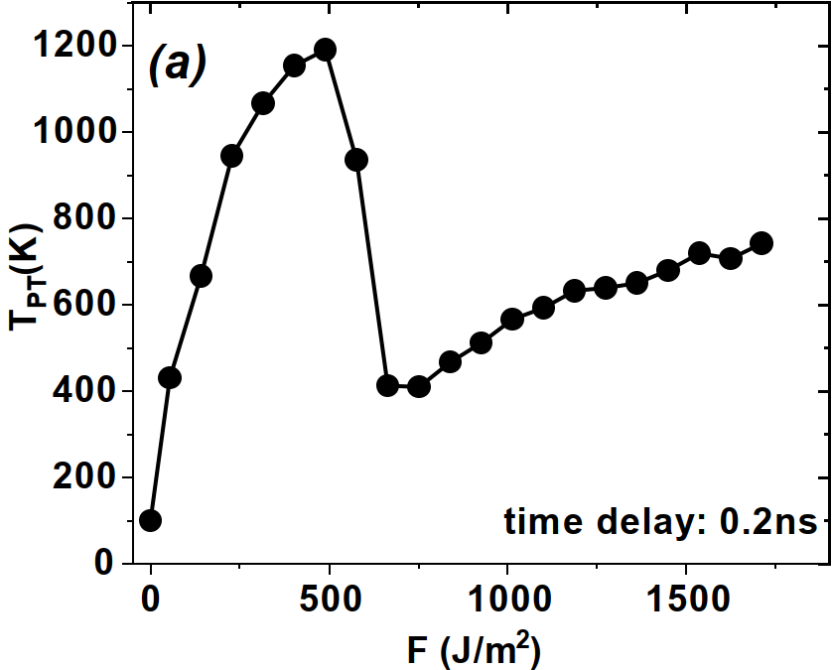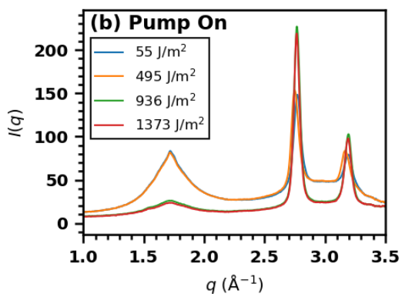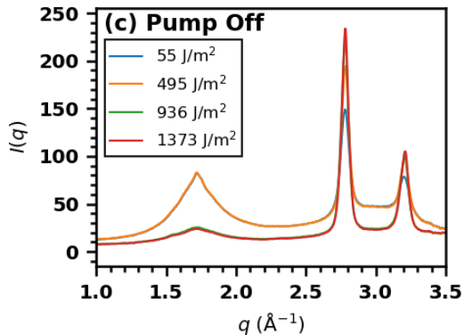
Figure S1. The diffraction profiles of Pt and ASW recorded at various pump–probe fluences. Pump–probe measurements on amorphous solid water (ASW) deposited on a Pt substrate and the resulting transient structural and thermal response. (a) Experimentally determined temperature of Pt at 0.2 ns after pumping with various pump laser fluences. (b) X-ray scattering intensity $I(q)$ recorded 0.25 ns after the pump pulse for different pump fluences. (c) Reference $I(q)$ profiles collected without applying the pump pulse. At fluences approaching ∼500 J/m², a qualitative change in the Pt temperature is observed, marking a threshold at which the ASW layer begins to be ablated from the substrate—likely caused by partial melting or restructuring of the Pt film under extreme excitation.

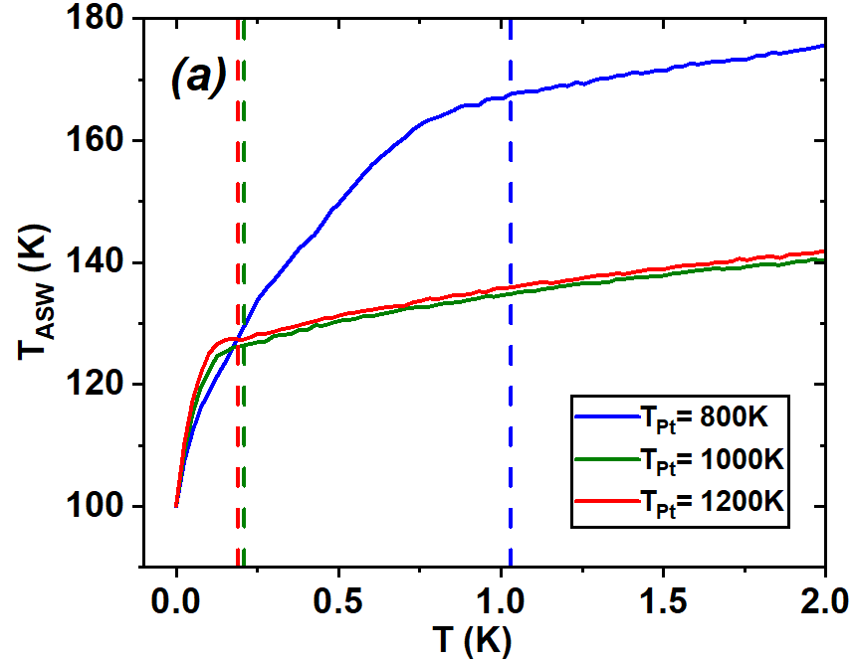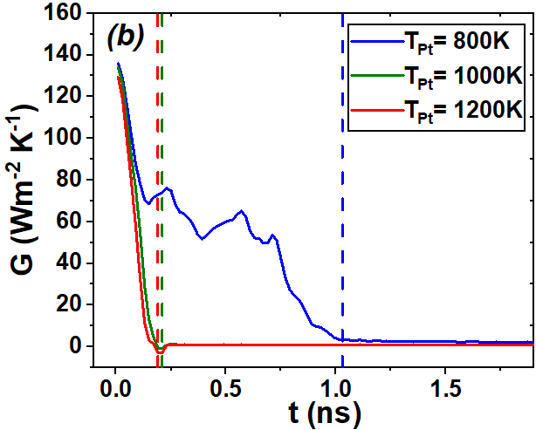
Figure S2. Transient temperature evolution and interfacial thermal conductance during Pt-induced heating of ASW. (a) Temperature evolution of the 100-nm ASW film when the Pt substrate is held at fixed temperatures of 800 K, 1000 K, and 1200 K. The dashed lines indicate the approximate onset of nanoscale vapor-gap formation at the Pt–ASW interface. After the gap forms, the rate of temperature rise in the ASW decreases markedly, reflecting the strong suppression of heat transfer across the interface. (b) Interfacial thermal conductance G(t) extracted from the ASW energy flux and interfacial temperature difference. Before gap formation, G remains at ∼130 MW m⁻²K⁻¹, consistent with literature values for metal–water interfaces. Once the vapor gap develops, G drops by 2–3 orders of magnitude to ∼0.4 MW m⁻²K⁻¹, demonstrating the dramatic thermal decoupling.
- (b) (c)

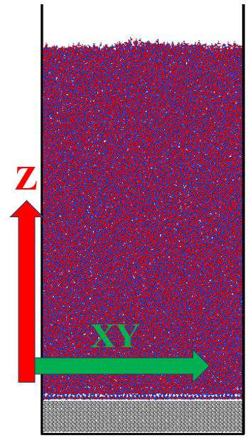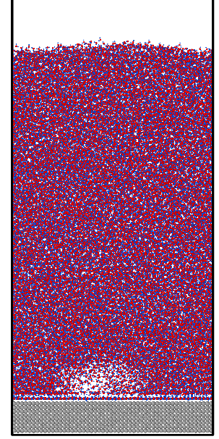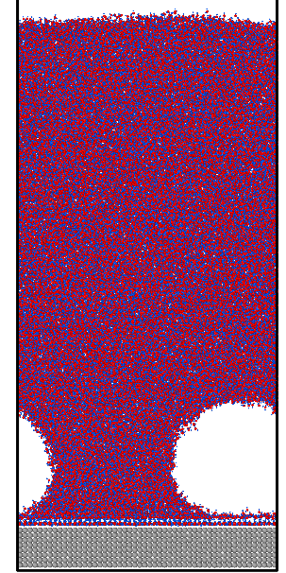
Figure S3. Representative atomic configurations with different vacuum-gap thicknesses used for structure-factor calculations. (a) Configuration without a vacuum gap at the Pt–ASW interface, obtained by keeping the Pt slab fixed at 250 K, which removes the interfacial vacuum gap. (b) Configuration with a ~2 nm vacuum layer near the interface; only half of the simulation box along the x direction is shown for clarity. (c) Configuration with a ~4.6 nm vacuum layer at the interface.
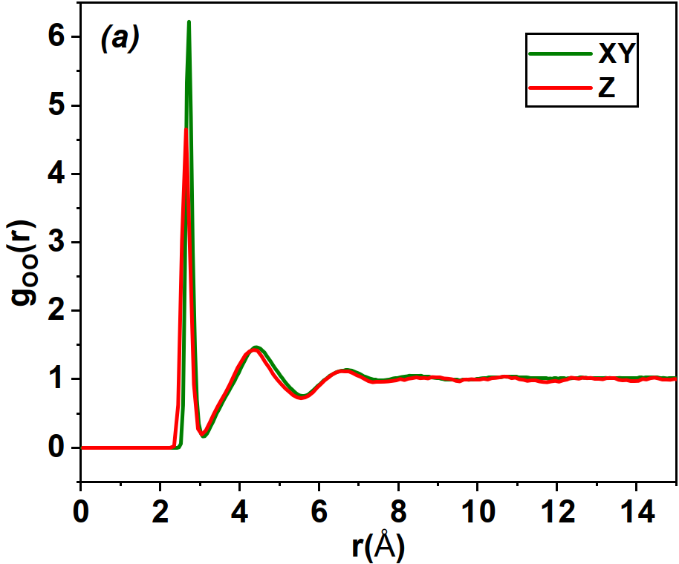
Figure S4. Structural anisotropy in the radial distribution function 𝑔(𝑟) from MD simulations for the configuration shown in Fig. S3b.

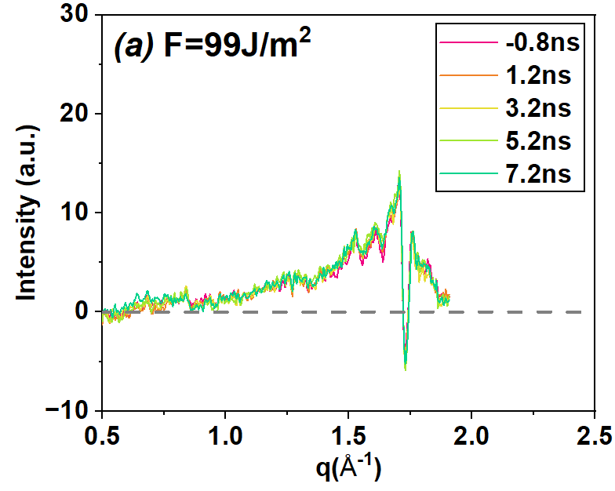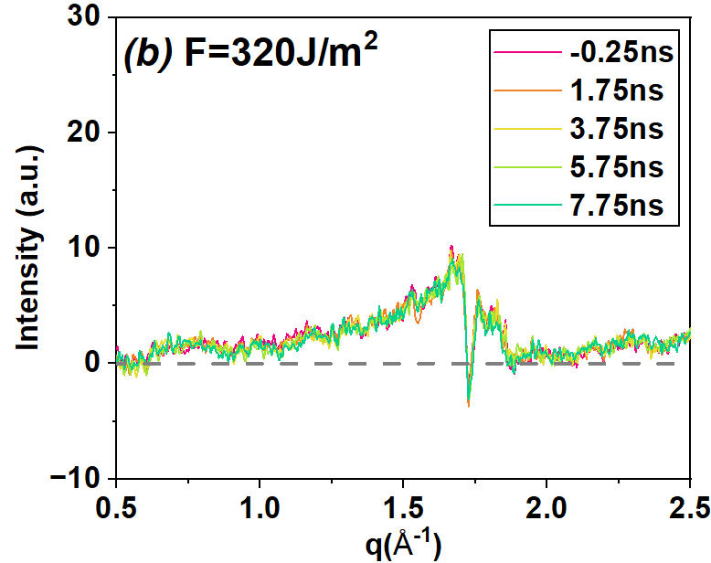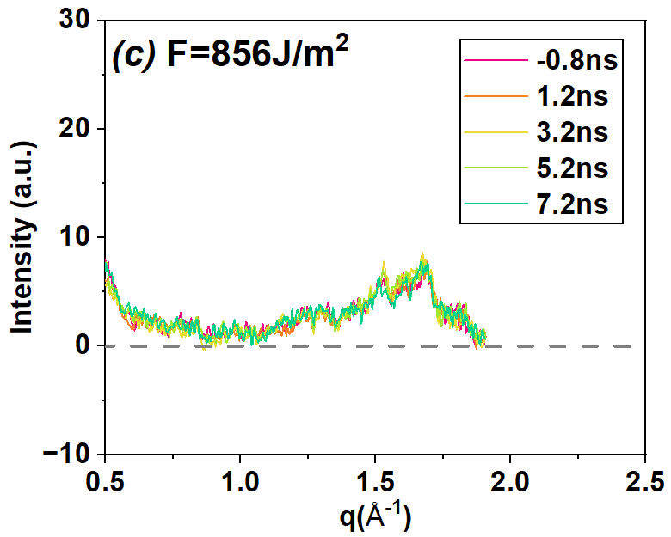
Figure S5. Anisotropic diffraction response of the ASW layer under pump–probe excitation. Difference between the in-plane and out-of-plane X-ray scattering intensities, $ΔI(q)=I_{xy}(q)-I_{z}(q)$, measured at selected pump–probe delays for three pump fluences: (a) 99 $J/m^{-2}$, (b) 320 $J/m^{-2}$, and (c) 856 $J/m^{-2}$. Different colors correspond to different pump–probe delays, as indicated. Notably, the anisotropic signal $ΔI(q)$ is already present at the earliest measured pump–probe delay and shows no discernible evolution with time. This behavior suggests that the anisotropy is not driven by gradual heating of the ASW film. Instead, it is consistent with an interfacial origin, which we associate with the formation of a vapor layer at the Pt–ASW interface upon pumping.
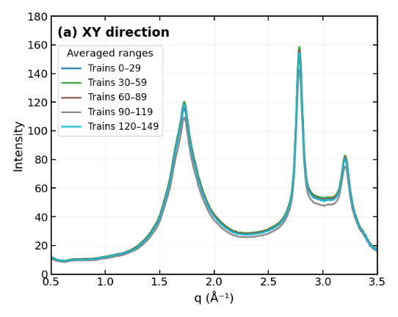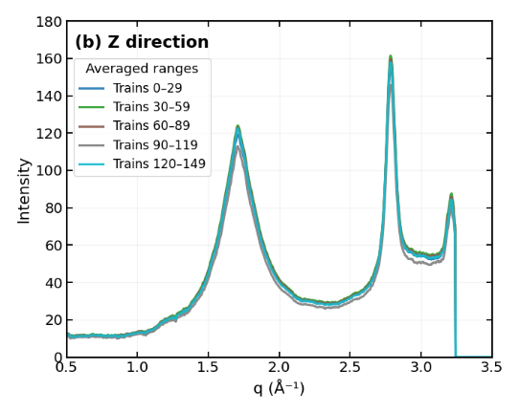
Figure S6. X-ray–only stability test of the ASW scattering signal. Average I(q) computed from consecutive X-ray probe trains in the absence of pump excitation. Each curve represents the mean of 30 trains (each train containing 30 X-ray pulses). (a) XY-direction scattering. (b) Z-direction scattering. All curves nearly overlap, demonstrating that prolonged X-ray exposure alone does not induce any detectable structural evolution or crystallization in the amorphous ice film. No double peak is observed in the Z direction.

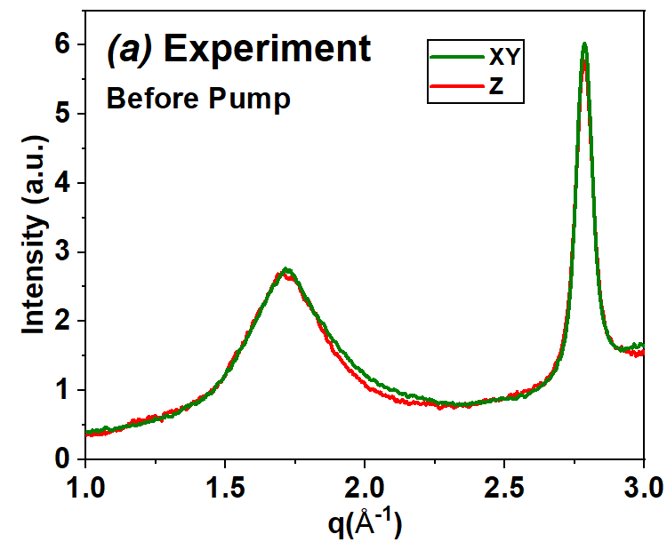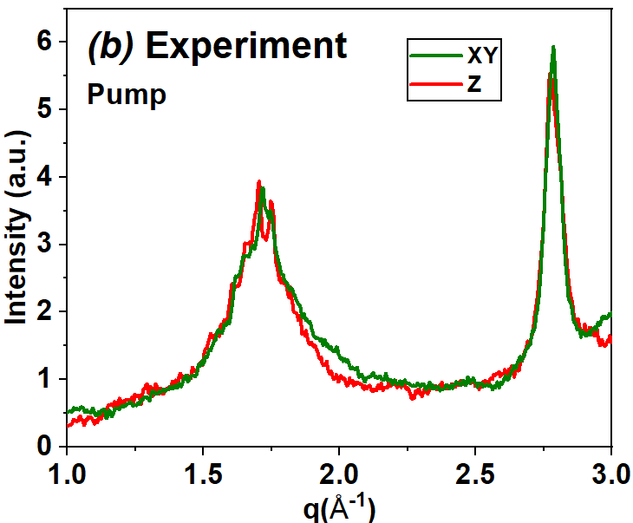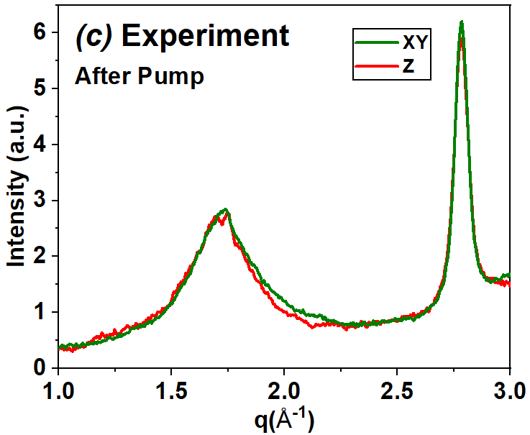
Figure S7. Representative data from the multi-pulse mode. Each sequence consists of one pump pulse (360 J/m²) followed by 30 X-ray probe pulses. Panel (a) shows the scattering signal before the pump pulse, panel (b) corresponds to the pumped state, and panel (c) shows the scattering after the pump pulse.

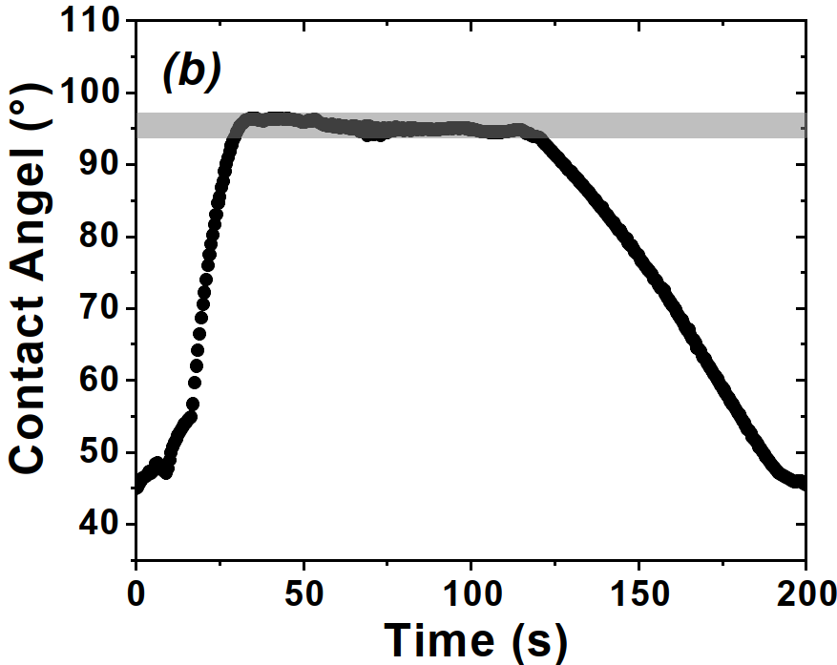
(a)
Figure S8. Wettability characterization of the Pt substrate using dynamic contact-angle measurements. (a) Representative snapshot of the water droplet on Pt, showing a static contact angle of ~95°. (b) Time evolution of the contact angle during cycles of water injection and withdrawal. The transient minima arise during receding stages, while a stable plateau around ~90° persists in quasi-static periods, reflecting the intrinsic wettability of the Pt surface.

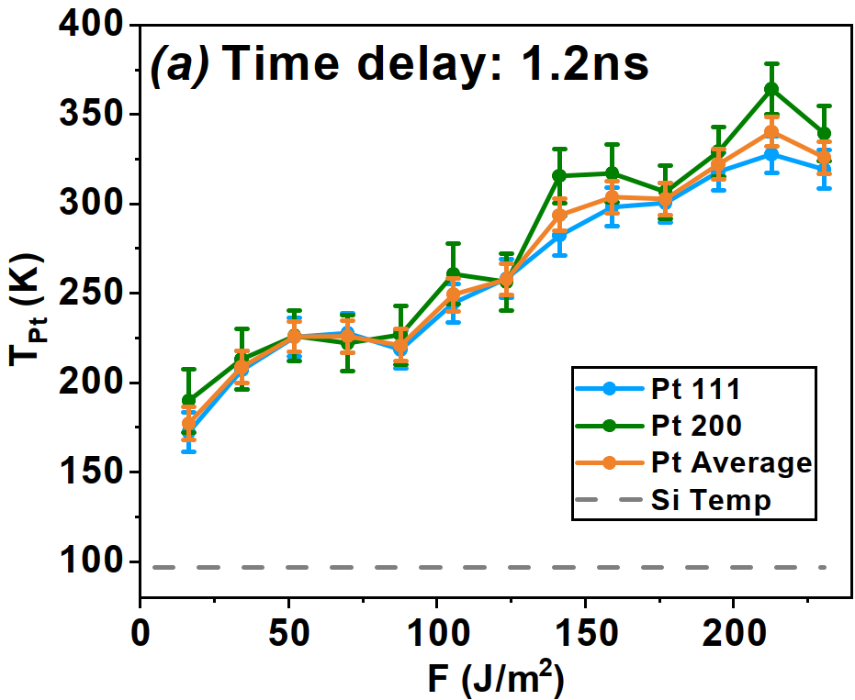
Figure S9. Experimentally determined evolution of the Pt temperature in fluences scan. $T(t)$ under different pump fluences at fixed pump-probe delay (1.2ns), showing the transient heating dynamics.

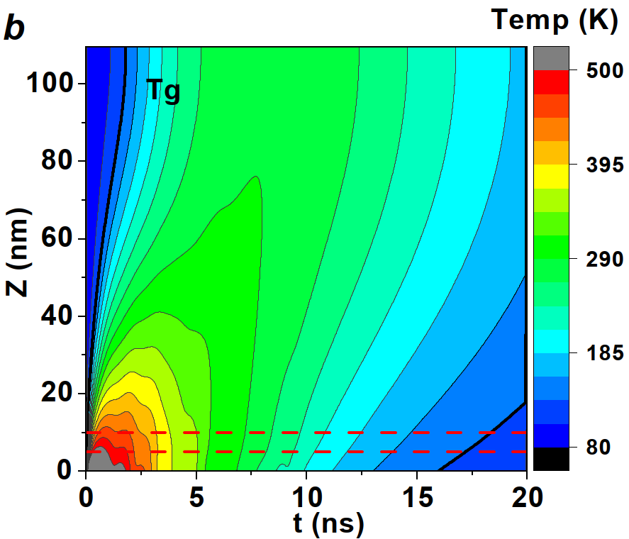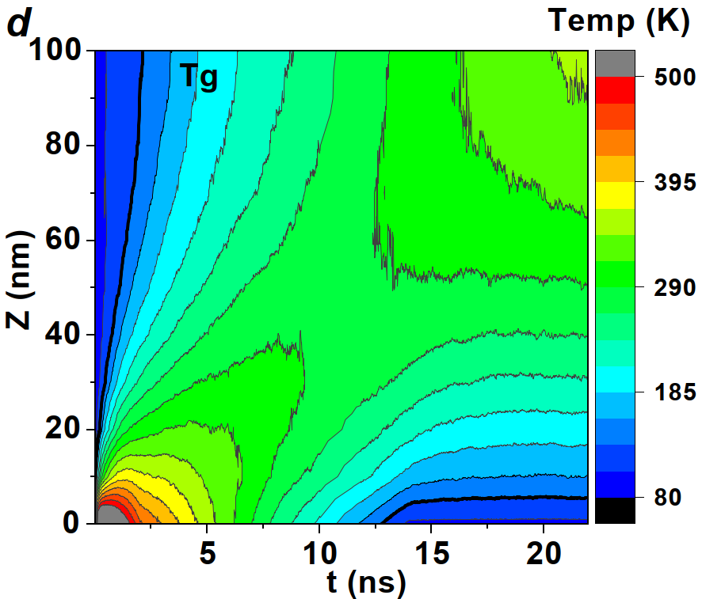
Figure S10. Temperature profiles $T(x,t)$ of ASW under different Pt heating protocols. Continuum heat-conduction simulations based on the one-dimensional thermal diffusion equation: (b) Pt heated to 750 K and then cooled. The temperature front propagates from the Pt–ASW interface into the film; the black contour marks the glass-transition isotherm ($T_{g}$ ≈ 133 K). (d) Molecular dynamics simulations (3x3x150nm box) under corresponding thermal conditions, showing similar evolution of temperature across the ASW film.

