Picture
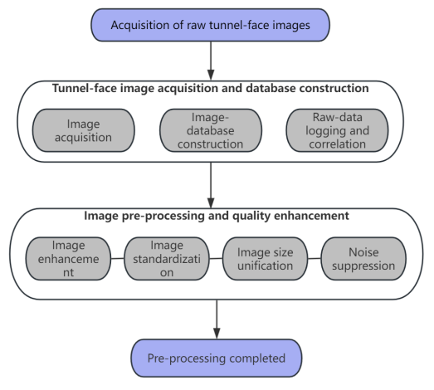
Fig. 1 Palm Face Image Preprocessing Flowchart

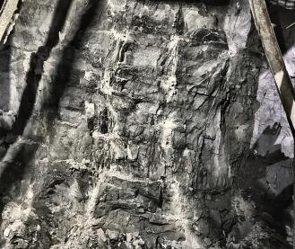
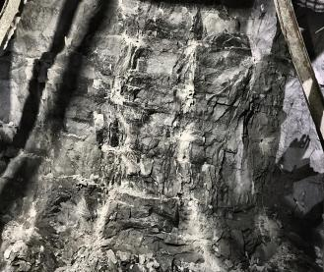
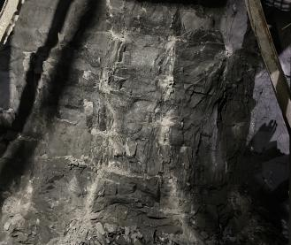

(a) Raw image (b) Pre-processed image (c) Digitally geologically-enhanced image
Fig. 2 Schematic diagram of progressive enhancement of tunnel palm face images

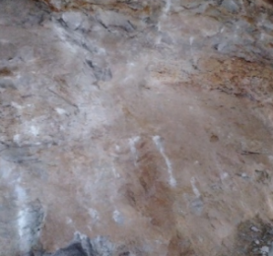 |  | 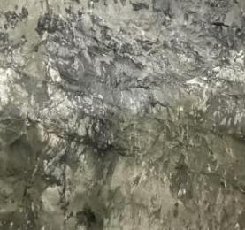 |  | 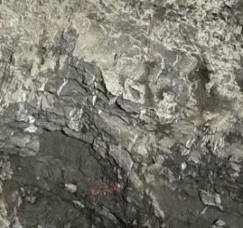
(a) Joints undeveloped |  | (b) Joints moderately developed |  | (c) Joints well-developed
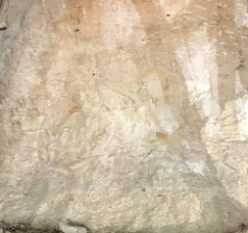 | 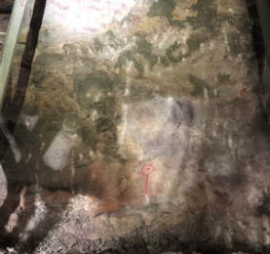 |  | 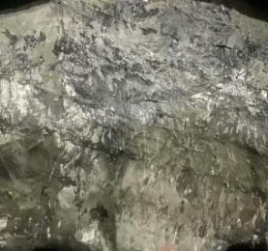 |  | 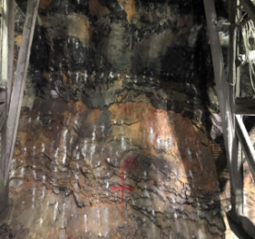
(d) Rock mass unweathered | (e) Rock mass slightly weathered |  | (f) Moderately weathered rock |  | (g) Rock mass highly weathered
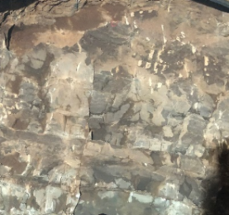 | 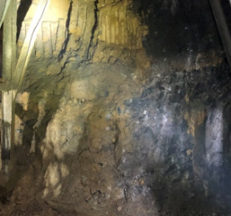 |  | 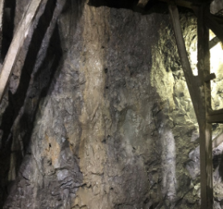 |  | 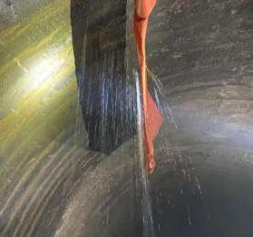
(h) Dry | (i) Moist |  | (j) Seepage |  | (k) Inflow
Fig. 3 Example image of palm face features

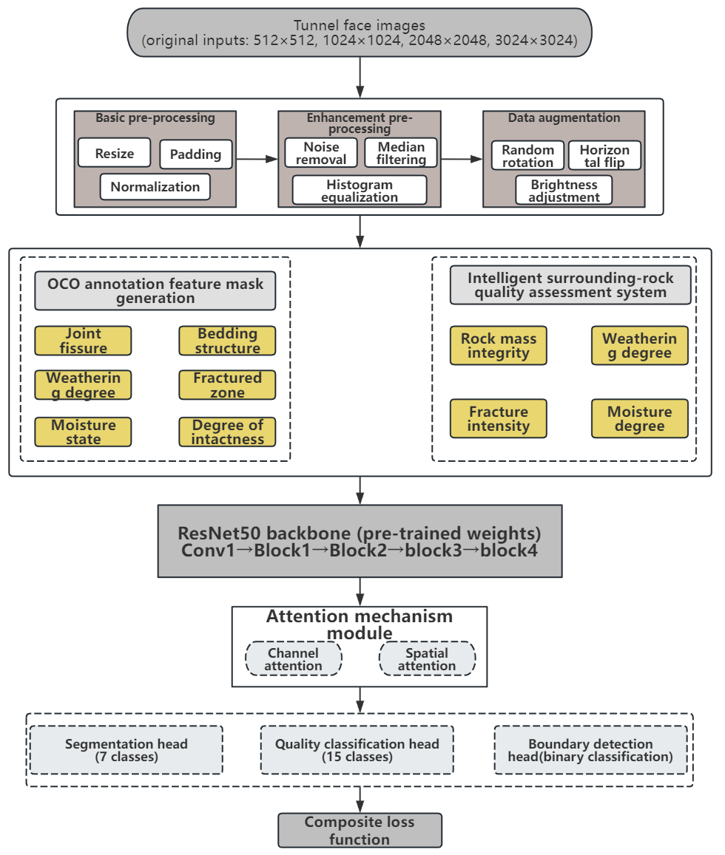
Fig.4 Overall flowchart of the intelligent assessment system of the enclosure rock level

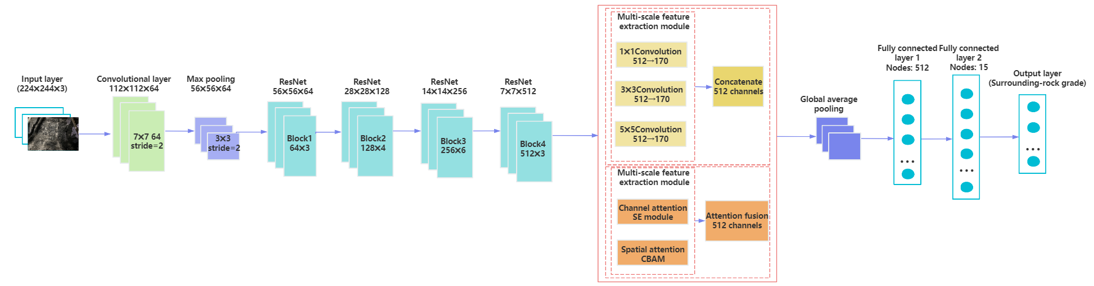
Fig. 5 Improved ResNet convolutional neural network architecture diagram

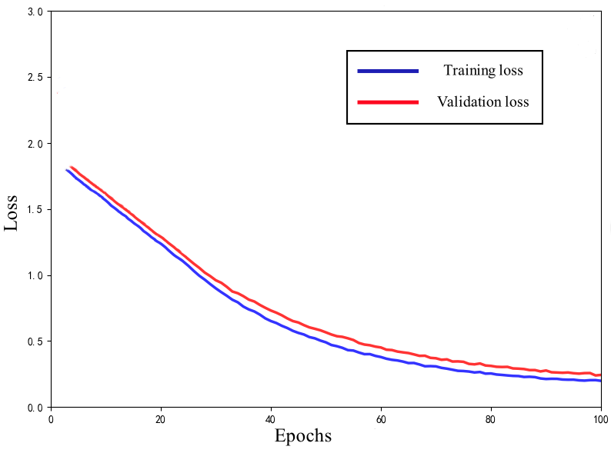 | 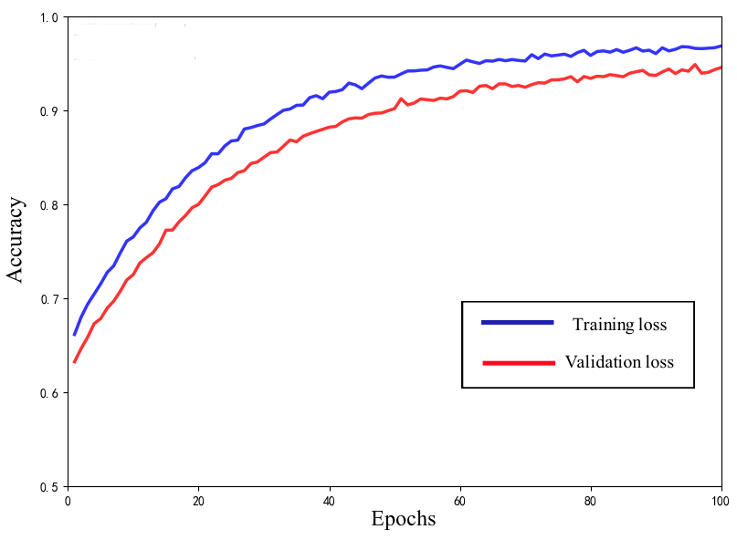
(a) Training-loss convergence curve of the improved ResNet | (b) Accuracy convergence curve of the improved ResNet
Fig. 6 Improved loss vs. accuracy convergence curves for ResNet models

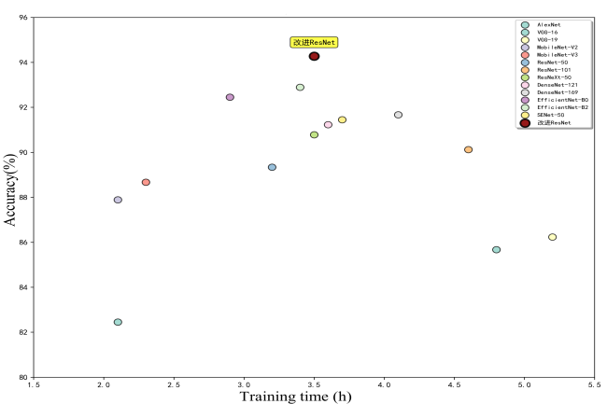 | 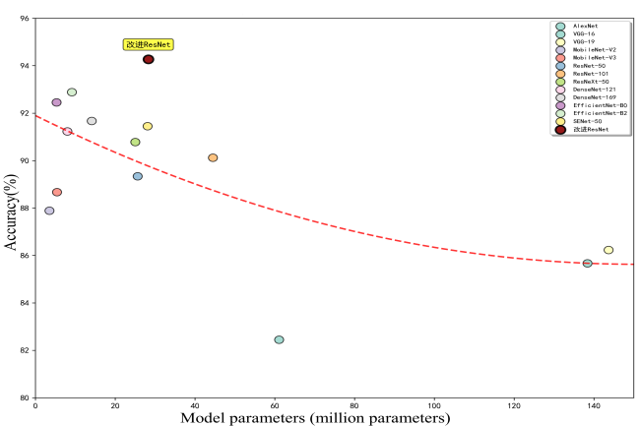
(a) Efficiency-performance trade-off | (b) Accuracy-vs-parameters regression
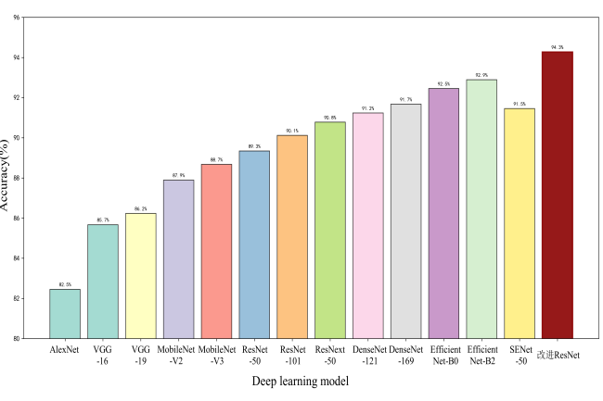 | 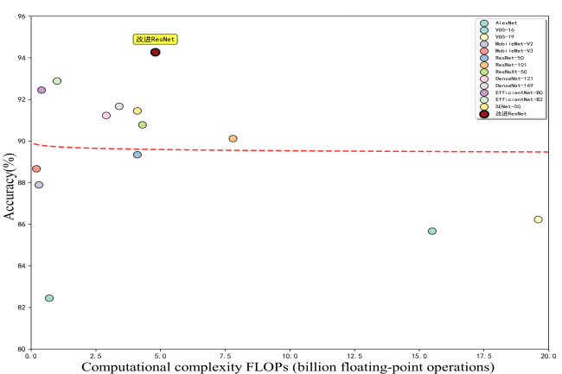
(c) Accuracy comparison across models | (d) Accuracy-complexity regression
Fig. 7 Multi-dimensional evaluation and analysis of the performance of each model

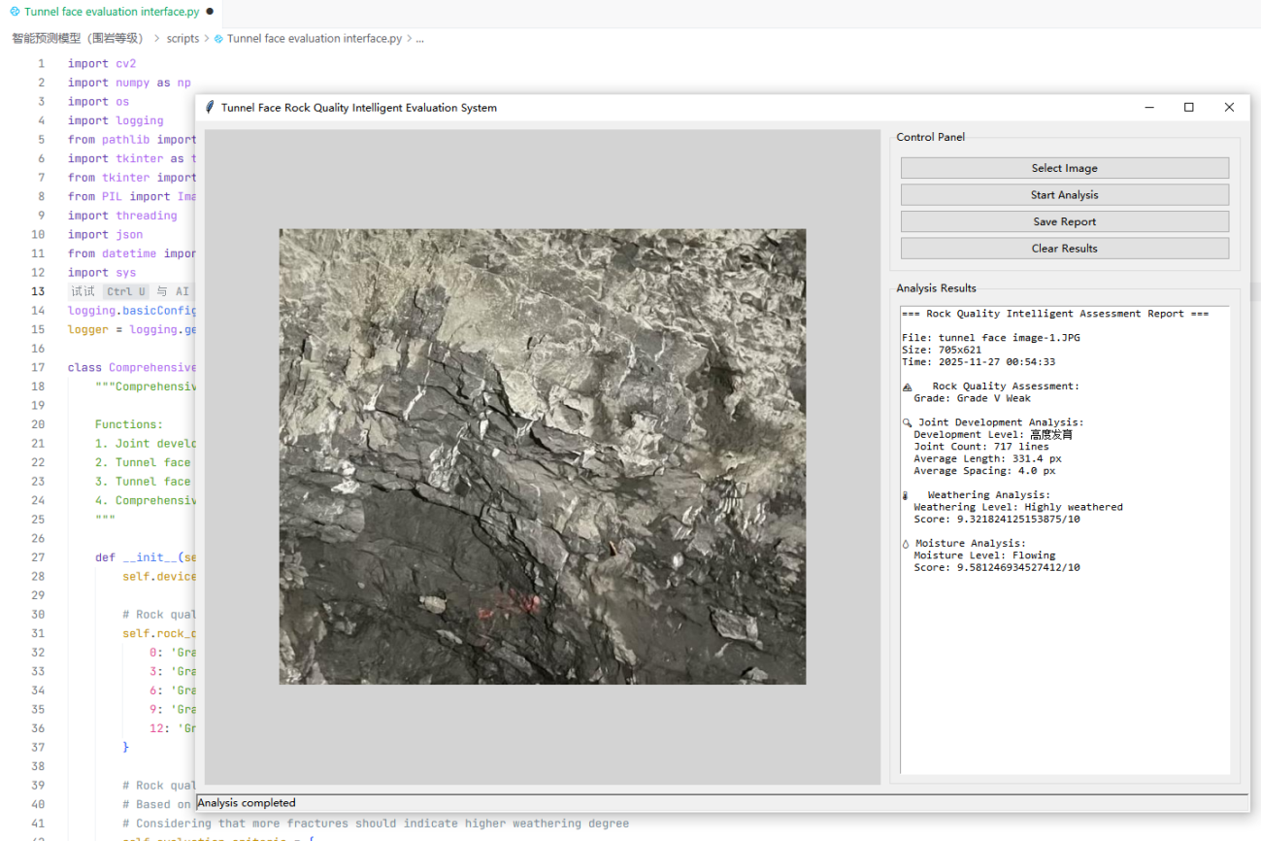
Fig. 8 Output results of parameters of surrounding rock properties

Table
Table 1 Data distribution
Factor | Surrounding Rock Characteristic Factor | Specific classification method | Training set | Validation set | Test set
Joint spacing | undeveloped | 1–2 sets, > 1 m | 1 400 | 300 | 300
Joint spacing | moderately developed | 1–3 sets, 0.2–1.0 m | 1 400 | 300 | 300
Joint spacing | highly developed | ≥ 3 sets, < 0.5 m | 1 400 | 300 | 300
Weathering | fresh | slight discoloration along joints | 1 400 | 300 | 300
Weathering | slightly weathered | secondary minerals, blocky | 1 400 | 300 | 300
Weathering | moderately weathered | altered, fractured blocks | 1 400 | 300 | 300
Weathering | highly weathered | soil-like, discoloured | 1 400 | 300 | 300
Water inflow | dry | no moisture | 1 400 | 300 | 300
Water inflow | damp | local wet spots | 1 400 | 300 | 300
Water inflow | seepage | continuous trickle | 1 400 | 300 | 300
Water inflow | inflow | visible water jet | 1 400 | 300 | 300

Table 2 Comprehensive comparative analysis of multi-model performance
Model | Acc/% | Prec/% | Rec/% | F1/% | Params/M | FLOPs/G
AlexNet | 82.45 | 82.12 | 81.89 | 82.00 | 61.1 | 0.7
VGG-16 | 85.67 | 85.23 | 85.01 | 85.12 | 138.4 | 15.5
VGG-19 | 86.23 | 85.89 | 85.67 | 85.78 | 143.7 | 19.6
ResNet-50 | 89.34 | 89.12 | 88.95 | 89.03 | 25.6 | 4.1
ResNet-101 | 90.12 | 89.87 | 89.73 | 89.8 | 44.5 | 7.8
ResNeXt-50 | 90.78 | 90.45 | 90.32 | 90.38 | 25.0 | 4.3
DenseNet-121 | 91.23 | 90.98 | 90.87 | 90.92 | 8.0 | 2.9
DenseNet-169 | 91.67 | 91.34 | 91.21 | 91.27 | 14.1 | 3.4
EfficientNet-B0 | 92.45 | 92.18 | 92.03 | 92.10 | 5.3 | 0.4
EfficientNet-B2 | 92.89 | 92.67 | 92.54 | 92.60 | 9.1 | 1.0
MobileNet-V2 | 87.89 | 87.45 | 87.23 | 87.34 | 3.5 | 0.3
MobileNet-V3 | 88.67 | 88.34 | 88.12 | 88.23 | 5.4 | 0.2
SENet-50 | 91.45 | 91.23 | 91.08 | 91.15 | 28.1 | 4.1
Improving ResNet | 94.27 | 94.16 | 94.09 | 94.12 | 28.3 | 4.8

Table 3 Multi-metric evaluation of classification performance for each surrounding-rock class using the improved ResNet model
Rock class | Samples | Acc/% | Prec /% | Rec/% | F1 /% | Key features
I (hard) | 799 | 96.73 | 96.45 | 96.32 | 96.38 | intact, no visible joints
II (firm) | 1 019 | 94.87 | 94.56 | 94.23 | 94.39 | few joints, fairly intact
III (soft) | 1 399 | 93.69 | 93.34 | 93.12 | 93.23 | moderately jointed, fissured
IV (weak) | 1 163 | 92.98 | 92.67 | 92.45 | 92.56 | highly jointed, fractured
V (very weak) | 617 | 95.24 | 94.89 | 94.76 | 94.82 | heavily broken, block-in-matrix

Table 4 Comparison of judgment results of palm face images based on improved ResNet models
Face image (chainage) | Expert grade | Model grade | Face image (chainage) | Expert grade | Model grade
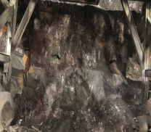 | Grade IV  (strong) | Grade V (weak) | 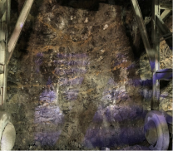 | Grade IV  (strong) | Grade V  (weak)
K2+315 | Grade IV  (strong) | Grade V (weak) | K3+177 | Grade IV  (strong) | Grade V  (weak)
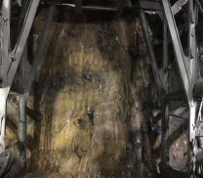 | Grade V  (strong) | Grade V  (strong) | 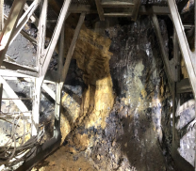 | Grade V  (strong) | Grade V  (strong)
K4+566 | Grade V  (strong) | Grade V  (strong) | ZK4+528 | Grade V  (strong) | Grade V  (strong)
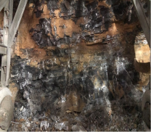 | Grade V  (weak) | Grade V (weak) | 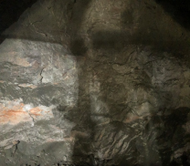 | Grade IV  (strong) | Grade IV  (strong)
ZK6+725 | Grade V  (weak) | Grade V (weak) | ZK9+103 | Grade IV  (strong) | Grade IV  (strong)

