Table 1: Selected Ghanaian Adinkra symbols
Adinkra Symbol Translation in English Language Philosophical Significance

Adinkrahene King of the Adinkra symbols Authority, leadership, and charisma

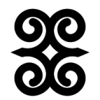
Dwennimmen The horns of a ram. Strength (in mind, body, and soul),
humility, wisdom, and learning.
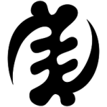
Gye Nyame Except God. Omnipotence and supremacy of God
in all affairs.

Esono Anantam Elephant’s footprint. Leadership, protection, power, and security.


Se Obedi Hene He who wants to be a king. Qualities of a leader, service, and leadership
skills.
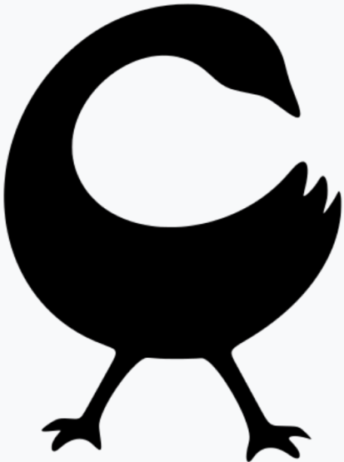
Sankofa Go back and get it. Wisdom of learning from the past to build for
the future

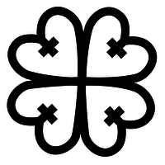
Nyame Dua God's tree A symbol of God's presence and protection.

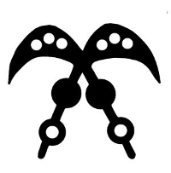
Akofena Sword of war. Authority, legality, gallantry of heroic deeds.


Epa Handcuffs. It is a symbol of law and justice.


Ananse Ntentan Spider’s web. Wisdom, craftiness, creativity, and the
(Ananse Ntontan) complexities of life.

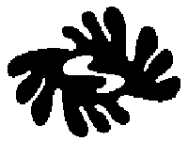
Bi Nka Bi Somebody should not bite somebody, Justice, fairplay, freedom, peace,
or Nobody should bite the other. Forgiveness, unity, harmony,
avoidance of conflict or strife.
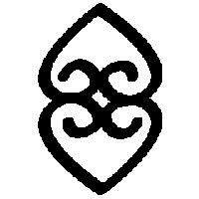
Asase Ye Duru The earth has weight. Providence and the divinity of Mother Earth.

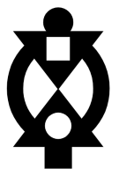
Boa Me Na Me Mmoa Wo Help me and let me help you. Cooperation and interdependence

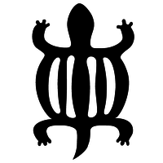
Denkyem Crocodile. It is a symbol of adaptability, cleverness.


Ese ne Tekrema Teeth and tongue. Improvement, advancement, growth,
friendship and interdependence.
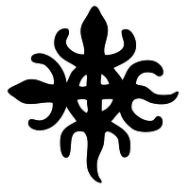
Funtunfunefu Conjoined crocodiles. Democracy, unity in diversity giving a
Denkyemfunefu common destiny; sharing

(Source: Adinkra Symbols & Meanings, 2016–2025
https://www.adinkrasymbols.org/#gsc.tab=0)

