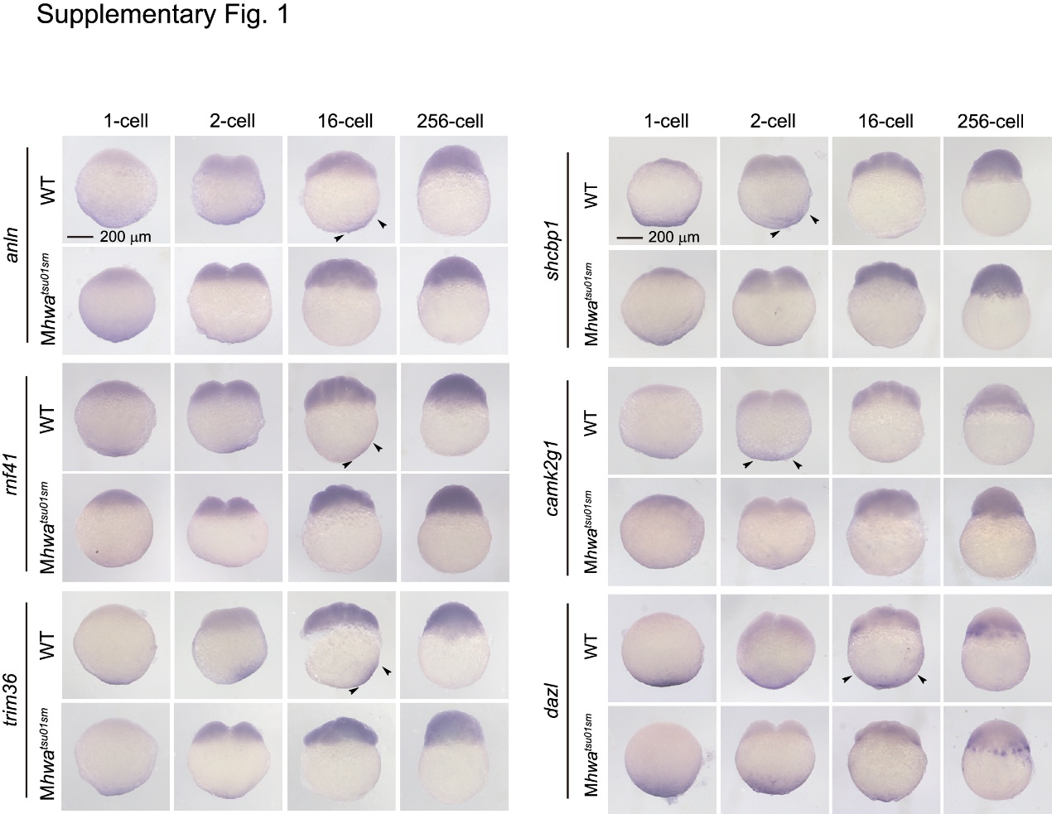
Supplementary Fig. 1. Impaired vegetal localization and transport of maternal mRNAs in Mhwa^{tsu01sm} mutants.
Whole-mount in situ hybridization of the indicated maternal mRNAs in WT and Mhwa^{tsu01sm} mutant embryos at indicated stages. Black arrows indicated vegetally localized mRNAs in WT embryos at stages where corresponding signals were absent or markedly reduced at the vegetal pole in mutants.

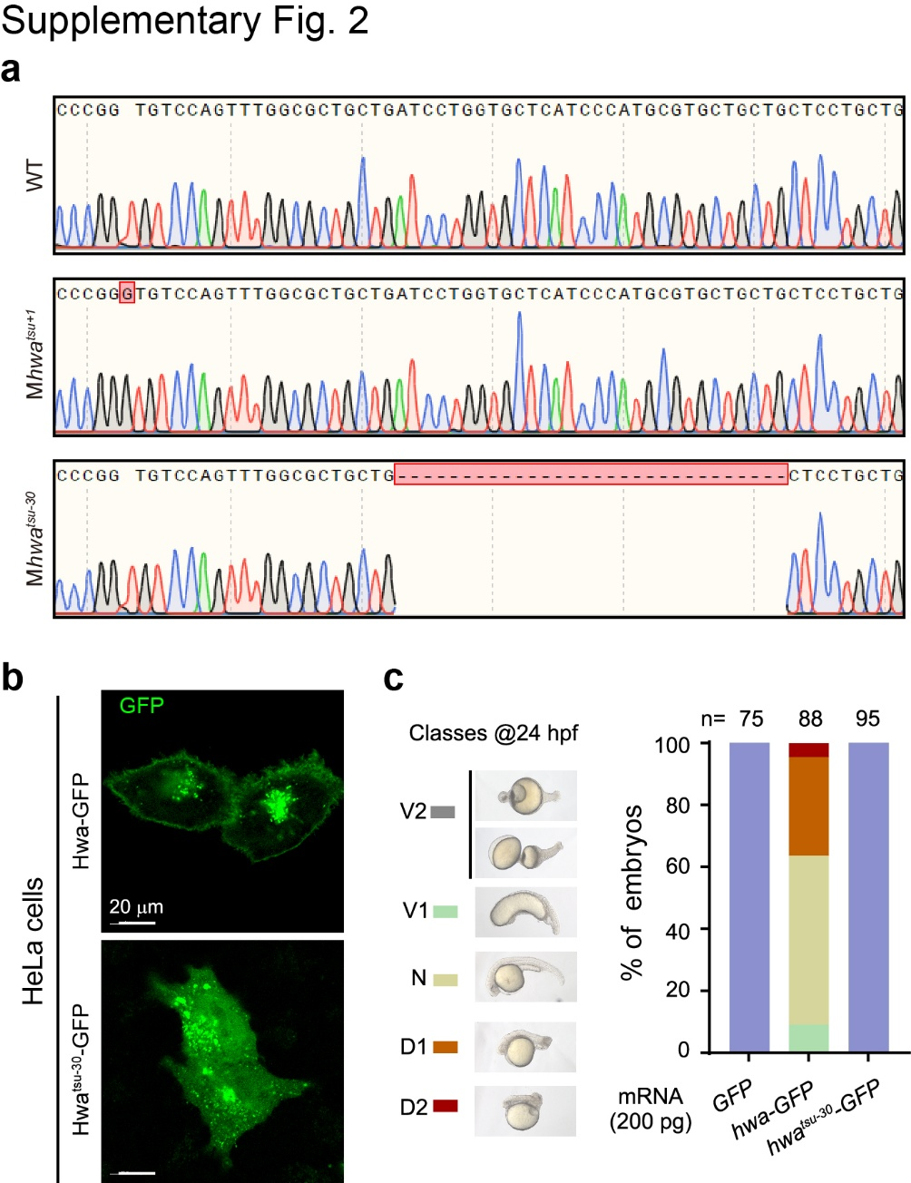
Supplementary Fig. 2. Characterization of Mhwa^{tsu+1} and Mhwa^{tsu-30} mutants.
a, Sequences of hwa cDNA from WT, Mhwa^{tsu+1} or Mhwa^{tsu-30} mutant embryos at the 1c stage, respectively. Mutated or deleted bases were highlighted. b, Subcellular localization of overexpressed Hwa-GFP Hwa^{tsu-30} in HeLa cells. Plasmid containing a corresponding hwa allele fused to GFP was transfected into HeLa cells and immunostained with anti-GFP antibody 24 h post-transfection. Note that Hwa^{tsu-30} mutant form, which lacks part of the transmembrane domain, was not enriched on the plasma membrane. c, Effect of hwa^{tsu-30} mutant mRNA overexpression in Mhwa^{tsu01sm} mutants. was injected into 1c stage Mhwa^{tsu01sm} mutants was injected with hwa^{tsu-30} mRNA (200 pg per embryo) and observed for morphology at 24 hpf. Left, phenotypic classes; right, ratio of embryos. n, number of observed embryos.
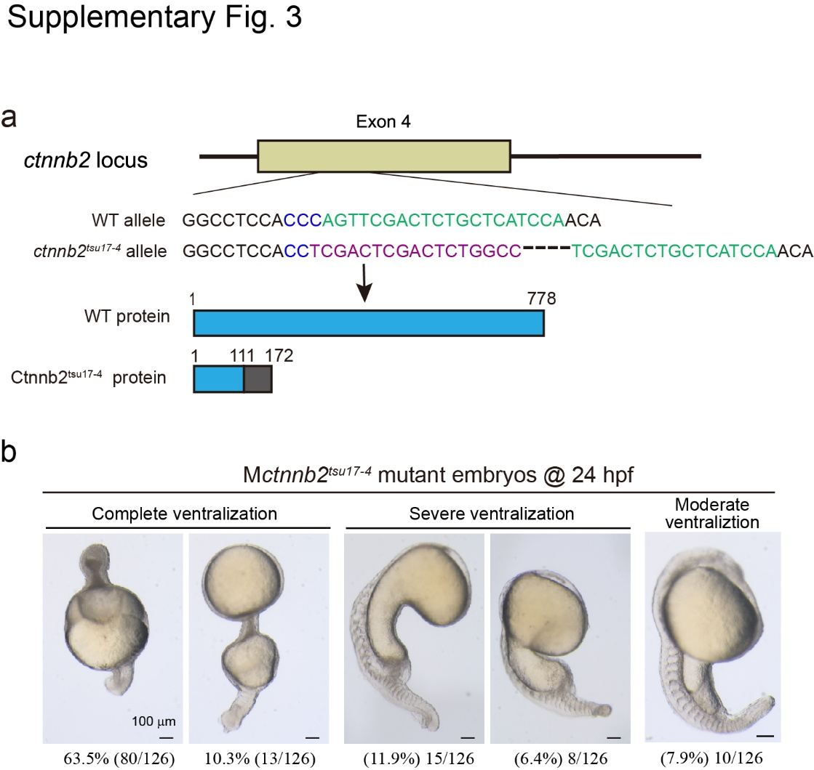
Supplementary Fig. 3. Generation and characterization of maternal ctnnb2^{tsu17-4} mutants.
a, Illustration of the mutant allele. Top, position and sequences of WT and the mutant allele. The gRNA target site and PAM sequence were highlighted in green and blue, respectively. Bottom: putative proteins with residue positions indicated. b, Representative morphological changes and ratio of Mctnnb2^{tsu17-4} mutant embryos at 24 hpf. All embryos were derived from one ctnnb2^{tsu17-4} mutant female crossed to one WT male.

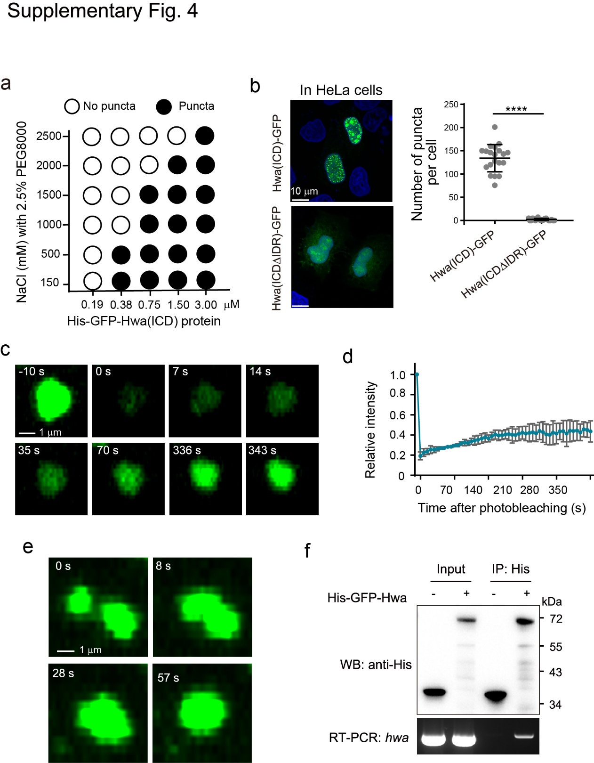
Supplementary Fig. 4. Hwa could undergo phase transition in cultured human cells.
a, His-GFP-Hwa(ICD) phase transition induced by 2.5% PEG8000 in different protein and salt concentrations in vitro. b, Condensate formation of Hwa-GFP variants expressed in 20 HeLa cells. Left, representative images; right, counted puncta number per cell. Two-tailed unpaired t-test was performed with ****P < 0.0001. c, Representative images showing fluorescence recovery after photobleaching (FRAP) of one Hwa(ICD)-GFP punctum in HeLa cells. d, Quantification of fluorescence recovery. Three puncta were analyzed. e, Representative time-lapse confocal images showing fusion of two Hwa(ICD)-GFP puncta in HeLa cells. f, RNA immunoprecipitation assay showing association of His-GFP-Hwa protein with hwa mRNA. Synthetic hwa mRNA including 5’UTR, coding region, and 3’UTR was incubated with purified His-GFP-Hwa protein, followed by immunoprecipitation with His antibody and then RNA extraction for RT-PCR.

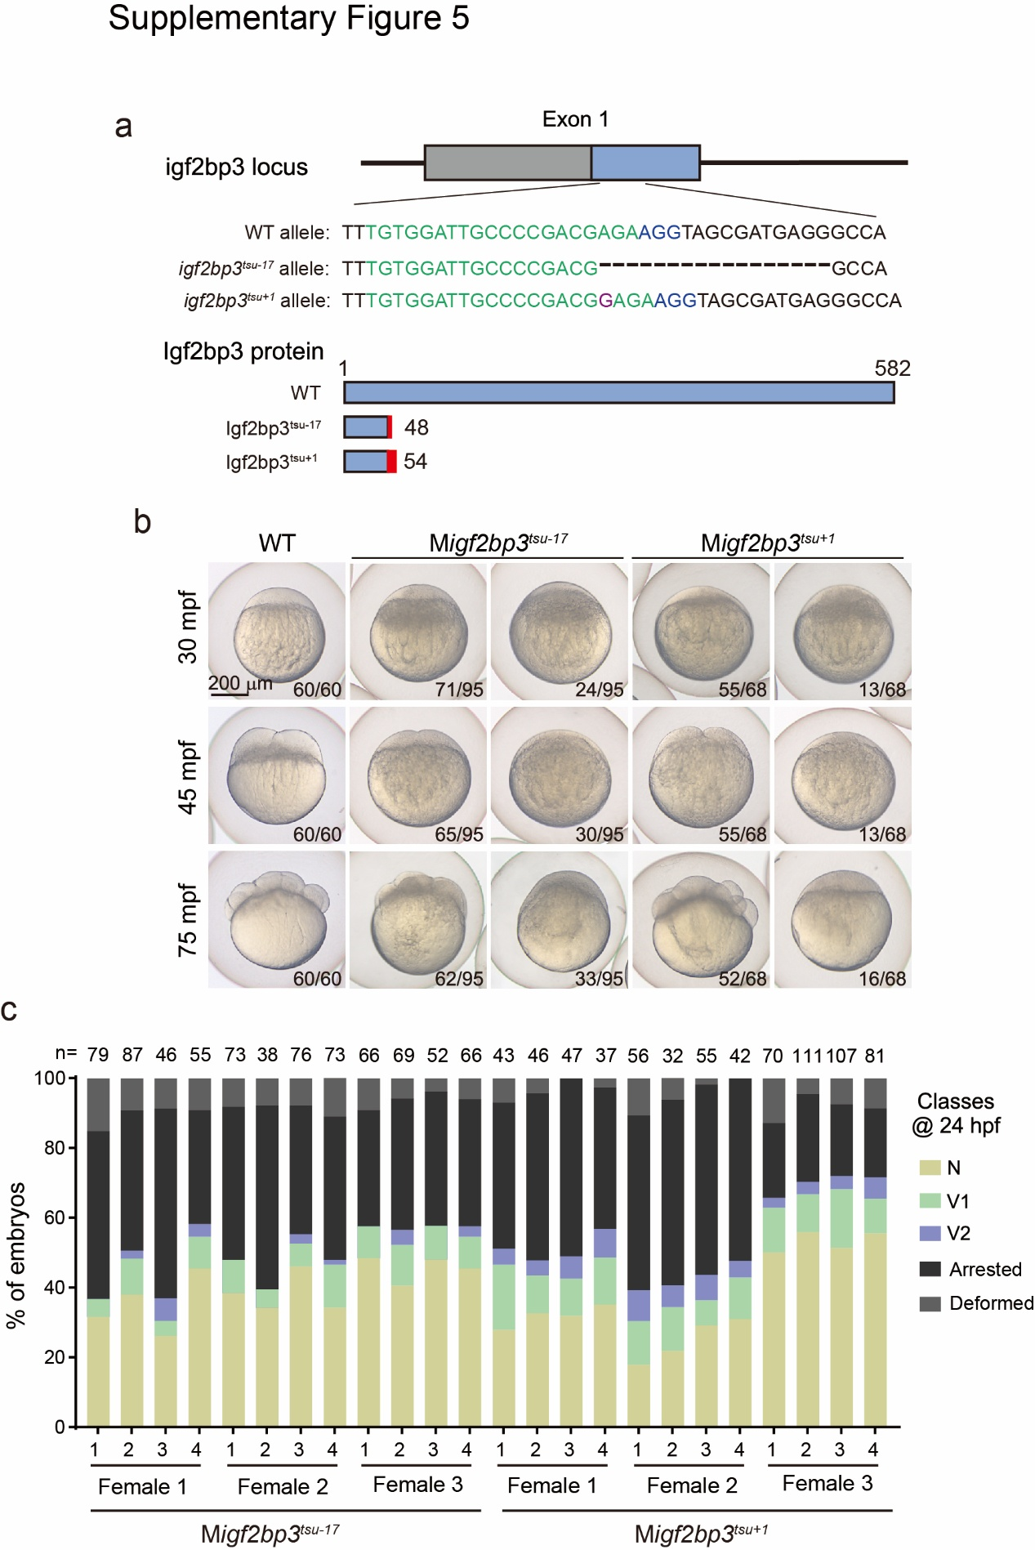
Supplementary Fig. 5. Generation and characterization of maternal igf2bp3 mutants.
a, Schematic of two igf2bp3 mutant allele sequences and their putative encoding peptides. Altered regions of the putative peptides were shown in red. b, Morphology of maternal igf2bp3 mutant embryos during early cleavage period. The ratio of embryos with the representative pattern was indicated. c, RT-qPCR shows significantly reduced igf2bp3 mRNA levels in Migf2bp3 1-cell embryos compared to WT. Two-tailed unpaired t-test; ****P < 0.0001. c, Ratio of Migf2bp3 embryos with different phenotypes at 24 hpf in different batches. Representative images for different phenotypic classes were shown in main Fig. 6e. For each mutant line, 3 homozygous mutant females were individually mated to WT male for 4 consecutive times (1-4). n, total number of observed embryos.

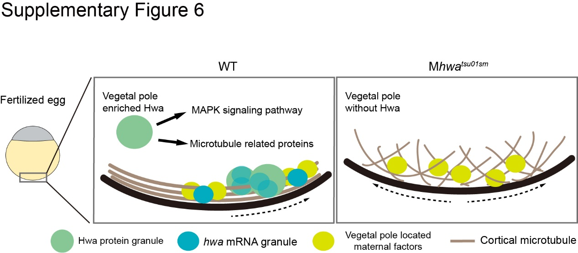
Supplementary Fig. 6. Work model for Hwa regulation of the VPM microtubule network in fertilized eggs.

