Table 6 : herg prediction
compound | Binary prediction | Binary Confiabilityn(%) | Multiclass confiability (%) | Applicability domain | Reg prediction (IC₅₀) | Fragment Contribution Maps for the Regression Model
Chloroquine | Blocker | 99.5 | 54.9 | Inside | 5.579 | 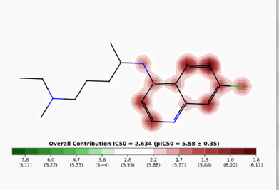
Artocarpin | Non blocker | 76.27 | 39.3 | Inside | 5.271 | 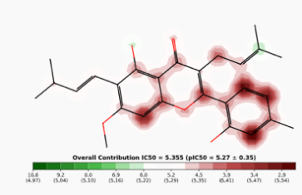
cycloartocarpin | Non blocker | 95.76 | 36.5 | inside | 5.192 | No fragment constribution maps
artocarpanone | Non blocker | 77.74 | 34.5 | inside | 5.327 | 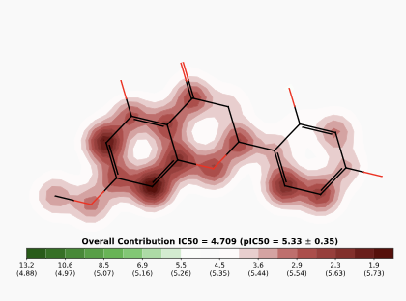
Cyanomaclurin | Blocker | 63.98 | 34.0 | Outside | 5.367 | No fragment constribution maps

