Supplementary Information

Closed-to-Open-Shell Molecular Sensing Enables Highly Selective Detection of Chemical Warfare Agents

Yunhui Meng¹, Shuqi Zou¹, Mingyang Wu¹, Xiaobai Li¹*, Kun Song¹, Lijia Zhang¹, Yuling Yang¹, Alim Abdurahman²*, Hongwei Ma^{1,3}*, Geyu Lu²*

¹ College of Chemistry, Chemical Engineering and Resource Utilization, Northeast Forestry University, Harbin 150040, China.
² State Key Laboratory of Integrated Optoelectronics, JLU Region, College of Electronic Science and Engineering Jilin University, Changchun 130012, P. R. China.
³ Heilongjiang Key Laboratory of Complex Traits and Protein Machines in Organisms, Northeast Forestry University, Harbin 150040, China.

Contents
Supplementary Figures
Supplementary Fig. 1 Synthetic route of DTE-3PCz, DTE-3NCz. 4
Supplementary Fig. 2 ¹H NMR spectrum of DTE-2Cl in CDCl₃. 5
Supplementary Fig. 3 ¹H NMR spectrum of DTE-3PCz in CDCl₃. 5
Supplementary Fig. 4 ¹H NMR spectrum of DTE-3NCz in CDCl₃. 6
Supplementary Fig. 5 ¹³C NMR spectrum of DTE-2Cl in CDCl₃. 6
Supplementary Fig. 6 ¹³C NMR spectrum of DTE-3PCz in CDCl₃. 7
Supplementary Fig. 7 ¹³C NMR spectrum of DTE-3NCz in CDCl₃. 7
Supplementary Fig. 8 Liquid chromatography-mass spectrometry of DTE-2Cl. 8
Supplementary Fig. 9 Liquid chromatography-mass spectrometry of DTE-3PCz. 8
Supplementary Fig. 10 Liquid chromatography-mass spectrometry of DTE-3NCz. 9
Supplementary Fig. 11 Photochemical properties. (a) UV-vis absorption spectra and (b) Fluorescence spectra of DTE-3NCz (1.0×10⁻⁵ M in dichloromethane (DCM)) upon UV irradiation at room temperature. c Color shifts in the CIE 1931 diagram of a solution of DTE-3NCz (1.0×10⁻⁵ M in DCM) under different times of UV irradiation. d EPR spectra before and after UV irradiation (in toluene). 9
Supplementary Fig. 12 UV-vis absorption spectra of DTE-3PCz (a) and DTE-3NCz (b) (1.0×10⁻⁵ M in DCM) after UV irradiation and subsequent addition of 10 equiv. of TEMPO. 10
Supplementary Fig. 13 High-performance liquid chromatography analysis of DTE-3PCz (1.0×10⁻⁵ M in acetonitrile) before and after UV irradiation (365 nm). Reaction of DTE-3PCz radical molecules with TEMPO (10 equiv.). 10
Supplementary Fig. 14 Fluorescence spectra of DTE-3PCz (a) and DTE-3NCz (b) (1.0×10⁻⁵ M in DCM) upon addition of HCl. c The quenching efficiency of DTE-3NCz (1.0×10⁻⁵ M in DCM) under UV light irradiation after addition of 10 equiv. of DCP, HCl, and other interfering substances. 11
Supplementary Fig. 15 Fluorescence spectra of DTE-3PCz (1.0×10⁻⁵ M in DCM) upon addition of (a) BTC, (c) 2-CEES. Linear relationship between quenching efficiency of DTE-3PCz solution upon addition of (b) BTC, (d) 2-CEES. Error bars stand for standard deviation. 11
Supplementary Fig. 16 The photoluminescence quantum yield (PLQY) of DTE-3PCz (1.0×10⁻⁵ M) in (a) original, (b) DCP, (c) HCl, (d) 2-CEES and (e) BTC DCM solution. 12
Supplementary Fig. 17 UV-vis spectra of DTE-3PCz and DTE-3NCz (1.0×10⁻⁵ M in DCM) upon addition of DCP (a, b), HCl (c, d). 12
Supplementary Fig. 18 Liquid chromatography-mass spectrometry of DTE-3PCz (HCl) radical. 13
Supplementary Fig. 19 Liquid chromatography-mass spectrometry of DTE-3PCz (DCP) radical. 13
Supplementary Fig. 20 ¹H NMR of DTE-3PCz in CDCl₃ solution under UV irradiation after addition of 10 equiv. of HCl. 14
Supplementary Fig. 21 ¹H NMR of DTE-3PCz in CDCl₃ solution under UV irradiation after addition of 10 equiv. of DCP. 14
Supplementary Fig. 22 Normalized absorption (blue line) and PL spectra (green line) of DTE-3PCz (1.0×10⁻⁵ M in DCM) upon addition of DCP (a) and HCl (b). Normalized PL spectra of DTE-3PCz (c) at different excitation wavelengths and normalized excitation spectra of DTE-3PCz (d) at different emission wavelengths. 15
Supplementary Fig. 23 ESP plots of DTE-3NCz before and after addition of DCP. 15
Supplementary Fig. 24 Electronic spin density distributions (up), electronic density distributions of the frontier molecular orbitals (down) of DTE-3PCz radical (HCl) calculated at the theoretical level of uM062X/6-31 g(d, p). 16
Supplementary Fig. 25 Orbital transitions and electron-hole distribution corresponding to the DTE-3PCz radical (HCl). 16
Supplementary Fig. 26 Electronic spin density distributions (up), electronic density distributions of the frontier molecular orbitals (down) of DTE-3PCz radical (DCP) calculated at the theoretical level of uM062X/6-31 g(d, p). 17
Supplementary Fig. 27 Electronic spin density distributions (up), electronic density distributions of the frontier molecular orbitals (down) of DTE-3NCz radical (HCl) calculated at the theoretical level of uM062X/6-31 g(d, p). 17
Supplementary Fig. 28 Orbital transitions and electron-hole distribution corresponding to the DTE-3NCz radical (HCl). 18
Supplementary Fig. 29 Electronic spin density distributions (up), electronic density distributions of the frontier molecular orbitals (down) of DTE-3NCz radical (DCP) calculated at the theoretical level of uM062X/6-31 g(d, p). 18
Supplementary Fig. 30 Orbital transitions and electron-hole distribution corresponding to the DTE-3NCz radical (DCP). 19
Supplementary Fig. 31 The photographs of DTE-3PCz (1.0×10⁻⁵ M in DCM) placed at 298 K and 77 K. 19
Supplementary Fig. 32 Scanning electron microscope image of DTE-3PCz film. 20
Supplementary Fig. 33 Schematic diagram of the adsorption testing system for DTE-3PCz films. The section enclosed by dashed lines can be removed for weighing. 20
Supplementary Fig. 34 Particle diffusion model. 21
Supplementary Fig. 35 Cell viability by WST-8 method. 21
Supplementary Tables
Supplementary Table 1 Luminescence performance data of DTE-3PCz (1.0×10⁻⁵ M) in original, DCP, HCl, 2-CEES and BTC DCM (1.0×10⁻⁵ M) solution. 21
Supplementary Table 2 Calculated wavelength (λ) and oscillator strength (ƒ) for absorption of DTE-3PCz (HCl) radical with uM062X functional at the basis set level of 6-31 g(d, p). 22
Supplementary Table 3 Calculated wavelength (λ) and oscillator strength (ƒ) for absorption of DTE-3PCz (DCP) radical with uM062X functional at the basis set level of 6-31 g(d, p). 22

Supplementary Figures
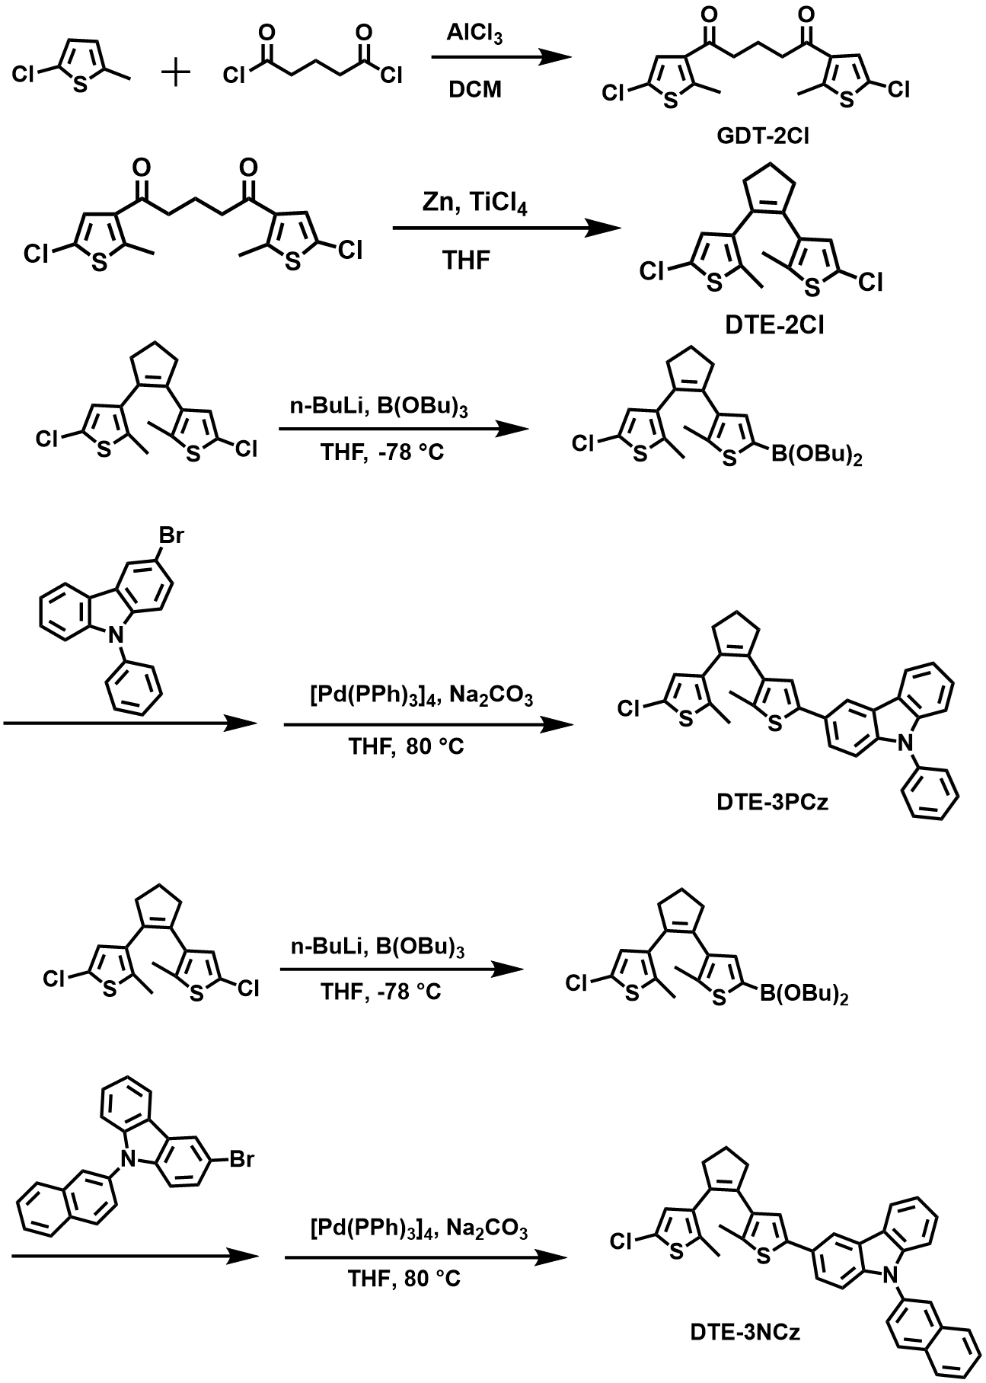
Supplementary Fig. 1 Synthetic route of DTE-3PCz, DTE-3NCz.
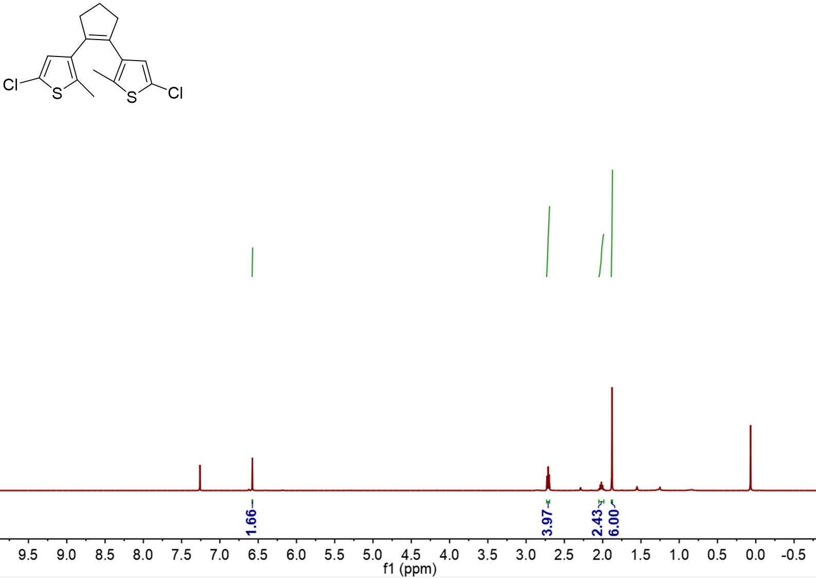
Supplementary Fig. 2 ¹H NMR spectrum of DTE-2Cl in CDCl₃.

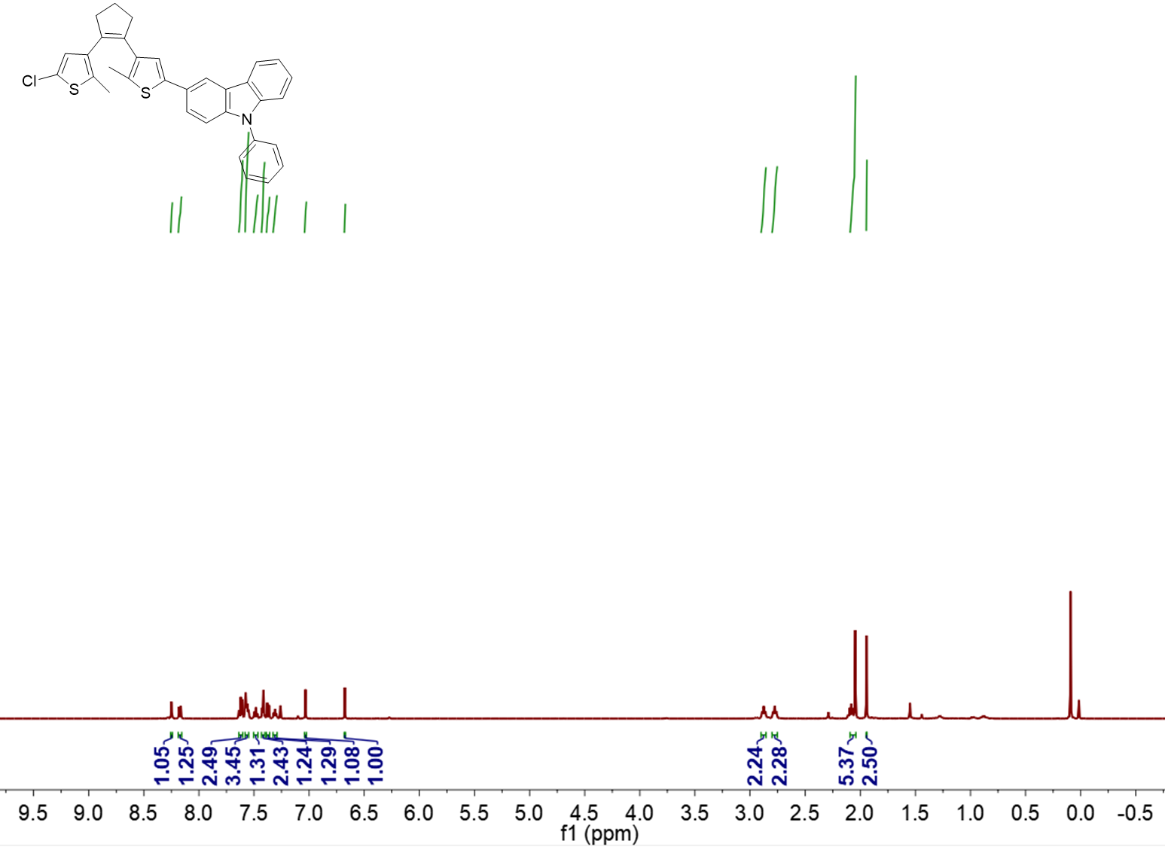
Supplementary Fig. 3 ¹H NMR spectrum of DTE-3PCz in CDCl₃.
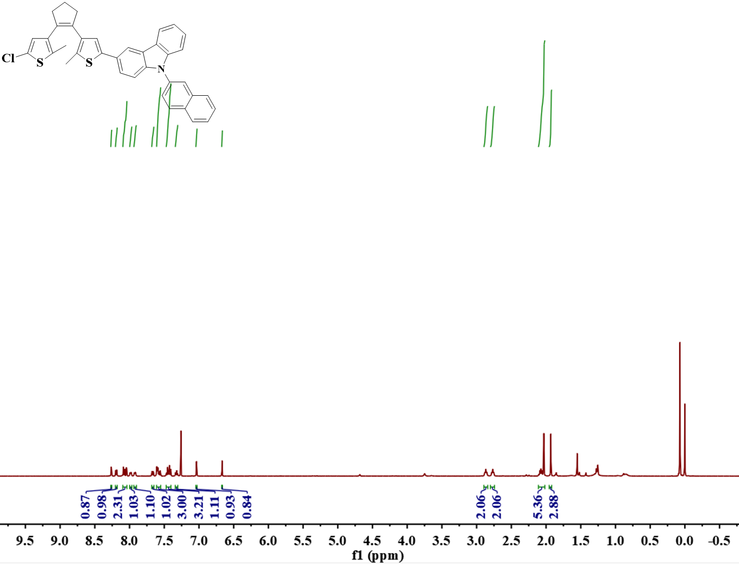
Supplementary Fig. 4 ¹H NMR spectrum of DTE-3NCz in CDCl₃.
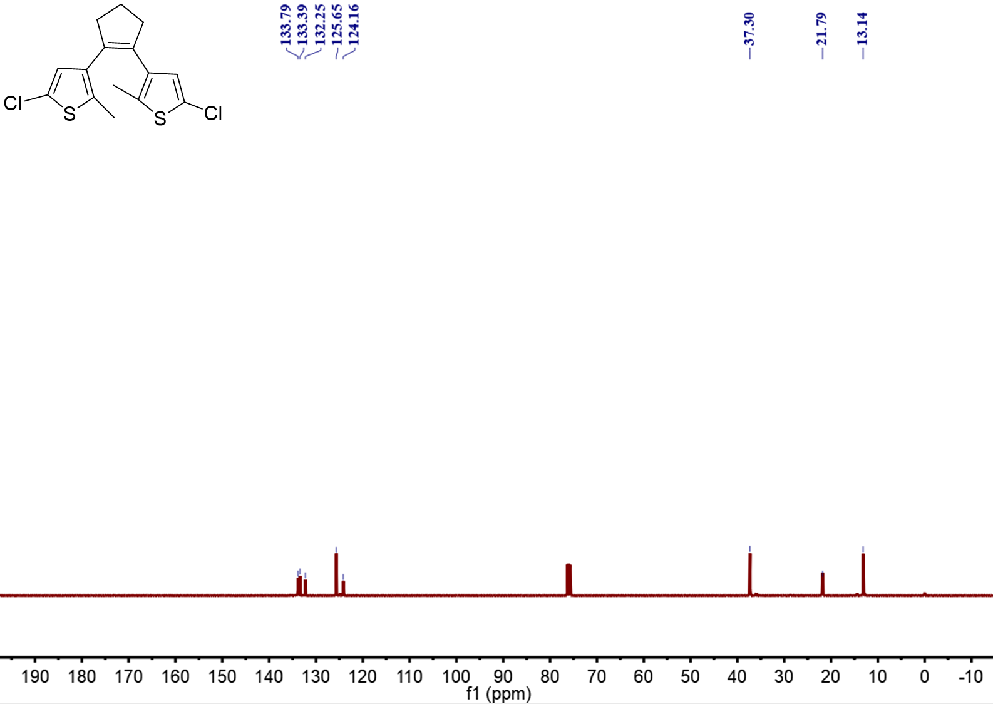
Supplementary Fig. 5 ¹³C NMR spectrum of DTE-2Cl in CDCl₃.

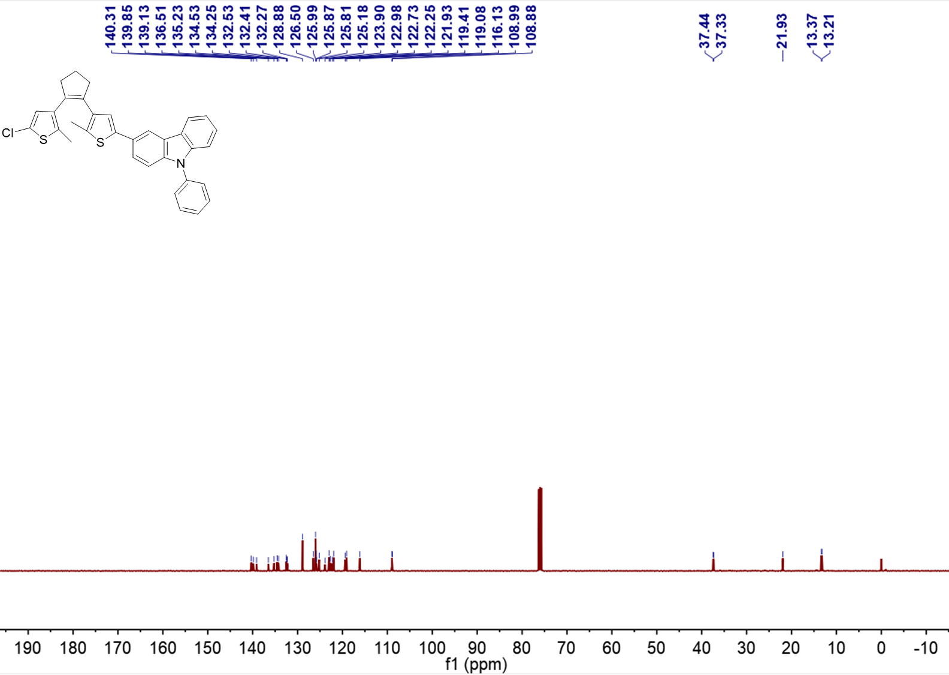
Supplementary Fig. 6 ¹³C NMR spectrum of DTE-3PCz in CDCl₃.
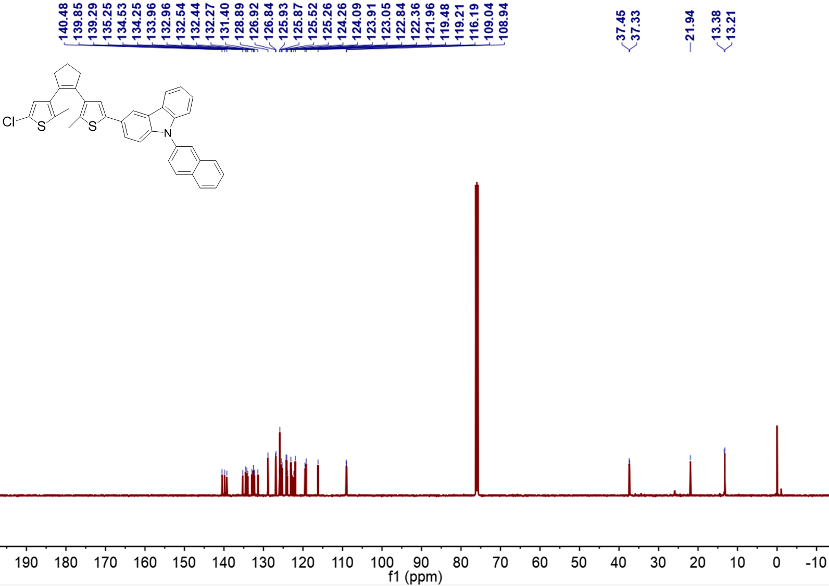
Supplementary Fig. 7 ¹³C NMR spectrum of DTE-3NCz in CDCl₃.
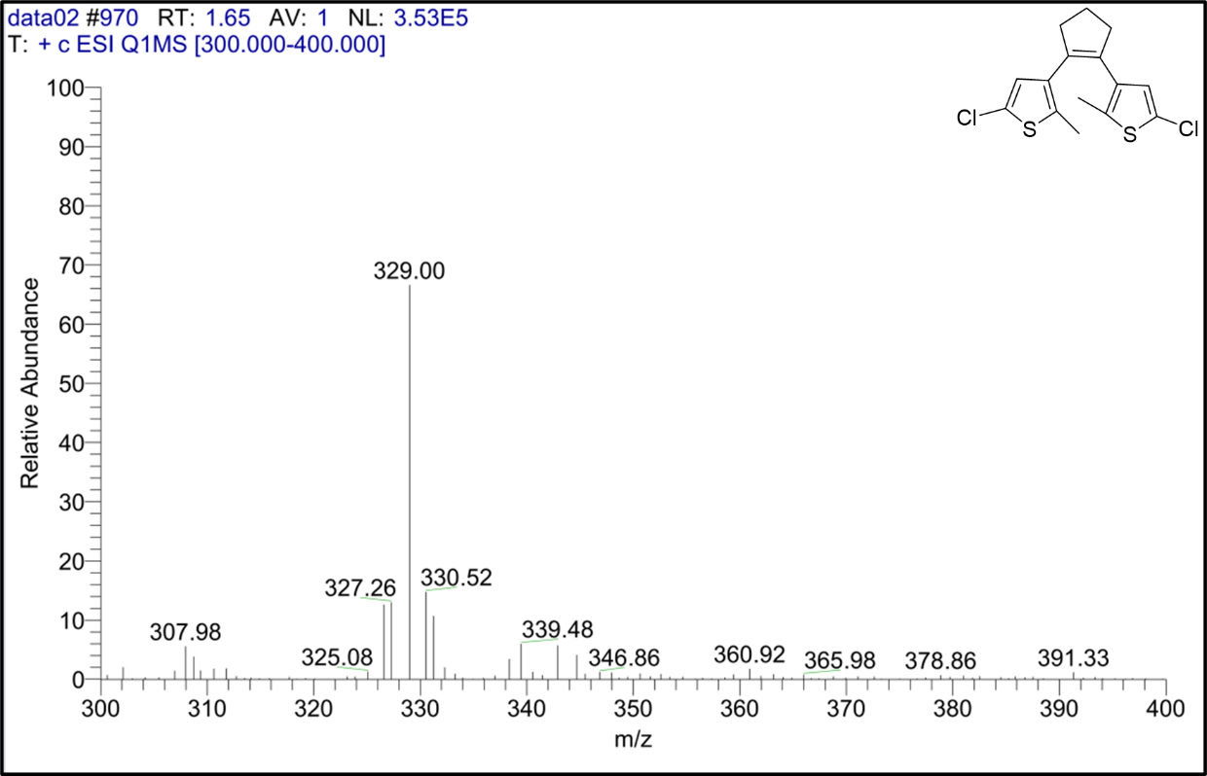
Supplementary Fig. 8 Liquid chromatography-mass spectrometry of DTE-2Cl.
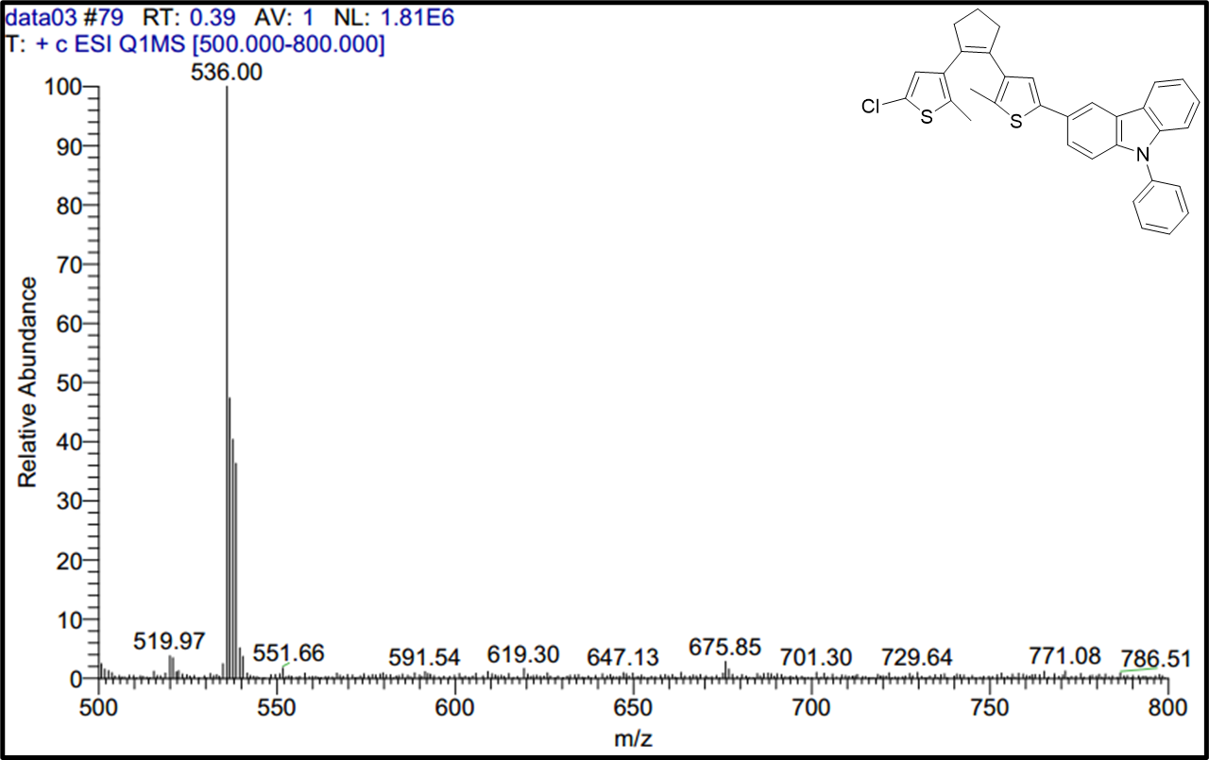
Supplementary Fig. 9 Liquid chromatography-mass spectrometry of DTE-3PCz.
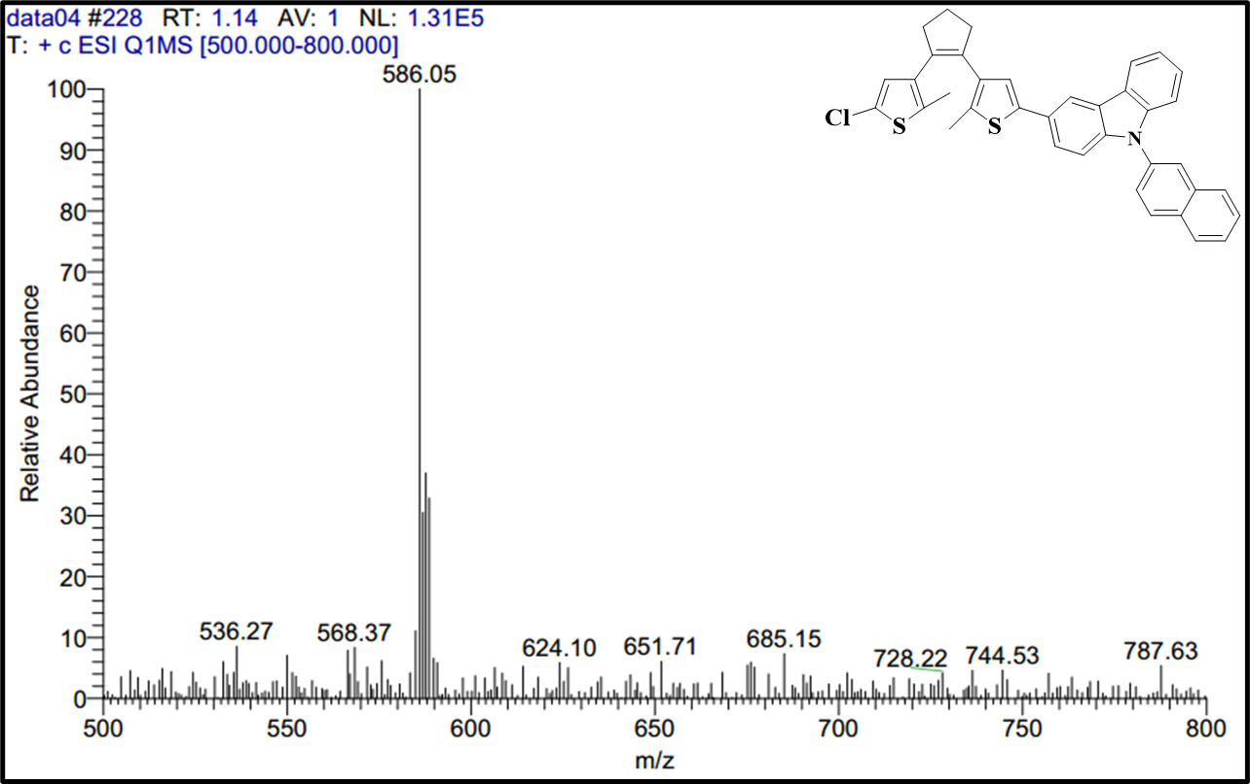
Supplementary Fig. 10 Liquid chromatography-mass spectrometry of DTE-3NCz.
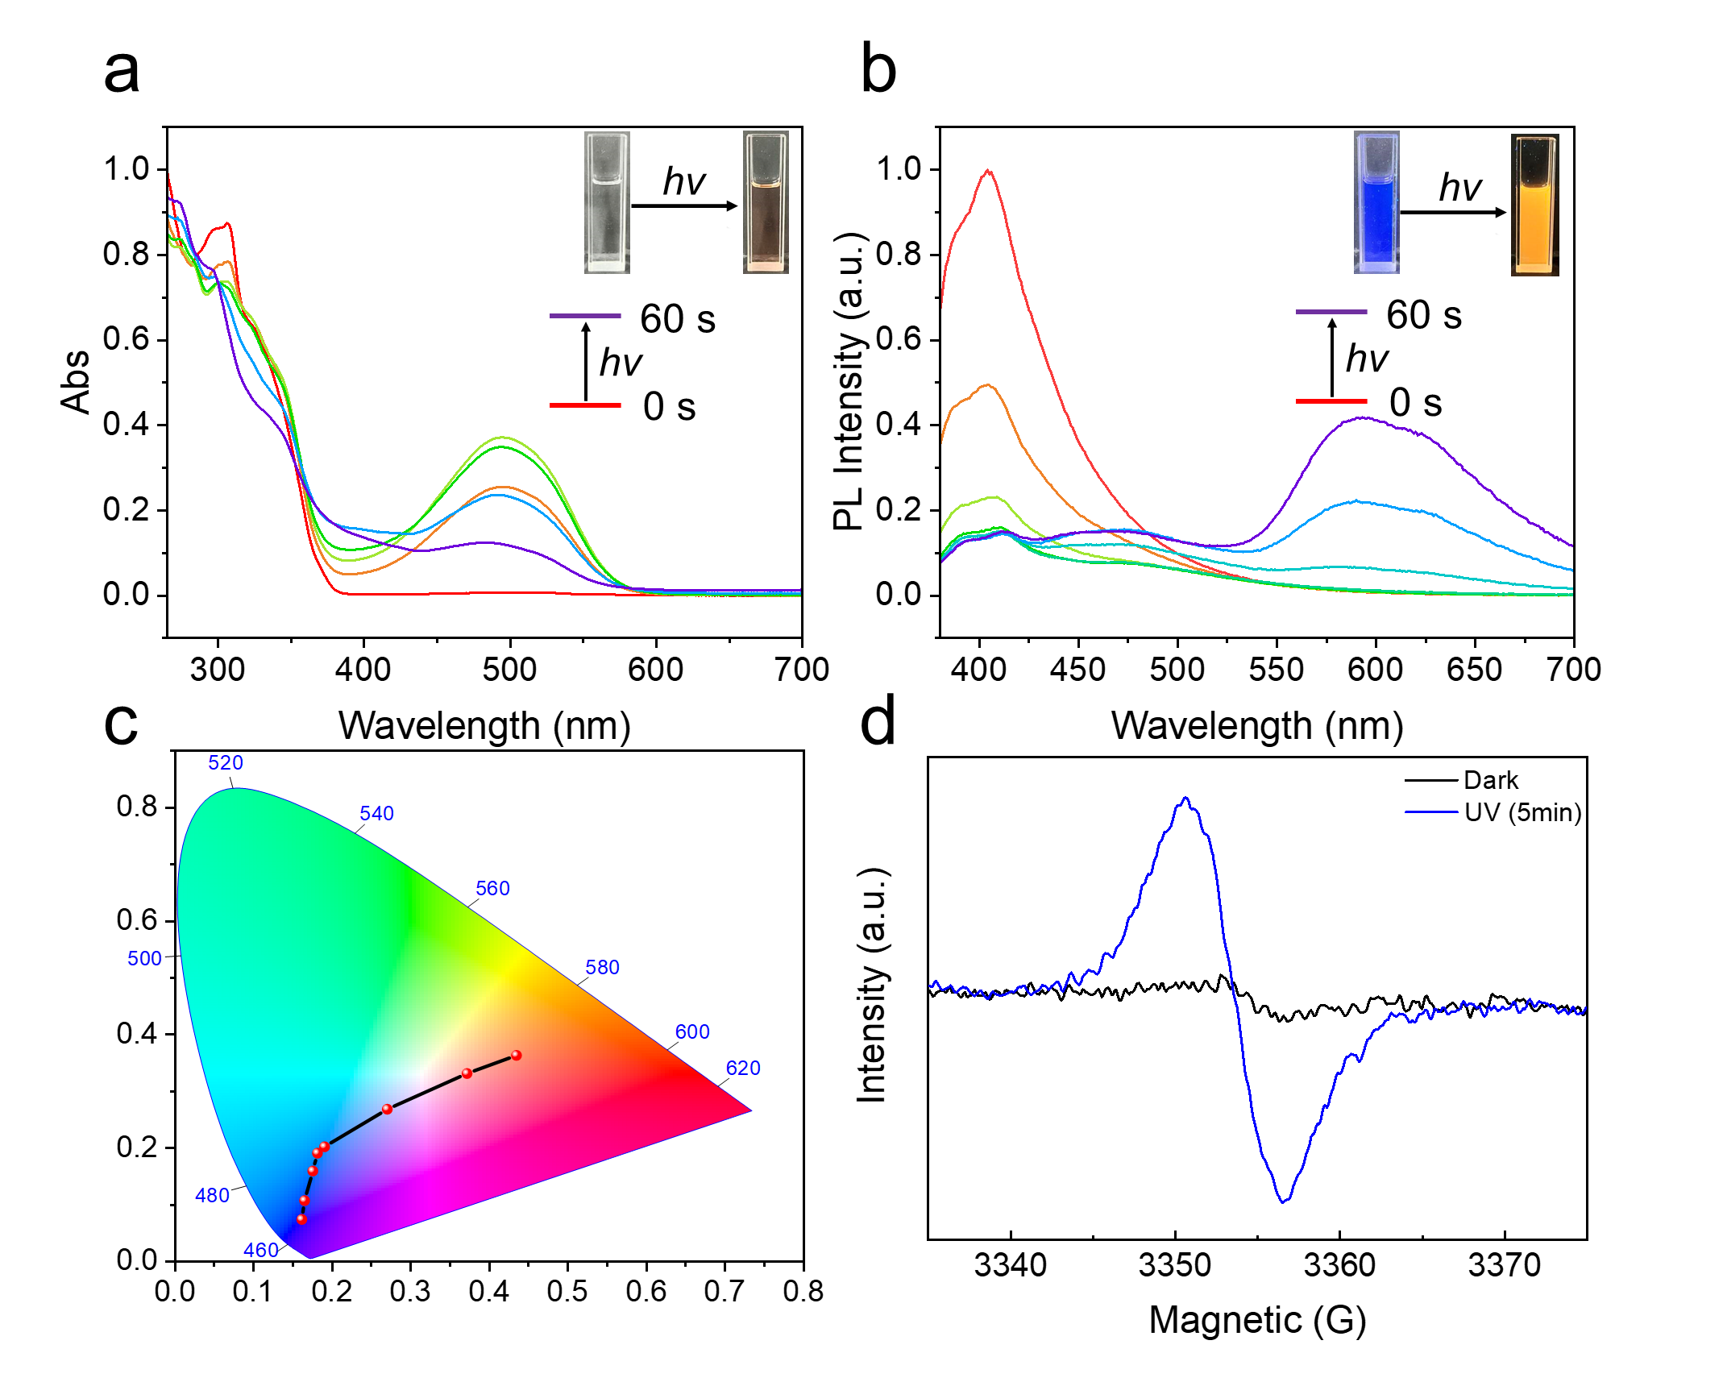
Supplementary Fig. 11 Photochemical properties. (a) UV-vis absorption spectra and (b) Fluorescence spectra of DTE-3NCz (1.0×10⁻⁵ M in dichloromethane (DCM)) upon UV irradiation at room temperature. c Color shifts in the CIE 1931 diagram of a solution of DTE-3NCz (1.0×10⁻⁵ M in DCM) under different times of UV irradiation. d EPR spectra before and after UV irradiation (in toluene).
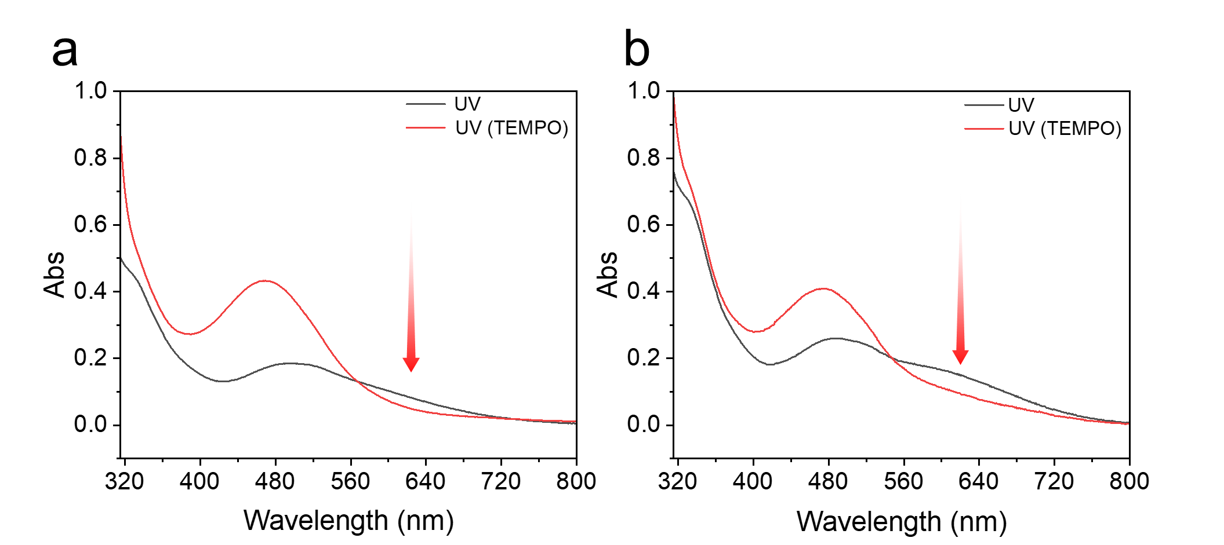
Supplementary Fig. 12 UV-vis absorption spectra of DTE-3PCz (a) and DTE-3NCz (b) (1.0×10⁻⁵ M in DCM) after UV irradiation and subsequent addition of 10 equiv. of TEMPO.
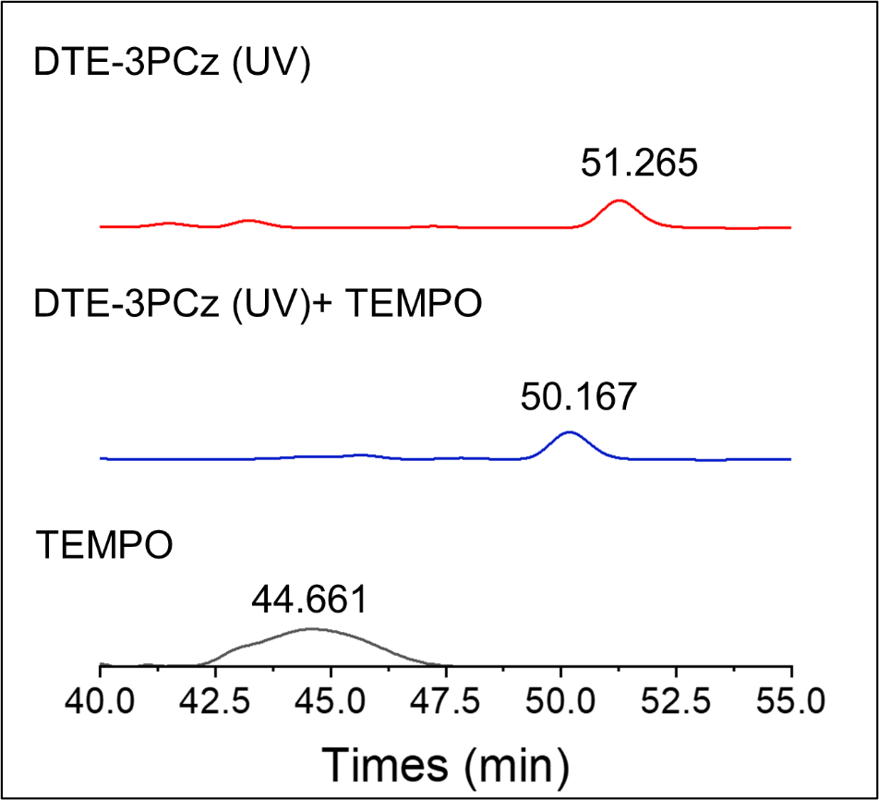
Supplementary Fig. 13 High-performance liquid chromatography analysis of DTE-3PCz (1.0×10⁻⁵ M in acetonitrile) before and after UV irradiation (365 nm). Reaction of DTE-3PCz radical molecules with TEMPO (10 equiv.).
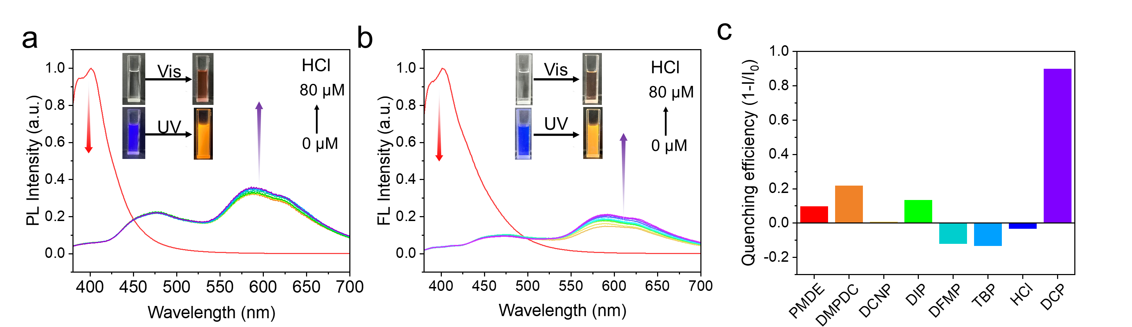
Supplementary Fig. 14 Fluorescence spectra of DTE-3PCz (a) and DTE-3NCz (b) (1.0×10⁻⁵ M in DCM) upon addition of HCl. c The quenching efficiency of DTE-3NCz (1.0×10⁻⁵ M in DCM) under UV light irradiation after addition of 10 equiv. of DCP, HCl, and other interfering substances.
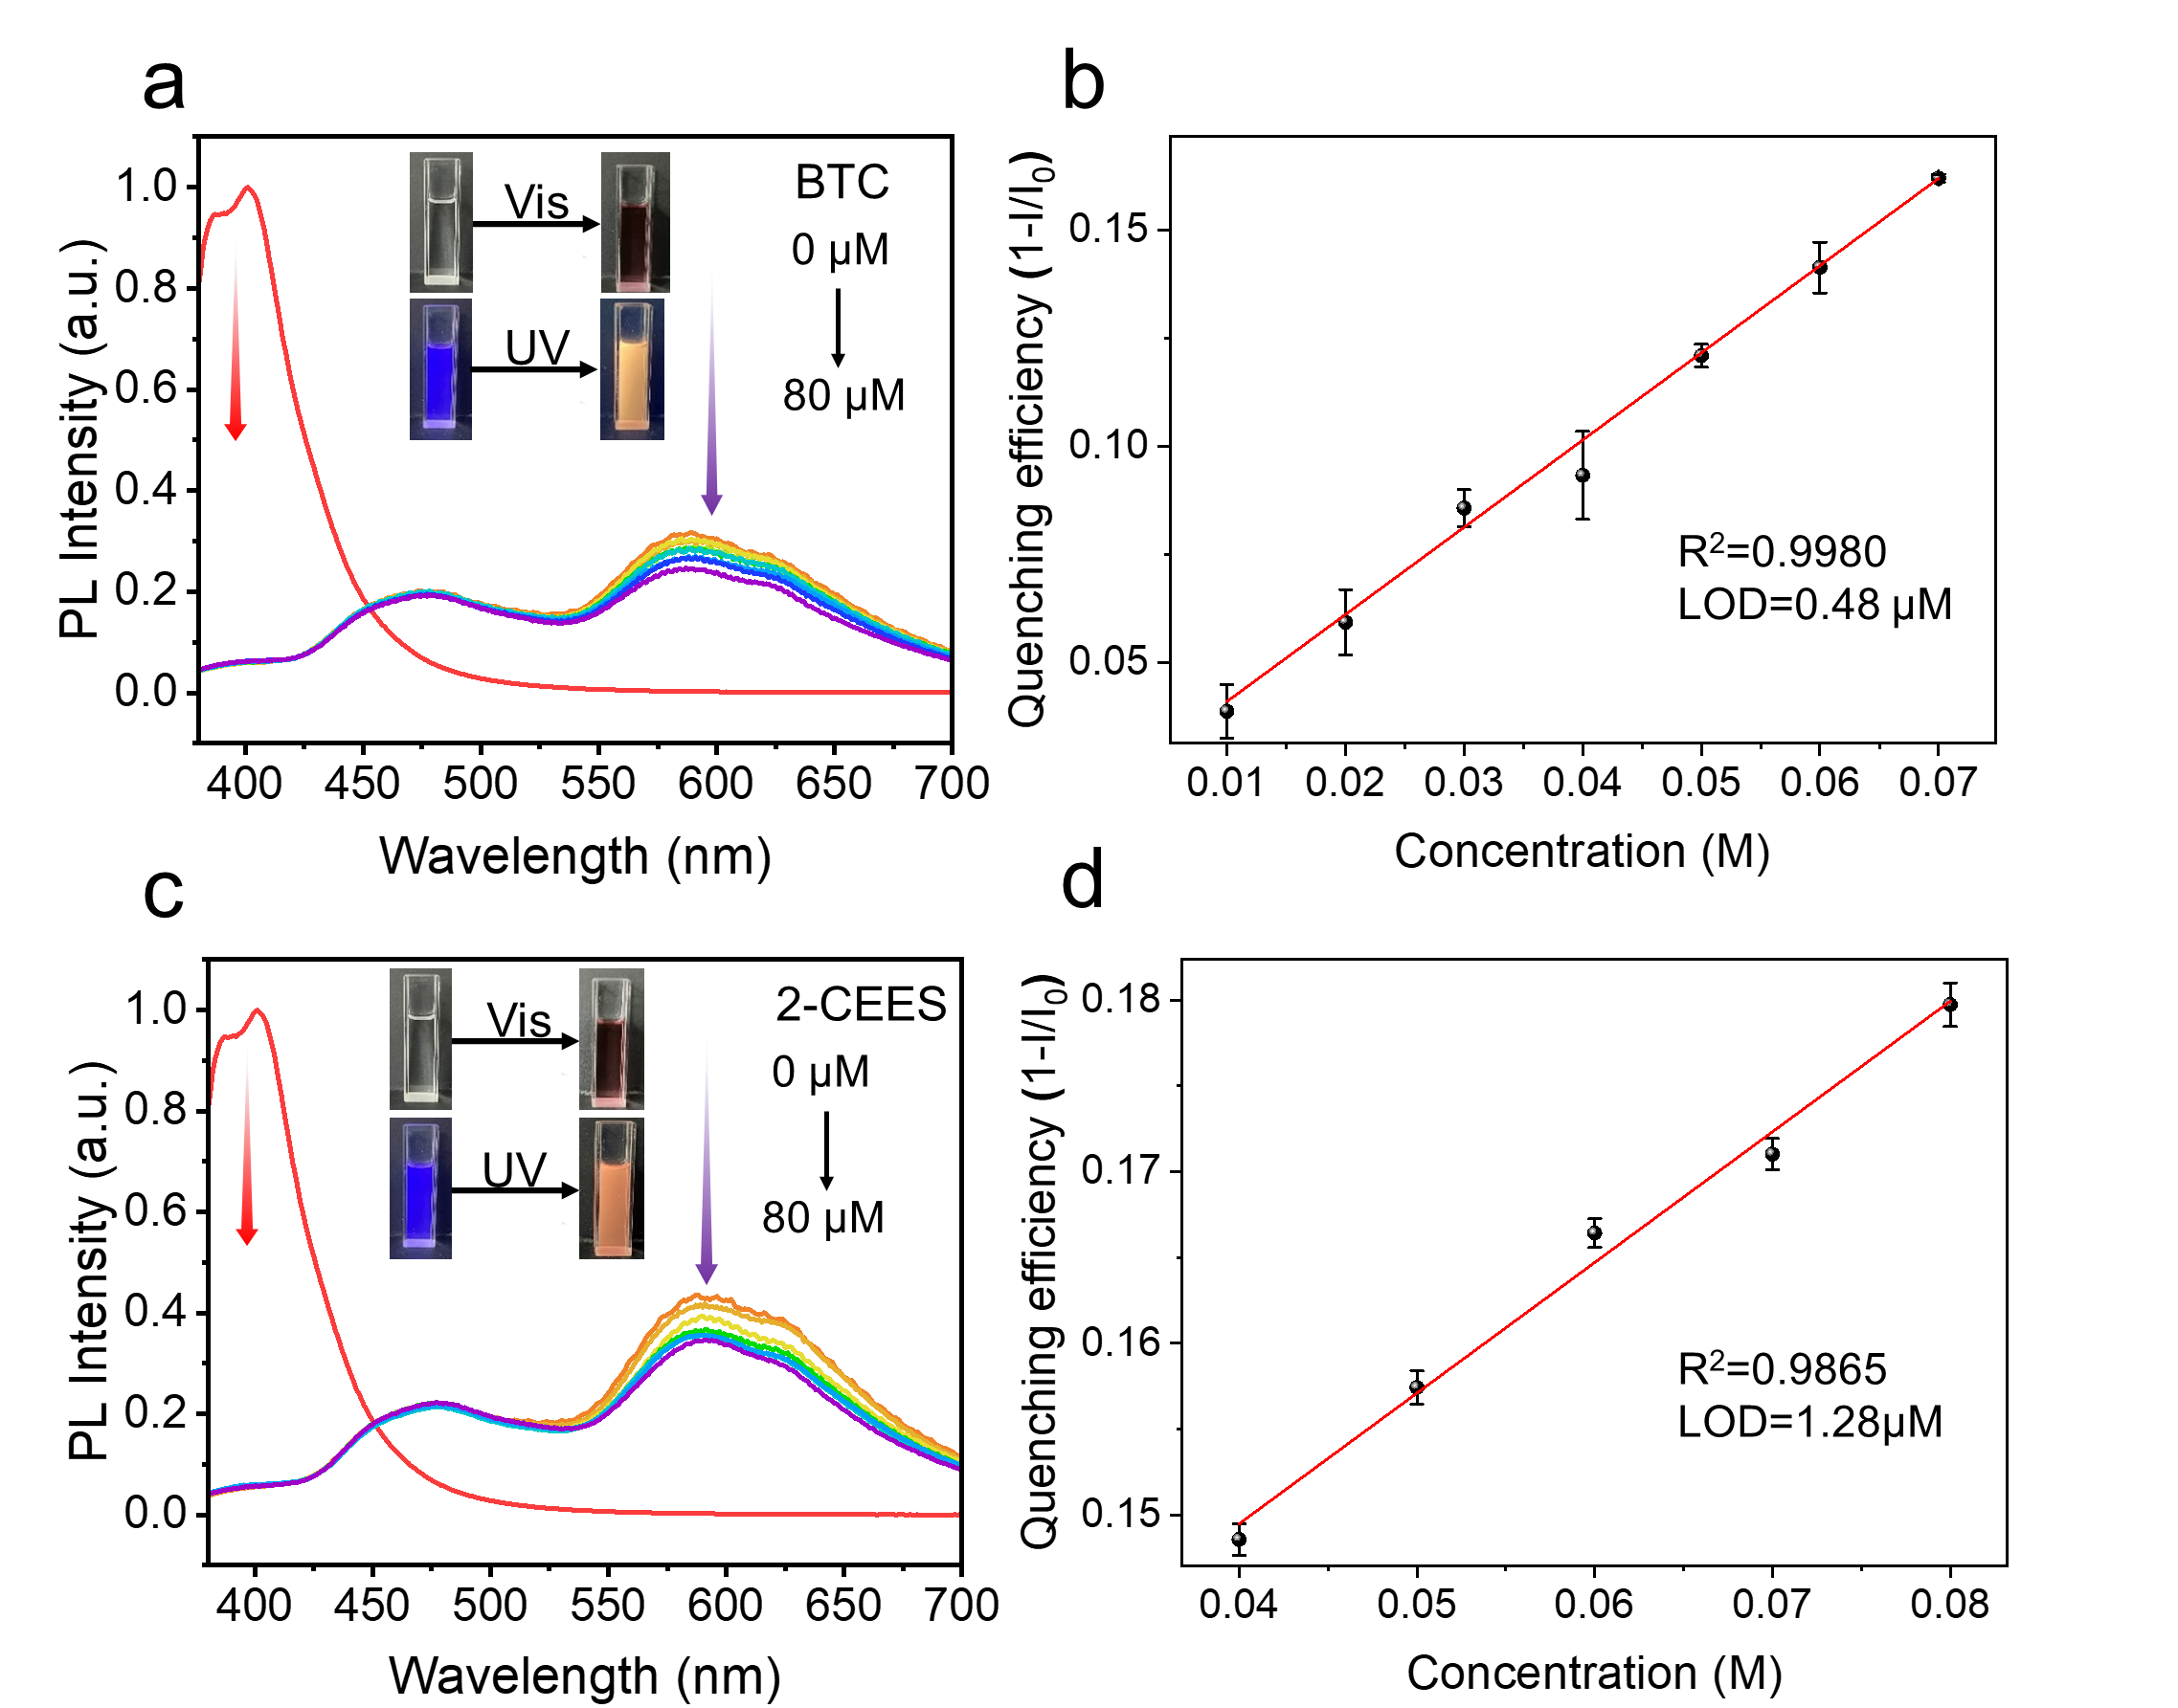
Supplementary Fig. 15 Fluorescence spectra of DTE-3PCz (1.0×10⁻⁵ M in DCM) upon addition of (a) BTC, (c) 2-CEES. Linear relationship between quenching efficiency of DTE-3PCz solution upon addition of (b) BTC, (d) 2-CEES. Error bars stand for standard deviation.
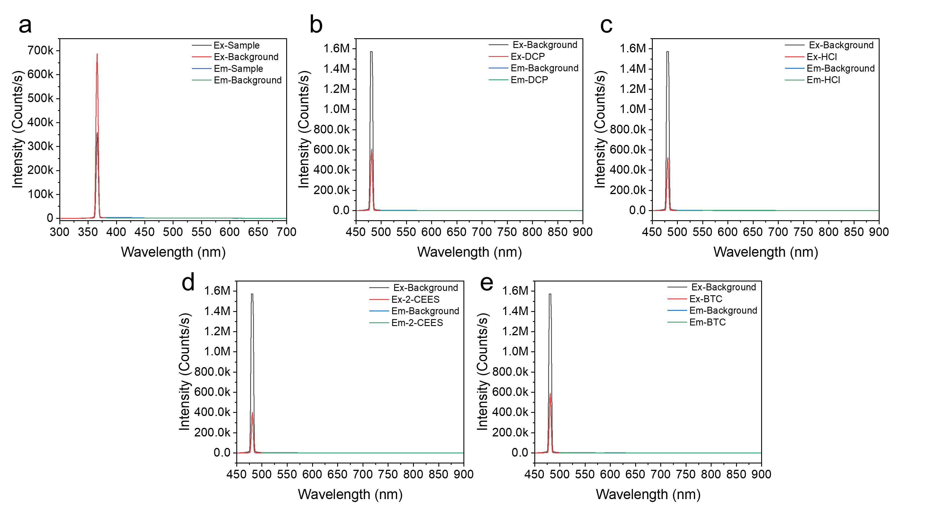
Supplementary Fig. 16 The photoluminescence quantum yield (PLQY) of DTE-3PCz (1.0×10⁻⁵ M) in (a) original, (b) DCP, (c) HCl, (d) 2-CEES and (e) BTC DCM solution.

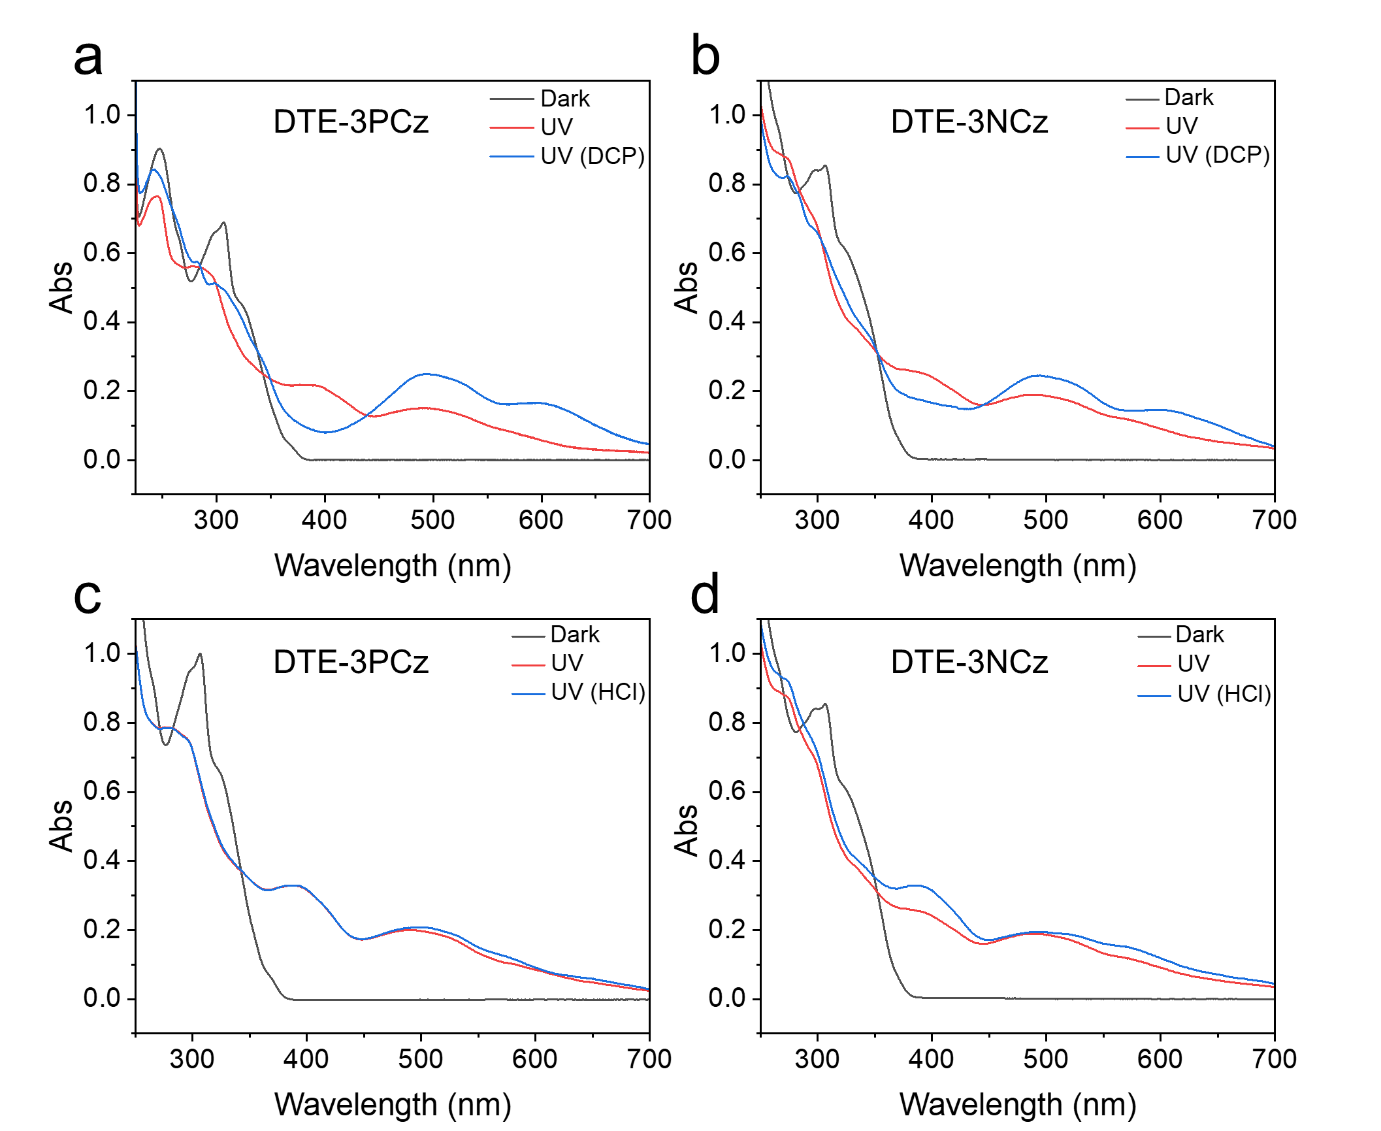
Supplementary Fig. 17 UV-vis spectra of DTE-3PCz and DTE-3NCz (1.0×10⁻⁵ M in DCM) upon addition of DCP (a, b), HCl (c, d).
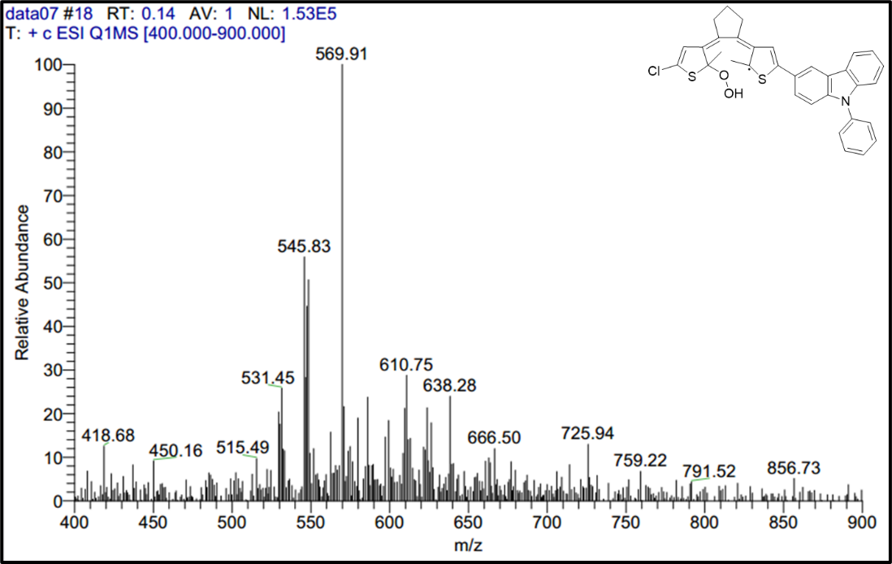
Supplementary Fig. 18 Liquid chromatography-mass spectrometry of DTE-3PCz (HCl) radical.
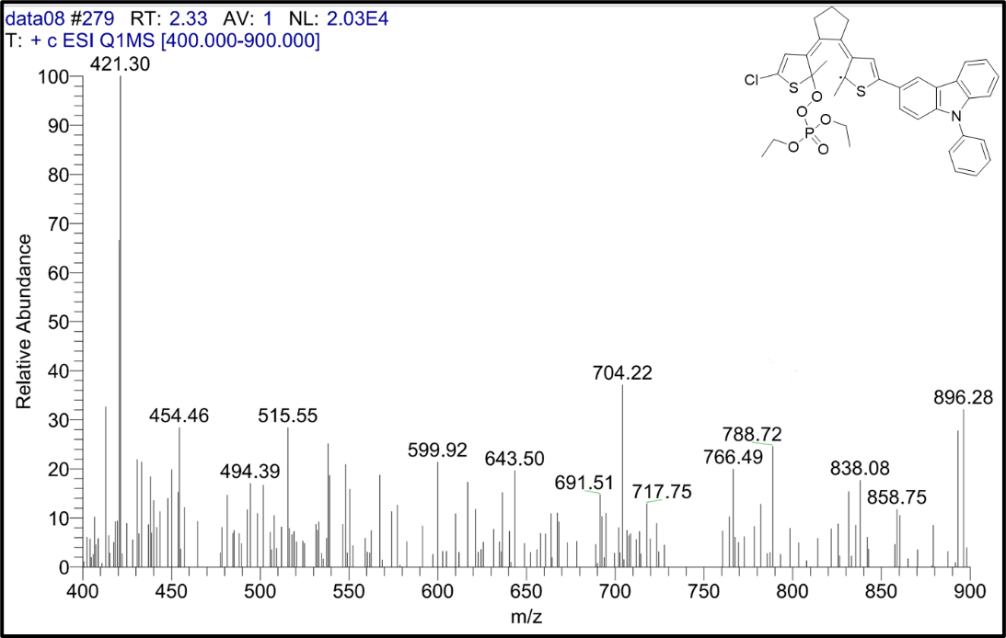
Supplementary Fig. 19 Liquid chromatography-mass spectrometry of DTE-3PCz (DCP) radical.
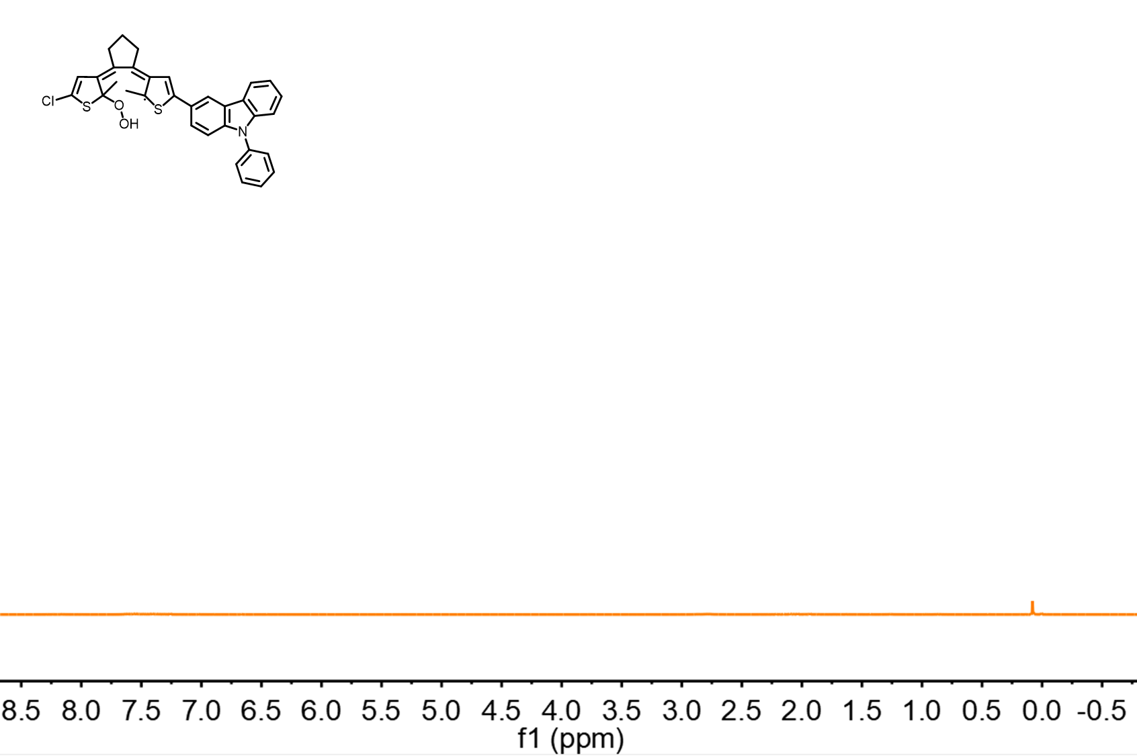
Supplementary Fig. 20 ¹H NMR of DTE-3PCz in CDCl₃ solution under UV irradiation after addition of 10 equiv. of HCl.
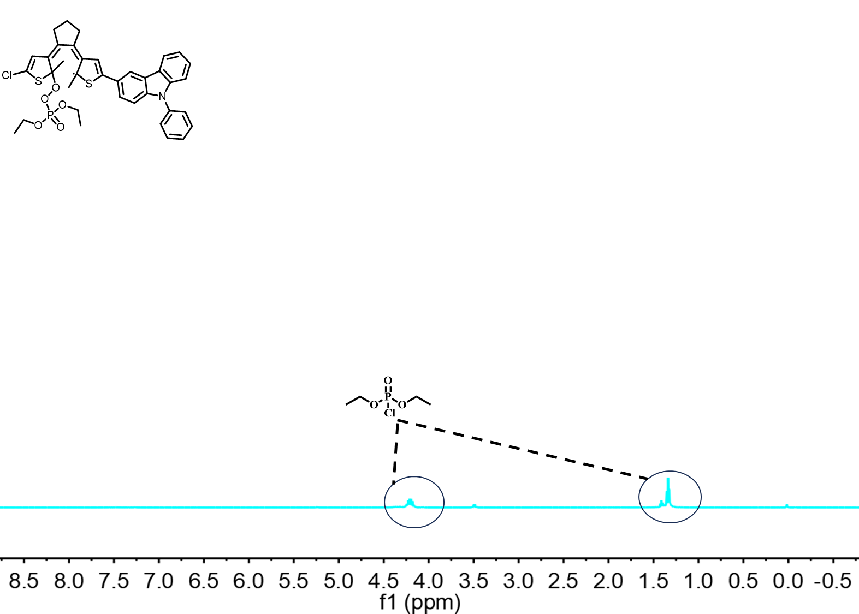
Supplementary Fig. 21 ¹H NMR of DTE-3PCz in CDCl₃ solution under UV irradiation after addition of 10 equiv. of DCP.
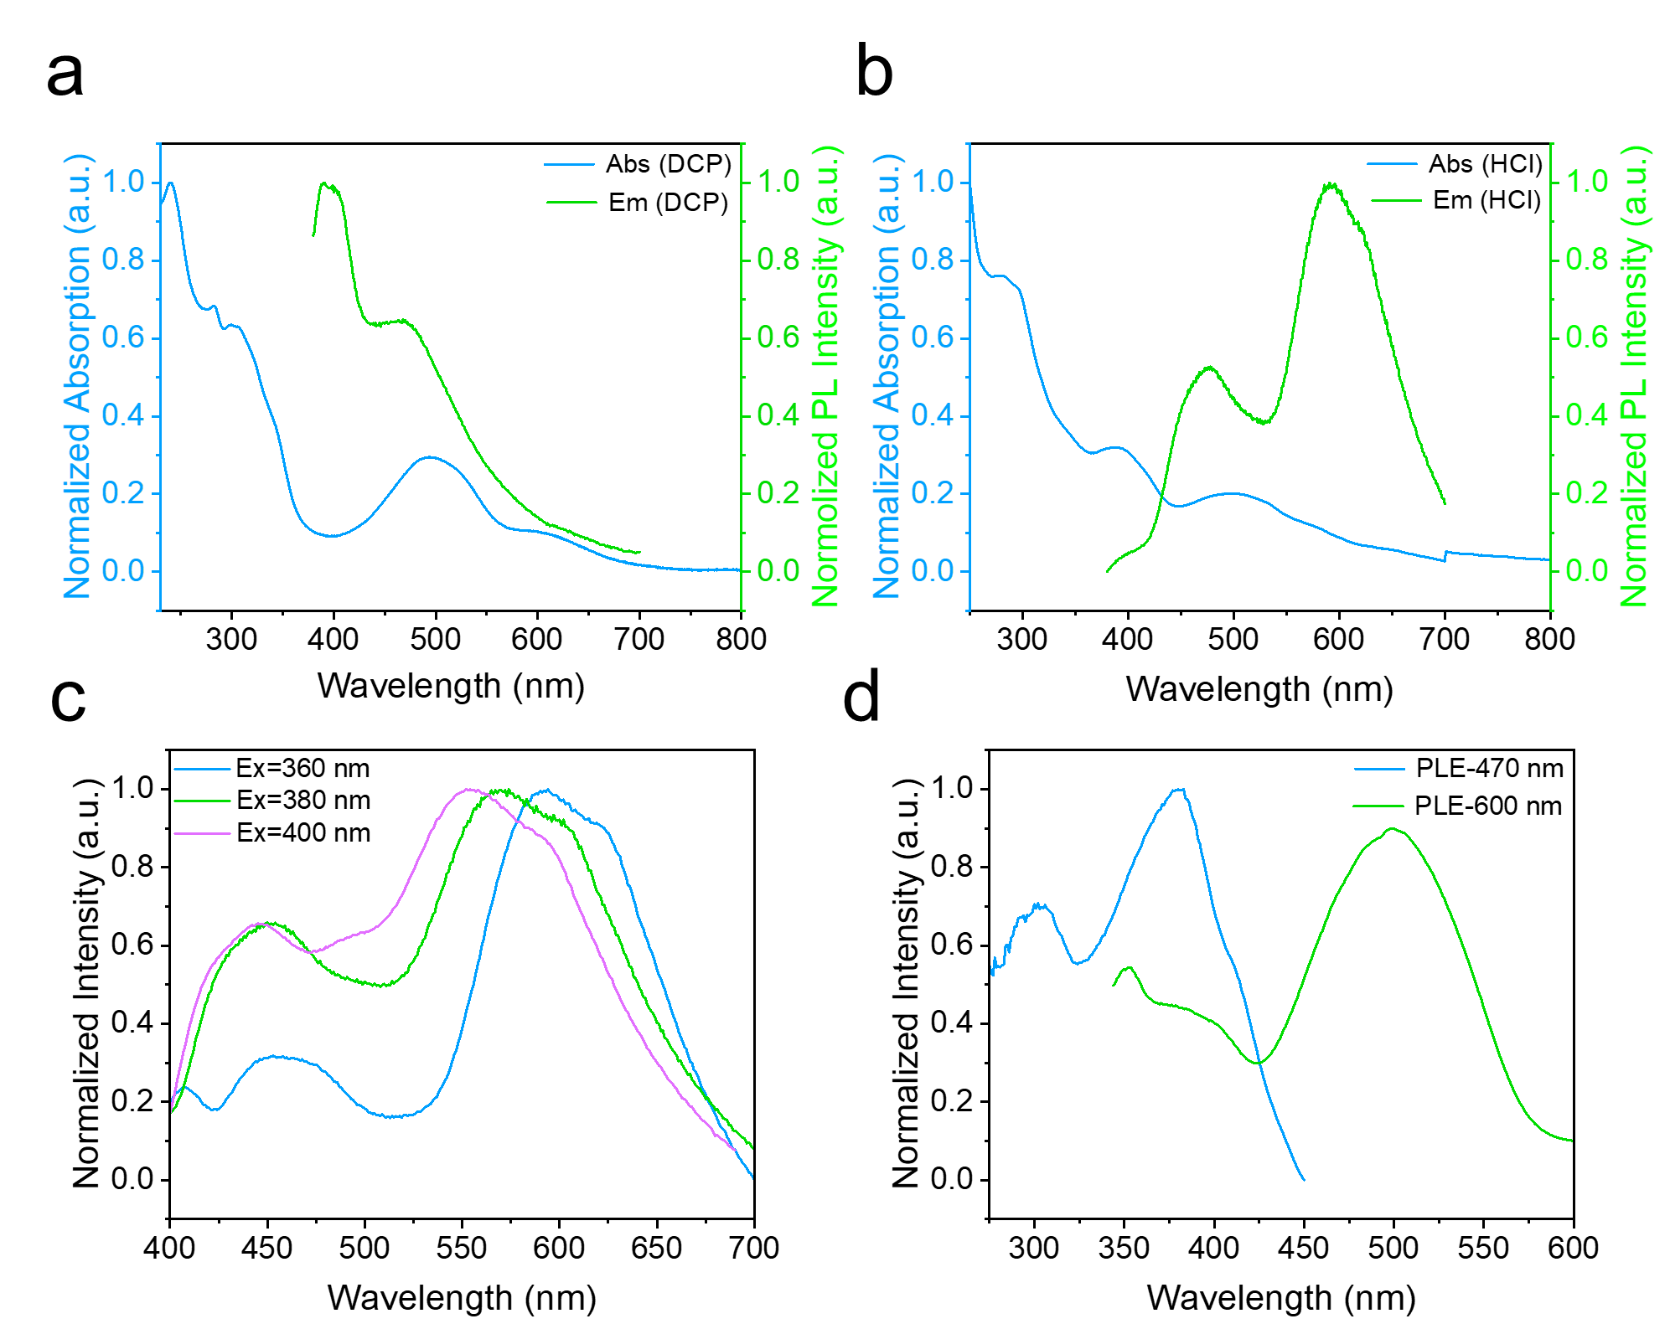
Supplementary Fig. 22 Normalized absorption (blue line) and PL spectra (green line) of DTE-3PCz (1.0×10⁻⁵ M in DCM) upon addition of DCP (a) and HCl (b). Normalized PL spectra of DTE-3PCz (c) at different excitation wavelengths and normalized excitation spectra of DTE-3PCz (d) at different emission wavelengths.
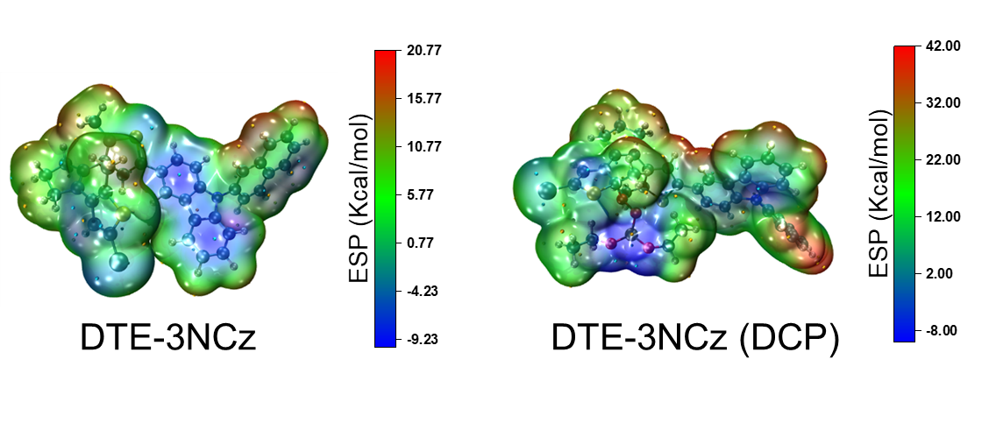
Supplementary Fig. 23 ESP plots of DTE-3NCz before and after addition of DCP.
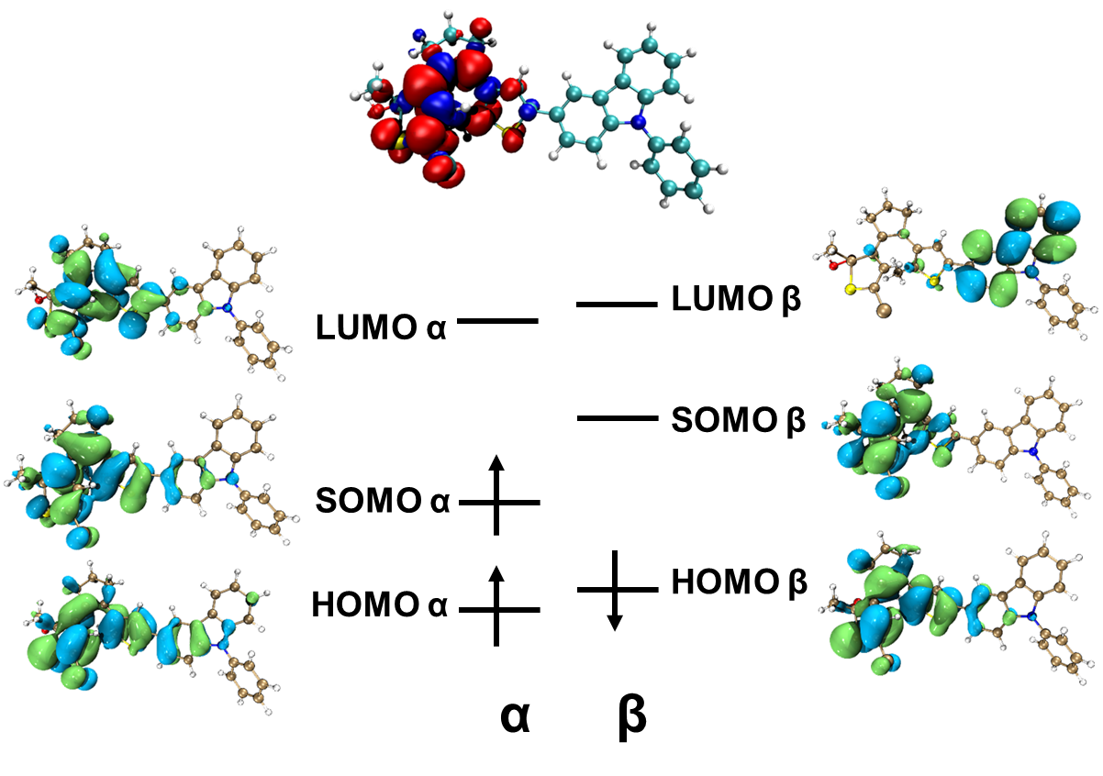
Supplementary Fig. 24 Electronic spin density distributions (up), electronic density distributions of the frontier molecular orbitals (down) of DTE-3PCz radical (HCl) calculated at the theoretical level of uM062X/6-31 g(d, p).
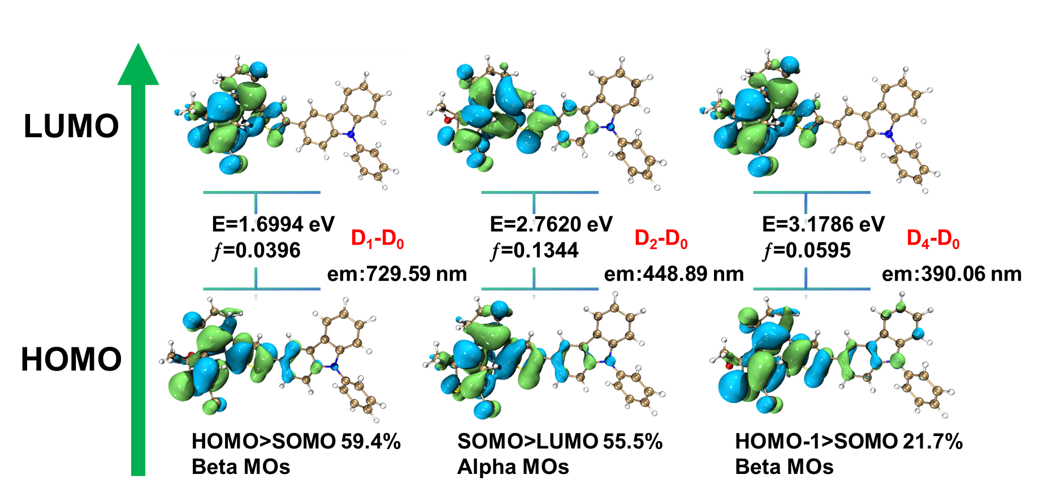
Supplementary Fig. 25 Orbital transitions and electron-hole distribution corresponding to the DTE-3PCz radical (HCl).
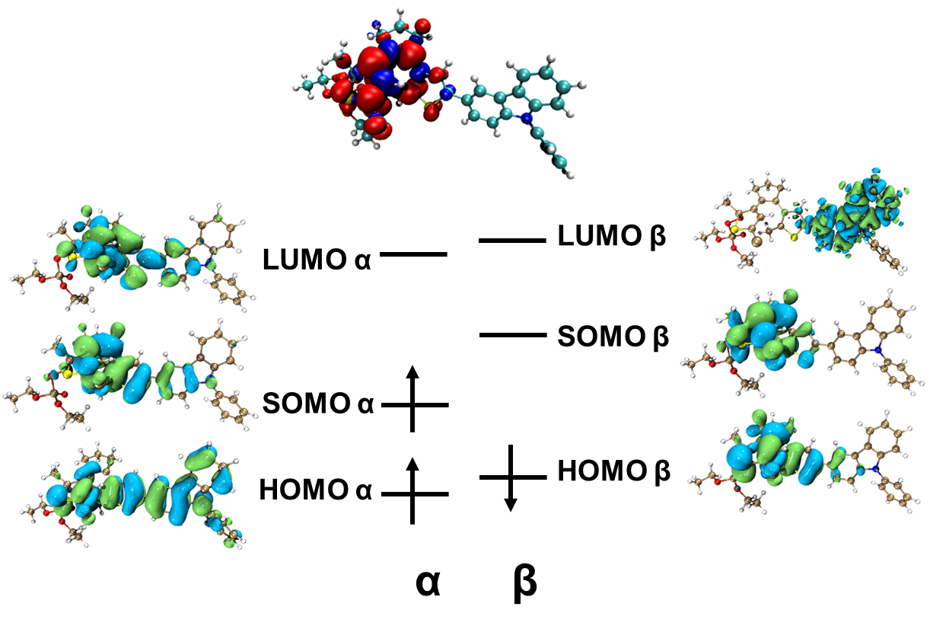
Supplementary Fig. 26 Electronic spin density distributions (up), electronic density distributions of the frontier molecular orbitals (down) of DTE-3PCz radical (DCP) calculated at the theoretical level of uM062X/6-31 g(d, p).
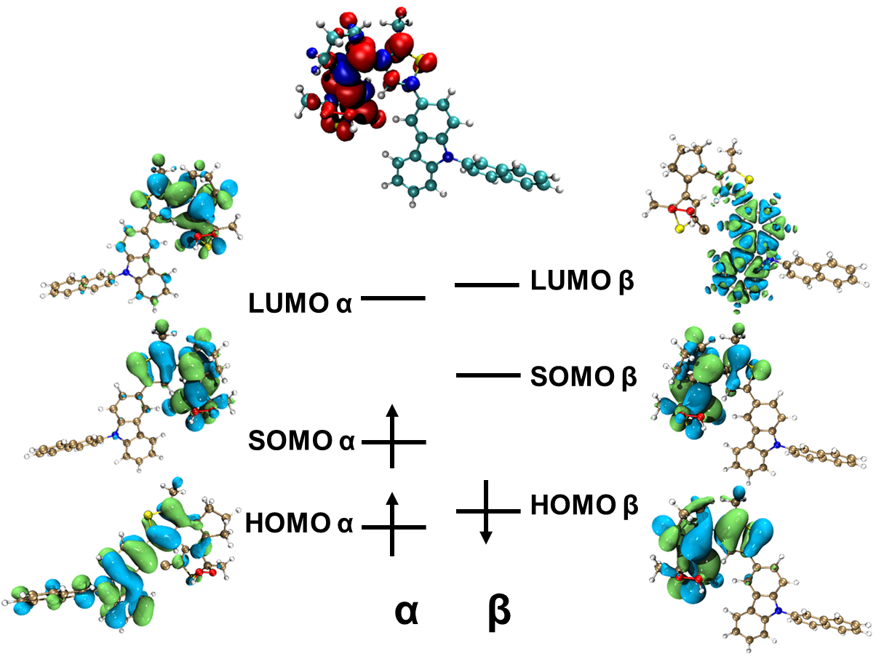
Supplementary Fig. 27 Electronic spin density distributions (up), electronic density distributions of the frontier molecular orbitals (down) of DTE-3NCz radical (HCl) calculated at the theoretical level of uM062X/6-31 g(d, p).
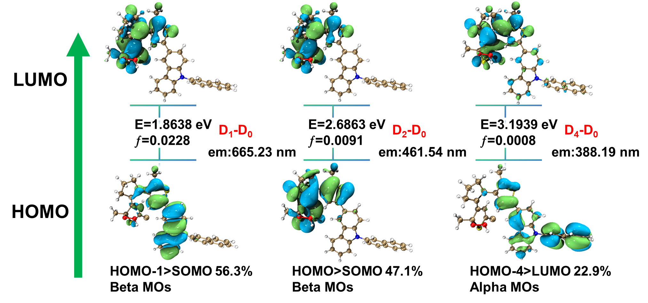
Supplementary Fig. 28 Orbital transitions and electron-hole distribution corresponding to the DTE-3NCz radical (HCl).

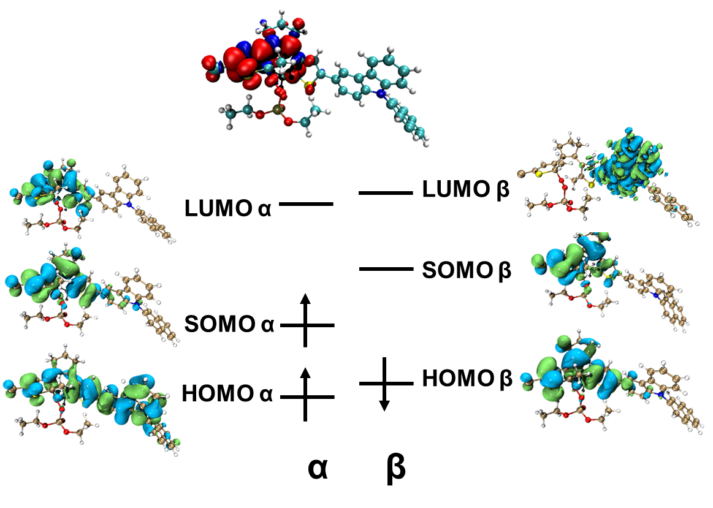
Supplementary Fig. 29 Electronic spin density distributions (up), electronic density distributions of the frontier molecular orbitals (down) of DTE-3NCz radical (DCP) calculated at the theoretical level of uM062X/6-31 g(d, p).
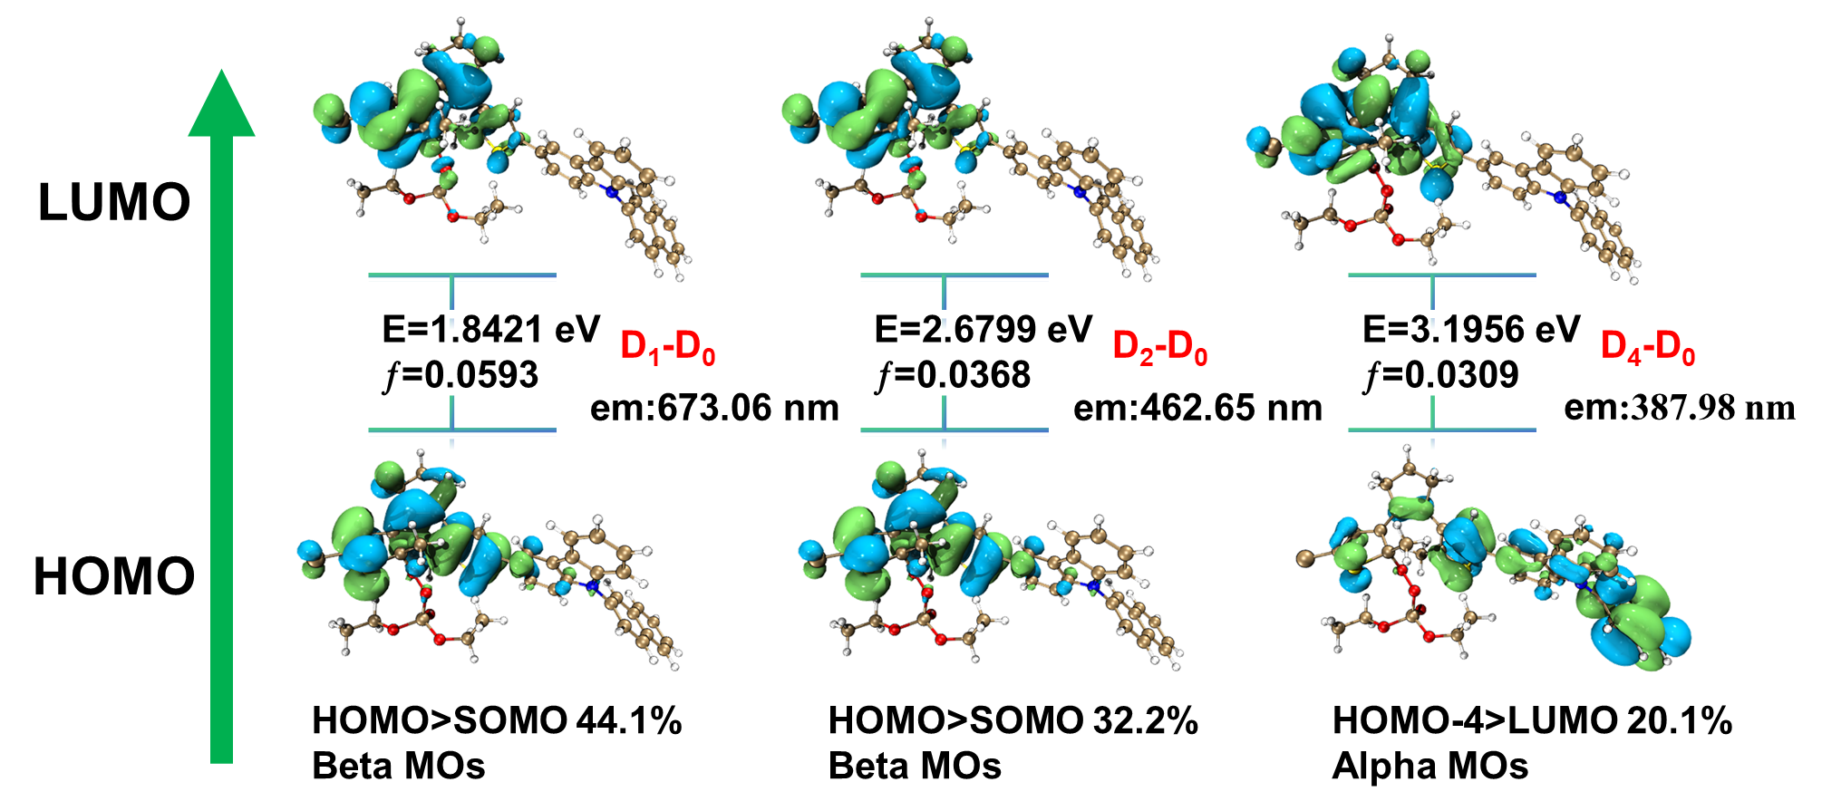
Supplementary Fig. 30 Orbital transitions and electron-hole distribution corresponding to the DTE-3NCz radical (DCP).
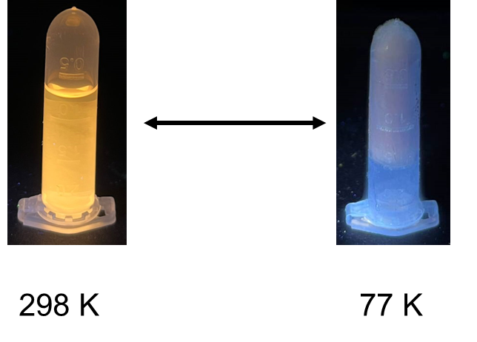
Supplementary Fig. 31 The photographs of DTE-3PCz (1.0×10⁻⁵ M in DCM) placed at 298 K and 77 K.
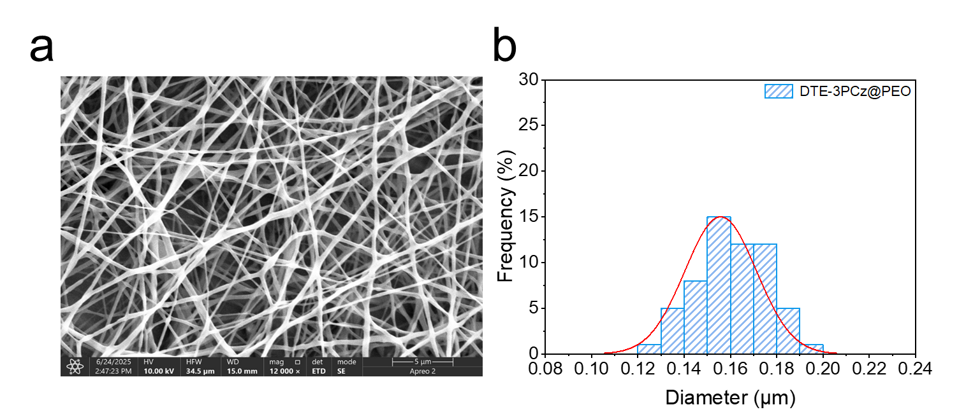
Supplementary Fig. 32 Scanning electron microscope image of DTE-3PCz film.
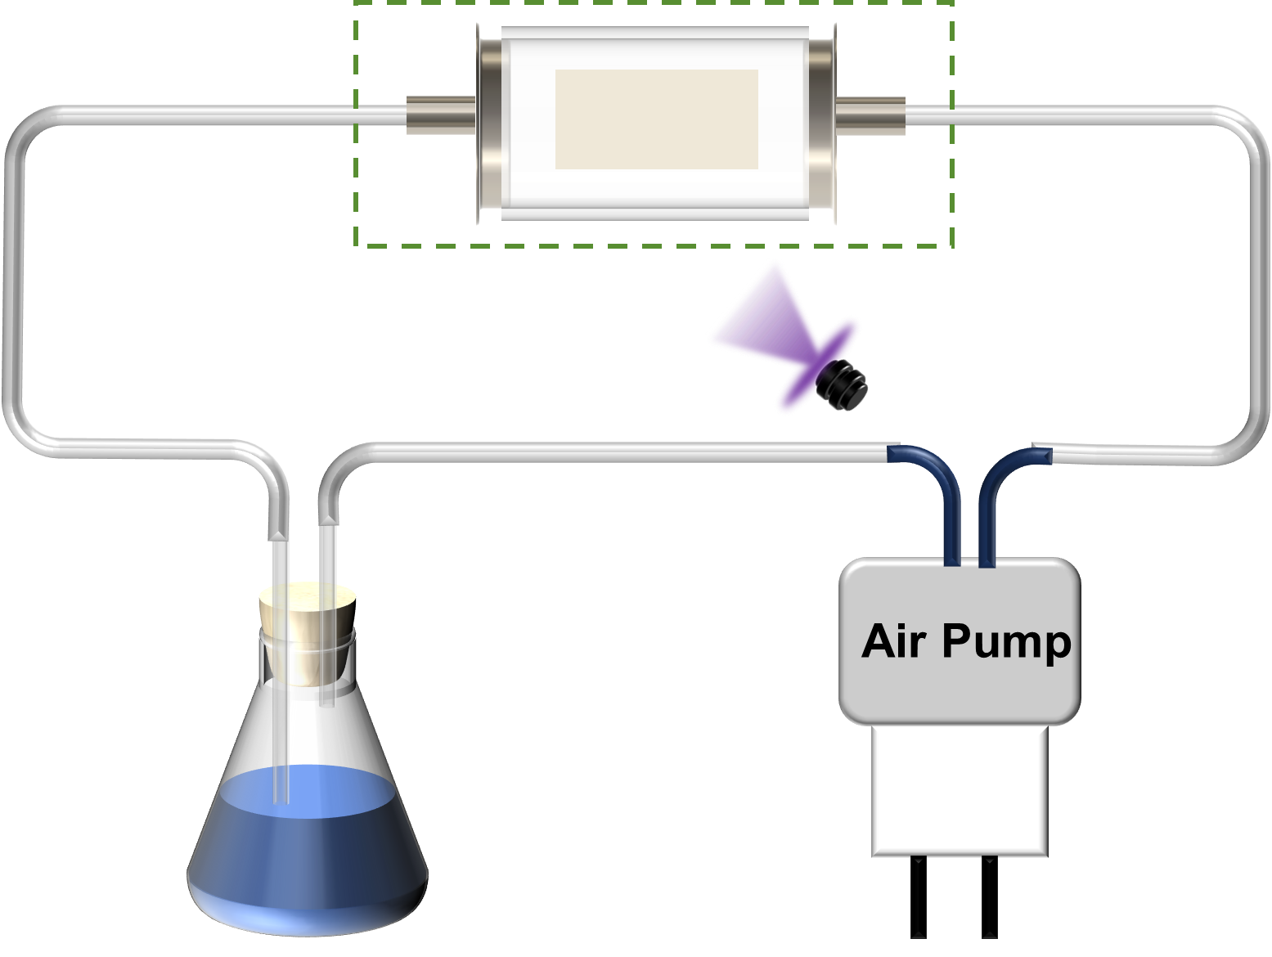
Supplementary Fig. 33 Schematic diagram of the adsorption testing system for DTE-3PCz films. The section enclosed by dashed lines can be removed for weighing.

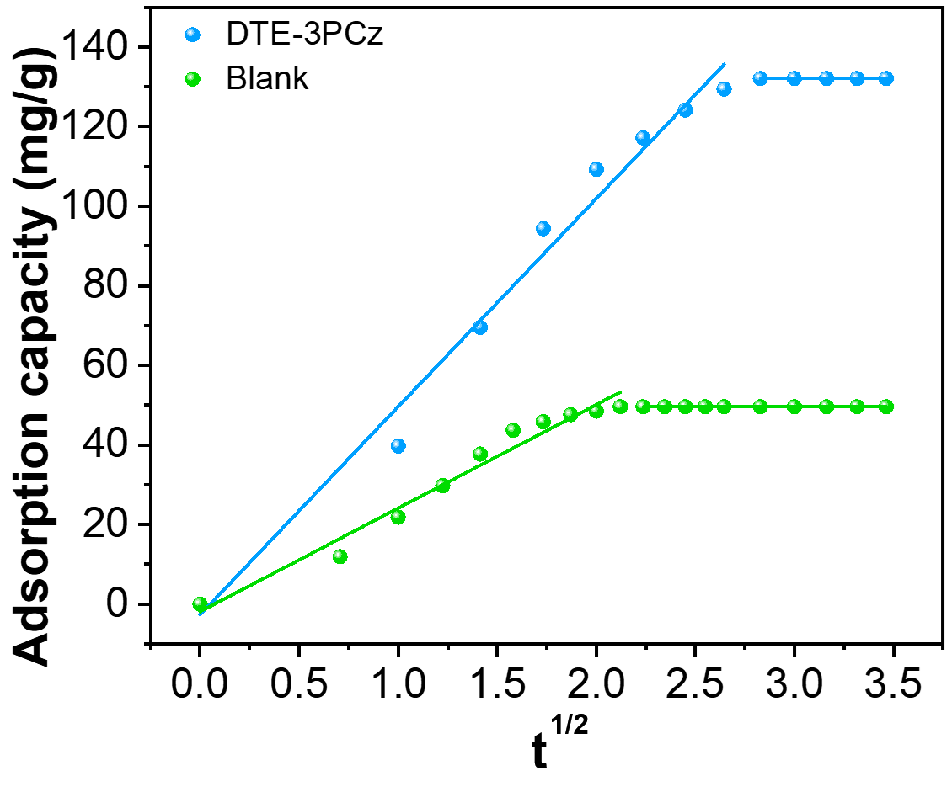
Supplementary Fig. 34 Particle diffusion model.
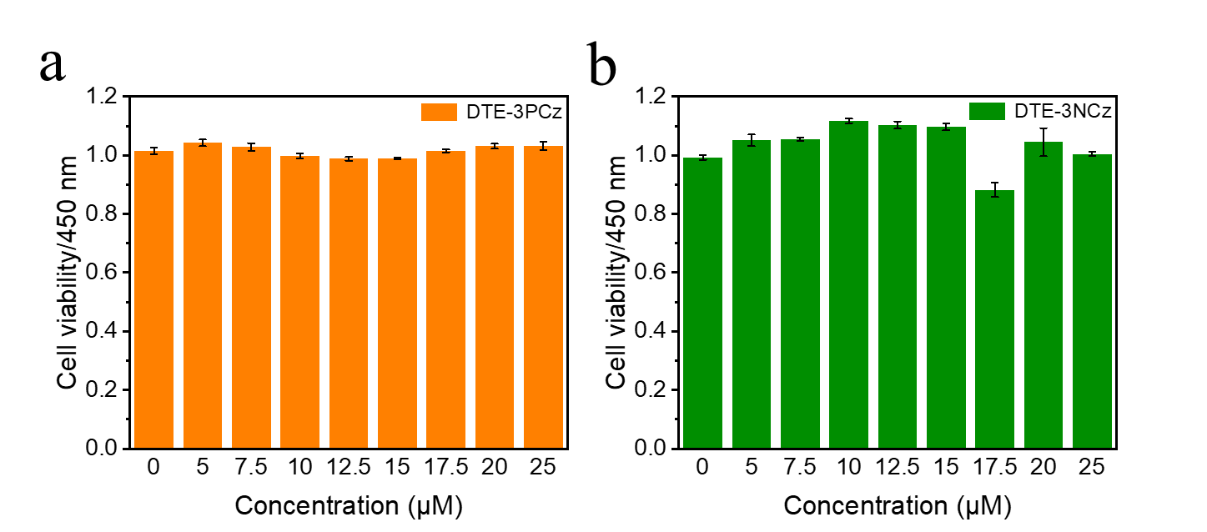
Supplementary Fig. 35 Cell viability by WST-8 method.

Supplementary Tables
Supplementary Table 1 Luminescence performance data of DTE-3PCz (1.0×10⁻⁵ M) in original, DCP, HCl, 2-CEES and BTC DCM (1.0×10⁻⁵ M) solution.
 | λ_{ex} (nm) | λ_{em (max)} (nm) | Φ_{PL} (%)
DTE-3PCz | 365 | 400 | 6.92
DTE-3PCz (HCl) | 365 | 621 | 3.89
DTE-3PCz (BTC) | 365 | 619 | 1.4
DTE-3PCz (2-CEES) | 365 | 600 | 0.38
DTE-3PCz (DCP) | 365 | 465 | 0.04
Supplementary Table 2 Calculated wavelength (λ) and oscillator strength (ƒ) for absorption of DTE-3PCz (HCl) radical with uM062X functional at the basis set level of 6-31 g(d, p).
Excited state | E (eV) | λ (nm) | ƒ
1 | 2.3143 | 535.75 | 0.0385
2 | 3.1709 | 391.01 | 0.1348
3 | 3.1836 | 389.45 | 0.0152
4 | 3.4332 | 361.14 | 0.1158

Supplementary Table 3 Calculated wavelength (λ) and oscillator strength (ƒ) for absorption of DTE-3PCz (DCP) radical with uM062X functional at the basis set level of 6-31 g(d, p).
Excited state | E (eV) | λ (nm) | ƒ
1 | 2.2938 | 540.52 | 0.0420
2 | 3.0962 | 400.44 | 0.0153
3 | 3.2003 | 387.41 | 0.0405
4 | 3.4094 | 363.66 | 0.0970

