Supplementary File-1

Supplementary Table 1. Public ALS RNA-seq datasets used in this study.
GEO Series | PRJNA | Total samples | ALS (n) | Control (n) | Tissue region(s) | Reference
GSE124439 | PRJNA512012 | 176 | 148 | 28 | Multiple cortical tissue regions | Tam et al., Cell Reports (2019)
GSE201407 | PRJNA831563 | 24 | 12 | 12 | Primary motor cortex | Sommer et al., Front. Mol. Neurosci. (2022)
GSE277709 | PRJNA1163403 | 84 | 42 | 42 | Whole blood | Kõks et al., (2025)

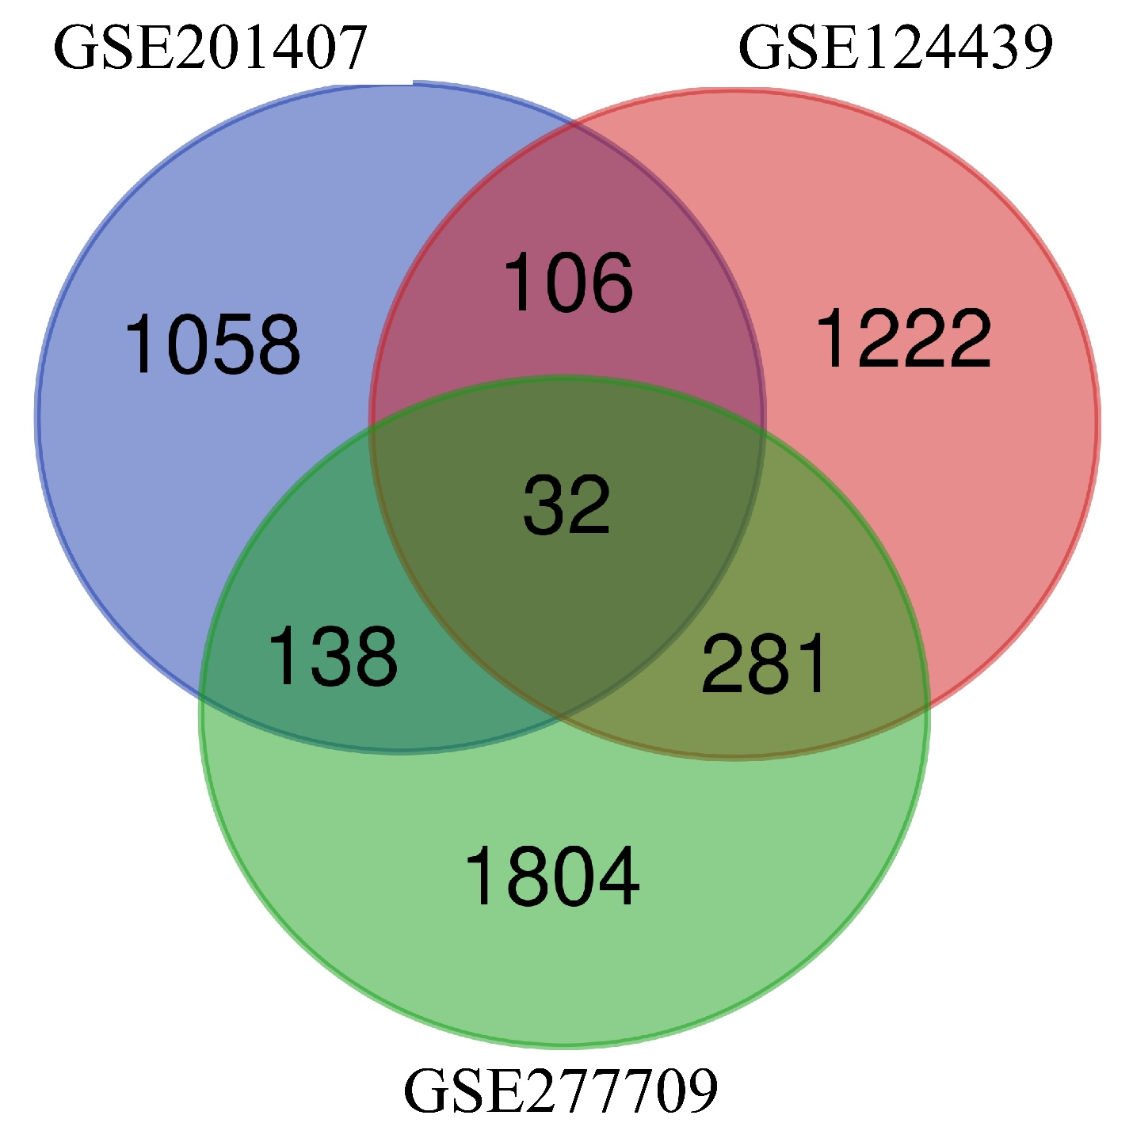
Figure S1. Venn diagram showing the overlap of differentially expressed genes (DEGs) identified across the three ALS RNA-seq datasets (GSE201407, GSE124439, and GSE277709). A total of 32 DEGs were consistently shared among all three datasets.

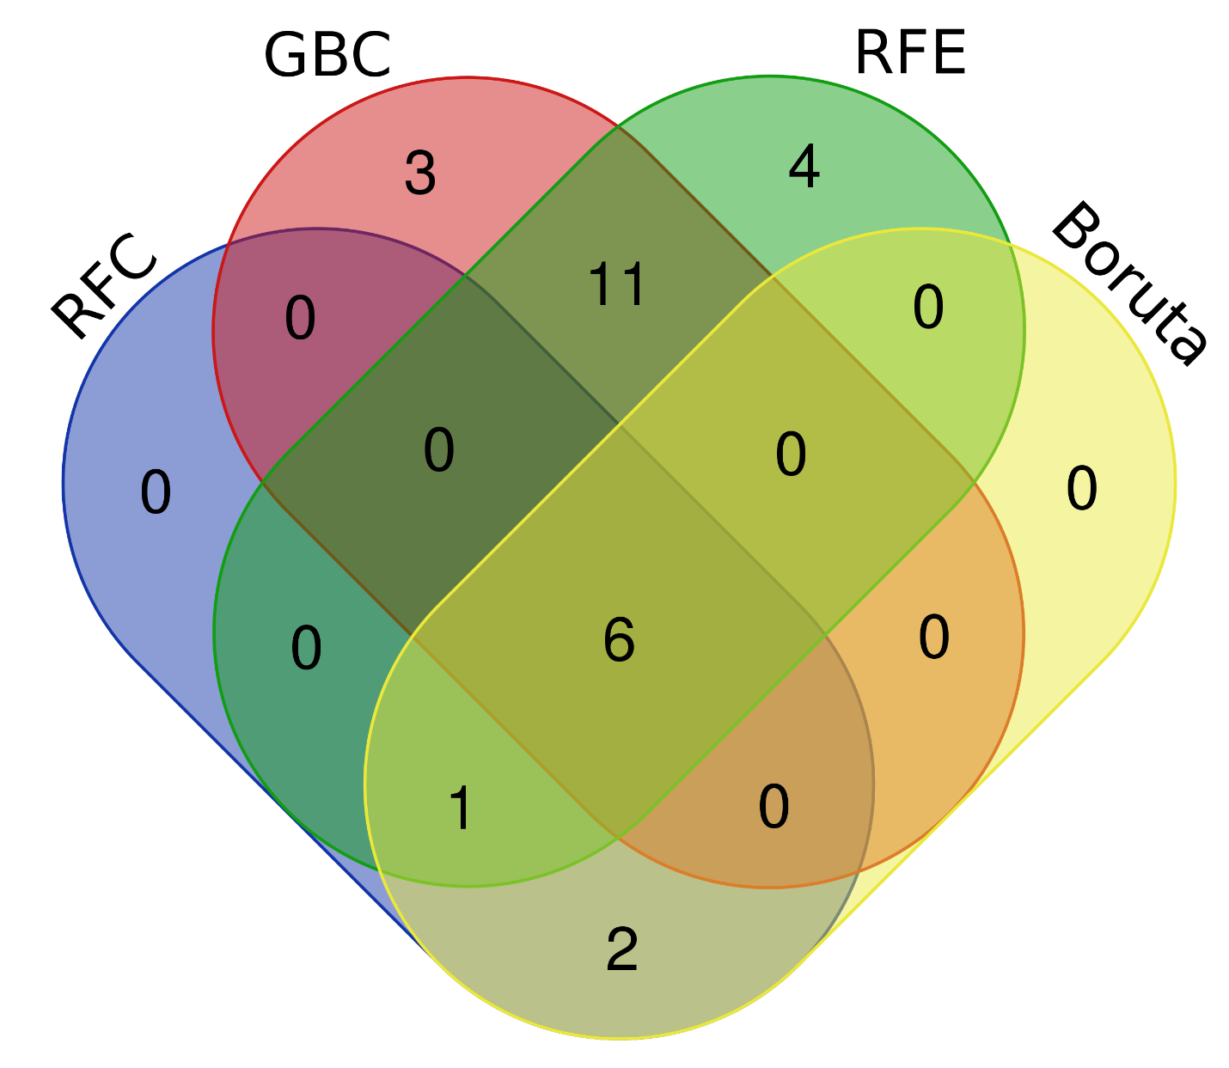
Figure S2. Venn diagram illustrating the overlap of gene features selected by four independent feature selection methods: Random Forest (RFC), Gradient Boosting Classifier (GBC), Recursive Feature Elimination (RFE), and Boruta, for ALS versus control classification. A total of six genes were consistently selected across methods.

