Supplementary Table S1. In silico characteristics of the COL4A1 variant identified in the index patient.
Parameter | Result / Score | Interpretation
Variant | c.3662C>T (p.Pro1221Leu) | Missense variant
ClinVar | Uncertain Significance | No established pathogenic classification
Population frequency (gnomAD) | 0.007% (Ultra-rare) | Extremely rare
Conservation (phyloP100) | 2.108 | Evolutionarily conserved residue
CADD Score | 23.5 | High predicted deleteriousness
Inheritance | De Novo | Absent in unaffected family members.
Expression Data | High in Arteries | High expression in vascular system
Abbreviations: CADD: Combined Annotation Dependent Depletion; gnomAD: Genome Aggregation Database; NA: Not Applicable.
Note: Predicted deleteriousness was evaluated using CADD (v1.6). Conservation scores represent phyloP 100-way vertebrate alignment.

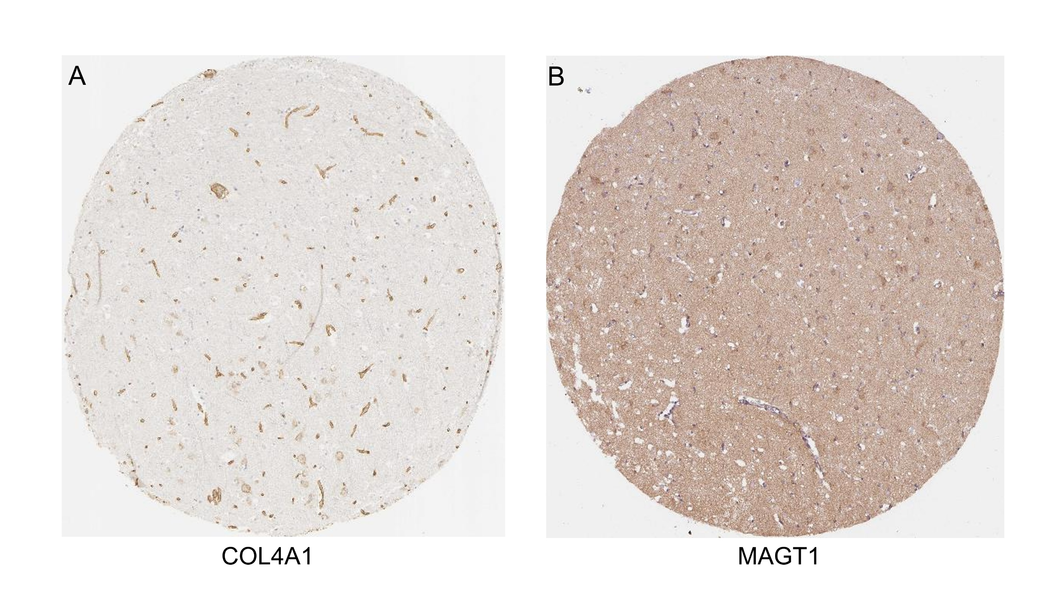
Supplementary Figure S1. Expression patterns of COL4A1 and MAGT1 in human brain tissue.
Representative immunohistochemistry images from the Human Protein Atlas illustrating (A) COL4A1 localization predominantly associated with vascular and basement membrane structures in cerebral microvessels, and (B) widespread MAGT1 expression in the human cerebral cortex. Images are provided for contextual support of the proposed glycosylation–matrix vulnerability axis and do not imply variant-specific or disease-specific pathology. Images reproduced from the Human Protein Atlas (https://www.proteinatlas.org) under the Creative Commons Attribution-ShareAlike 4.0 International License (CC BY-SA 4.0).

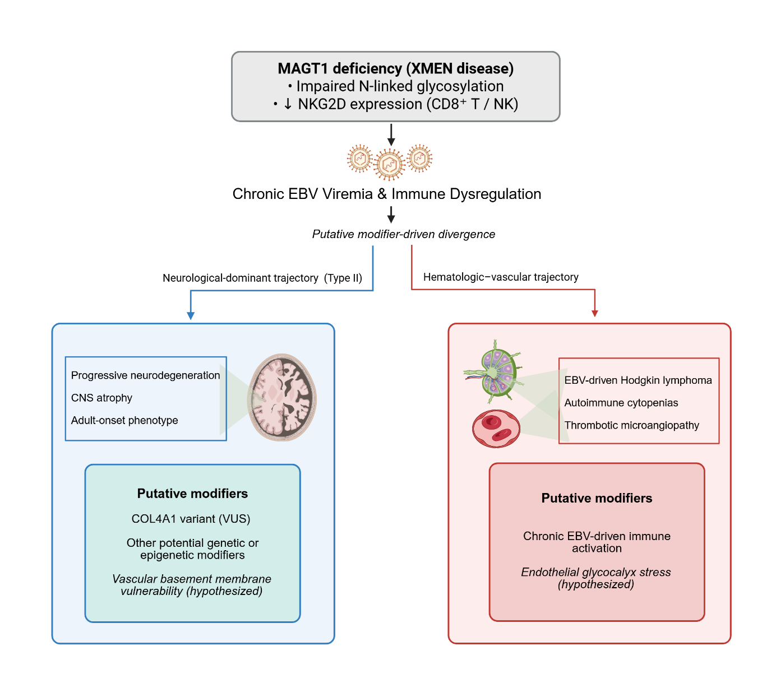
Supplementary Figure S2. Conceptual model of modifier-sensitive, organ-dominant disease trajectories in XMEN disease
This diagram illustrates a conceptual model in which a shared MAGT1 deficiency and chronic EBV viremia give rise to modifier-sensitive, organ-dominant clinical trajectories in XMEN disease. The neurological-dominant trajectory (Type II, left panel) is characterized by progressive neurodegeneration and CNS atrophy and may be influenced by putative genetic and vascular modifiers, including a COL4A1 variant. In contrast, the hematologic–vascular trajectory (right panel) is associated with EBV-driven lymphoproliferation, autoimmune cytopenias, and thrombotic microangiopathy, potentially modulated by chronic immune activation and endothelial stress. Figure created with BioRender.com.

