Figure S1
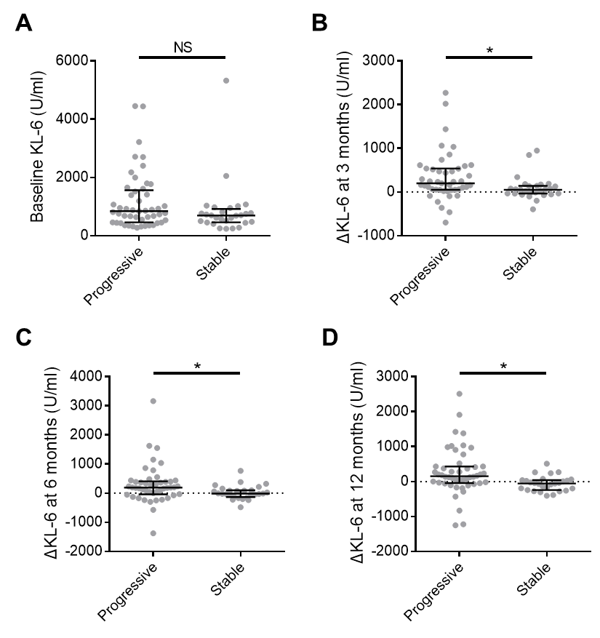
KL-6 at baseline and ΔKL-6 at 3, 6, and 12 months between progressive and stable ILD. A Baseline KL-6; B ΔKL-6 at 3 months; C ΔKL-6 at 6 months; D ΔKL-6 at 12 months from baseline. Lines and scatter plots showing the medians with interquartile range. P values calculated by Mann-Whitney test. * p<0.05. Abbreviations: KL-6, Krebs von den Lungen-6; ΔKL-6, serial changes in KL-6; NS, Not significant

Figure S2
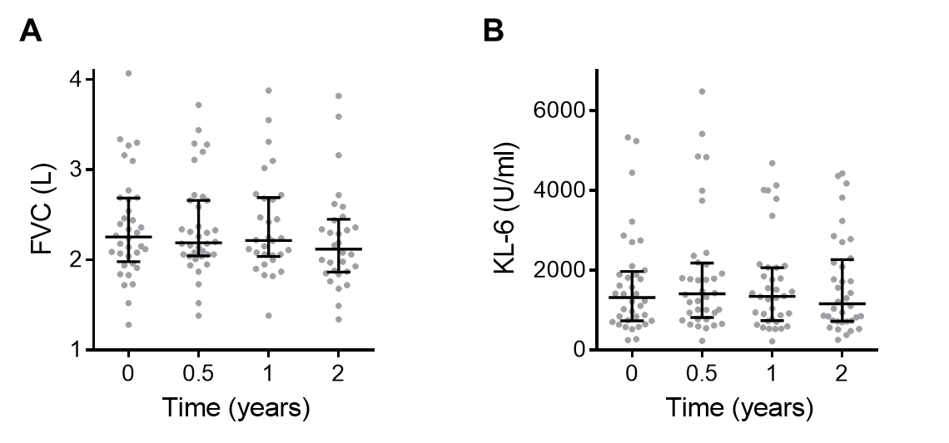
Trajectories of FVC and KL-6 after the intravenous cyclophosphamide pulse therapy. A FVC; B Serum KL-6 levels from baseline at 0.5, 1, and 2 years. Lines and scatter plots showing the median values with interquartile range. Abbreviations: FVC, forced vital capacity; KL-6, Krebs von den Lungen-6

