Supplemental Figures and Tables
Table S1. Metadata of all MRSN K. pneumoniae isolates in this study
Table S2. cgMLST pairwise allele distance matrix
Table S3. Metadata, assembly statistics, PlasmidFinder, and Kleborate results for each MRSN contig (n=168).
Table S4. Metadata, PlasmidFinder, and Kleborate results for each GenBank contig (n=7,347).
Table S5. Metadata, PlasmidFinder, and Kleborate results for each MRSN contig sample and each GenBank contig clustering with MRSN contigs (n=4,052).
Table S6. Antibiotic susceptibility testing, virulence in vivo and siderophore production for representative isolates of 25 convergent routes.
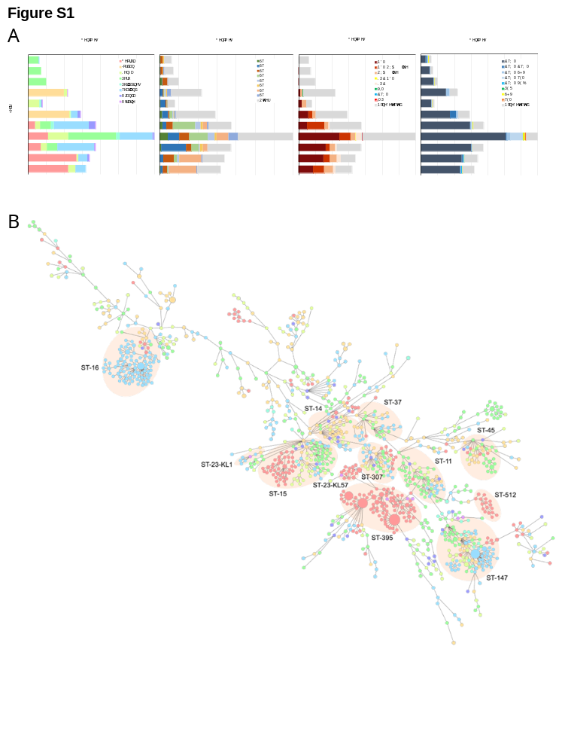
Figure S1. Population structure of all Klebsiella pneumoniae samples in this study. A) A Minimum Spanning Tree (MST) depicting pairwise allelic distances between all K. pneumoniae, colored by country of origin (n=1,468). High-risk sequence types (STs) are shaded in pink. B) Number of K. pneumoniae isolates belonging to each country, sequence type, carrying extended-spectrum beta-lactamases (ESBLs), and carrying carbapenemases, respectively, between years 2011-2021.
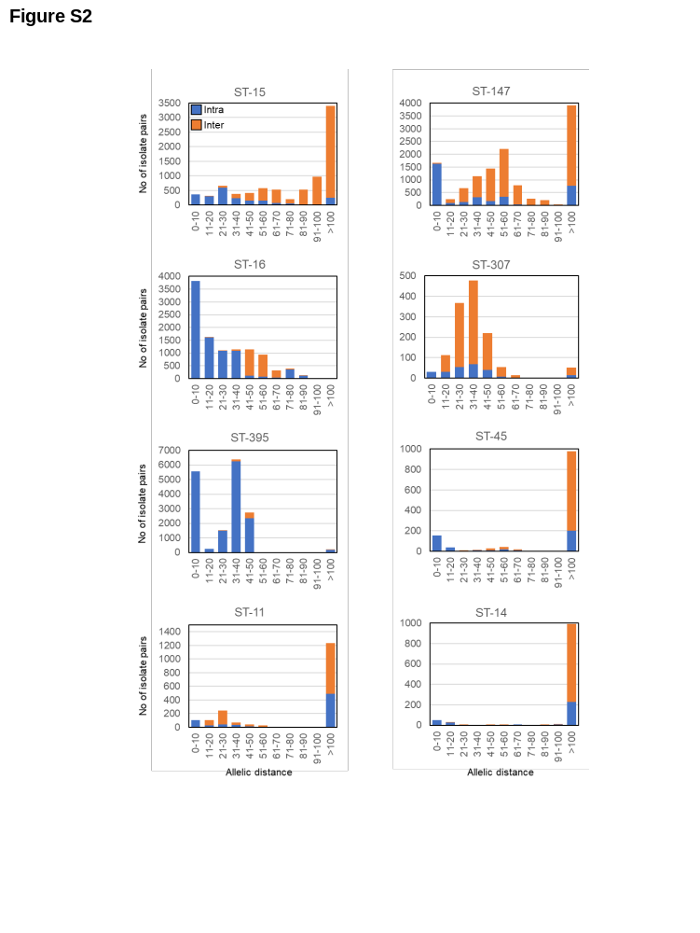
Figure S2. Pairwise allelic distances between isolates within the same country (intra, blue) and isolates across different countries (inter, orange) for each high-risk sequence type.
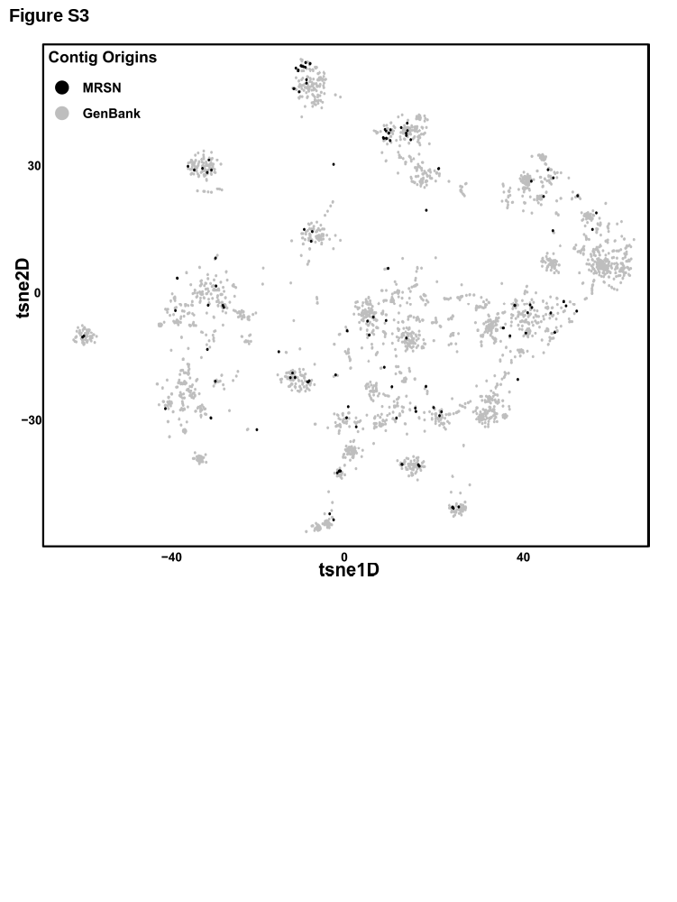Figure S3. MGE-cluster analysis. All plasmids included in cluster analysis. Plasmids colored in black (n=168) belong to samples from the MRSN, and plasmids colored in gray (n=7, 347) were extracted from public GenBank samples.
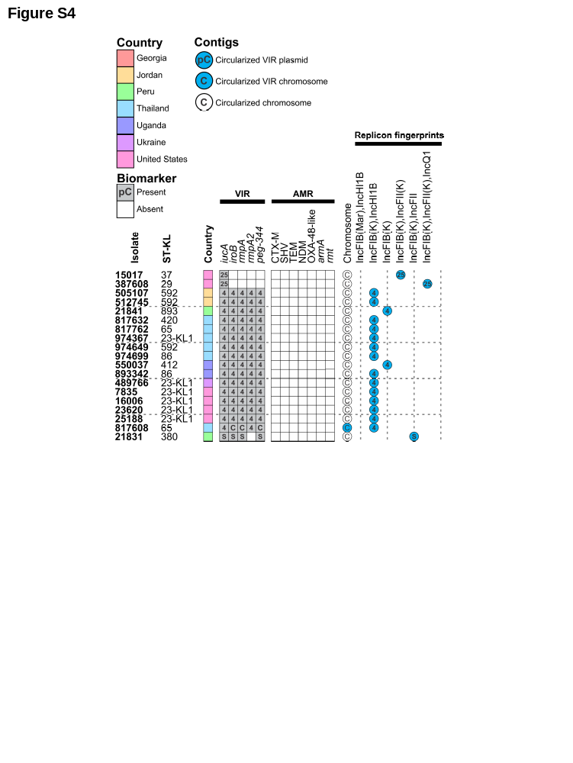
Figure S4. Heatmap of plasmid diversity for isolates with at least one virulence biomarker but lacking an acquired ESBL or carbapenemase. Isolates are shown with their corresponding metadata including country of origin, ST, and replicon fingerprint. Each contig from each sample are categorized by their numerical MGE cluster assignment, or otherwise indicated as chromosomal, and further categorized by virulence gene carriage (blue). KL type (ST-KL), country of origin, virulence and resistance gene cargo, and replicon fingerprint of each closed plasmid from each sample. Numbers denoted in the filled virulence boxes or replicon fingerprint circles indicate the plasmid type of the harboring plasmid. Plasmids colored in blue represent virulence-carrying plasmids. Chromosomal virulence gene carriage are designated by blue circles.
Figure S5. Identification of 25 independent convergence events. Neighbor joining tree calculated using the cgMLST pairwise allelic distances between all 1,468 K. pneumoniae. The ESBL and carbapenemase resistance alleles are indicated as well as the distinct alleles for the 5 virulence biomarkers. Red shading indicates independent convergence events inferred by maximum parsimony calculated at each node using the presence/absence of virulence and resistance alleles. Independent events are labeled with a letter A to Y. Select isolates for long-read sequencing and plasmidome analysis are indicated by an asterisk.

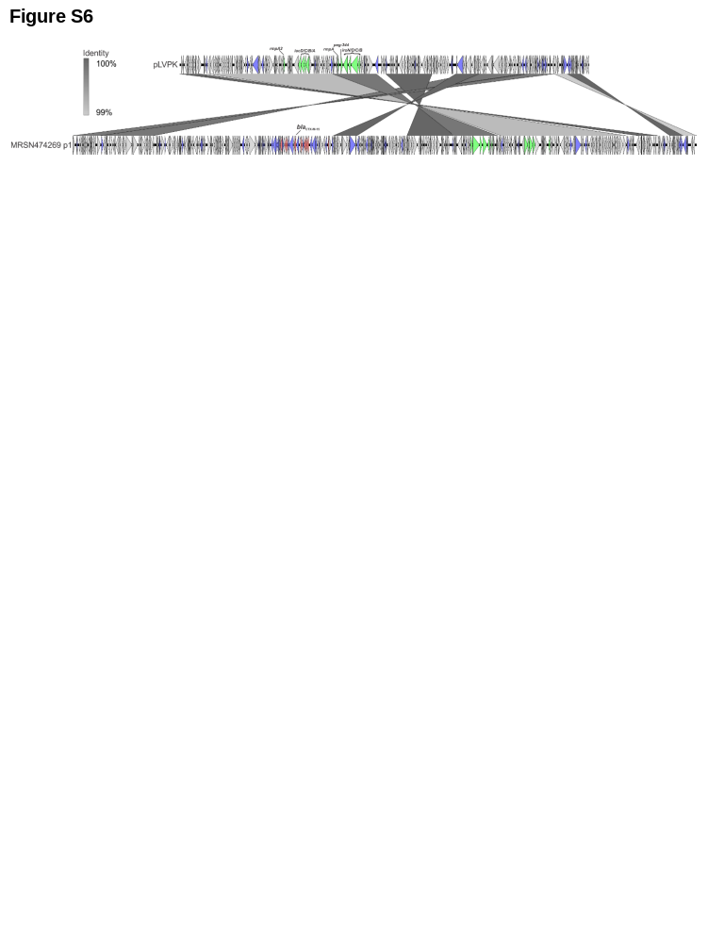
Figure S6. Acquisition of an ESBL gene inserted within the canonical pC-4 virulence plasmid in isolate MRSN474269, a ST-23/KL1 MDR-hvkp isolate. Plasmid alignment was done using the reference pLVPK (carrying all 5 virulence biomarkers but lacking an ESBL) as a comparator.

