SUPPLEMENTARY DATA : The 5-points photographic scale to evaluate HHD and DD clinical severity
Severity of affected area | HHD |  | DD
0: None | No cutaneous lesion
1: Mild | Slightly inflammatory basis  (< 30cm²) | 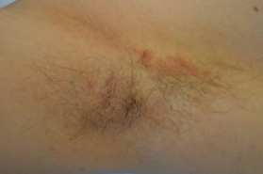 | Sparse and slightly inflammatory papules (that may be slightly hyperkeratotic) | 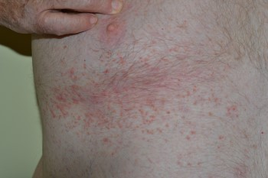
2: Moderate | Small erosions on a moderate (light red color) inflammatory basis  (< 30cm²) | 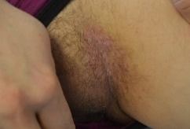 | Numerous hyperkeratotic papules with moderate inflammation  (light red color) | 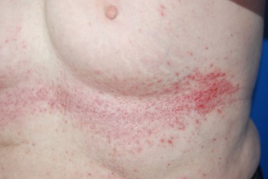
3: Severe | Non confluent ulcerations on a severe (bright red color) inflammatory basis  (< 30cm²)  Oozing, moderate maceration | 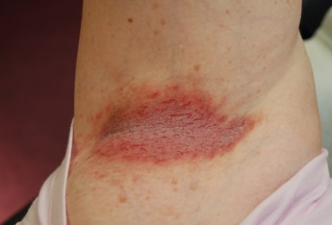 | Confluent (< 30 cm²) hyperkeratotic papules with severe inflammation (bright red color) | 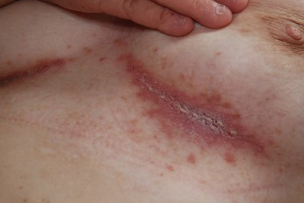
4: Very severe | Confluents ulcerations on a very severe (bright red or purplished color) inflammatory basis (> 30cm²)  Oozing, moderate maceration | 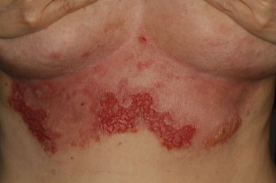 | Confluent and extensive (> 30 cm²) hyperkeratotic papules with very severe inflammation (bright red or purplished color) | 