SUPPLEMENTARY MATERIAL
Interannual variability of planting-date effects on Fusarium verticillioides grain colonization and fumonisin contamination in maize
Pérez-Pizá M. C., Vicente S., Pacín A., Sautua F.J., Mousegne F., Jecke F., Vago M. E., Carmona M.A., Stenglein S. A.

Table S1. Sowing, flowering, and harvest dates of early- and late-planted maize hybrid field trials conducted at San Antonio de Areco (INTA AER San Antonio de Areco, Buenos Aires, Argentina) during the 2020–2024 cropping seasons.
Season | Planting type | Previous crop | Sowing date | Flowering period | Harvest date
2020–21 | Early | Vetch cover crop | 5 Oct 20 | 16–20 Dec 20 | Late March 21
2021–22 | Early | Oat for grazing | 5 Oct 21 | 15–20 Dec 21 | Early April 22
2023–24 | Early | Wheat/second soybean | 28 Sep 23 | 20–27 Dec 23 | Early April 24
2020–21 | Late | First soybean | 12 Dec 20 | 18–23 Feb 21 | Early June 21
2022–23 | Late | First soybean | 29 Dec 22 | 1–10 Mar 23 | Early June 23
2023–24 | Late | Forage oat | 14 Dec 23 | 11–16 Feb 24 | Early June 24

Table S2. Soil chemical properties at sowing for early- and late-planted maize hybrid field trials conducted at San Antonio de Areco (INTA AER San Antonio de Areco, Buenos Aires, Argentina) during the 2020–2024 cropping seasons.
Season | Planting type | pH | Organic matter (%) | P Bray (mg kg⁻¹) | N–NO₃⁻ (0–20 cm) | N–NO₃⁻ (20–40 cm) | N–NO₃⁻ (40–60 cm) | Source
2020–21 | Early | 5.6 | 3.3 | 16 | 14.8 | 20.2 | 10.1 | Mousegne et al. 2021a
2020–21 | Late | 5.6 | 3.3 | 16 | 14.8 | 20.2 | 10.1 | Mousegne et al. 2021b
2021–22 | Early | 5.7 | 3.59 | 16 | 19.2 | 15.5 | 7.75 | Mousegne et al. 2022
2022–23 | Late | 5.6 | 3.5 | 13.3 | 16.3 | 7.2 | 3.6 | Mousegne et al. 2023
2023–24 | Early | 5.7 | 3.19 | 11.5 | 14.1 | 7.6 | — | Mousegne et al. 2024a
2023–24 | Late | 5.8 | 3.9 | 12 | 9.1 | 6.3 | — | Mousegne et al. 2024b

Table S3. Presence of maize hybrids across early- and late-planted trials (INTA San Antonio de Areco, 2020–2024 seasons). A cross (✓) indicates participation of a hybrid in each trial. Totals per trial: Early = 13 (2020–21), 9 (2021–22), 4 (2023–24), 26 overall; Late = 13 (2020–21), 5 (2022–23), 2 (2023–24), 20 overall.
Hybrid | Early |  |  | Late
Hybrid | 2020–21 | 2021–22 | 2023–24 | 2020–21 | 2022–23 | 2023–24
A | ✓ |  |  | ✓
B | ✓ | ✓ | ✓ | ✓ | ✓ | ✓
C | ✓ | ✓ |  | ✓
D | ✓ | ✓ |  | ✓ | ✓
E | ✓ |  |  | ✓
F | ✓ | ✓ |  | ✓
G | ✓ | ✓ | ✓ | ✓ | ✓
H | ✓ |  |  | ✓
I | ✓ | ✓ | ✓ | ✓ | ✓
J | ✓ |  |  | ✓
K | ✓ | ✓ | ✓ | ✓ | ✓
L | ✓ | ✓ |  | ✓ |  | ✓
M | ✓ | ✓ |  | ✓

Table S4. Flowering dates and critical flowering period (−7/+21 days; ~28 days) for early and late plantings across three campaigns (C1–C3), showing the flowering window and the mean temperature and precipitation during the corresponding critical period.
Planting Date | Campaing | Flowering period | Critical period (−7/+21)
Planting Date | Campaing | Flowering period | Dates | Mean T (°C) | Precip (mm)
Early | C1 2020-21 | 16–20 Dec 20 | 11 Dec 20 – 8 Jan 21 | 24.9 | 34.5
Early | C2 2021-22 | 15–20 Dec 21 | 10 Dec 21 – 7 Jan 22 | 27.0 | 22.5
Early | C3 2023-24 | 20–27 Dec 23 | 16 Dec 23 – 13 Jan 24 | 23.5 | 93.2
Late | C1 2020-21 | 18–23 Feb 21 | 13 Feb – 13 Mar 21 | 23.4 | 36.2
Late | C2 2022-23 | 1–10 Mar 23 | 26 Feb – 26 Mar 23 | 27.8 | 29.5
Late | C3 2023-24 | 11–16 Feb 24 | 6 Feb – 5 Mar 24 | 24.7 | 112.7

Table S5. Overview of studies examining the relationship between Fusarium verticillioides presence/colonization metrics in maize grain and fumonisins (FBs) accumulation.
Study | Type of measurement related to Fusarium verticillioides | Outcome regarding correlation with FBs
Cao et al., 2014 | Incidence in grains (infection and infestation), and ergosterol content | Strong positive correlation with infection, weak correlation with infestation, no correlation with ergosterol
Munhoz et al., 2015 | Incidence and severity of ear rot | Positive correlation, but with high interannual variability
Silva et al., 2017 | Fungal counts (CFU g⁻¹) in grain | No correlation
van Rensburg et al., 2017 | Fungal biomass (determined by qPCR) | Positively related, but the magnitude of FBs synthesis per unit biomass depends strongly on environmental variables
Links et al., 2019 | Fungal biomass (quantified by qPCR), ear rot severity | Strong positive correlations
Castañares et al., 2019 | Incidence in ears | Positive but weak or inconsistent correlation
Krnjaja et al., 2019 | Incidence in ears | Some positive correlations, but dependent on year and hybrid
Ponce-García et al., 2020 | Fungal counts (CFU g⁻¹) in grain | No correlation; hybrid genetics strongly influenced outcomes
Arias-Martín et al., 2021 | Quantification of fungal DNA in grain | Generally no consistent correlation
Pérez-Pizá et al., 2024 | Fungal counts in grains (NFv; CFU g⁻¹); incidence in grains (infection, IFv) | Positive correlations

FIGURES
Fig. S1. Three-dimensional response surfaces showing the combined effects of mean temperature and accumulated precipitation during the critical flowering period on A) fumonisins (Total FB) accumulation and B) Fusarium verticillioides (NFv) colony counts across early- and late-sown maize campaigns (C1–C3).
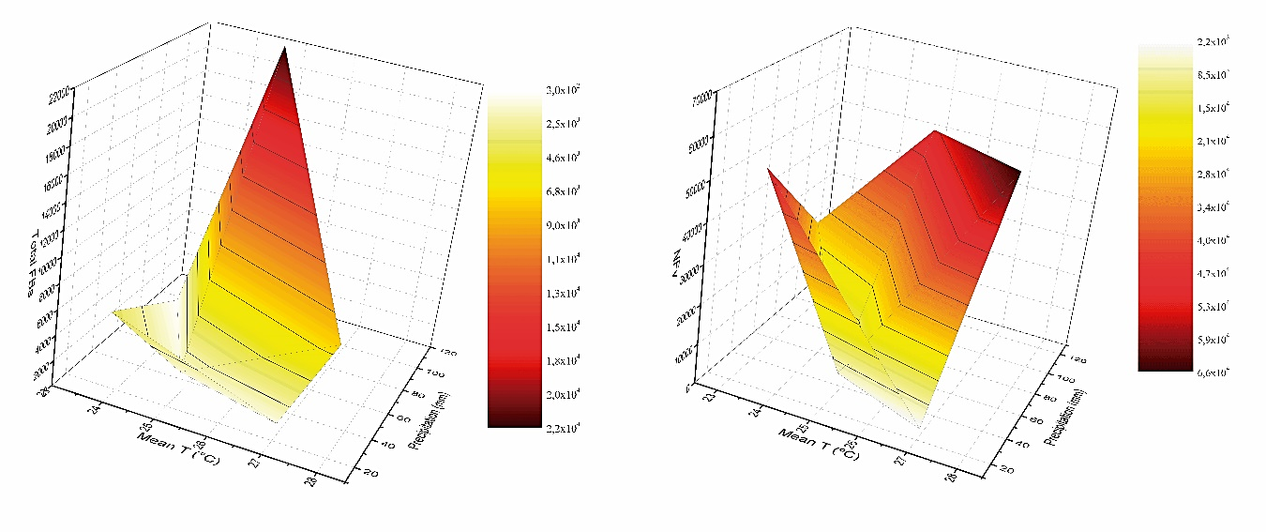
NFv
Total FBs
B)
A)

Fig. S2. Meteorological conditions during the early planting period field experiments of maize conducted at San Antonio de Areco (AER INTA San Antonio de Areco), Buenos Aires, Argentina, across three cropping seasons: (a) 2020–21, (b) 2021–22, and (c) 2023–24. Bars represent monthly precipitation (black bars, corresponding to the experimental period; open bars, long-term historical means), while lines indicate maximum (red), mean (black), and minimum (blue) monthly air temperatures. Historical precipitation data correspond to the periods 1982–2019, 1982–2020, and 1982–2022 for the 2020–21, 2021–22, and 2023–24 seasons, respectively. Meteorological data were obtained from the NASA POWER Data Access Viewer (https://power.larc.nasa.gov/data-access-viewer/).
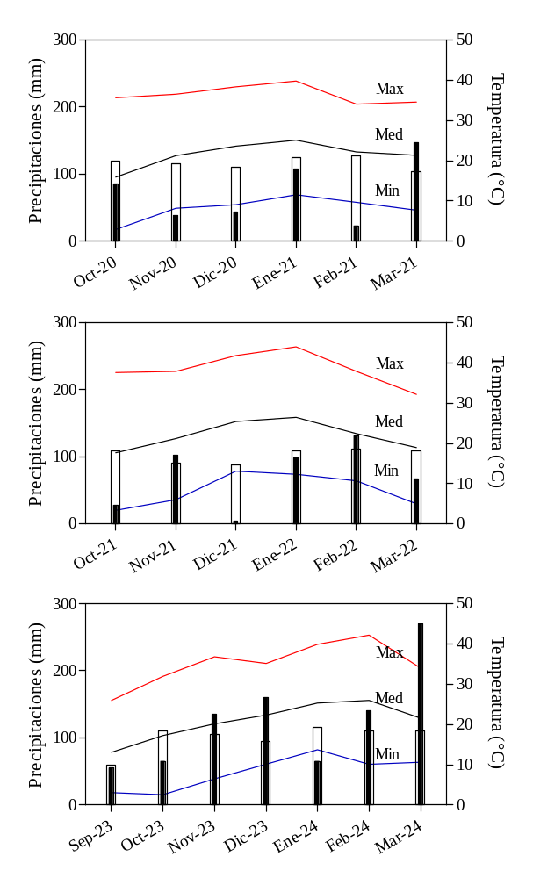
Fig. S3. Meteorological conditions during the late planting period field experiments of maize conducted at San Antonio de Areco (AER INTA San Antonio de Areco), Buenos Aires, Argentina, across three cropping seasons: (a) 2020–21, (b) 2022–23, and (c) 2023–24. Bars represent monthly precipitation (black bars, corresponding to the experimental period; open bars, long-term historical means), while lines indicate maximum (red), mean (black), and minimum (blue) monthly air temperatures. Historical precipitation data correspond to the periods 1982–2019, 1982–2021, and 1982–2022 for the 2020–21, 2022–23, and 2023–24 seasons, respectively. Meteorological data were obtained from the NASA POWER Data Access Viewer (https://power.larc.nasa.gov/data-access-viewer/).
