[Table 1. Summary Statistics for Clergy Demographics, Political Perceptions, and Congregational Context (N = 648)]
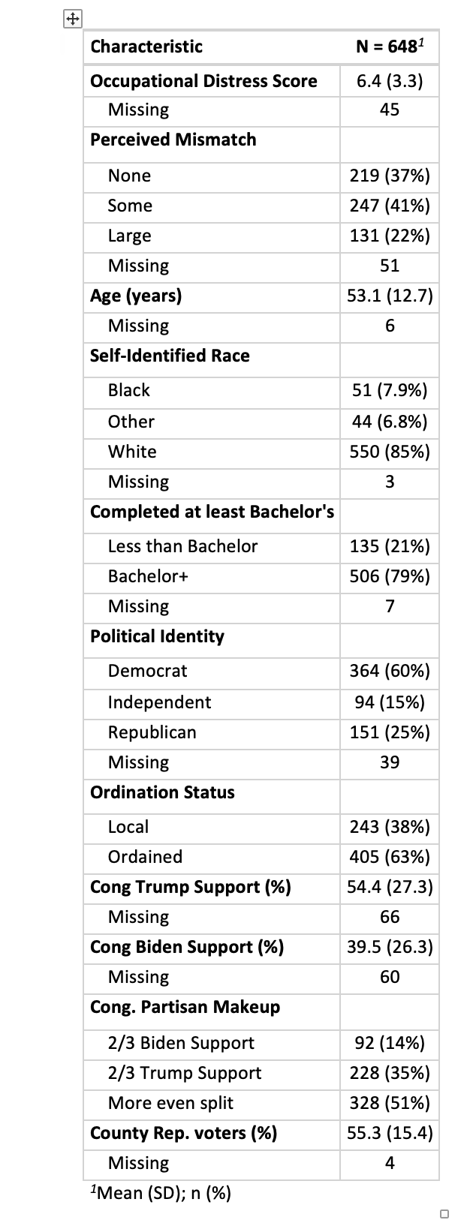
[Table 2. Perceived Congregational Partisan Makeup by Clergy Political Identity]
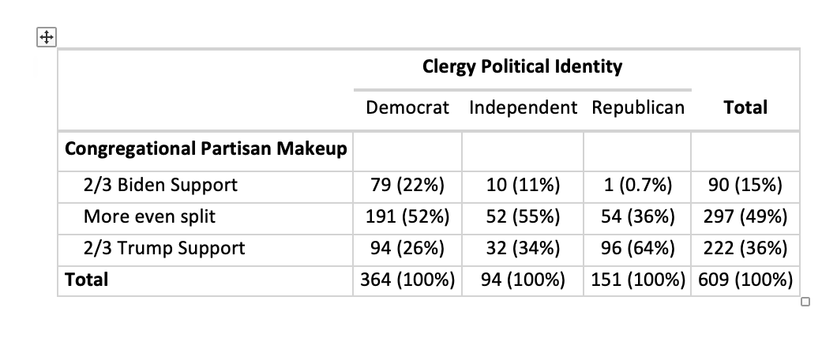

[Table 3. Regression Coefficients from the Final Multi-Group Structural Equation Model of Occupational Distress, Political Mismatch and Conflict.]
