Acridinone-Sulfonamide Hybrids: Synthesis, photophysical properties, DFT Analysis, and Antiviral Docking Against Adenovirus
Supporting Data
Shanmugavel Balamurugan, Vijayaparthasarathi Vijayakumar.
Department of Chemistry, School of Advanced Sciences, Vellore Institute of
Technology, Vellore- 632014, India.
Table of Contents
1. General synthesis procedure
2. Synthesis Procedure for substrate scope (6a-6j)
3. Synthesis Procedure for substrate scope (10a-10j)
4. DFT, FMO, MEP Calculation for Substrate Scope (6a-6j) & (10a-10j):
5. Docking Studies
6. IR, ¹H, ¹³C, DEPT-135 and 2D NMR and HRMS Spectra
1. General procedure for the synthesis of 6a-6j
A mixture containing (0.001 mmol, 1.0 equiv.) of 7-amino-3,3-dimethyl-9-phenyl-3,4-dihydroacridin-1(2H)-one, substituted sulfonyl chloride (0.0015 mmol, 1.5 equiv.), and pyridine (0.003 mmol, 3.0 equiv.) in 10 mL of DCM was stirred in a round-bottom flask at reflux for 30 minutes. TLC monitored the reaction. Once complete, the mixture was poured into ice-cold water, and the pH was adjusted to 7-8 with 10% dilute hydrochloric acid (HCl). The product was extracted with ethyl acetate (2 x 100 mL). The organic phase was washed with 40% brine, filtered through Na₂SO₄ to remove moisture, and purified by steam distillation. Final purification was achieved via column chromatography on silica (60-120 mesh) using 30% ethyl acetate in hexane as the eluent, yielding the pure compounds (6a-6j and 10a-10j).
Step-01: Preparation of 3,3-dimethyl-7-nitro-9-phenyl-3,4-dihydroacridin-1(2H)-one (3)
(2-Amino-5-nitrophenyl) (phenyl)methanone (2g, 0.0825 mol) was reacted with 5,5-dimethylcyclohexane-1,3-dione (0.8677g, 0.0619 mol) and Con.HCl (1 mL) in 50 mL of AR-grade ethanol in a 250 mL round-bottom flask, with continuous stirring at 78 °C for 12 hours. After confirming the reaction by TLC, the mixture was poured into an ice-cold water bath, causing precipitation. The precipitate was filtered and washed with n-hexane. The crude product was purified via column chromatography on silica gel (60-120 mesh) using a 1:1 mixture of ethanol and hexane as the eluent. ¹H NMR (400 MHz, CDCl₃): δ 8.51 (dd, J = 2.40, 9.20 Hz, 1H), 8.44 (d, J = 9 Hz, 1H), 8.19 (d, J = 9.20 Hz, 1H), 7.56 (t, J = 3.20 Hz, 3H), 7.20-7.20 (m, 2H), 3.32 (s, 2H), 2.62 (s, 2H), 1.18 (s, 6H). ¹³C NMR (100 MHz, CDCl₃): δ 197.19, 165.12, 152.84, 150.79, 145.57, 135.76, 130.49, 128.60, 126.75, 125.09, 124.87, 124.16, 54.10, 48.61, 32.27, and 28.37.

Step-02: The Preparation 7-amino-3,3-dimethyl-9-phenyl-3,4-dihydroacridin-1(2H)-one (4)
A mixture of 3,3-Dimethyl-7-nitro-9-phenyl-3,4-dihydroacridin-1 (2H)-one (2 g, 0.0578 mol), SnCl₂ (1.1337 g, 0.1734 mol), and Con.HCl (0.5 mL) was dissolved in 25 mL of AR-grade ethanol in a 250 mL round-bottom flask. The mixture was stirred continuously at 70 °C for 45 minutes, with monitoring via TLC. Once complete, the reaction mixture was poured into ice-cold water, and the pH was adjusted to approximately 7-8 using 20% NaOH. A noticeable colour change from red to yellow was observed. The mixture was then extracted with ethyl acetate twice, 100 mL each time. The organic layer was washed with brine water twice, then concentrated under high vacuum to obtain a solid product. This product was characterised as previously described. Its structure was confirmed by ¹H NMR (400 MHz, CDCl₃), showing δ 7.88 (d, J = 9.20 Hz, 1H), 7.50-7.48 (m, 3H), 7.20 (dd, J = 2.80, 7.56 Hz, 1H), 7.16 (d, J = 6.40 Hz, 2H), 6.49 (d, J = 2.80 Hz, 1H), 3.20 (s, 2H), 2.52 (s, 2H), 1.14 (s, 6H).

Step-03: Sulfonation of 7-amino-3,3-dimethyl-9-phenyl-3,4-dihydroacridin-1(2H)-ones (6a-6j)
Scheme-01:
N-(6,6-dimethyl-8-oxo-9-phenyl-5,6,7,8-tetrahydroacridin-2-yl) alkylsulfonamide

Substrate Scope(6a-6j):
Scheme-02
Step-03: Sulfonation of 7-amino-3,3-dimethyl-9-phenyl-3,4-dihydroacridin-1(2H)-one (10a-10j)

Substrate Scope (10a-10j):

Plausible Mechanism

2. Synthesis Procedure for substrate scope (6a-6j)
N-(6,6-dimethyl-8-oxo-9-phenyl-5,6,7,8-tetrahydroacridin-2-yl)-4-methylbenzene sulfonamide (6a)
A mixture of 7-Amino-3,3-dimethyl-9-phenyl-3,4-dihydroacridin-1(2H)-one (250 mg, 0.7907 mmol), 4-methylbenzenesulfonyl chloride (225 mg, 1.1842 mmol), and pyridine (0.18 mL, 2.3640 mmol) was stirred in 10 mL of dichloromethane (DCM) at reflux for 30 minutes. The compound was then isolated using silica gel chromatography (60/120 mesh) with a 30% ethyl acetate in hexane mixture. Thin-layer chromatography (TLC) showed an Rf value of 0.3 (ethyl acetate/hexane, 4:6) under UV light after staining with H₂SO₄ and KMnO₄. The melting point was between 130 °C and 135 °C. ¹H NMR: 400 MHz, CDCl₃: δ 7.98 (d, J = 7.60 Hz, 1H), 7.48-7.45 (m, 6H), 7.10 (d, J = 7.60 Hz, 2H), 7.07-6.98 (m, 2H), 6.94 (d, J = 18.00 Hz, 1H), 3.21 (s, 2H), 2.48 (s, 2H), 2.31 (s, 3H), 1.07 (s, 6H). ¹³C NMR: 197.94, 160.53, 150.16, 146.44, 137.16, 135.53, 134.84, 129.94, 129.70, 128.20, 127.98, 127.76, 127.73, 127.47, 127.13, 123.15, 116.65, 54.16, 48.16, 32.27, 28.32, 21.58. DEPT-135: Positive peak: 129.94, 129.70, 128.20, 127.98, 127.73, 127.47, 126.13, 116.65, 28.32, 21.58. Negative peak: 54.17, 48.16. HRMS (ESI) m/z [M+H]⁺ Calculated Exact Mass for Chemical Formula: C₂₈H₂₇N₂O₃S is 471.1742. Obtained Mass is 471.1745.

N-(6,6-dimethyl-8-oxo-9-phenyl-5,6,7,8-tetrahydroacridin-2-yl)-4-methoxybenzene sulfonamide (6b)
A mixture of 7-Amino-3,3-dimethyl-9-phenyl-3,4-dihydroacridin-1(2H)-one (250 mg, 0.7907 mmol), 4-methylbenzenesulfonyl chloride (244 mg, 1.1845 mmol), and pyridine (0.18 mL, 2.3640 mmol) was stirred in 10 mL of dichloromethane (DCM) at reflux for 30 minutes. The compound was then isolated by silica gel chromatography (60/120 mesh) using a 50% ethyl acetate/hexane mixture. Thin-layer chromatography (TLC) showed an Rf value of 0.5 (ethyl acetate/hexane, 4:6) under UV light after staining with H₂SO₄ and KMnO₄. The melting point was between 126 °C and 131 °C. ¹H NMR: 400 MHz, CDCl₃: δ 8.29 (d, J = 8.00 Hz, 1H), 7.64 (d, J = 8.40 Hz, 1H), 7.51 (s, 3H), 7.44 (d, J = 8.80 Hz, 2H), 7.02 (s, 3H), 6.73 (d, J = 8.40 Hz, 2H), 3.74 (s, 3H), 3.48 (s, 2H), 2.53 (s, 2H), 1.08 (s, 6H). ¹³C NMR: 197.93, 163.24, 160.55, 137.18, 134.85, 129.97, 129.90, 129.65, 128.22, 128.00, 127.73, 126.26, 123.14, 116.76, 114.24, 55.63, 54.17, 48.19, 32.28, 28.33. DEPT-135: Positive peak: 133.20, 129.52, 129.11, 128.27, 127.94, 127.81, 127.41, 126.32, 116.48, 28.31. Negative peak: 54.11, 47.80. HRMS (ESI) m/z [M+H]⁺ Calculated Exact Mass for Chemical Formula: C₂₈H₂₇N₂O₄S is 487.1691. Obtained Mass is 487.1693.

N-(6,6-dimethyl-8-oxo-9-phenyl-5,6,7,8-tetrahydroacridin-2-yl) benzenesulfonamide (6c)
A mixture of 7-Amino-3,3-dimethyl-9-phenyl-3,4-dihydroacridin-1(2H)-one (250 mg, 0.7907 mmol), 4-methylbenzenesulfonyl chloride (208 mg, 1.1820 mmol), and pyridine (0.18 mL, 2.3640 mmol) was stirred in 10 mL of dichloromethane (DCM) at reflux for 30 minutes. The compound was then isolated using silica gel chromatography (60/120 mesh) with a 40% ethyl acetate in hexane mixture. Thin-layer chromatography (TLC) showed an Rf value of 0.4 (ethyl acetate/hexane, 4:6) under UV light after staining with H₂SO₄ and KMnO₄. The melting point was between 125 °C and 129 °C. ¹H NMR: 400 MHz, CDCl₃: δ 7.92 (d, J = 8.80 Hz, 1H), 7.53 (d, J = 7.60 Hz, 2H), 7.47-7.45 (m, 5H), 7.31 (t, J = 8.00 Hz, 2H), 6.96 (d, J = 2.00 Hz, 2H), 6.94 (dd, J = 3.60, 7.40 Hz, 1H), 3.18 (s, 2H), 2.47 (s, 2H), 1.06 (s, 6H). ¹³C NMR: 197.98, 160.62, 150.18, 146.47, 138.49, 137.14, 134.69, 133.19, 129.97, 128.24, 127.96, 127.76, 127.72, 127.40, 126.16, 123.17, 116.76, 54.15, 48.15, 32.28, 28.32. DEPT-135: Positive peak: 133.20, 129.52, 129.11, 128.27, 127.94, 127.81, 126.32, 116.48, 28.31. Negative peak: 54.11, 47.80. HRMS (ESI) m/z [M+H]⁺Calculated Exact Mass for Chemical Formula: C₂₇H₂₅N₂O₃S is 457.1585. Obtained Mass is 457.1587.

N-(6,6-dimethyl-8-oxo-9-phenyl-5,6,7,8-tetrahydroacridin-2-yl) naphthalene-2-sulfonamide (6d)
A mixture of 7-Amino-3,3-dimethyl-9-phenyl-3,4-dihydroacridin-1(2H)-one (250 mg, 0.7907 mmol), 4-methylbenzenesulfonyl chloride (268 mg, 1.1858 mmol), and pyridine (0.18 mL, 2.3640 mmol) was stirred in 10 mL of dichloromethane (DCM) at reflux for 30 minutes. The compound was then isolated using silica gel chromatography (60/120 mesh) with a 45% ethyl acetate in hexane mixture. Thin-layer chromatography (TLC) showed an Rf value of 0.45 (ethyl acetate/hexane, 4:6) under UV light after staining with H₂SO₄ and KMnO₄. The melting point was between 128 °C and 132 °C. ¹H NMR: 400 MHz, CDCl₃: δ 8.12 (d, J = 2.00 Hz, 1H), 7.84 (dd, J = 8.80, 32.20 Hz, 1H), 7.76 (t, J = 7.20 Hz, 3H), 7.60-7.58 (m, 4H), 7.33 (t, J = 7.20 Hz, 1H), 7.24 (d, J = 7.60 Hz, 2H), 7.22 (s, 1H), 6.83 (dd, J = 2.00, 2H), 3.12 (s, 2H), 2.44 (s, 2H), 1.04 (s, 6H). ¹³C NMR: 197.88, 160.72, 136.94, 135.24, 134.99, 134.60, 131.93, 130.02, 129.49, 129.35, 129.19, 128.11, 127.91, 127.82, 127.67, 126.75, 123.10, 122.17, 117.66, 54.13, 48.13, 32.25, 28.31. DEPT-135: Positive peak: 130.03, 129.50, 129.35, 129.19, 129.10, 128.12, 127.92, 127.82, 127.67, 122.17, 117.66, 28.31. Negative peak: 54.13, 48.15. HRMS (ESI) m/z [M+H]⁺ Calculated Exact Mass for Chemical Formula: C₃₁H₂₇N₂O₃S is 507.1742. Obtained Mass is 507.1743.

N-(6,6-dimethyl-8-oxo-9-phenyl-5,6,7,8-tetrahydroacridin-2-yl)-2,4,6-triisopropylbenzenesulfonamide (6e)
A mixture of 7-Amino-3,3-dimethyl-9-phenyl-3,4-dihydroacridin-1(2H)-one (250 mg, 0.7907 mmol), 4-methylbenzenesulfonyl chloride (225 mg, 1.1842 mmol), and pyridine (0.18 mL, 2.3640 mmol) was stirred in 10 mL of dichloromethane (DCM) at reflux for 30 minutes. The compound was then isolated using silica gel chromatography (60/120 mesh) with a 40% ethyl acetate in hexane mixture. Thin-layer chromatography (TLC) showed an Rf value of 0.4 (ethyl acetate/hexane, 4:6) under UV light after staining with H₂SO₄ and KMnO₄. The melting point was between 130°C and 135°C.

4-chloro-N-(6,6-dimethyl-8-oxo-9-phenyl-5,6,7,8-tetrahydroacridin-2-yl) benzenesulfonamide (6f)
A mixture of 7-Amino-3,3-dimethyl-9-phenyl-3,4-dihydroacridin-1(2H)-one (250 mg, 0.7907 mmol), 4-methyl benzene sulfonyl chloride (248 mg, 1.1813 mmol), and pyridine (0.18 mL, 2.3640 mmol) was stirred in 10 mL of dichloromethane (DCM) at reflux for 30 minutes. The compound was then isolated using silica gel chromatography (60/120 mesh) with a 50% ethyl acetate in hexane mixture. Thin-layer chromatography (TLC) showed an Rf value of 0.5 (ethyl acetate/hexane, 4:6) under UV light after staining with H₂SO₄ and KMnO₄. The melting point was between 121 °C and 125 °C. ¹H NMR: 400 MHz, CDCl₃: δ 7.91 (d, J = 9.20 Hz, 1H), 7.45-7.43 (m, 6H), 7.27 (d, J = 8.80 Hz, 2H), 6.95 (dd, J = 2.40, 4.00 Hz, 2H), 6.89 (d, J = 16.60 Hz, 1H), 3.16 (s, 2H), 2.48 (s, 2H), 1.07 (s, 6H). ¹³C NMR: 197.85, 160.93, 139.81, 137.08, 136.90, 134.23, 130.18, 129.42, 128.85, 128.26, 127.91, 127.79, 127.74, 126.56, 123.21, 117.54, 54.13, 48.19, 32.27, 28.32. DEPT-135: Positive peak: 130.18, 129.42, 128.85, 128.26, 127.91, 127.79, 126.56, 117.53, 28.33. Negative peak: 54.14, 48.19. HRMS (ESI) m/z [M+H]⁺ Calculated Exact Mass for Chemical Formula: C₂₇H₂₄ClN₂O₃S is 491.1196. Obtained Mass is 491.1198.

4-bromo-N-(6,6-dimethyl-8-oxo-9-phenyl-5,6,7,8-tetrahydroacridin-2-yl) benzenesulfonamide (6g)

A mixture of 7-Amino-3,3-dimethyl-9-phenyl-3,4-dihydroacridin-1(2H)-one (250 mg, 0.7907 mmol), 4-methylbenzenesulfonyl chloride (301 mg, 1.1855 mmol), and pyridine (0.18 mL, 2.3640 mmol) was stirred in 10 mL of dichloromethane (DCM) at reflux for 30 minutes. The compound was then isolated using silica gel chromatography (60/120 mesh) with a 40% ethyl acetate in hexane mixture. Thin-layer chromatography (TLC) showed an Rf value of 0.4 (ethyl acetate/hexane, 4:6) under UV light after staining with H₂SO₄ and KMnO₄. The melting point was between 123 °C and 127 °C. ¹H NMR: 400 MHz, CDCl3: δ 7.91 (d, J = 9.20 Hz, 1H), 7.45-7.43 (m, 6H), 7.27 (d, J = 8.80 Hz, 2H), 6.95 (dd, J = 2.40, 4.00 Hz, 2H), 6.89 (d, J = 18.60 Hz, 1H), 3.16 (s, 2H), 2.48 (s, 2H), 1.07 (s, 6H). ¹³C NMR: 197.85, 160.93, 139.81, 137.08, 136.90, 134.23, 130.18, 129.42, 128.85, 128.26, 127.91, 127.79, 127.74, 126.56, 123.21, 117.54, 54.13, 48.19, 32.27, 28.32. DEPT-135: Positive peak: 130.18, 129.42, 128.85, 128.26, 127.79, 126.56, 117.53, 28.33. Negative peak: 54.14, 48.19. HRMS (ESI) m/z [M+H]⁺ Calculated Exact Mass for Chemical Formula: C₂₇H₂₄BrN₂O₃S is 535.0691. Obtained Mass is 535.0693.

N-(6,6-dimethyl-8-oxo-9-phenyl-5,6,7,8-tetrahydroacridin-2-yl)-2-nitrobenzenesulfonamide (6h)
A mixture of 7-Amino-3,3-dimethyl-9-phenyl-3,4-dihydroacridin-1(2H)-one (250 mg, 0.7907 mmol), 4-methylbenzenesulfonyl chloride (262 mg, 1.1909 mmol), and pyridine (0.18 mL, 2.3640 mmol) was stirred in 10 mL of dichloromethane (DCM) at reflux for 30 minutes. The compound was then isolated using silica gel chromatography (60/120 mesh) with a 55% ethyl acetate in hexane mixture. Thin-layer chromatography (TLC) showed an Rf value of 0.55 (ethyl acetate/hexane, 4:6) under UV light after staining with H₂SO₄ and KMnO₄. The melting point was between 130 °C and 135 °C. ¹H NMR: 400 MHz, CDCl3: δ 7.93 (d, J = 2.00 Hz, 1H), 7.75 (dd, J = 0.80, 8.00 Hz, 1H), 7.60 (dt, J = 1.20, Hz, 1H), 7.55-7.55 (m, 2H), 7.48 (d, J = 0.80 Hz, 1H), 7.46-7.46 (m, 3H), 7.10 (d, J = 2.40 Hz, 1H), 6.95-6.95 (m, 2H), 3.17 (s, 2H), 2.48 (s, 2H), 1.07 (s, 6H). ¹³C NMR: 197.78, 161.28, 136.94, 134.12, 133.75, 132.60, 131.93, 131.87, 130.22, 128.26, 127.90, 127.71, 127.50, 125.43, 123.23, 119.46, 54.14, 48.23, 32.29, 28.32. DEPT-135: Positive peak: 134.12, 132.60, 131.92, 130.04, 128.27, 127.95, 127.89, 127.55, 125.43, 119.36, 28.31. Negative peak: 54.13, 48.06. HRMS (ESI) m/z [M+H]⁺Calculated Exact Mass for Chemical Formula: C₂₉H₂₆N₂O₃ is 450.2021. Obtained Mass is 451.2021. HRMS (ESI) m/z [M+H]⁺ Calculated Exact Mass for Chemical Formula: C₂₇H₂₄N₃O₅S is 502.1436. Obtained Mass is 502.1437.

N-(6,6-dimethyl-8-oxo-9-phenyl-5,6,7,8-tetrahydroacridin-2-yl)-4-iodobenzenesulfonamide (6i)
A mixture of 7-Amino-3,3-dimethyl-9-phenyl-3,4-dihydroacridin-1(2H)-one (250 mg, 0.7907 mmol), 4-methylbenzenesulfonyl chloride (358 mg, 1.1859 mmol), and pyridine (0.18 mL, 2.3640 mmol) was stirred in 10 mL of dichloromethane (DCM) at reflux for 30 minutes. The compound was then isolated using silica gel chromatography (60/120 mesh) with a 40% ethyl acetate in hexane mixture. Thin-layer chromatography (TLC) showed an Rf value of 0.4 (ethyl acetate/hexane, 4:6) under UV light after staining with H₂SO₄ and KMnO₄. The melting point was between 138 °C and 141 °C. ¹H NMR: 400 MHz, CDCl3: δ 7.99 (d, J = 8.80 Hz, 1H), 7.64 (d, J = 8.40 Hz, 2H), 7.45 (t, J = 2.80 Hz, 4H), 7.22-7.20 (m, 1H), 6.97 (d, J = 2.40 Hz, 1H), 6.95 (d, J = 3.20 Hz, 2H), 6.88 (s, 1H), 3.22 (s, 2H), 2.49 (s, 2H), 1.07 (s, 6H). ¹³C NMR: 197.66, 160.66, 150.74, 138.36, 138.10, 136.94, 134.59, 129.63, 128.72, 128.31, 127.88, 127.84, 126.68, 123.26, 117.06, 100.88, 54.09, 47.79, 32.31, 28.32. DEPT-135: Positive peak: 138.37, 129.62, 128.72, 128.31, 127.88, 126.68, 117.05, 28.32. Negative peak: 54.09, 47.78. HRMS (ESI) m/z [M+H]⁺ Calculated Exact Mass for Chemical Formula: C₂₉H₂₆N₂O₃ is 450.2021. Obtained Mass is 451.2021. HRMS (ESI) m/z [M+H]⁺Calculated Exact Mass for Chemical Formula: C₂₇H₂₄IN₂O₃S is 583.0552. Obtained Mass is 583.0551.

4-cyano-N-(6,6-dimethyl-8-oxo-9-phenyl-5,6,7,8-tetrahydroacridin-2-yl) benzene sulfonamide (6j)
A mixture of 7-Amino-3,3-dimethyl-9-phenyl-3,4-dihydroacridin-1(2H)-one (250 mg, 0.7907 mmol), 4-methylbenzenesulfonyl chloride (238 mg, 1.1842 mmol), and pyridine (0.18 mL, 2.3640 mmol) was stirred in 10 mL of dichloromethane (DCM) at reflux for 30 minutes. The compound was then isolated using silica gel chromatography (60/120 mesh) with a 60% ethyl acetate in hexane mixture. Thin-layer chromatography (TLC) showed an Rf value of 0.6 (ethyl acetate/hexane, 4:6) under UV light after staining with H₂SO₄ and KMnO₄. The melting point was between 131 °C and 136 °C. ¹H NMR: 400 MHz, CDCl3: δ 8.04 (d, J = 8.80 Hz, 1H), 7.63 (d, J = 8.40 Hz, 2H), 7.59-7.57 (m, 2H), 7.52-7.50 (m, 4H), 6.98 (t, J = 4.80 Hz, 2H), 6.91 (d, J = 1.20 Hz, 1H), 3.24 (s, 2H), 2.50 (s, 2H), 1.08 (s, 6H). ¹³C NMR: 197.66, 142.72, 136.86, 132.88, 128.34, 128.03, 127.98, 127.87, 126.59, 123.38, 117.33, 117.05, 117.90, 54.06, 47.76, 32.32, 28.30. DEPT-135: Positive peak: 138.37, 129.62, 128.72, 128.31, 127.88, 126.68, 117.05, 28.32. Negative peak: 54.09, 47.78. HRMS (ESI) m/z [M+H]⁺ Calculated Exact Mass for Chemical Formula: C₂₉H₂₆N₂O₃ is 450.2021. Obtained Mass is 451.2021. HRMS (ESI) m/z [M+H]⁺ Calculated Exact Mass for Chemical Formula: C₂₈H₂₄N₃O₃S is 482.1538. Obtained Mass is 482.1537.

3. Synthesis Procedure for substrate scope (10a-10j)
4-methyl-N-(8-oxo-9-phenyl-5,6,7,8-tetrahydroacridin-2-yl) benzenesulfonamide (10a)
A mixture of 7-amino-9-phenyl-3,4-dihydroacridin-1(2H)-one (250 mg, 0.8680 mmol), 4-methylbenzenesulfonyl chloride (247 mg, 1.300 mmol), and pyridine (0.2 mL, 2.5916 mmol) was stirred in 10 mL of dichloromethane (DCM) at reflux for 30 minutes. The compound was then isolated using silica gel chromatography (60/120 mesh) with a 40% ethyl acetate in hexane mixture. Thin-layer chromatography (TLC) showed an Rf value of 0.4 (ethyl acetate/hexane, 4:6) under UV light after staining with H₂SO₄ and KMnO₄. The melting point was between 123 °C and 128 °C. ¹H NMR: 400 MHz, CDCl3: δ 7.89 (d, J = 8.80 Hz, 1H), 7.47 (d, J = 2.40 Hz, 1H), 7.45-7.44 (m, 5H), 7.09 (d, J = 8.00 Hz, 2H), 6.95 (t, J = 3.60 Hz, 2H), 6.89 (d, J = 2.00 Hz, 1H), 3.26 (t, J = 6.40 Hz, 2H), 2.61 (t, J = 6.40 Hz, 2H), 2.31 (s, 3H), 2.18-2.16 (m, 2H). ¹³C NMR: 197.86, 161.06, 144.09, 137.18, 135.47, 134.85, 129.85, 129.68, 128.19, 127.94, 127.84, 127.77, 127.46, 126.34, 124.28, 116.71, 40.58, 30.95, 21.58, 21.31. DEPT-135: Positive peak: 129.85, 129.69, 128.19, 127.94, 127.77, 126.34, 116.70, 30.96, 21.31. Negative peak: 40.58, 34.33. HRMS (ESI) m/z [M+H]⁺ Calculated Exact Mass for Chemical Formula: C₂₉H₂₆N₂O₃ is 450.2021. Obtained Mass is 451.2021. HRMS (ESI) m/z [M+H]⁺ Calculated Exact Mass for Chemical Formula: C₂₆H₂₃N₂O₃S is 443.1429. Obtained Mass is 443.1429.

4-methoxy-N-(8-oxo-9-phenyl-5,6,7,8-tetrahydroacridin-2-yl) benzenesulfonamide (10b)
A mixture of 7-amino-9-phenyl-3,4-dihydroacridin-1(2H)-one (250 mg, 0.8680 mmol), 4-methylbenzenesulfonyl chloride (268 mg, 1.3010 mmol), and pyridine (0.2 mL, 2.5916 mmol) was stirred in 10 mL of dichloromethane (DCM) at reflux for 30 minutes. The compound was then isolated using silica gel chromatography (60/120 mesh) with a 60% ethyl acetate in hexane mixture. Thin-layer chromatography (TLC) showed an Rf value of 0.6 (ethyl acetate/hexane, 4:6) under UV light after staining with H₂SO₄ and KMnO₄. The melting point was between 134 °C and 139 °C. ¹H NMR: 400 MHz, CDCl3: δ 8.00 (d, J = 8.80 Hz, 1H), 7.50-7.50 (m, 6H), 6.97 (t, J = 4.00 Hz, 2H), 6.91 (d, J = 2.00 Hz, 1H), 6.74 (d, J = 8.80 Hz, 2H), 3.75 (s, 3H), 3.34 (t, J = 6.00 Hz, 2H), 2.62 (t, J = 6.40 Hz, 2H), 2.18-2.16 (m, 2H). ¹³C NMR: 197.80, 163.23, 161.46, 161.46, 150.91, 137.15, 135.10, 129.85, 129.65, 128.21, 127.95, 127.90, 127.79, 126.48, 124.29, 116.37, 114.22, 55.63, 40.55, 34.14, 21.27. DEPT-135: Positive peak: 129.65, 129.55, 128.21, 127.95, 127.80, 126.48, 116.37, 114.22, 55.63, 21.28. Negative peak: 40.55, 34.14. HRMS (ESI) m/z [M+H]⁺ Calculated Exact Mass for Chemical Formula: C₂₉H₂₆N₂O₃ is 459.1378. Obtained Mass is 459.1380.

N-(8-oxo-9-phenyl-5,6,7,8-tetrahydroacridin-2-yl) benzenesulfonamide (10c)
A mixture of 7-amino-9-phenyl-3,4-dihydroacridin-1(2H)-one (250 mg, 0.8680 mmol), 4-methylbenzenesulfonyl chloride (229 mg, 1.3013 mmol), and pyridine (0.2 mL, 2.5916 mmol) was stirred in 10 mL of dichloromethane (DCM) at reflux for 30 minutes. The compound was then isolated using silica gel chromatography (60/120 mesh) with a 40% ethyl acetate in hexane mixture. Thin-layer chromatography (TLC) showed an Rf value of 0.4 (ethyl acetate/hexane, 4:6) under UV light after staining with H₂SO₄ and KMnO₄. The melting point was between 121 °C and 125 °C. ¹H NMR: 400 MHz, CDCl3: δ 8.05 (d, J = 16.80 Hz, 1H), 7.51 (d, J = 7.20 Hz, 3H), 7.44 (s, 4H), 7.31-7.29 (m, 2H), 6.96 (d, J = 8.00 Hz, 3H), 3.36 (s, 2H), 2.62 (s, 2H), 2.16 (s, 2H). ¹³C NMR: 197.62, 161.46, 138.42, 137.01, 135.00, 133.19, 129.32, 129.09, 128.26, 127.89, 127.85, 127.41, 126.7, 124.34, 116.39, 40.51, 33.96, 21.22. DEPT-135: Positive peak: 133.20, 129.32, 129.10, 128.26, 127.89, 127.85, 127.41, 126.57, 116.39. Negative peak: 40.51, 33.97, 21.22. HRMS (ESI) m/z [M+H]⁺ Calculated Exact Mass for Chemical Formula: C₂₉H₂₆N₂O₃ is 450.2021. Obtained Mass is 451.2021. HRMS (ESI) m/z [M+H]⁺ Calculated Exact Mass for Chemical Formula: C₂₅H₂₁N₂O₃S is 429.1272. Obtained Mass is 429.1275.

N-(8-oxo-9-phenyl-5,6,7,8-tetrahydroacridin-2-yl) naphthalene-2-sulfonamide (10d)
A mixture of 7-amino-9-phenyl-3,4-dihydroacridin-1(2H)-one (250 mg, 0.8680 mmol), 4-methylbenzenesulfonyl chloride (294 mg, 1.300 mmol), and pyridine (0.2 mL, 2.5916 mmol) was stirred in 10 mL of dichloromethane (DCM) at reflux for 30 minutes. The compound was then isolated using silica gel chromatography (60/120 mesh) with a 60% ethyl acetate in hexane mixture. Thin-layer chromatography (TLC) showed an Rf value of 0.6 (ethyl acetate/hexane, 4:6) under UV light after staining with H₂SO₄ and KMnO₄. The melting point was between 138 °C and 142 °C. ¹H NMR: 400 MHz, CDCl₃: δ 8.04 (d, J = 14.80 Hz, 1H), 7.88 (d, J = 15.20 Hz, 1H), 7.75 (t, J = 11.20 Hz, 3H), 7.59-7.57 (m, 4H), 7.38-7.36 (m, 1H), 7.28 (d, J = 7.60 Hz, 2H), 6.90 (d, J = 1.60 Hz, 1H), 6.81 (d, J = 7.60 Hz, 2H), 3.29 (t, J = 6.00 Hz, 2H), 2.59 (t, J = 6.40 Hz, 2H), 2.16-2.14 (m, 2H). ¹³C NMR: 197.62, 161.46, 138.42, 137.01, 135.00, 133.19, 129.32, 128.26, 127.89, 127.85, 127.41, 126.57, 124.34, 116.39, 40.51, 33.96, 21.22. DEPT-135: Positive peak: 133.20, 129.32, 129.10, 128.26, 127.89, 127.85, 127.41, 126.41, 116.39. Negative peak: 40.51, 33.97. HRMS (ESI) m/z [M+H]⁺ Calculated Exact Mass for Chemical Formula: C₂₉H₂₃N₂O₃S is 479.1429. Obtained Mass is 479.1430.

2,4,6-triisopropyl-N-(8-oxo-9-phenyl-5,6,7,8-tetrahydroacridin-2-yl)benzenesulfonamide (10e)
A mixture of 7-amino-9-phenyl-3,4-dihydroacridin-1(2H)-one (250 mg, 0.8680 mmol), 4-methylbenzenesulfonyl chloride (247 mg, 1.300 mmol), and pyridine (0.2 mL, 2.5916 mmol) was stirred in 10 mL of dichloromethane (DCM) at reflux for 30 minutes. The compound was then isolated using silica gel chromatography (60/120 mesh) with a 30% ethyl acetate in hexane mixture. Thin-layer chromatography (TLC) showed an Rf value of 0.3 (ethyl acetate/hexane, 4:6) under UV light after staining with H₂SO₄ and KMnO₄. The melting point was between 130 °C and 135 °C.
4-chloro-N-(8-oxo-9-phenyl-5,6,7,8-tetrahydroacridin-2-yl) benzenesulfonamide (10f)
A mixture of 7-amino-9-phenyl-3,4-dihydroacridin-1(2H)-one (250 mg, 0.8680 mmol), 4-methylbenzenesulfonyl chloride (273 mg, 1.300 mmol), and pyridine (0.2 mL, 2.5916 mmol) was stirred in 10 mL of dichloromethane (DCM) at reflux for 30 minutes. The compound was then isolated using silica gel chromatography (60/120 mesh) with a 50% ethyl acetate in hexane mixture. Thin-layer chromatography (TLC) showed an Rf value of 0.5 (ethyl acetate/hexane, 4:6) under UV light after staining with H₂SO₄ and KMnO₄. The melting point was between 132 °C and 135 °C. ¹H NMR: 400 MHz, CDCl₃: δ 7.92 (d, J = 9.20 Hz, 2H), 7.45-7.45 (m, 6H), 7.24-7.22 (m, 2H), 6.96 (t, J = 2.00 Hz, 2H), 6.89 (d, J = 2.00 Hz, 1H), 3.28 (t, J = 6.00 Hz, 2H), 2.84 (t, J = 6.40 Hz, 2H). ¹³C NMR: 207.47, 197.71, 161.56, 151.30, 145.16, 139.68, 137.02, 136.96, 134.94, 129.36, 129.28, 128.86, 128.23, 127.95, 127.86, 127.73, 126.73, 124.35, 116.44, 40.47, 33.89, 30.98. DEPT-135: Positive peak: 129.36, 129.28, 128.86, 128.23, 127.86, 126.86, 126.73, 116.43, 21.18. Negative peak: 40.47, 33.89, 29.70. HRMS (ESI) m/z [M+H]⁺ Calculated Exact Mass for Chemical Formula: C₂₅H₂₀ClN₂O₃S is 463.0883. Obtained Mass is 463.0886.

4-bromo-N-(8-oxo-9-phenyl-5,6,7,8-tetrahydroacridin-2-yl) benzenesulfonamide (10g)
A mixture of 7-amino-9-phenyl-3,4-dihydroacridin-1(2H)-one (250 mg, 0.8680 mmol), 4-methylbenzenesulfonyl chloride (330 mg, 1.2998 mmol), and pyridine (0.2 mL, 2.5916 mmol) was stirred in 10 mL of dichloromethane (DCM) at reflux for 30 minutes. The compound was then isolated using silica gel chromatography (60/120 mesh) with a 60% ethyl acetate in hexane mixture. Thin-layer chromatography (TLC) showed an Rf value of 0.6 (ethyl acetate/hexane, 4:6) under UV light after staining with H₂SO₄ and KMnO₄. The melting point was between 113 °C and 125 °C. ¹H NMR: 400 MHz, CDCl3: δ 7.95 (d, J = 8.80 Hz, 1H), 7.63-7.61 (m, 4H), 7.45-7.44 (m, 4H), 6.97 (d, J = 3.60 Hz, 2H), 6.90 (d, J = 18.40 Hz, 1H), 3.28 (t, J = 6.00 Hz, 2H), 2.63 (t, J = 6.40 Hz, 2H), 2.19-2.18 (m, 2H). ¹³C NMR: 137.37, 132.39, 128.91, 128.29, 127.83, 127.01, 117.18, 60.44, 40.49, 21.08. DEPT-135: Positive peak: 132.39, 128.91, 128.29, 127.94, 127.83, 127.01, 117.17. Negative peak: 60.45, 40.49, 21.19. HRMS (ESI) m/z [M+H]⁺ Calculated Exact Mass for Chemical Formula: C₂₅H₂₀BrN₂O₃S is 507.0378. Obtained Mass is 507.0375.

2-nitro-N-(8-oxo-9-phenyl-5,6,7,8-tetrahydroacridin-2-yl) benzenesulfonamide (10h)
A mixture of 7-amino-9-phenyl-3,4-dihydroacridin-1(2H)-one (250 mg, 0.8680 mmol), 4-methylbenzenesulfonyl chloride (287 mg, 1.2989 mmol), and pyridine (0.2 mL, 2.5916 mmol) was stirred in 10 mL of dichloromethane (DCM) at reflux for 30 minutes. The compound was then isolated using silica gel chromatography (60/120 mesh) with a 50% ethyl acetate in hexane mixture. Thin-layer chromatography (TLC) showed an Rf value of 0.5 (ethyl acetate/hexane, 4:6) under UV light after staining with H₂SO₄ and KMnO₄. The melting point was between 131 °C and 136 °C.
4-iodo-N-(8-oxo-9-phenyl-5,6,7,8-tetrahydroacridin-2-yl) benzenesulfonamide (10i)
A mixture of 7-amino-9-phenyl-3,4-dihydroacridin-1(2H)-one (250 mg, 0.8680 mmol), 4-methylbenzenesulfonyl chloride (393 mg, 1.3018 mmol), and pyridine (0.2 mL, 2.5916 mmol) was stirred in 10 mL of dichloromethane (DCM) at reflux for 30 minutes. The compound was then isolated using silica gel chromatography (60/120 mesh) with a 40% ethyl acetate in hexane mixture. Thin-layer chromatography (TLC) showed an Rf value of 0.4 (ethyl acetate/hexane, 4:6) under UV light after staining with H₂SO₄ and KMnO₄. The melting point was between 122 °C and 128 °C. ¹H NMR: 400 MHz, CDCl3: δ 7.97 (d, J = 9.20 Hz, 1H), 7.64 (d, J = 8.00 Hz, 2H), 7.50 (d, J = 2.00 Hz, 1H), 7.48-7.48 (m, 3H), 7.21-7.19 (m, 2H), 6.96 (t, J = 2.00 Hz, 2H), 6.84 (d, J = 1.60 Hz, 1H), 3.32 (t, J = 6.00 Hz, 2H), 2.63 (t, J = 6.40 Hz, 2H), 2.20-2.18 (m, 2H). ¹³C NMR: 197.07, 161.25, 138.33, 138.03, 136.70, 135.29, 128.75, 128.33, 128.11, 128.07, 127.78, 127.18, 124.44, 116.19, 100.89, 40.39, 33.33, 21.06. DEPT-135: Positive peak: 138.34, 129.31, 128.73, 128.31, 127.95, 127.82, 126.99, 117.00. Negative peak: 40.48, 33.89, 21.18. HRMS (ESI) m/z [M+H]⁺ Calculated Exact Mass for Chemical Formula: C₂₅H₂₀IN₂O₃S is 555.0239. Obtained Mass is 555.0241.

4-cyano-N-(8-oxo-9-phenyl-5,6,7,8-tetrahydroacridin-2-yl) benzenesulfonamide (10j)

A mixture of 7-amino-9-phenyl-3,4-dihydroacridin-1(2H)-one (250 mg, 0.8680 mmol), 4-methylbenzenesulfonyl chloride (261 mg, 1.2987 mmol), and pyridine (0.2 mL, 2.5916 mmol) was stirred in 10 mL of dichloromethane (DCM) at reflux for 30 minutes. The compound was then isolated using silica gel chromatography (60/120 mesh) with a 60% ethyl acetate in hexane mixture. Thin-layer chromatography (TLC) showed an Rf value of 0.6 (ethyl acetate/hexane, 4:6) under UV light after staining with H₂SO₄ and KMnO₄. The melting point was between 120 °C and 125 °C. ¹H NMR: 400 MHz, CDCl3: δ 7.95 (d, J = 8.80 Hz, 1H), 7.63-7.61 (m, 4H), 7.44 (d, J = 5.60 Hz, 4H), 6.97 (d, J = 3.60 Hz, 2H), 6.90 (d, J = 18.40 Hz, 1H), 3.28 (t, J = 6.00 Hz, 2H), 2.63 (t, J = 6.40 Hz, 2H), 2.19-2.18 (m, 2H). ¹³C NMR: 197.33, 161.76, 142.72, 136.83, 134.54, 132.86, 129.21, 128.33, 128.04, 127.83, 126.79, 124.50, 117.07, 116.83, 116.67, 40.42, 33.70, 21.10. DEPT-135: Positive peak: 132.86, 129.97, 128.30, 128.02, 127.92, 126.57, 117.29. Negative peak: 40.50, 34.18, 21.21. HRMS (ESI) m/z [M+H]⁺ Calculated Exact Mass for Chemical Formula: C₂₆H₂₀N₃O₃S is 454.1225. Obtained Mass is 454.1227.

4. DFT Calculation for Substrate Scope (6a-6j) & (10a-10j)
DFT calculations were conducted at the B3LYP/6-31+G’ (d.p) level using the Gaussian 09 software package. The results were compared among compounds 6a-6j and 10a-10j. Table 1 shows the HOMO and LUMO energy differences ΔE (eV), Ionization Potential (IP), Electron Affinity (EA), Electronegativity (χ), Chemical Potential (μ), Chemical Hardness (η), Softness (S), and Global Electrophilicity Index (ω- and ω+). Compounds 6b, 6c, 6d, and 6j within the 6a-6j series form a cluster with the most significant energy gaps (~3.65 eV), indicating they are the most electronically stable and least reactive. Similarly, compounds 10a, 10b, and 10f in the 10a-10j series have the largest energy gaps, making them the least reactive and most stable in that series. Among compounds 6a-6j, 6i and 6a are the most electronically reactive due to their small energy gaps, which allow easier electron transfer or acceptance. Likewise, among compounds 10a-10j, 10h and 10e are the most reactive because of their small energy gaps.
Table 1
Cpd. no | HOMO | LUMO | ΔE | IP | EA | χ | μ | η | S | ω | ω- | ω+
6a | -4.365 | -3.631 | 0.734 | 4.365 | 3.631 | 3.998 | -3.998 | 0.367 | 2.723 | 21.772 | 23.817 | 19.818
6b | -5.948 | -2.289 | 3.658 | 5.948 | 2.289 | 4.118 | -4.118 | 1.829 | 0.546 | 4.637 | 6.925 | 2.806
6c | -5.964 | -2.31 | 3.653 | 5.964 | 2.31 | 4.137 | -4.137 | 1.826 | 0.547 | 4.686 | 6.983 | 2.845
6d | -5.926 | -2.273 | 3.653 | 5.926 | 2.273 | 4.099 | -4.099 | 1.826 | 0.547 | 4.601 | 6.879 | 2.779
6e | -5.305 | -2.038 | 3.267 | 5.305 | 2.038 | 3.672 | -3.672 | 1.633 | 0.612 | 4.127 | 6.167 | 2.495
6f | -4.796 | -2.421 | 2.374 | 4.796 | 2.421 | 3.608 | -3.608 | 1.187 | 0.842 | 5.486 | 7.438 | 3.829
6g | -4.646 | -3.682 | 0.963 | 4.646 | 3.682 | 4.164 | -4.164 | 0.481 | 2.074 | 17.994 | 20.13 | 15.972
6h | -6.01 | -2.964 | 3.045 | 6.01 | 2.964 | 4.487 | -4.487 | 1.522 | 0.656 | 6.6117 | 9.045 | 4.558
6i | -4.196 | -3.488 | 0.707 | 4.196 | 3.488 | 3.842 | -3.842 | 0.353 | 2.826 | 20.861 | 22.826 | 18.984
6j | -6.115 | -2.481 | 3.634 | 6.115 | 2.481 | 4.298 | -4.298 | 1.817 | 0.55 | 5.083 | 7.46 | 3.161
10a | -5.98 | -2.316 | 3.663 | 5.98 | 2.316 | 4.148 | -4.148 | 1.831 | 0.545 | 4.697 | 7.001 | 2.852
10b | -5.964 | -2.311 | 3.653 | 5.964 | 2.311 | 4.137 | -4.137 | 1.826 | 0.547 | 4.686 | 6.983 | 2.846
10c | -5.94 | -2.295 | 3.645 | 5.94 | 2.295 | 4.117 | -4.117 | 1.822 | 0.548 | 4.651 | 6.937 | 2.82
10d | -5.937 | -2.292 | 3.645 | 5.937 | 2.292 | 4.114 | -4.114 | 1.822 | 0.548 | 4.645 | 6.93 | 2.815
10e | -5.308 | -2.041 | 3.267 | 5.308 | 2.041 | 3.674 | -3.674 | 1.633 | 0.612 | 4.133 | 6.174 | 2.501
10f | -6.164 | -2.405 | 3.758 | 6.164 | 2.405 | 4.284 | -4.284 | 1.879 | 0.532 | 4.885 | 7.262 | 2.977
10g | -6.031 | -2.394 | 3.636 | 6.031 | 2.394 | 4.213 | -4.213 | 1.818 | 0.549 | 4.881 | 7.215 | 3.001
10h | -6.199 | -3.361 | 2.837 | 6.199 | 3.361 | 4.78 | -4.78 | 1.418 | 0.704 | 8.052 | 10.62 | 5.84
10i | -5.869 | -2.23 | 3.639 | 5.869 | 2.23 | 4.05 | -4.05 | 1.819 | 0.549 | 4.506 | 6.759 | 2.709
10j | -5.969 | -2.5 | 3.469 | 5.969 | 2.5 | 4.234 | -4.234 | 1.734 | 0.576 | 5.169 | 7.503 | 3.268

4.1 Global reactivity parameters
From the optimized structures and FMO calculations, the molecular reactivity descriptors were determined. The table displays the molecular orbital energy levels and global reactivity descriptors of the titled 6a-6j and 10a-10j compounds.
ΔE = LUMO - HOMO (ev) (1)
A = -E_{HOMO} (ev) (2)
Χ = (I + A)/ 2 (ev) (3)
μ = -χ (ev) (4)
η = (I - A)/ 2 (ev) (5)
S = 1/η (ev) (6)
ω = μ²/2η (ev) (7)
ω⁻ = (3I - A)²/ 16(I - A) (ev) (8)
ω⁺ = (I + 3A)²/ 16(I - A) (ev) (9)
Fig S1

Fig S2
MEP for compounds 6a-6j & 10a-10j

5. Docking Studies
Fig S3

Cpd.  code | Binding Affinity (kcal/mol) | RMSD  (Å) | Ki (μM) | Key Residues → Interaction Type → Distance
6a | -10.3 | 1.80 | 0.0278 | PHE480 → π-π T-Shaped (5.5Å)
6b | -10.4 | 2.61 | 0.0235 | THR414 → H-Bonding (2.79Å) ASN476 → H-Bonding (3.67Å)  PHE483 → π-π stacked (3.62Å) LUE479 → π-Alkyl (5.14Å)
6c | -10.1 | 1.19 | 0.0389 | TRP480 → π-σ → (3.55Å) TRP480 → π-σ → (3.93Å)  TRP480 → π-π Stacked → (5.30Å) LEU479 → π-Alkyl → (4.43Å)  Arg-550 → π-Alkyl → (5.24Å)
6d | -11.1 | 4.50 | 0.0071 | THR414 → H-Bonding (3.02Å) PHE483 → π-π Stacked (3.82Å)  PHE483 → π-π stacked (4.18Å) TRP480 → π-Sulfur (4.36Å)  TRP480 → π-π Stacked (5.16Å)
6e | -10.7 | 1.78 | 0.0141 | HIS412 → H-Bonding (3.37Å) PHE483 → π-σ (3.97Å)  PHE483 → π-π T-Shaped (5.59Å)
6f | -10.2 | 1.83 | 0.0329 | THR414 → π-Donor H-Bond (3.65Å) PHE483 → π-π Stacked (4.86Å)  LEU479 → π-Alkyl (5.03Å)
6g | -9.3 | 2.09 | 0.150 | THR414 → H-Bond (5.45Å) PHE483 → π-π Stacked (4.68Å)  LEU479 → π-Alkyl (6.18Å) PHE483 → π-π T-Shaped (5.40Å)
6h | -10.8 | 2.91 | 0.0119 | PHE483 → π-π T-Shaped (5.40Å)
6i | -10.2 | 1.80 | 0.0329 | THR414 π-Donor → H-Bond (3.65Å) PHE483 → π-π Stacked (4.83Å)  LEU → π-Alkyl (5.02Å)
6j | -10.1 | 2.76 | 0.0389 | THR414 → H-Bonding (3.02Å) PHE483 → π-π Stacked (4.18Å)  PHE483 → π-π Stacked (5.51) TRP480 → π-Sulfur (4.34Å)
10a | -9.8 | 1.39 | 0.0647 | THR414 → H-Bonding (2.77Å) GLU415 → π-Donor H-Bonding (3.68Å)  PHE483 → π-σ Interaction (3.63Å) PHE483 → π-π Stacked (5.87Å)  LEU479 → π-Alkyl (5.15Å) TRP480 → π-Alkyl (5.15Å)
10b | -10.0 | 1.25 | 0.0461 | THR414 → H-Bonding (2.69Å) GLU415 → H-Bonding (2.83Å)  GLU415 → H-Bonding (3.14Å) ARG550 → Donor-Donor (2.32Å)  ARG550 → π-Cation (4.80Å) PHE483 → π-π Stacked (5.00Å)  PHE483 → π-π Stacked (5.51Å) LEU479 → Alkyl Interaction (4.79Å)
10c | -9.6 | 1.33 | 0.0906 | THR414 → H-Bonding (2.78Å) THR414 → π-Donor H-Bonding (3.69Å)  PHE483 → π-σa (3.65Å) LEU479 → π-Alkyl (5.33Å)  LEU479 → π-Alkyl (5.16Å)
10d | -10.4 | 1.69 | 0.0235 | PHE483 → Aromatic (4.14Å) PHE483 → Hydrophobic (4.14Å)  TRP480 → π-Sulpur (4.47Å) THR414 → H-Bonding (2.89Å)
10e | -10.0 | 1.52 | 0.0461 | GLU415 → H-Bonding (2.84Å) THR414 → H-Bonding (2.85Å)  ARG550 → π-Interaction (4.53Å) GLU415 → π-π Stacking (4.20)  PHE483 → π-π Stacked (5.39) PHE483 → π-π Stacked (5.59)  TRP480 → π-π Stacked (4.49Å) LEU479 → π-Alkyl (4.55Å)  PHE483 → π-Alkyl (5.26Å)
10f | -10.1 | 3.04 | 0.0389 | THR414 → π-Donor H-Bonding (3.24Å) LEU479 → π-Alkyl (5.08Å)
10g | -9.2 | 1.66 | 0.150 | GLU415 → H-Bonding (2.90Å) GLU415 → H-Bonding (3.06Å)  THR414 → H-Bonding (2.59Å) ARG550 → Donor- Donor (2.27Å)  PHE483 → π-π (4.97Å) PHE483 → π-π (4.69Å)  LEU479 → π-Alkyl (5.35Å) PHE483 → π-Alkyl (5.0Å)
10h | -9.5 | 2.19 | 0.107 | THR414 → H-Bonding (2.70Å) GLU415 → H-Bonding (3.10Å)  GLU415 → H-Bonding (2.80Å) ARG550 → H-Bonding (2.40Å)  ARG550 → H-Bonding (2.86Å) GLU415 → Donor-Donor (2.40Å)  PHE483 → π-π Stacking (4.56Å) PHE483 → π-π Stacking (5.12Å)  LUE479 → π-Alkyl (4.60Å)
10i | -10.2 | 1.03 | 0.0329 | GLU415 → H-Bonding (2.90Å) GLU415 → H-Bonding (3.06Å)  THR414 → H-Bonding (2.59Å) ARG → H-Bonding (2.27Å)  PHE483 → π-π Stacked (4.97Å) PHE483 → π-π Stacked (4.69Å)  LEU479 → π-Alkyl Stacked (5.35Å)
10j | -10.3 | 0.91 | 0.0278 | GLU415 → H-Bonding (2.89Å) GLU415 → H-Bonding (3.45Å)  THR414 → H-Bonding (2.61Å) ASN476 → H-Bonding (3.37Å)  PHE483 → π-σ (3.37Å) PHE483 → π-π Stacked (4.98Å)  LEU479 → π-π (5.35Å) TRP480 → π-Alkyl (5.19Å)
Table 2 Interaction of Ligands (6a-6j & 10a-10j) with Adenovirus (pdb: 9cm2)
6. IR, 1H, 13C, DEPT-135 and 2D NMR and HRMS Spectra
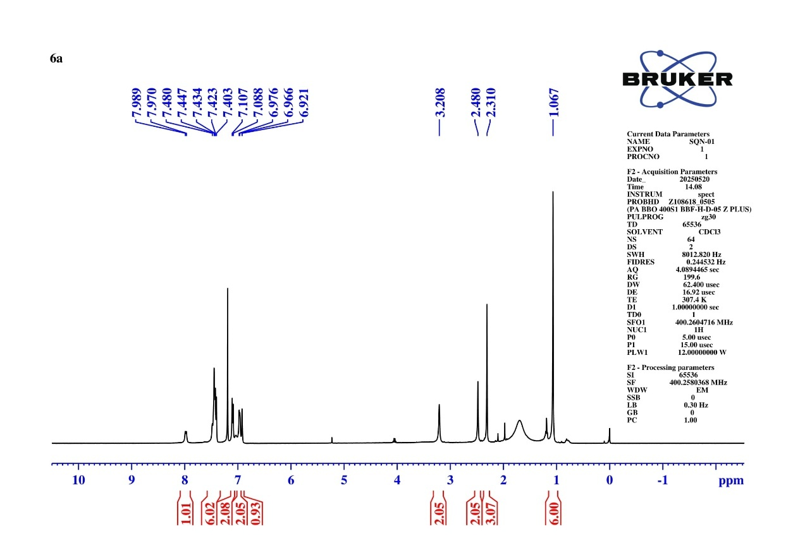
Fig S4 ¹H NMR Spectrum of N-(6,6-dimethyl-8-oxo-9-phenyl-5,6,7,8-tetrahydroacridin-2-yl)-4-methylbenzenesulfonamide (6a)
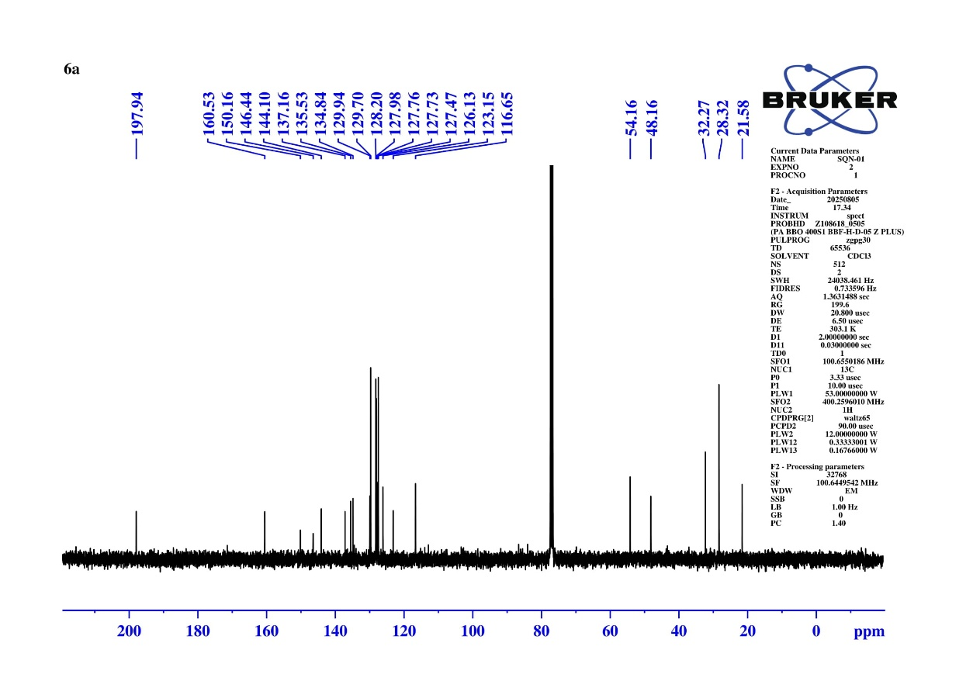
Fig S5 ¹³C NMR Spectrum of N-(6,6-dimethyl-8-oxo-9-phenyl-5,6,7,8-tetrahydroacridin-2-yl)-4-methylbenzenesulfonamide (6a)
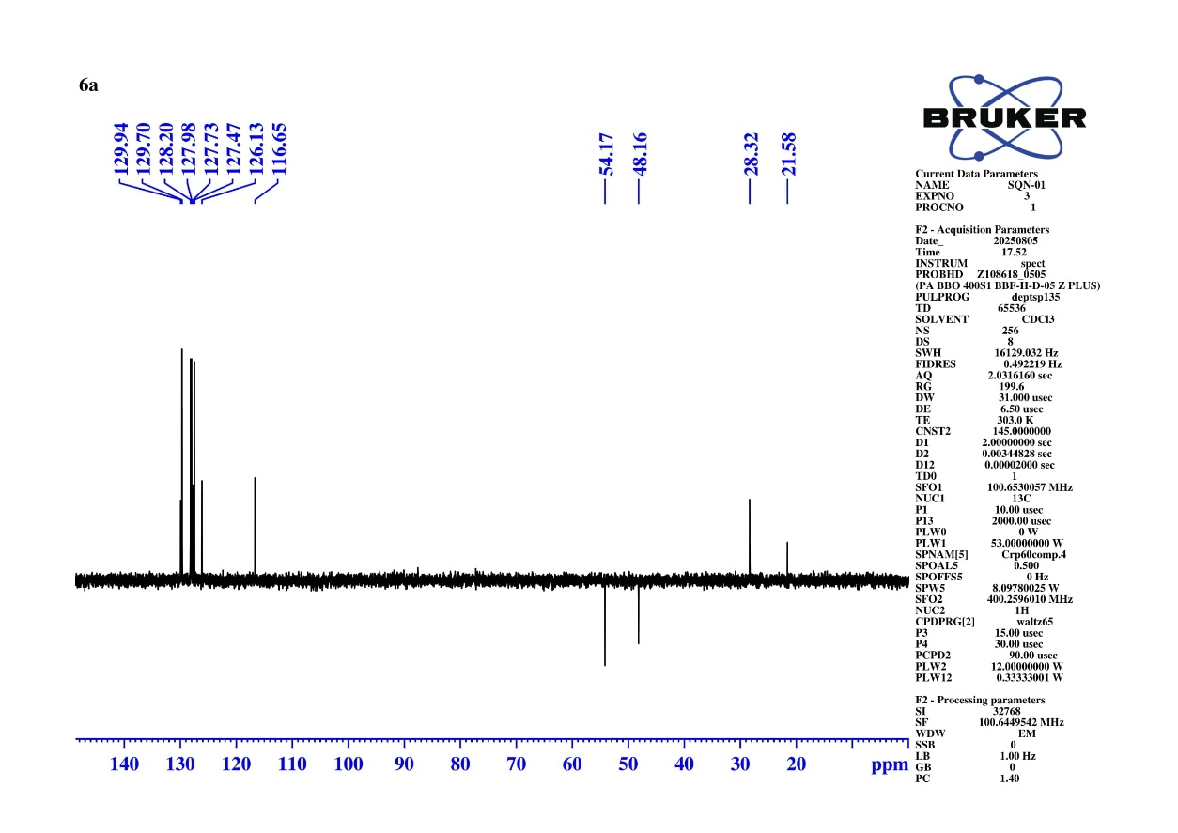
Fig S6 DEPT-135 NMR Spectrum of N-(6,6-dimethyl-8-oxo-9-phenyl-5,6,7,8-tetrahydroacridin-2-yl)-4-methylbenzenesulfonamide (6a)
Calculated Exact Mass = 471.1742
[M+H] = 471.174
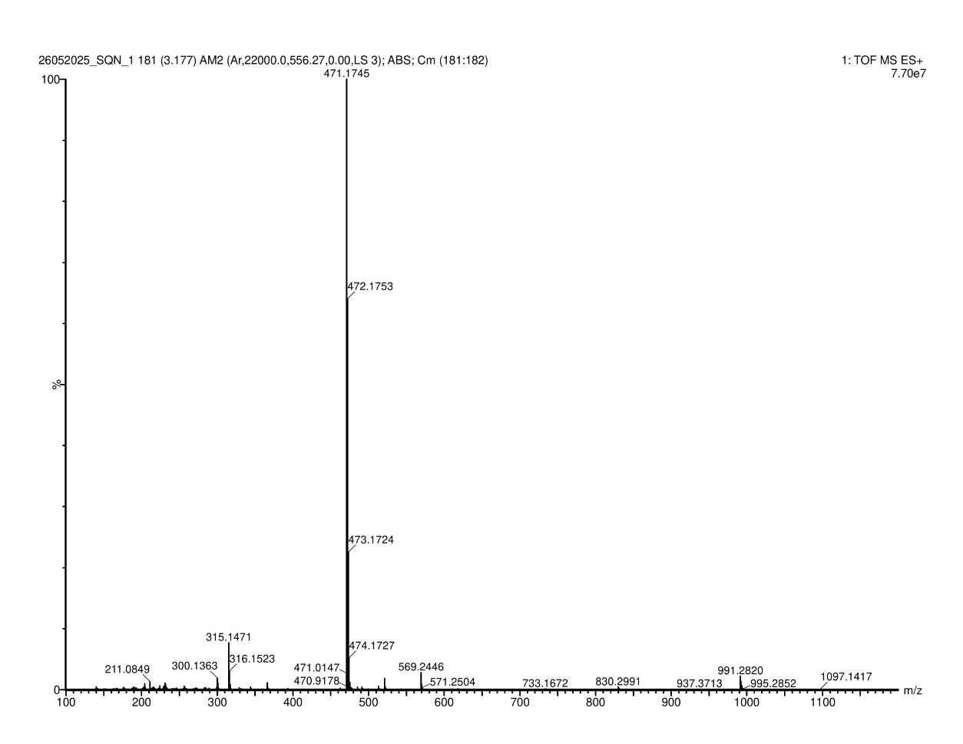
Fig S7 HRMS Spectrum of N-(6,6-dimethyl-8-oxo-9-phenyl-5,6,7,8-tetrahydroacridin-2-yl)-4-methylbenzenesulfonamide (6a)
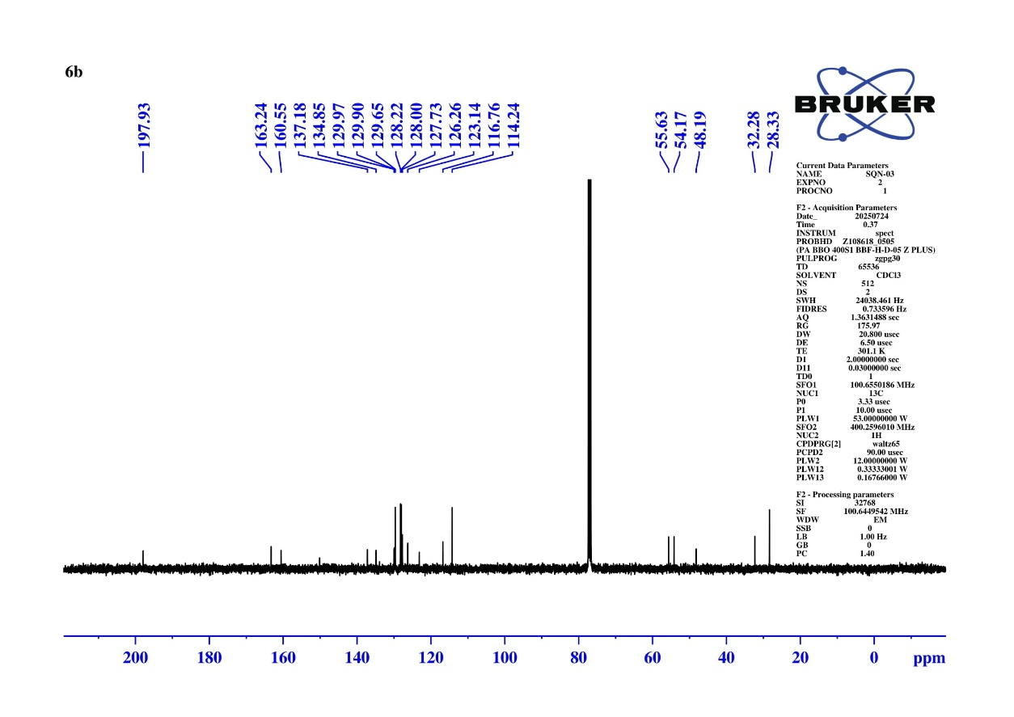
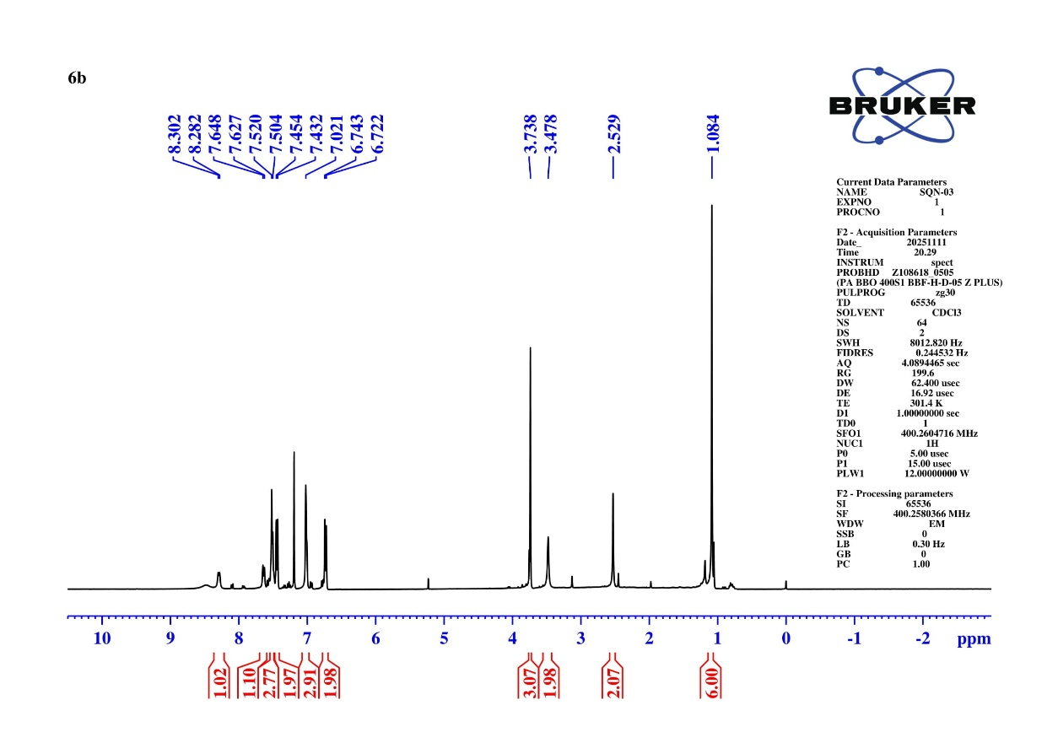
Fig S8 ¹H NMR Spectrum of N-(6,6-dimethyl-8-oxo-9-phenyl-5,6,7,8-tetrahydroacridin-2-yl)-4-methoxybenzenesulfonamide (6b)
Fig S9 ¹³C NMR Spectrum of N-(6,6-dimethyl-8-oxo-9-phenyl-5,6,7,8-tetrahydroacridin-2-yl)-4-methoxybenzenesulfonamide (6b)
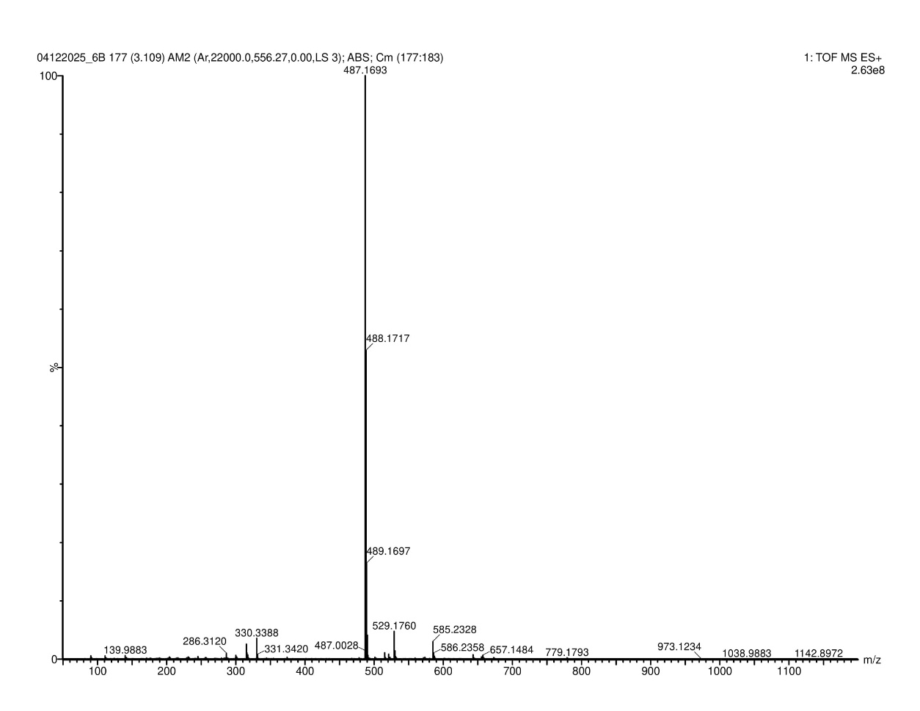
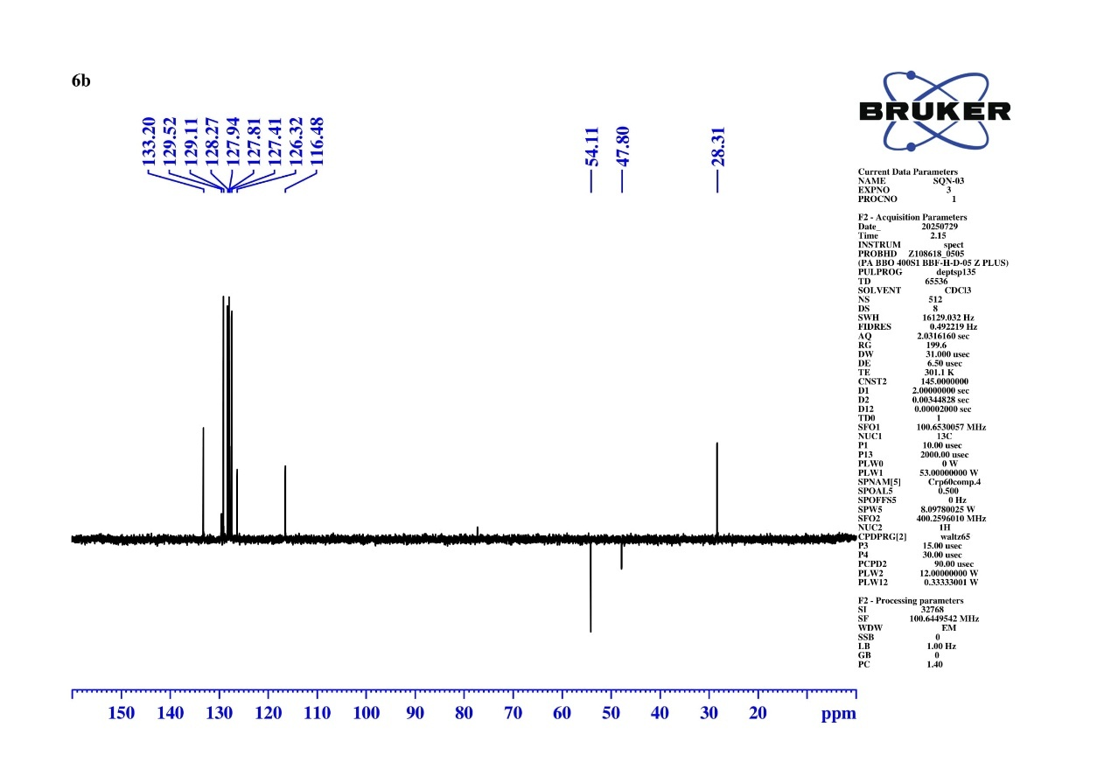
Fig S10 DEPT-135 NMR Spectrum of N-(6,6-dimethyl-8-oxo-9-phenyl-5,6,7,8-tetrahydroacridin-2-yl)-4-methoxybenzenesulfonamide (6b)
Calculated Exact Mass = 487.1691
[M+H] = 487.1693
Fig S11 HRMS Spectrum of N-(6,6-dimethyl-8-oxo-9-phenyl-5,6,7,8-tetrahydroacridin-2-yl)-4-methoxybenzenesulfonamide (6b)
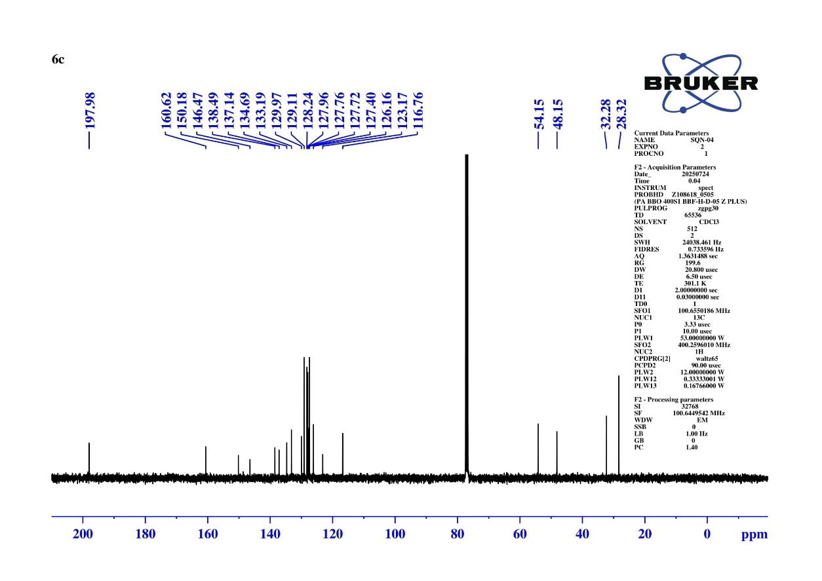
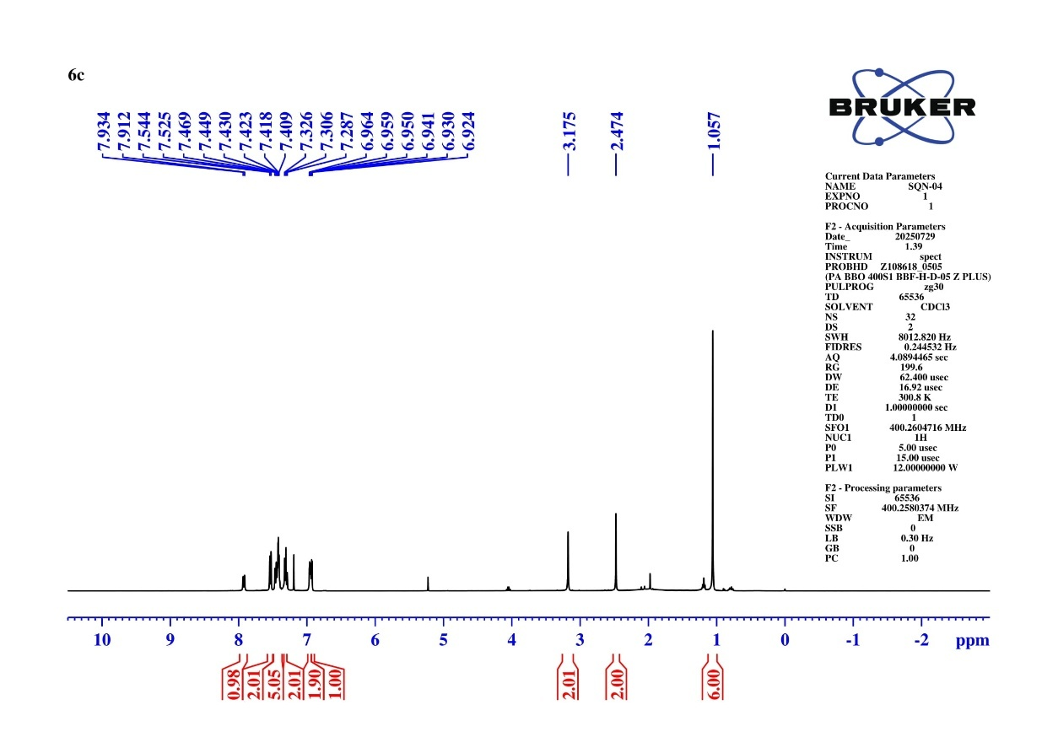
Fig S12 ¹H NMR spectrum of N-(6,6-dimethyl-8-oxo-9-phenyl-5,6,7,8-tetrahydroacridin-2-yl) benzenesulfonamide (6c)
Fig 13 ¹³C NMR spectrum of N-(6,6-dimethyl-8-oxo-9-phenyl-5,6,7,8-tetrahydroacridin-2-yl) benzenesulfonamide (6c)

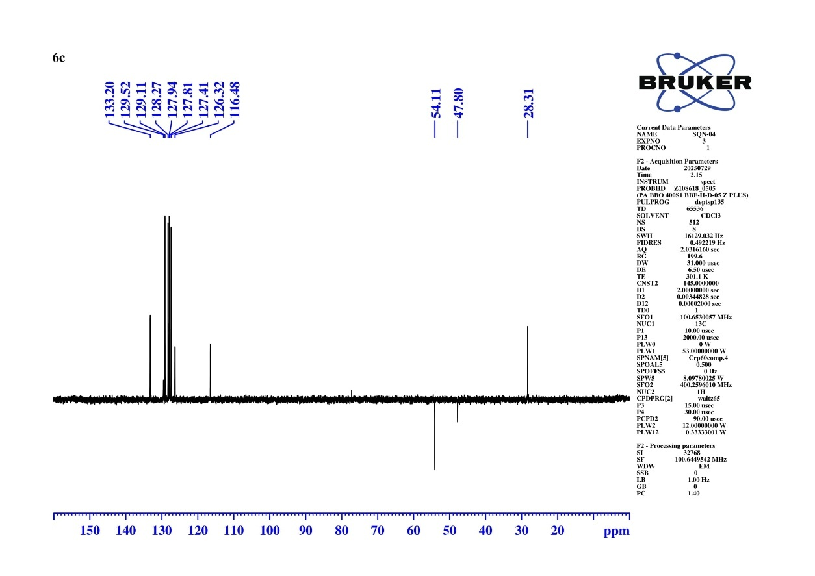
Fig S15 DEPT-135 spectrum of N-(6,6-dimethyl-8-oxo-9-phenyl-5,6,7,8-tetrahydroacridin-2-yl) benzenesulfonamide (6c)
Calculated Exact Mass = 457.1585
[M+H] = 457.1587
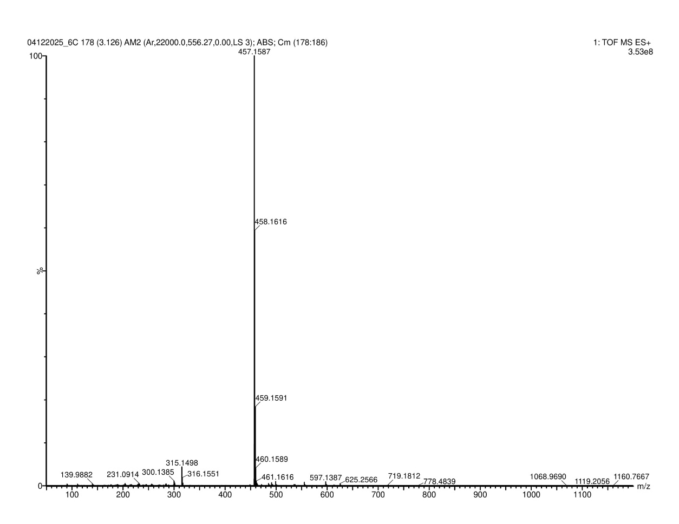
Fig S16 HRMS spectrum of N-(6,6-dimethyl-8-oxo-9-phenyl-5,6,7,8-tetrahydroacridin-2-yl) benzenesulfonamide (6c)
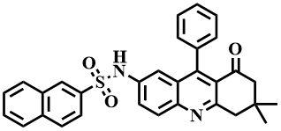
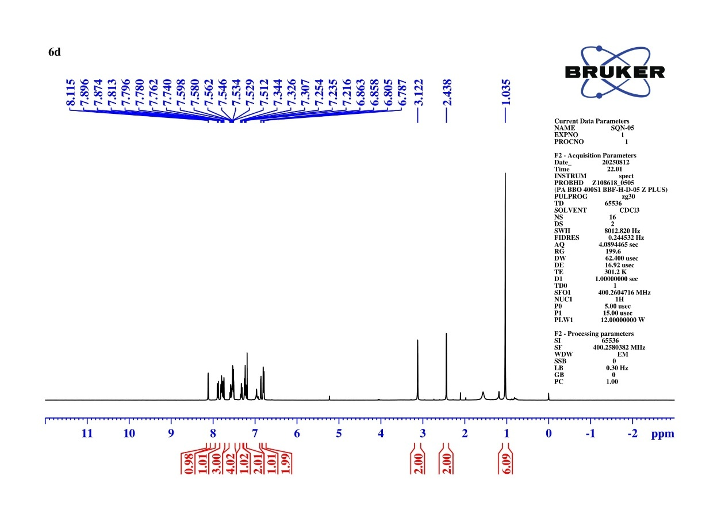
Fig S17 ¹H NMR Spectrum of N-(6,6-dimethyl-8-oxo-9-phenyl-5,6,7,8-tetrahydroacridin-2-yl) naphthalene-2-sulfonamide (6d)
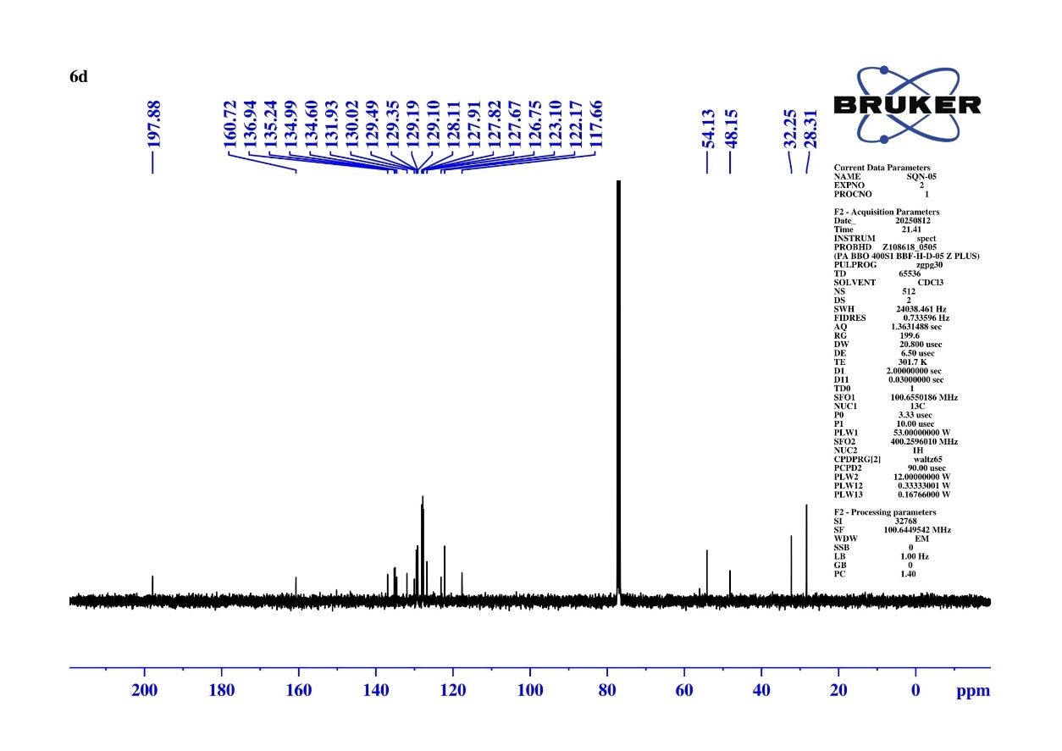
Fig S18 ¹³C NMR Spectrum of N-(6,6-dimethyl-8-oxo-9-phenyl-5,6,7,8-tetrahydroacridin-2-yl) naphthalene-2-sulfonamide (6d)

Fig 19 DEPT-135 NMR Spectrum of N-(6,6-dimethyl-8-oxo-9-phenyl-5,6,7,8-tetrahydroacridin-2-yl) naphthalene-2-sulfonamide (6d)
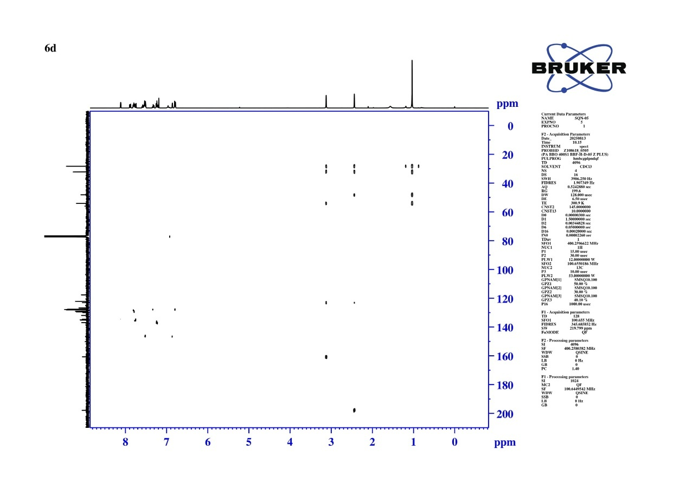
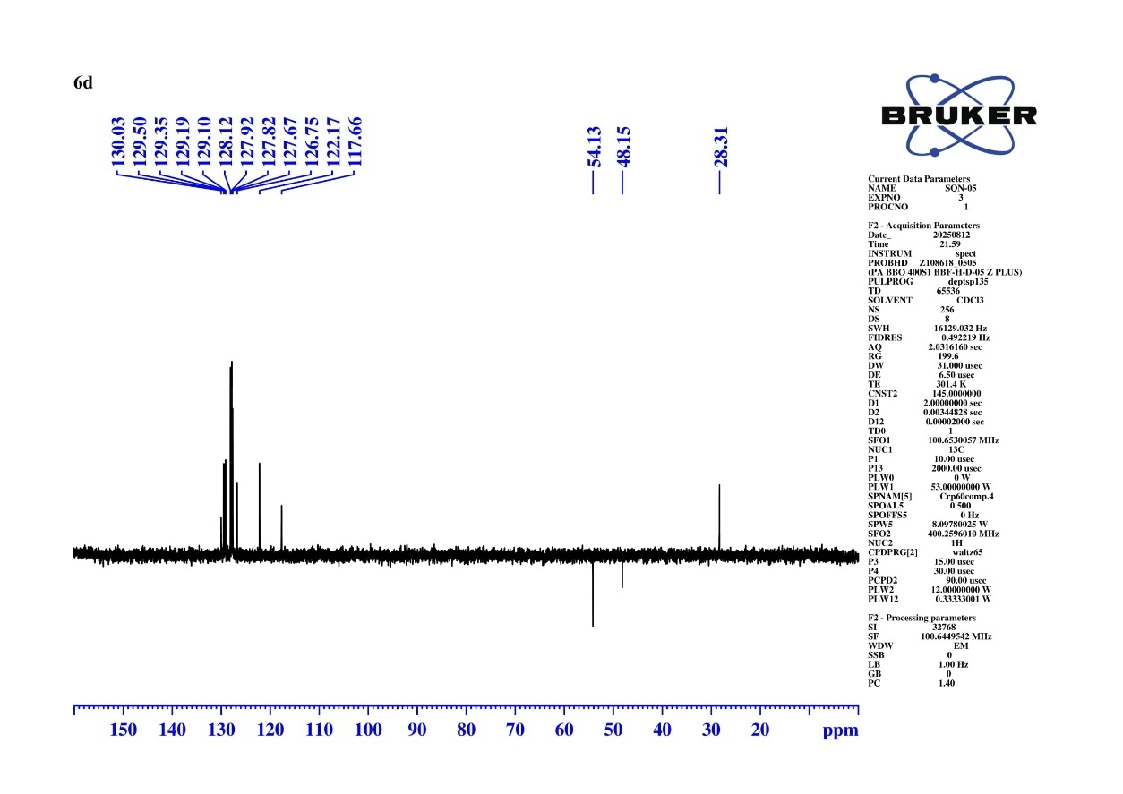
Fig S20 HMBC NMR Spectrum of N-(6,6-dimethyl-8-oxo-9-phenyl-5,6,7,8-tetrahydroacridin-2-yl) naphthalene-2-sulfonamide (6d)
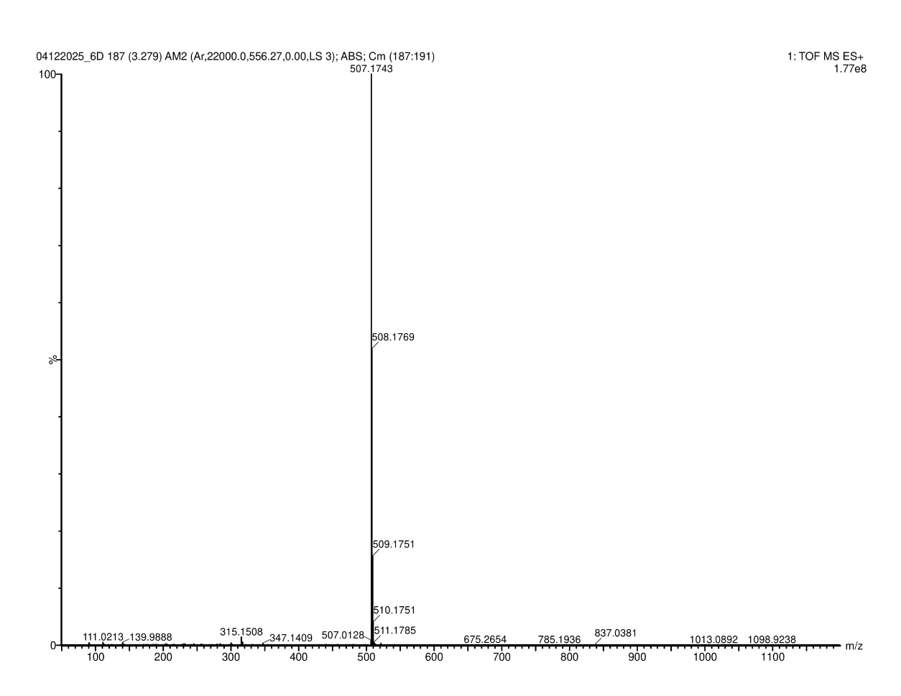
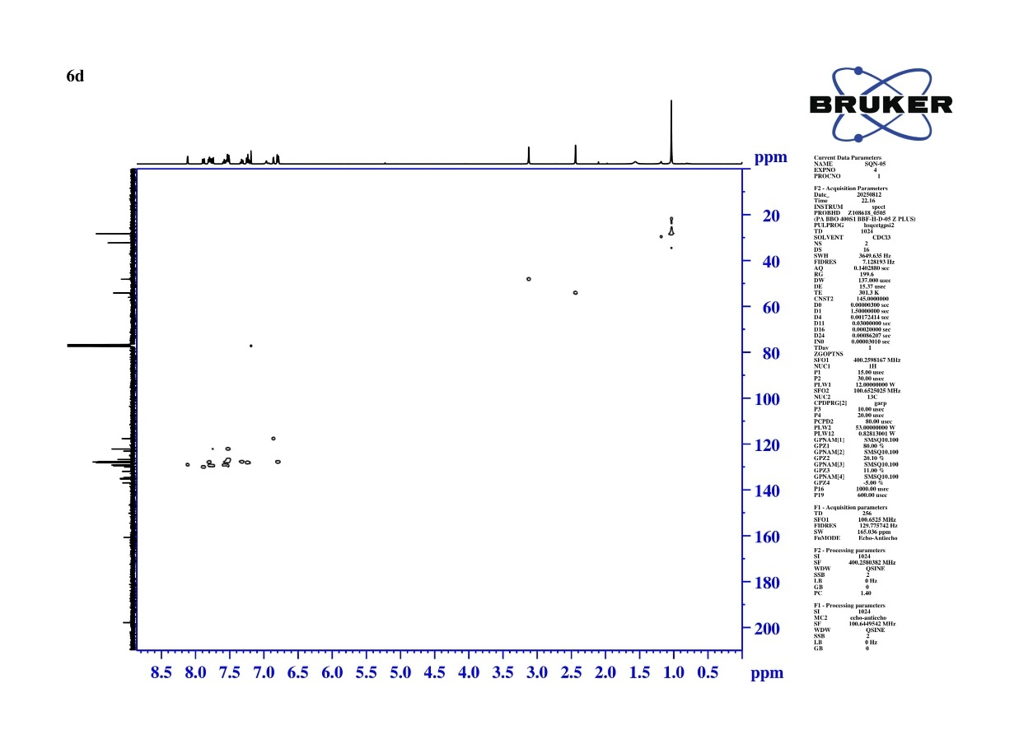
Fig S21 HSQC NMR Spectrum of N-(6,6-dimethyl-8-oxo-9-phenyl-5,6,7,8-tetrahydroacridin-2-yl) naphthalene-2-sulfonamide (6d)
Calculated Exact Mass = 507.1742
[M+H] = 507.1743
Fig S22 HRMS Spectrum of N-(6,6-dimethyl-8-oxo-9-phenyl-5,6,7,8-tetrahydroacridin-2-yl) naphthalene-2-sulfonamide (6d)
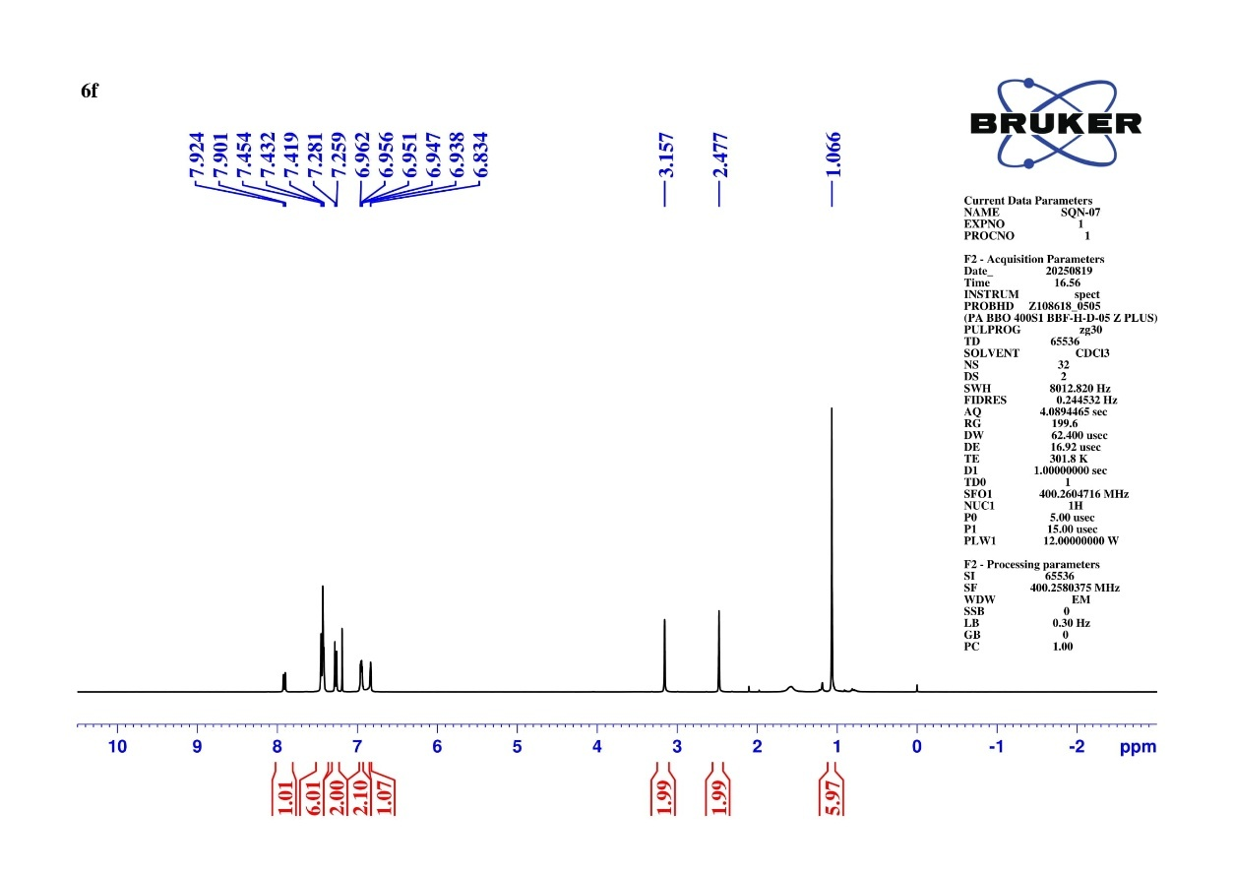
Fig S27 ¹H NMR Spectrum of 4-chloro-N-(6,6-dimethyl-8-oxo-9-phenyl-5,6,7,8-tetrahydroacridin-2-yl) benzenesulfonamide (6f)
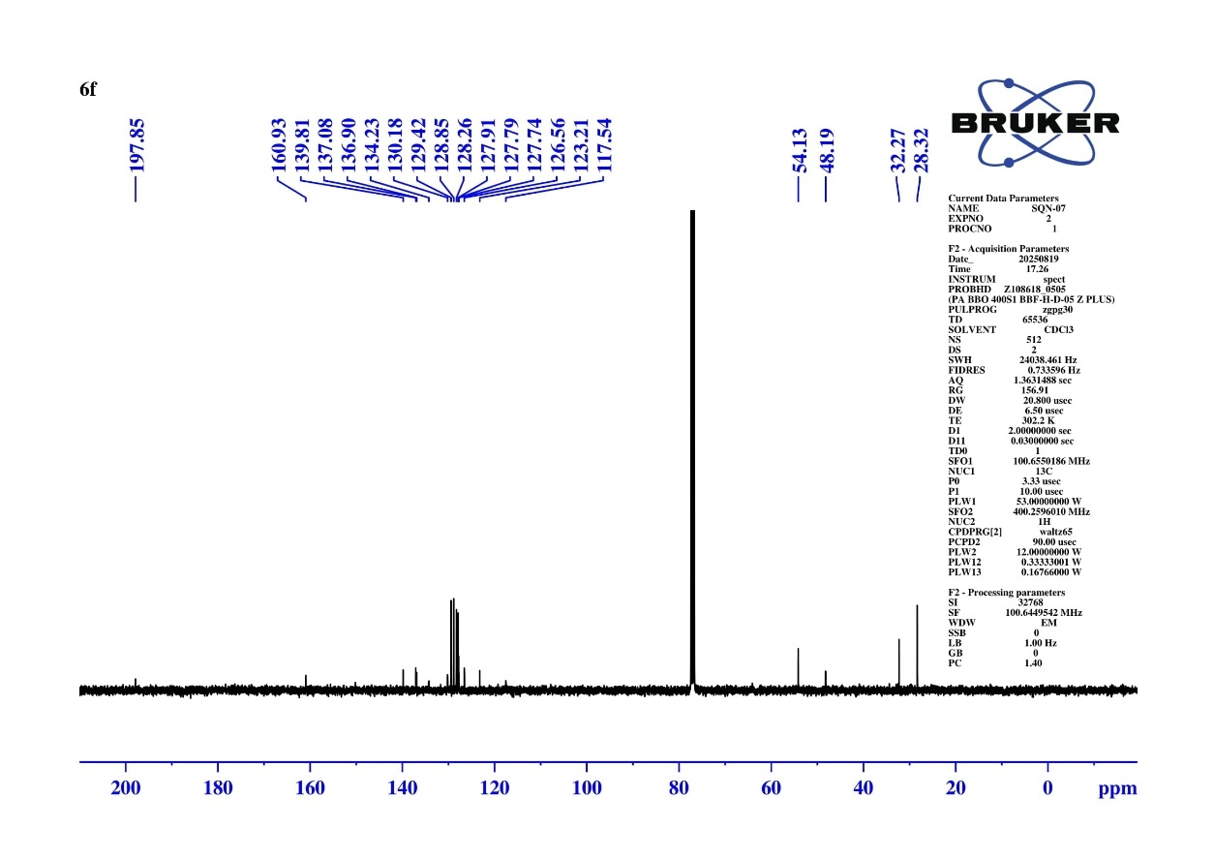
Fig S28 ¹³C NMR Spectrum of 4-chloro-N-(6,6-dimethyl-8-oxo-9-phenyl-5,6,7,8-tetrahydroacridin-2-yl) benzenesulfonamide (6f)

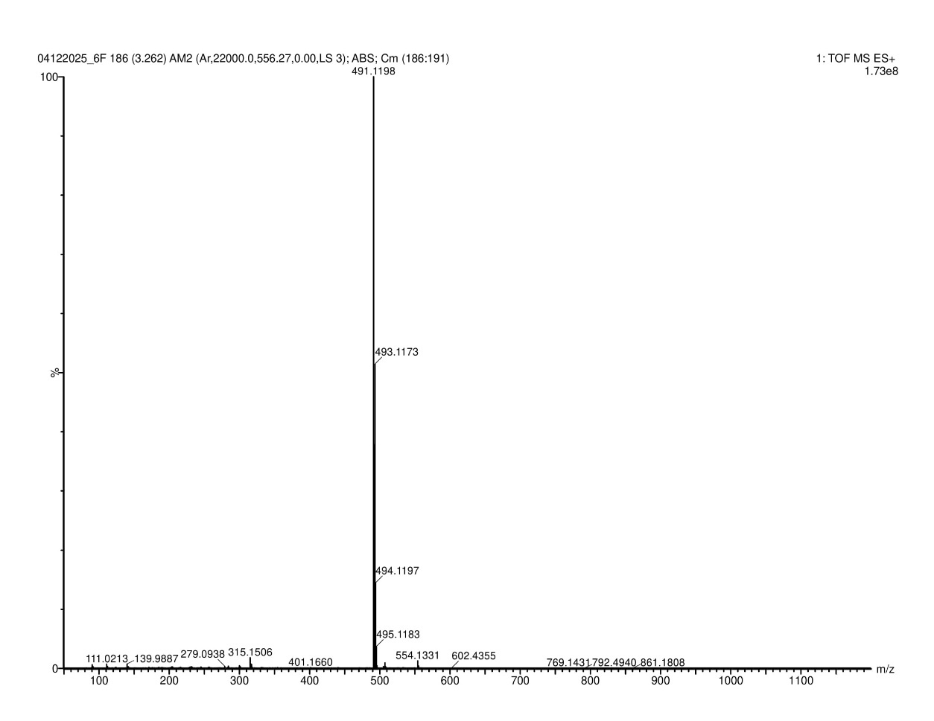
Fig S29 DEPT-135 NMR Spectrum of 4-chloro-N-(6,6-dimethyl-8-oxo-9-phenyl-5,6,7,8-tetrahydroacridin-2-yl) benzenesulfonamide (6f)
Calculated Exact Mass = 491.1198
[M+H] = 491.1198
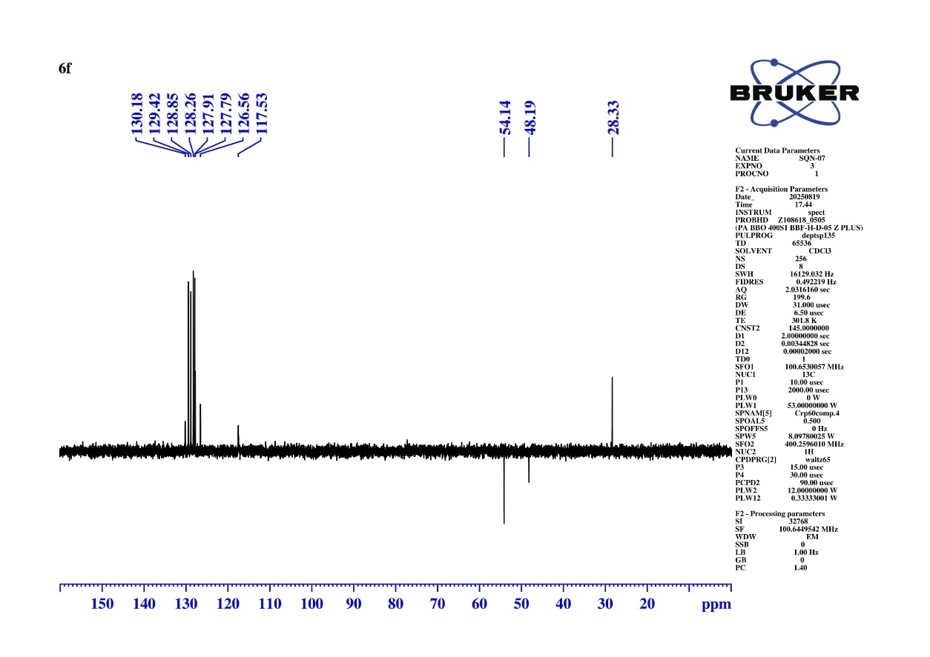
Fig 30 HRMS Spectrum of 4-chloro-N-(6,6-dimethyl-8-oxo-9-phenyl-5,6,7,8-tetrahydroacridin-2-yl) benzenesulfonamide (6f)
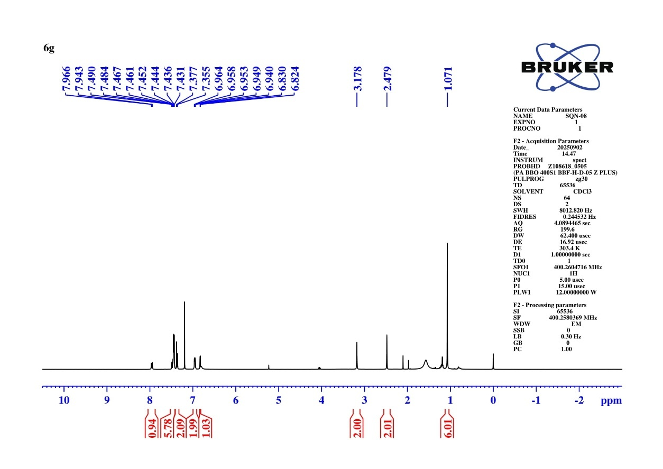
Fig S31 ¹H NMR Spectrum of 4-bromo-N-(6,6-dimethyl-8-oxo-9-phenyl-5,6,7,8-tetrahydroacridin-2-yl) benzenesulfonamide (6g)
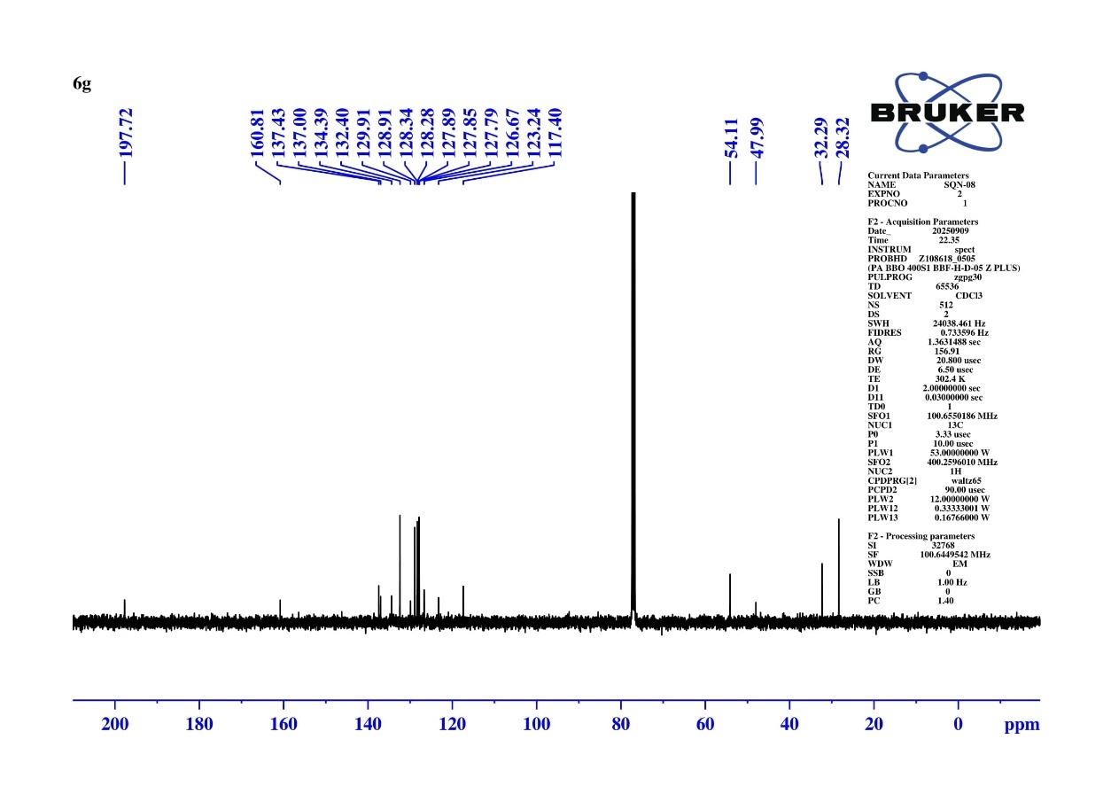
Fig S32 ¹³C NMR Spectrum of 4-bromo-N-(6,6-dimethyl-8-oxo-9-phenyl-5,6,7,8-tetrahydroacridin-2-yl) benzenesulfonamide (6g)
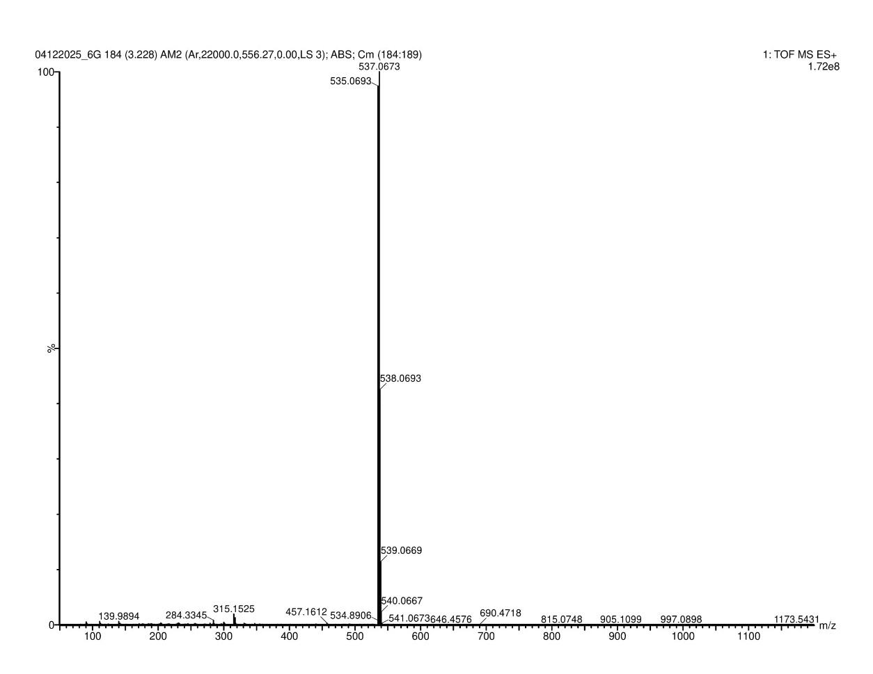
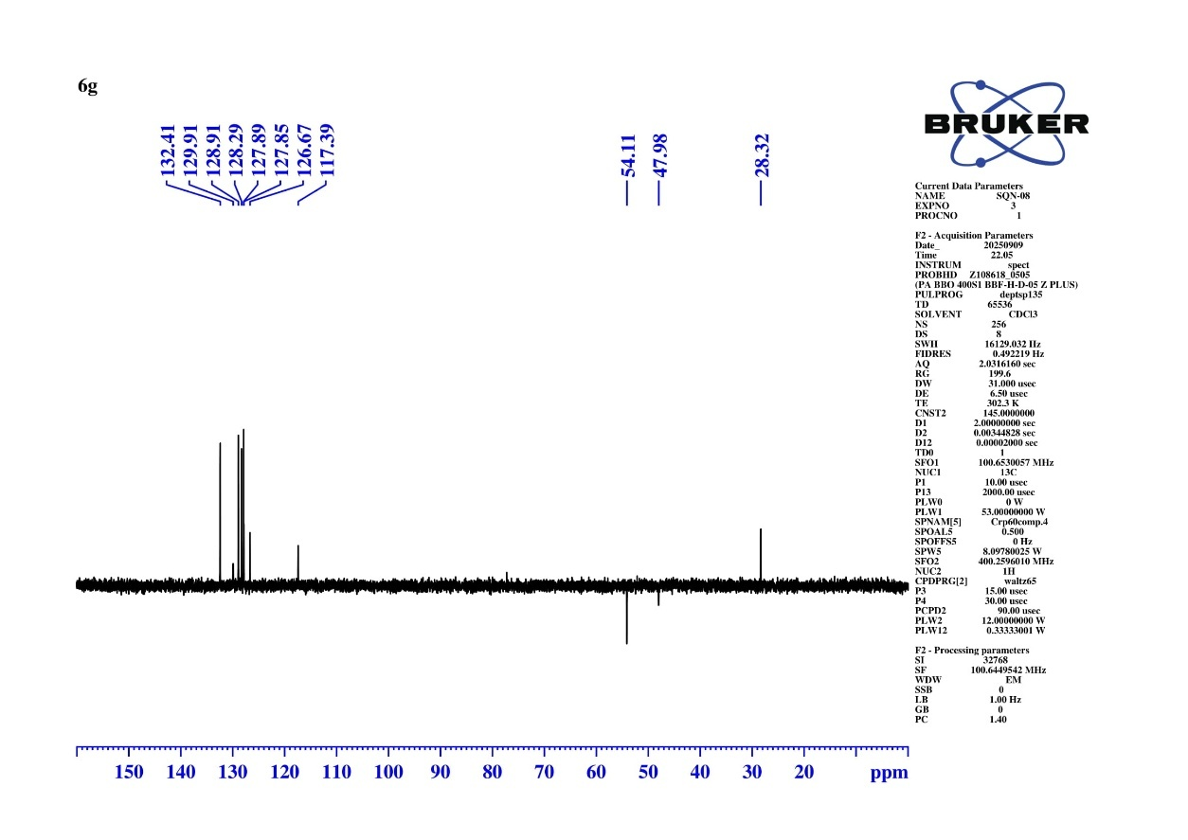
Fig S33 DEPT-135 NMR Spectrum of 4-bromo-N-(6,6-dimethyl-8-oxo-9-phenyl-5,6,7,8-tetrahydroacridin-2-yl) benzenesulfonamide (6g)
Calculated Exact Mass = 535.0691
[M+H] = 535.0693
Fig S34 HRMS Spectrum of 4-bromo-N-(6,6-dimethyl-8-oxo-9-phenyl-5,6,7,8-tetrahydroacridin-2-yl) benzenesulfonamide (6g)
Fig S35 ¹H NMR Spectrum N-(6,6-dimethyl-8-oxo-9-phenyl-5,6,7,8-tetrahydroacridin-2-yl)-2-nitrobenzenesulfonamide (6h)
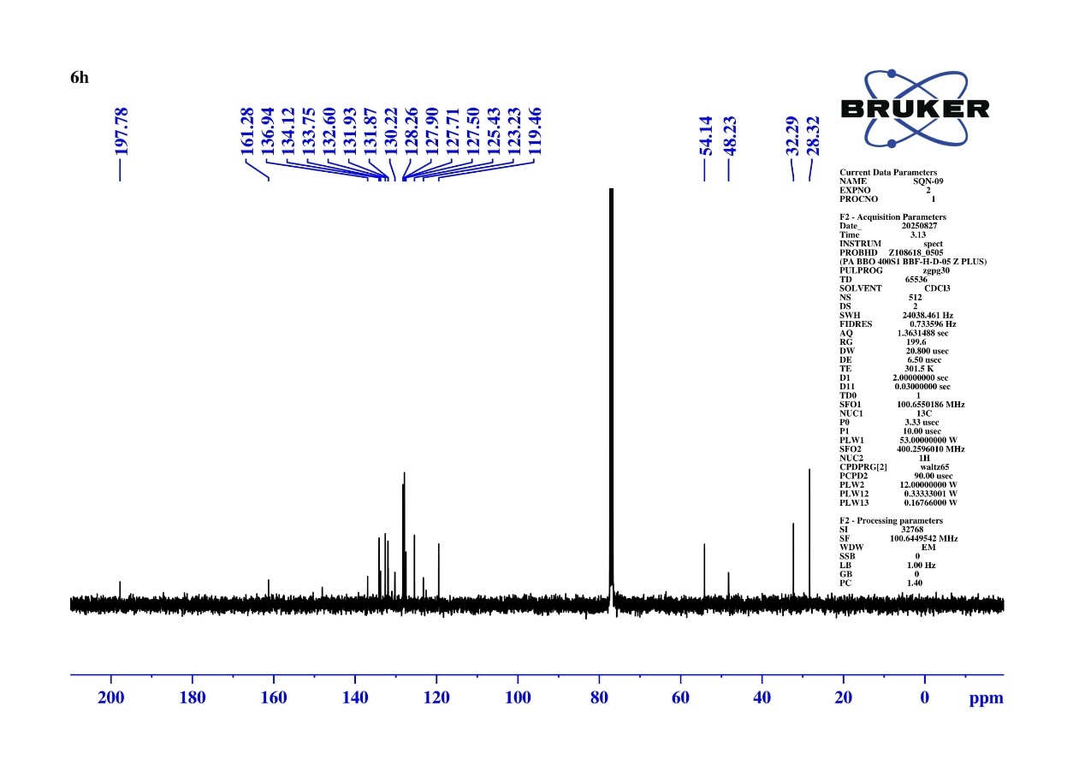
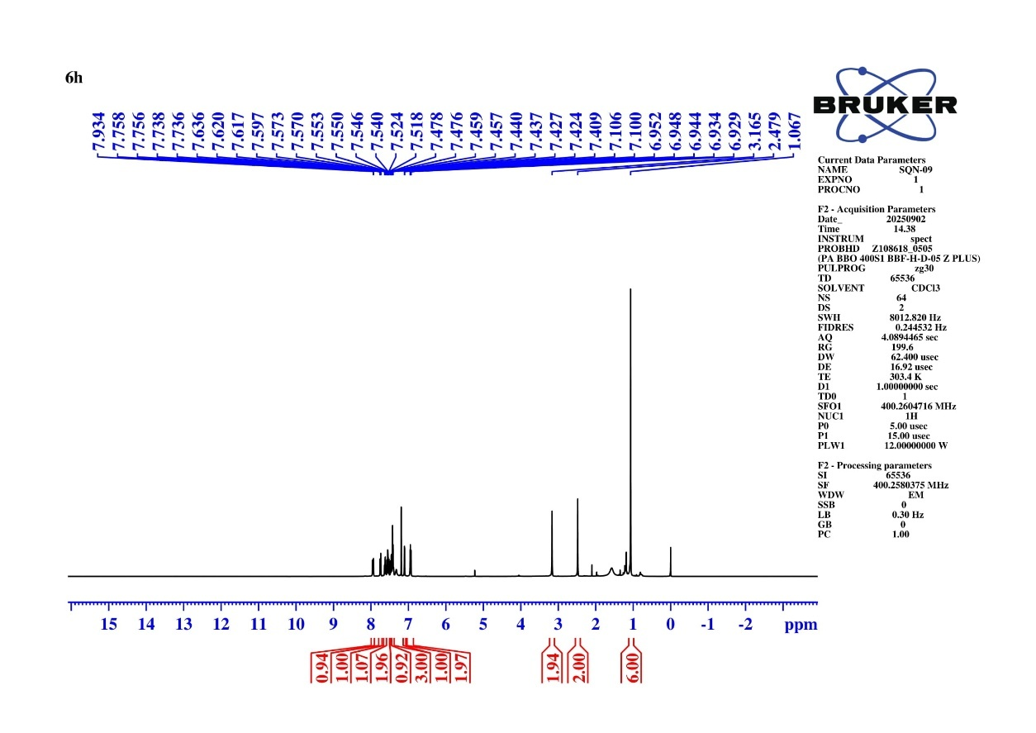
Fig S36 ¹³C NMR Spectrum N-(6,6-dimethyl-8-oxo-9-phenyl-5,6,7,8-tetrahydroacridin-2-yl)-2-nitrobenzenesulfonamide (6h)
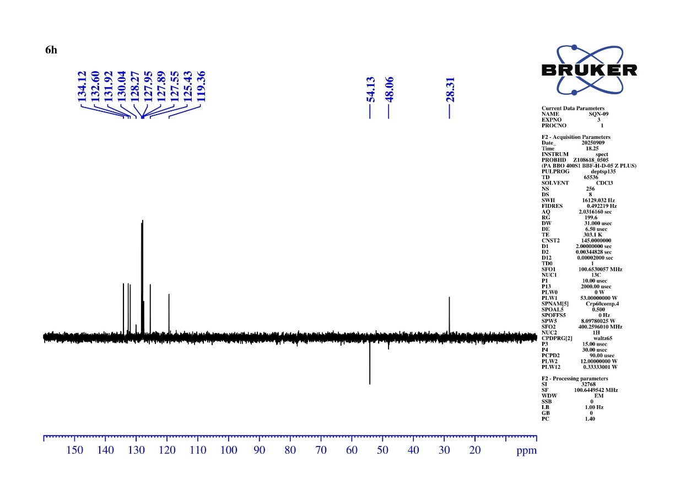
Fig 37 DEPT-135 NMR Spectrum N-(6,6-dimethyl-8-oxo-9-phenyl-5,6,7,8-tetrahydroacridin-2-yl)-2-nitrobenzenesulfonamide (6h)
Calculated Exact Mass = 502.1436
[M+H] = 502.1437
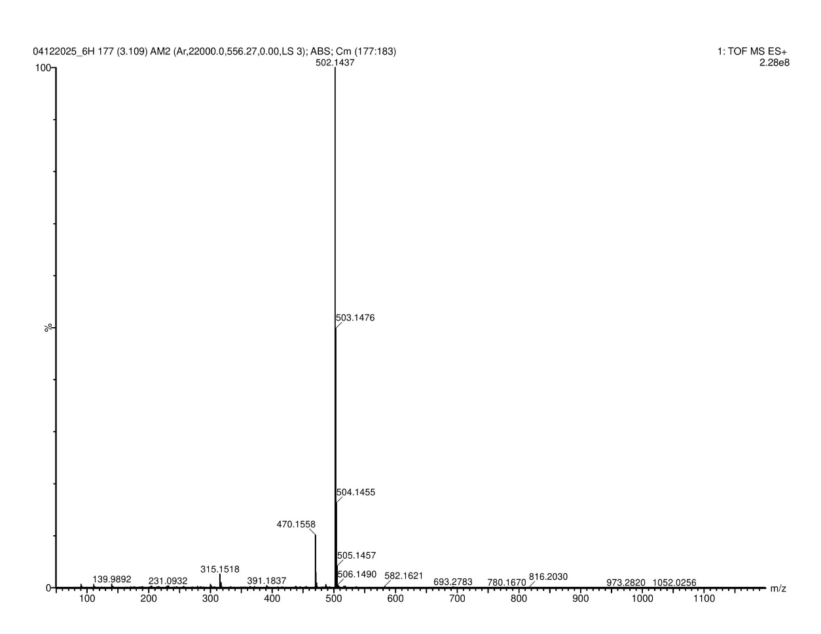
Fig HRMS Spectrum N-(6,6-dimethyl-8-oxo-9-phenyl-5,6,7,8-tetrahydroacridin-2-yl)-2-nitrobenzenesulfonamide (6h)
Fig S38 ¹H NMR Spectrum N-(6,6-dimethyl-8-oxo-9-phenyl-5,6,7,8-tetrahydroacridin-2-yl)-4-iodobenzenesulfonamide (6i)

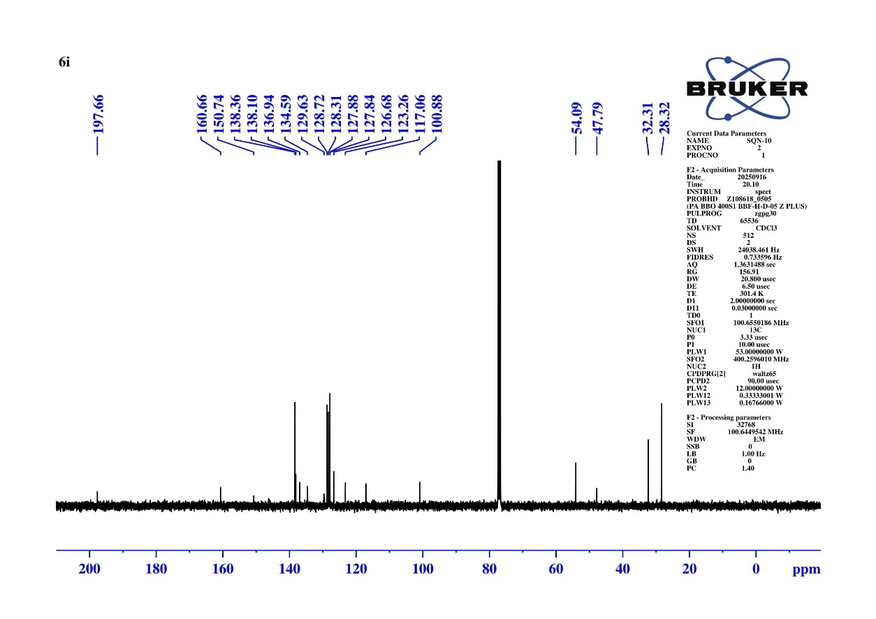
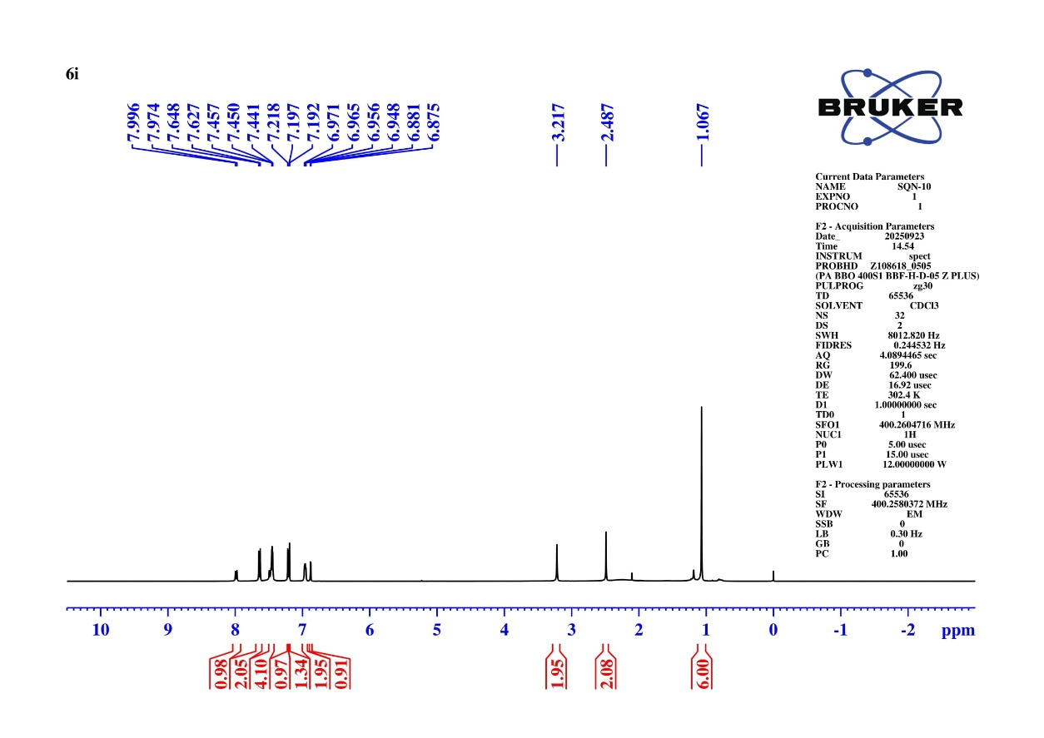
Fig S39 ¹³C NMR Spectrum N-(6,6-dimethyl-8-oxo-9-phenyl-5,6,7,8-tetrahydroacridin-2-yl)-4-iodobenzenesulfonamide (6i)
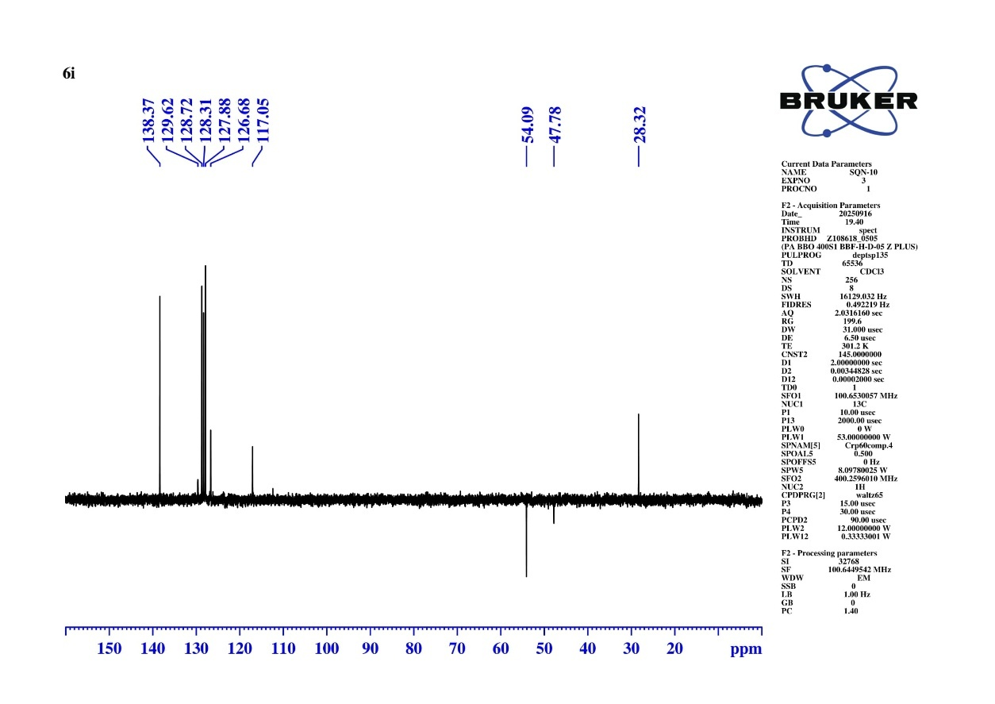
Fig S40 DEPT-135 NMR Spectrum N-(6,6-dimethyl-8-oxo-9-phenyl-5,6,7,8-tetrahydroacridin-2-yl)-4-iodobenzenesulfonamide (6i)
Calculated Exact Mass = 583.0552
[M+H] = 583.0551
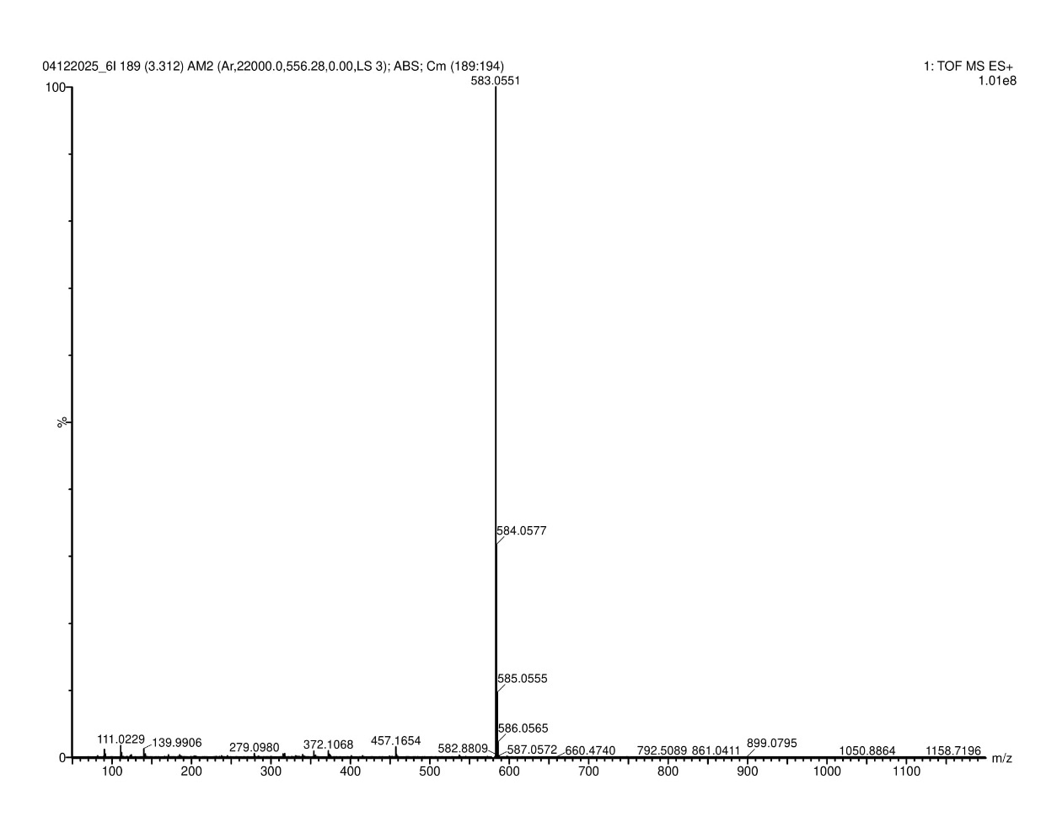
Fig S41 HRMS Spectrum N-(6,6-dimethyl-8-oxo-9-phenyl-5,6,7,8-tetrahydroacridin-2-yl)-4-iodobenzenesulfonamide (6i)
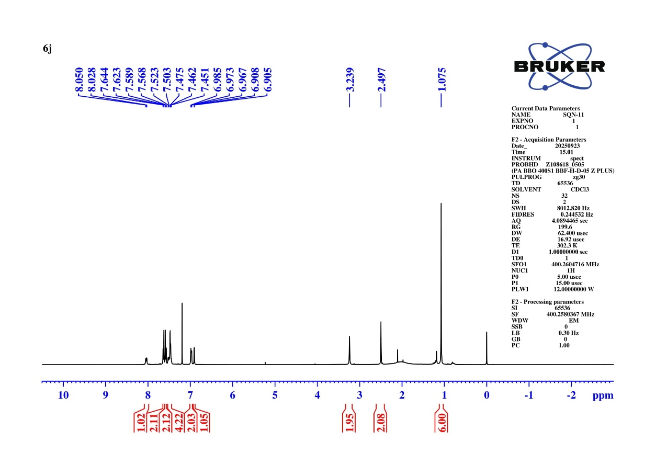
Fig S42 ¹H NMR Spectrum of 4-cyano-N-(6,6-dimethyl-8-oxo-9-phenyl-5,6,7,8-tetrahydroacridin-2-yl) benzenesulfonamide (6j)
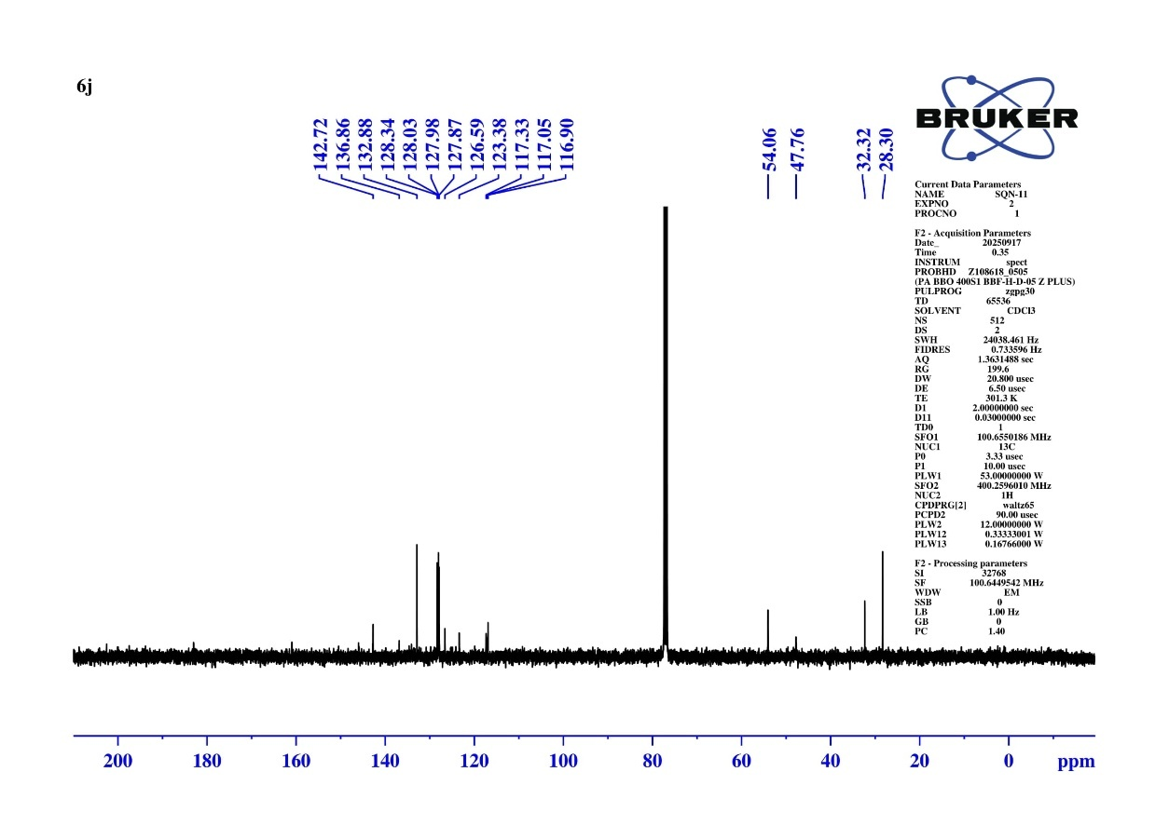
Fig S43 ¹³C NMR Spectrum of 4-cyano-N-(6,6-dimethyl-8-oxo-9-phenyl-5,6,7,8-tetrahydroacridin-2-yl) benzenesulfonamide (6j)
Fig S44 DEPT-135 NMR Spectrum of 4-cyano-N-(6,6-dimethyl-8-oxo-9-phenyl-5,6,7,8-tetrahydroacridin-2-yl) benzenesulfonamide (6j)
Calculated Exact Mass = 482.1538
[M+H] = 482.1537
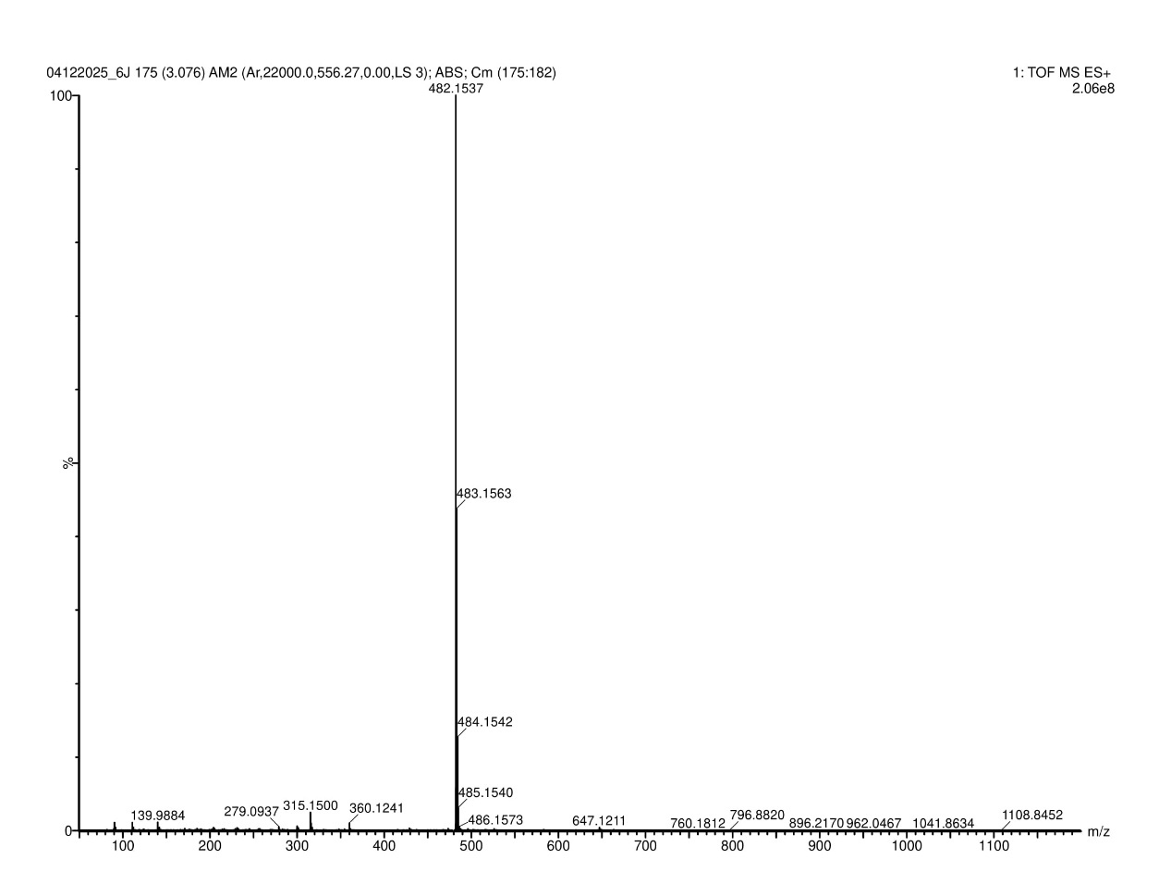
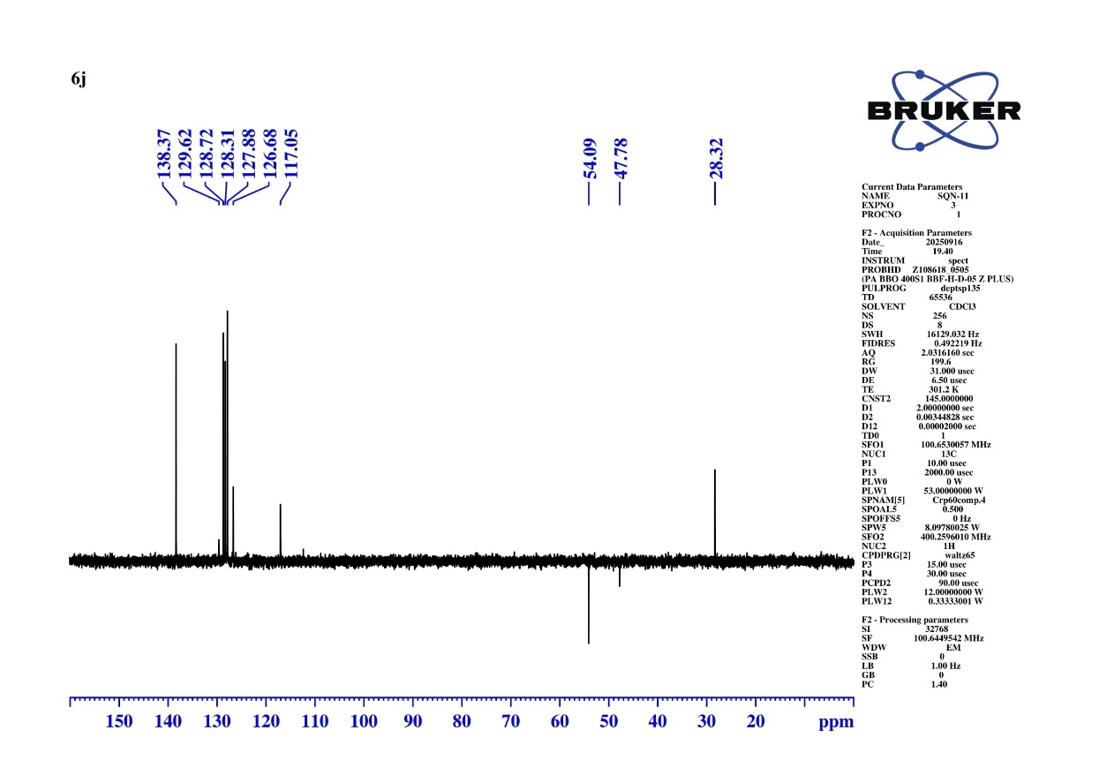
Fig S45 HRMS Spectrum of 4-cyano-N-(6,6-dimethyl-8-oxo-9-phenyl-5,6,7,8-tetrahydroacridin-2-yl) benzenesulfonamide (6j)
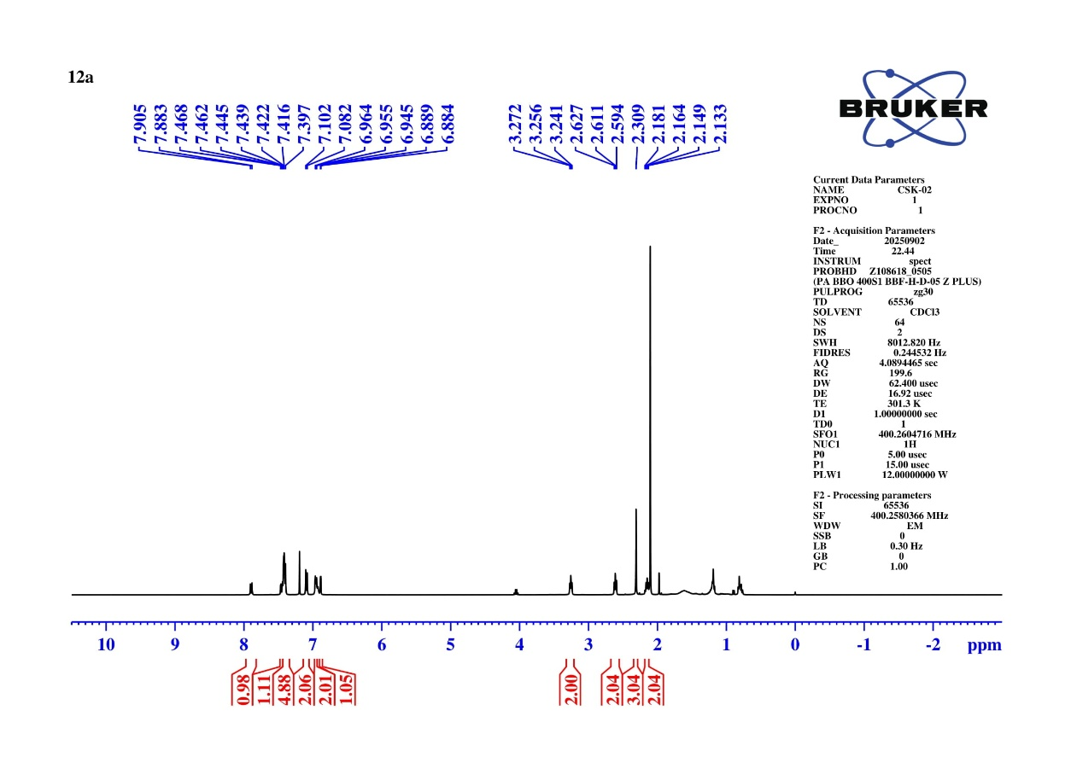
Fig S46 ¹H NMR Spectrum of 4-methyl-N-(8-oxo-9-phenyl-5,6,7,8-tetrahydroacridin-2-yl) benzenesulfonamide (10a)
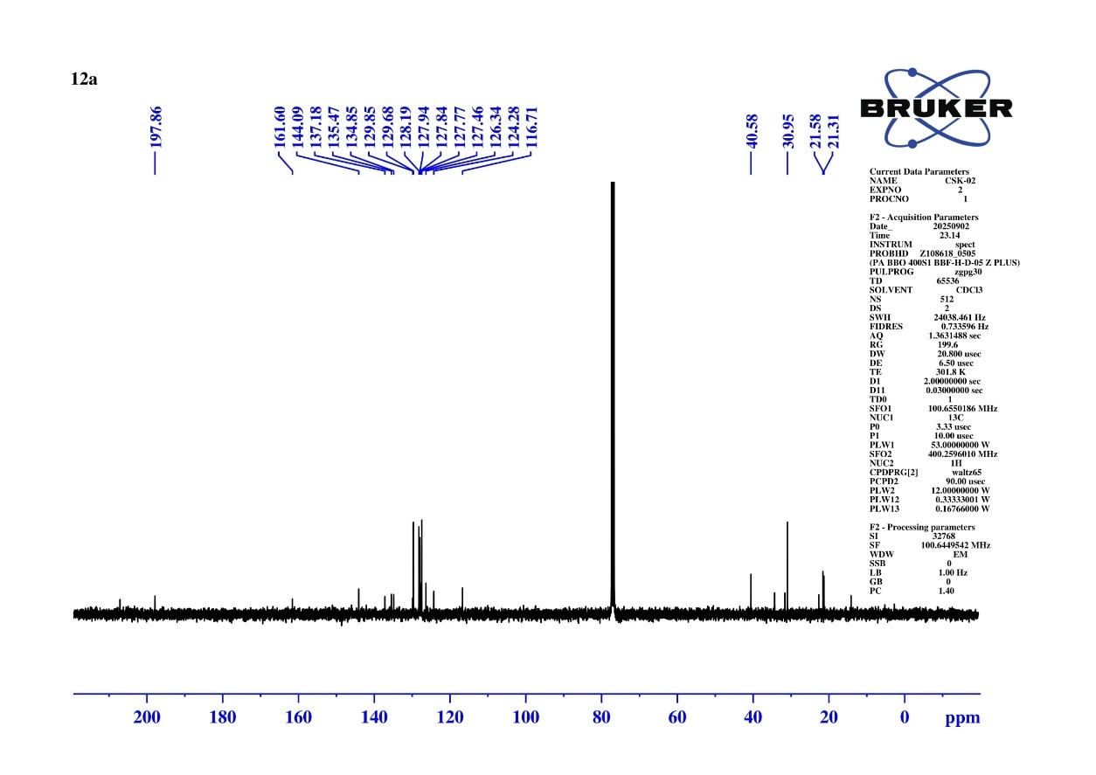
Fig S47 ¹³C NMR Spectrum of 4-methyl-N-(8-oxo-9-phenyl-5,6,7,8-tetrahydroacridin-2-yl) benzenesulfonamide (10a)
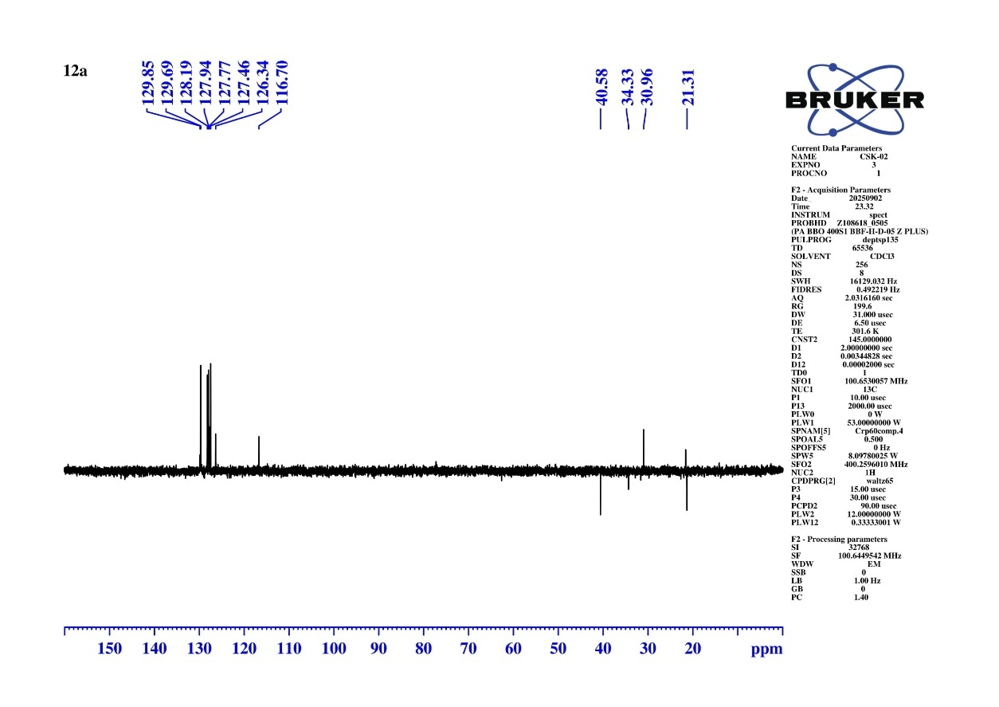
Fig S48 DEPT-135 Spectrum of 4-methyl-N-(8-oxo-9-phenyl-5,6,7,8-tetrahydroacridin-2-yl) benzenesulfonamide (10a)
Calculated Exact Mass = 443.1429
[M+H] = 443.1429
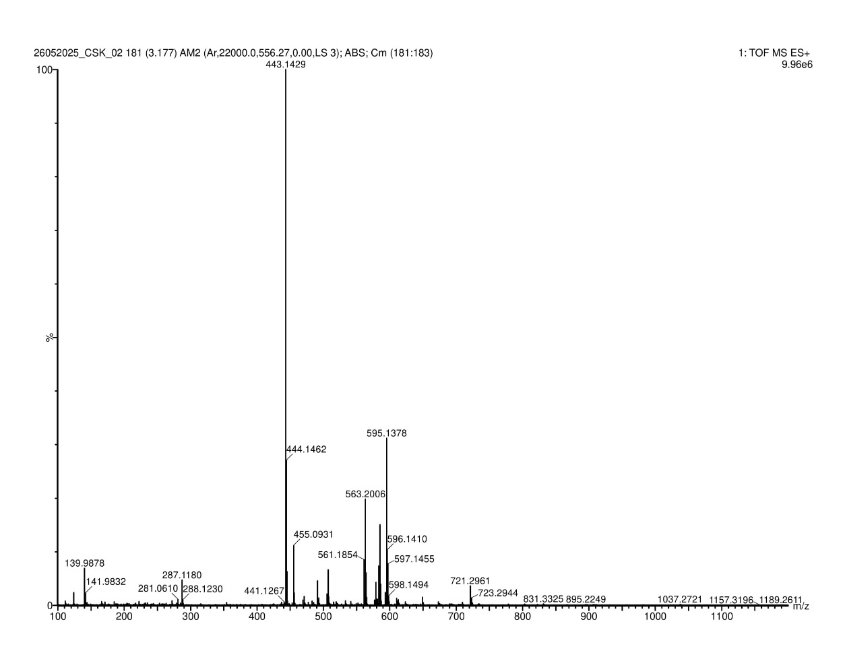
Fig S49 HRMS Spectrum of 4-methyl-N-(8-oxo-9-phenyl-5,6,7,8-tetrahydroacridin-2-yl) benzenesulfonamide (10a)
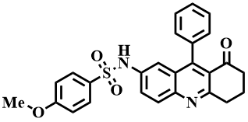
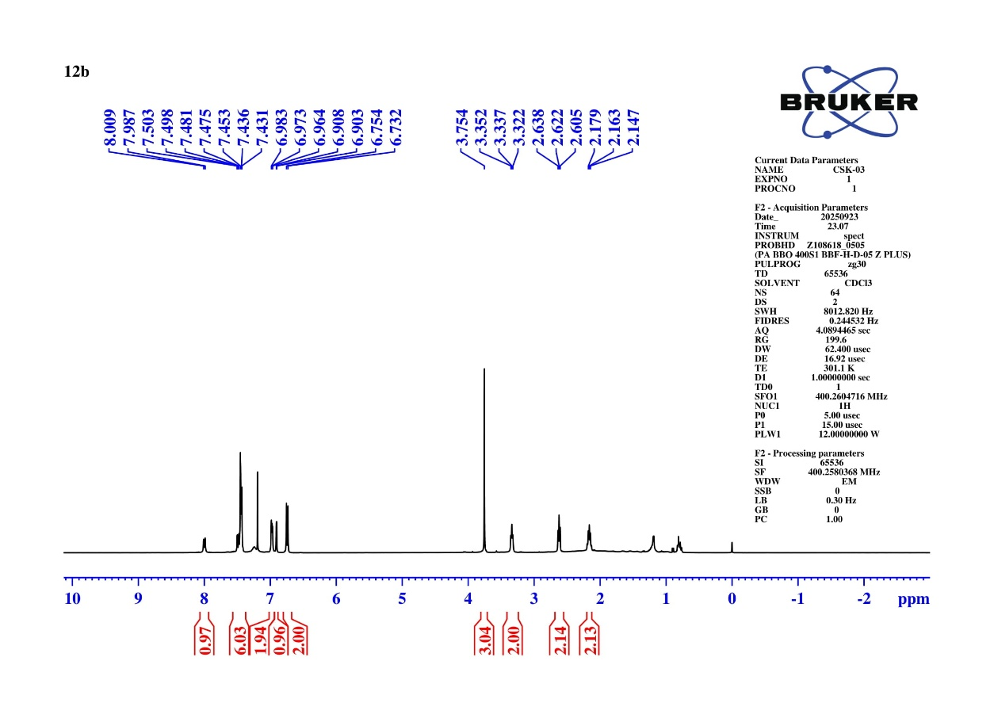
Fig S50 ¹H NMR Spectrum of 4-methoxy-N-(8-oxo-9-phenyl-5,6,7,8-tetrahydroacridin-2-yl) benzenesulfonamide (10b)

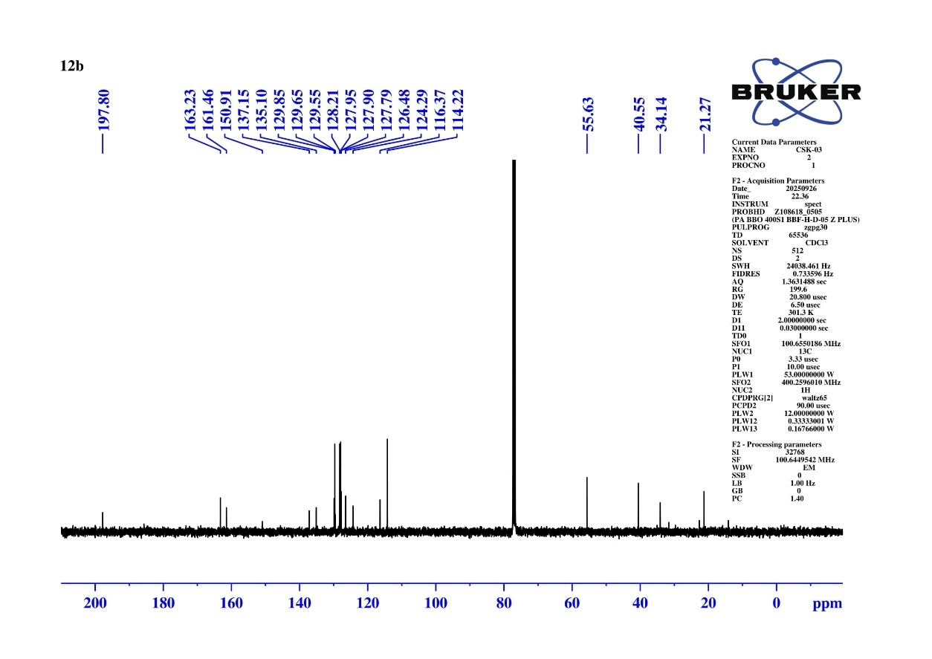
Fig S51 ¹³C NMR Spectrum of 4-methoxy-N-(8-oxo-9-phenyl-5,6,7,8-tetrahydroacridin-2-yl) benzenesulfonamide (10b)
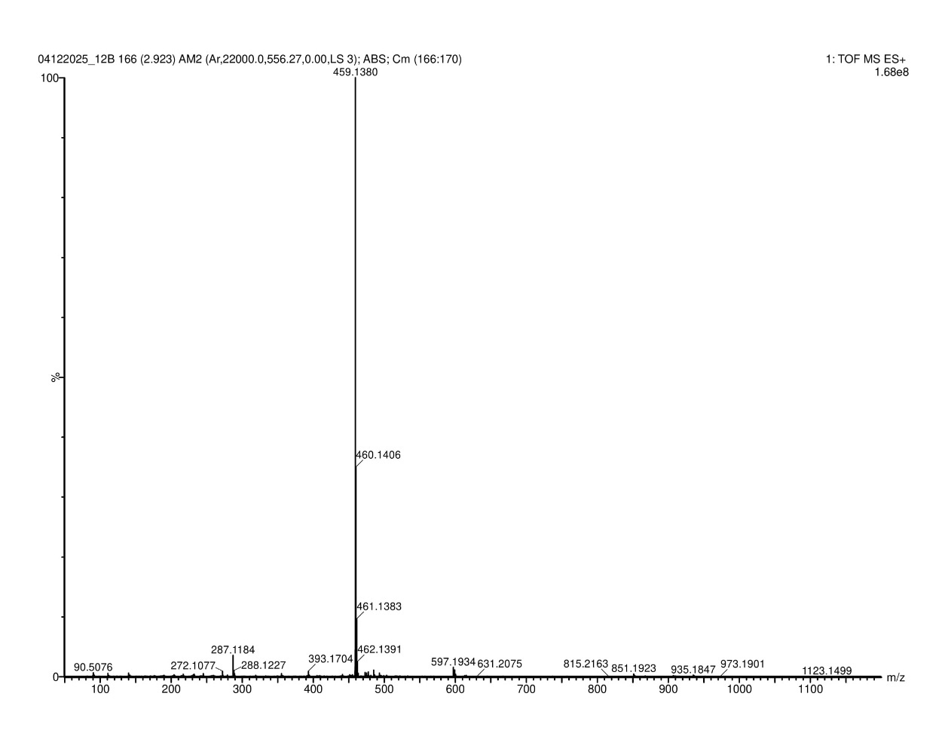
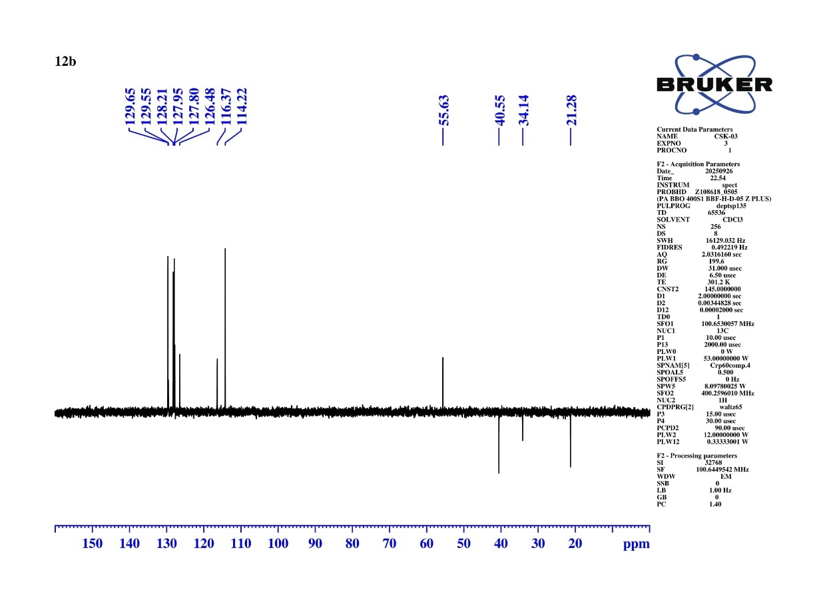
Fig S52 DEPT-135 NMR Spectrum of 4-methoxy-N-(8-oxo-9-phenyl-5,6,7,8-tetrahydroacridin-2-yl) benzenesulfonamide (10b)
Calculated Exact Mass = 459.1378
[M+H] = 459.1380
Fig S53 HMRS Spectrum of 4-methoxy-N-(8-oxo-9-phenyl-5,6,7,8-tetrahydroacridin-2-yl) benzenesulfonamide (10b)
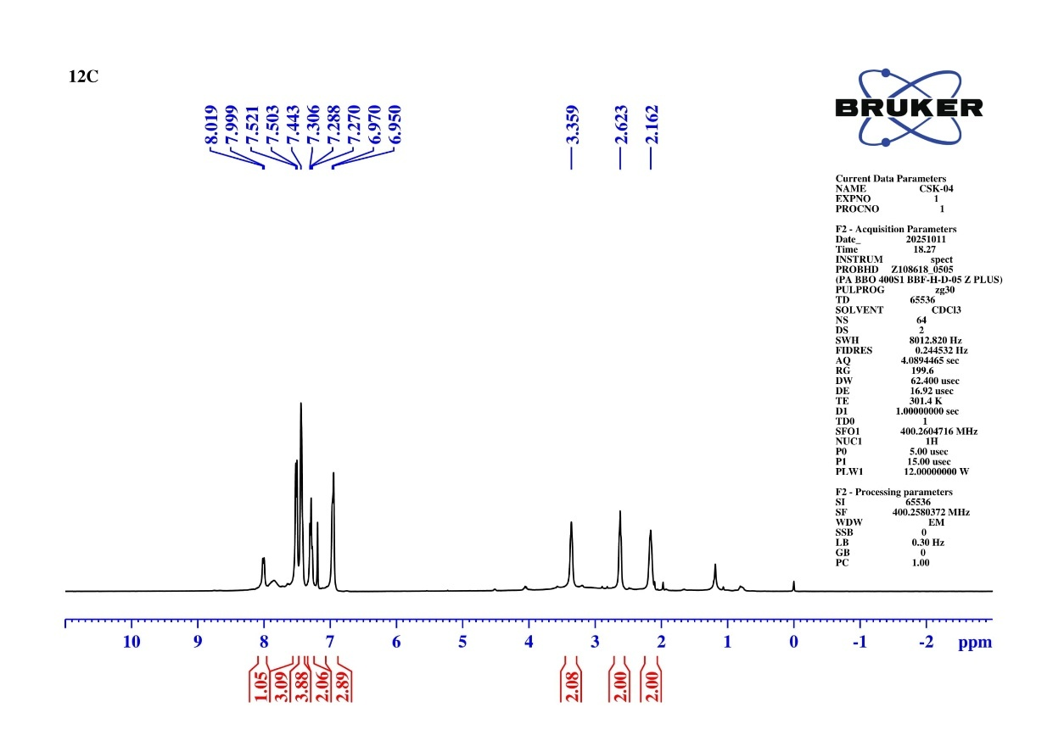
Fig S54 ¹H NMR Spectrum of N-(8-oxo-9-phenyl-5,6,7,8-tetrahydroacridin-2-yl) benzenesulfonamide (10c)
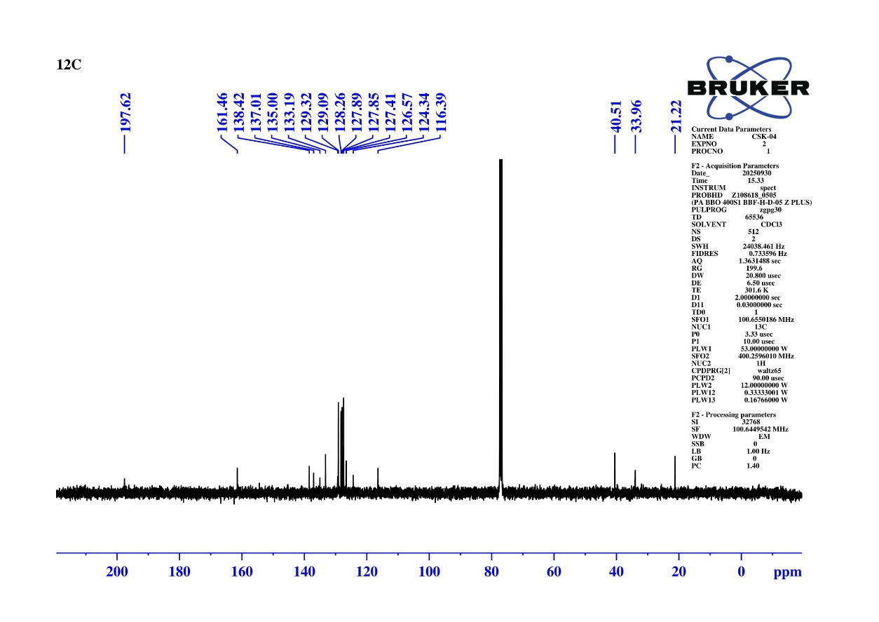
Fig S55 ¹³C NMR Spectrum of N-(8-oxo-9-phenyl-5,6,7,8-tetrahydroacridin-2-yl) benzenesulfonamide (10c)

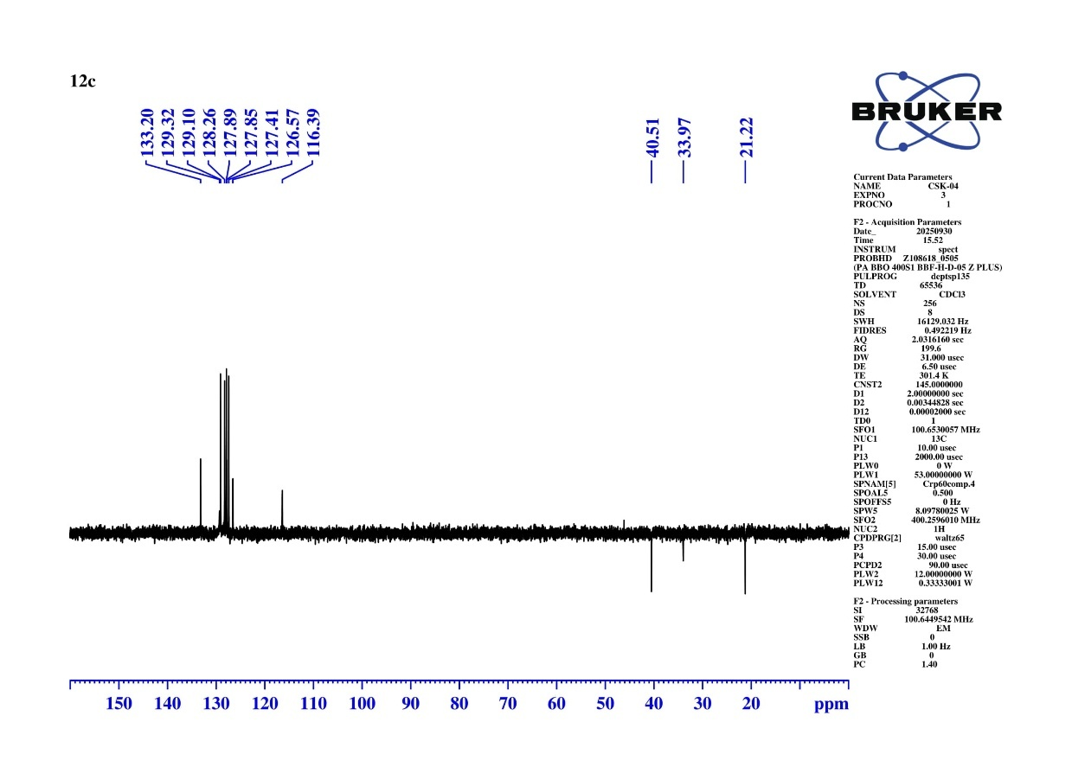
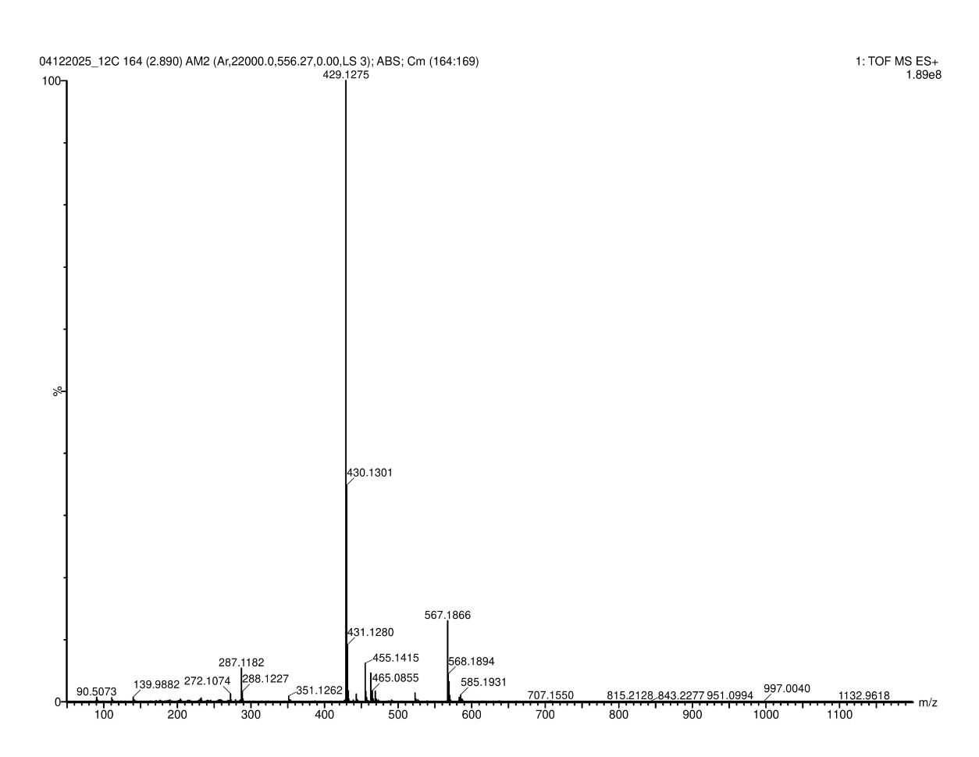
Fig S56 DEPT-135 NMR Spectrum of N-(8-oxo-9-phenyl-5,6,7,8-tetrahydroacridin-2-yl) benzenesulfonamide (10c)
Calculated Exact Mass = 429.1272
[M+H] = 429.1275
Fig S57 HRMS Spectrum of N-(8-oxo-9-phenyl-5,6,7,8-tetrahydroacridin-2-yl) benzenesulfonamide (10c)
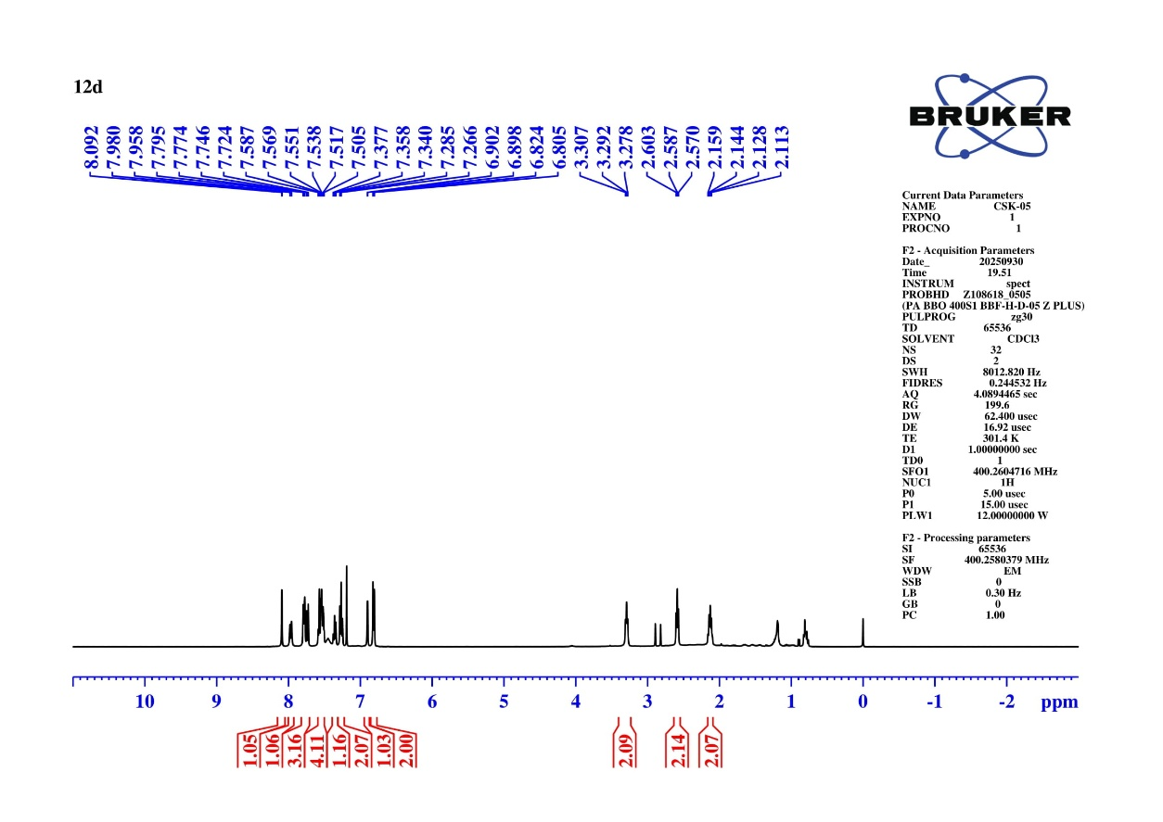
Fig S58 ¹H NMR Spectrum of N-(8-oxo-9-phenyl-5,6,7,8-tetrahydroacridin-2-yl) naphthalene-2-sulfonamide (10d)
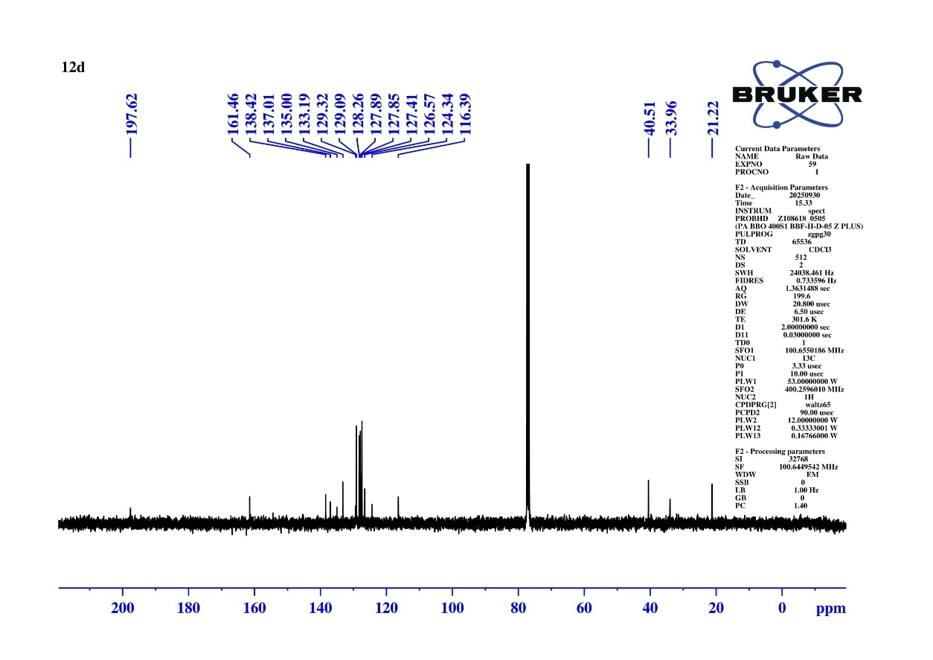
Fig S59 ¹³C NMR Spectrum of N-(8-oxo-9-phenyl-5,6,7,8-tetrahydroacridin-2-yl) naphthalene-2-sulfonamide (10d)
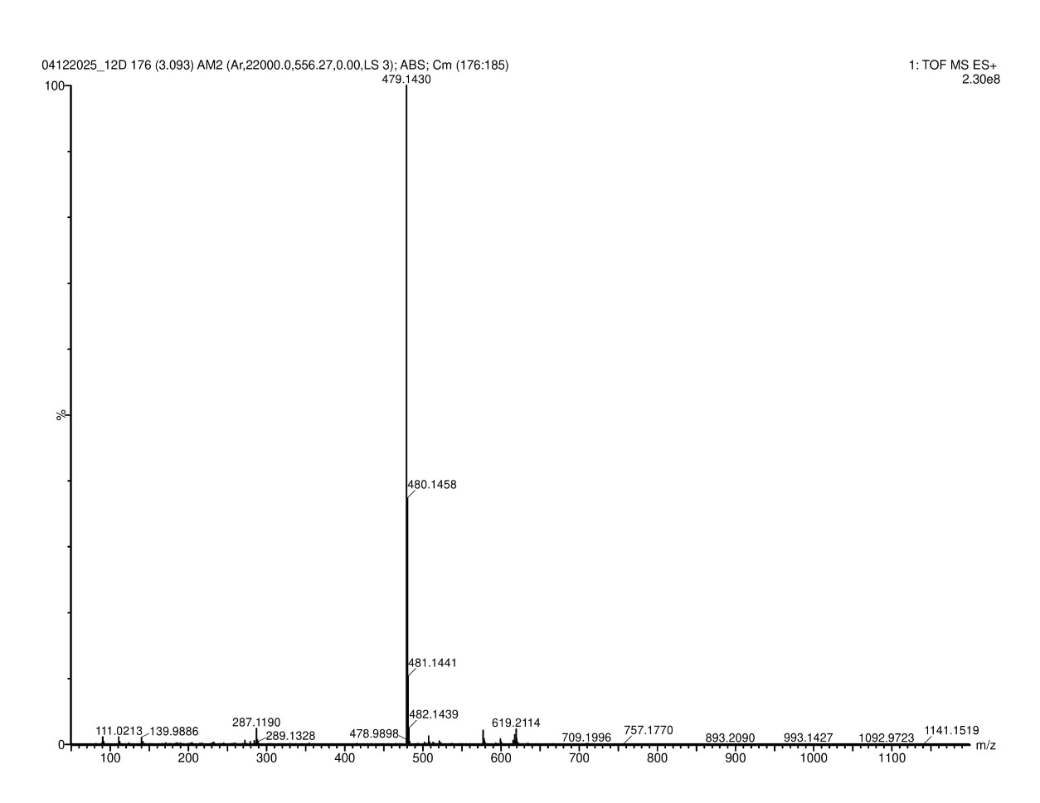
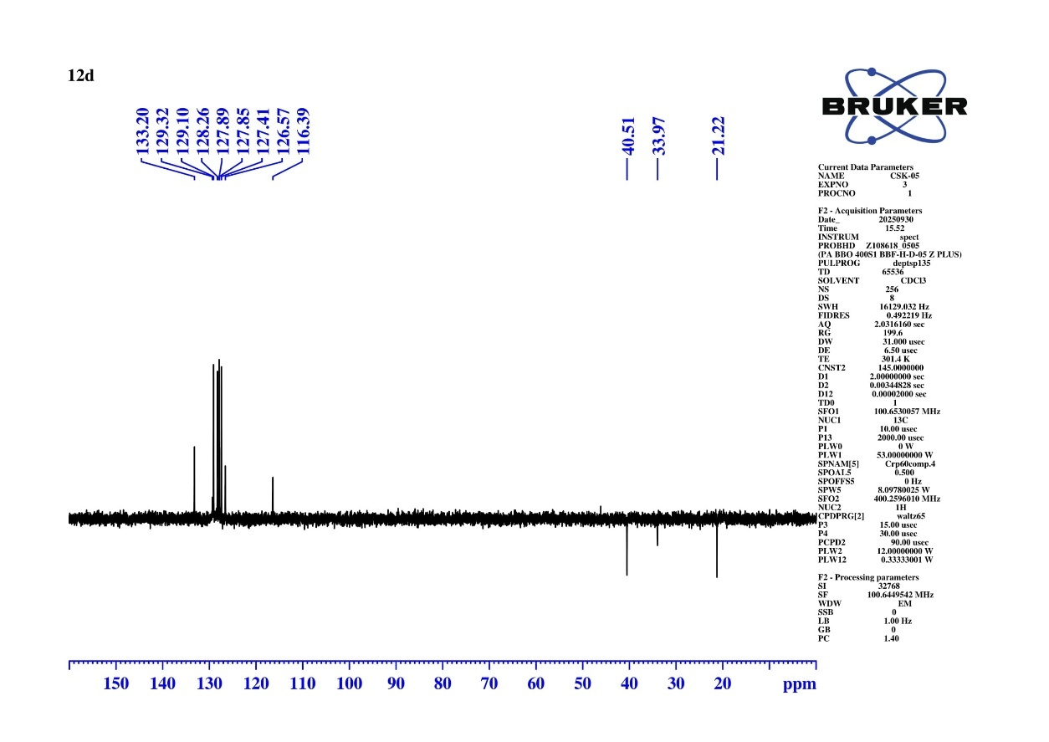
Fig S60 DEPT-135 NMR Spectrum of N-(8-oxo-9-phenyl-5,6,7,8-tetrahydroacridin-2-yl) naphthalene-2-sulfonamide (10d)
Calculated Exact Mass = 479.1429
[M+H] = 479.1430
Fig S61 HRMS Spectrum of N-(8-oxo-9-phenyl-5,6,7,8-tetrahydroacridin-2-yl) naphthalene-2-sulfonamide (10d)
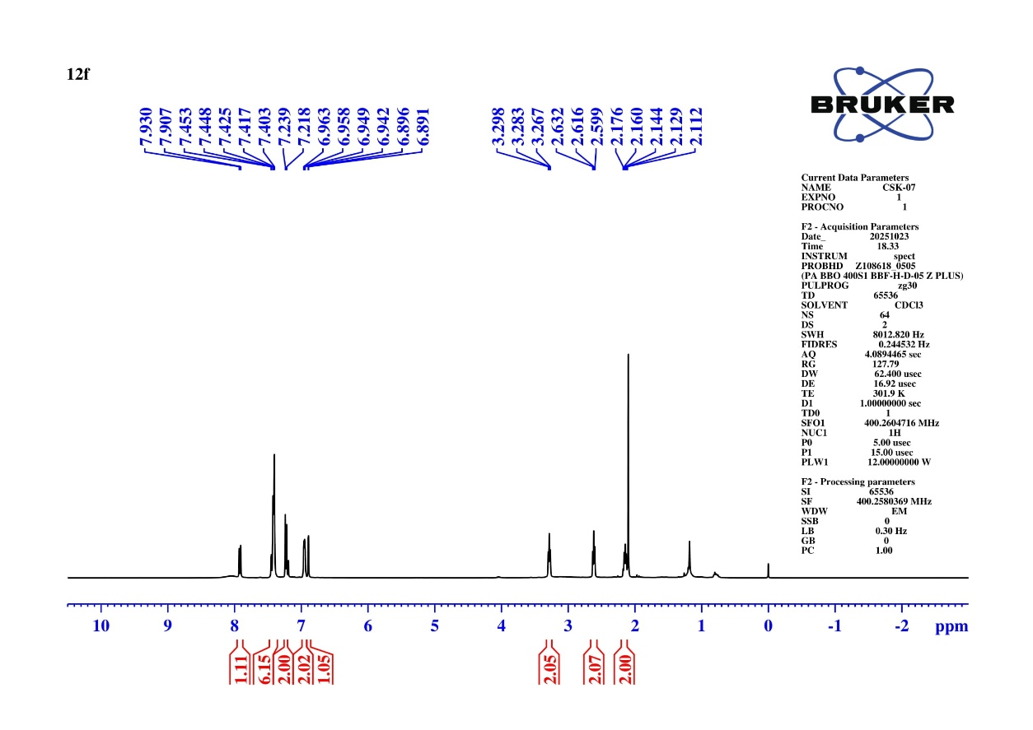
Fig S66 ¹H NMR Spectrum of 4-chloro-N-(8-oxo-9-phenyl-5,6,7,8-tetrahydroacridin-2-yl) benzenesulfonamide (10f)
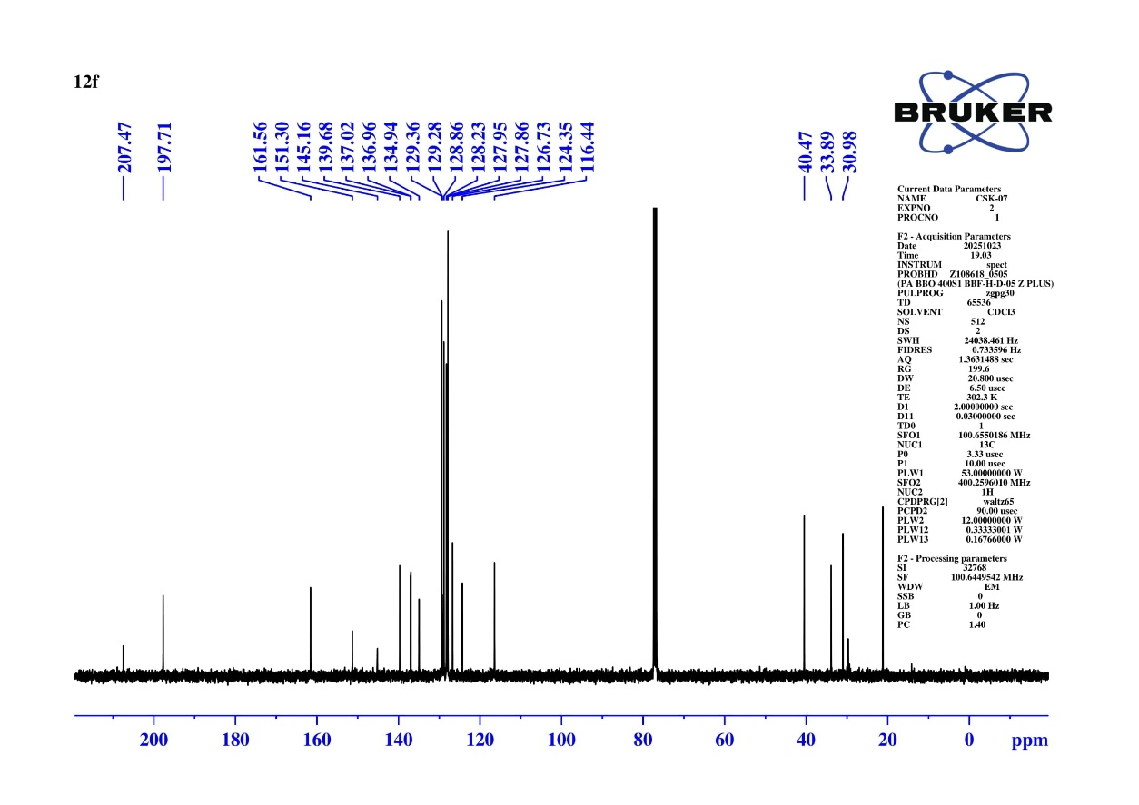
Fig S67 ¹³C NMR Spectrum of 4-chloro-N-(8-oxo-9-phenyl-5,6,7,8-tetrahydroacridin-2-yl) benzenesulfonamide (10f)
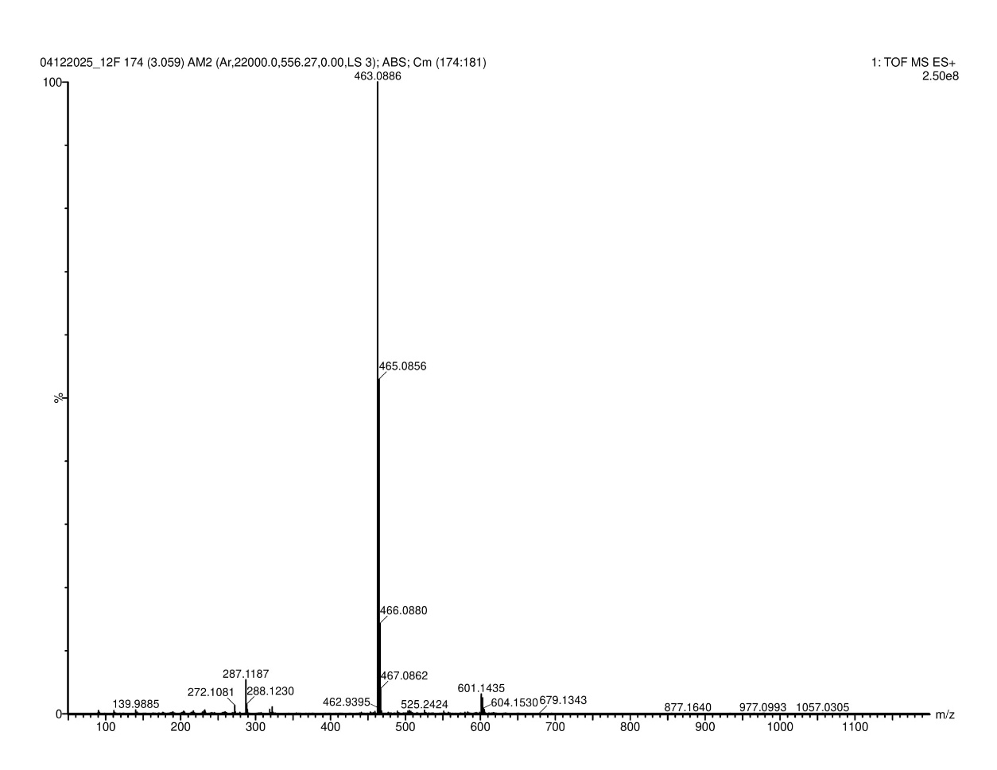
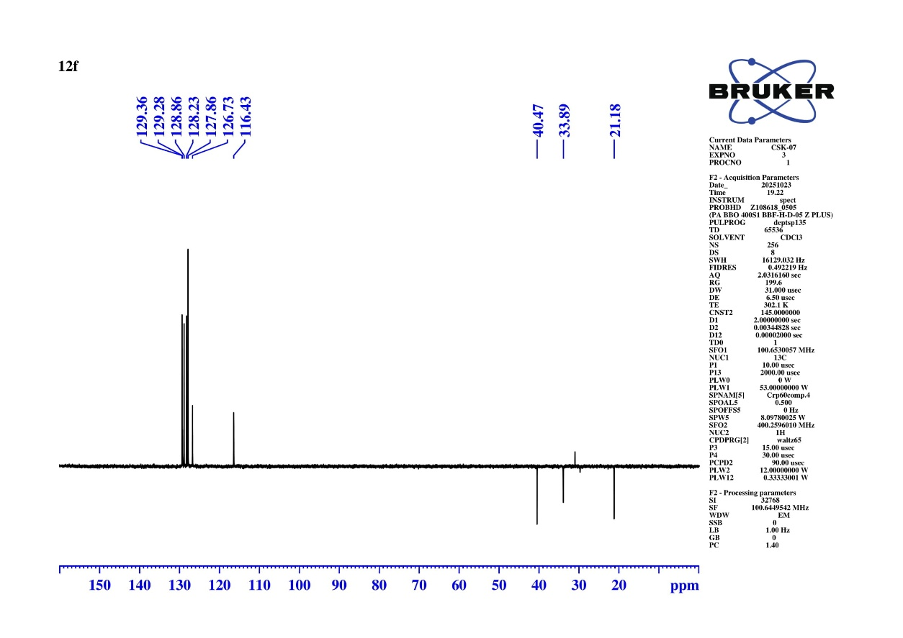
Fig S68 DEPT-135 NMR Spectrum of 4-chloro-N-(8-oxo-9-phenyl-5,6,7,8-tetrahydroacridin-2-yl) benzenesulfonamide (10f)
Calculated Exact Mass = 463.0883
[M+H] = 463.0886
Fig S69 HRMS Spectrum of of 4-chloro-N-(8-oxo-9-phenyl-5,6,7,8-tetrahydroacridin-2-yl) benzenesulfonamide (10f)
Fig S70 ¹H NMR Spectrum of 4-bromo-N-(8-oxo-9-phenyl-5,6,7,8-tetrahydroacridin-2-yl) benzenesulfonamide (10g)
Fig S71 ¹³C NMR Spectrum of 4-bromo-N-(8-oxo-9-phenyl-5,6,7,8-tetrahydroacridin-2-yl) benzenesulfonamide (10g)
Fig S72 DEPT-135 NMR Spectrum of 4-bromo-N-(8-oxo-9-phenyl-5,6,7,8-tetrahydroacridin-2-yl) benzenesulfonamide (10g)
Calculated Exact Mass = 507.0378
[M+H] = 507.0375
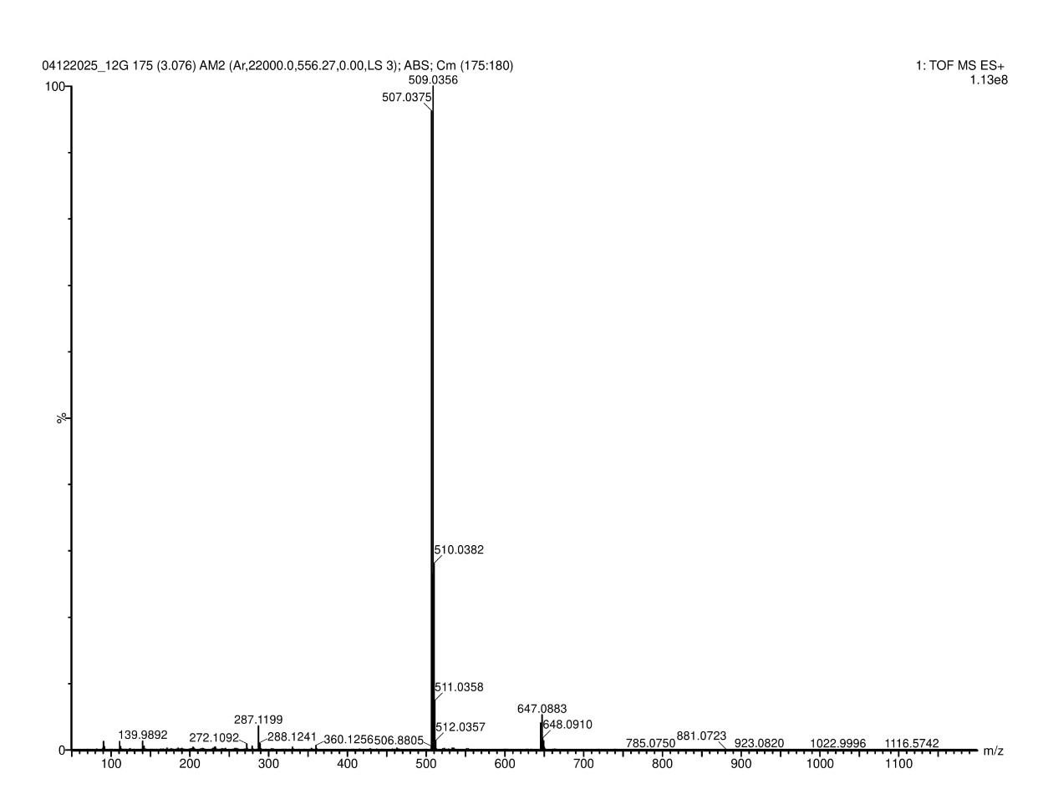
Fig S73 HMRS Spectrum of 4-bromo-N-(8-oxo-9-phenyl-5,6,7,8-tetrahydroacridin-2-yl) benzenesulfonamide (10g)
Fig S78 ¹H NMR Spectrum of 4-iodo-N-(8-oxo-9-phenyl-5,6,7,8-tetrahydroacridin-2-yl) benzenesulfonamide (10i)

Fig S79 ¹³C NMR Spectrum of 4-iodo-N-(8-oxo-9-phenyl-5,6,7,8-tetrahydroacridin-2-yl) benzenesulfonamide (10i)
Fig S80 DEPT-135 NMR Spectrum of 4-iodo-N-(8-oxo-9-phenyl-5,6,7,8-tetrahydroacridin-2-yl) benzenesulfonamide (10i)
Calculated Exact Mass = 555.0239
[M+H] = 555.0241
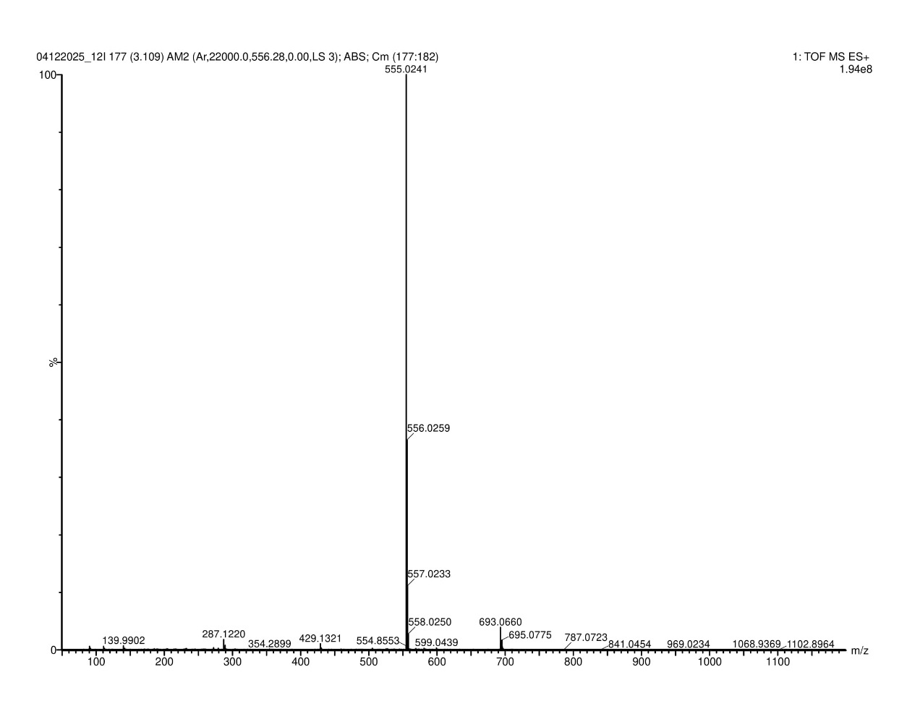
Fig S81 HRMS Spectrum of 4-iodo-N-(8-oxo-9-phenyl-5,6,7,8-tetrahydroacridin-2-yl) benzenesulfonamide (10i)
Fig S82 ¹H NMR Spectrum of 4-cyano-N-(8-oxo-9-phenyl-5,6,7,8-tetrahydroacridin-2-yl) benzenesulfonamide (10j)
Fig S83 ¹³C NMR Spectrum of 4-cyano-N-(8-oxo-9-phenyl-5,6,7,8-tetrahydroacridin-2-yl) benzenesulfonamide (10j)
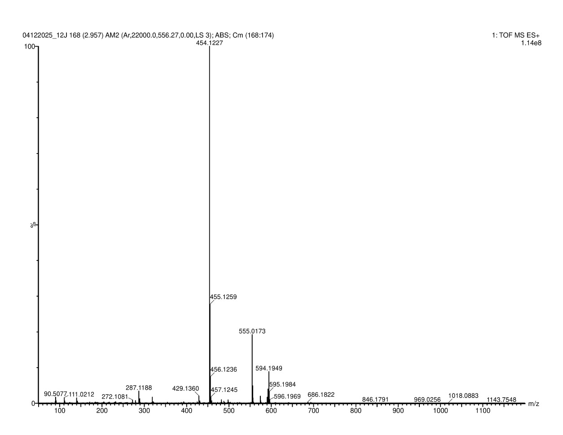
Fig S84 DEPT-135 NMR Spectrum of 4-cyano-N-(8-oxo-9-phenyl-5,6,7,8-tetrahydroacridin-2-yl) benzenesulfonamide (10j)
Calculated Exact Mass = 454.1225
[M+H] = 454.1227
Fig S85 HRMS Spectrum of 4-cyano-N-(8-oxo-9-phenyl-5,6,7,8-tetrahydroacridin-2-yl) benzenesulfonamide (10j)

