Correlation between neutrophil-to-lymphocyte ratio and postoperative mortality in elderly patients with hip fracture: A meta-analysis

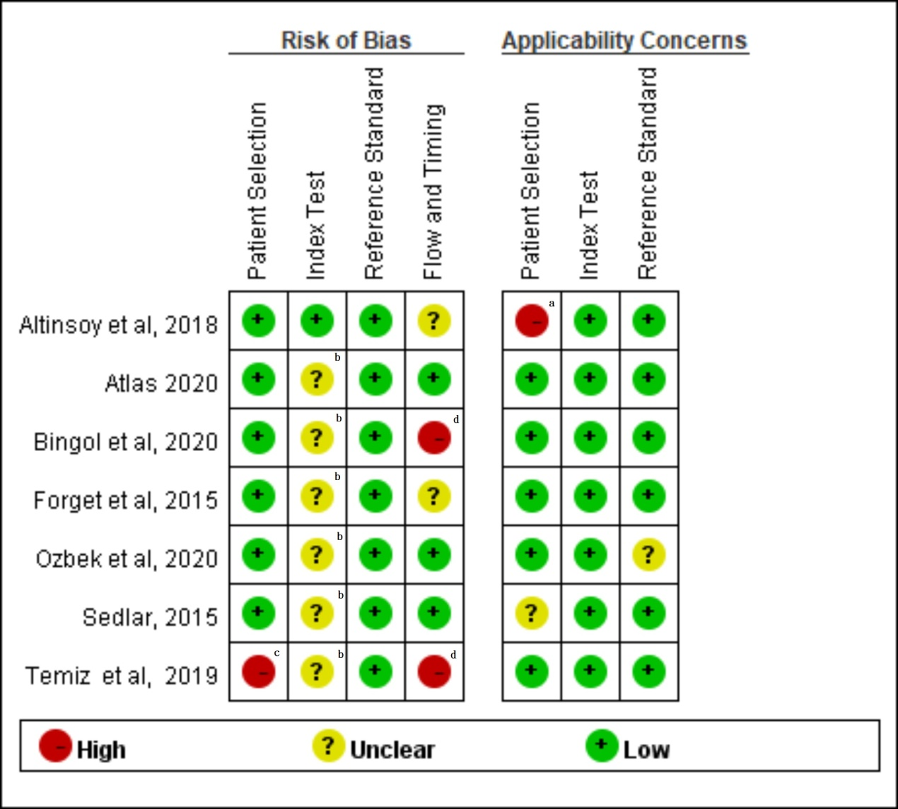
Supplementary Figure 1.
ªInclusion and exclusion criteria were nonspecific.
^{b}The methods of how blood was collected and blood cell counts were measured could have introduced a bias.
^{c}A case–control designed was not avoid and a consecutive sample of patients were not enrolled
^{d}Only a small portion of the patients included in the study was included in the analysis.

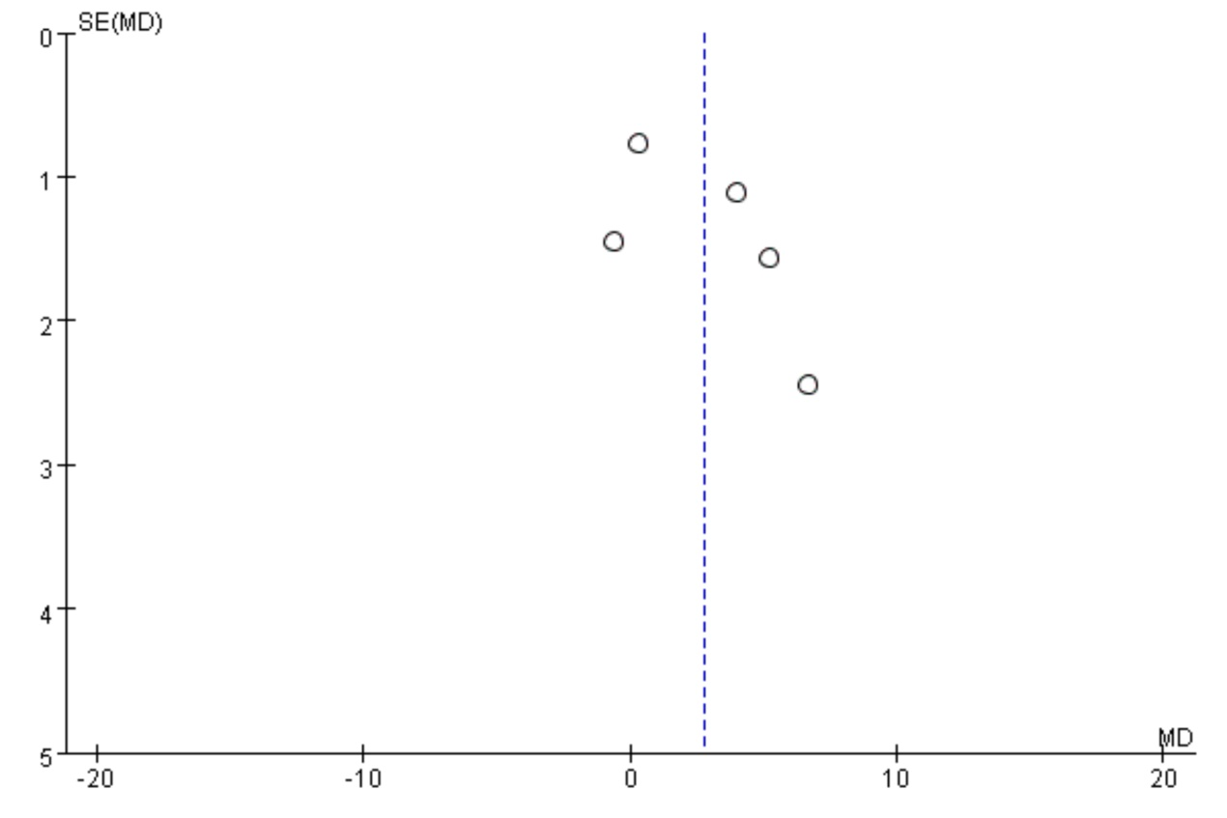
Supplementary Figure 2. Funnel plot of the studies with preoperative NLR and follow-up duration >1 year. This selection included most studies and their results demonstrate asymmetry in the graph.

