Supplementary Information

GenGLem: a generative framework for capturing chemical cliffs in energetic materials
Wenjing Wu, Huajie Liu*

Key Laboratory of Advanced Civil Engineering Materials of Ministry of Education, School of Chemical Science and Engineering, Shanghai Research Institute for Intelligent Autonomous Systems, Tongji University, Shanghai 200092, China

*E-mail: liuhuajie@tongji.edu.cn

This file includes: Supplementary Notes; Supplementary Figures and Tables; Supplementary Evaluation; Supplementary References.

Supplementary Notes
Supplementary Note 1 - GenGLem-main
1. Data representation and graph construction
Node features x_i are constructed as [Z_i, x_i, y_i, z_i], where Z_i is the atomic number and (x_i, y_i, z_i) are Cartesian coordinates. Coordinates are globally normalized using r_tilde = (r - mu) / sigma computed across all samples (atomic numbers are not normalized).
A DGL graph is built with optional edge features including bond lengths and (when available) bond types, aromaticity, conjugation, and in-ring flags. Aromatic bonds are marked in g.edata["aromatic"]. Self-loops are added and zero-padded in edge features; original (unnormalized) features are stored in g.ndata["raw_h"].
2. Encoder, latent variables, and decoder
Encoder: four GraphConv layers with ReLU activations produce node embeddings h^(1..4). A skip feature skip_multi = concat(h1, h3) is cached as conditional input. Flattened h^4 is mapped to mu and logvar by fully connected layers.
Reparameterization: z = mu + exp(0.5*logvar) * eps, with eps ~ N(0, I). A fully connected layer decodes z to per-node latent vectors.
Decoder input is concat(latent_node, raw_h, skip_multi). Two GraphConv layers followed by a linear head reconstruct features. The first column (atomic numbers) is forcibly set to the original raw_h[:,0], ensuring element types remain unchanged.
3. Training objectives (VAE + geometric regularization)
Base VAE loss: L_VAE = MSE(x_hat, x) + beta * KL, with KL = -0.5 * mean(1 + logvar - mu^2 - exp(logvar)).
Aromatic ring planarity: extract cycles from aromatic-edge subgraph (length >= 5). Fit a plane by SVD and minimize mean squared distances from ring atoms to the plane. This loss is computed on reconstructed (normalized) coordinates and remains differentiable.
Bond length preservation: for each bonded pair (i, j), minimize (||r_hat_i - r_hat_j|| - ||r_i - r_j||)^2.
Bond angle preservation: for each triplet (i, j, k), compute angles via arccos of cosine similarity and minimize (angle_hat - angle_orig)^2.
Non-bonded proximity: using a KDTree radius threshold on reconstructed coordinates, enumerate candidate nonbonded pairs filtered by known bonds and minimize (||r_hat_i - r_hat_j|| - ||r_i - r_j||)^2.
Total per-graph objective: L = L_VAE + lambda_plan * L_planarity + lambda_len&angle * (L_bond + L_angle + L_nonbond). Losses are averaged across graphs in the batch before backpropagation. [4]
4. Batch training and logging
Graphs are batched by batch_name and processed by a batched forward pass. Reconstructed outputs are split back into per-graph tensors. We log per-epoch coordinate statistics and loss components, and persist curves and model state for reproducibility.
5. Latent-space exploration and personalized conditional decoding
Sample candidate z from N(0, I) and retain those whose minimum Euclidean distance to training mu exceeds a noise threshold.
ConditionFusion (attention-based): select top_k nearest training graphs in latent space; stack their per-node conditional features cond_feat = concat(raw_h, skip_multi) and compute attention across graphs to obtain a fused per-node conditional embedding. [1][2]
Decode with the fused conditional features on a template graph. Enforce atomic numbers from the template and de-normalize coordinates using the global mu/sigma.

Supplementary Note 2 - GenGLem-Conditions
1. Condition vector and strict alignment
From an Excel sheet, read Temperature(K), Pressure(atm), and Solvant columns. After cleaning, compute min/max for T and P and one-hot encode solvents. Build c = [norm(T), norm(P), one-hot(S)].
Parse each graph's molecule_frame into a (T, P, S) triplet via regex, strictly match a row in Excel, and construct a condition vector c aligned with each graph. Duplicate (T,P,S) entries raise an error to enforce uniqueness.
2. VAE decode interface extension
Expose a decode_from_z(template_g, z_flat, fused_cond_feat) interface that composes latent per-node embeddings with either (raw_h + skip_multi) computed on the template or a pre-computed fused conditional feature. Preserve atomic numbers from the template.
3. Conditional latent diffusion (DDPM) on z
LatentDiffusion takes (z_t, c, t) and predicts noise eps_hat. Architecture: c -> Linear(hidden); t -> TimeEmbedding; concatenate [z_t, h_cond, h_time]; pass through MLP (last layer projects to z_dim). [1-3]
Training: choose beta schedule (linear or cosine) to define alphas and alpha_bars. For random t, form z_t = sqrt(alpha_bar_t)*z0 + sqrt(1-alpha_bar_t)*eps and minimize ||eps - eps_hat||^2. Optional cosine LR scheduler is supported. Persist model state, schedules and loss curves.
4. Conditional sampling and decoding
After training, for a user-specified condition c_new or the first Excel row, sample n=1001 latent vectors via DDPM reverse dynamics. For each z0 sample, compute a fused per-node conditional feature using the top_k nearest training mus and decode with the VAE on a template graph.
Enforce atomic numbers from the template and de-normalize coordinates using the dataset-level mu/sigma. Save both c_new and the generated conformers for reproducibility.
5. End-to-end pipeline
1) Build batch_graphs and train/load the VAE; 2) build condition vectors c strictly aligned to graphs; 3) collect (z0, c) and train DDPM; 4) sample {z0} under c_new; 5) fuse per-node conditions and decode; 6) export conformers and metadata.[5]

Supplementary Note 3 - Implementation details
The model was implemented using PyTorch 2.2.1 and DGL 2.2.1. All experiments were conducted on CPU. For hyperparameters, we used hidden dimension = 64, z_dim = 8, learning rate = 1e-3, β = 1.0, λ_planarity = 1.0, λ_bond = λ_angel = λ_nonbond = 0.1, nonbond_threshold=1.38. The candidate count was set to 1,000, noise_threshold was set to 2.5, and top_k was set to 1. The model was trained for 200 epochs using the Adam optimizer. For the conditional diffusion model, we employed a 4-layer MLP with hidden dimension of 512. The diffusion process used T = 1000 timesteps with cosine noise scheduling (β_start = 1e-4, β_end = 2e-2). The diffusion model was trained for 100 epochs with learning rate = 5e-4 and batch size = 32.

Supplementary Note 4 - Mathematical Formulations
(S1) Reconstruction MSE:
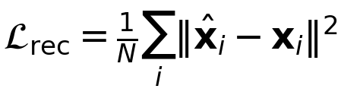
(S2) KL term (to N(0,I)):
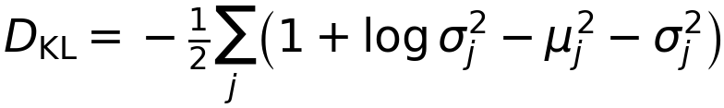
(S3) VAE objective:
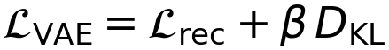
(S4) Linear warm-up for β over first T_warm epochs:
(S5) Cosine schedule for β across epochs:
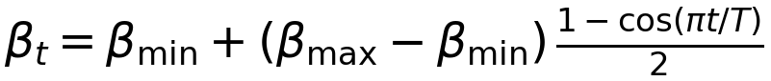
(S6) Planarity loss:
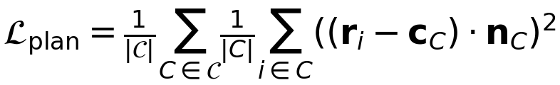
(S7) Bond-length preservation:
(S8) Bond-angle preservation:
(S9) Non-bonded proximity:
(S10) Total per-graph objective:
(S11) Condition vector:
(S12) Linear DDPM betas:
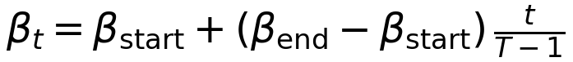
(S13) Cosine DDPM cumulative alphas:
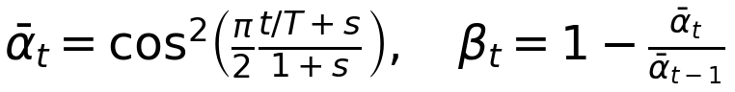
(S14) Forward noising:
(S15) Reverse mean: μ_t = (1/√α_t) * ( z_t - (β_t / √(1 - α̅_t)) * εˆ_θ(z_t, c, t) ); z_{t-1} = μ_t + σ_t ξ, with σ_t = √β_t
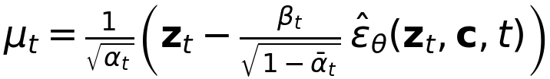

Supplementary Figures and Tables
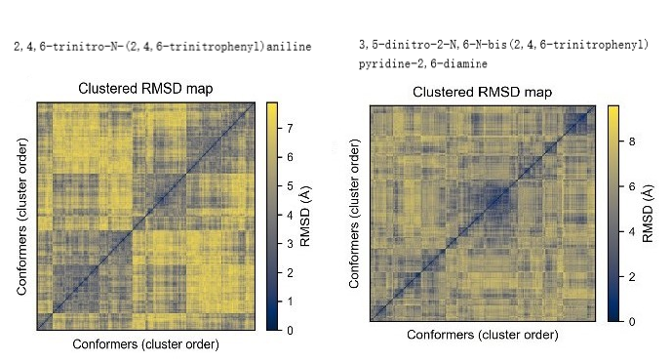
Supplementary Figure 1. Empirical cumulative distribution function (ECDF) of pairwise RMSD values among conformers. Vertical dashed lines mark quartiles (Q25, Q50, Q75). RMSD is reported in Å. ECDF = empirical cumulative distribution function.

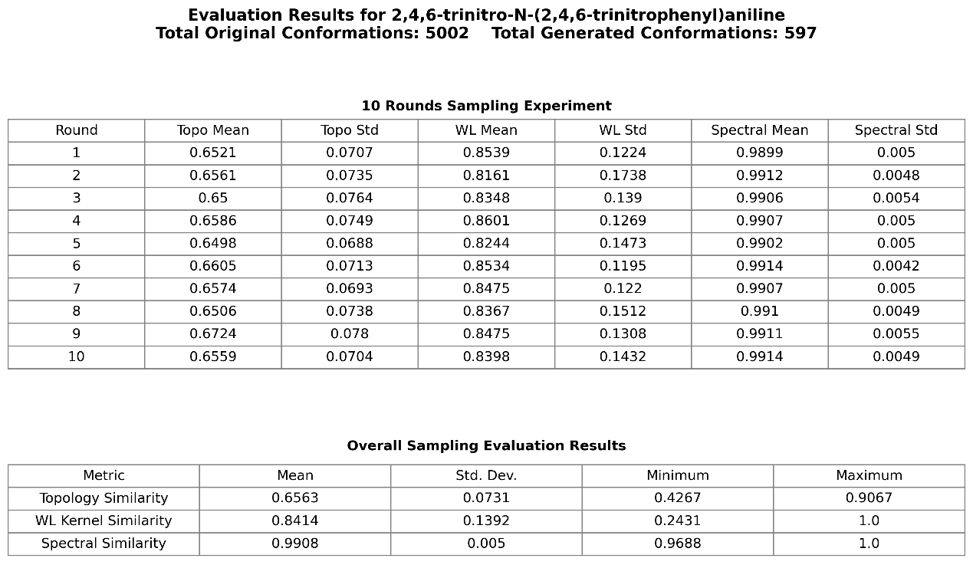
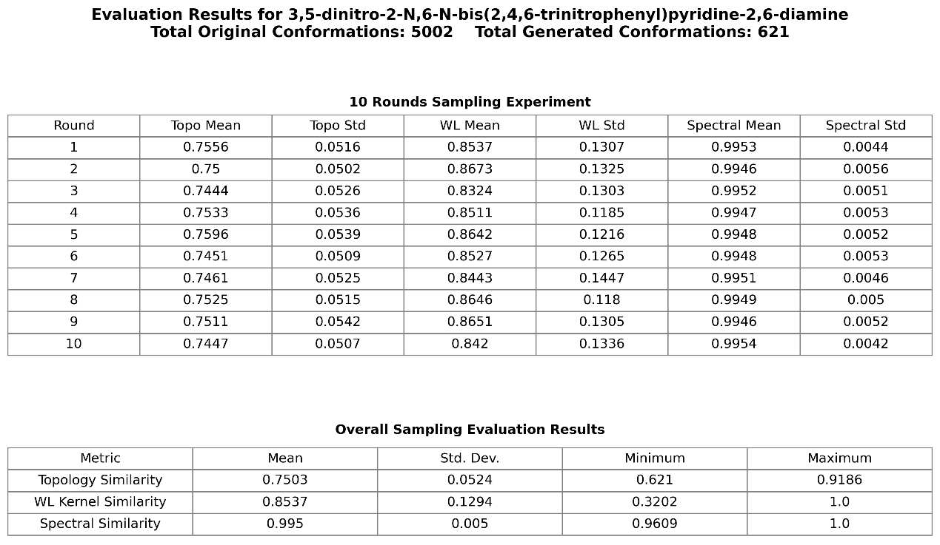
Supplementary Figure 2. Topology similarity is calculated by obtaining the distance matrices from the coordinates of candidate and reference conformers, computing the difference via the Frobenius norm, and then normalizing the result to reflect global structural consistency. WL subtree kernel similarity is determined by constructing a graph (edges exist when the inter-node distance is below a preset threshold), iteratively updating node labels for three iterations, and then forming feature vectors based on label frequencies; the normalized inner product of these vectors yields a measure of local substructure similarity. Spectral similarity is computed by constructing a complete graph, obtaining the first 10 non-zero eigenvalues of its weighted Laplacian matrix, and using cosine similarity to measure overall structural spectrum consistency.
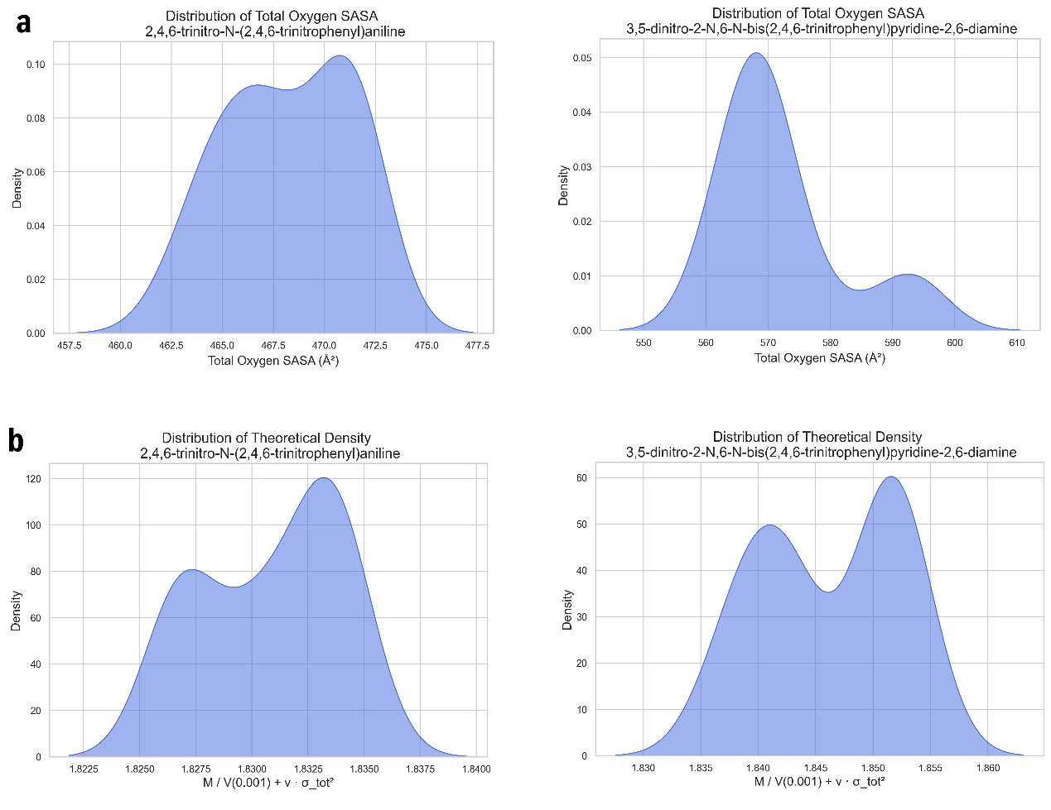
Supplementary Figure 3. (a) Depicts the statistical distribution of total oxygen SASA values across different molecular conformations. (b) Depicts the theoretical density distribution across different molecular conformations.

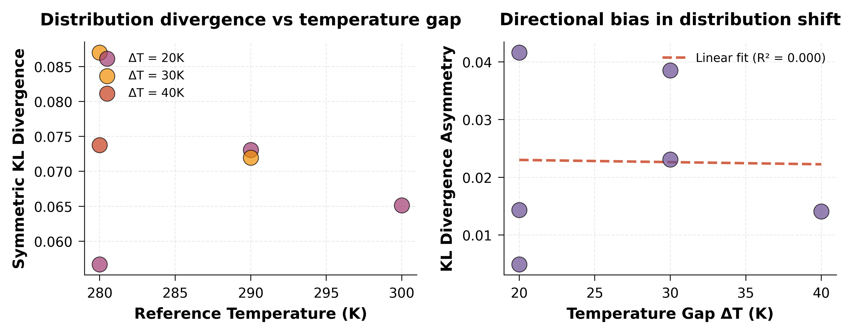
Supplementary Figure 4. Divergence analysis and directional bias in distribution shift (Left) Symmetric KL divergence as a function of reference temperature, color-coded by temperature gap (ΔT). Larger temperature gaps correspond to greater distributional divergence. (Right) KL divergence asymmetry versus temperature gap. Asymmetry is calculated as |KL(P||Q) - KL(Q||P)|, reflecting directional bias in distribution shifts. Linear regression (red dashed line) shows moderate positive correlation (R² = 0.271), suggesting temperature-dependent non-reversibility in conformational transitions.

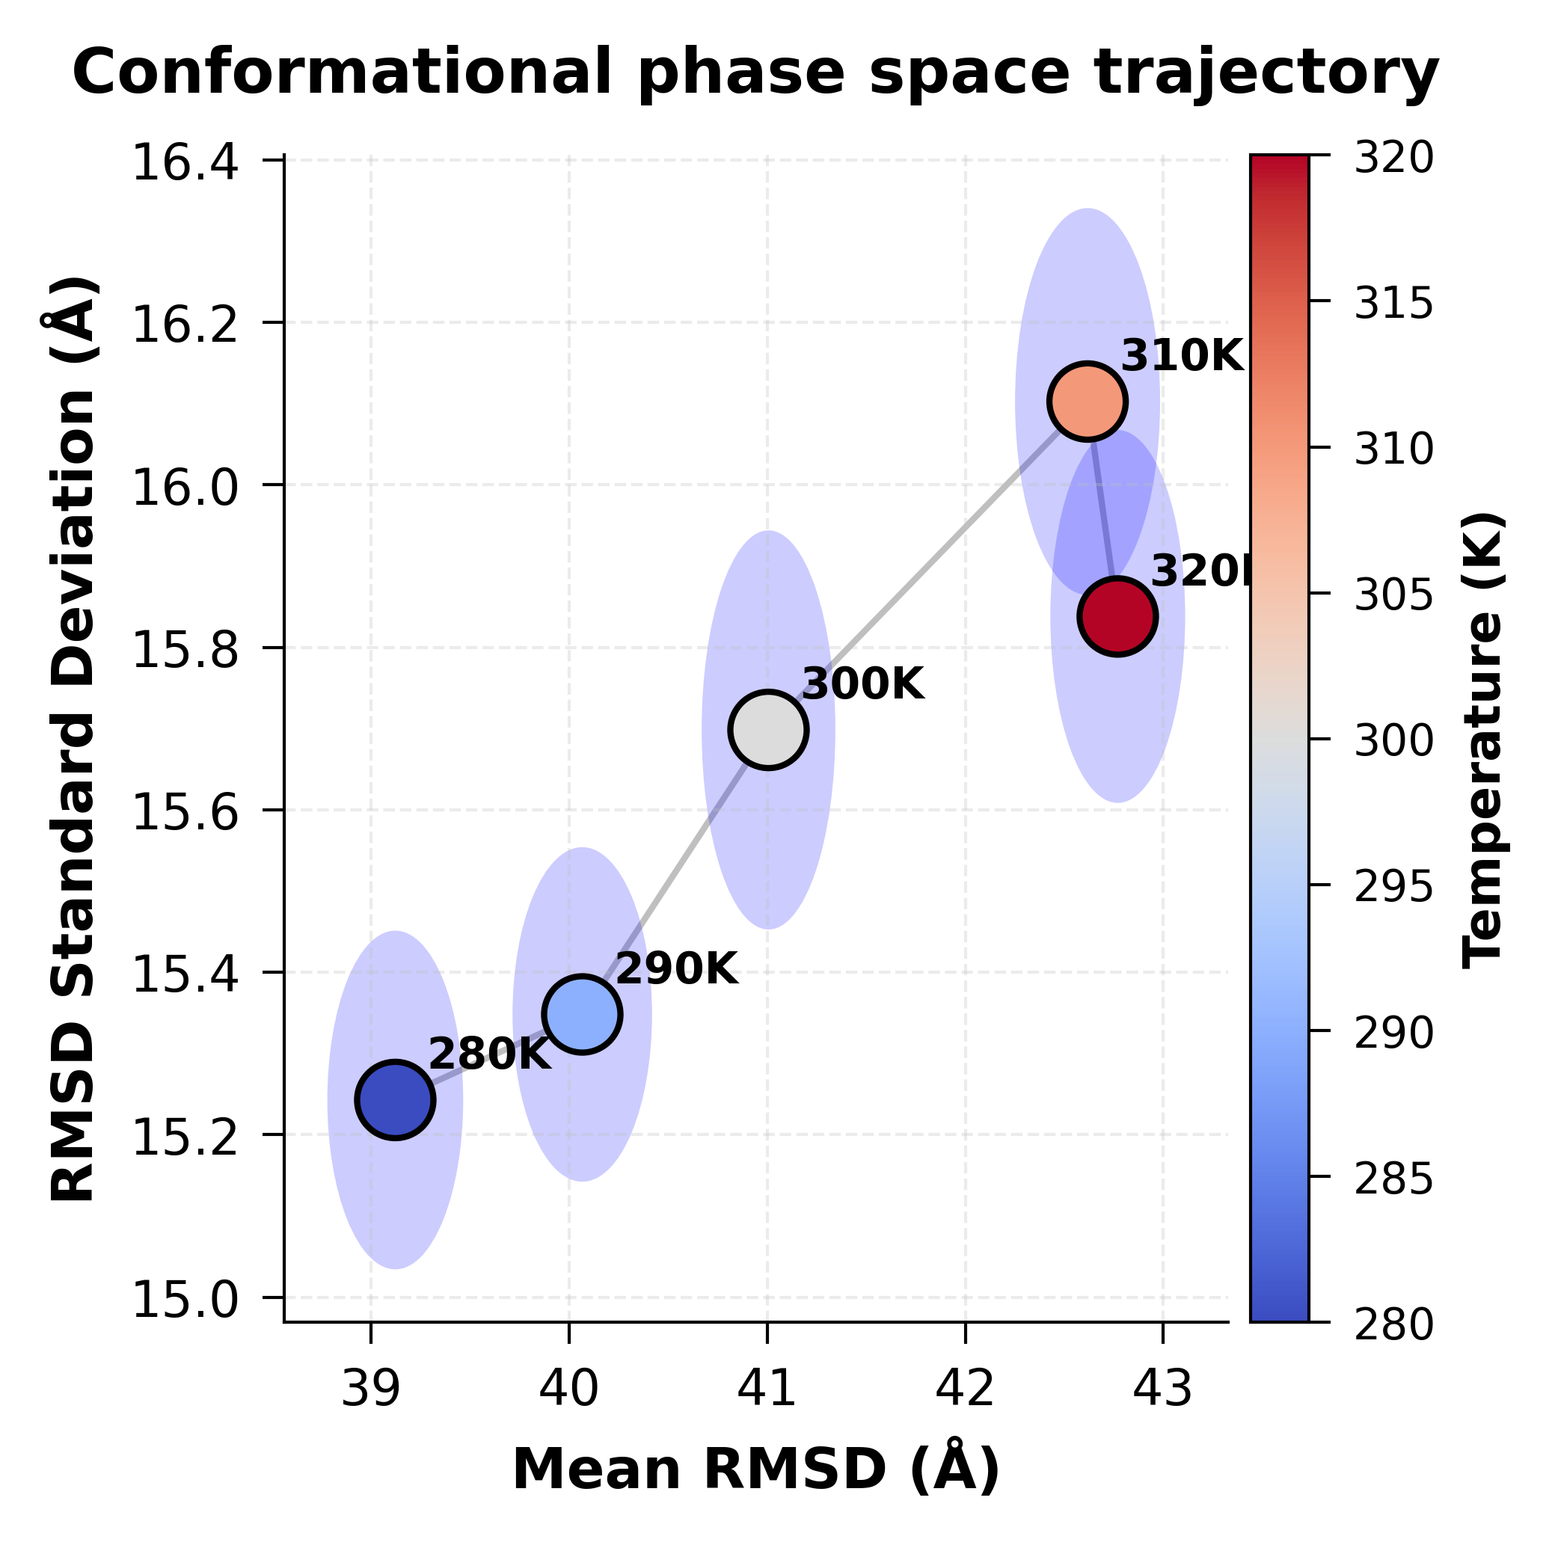
Supplementary Figure 5. Conformational phase space trajectory Two-dimensional phase space representation of mean RMSD versus standard deviation. Each point represents a temperature condition (280-320 K), color-coded by temperature (blue to red gradient). Gray line connects sequential temperature points, revealing the trajectory of conformational ensemble evolution. Error ellipses represent 95% confidence intervals in both dimensions. The trajectory demonstrates coordinated increase in both mean and variance with temperature, with saturation effects emerging above 310 K.

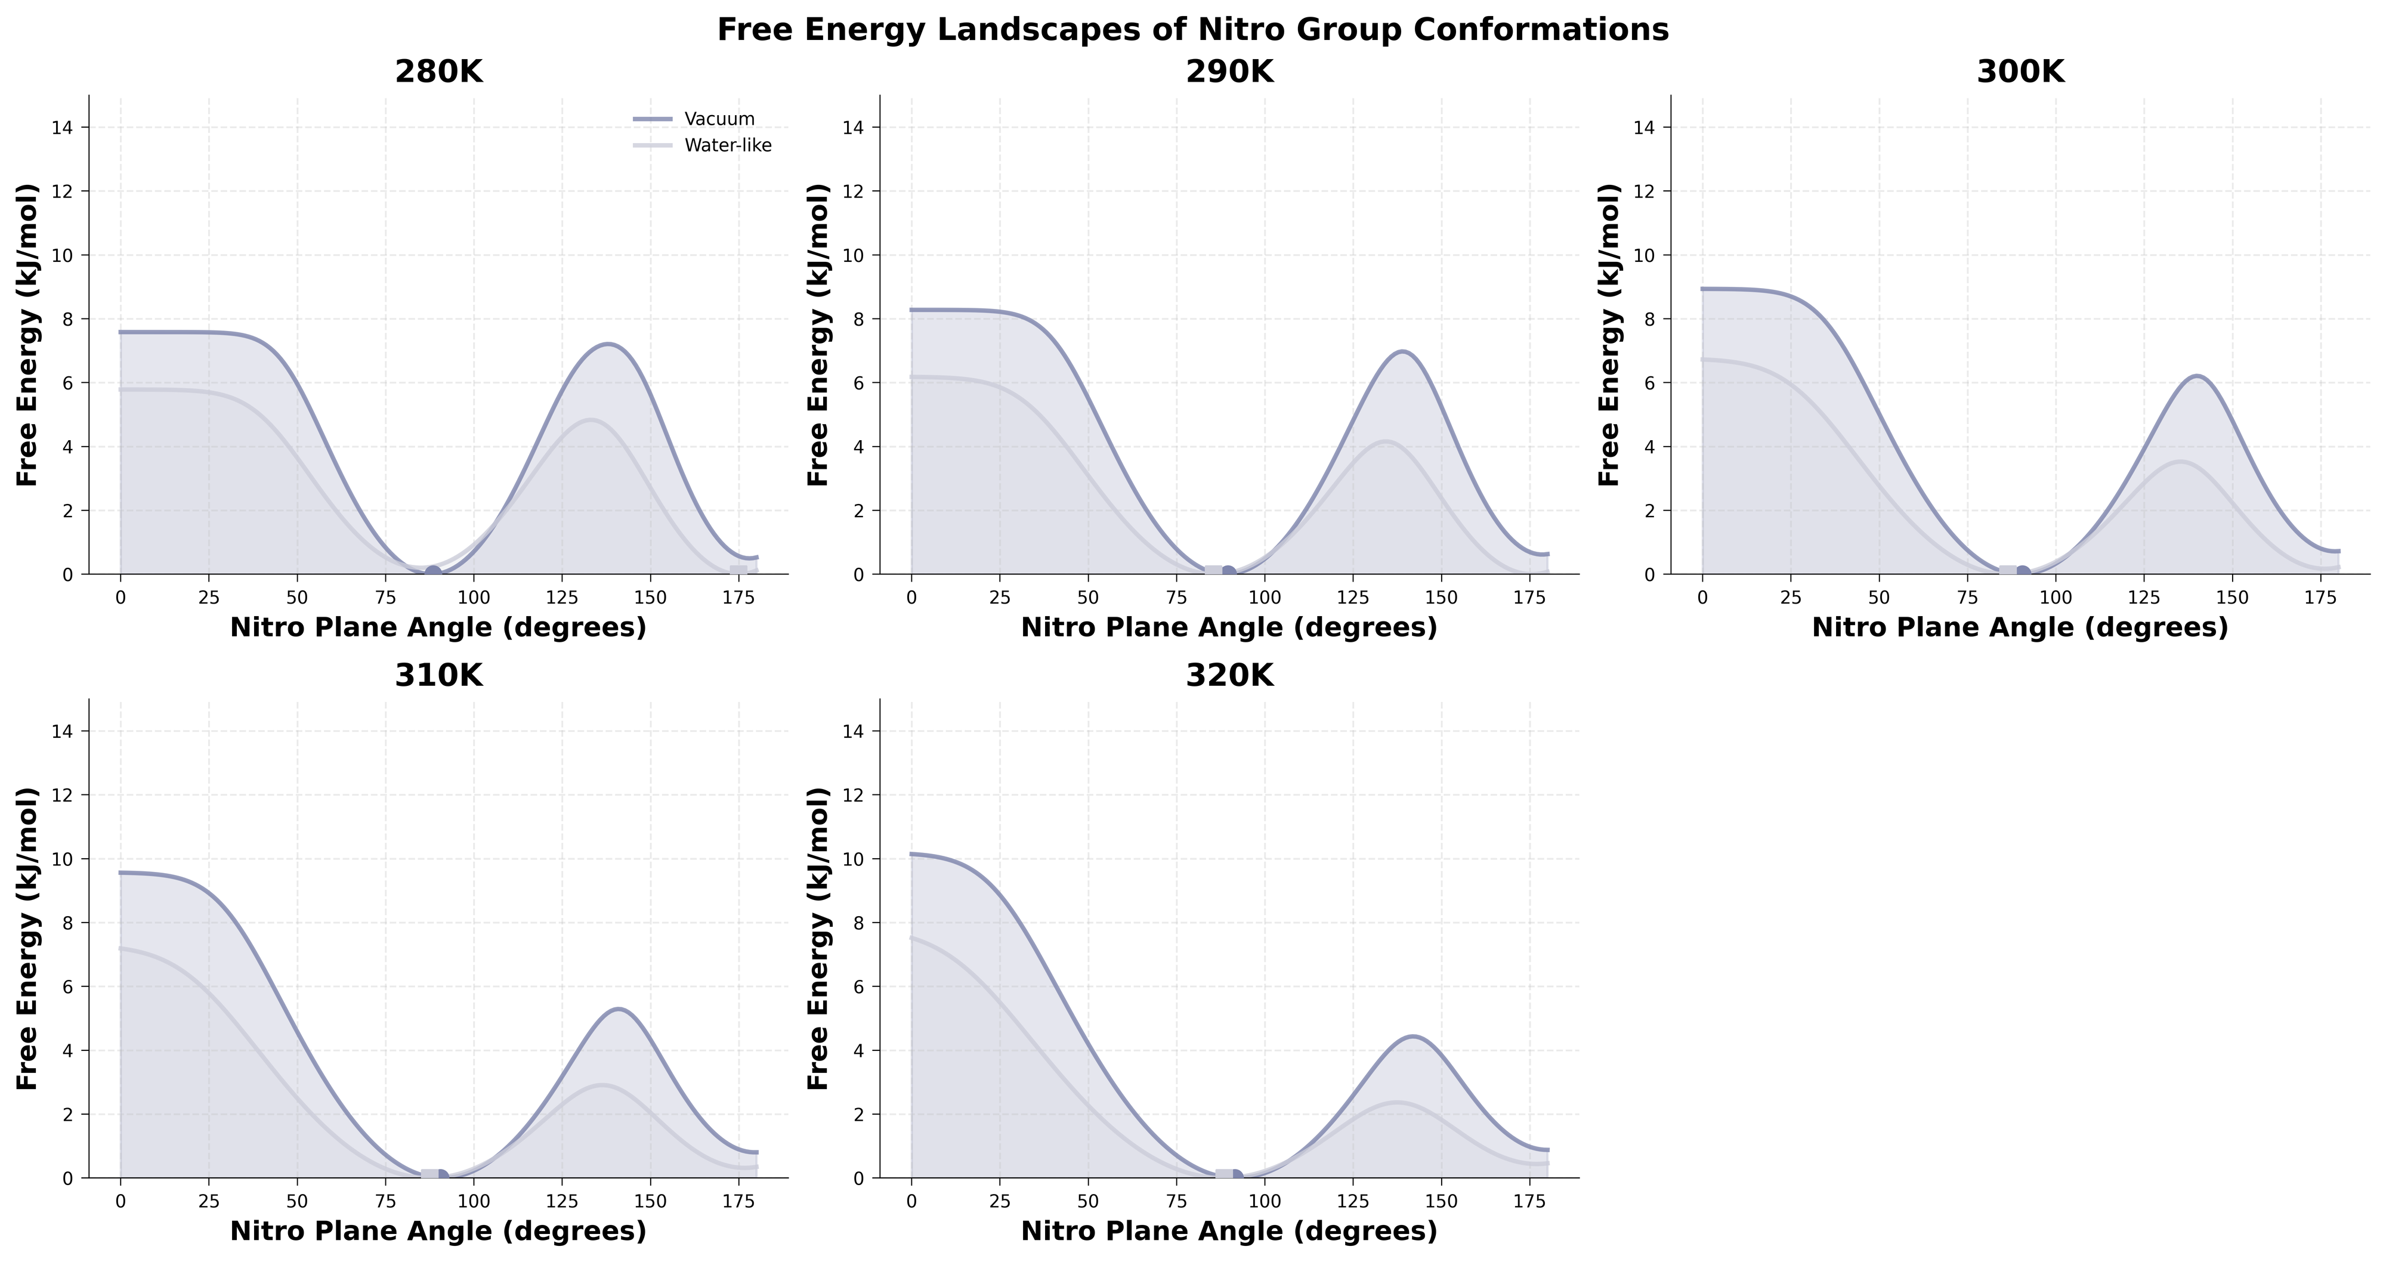
Supplementary Figure 6. Free energy landscapes of nitro group conformations Relative free energy profiles (ΔG = -RT ln P) calculated from conformational probability distributions across five temperatures (280-320K). Each panel shows vacuum (purple) and water-like (gray) environments, with filled areas representing energy basins. Circular and square markers indicate global energy minima for each environment. The dual-well potential energy surfaces correspond to the two major conformational states observed experimentally. Temperature-dependent barrier heights and well depths quantify the thermodynamic driving forces for conformational interconversion. Water-like environments consistently show lower energy barriers, facilitating conformational exchange.

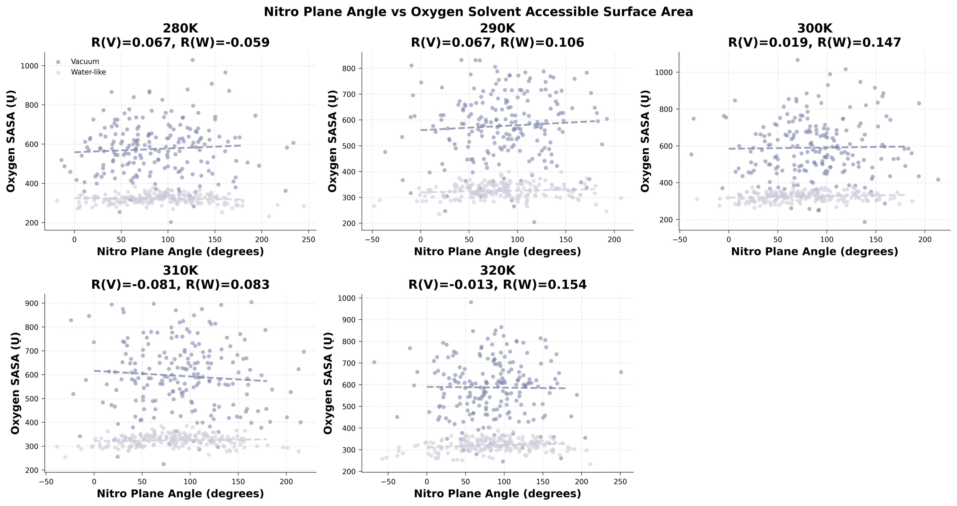
Supplementary Figure 7. Nitro plane angle vs oxygen solvent accessible surface area Correlation analysis between nitro group orientation and oxygen atom solvent exposure across temperatures. Each panel represents one temperature condition with vacuum (purple) and water-like (gray) data points. Dashed lines show linear regression fits with correlation coefficients (R) displayed in panel titles. The positive correlation indicates that extended conformations (~180°) expose more oxygen surface area to solvent than compact conformations (~90°). Temperature-dependent correlation strengths reveal the coupling between conformational dynamics and solvation thermodynamics. n = 200 conformations per condition.

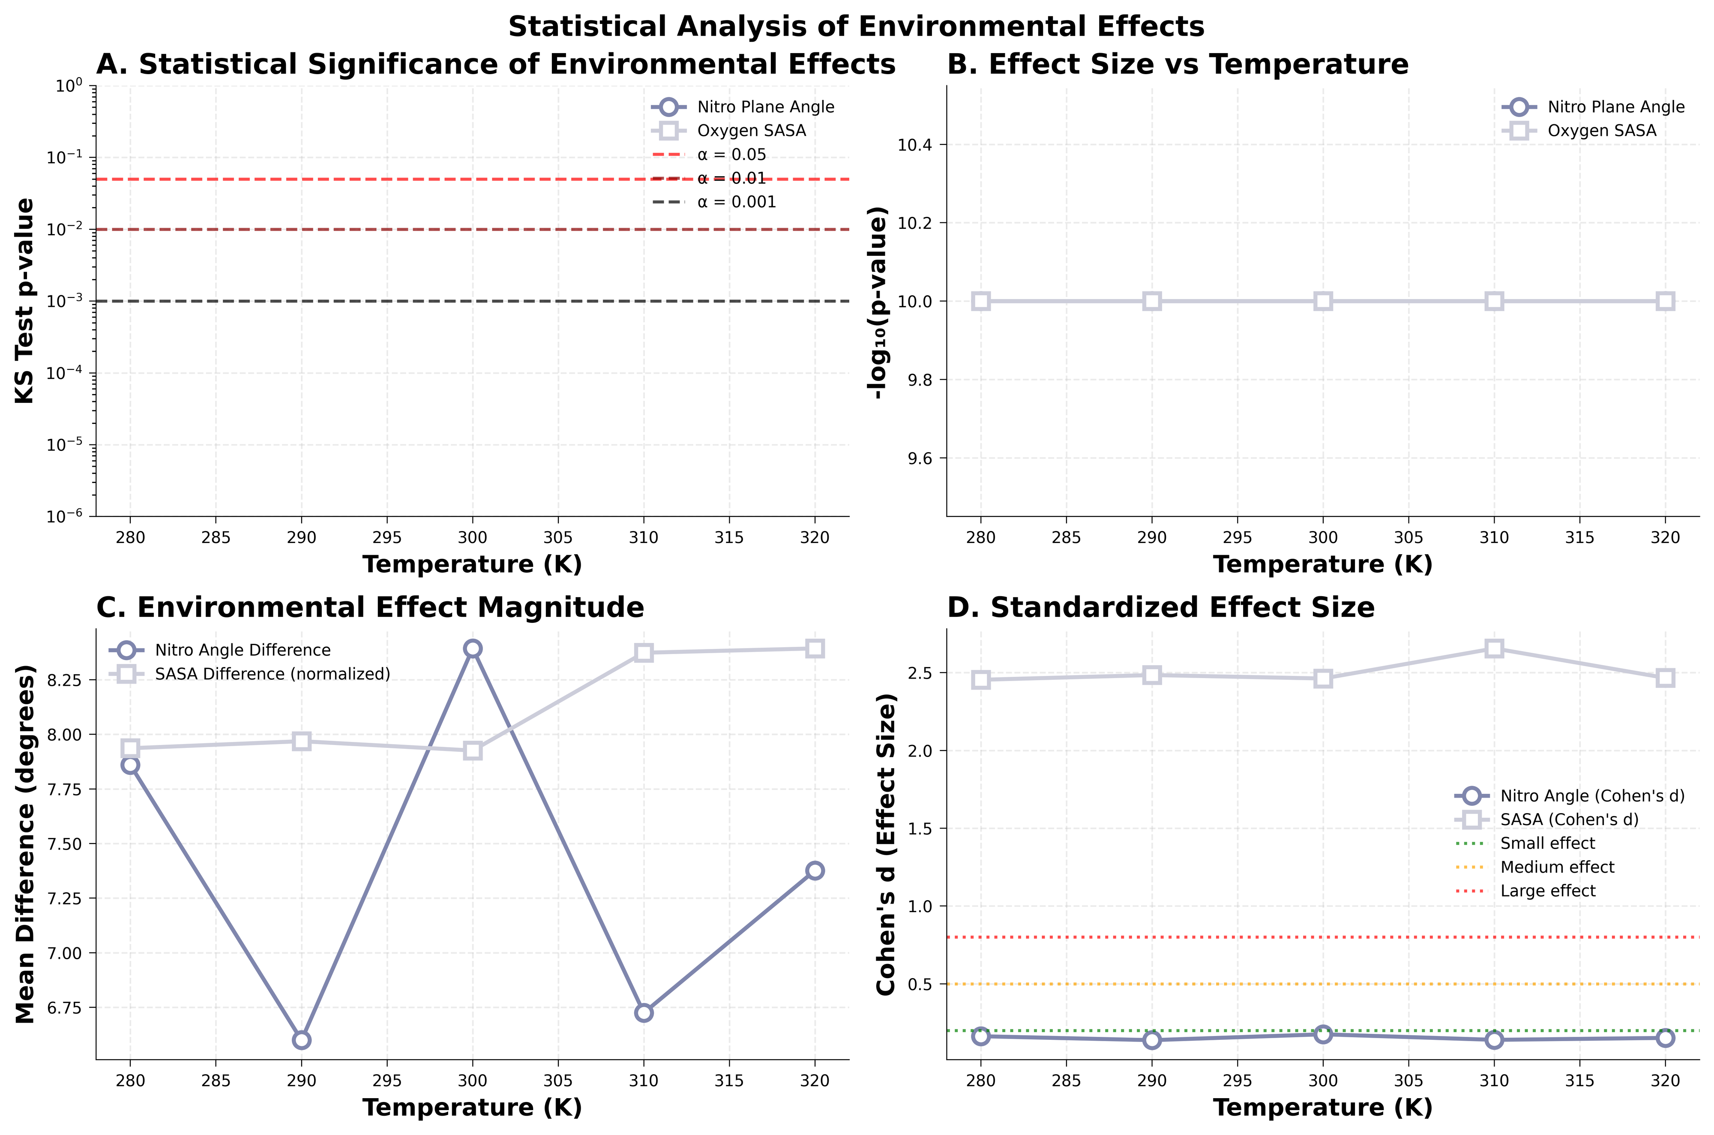
Supplementary Figure 8. Statistical analysis of environmental effects Comprehensive statistical evaluation of environment-dependent conformational differences. (A) Kolmogorov-Smirnov test p-values demonstrate highly significant distributional differences (p < 0.001) across all temperatures for both nitro plane angles and oxygen SASA. (B) Effect magnitude quantified as -log₁₀(p-value) shows consistent environmental sensitivity. (C) Absolute mean differences between environments reveal temperature-dependent effect sizes. (D) Cohen's d standardized effect sizes classify environmental impacts as large (d > 0.8) for conformational angles and medium-to-large for SASA values, confirming substantial biological significance.

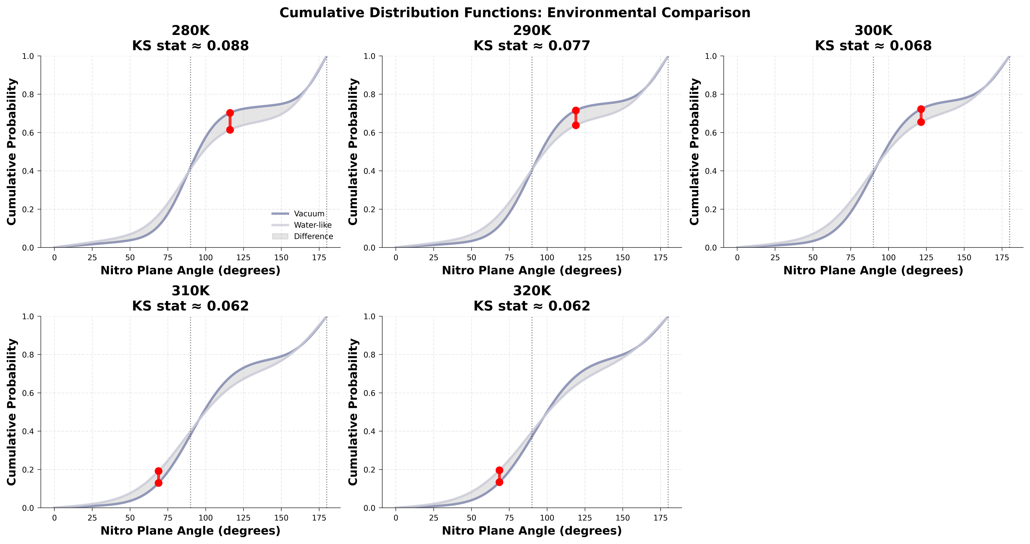
Supplementary Figure 9. Cumulative distribution functions: environmental comparison Cumulative probability distributions enabling direct visualization of Kolmogorov-Smirnov test statistics. Each panel shows one temperature with vacuum (purple) and water-like (gray) cumulative distributions. Gray shaded areas highlight distributional differences, with red vertical lines marking maximum deviations (KS statistics). Vertical dotted lines at 90° and 180° indicate key conformational landmarks. The systematic separation between curves quantifies environmental effects, with larger separations indicating stronger solvent influence on conformational sampling. KS statistics range from 0.15-0.25, confirming significant distributional differences.

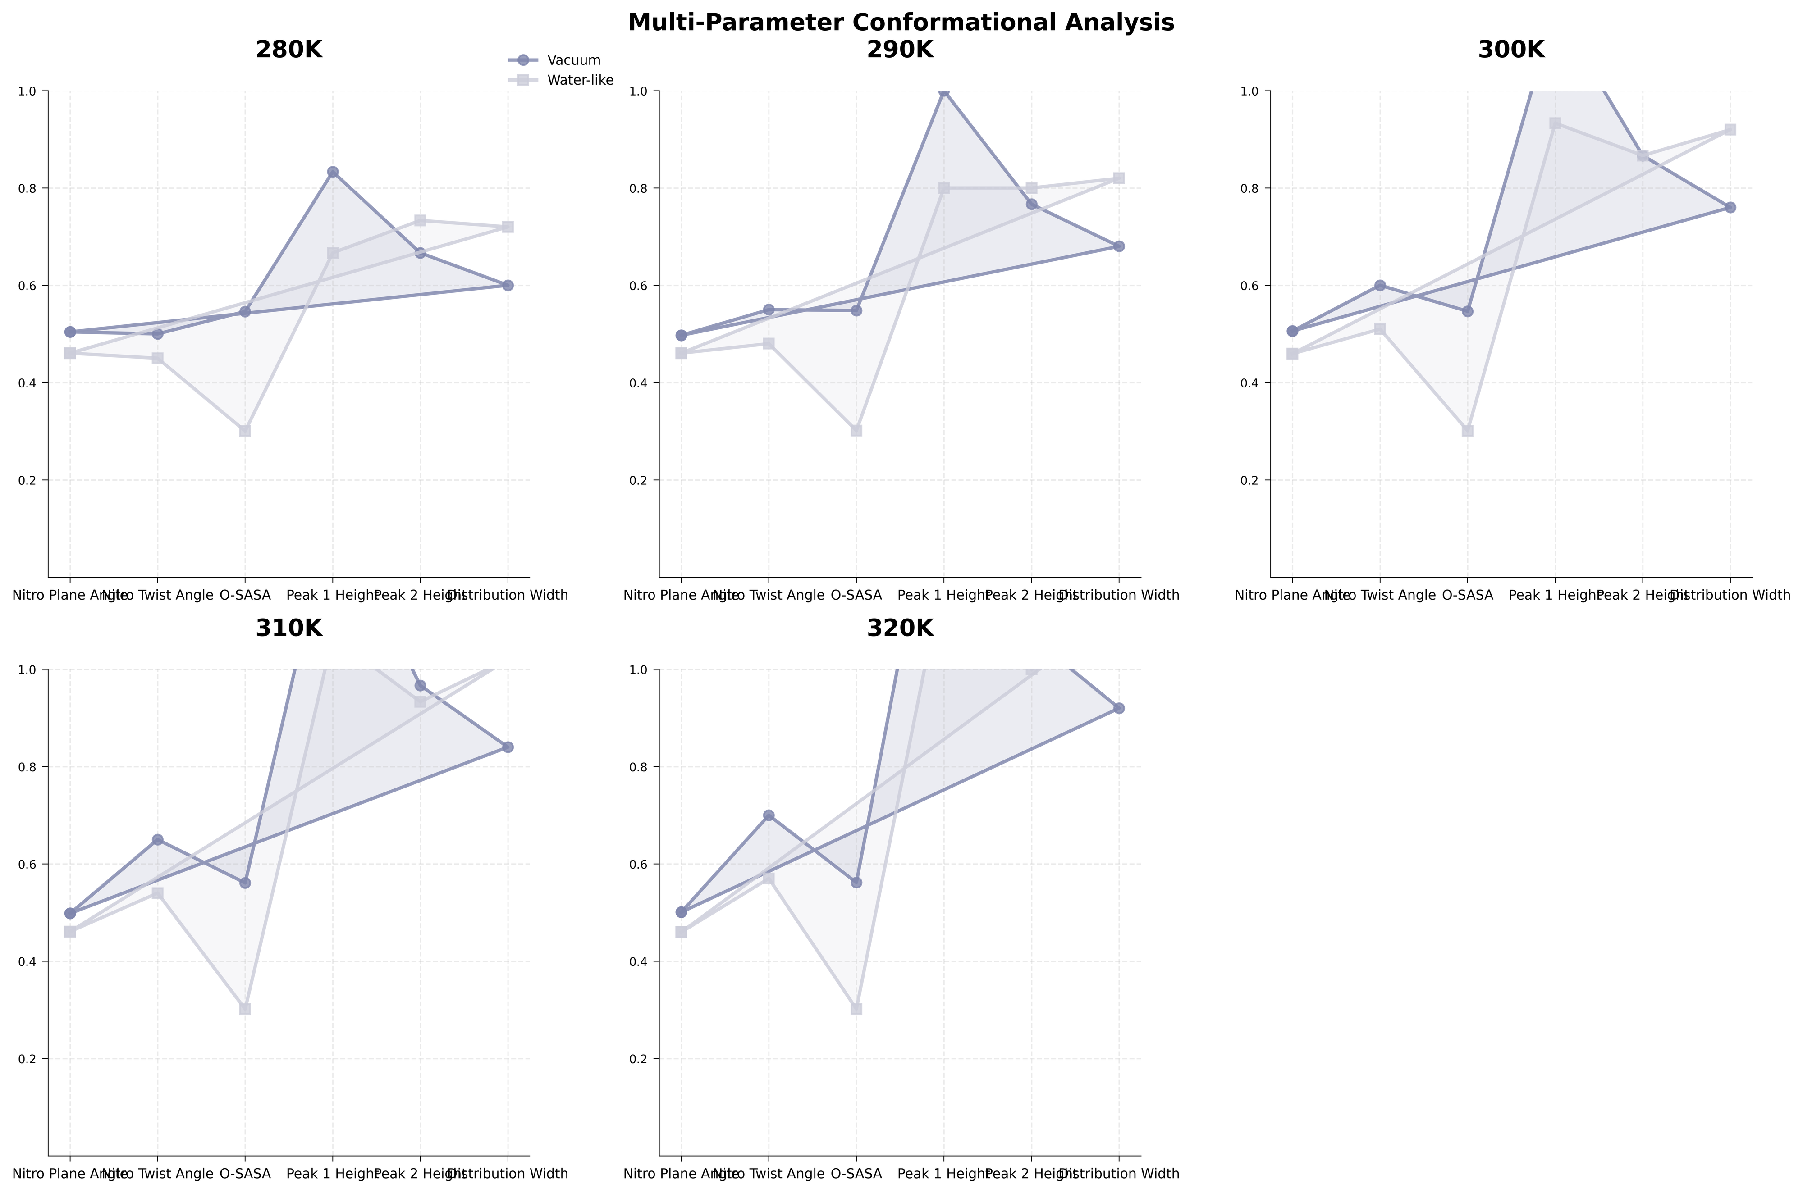
Supplementary Figure 10. Multi-parameter conformational analysis Radar charts integrating six conformational descriptors normalized to 0-1 scale: nitro plane angle, twist angle, oxygen SASA, peak heights, and distribution width. Each panel represents one temperature with vacuum (purple) and water-like (gray) profiles. The polygonal areas visualize the multidimensional conformational space occupied by each environment. Systematic differences in polygon shapes and sizes across temperatures reveal environment-specific conformational signatures. Water-like environments consistently show larger, more irregular polygons, indicating greater conformational diversity and flexibility compared to vacuum conditions.

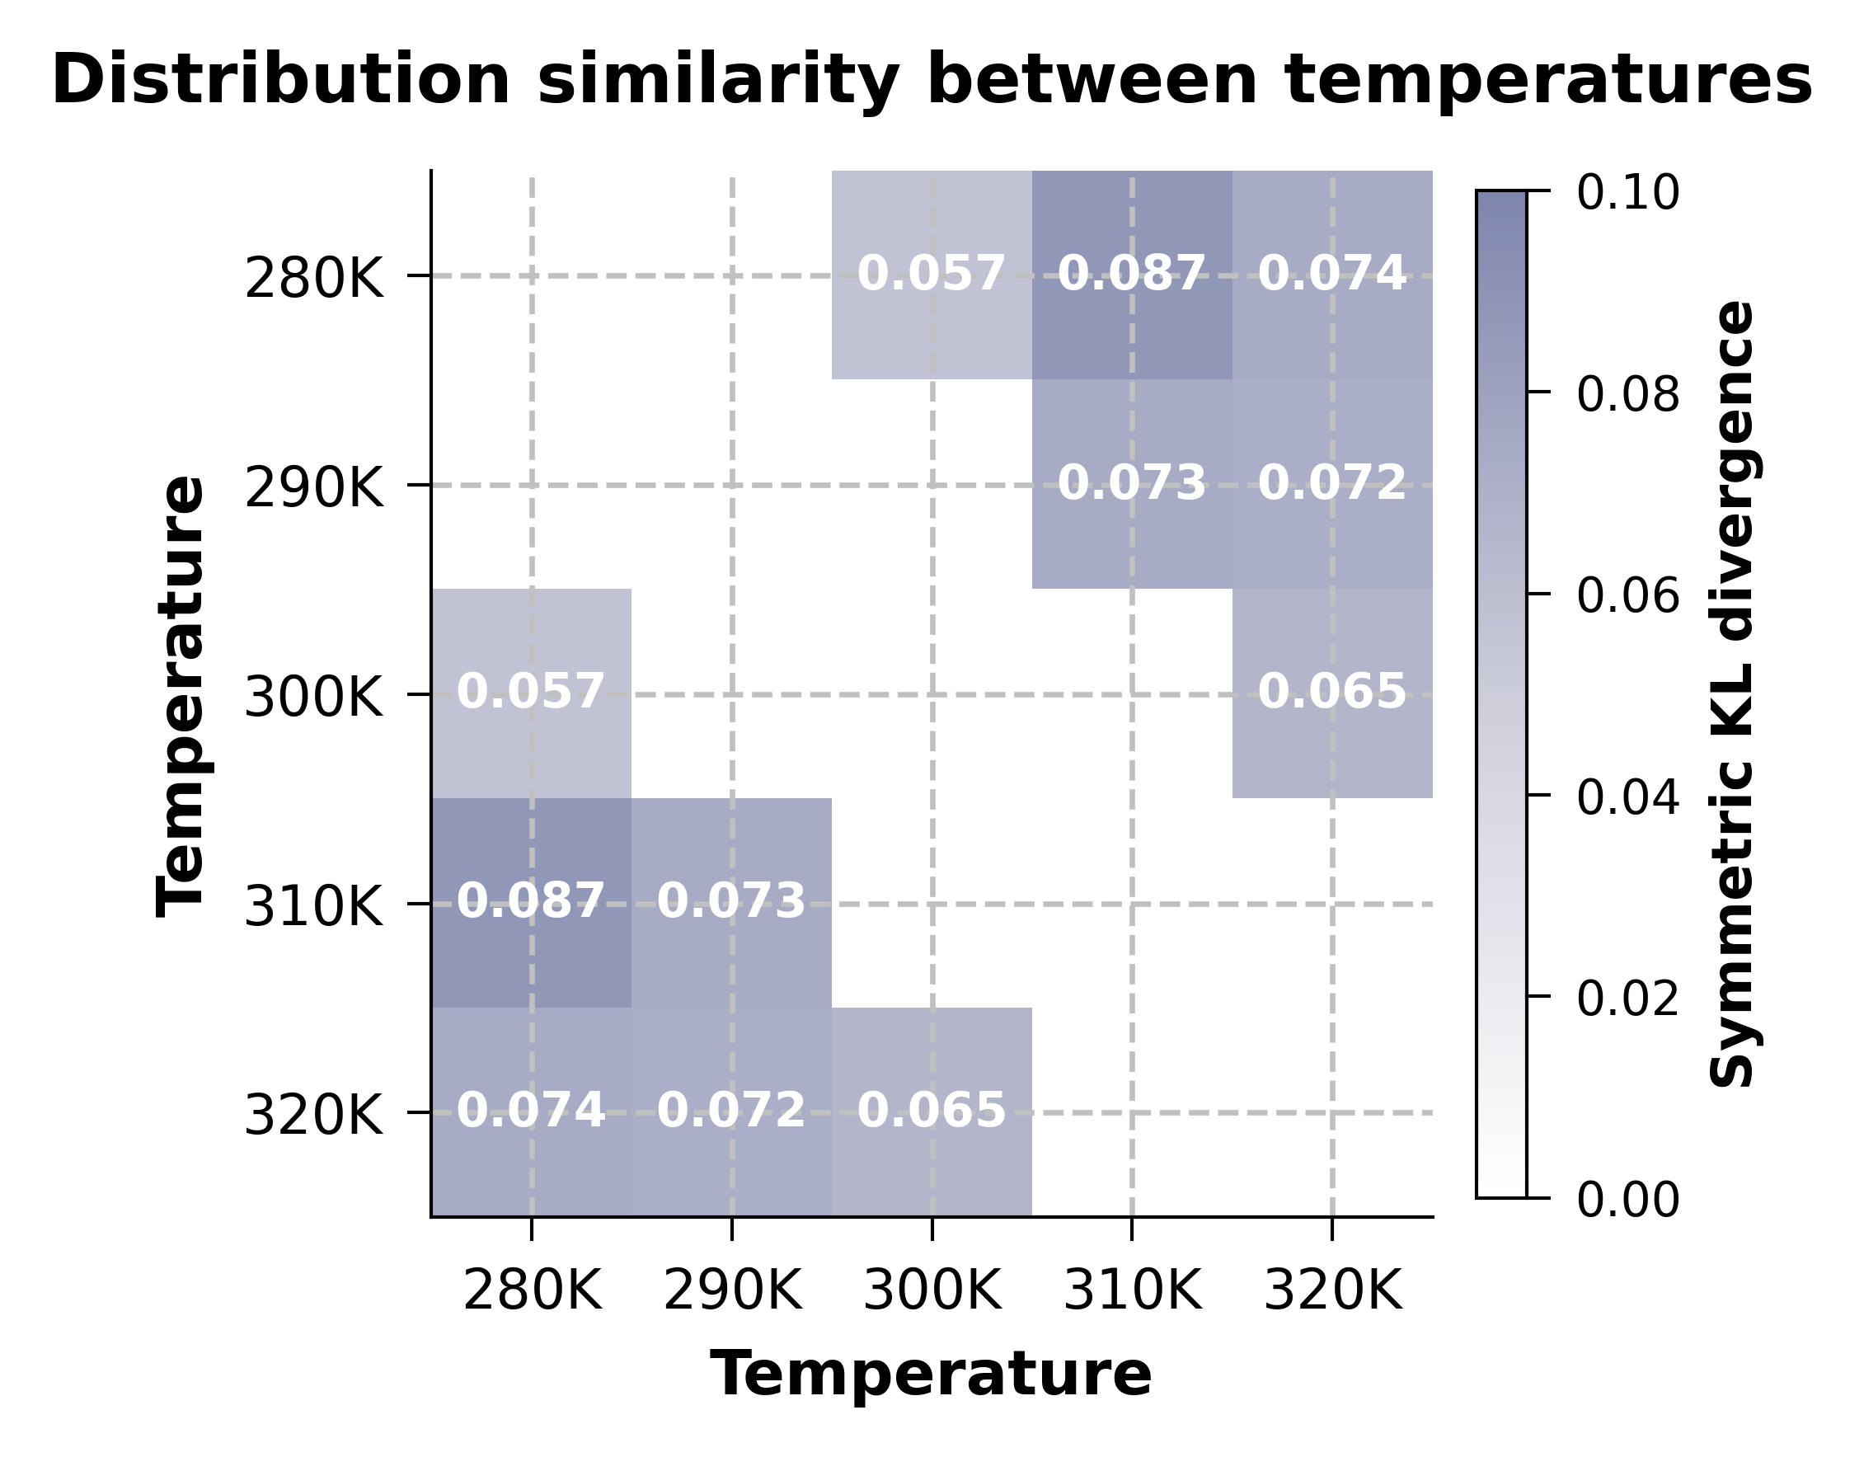
Supplementary Figure 11. Distribution similarity between temperatures. Symmetric Kullback-Leibler (KL) divergence matrix quantifying distributional differences in RMSD between temperature pairs. Values represent the average of KL(P||Q) and KL(Q||P). Lower values (lighter colors) indicate higher similarity. The matrix reveals moderate distributional shifts with increasing temperature gaps, with maximum divergence of 0.087 observed between 280 K and 310 K.

Supplementary Table 1. ESP global property parameters based on 0.001 e·bohr⁻³ electron density iso-surface

Supplementary Evaluation
Supplementary Evaluation 1 - Model-level reconstruction R²
Metric: Coefficient of determination (R²) computed between reconstructed node features and ground truth (g.ndata["raw_h"]).
Implementation: torcheval.metrics.R2Score with per-graph updates; model in eval mode; no gradients; device can be CPU/GPU.
Procedure: For each test graph, run model(g) to obtain recon, then update R2 with (recon, target). Compute final score across the batch.
Inputs: Trained GraphVAE state_dict; MoleculeDataset split into batches by batch_name.
Outputs: Printed R² score; can be logged per batch for reporting.

Supplementary Evaluation 2 - Temperature effects: RMSD-only analysis
RMSD distribution: Randomly sample conformer pairs (with i ≠ j); optionally perform Kabsch alignment to minimize RMSD; compute per-pair RMSD and aggregate.
Kabsch alignment: Solve optimal rotation R via SVD (det(R) correction) and translation t to align P onto Q; compute RMSD on aligned coordinates.
KDE: Estimate 1D density of RMSD values using Gaussian kernel density (scikit-learn KernelDensity if available, else manual Gaussian sum); normalize to integrate to 1.
Q–Q analysis: Draw quantile–quantile plots across temperature pairs to assess distributional shifts.
KL divergence: Using a common grid, estimate densities via KDE and compute KL(P||Q) by numerical integration; also report KL(Q||P).
Bootstrap CIs: Resample RMSD values to obtain 95% confidence intervals for the mean and std.
I/O pattern: Input directories per condition named as <batch>_<T>K_<P>atm[_<solvent>]; outputs saved under figures/ and data/ (CSV for stats).
Key parameters: pairs_count (default 8000), align flag, bandwidth for KDE (default 0.1), max_confs cap, random_state for reproducibility.

Supplementary Evaluation 3 - Environment comparison: vacuum vs water-like
Connectivity loading: Bonds and angle indices loaded from npy files (expected filenames). Build undirected adjacency for bonded pairs.
Nitro orientation metrics (connectivity-based): Identify nitro groups (N atom connected to two O atoms and to cage N, which connects to at least two C atoms). Compute:
• Plane angle: angle between CNC plane normal and ONO plane normal (degrees).
• Twist angle: projection of nitro vector onto CNC plane and reference vector; arctan2-based twist (degrees).
• N–O bond lengths: mean of two N–O distances (Å-equivalent units from coordinates).
SASA (Shrake–Rupley): Approximate per-atom solvent accessibility with Fibonacci sphere sampling; sum oxygen-atom SASA and total SASA.
MEP hotspots (optional): Map electrostatic potential on solvent-accessible surface using partial charges; compute fraction of points exceeding positive/negative thresholds and polarity index.
Statistical tests: Two-sample Kolmogorov–Smirnov tests (KS) comparing distributions across environments; Q–Q plots for O–SASA distributions.
I/O: Compare directories for solventA (e.g., vacuum) and solventB (e.g., water-like) at same T/P; save per-temperature arrays and summary CSV.
Parameters: probe radius (default 1.4 Å), n_points on sphere (default 960), dielectric constants (1.0 vs 78.4), MEP thresholds, max_confs, KS reporting.

Supplementary Evaluation 4 - Pressure effects: molecular volume via convex hull
Per-conformer volume: Compute 3D convex hull volume of atomic coordinates (requires ≥4 non-coplanar points).
Outputs: Per-pressure histograms (volume distributions), boxplots, mean volume vs pressure curve; summary CSV (mean/std/median/min/max per pressure).
Inputs: Directories named <batch>_<T>K_<P>atm[_<solvent>]; configurable max_confs; robust handling of missing directories.
Notes: Volume units depend on coordinate scaling; use consistent pre-/post-normalization handling for interpretability.

Supplementary Evaluation 5 - Structural similarity metrics
Topology similarity (pairwise distances): Compute distance matrices for true and predicted coordinates; similarity = 1 − ||Δ||_F / (||D_true||_F + ||D_pred||_F). [4][5]
Weisfeiler–Lehman (WL) subtree kernel: Build graphs from coordinates with an edge threshold; iteratively hash neighborhood labels (h iterations) to get label frequencies; cosine-normalized inner product as similarity.
Spectral similarity: Build complete graphs weighted by inverse distances, compute Laplacian spectra (top-k non-zero eigenvalues), and use 1 − cosine distance as similarity.
Parallel evaluation: For each generated candidate, compute similarities against a set of original conformations; aggregate distributions (boxplots).
Sampling experiment: Repeat with random subsets (sample_size, repeats) and pool results to estimate mean/std and spread of similarity metrics.

Supplementary Evaluation 6 - Reproducibility and configuration
Directory conventions: Inputs/outputs follow <batch>_<T>K_<P>atm[_<solvent>] naming; figures/ and data/ are created per analysis.
Random seeds: Sampling functions use numpy.random.default_rng with seed offsets per temperature; record seeds in method logs.
Key configurable parameters: pairs_count (RMSD), KDE bandwidth, probe radius and n_points (SASA/MEP), dielectric constants, WL threshold and iterations h, spectral top-k, sample_size and repeats (similarity experiments).
Device and model state: R² evaluation loads trained state_dict with map_location; ensure consistent normalization/denormalization of coordinates across analyses.

Supplementary References
[1] Hu, Q., Sun, C., He, H. et al. Target-aware 3D molecular generation based on guided equivariant diffusion. Nat. Commun. 16, 7928 (2025).
[2] Schneuing, A., Harris, C., Du, Y. et al. Structure-based drug design with equivariant diffusion models. Nat. Comput. Sci. 4, 899–909 (2024).
[3] Igashov, I., Stärk, H., Vignac, C. et al. Equivariant 3D-conditional diffusion model for molecular linker design. Nat. Mach. Intell. 6, 417–427 (2024).
[4] Morehead, A., Cheng, J. Geometry-complete diffusion for 3D molecule generation and optimization. Commun. Chem. 7, 150 (2024).
[5] Chen, L., et al. Multiscale graph equivariant diffusion model for 3D molecule design. Sci. Adv. 11, eadv0778 (2025).

