Table S1 Primers used in this study
Purpose | Gene name | Primer name | Primer sequence (5'-3')
Promoter cloning | HaCHT4 | SP1 | TTCTGTCTTAGCGTGGAATTGTTTG
Promoter cloning | HaCHT4 | SP2 | CTACCGCATTTTCGCTAGCCACAATA
RT-qPCR | HaBRC Z2 | HaBRC Z2-QF | TGCGGGAAGGTTCTGTGC
RT-qPCR | HaBRC Z2 | HaBRC Z2-QR | CCTGTCCTCGACTTGTGGTAC
RT-qPCR | HaCHT4 | HaCHT4-QF | CCTACGACGATGTGAACTCCATAAC
RT-qPCR | HaCHT4 | HaCHT4-QR | GCAGTGTTGATAGCAGAGTAAAGG
RT-qPCR | β-actin | β-actin-QF | TGCGGGAAGGTTCTGTGC
RT-qPCR | β-actin | β-actin-QR | CCTGTCCTCGACTTGTGGTAC
RNAi | HaBRC Z2 | dsHaBRC Z2-F | TAATACGACTCACTATAGGGAGACAATAACAACGAACAACCC
RNAi | HaBRC Z2 | dsHaBRC Z2-R | TAATACGACTCACTATAGGGAACCAGTCAAAGAGGGATGC
RNAi | GFP | dsGFP-F | TAATACGACTCACTATAGGGACAGTGCTTCAGCCGCTAC
RNAi | GFP | dsGFP-R | TAATACGACTCACTATAGGGAGTTCACCTTGATGCCGTTC
Note: The underlined sequence represents the T7 RNA polymerase promoter sequence.

Table S2 Nested PCR reaction procedure
PCR steps | Cycles | Temperature & Duration
SP1 | 5 | 95°C (1 min); 94°C (30 s) → 65°C (1 min) → 72°C (2 min)
SP1 | 40 | 95°C (15 s) → 60°C (30 s) → 72°C (2 min)
SP2 | 15 | 94°C (30 s) → 62°C (1 min) → 72°C (2 min)
SP2 | 15 | 94°C (30 s) → 44°C (1 min) → 72°C (2 min)
SP2 | 1 | 72°C (10 min)

Table S3 Basic information of BTB family proteins
Rename | Gene ID | Number of Amino Acid | Molecular Weight | Theoretical pI | Instability Index | Aliphatic Index | Grand Average of Hydropathicity | Subcellular Localization
HaABTB1 | LOC110371202 | 1234 | 138307.30 | 8.40 | 45.69 | 85.43 | -0.356 | Nuclear
HaABTB2 | LOC110370878 | 1183 | 127884.1 | 5.57 | 36.87 | 94.69 | -0.154 | Cytoplasmic
HaBBK1 | LOC110374871 | 638 | 72075.33 | 5.52 | 42.66 | 90.94 | -0.287 | Nuclear
HaBBK2 | LOC110369920 | 588 | 65068.18 | 6.08 | 43.56 | 91.41 | -0.163 | Nuclear
HaBBK3 | LOC110372548 | 1239 | 141495.80 | 8.38 | 49.98 | 71.92 | -0.515 | Nuclear
HaBBK4 | LOC110375210 | 1287 | 135622.80 | 8.70 | 58.25 | 82.64 | -0.181 | Nuclear
HaBBK5 | LOC126056157 | 642 | 67472.07 | 8.29 | 57.28 | 87.87 | -0.054 | Nuclear
HaBBK6 | LOC110375607 | 799 | 90445.17 | 6.54 | 51.17 | 83.17 | -0.269 | Plasma Membrane
HaBBP1 | LOC110379071 | 507 | 56458.02 | 5.08 | 33.78 | 85.38 | -0.201 | Cytoplasmic
HaBBP2 | LOC110380429 | 590 | 65348.11 | 5.68 | 48.02 | 79.71 | -0.168 | Mitochondrial
HaBBTB1 | LOC110379386 | 1739 | 191896.6 | 6.36 | 52.42 | 75.08 | -0.554 | Plasma Membrane
HaBBTB2 | LOC110380553 | 645 | 71723.88 | 5.90 | 48.77 | 82.22 | -0.152 | Cytoplasmic
HaBBTB3 | LOC126055061 | 345 | 39489.03 | 4.86 | 38.45 | 89.86 | -0.169 | Cytoplasmic
HaBBTB4 | LOC110381200 | 610 | 67791.08 | 5.81 | 52.03 | 82.13 | -0.284 | Nuclear
HaBBTB5 | LOC110376995 | 591 | 65191.01 | 6.48 | 56.61 | 83.79 | -0.248 | Cytoplasmic and nuclear
HaBBTB6 | LOC110370251 | 609 | 66488.97 | 6.18 | 48.99 | 89.69 | -0.051 | Nuclear
HaBBTB7 | LOC110372258 | 359 | 40110.05 | 6.67 | 49.62 | 88.58 | -0.208 | Nuclear
HaBBTB8 | LOC110374871 | 638 | 72075.33 | 5.52 | 42.66 | 90.94 | -0.287 | Nuclear
HaBBTB9 | LOC110375966 | 489 | 53665.22 | 5.98 | 38.46 | 85.48 | -0.087 | Cytoplasmic
HaBBTB10 | LOC110378080 | 398 | 43967.29 | 5.73 | 63.61 | 92.34 | -0.239 | Cytoplasmic
HaBBTB11 | LOC110377969 | 628 | 71546.66 | 6.91 | 42.77 | 80.27 | -0.262 | Nuclear
HaBBTB12 | LOC110384382 | 666 | 75426.00 | 5.45 | 51.52 | 85.69 | -0.221 | Nuclear
HaBBTB13 | LOC110371681 | 599 | 68273.95 | 5.65 | 43.76 | 86.19 | -0.218 | Nuclear
HaBBTB14 | LOC110383061 | 339 | 39091.88 | 5.82 | 34.58 | 96.67 | -0.293 | Cytoplasmic
HaBBTB15 | LOC110382872 | 1420 | 152568.40 | 9.76 | 47.00 | 84.65 | -0.171 | Cytoplasmic
HaBTBD1 | LOC110378022 | 387 | 43251.83 | 6.29 | 55.77 | 68.84 | -0.607 | Nuclear
HaBTBD2 | LOC110377571 | 423 | 46867.22 | 8.26 | 62.37 | 61.82 | -0.684 | Nuclear
HaBTBD3 | LOC110377815 | 173 | 20291.21 | 7.14 | 45.31 | 77.17 | -0.573 | Cytoplasmic
HaBTBD4 | LOC110374605 | 628 | 71490.58 | 5.51 | 54.30 | 88.98 | -0.205 | Plasma Membrane
HaBTBD5 | LOC110377077 | 217 | 25273.29 | 5.16 | 50.50 | 80.78 | -0.691 | Cytoplasmic
HaBTBD6 | LOC110383758 | 566 | 63195.71 | 6.50 | 60.31 | 67.93 | -0.741 | Nuclear
HaBTBD7 | LOC110370508 | 543 | 59939.62 | 5.99 | 57.80 | 72.60 | -0.564 | Nuclear
HaBTBD8 | LOC110384143 | 714 | 80757.92 | 9.24 | 48.12 | 67.98 | -0.535 | Nuclear
HaBTBD9 | LOC110384113 | 477 | 52673.20 | 6.40 | 50.03 | 73.98 | -0.538 | Nuclear
HaBTBD10 | LOC110377462 | 573 | 63929.82 | 5.93 | 62.24 | 69.65 | -0.678 | Nuclear
HaBTBD11 | LOC110374654 | 349 | 39676.61 | 6.55 | 31.49 | 87.94 | -0.185 | Cytoplasmic
HaBTBD12 | LOC135116971 | 662 | 72907.54 | 5.98 | 53.61 | 61.07 | -0.869 | Nuclear
HaBTBD13 | LOC110380998 | 672 | 73802.67 | 5.86 | 52.59 | 61.62 | -0.844 | Nuclear
HaBTBD14 | LOC110380998 | 663 | 72954.70 | 5.86 | 53.55 | 60.98 | -0.868 | Nuclear
HaBTBD15 | LOC110381096 | 451 | 49446.29 | 9.06 | 63.84 | 54.01 | -0.789 | Nuclear
HaBTBD16 | LOC110381096 | 448 | 49189.04 | 9.14 | 64.39 | 54.15 | -0.79 | Nuclear
HaBTBD17 | LOC110371926 | 449 | 51956.77 | 5.98 | 38.24 | 98.73 | -0.082 | Cytoplasmic
HaBTBD18 | LOC110371966 | 320 | 36514.09 | 5.86 | 51.18 | 71.88 | -0.634 | Nuclear
HaBTBD19 | LOC110371056 | 447 | 49778.91 | 6.11 | 46.31 | 81.74 | -0.601 | Nuclear
HaBTBD20 | LOC126053462 | 233 | 26328.57 | 6.19 | 35.35 | 72.88 | -0.55 | Cytoplasmic
HaBTBD21 | LOC110372773 | 1080 | 119639.20 | 5.86 | 45.75 | 95.87 | -0.183 | Nuclear
HaBTBD22 | LOC110369927 | 292 | 32891.53 | 6.34 | 52.29 | 86.47 | -0.358 | Cytoplasmic
HaBTBD23 | LOC110372595 | 552 | 60778.55 | 5.62 | 52.38 | 65.49 | -0.685 | Nuclear
HaBTBD24 | LOC110372595 | 546 | 60057.71 | 5.54 | 52.90 | 65.49 | -0.693 | Nuclear
HaBTBD25 | LOC110372361 | 162 | 18439.93 | 4.36 | 46.05 | 83.02 | -0.57 | Cytoplasmic
HaBTBD26 | LOC110375960 | 370 | 41467.60 | 6.19 | 75.44 | 63.59 | -0.777 | Nuclear
HaBTBD27 | LOC110379625 | 900 | 99320.92 | 6.38 | 51.97 | 79.82 | -0.357 | Plasma Membrane
HaBTBD28 | LOC110384046 | 840 | 93993.13 | 4.62 | 53.67 | 78.10 | -0.676 | Nuclear
HaBTBD29 | LOC110384377 | 327 | 37265.78 | 5.14 | 39.33 | 85.81 | -0.522 | Cytoplasmic
HaBTBD30 | LOC110380888 | 410 | 45294.08 | 7.42 | 63.94 | 63.63 | -0.605 | Nuclear
HaBTBD31 | LOC110379733 | 315 | 34872.16 | 6.15 | 39.89 | 96.10 | -0.107 | Cytoplasmic
HaBTBD32 | LOC110384284 | 1494 | 168862.50 | 4.64 | 59.59 | 77.55 | -0.709 | Nuclear
HaBTBD33 | LOC110376725 | 621 | 70593.43 | 7.92 | 43.12 | 86.18 | -0.178 | Plasma Membrane
HaBTBD34 | LOC110376737 | 662 | 74177.30 | 5.92 | 46.88 | 99.08 | -0.07 | Plasma Membrane
HaBTBD35 | LOC110376709 | 719 | 80234.94 | 5.93 | 51.55 | 68.32 | -0.743 | Nuclear
HaBTBD36 | LOC110377459 | 578 | 66121.11 | 5.71 | 42.58 | 93.91 | -0.152 | Cytoplasmic
HaBTBD37 | LOC110373447 | 661 | 72155.49 | 8.11 | 40.48 | 80.38 | -0.266 | Nuclear
HaBTBD38 | LOC110377143 | 406 | 44343.46 | 5.27 | 35.65 | 93.25 | -0.175 | Mitochondrial
HaBTBD39 | LOC110370789 | 851 | 96786.79 | 8.90 | 57.14 | 69.79 | -0.68 | Nuclear
HaBTBD40 | LOC110383328 | 278 | 30960.11 | 8.18 | 50.63 | 86.98 | -0.413 | Nuclear
HaBTBD41 | LOC110383328 | 278 | 30960.11 | 8.18 | 50.63 | 86.98 | -0.413 | Nuclear
HaBTBD42 | LOC110377621 | 128 | 14574.91 | 7.73 | 53.01 | 80.78 | -0.273 | Cytoplasmic
HaBTBD43 | LOC110379554 | 154 | 16143.04 | 4.81 | 41.97 | 72.34 | -0.117 | Cytoplasmic and nuclear
HaBTBD44 | LOC110372654 | 613 | 68280.28 | 8.45 | 44.02 | 82.15 | -0.132 | Plasma Membrane
HaBTBD45 | LOC110376192 | 381 | 43898.24 | 5.47 | 51.44 | 66.22 | -0.813 | Nuclear
HaBTBD46 | LOC110377829 | 439 | 48732.56 | 5.76 | 61.14 | 67.79 | -0.658 | Nuclear
HaBTBD47 | LOC110382039 | 696 | 76298.93 | 6.26 | 45.31 | 75.00 | -0.595 | Nuclear
HaBTB-ZF1 | LOC110383294 | 448 | 49840.60 | 7.75 | 61.15 | 66.41 | -0.753 | Nuclear
HaBTB-ZF2 | LOC110373894 | 818 | 93003.76 | 6.73 | 58.49 | 63.69 | -0.921 | Nuclear
HaBTB-ZF3 | LOC110384388 | 344 | 39595.59 | 6.24 | 54.91 | 72.56 | -0.792 | Cytoplasmic
HaBTB-ZF4 | LOC110370686 | 403 | 45235.15 | 6.54 | 53.76 | 75.93 | -0.476 | Nuclear
HaBTB-ZF5 | LOC135117716 | 364 | 40396.49 | 6.00 | 43.56 | 84.59 | -0.388 | Cytoplasmic and nuclear
HaBTB-ZF6 | LOC110377185 | 634 | 71199.81 | 5.22 | 44.91 | 69.02 | -0.635 | Nuclear
HaBTB-ZF7 | LOC110378827 | 419 | 48381.89 | 5.87 | 37.24 | 69.50 | -0.857 | Nuclear
HaHBTB1 | LOC110376628 | 551 | 59867.64 | 6.71 | 63.27 | 70.22 | -0.504 | Nuclear
HaHBTB2 | LOC110372381 | 498 | 54790.76 | 8.77 | 73.48 | 67.03 | -0.616 | Nuclear
HaHBTB3 | LOC110375819 | 500 | 55796.09 | 8.47 | 68.13 | 61.28 | -0.799 | Nuclear
HaMBTB | LOC110383902 | 352 | 39890.82 | 6.22 | 33.78 | 87.33 | -0.239 | Cytoplasmic
HaRhoBTB1 | LOC135118336 | 738 | 84840.75 | 8.26 | 47.12 | 83.10 | -0.292 | Extracellular
HaRhoBTB2 | LOC110381093 | 745 | 85424.19 | 8.26 | 45.92 | 84.16 | -0.279 | Extracellular

Figure S1: Methods
Chromosomal mapping of the BTB gene family
The chromosomal location data of the HaBTB genes in H. armigera were obtained from the NCBI GenBank database, along with the corresponding genome annotation files. The distribution of HaBTB genes on their chromosomes was visualized using MapChart software (https://www.wur.nl/en/show/Mapchart.htm).
Results
Analysis of the chromosomal localization of the BTB gene family
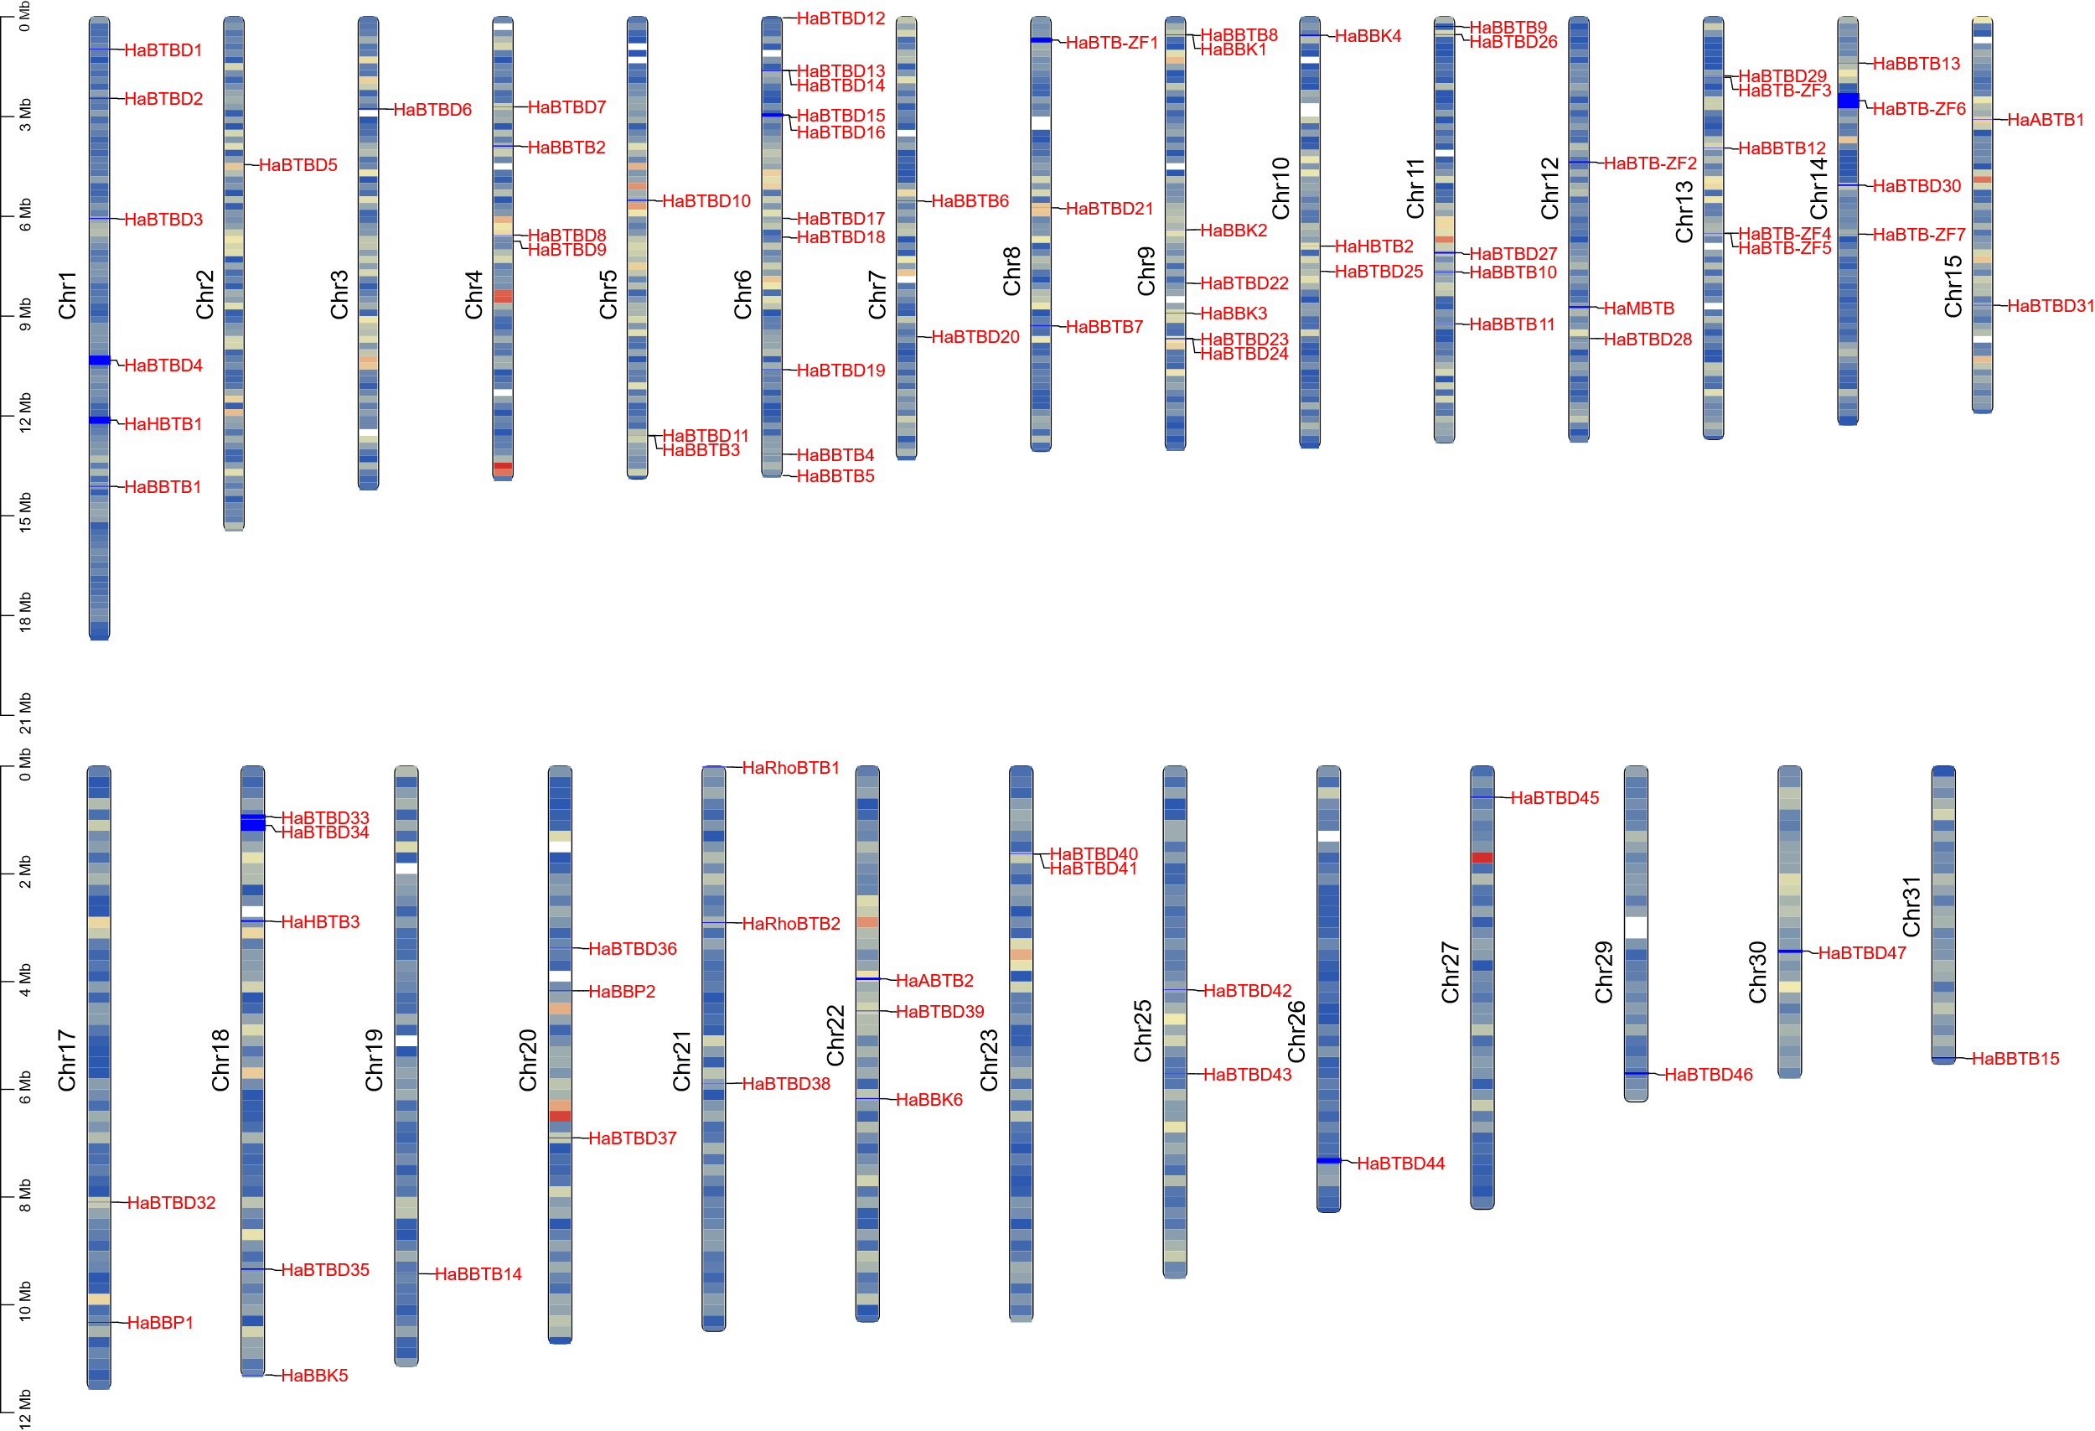
Figure S1 depicts the relationship between the chromosomal location of the HaBTB gene family. Members of the HaBTB family were unevenly distributed across the 28 chromosomes. Chromosome 6 harbored the highest number of HaBTB genes (10 genes), while chromosome 2, 3, 19, 26, 17, 19, 30, and 31 had the lowest number (1 gene each). These genes were mostly located relatively close to the telomeric region of the chromosome.
Figure S1. Schematic depictions of the chromosomal distribution of HaBTB genes. The chromosome number is indicated to the left of each chromosome.

