SUPPLEMENTARY MATERIAL
Supplementary Tables S1 - Full SPSS output of the multinomial logistic regression model
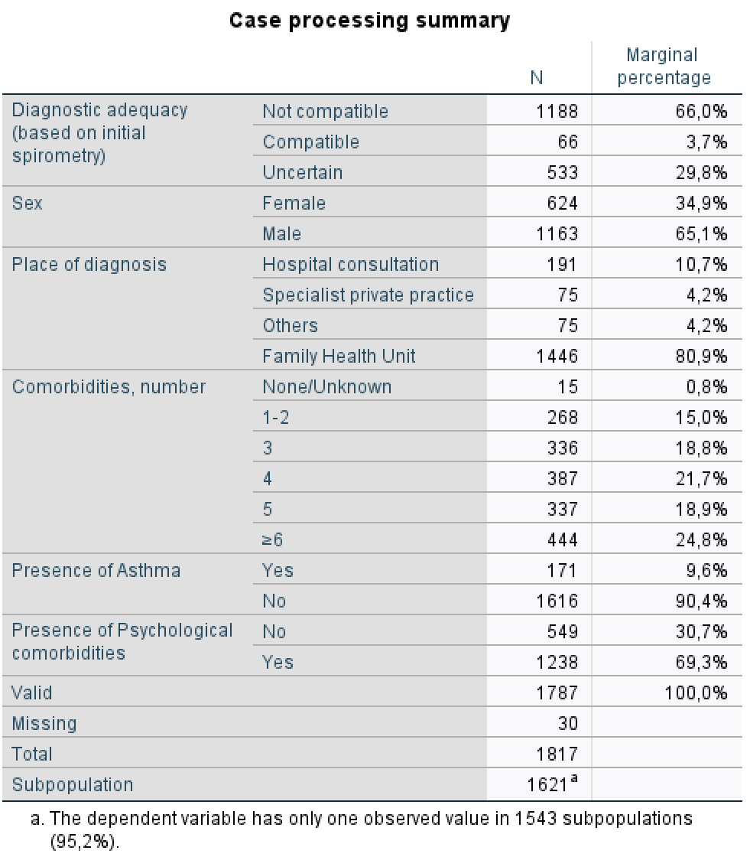
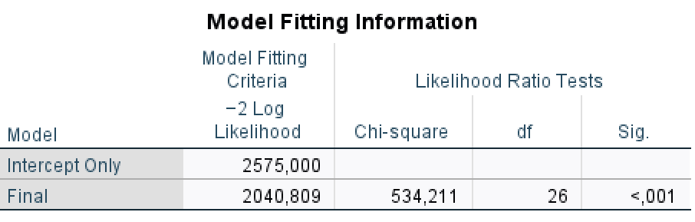

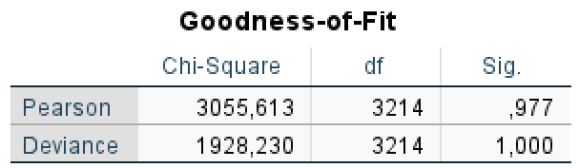

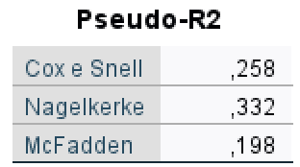

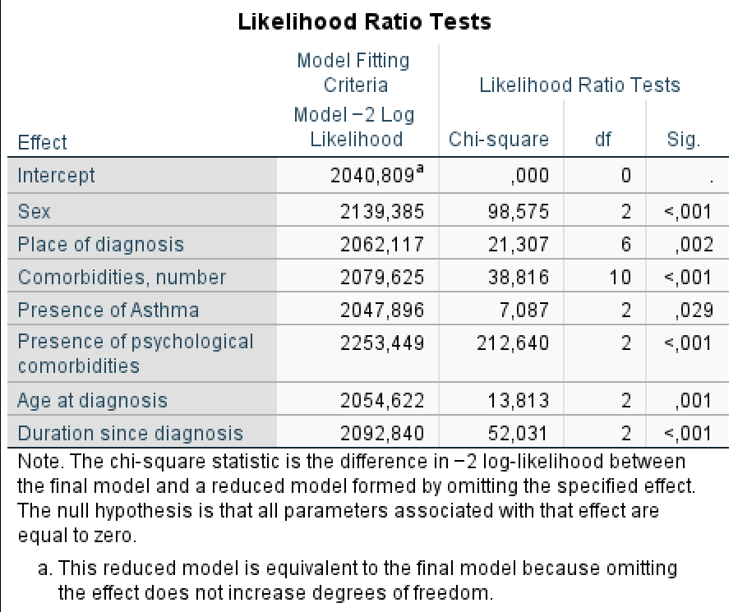

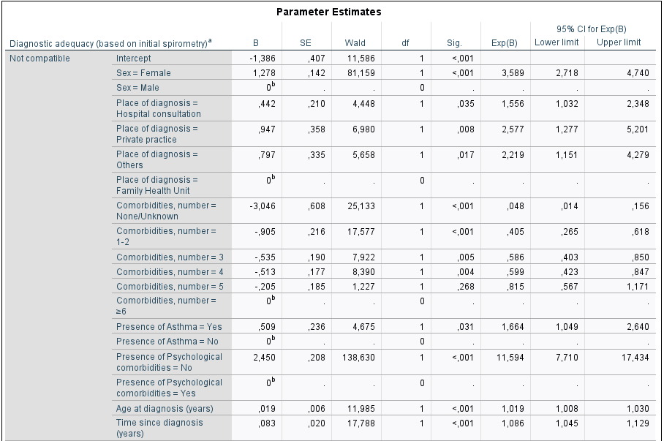
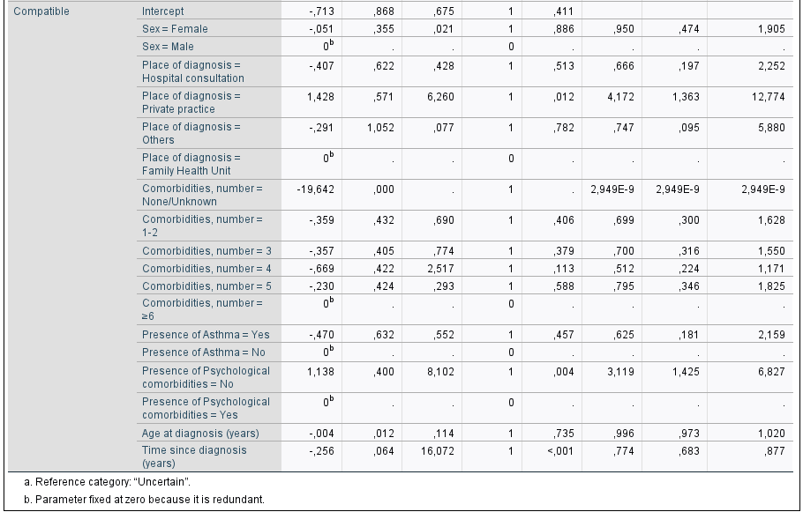

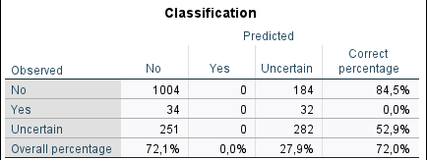
S1 - Multinomial logistic regression model using diagnostic compatibility (based on initial spirometry) as the dependent variable.
This supplement includes: (1) the Case Processing Summary detailing the number of valid observations and category distributions; (2) Model Fitting Information and Goodness-of-Fit statistics; (3) Likelihood Ratio Tests for each predictor; (4) full Parameter Estimates for all model coefficients (reference category: Uncertain); and (5) the Classification Table reporting the predictive performance of the final model. Predictors included in the model were: sex, place of diagnosis, number of comorbidities, presence of asthma, presence of psychological comorbidities, age at diagnosis, and time since diagnosis. Odds ratios (Exp(B)) and 95% confidence intervals are provided for all parameters.

Supplementary Table S2 - Full univariate analysis (original categories before recoding)
(Complete versions of tables underlying Table 6.)

Table S2.1. Association between ICPC-2 chapter-specific comorbidities and diagnostic compatibility (initial spirometry)
ICPC-2 Chapter | Not compatible n (%) | Compatible n (%) | Uncertain n (%) | p-value
D - Digestive | 21 (3.1) | 193 (28.4) | 466 (68.5) | 0.453
F - Eye | 11 (3.4) | 75 (22.9) | 242 (73.8) | 0.014
K - Circulatory | 42 (3.4) | 331 (26.6) | 871 (70.0) | <0.001
L - Musculoskeletal | 28 (3.2) | 210 (24.1) | 633 (72.7) | <0.001
P - Psychological | 55 (4.4) | 495 (39.7) | 698 (55.9) | <0.001
R - Respiratory | 15 (3.5) | 93 (21.7) | 321 (74.8) | <0.001
T - Endocrine/Metabolic | 52 (3.6) | 390 (26.8) | 1016 (69.7) | <0.001
U - Urinary | 6 (2.4) | 56 (22.1) | 192 (75.6) | 0.007
Y - Male genital | 14 (3.8) | 113 (30.5) | 243 (65.7) | 0.824
Others (B, H, N, S, X, Z) | 16 (2.5) | 149 (22.9) | 485 (74.6) | <0.001

Table S2.2. Association between ICPC-2 chapter-specific comorbidities and diagnostic compatibility (most recent spirometry)
ICPC-2 Chapter | Not compatible n (%) | Compatible n (%) | Uncertain n (%) | p-value
D - Digestive | 32 (4.7) | 201 (29.6) | 447 (65.7) | 0.885
F - Eye | 15 (4.6) | 65 (19.8) | 248 (75.6) | <0.001
K - Circulatory | 53 (4.3) | 334 (26.9) | 857 (68.9) | <0.001
L - Musculoskeletal | 32 (3.7) | 218 (25.0) | 621 (71.3) | <0.001
P - Psychological | 70 (50.6) | 498 (39.9) | 680 (54.5) | <0.001
R - Respiratory | 20 (4.7) | 110 (25.6) | 299 (69.7) | 0.101
T - Endocrine/Metabolic | 62 (4.3) | 400 (27.4) | 996 (68.3) | <0.001
U - Urinary | 9 (3.5) | 64 (25.2) | 181 (71.3) | 0.142
Y - Male genital | 15 (4.1) | 122 (33.0) | 233 (63.0) | 0.317
Others (B, H, N, S, X, Z) | 23 (3.5) | 150 (23.1) | 477 (73.4) | <0.001
Table S2.3a. Presence of Asthma vs diagnostic compatibility (initial spirometry)
Asthma | Not compatible | Compatible | Uncertain | p-value
Yes | 3 (1.7%) | 29 (16.9%) | 140 (81.4%) | <0.001
No | 63 (3.9%) | 504 (30.8%) | 1068 (65.3%) | <0.001

Table S2.3b. Presence of Chronic Bronchitis vs diagnostic compatibility (initial spirometry)
Chronic Bronchitis | Not compatible | Compatible | Uncertain | p-value
Yes | 3 (2.6%) | 30 (26.3%) | 81 (71.1%) | 0.197
No | 63 (3.7%) | 503 (29.7%) | 1127 (66.6%) | 0.197

Table S2.3c. Presence of Emphysema vs diagnostic compatibility (initial spirometry)
Emphysema | Not compatible | Compatible | Uncertain | p-value
Yes | 4 (5.1%) | 22 (28.2%) | 52 (66.7%) | 0.241
No | 62 (3.6%) | 511 (29.6%) | 1156 (66.9%) | 0.241

Table S2.3d. Presence of Asthma vs diagnostic compatibility (most recent spirometry)
Asthma | Not compatible | Compatible | Uncertain | p-value
Yes | 7 (4.1%) | 37 (21.5%) | 128 (74.7%) | 0.017
No | 73 (4.5%) | 504 (30.8%) | 1058 (64.7%) | 0.017

Table S2.3e. Chronic Bronchitis vs diagnostic compatibility (most recent)
Chronic Bronchitis | Not compatible | Compatible | Uncertain | p-value
Yes | 3 (2.6%) | 29 (25.4%) | 82 (71.9%) | 0.104
No | 77 (4.6%) | 512 (30.2%) | 1104 (65.2%) | 0.104

Table S2.3f. Emphysema vs diagnostic compatibility (most recent)
Emphysema | Not compatible | Compatible | Uncertain | p-value
Yes | 10 (2.8%) | 29 (37.2%) | 39 (50.0%) | 0.001
No | 70 (4.1%) | 512 (29.6%) | 1147 (66.3%) | 0.001

Table S2.4. Inhaled therapy regimens vs diagnostic compatibility (initial spirometry)
Therapy | Not compatible | Compatible | Uncertain | p-value
None / Unknown | 16 (2.5%) | 187 (28.8%) | 446 (68.7%) | <0.001
SABA/SAMA alone | 0 (0%) | 4 (30.8%) | 9 (69.2%) | <0.001
LAMA | 11 (7.1%) | 48 (30.8%) | 97 (62.2%) | <0.001
LABA | 2 (2.6%) | 32 (42.1%) | 42 (55.3%) | <0.001
ICS | 1 (7.7%) | 1 (7.7%) | 11 (84.6%) | <0.001
LAMA + LABA | 20 (6.4%) | 123 (39.1%) | 172 (54.6%) | <0.001
LAMA + ICS / LABA + ICS | 10 (2.7%) | 81 (21.9%) | 279 (75.4%) | <0.001
Triple therapy (LAMA + LABA + ICS) | 8 (2.7%) | 57 (25.3%) | 162 (72.0%) | <0.001
S2 - Expanded univariate analyses of diagnostic compatibility. Tables S2.1-S2.4 present full cross-tabulations for categorical variables explored in Table 6, including all ICPC-2 chapters, respiratory comorbidity subtypes, and the complete breakdown of inhaled therapy regimens. Percentages are row-percentages. p-values from chi-square or Fisher’s exact test, as appropriate..

Supplementary Table S3 - Univariable logistic regression models by ICPC-2 chapter (B-Z)
Outcome: Diagnostic inadequacy based on initial spirometry (binary)
(Reference: adequate diagnosis)

Outcome: Diagnostic inadequacy based on initial spirometry (binary)
(Reference: adequate diagnosis)
ICPC-2 Chapter | B | SE | Wald | df | p | OR | 95% CI Lower | 95% CI Upper
B – Blood / Immunity | 0.470 | 0.250 | 3.536 | 1 | 0.060 | 1.599 | 0.980 | 2.609
F – Eye | 0.391 | 0.137 | 8.177 | 1 | 0.004 | 1.479 | 1.131 | 1.934
H – Ear | 0.261 | 0.221 | 1.392 | 1 | 0.238 | 1.298 | 0.842 | 2.001
K – Cardiovascular | 0.419 | 0.106 | 15.786 | 1 | <0.001 | 1.521 | 1.237 | 1.870
L – Musculoskeletal | 0.506 | 0.101 | 24.901 | 1 | <0.001 | 1.658 | 1.359 | 2.023
N – Neurological | 0.672 | 0.159 | 17.932 | 1 | <0.001 | 1.958 | 1.435 | 2.673
P – Psychological | −2.124 | 0.160 | 176.300 | 1 | <0.001 | 0.120 | 0.087 | 0.164
R – Respiratory | 0.471 | 0.124 | 14.368 | 1 | <0.001 | 1.602 | 1.256 | 2.044
S – Skin | 0.425 | 0.152 | 7.809 | 1 | 0.005 | 1.530 | 1.135 | 2.062
T – Endocrine / Metabolic / Nutritional | 0.566 | 0.121 | 21.952 | 1 | <0.001 | 1.761 | 1.390 | 2.231
U – Urological | 0.445 | 0.151 | 8.677 | 1 | 0.003 | 1.560 | 1.160 | 2.097
X – Female genital | 0.613 | 0.257 | 5.665 | 1 | 0.017 | 1.846 | 1.114 | 3.057
Y – Male genital | −0.077 | 0.123 | 0.388 | 1 | 0.534 | 0.926 | 0.728 | 1.179
Z – Social problems | 0.140 | 0.402 | 0.121 | 1 | 0.728 | 1.150 | 0.523 | 2.527
S3 - Univariable binary logistic regression models evaluating the association between each ICPC-2 chapter (B-Z) and diagnostic inadequacy based on initial spirometry. For each chapter, a model was fitted with the presence of at least one condition in that chapter as the predictor. Reported metrics: regression coefficient (B), standard error (SE), Wald statistic, degrees of freedom, p-value, odds ratio (OR) and 95% confidence interval (CI). Reference category for the dependent variable: adequate diagnosis.

