Supplementary data

Halotolerant rhizobacterial consortia from desert ecosystems alleviate salinity stress in durum wheat through promoting root growth and shaping rhizosphere bacteriome

Said Khourchi^{1, 2,+}, Samuel Olabode^{1,+}, Hicham Chaouki³, Ayoub El Mouttaqi², Rachid Elfermi¹, Nabil Radouane¹, Mohamed Hijri^{1,4}, Abdelaziz Hirich², Bulbul Ahmed¹*

¹African Genome Center, University Mohammed VI Polytechnic, Ben Guerir, Morocco.

²African Sustainable Agriculture Research Institute, Mohammed VI Polytechnic University, Laâyoune, Morocco

³AgroBioSciences, College of Agriculture and Environmental Sciences, University Mohammed VI Polytechnic, Ben Guerir, Morocco

⁴Institut de Recherche en Biologie Végétale (IRBV), Département de Sciences Biologiques, Université de Montréal, 4101 Rue Sherbrooke Est, Montréal, QC, Canada

⁺ these authors contributed equally to this manuscript.

Corresponding author: bulbul.ahmed@um6p.ma

Supplementary figure legend:
Fig. S1. Schematic diagram showing the five sampled ecosystems and their geographical distribution in southern Morocco
Fig. S2. Correlation between morphophysiological parameters of both uninoculated and inoculated wheat plants.
Figure S3. Taxonomic composition and β-diversity of wheat rhizosphere bacterial communities under different inoculation treatments. (A) bar plot showing genus-level relative abundance of rhizosphere bacterial communities across inoculation treatments, the uninoculated salt-stressed control (nC), and the non-stressed positive control (pC). Dominant genera are shared across treatments but vary in relative abundance. (B) principal coordinate analysis (PCoA) based on Bray-Curtis dissimilarity illustrating differences in rhizosphere community composition among treatments.
Figure S4. Establishment of inoculated bacterial taxa in the wheat rhizosphere.
ANCOM-BC2 effect size estimates (log fold change ± s.e.) at the genus level comparing inoculated treatments with the uninoculated salt-stressed control (nC). Panels show results for consortia C1 (A), C2 (B), C3 (C), and the single isolate H17 (D). Points represent estimated log fold changes, and error bars indicate standard errors. Positive values indicate genera enriched following inoculation, demonstrating successful establishment of inoculated taxa in the rhizosphere.
Figure S5. Distance-based redundancy analysis (dbRDA) of rhizosphere microbial communities constrained by plant traits. ddRDA showing relationships between rhizosphere bacterial community composition and wheat growth traits across inoculation treatments and the uninoculated control (nC). Arrows indicate plant performance variables. The first two axes explained 7.1% and 6.6% of variation; the model was not significant (adjusted R² = 0.013, p = 0.234).

Supplementary figure 1.
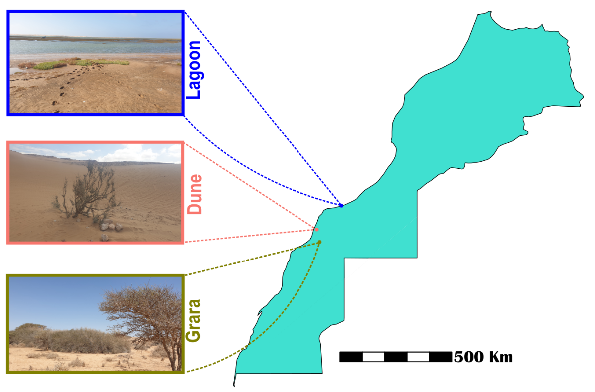

Supplementary figure 2.
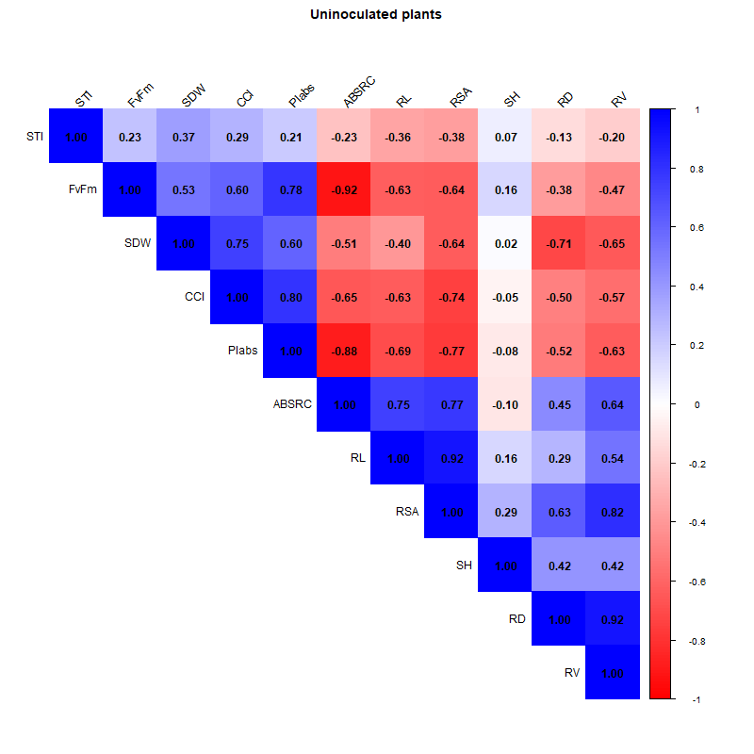
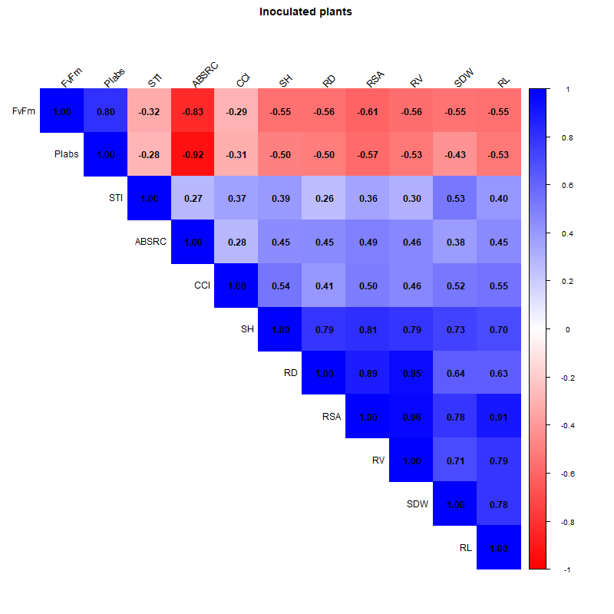

Supplementary Figure 3.

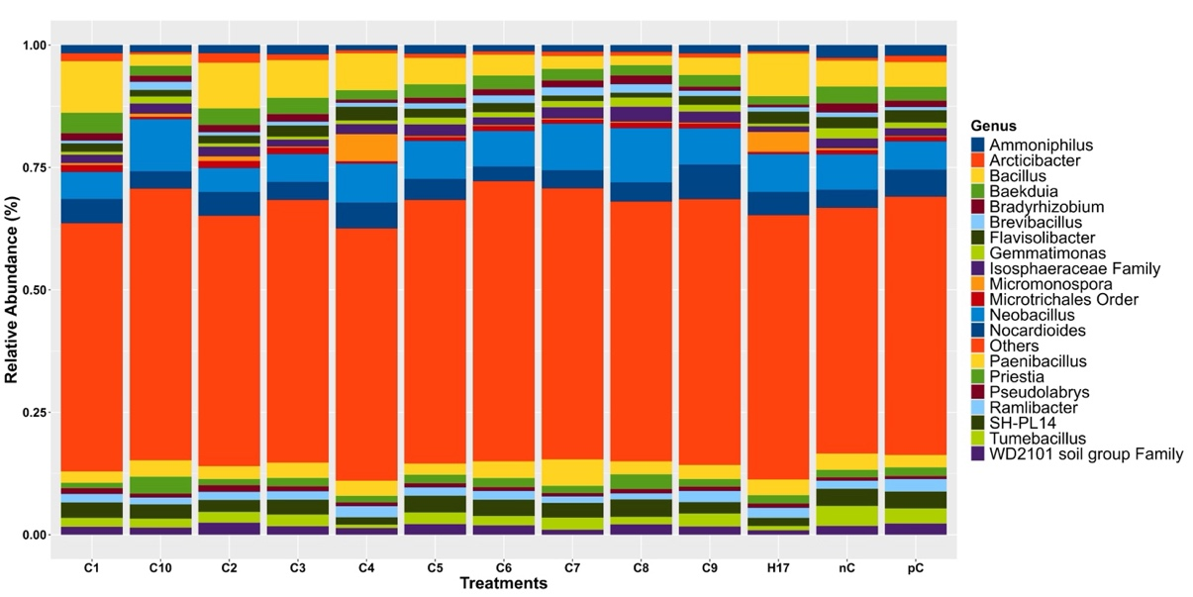
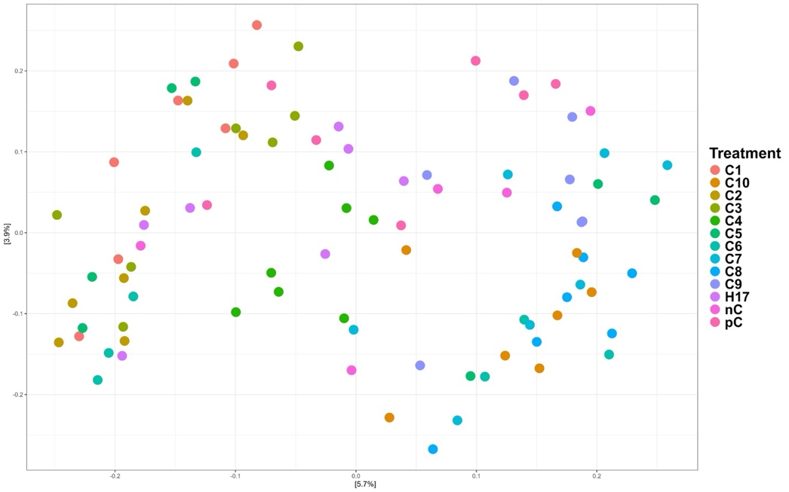
A
B

Supplementary Figure S4.
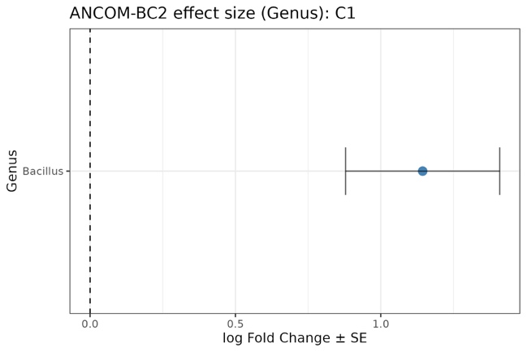
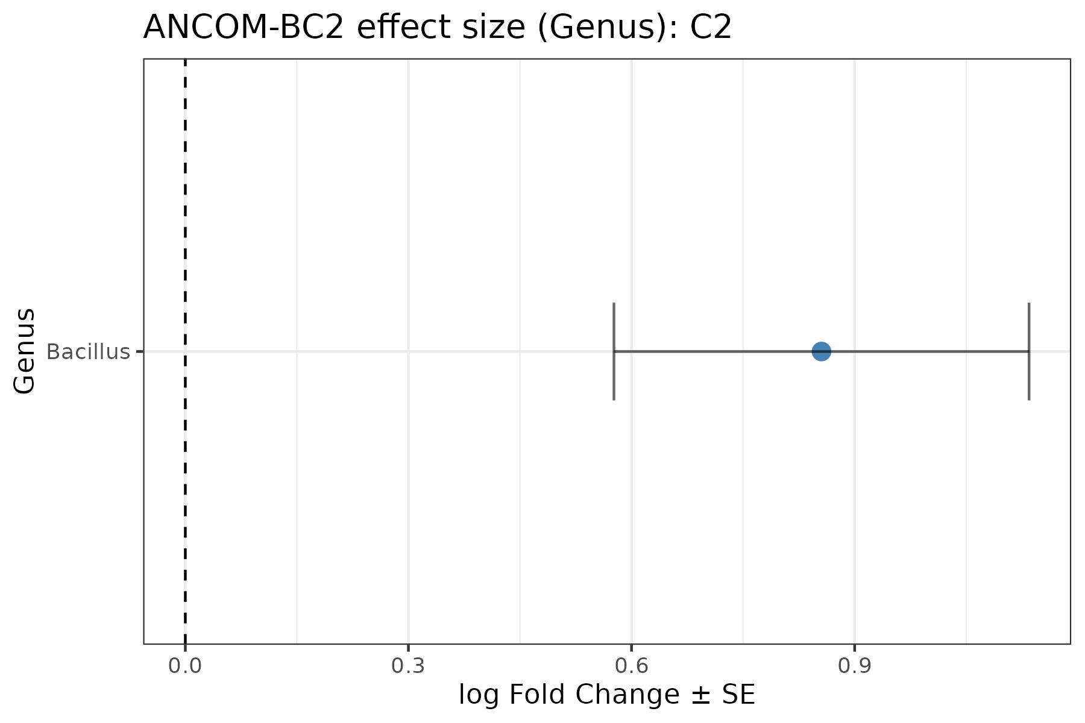
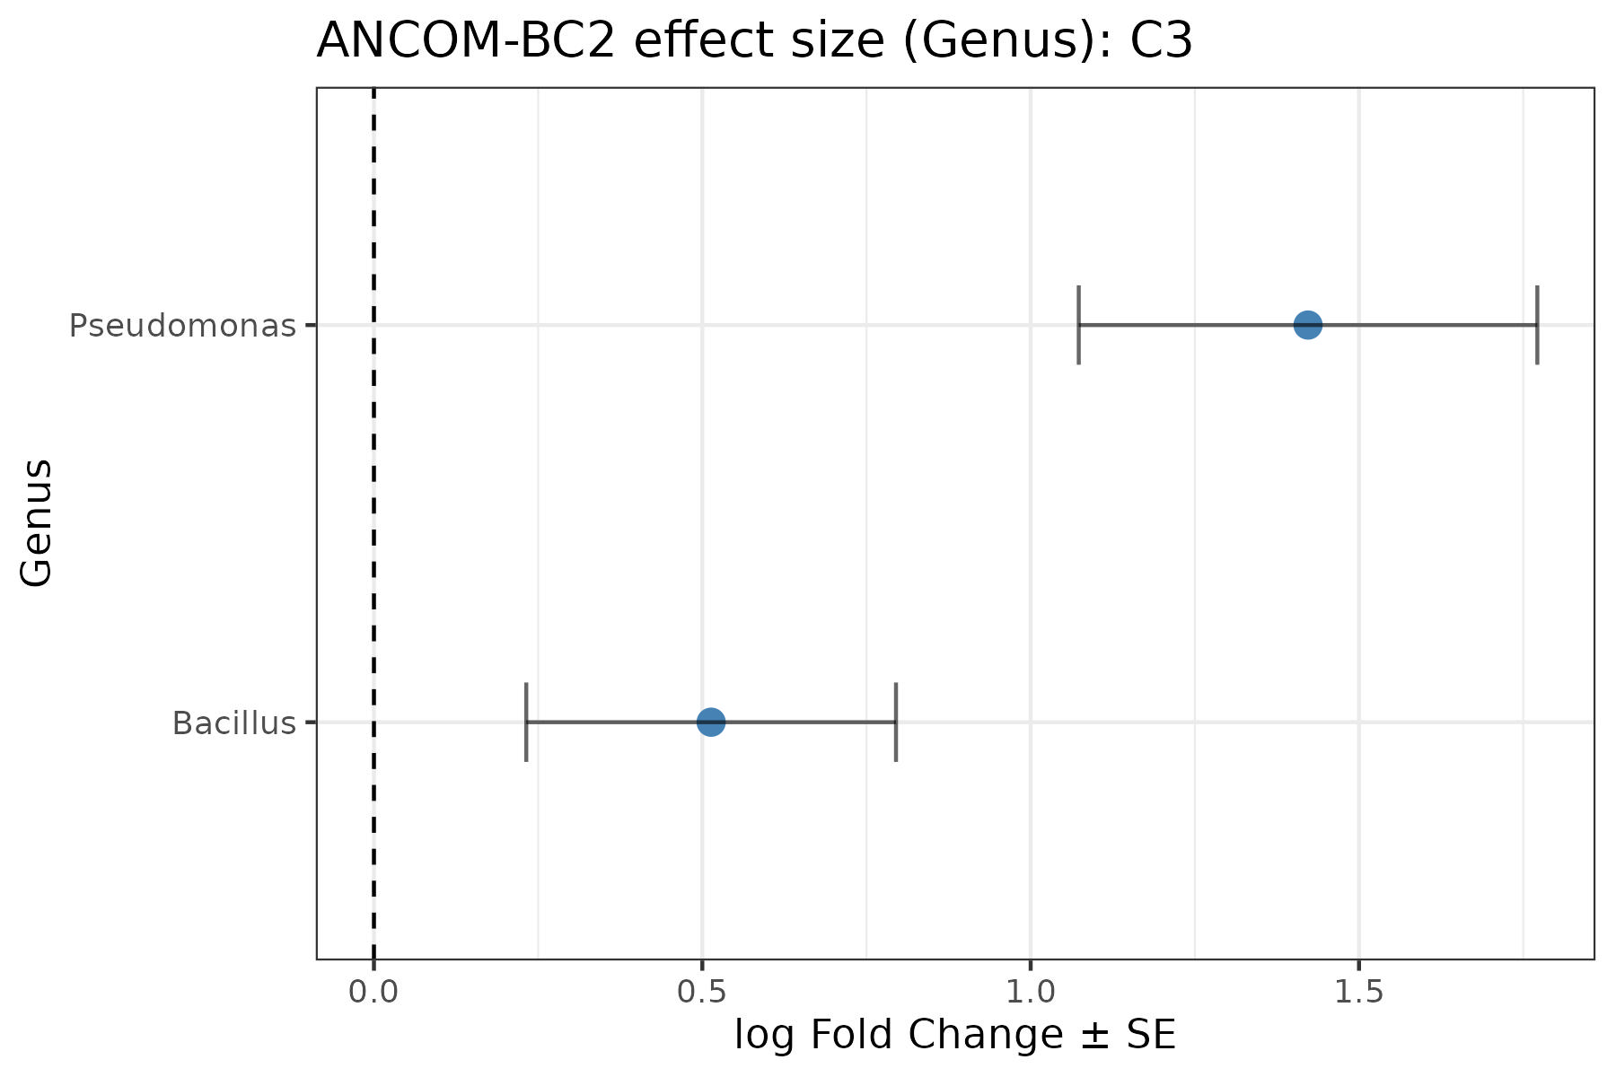
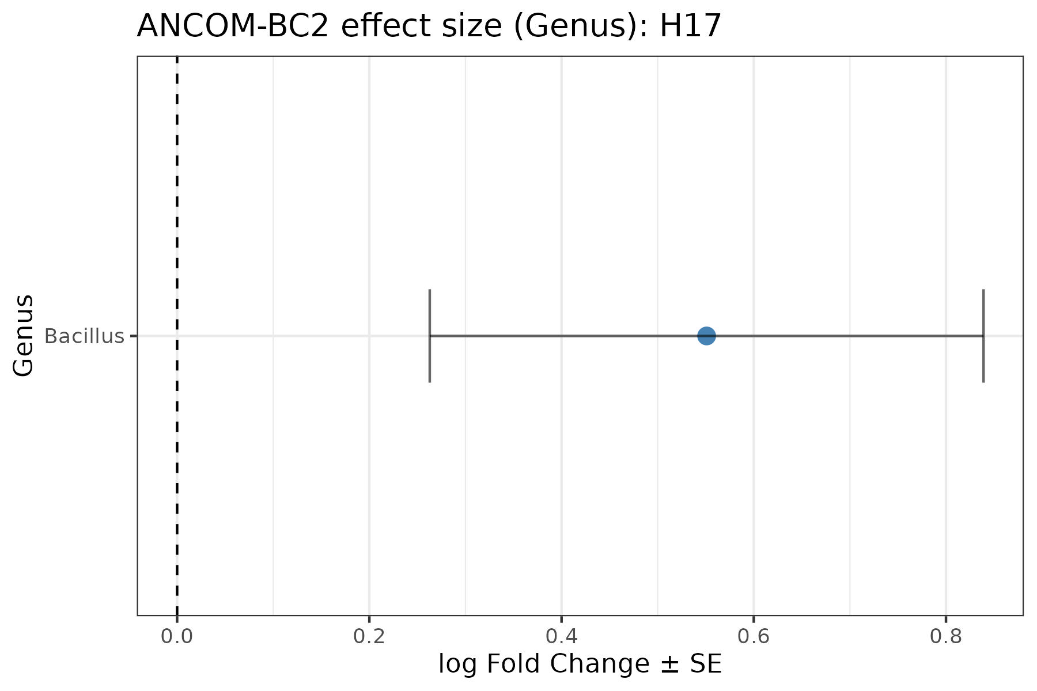
A
B
C
D

Supplementary Figure 5.
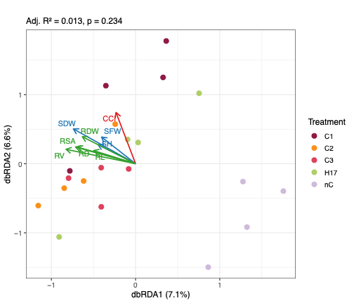

Supplementary Table 1: Table of Identified Bacterial Isolates from rhizosphere soil samples of the three ecosystems of the study, based on NCBI Nucleotide BLAST of full length bacterial 16S rRNA.
Isolate ID | Species identity | Ecosystem | Source plant species | % Identity | Query coverage
H1 | Bacillus coahuilensis | Dune | Tamarix amplexicaulis | 97.59 | 100
H2 | Bacillus licheniformis | Dune | Tamarix amplexicaulis | 98.80 | 100
H3 | Bacillus sp. | Dune | Tamarix amplexicaulis | 98.38 | 100
H4 | Bacillus halotolerans | Dune | Greuteria argyrea | 99.64 | 100
H5 | Metabacillus schmidteae | Dune | Greuteria argyrea | 99.50 | 100
H6 | Bacillus mojavensis | Dune | Greuteria argyrea | 99.22 | 100
H7 | Bacillus licheniformis | Dune | Launaea arborescens | 98.61 | 100
H8 | Bacillus safensis | Dune | Launaea arborescens | 99.43 | 100
H9 | Bacillus halotolerans | Dune | Launaea arborescens | 98.37 | 100
H10 | Bacillus pumilus | Dune | Heliotropium bacciferum | 99.22 | 100
H11 | Metabacillus niabensis | Dune | Heliotropium bacciferum | 98.51 | 100
H12 | Pseudomonas sp. | Dune | Heliotropium bacciferum | 98.56 | 100
H17 | Bacillus atrophaeus | Lagoon | Nitraria retusa | 98.31 | 100
H19 | Oceanobacillus sp. | Lagoon | Nitraria retusa | 97.98 | 100
H20 | Bacillus niabensis | Lagoon | Nitraria retusa | 96.20 | 100
H21 | Virgibacillus dokdonensis | Lagoon | Halimione portulacoides | 99.43 | 100
H23 | Virgibacillus sp. | Lagoon | Halimione portulacoides | 92.64 | 100
H24 | Virgibacillus chiguensis | Lagoon | Halimione portulacoides | 98.87 | 100
H29 | Nitratireductor aquibiodomus | Lagoon | Tetraena gaetula | 97.12 | 100
H30 | Bacillus licheniformis | Lagoon | Tetraena gaetula | 99.14 | 100
H31 | Bacillus safensis | Lagoon | Tetraena gaetula | 98.79 | 100
H32 | Bacillus tequilensis | Lagoon | Tetraena gaetula | 98.94 | 100
H33 | Pantoea septica | Grara | Vachellia tortilis | 98.40 | 98
H35 | Peribacillus frigoritolerans | Grara | Vachellia tortilis | 98.72 | 100
H37 | Erwinia endophytica | Grara | Vachellia tortilis | 97.32 | 100
H39 | Bacillus safensis | Grara | Vachellia tortilis | 98.60 | 100
H40 | Bacillus sp. | Lagoon | Tetraena gaetula | 94.26 | 100

