Table 1. Optimization of reaction conditions.ª
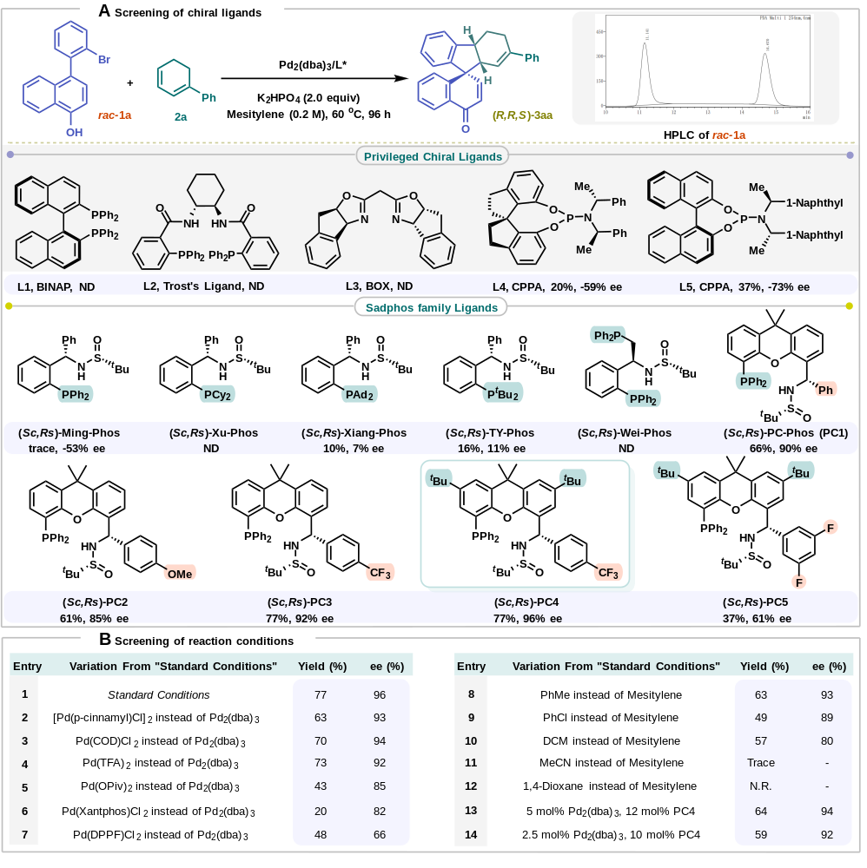
ªConditions: Reactions were conducted on 0.2 mmol scale as shown in the table; yields were determined by GC analysis; ee was determined by HPLC analysis.
Table 2. Scope of the asymmetric dearomatization Heck/Tsuji−Trost reaction of racemic biaryls 1 with dienes 2.ª
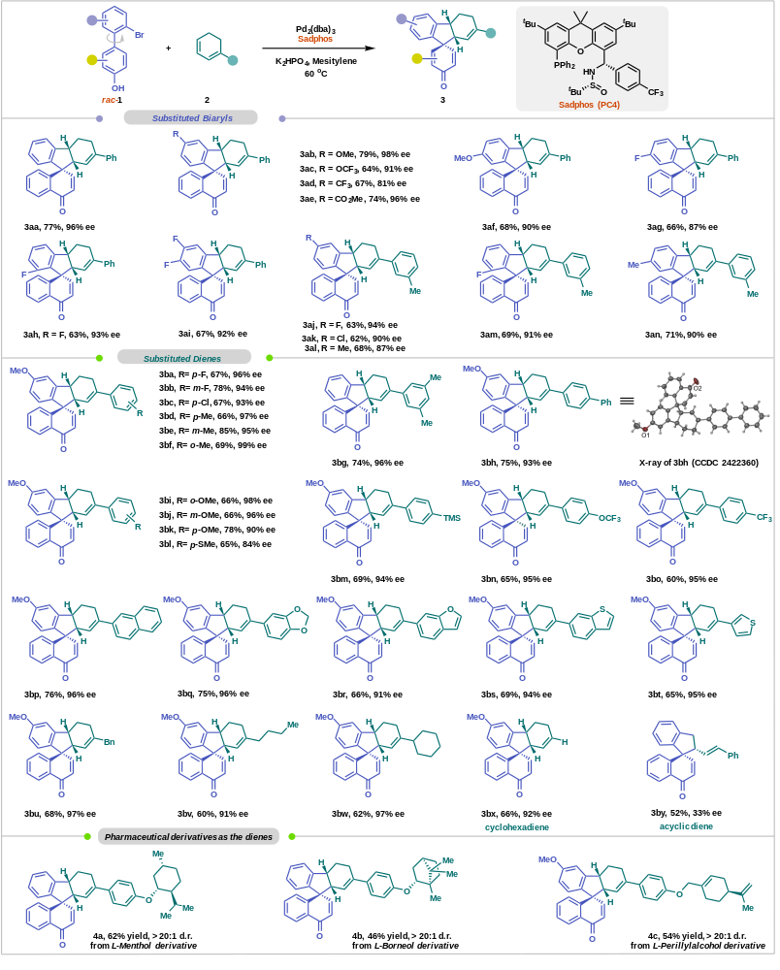
ªConditions: 1 (0.3 mmol), 2 (0.9 mmol), Pd₂(dba)₃ (5 mol %), (Sc,Rs)-PC4 (20 mol%), K₂HPO₄ (2.0 equiv), Mesitylene (1.5 mL), Ar, 60 °C; yields of isolated are products; enantiomeric excess (ee) was determined by HPLC analysis.
Table 3. Synthetic transformations and plausible mechanism. A) Gram-scale reaction. B) Functional transformations. C) Plausible asymmetric induction model.
