Supplementary information

Catalytic Asymmetric Spiroannulation to Access Polycyclic Spiro Enones via Transient Axial-to-Point Chirality Induction and Transfer

Qian Wang¹, Pei-Chao Zhang²*, Mei-Hua Huang¹, Wen-Wen Zhang², Yu Liu¹* & Junliang Zhang³*

¹College of Chemistry and Life Science, Advanced Institute of Materials Science, Changchun University of Technology, Changchun 130012, P. R. China
²The Center for Basic Research and Innovation of Medicine and Pharmacy (MOE), School of Pharmacy, Second Military Medical University (Naval Medical University), Shanghai 200433, P. R. China
³Department of Chemistry, Fudan University, 2005 Songhu Road, Shanghai 200438, P. R. China
E-mail: pczhang@smmu.edu.cn; yuliu@ccut.edu.cn; junliangzhang@fudan.edu.cn

Contents
1. Optimization of reaction conditions 3
2. Nonlinear effects experiment 4
3. Sensitivity assessment of the reaction between 1a and 2a 5
4. The effect of 3 on pro-inflammatory cytokine secretion in vitro. 6
5. Synthesis of the PC-Phos 8
6. Sythesis of the substrates 10
7. General procedure for dearomative spiroannulation of racemic phenolic biaryls with 1,3-cyclohexadienes. 12
8. Gram-scale synthesis. 44
9. Synthetic applications of the products. 44
10. NMR spectra 48
11. References. 99

General Information:
Unless otherwise noted, all reactions were carried out in standard Schlenk techniques with magnetic stirring bar under air. Materials obtained from commercial suppliers were used directly without further purification. ¹H NMR spectra were recorded in CDCl₃ with Bruker spectrometers at 400 (100 MHz) or 500 (125 MHz). Chemical shifts are reported in ppm with tetramethylsilane (TMS: 0 ppm) with the solvent resonance as the internal standard. Data are reported as follows: chemical shift, multiplicity (s = singlet, d = doublet, t = triplet, q = quartet, m = multiplet), coupling constants (Hz), and integration. ¹³C NMR spectra were recorded on Bruker 400 (100 MHz) and 500 (125 MHz) spectrometers in CDCl₃ with complete proton decoupling. Chemical shifts are reported in ppm with the deuterium solvent as the internal standard (CDCl₃: 77.0 ppm). The [α]^{D} were measured on a PolAAr 3005 High Accuracy Polarimeter. The ee was recorded using LC-2030C 3D from Shimadzu Company. Flash column chromatography was performed over silica gel (10-40 mesh).
The starting materials PC-Phos,¹ 1-naphthol 1² and cyclic 1,3-dienes 2^{3, 4} were synthesized according to published procedures. The spectral data of the substrates were consisted with that reported in the literature. The enantionmeric excesses of the products were determined by chiral stationary phase HPLC using Chiralpak IA, IB, ID, IF columns.

Note: The prepared cyclic 1,3-dienes should be stored at low temperature and protected from light, and used as soon as possible. If the storage time of cyclic 1,3-diene is too long, it should be purified by flash column chromatography on silica gel to remove excess water and impurities before use.
- Optimization of reaction conditions.

Fig S1. Optimization of chiral ligands.
Fig. S1. ª Unless otherwise noted, all reactions were carried out with 0.1 mmol of 1a, 0.3 mmol of 2a, and 5 mol% of Pd₂(dba)₃, L* (20 mol%) (Pd: L* = 1: 2) in 0.5 mL Mestiylene at 60 ºC for 96 h; yield and conversion were determined by GC, e.e. were determined by HPLC analysis. ^{b} ND = Not detected.

1.2 Evaluation of reaction parameters.ª
Entry | Variation From“Standard Conditions” | Ee% | Yield%
1 | None | 94 | 77(65^{b})
2 | Pd(dppf)Cl₂ instead of Pd₂(dba)₃ | 66 | 48
3 | Pd(Xantphos)Cl₂ instead of Pd₂(dba)₃ | 82 | 20
4 | [Pd(π-allylPh)Cl]₂ instead of Pd₂(dba)₃ | 93 | 63
5 | Pd(OPiv)₂ instead of Pd₂(dba)₃ | 85 | 43
6 | Pd(COD)Cl₂ instead of Pd₂(dba)₃ | 94 | 70
7 | Pd(TFA)₂ instead of Pd₂(dba)₃ | 92 | 73
8 | DCM instead of Mestiylene | 80 | 57
9 | PhCl instead of Mestiylene | 89 | 49
10 | PhMe instead of Mestiylene | 93 | 63
11 | MeCN instead of Mestiylene | - | Trace
12 | 1,4-Dioxane instead of Mestiylene | - | ND^{c}
13 | 5 mol% Pd₂(dba)₃ and 10 mol% L* | 92 | 59
14 | 12 mol% L* | 94 | 64
15 | no L* | - | Trace
16 | no K₂HPO₄ | - | ND^{c}
Fig S2. Unless otherwise noted, all reactions were carried out with 0.1 mmol of 1a, 0.3 mmol of 2a, and 5 mol% of Pd₂(dba)₃, L* (20 mol%) (Pd: L* = 1: 2) in 0.5 mL Mestiylene at 60 ºC for 96 h; yield and conversion were determined by GC, e.e. were determined by HPLC analysis. ^{b} Isolate yield; ^{c} ND = Not detected.

- Nonlinear effects experiment.
Non-linear effect reactions were set up with standard substrates (0.1 mmol), catalyst and N-H-PC10 with varied ee following the standard procedure as described in previous section. In this case, the amount of palladium precatalyst and N-H-PC10 enantiomers was weighed on an analytical balance, and the amount of solvent was measured with volumetric syringe. The reactions were allowed to run for 96 h, purification as described in standard procedure. Each experiment was repeated one time. The relationship between enantiomeric excess of N-H-PC10 ligand and product is listed here.

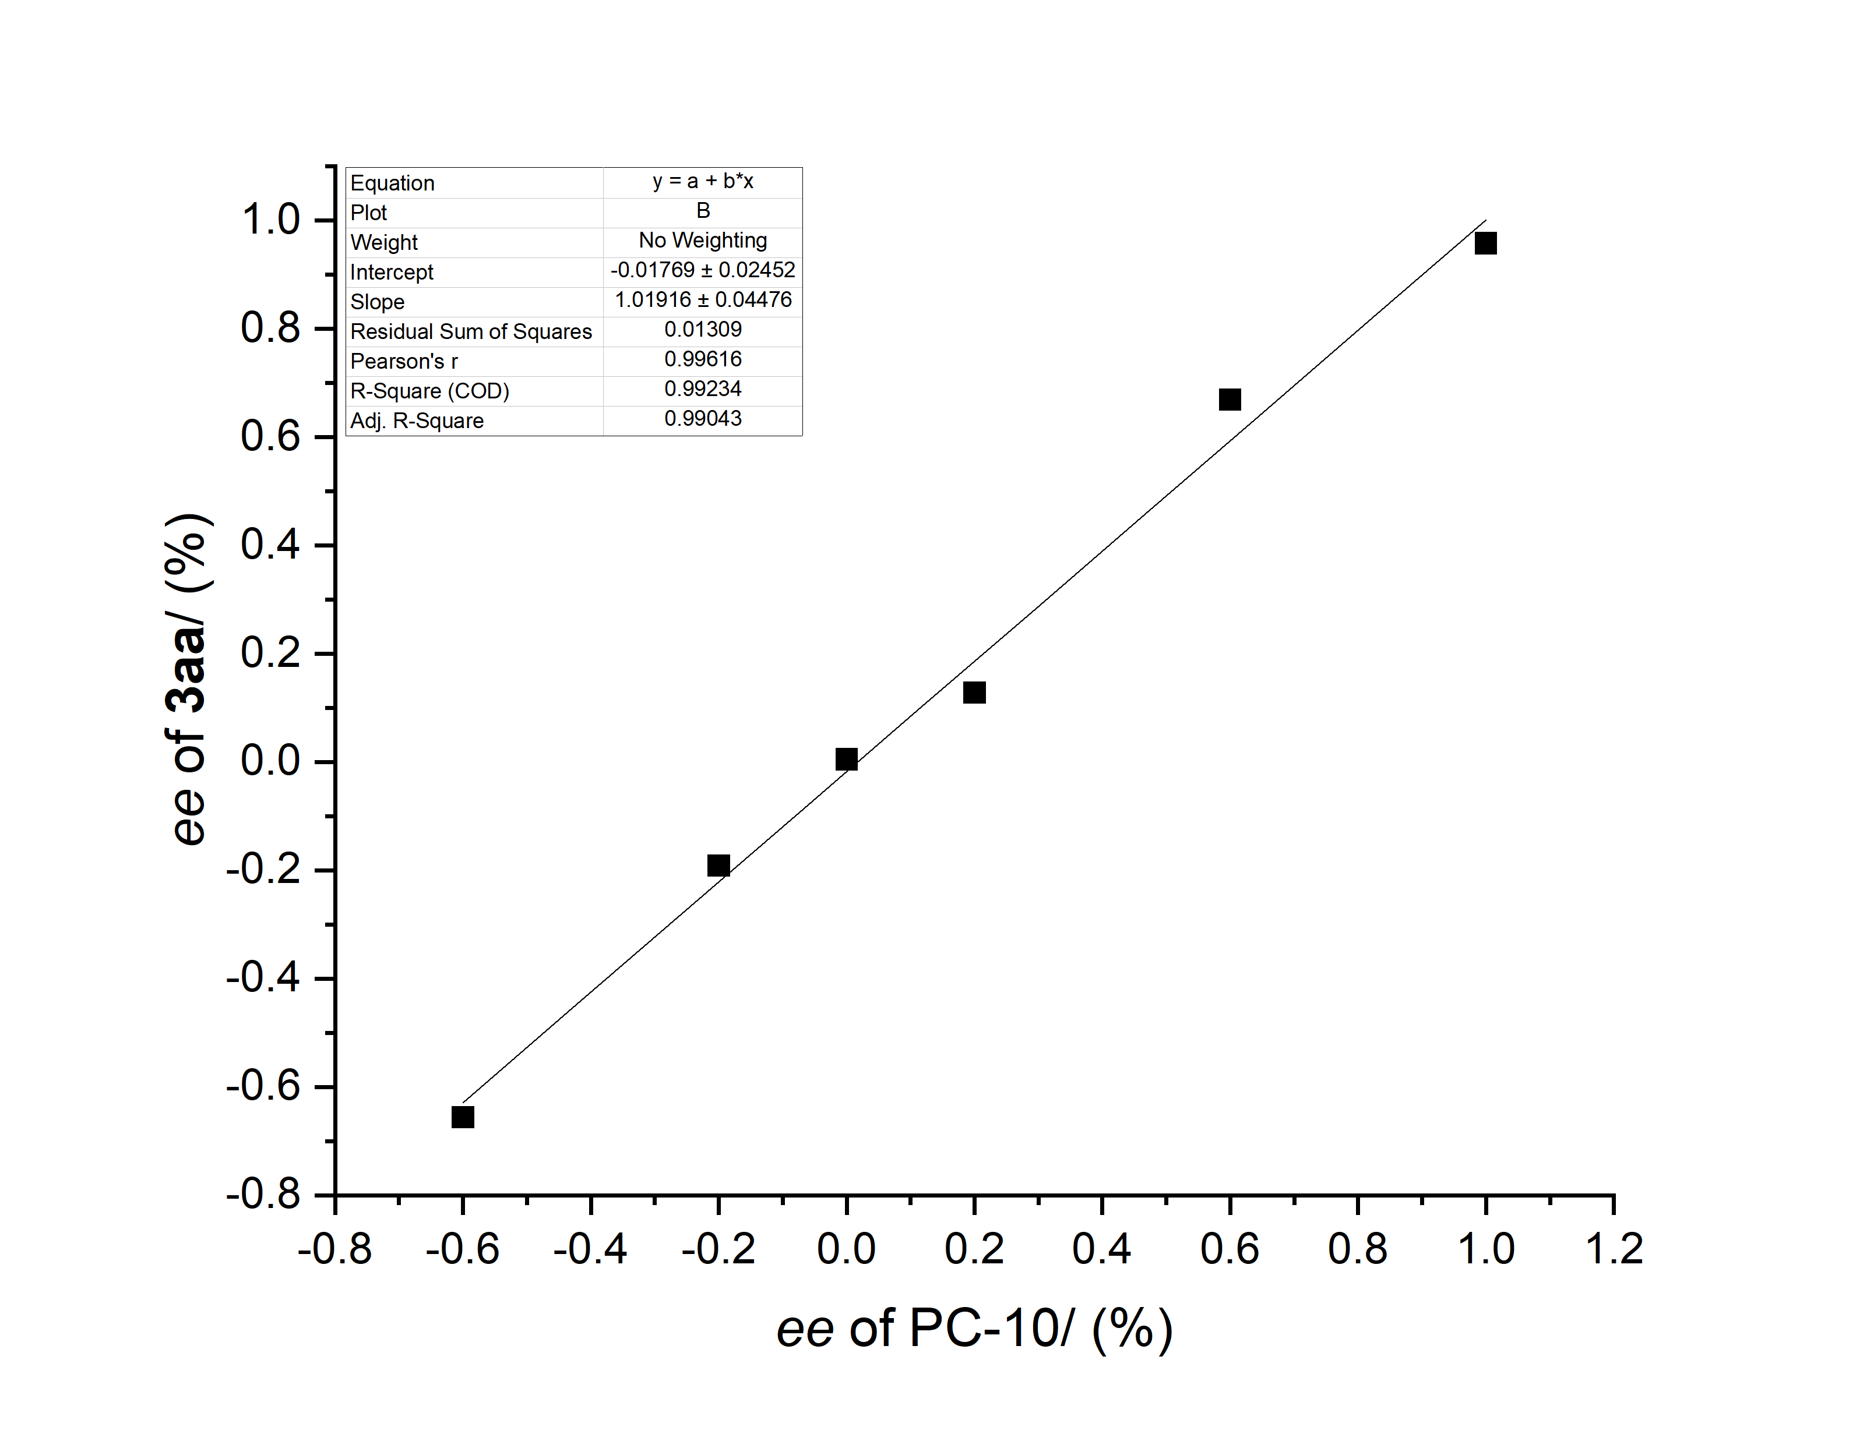
The linear relationship between the ee of the PC10 and those of product 3aa, which reveal that the enantioselectivity determining step might involve a single chiral sulfinamide phosphine ligand and one palladium species.

- Sensitivity assessment of the reaction between 1a and 2a.⁷
The results of the sensitivity assessment are shown in Table S3, which was conducted using the model reaction of rac-1a with 2a. The optimized conditions were chosen as the reference for comparison. Tables describe the results on yield and enantioselectivity, respectively.

Fig. S3. Sensitivity Assessment of the Reaction between 1a and 2a.
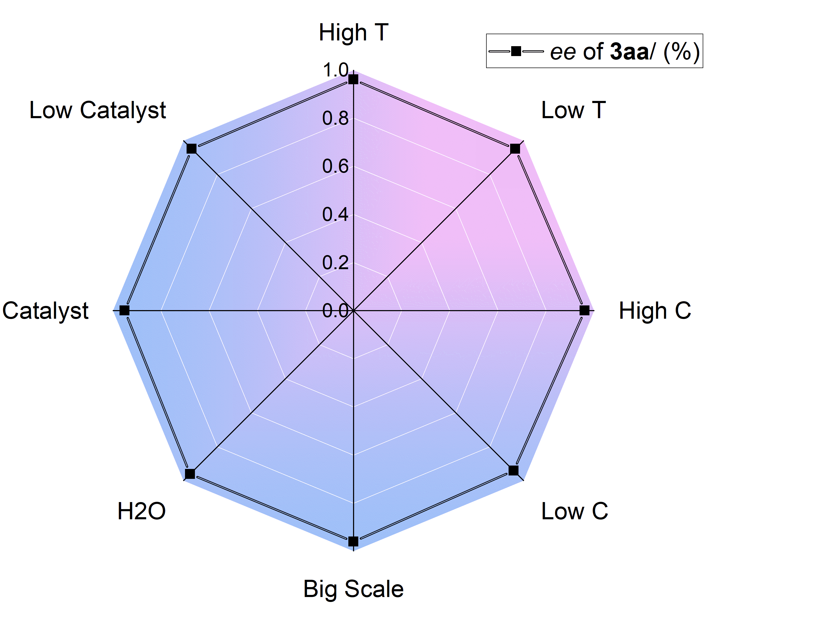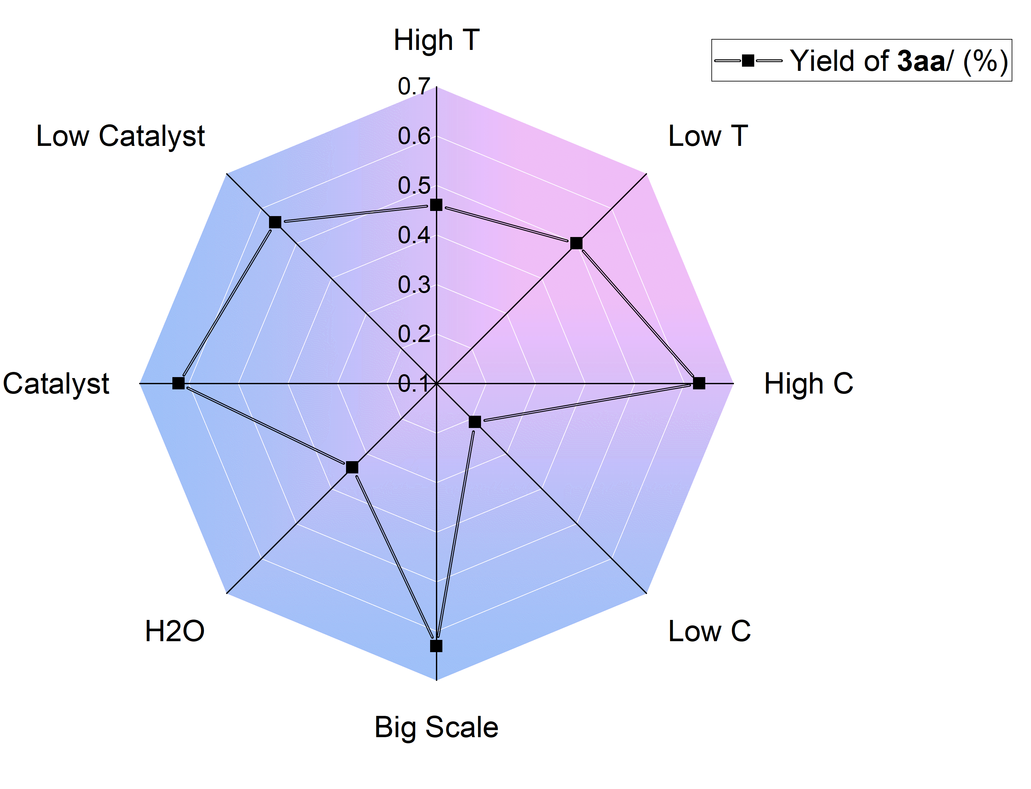

- The effect of 3 on pro-inflammatory cytokine secretion in vitro.
Cell culture: RAW264.7 cells were obtained from Shanghai Cell Bank, Chinese Academy of Sciences (China) and cultured in DMEM (Corning) containing 10% FBS (Gibco) and 1% penicillin-streptomycin solution (Gibco). Cells were cultured in a sterile environment at 37°C containing 5% CO₂ and 95% air.
Cell viability assay: The toxicity of the compound was determined by the CCK-8 assay (Beyotime, China). The RAW264.7 cells were seeded in a 96-well medium plate at a concentration of 5×104/well and cultured overnight. It was then incubated with compounds at concentrations of 50 μM and 20 μM for 24 h. Discard the old medium and add 100 μL of CCK-8 reagent and incubate for 30 min away from light. The absorbance value (OD value, 450 nm) was recorded by absorbance microplate reader (M5, Thermo, USA).
ELISA: Cell culture supernatants were collected and centrifuged at 12000 rpm for 5 minutes to remove dead cells. Cell supernatants were analyzed for IL-6 and TNF-α at different dilution ratios using ELISA kits (ThermoFisher, USA) according to the manufacturer's instructions.

Fig. S4 The Effect of 3 on Pro-inflammatory Cytokine Secretion in Vitro.
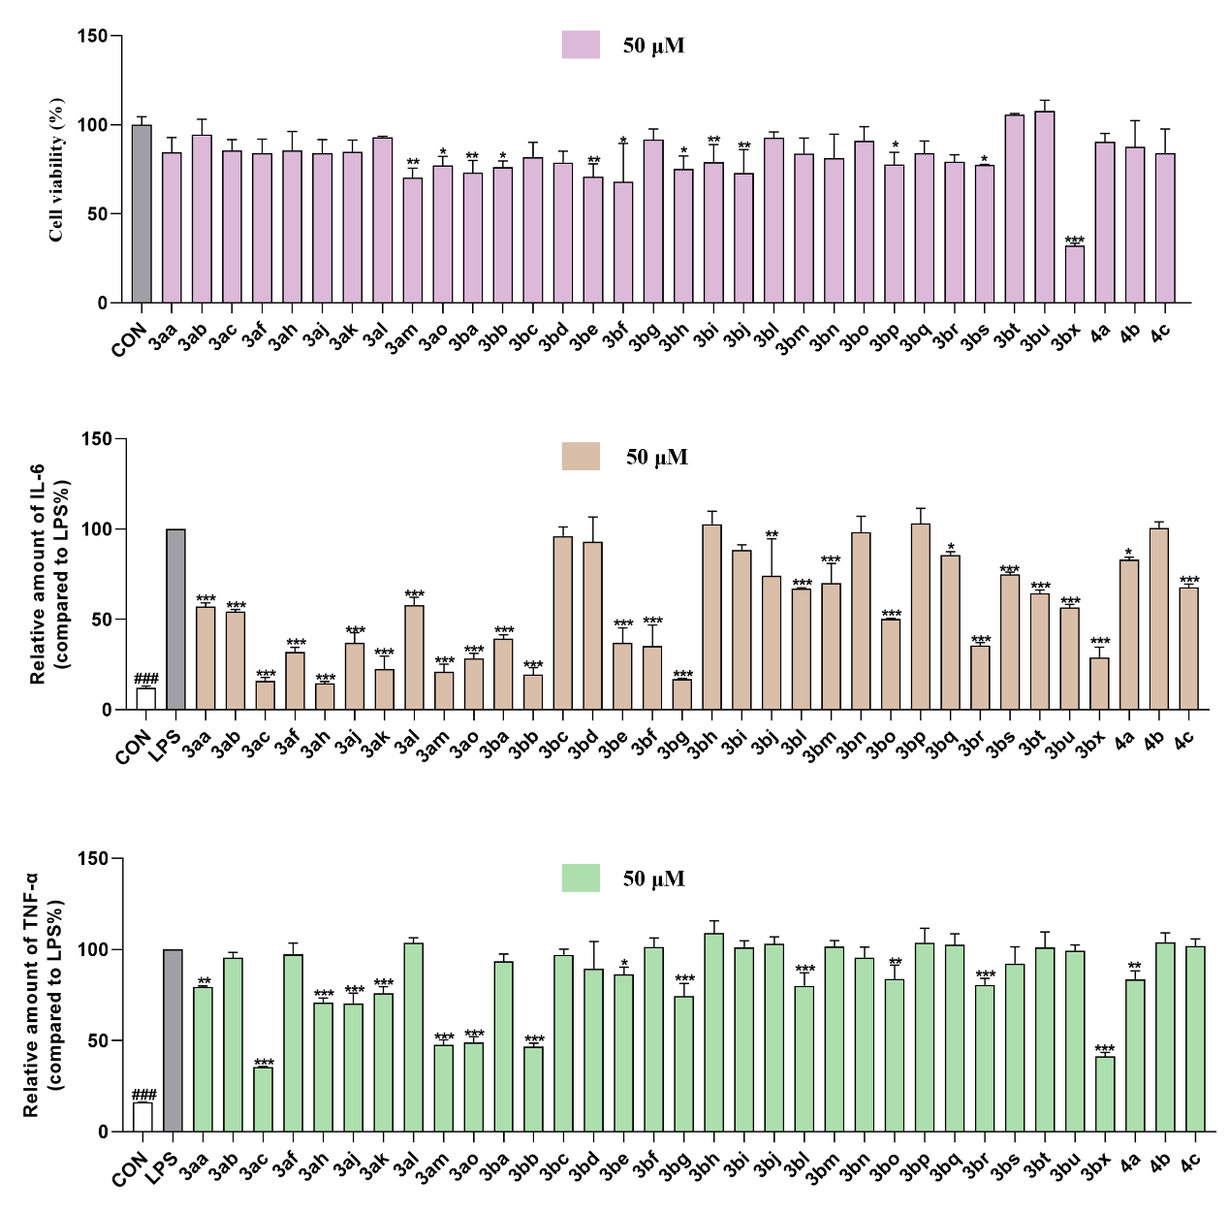
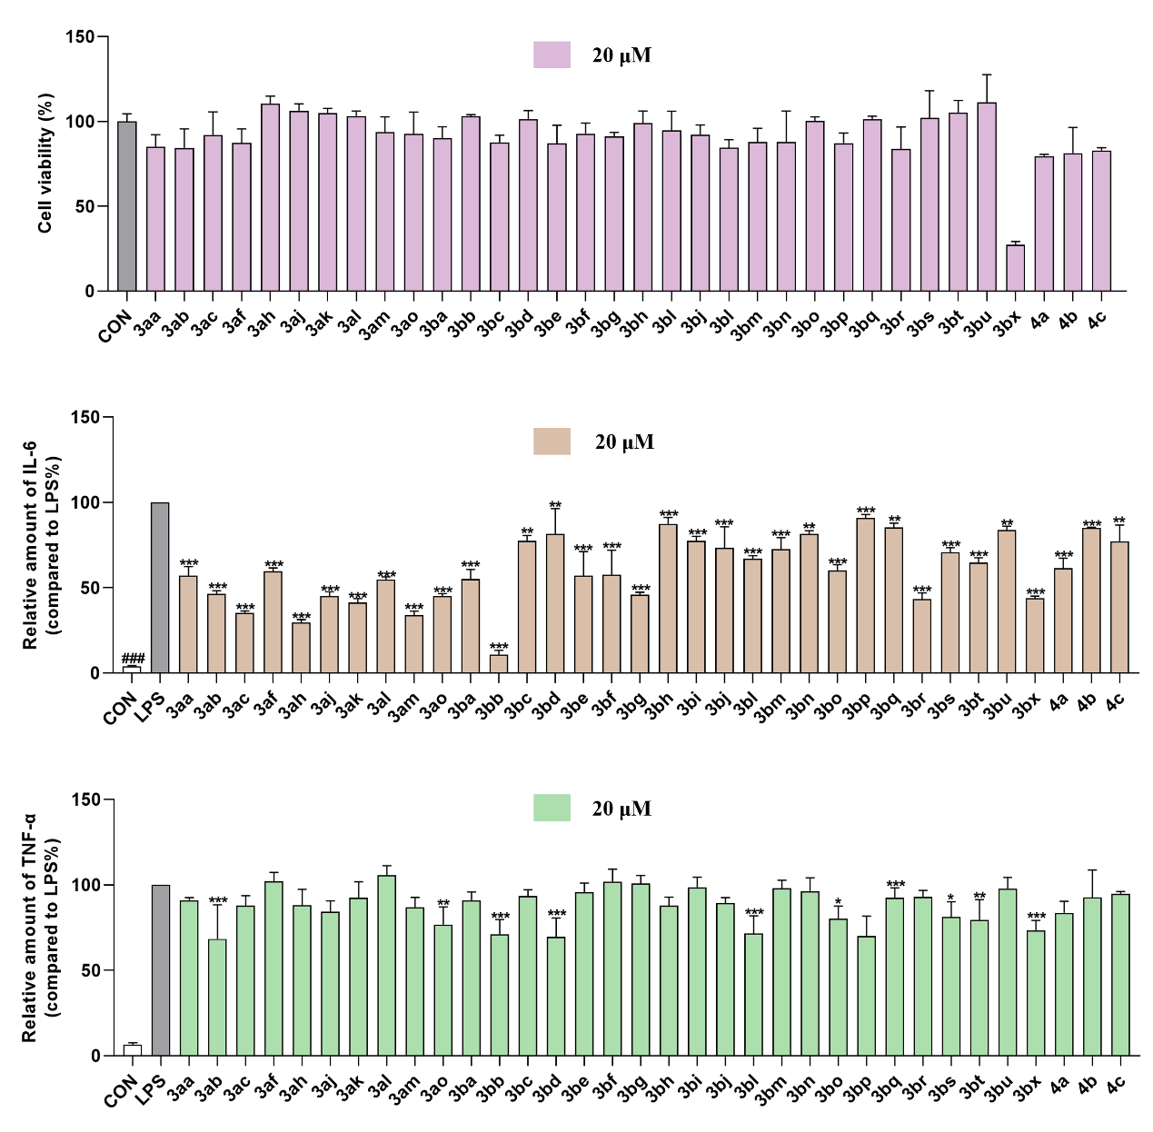
To evaluate their anti-inflammatory activity, we employed RAW 264.7 cells (mouse monocyte/macrophage cell) as the in vitro model. Initially, CCK-8 (Cell Counting Kit-8) assay was performed to test the effects of the spiralenones 3 on cell viability. RAW 264.7 cells were treated with the spiralenones 3 ranging from 20 to 50 µM for 24 hours, there had no effect on the cell viability of RAW 264.7 cell. Following treatment with spiralenones 3 (20 and 50 µM) and stimulated by LPS, the levels of two main pro-inflammation cytokines including interleukin-6 (IL-6) and tumor necrosis factor-alpha (TNF-α) were decreased.
- Synthesis of the PC-Phos.¹
To an oven-dried 500 mL three neck round bottom flask equipped with a stir bar was added 9,9-dimethylxanthene (21.0 g, 100 mmol, cas: 19814-75-6, Greenchem), anhydrous FeCl₃ (811 mg, 5% mol, cas: 7705-08-0, Macklin) in 100 mL DCM under N₂. The mixture was stirred at 0 ºC for 10 min, ^{t}BuCl (27.1 mL, 2.5 equiv, cas: 507-20-0, Energy Chemical) was added at a rate of 10 mL/min. After the addition is complete, moved the reaction to room temperature for 15 h, quenched by water, and extracted with DCM, dried over anhydrous Na₂SO₄, then the solvent was removed under reduced pressure. The crude product was recrystallized from ethanol to give S1 (29.3 g, 91% yield) as a white solid.
To an oven-dried 500 mL three neck round bottom flask equipped with a stir bar was added S1 (29.3 g, 91 mmol) in 150 mL CHCl₃ under N₂. The mixture was stirred at 0 ºC for 10 min, Br₂ (10.7 mL, 2.3 equiv) was added at a rate of 10 mL/min. (Note: HBr is produced during the dripping process, connect the pipe to pass it into the fume hood, and treat the exhaust gas with aq. NaHCO₃.) After the addition is complete, stirred at 0 ºC for 12 h, quenched by NaHSO₃, and extracted with DCM, dried over anhydrous Na₂SO₄, then the solvent was removed under reduced pressure. The crude product was recrystallized from EtOH to give S2 (40.6 g, 93% yield) as a white solid.
To an oven-dried 500 mL three neck round bottom flask equipped with a stir bar was added S2 (14.3 g, 30 mmol) in 250 mL THF under N₂. The mixture was cooled to -78 °C for 10 min, ^{n}BuLi (2.5 M in hexanes, 12 mL, 1 equiv) was added at a rate of 10 mL/min. The mixture was stirred at -78 °C for 1.5 h. Then added slowly ClPPh₂ (5.4 ml, 1 eq, cas: Energy Chemical) and stirred at -78 °C for 2 h. Later, ^{n}BuLi (2.5 M in hexanes, 24 mL, 2 equiv) was added at a rate of 10 mL/min, and stirred at -78 °C for 2 h. Then add dry DMF (6.9 mL, 3 equiv) at -78 °C, moved the reaction to room temperature for 2 h, quenched by NH₄Cl, extracted with EtOAc, dried over anhydrous Na₂SO₄, then the solvent was removed under reduced pressure. The crude product was purified by column chromatography (PE:EtOAc=20:1) to give S3 (9.6 g, 60% yield) as a white solid.
To an oven-dried 250 mL three neck round bottom flask equipped with a stir bar was added S3 (5.3 g, 10 mmol), (Rs)-TBSA (1.3 g, 1.1 eq, cas: 196929-78-9, Allychem) in 30 mL THF under N₂. The mixture was stirred 10 min, Ti(OEt)₄ (4.2 mL, 2 equiv, cas: 3087-36-3, Energy Chemical) was added and move the reaction to 60 °C for 10 h. (adding a large amount of EtOAc, water, silica gel and stirred at r.t. for 2 h to precipitate a large amount of titanate solids) Then filtered and extracted with EtOAc, wash with saturated NaCl, dried over anhydrous Na₂SO₄, then the solvent was removed under reduced pressure. The crude product was purified by column chromatography (PE:EtOAc:DCM= 20:1:1) to give S4 (4.7 g, 74% yield) as a white solid.
To an oven-dried 100 mL three neck round bottom flask equipped with a stir bar was added S4 (3.2 g, 5 mmol) in 30 mL THF under N₂. The mixture was cooled to -78 °C for 10 min, (3,5-difluorophenyl) magnesium bromide (20 mL, 2 equiv, 0.5 M in THF, cas: 62351-47-7, Sigma-Aldrich) was added. After the addition is complete, stirred at -78 °C for 0.5 h. Turn off refrigeration and stir overnight, quenched by saturated NH₄Cl, and then extracted with EtOAc, dried over anhydrous Na₂SO₄, then the solvent was removed under reduced pressure. The crude product was purified by column chromatography (PE:EtOAc = 10:1 to 5:1) to give ^{t}Bu-PC-Phos (PC-10) (2.8 g, 76% yield) as a white solid.
- Sythesis of the substrates.

6.1 General procedure for the preparation of racemic phenolic biaryls.²
The following 1-naphthol substrates were prepared by Suzuki-Miyaura coupling reaction between (4-methoxynaphthalen-1-yl)boronic acid and corresponding ortho-dihalogenated aryl derivatives, followed by demethylation with BBr₃.
Method A: A 50 mL round bottom flask with a stir bar was fitted with a rubber septum and flame dried under high vacuum. The flask was purged with N₂ and charged with Pd(dba)₂ (72 mg, 2.5 mol%), PPh₃ (65 mg, 5 mol%), CsF (1.5 g, 2.0 equiv.), (4-methoxyphenyl)boronic acid (1.5 g, 1.5 equiv), ortho-dihalogenated aryl derivatives (5 mmol), 15 mL DME. The mixture was stirred at 90 ºC until the reaction was judged to be completed by TLC analysis. Water was added and the mixture was diluted with ethyl acetate. The layers were separated and the organic layer was washed with water and brine, dried over anhydrous Na₂SO₄ and concentrated under reduced pressure. The residue was then chromatographed on silica gel to afford the desired compound.
Under an argon atmosphere, a solution of BBr₃ (2M in DCM) was slowly added to a solution of the above product in DCM (10 mL) at 0 ºC and the mixture was stirred at room temperature for 3 h. After cooling to 0 ºC, the reaction was quenched with cold water and extracted with DCM. The organic layer was dried over anhydrous Na₂SO₄ and concentrated under reduced pressure. The residue was then chromatographed on silica gel to afford the desired product 1.
Method B: A 50 mL round bottom flask with a stir bar was fitted with a rubber septum and flame dried under high vacuum. The flask was purged with a stir bar was fitted with a rubber septum and flame dried under high vacuum. The flask was purged with N₂ and charged with Pd(dba)₂ (72 mg, 2.5 mol%), PPh₃ (65 mg, 5 mol%), CsF (1.5 g, 2.0 equiv), (4-(methoxymethoxy)naphthalen-1-yl)boronic acid (1.70 g, 1.5 equiv), ortho-dihalogenated aryl derivatives, 15 mL DME. The mixture was stirred at 90 ºC until the reaction was judged to be completed by TLC analysis. Water was added and the mixture was diluted with ethyl acetate. The layers were separated and the organic layer was washed with water and brine, dried over anhydrous Na₂SO₄ and concentrated under reduced pressure. The residue was chromatographed on silica gel, eluted with PE:EA = 50:1 to afford the desired compound.
The above product was dissolved in 15 mL MeOH in a 50 mL round bottom flask, warmed to 70 ºC and conc. HCl aq. (4 drops) was added. After stirring for 3 h, the flask was removed from the oil bath and cooled to room temperature, 40 mL of distilled water was added and the aqueous layer was extracted with EtOAc. The combined organic layers were washed with brine, dried over anhydrous MgSO₄, and concentrated under reduced pressure to give a crude product, which was purified by column chromatography (PE:EA = 10:1) to afford product 1.

6.2 Sythesis of cyclic 1,3-diene.³
Conversion of allyl alcohols to cyclic 1,3-dienes (2) by sequential sulfenate-sulfoxide sigmatropic rearrangement and syn Elimination.
To a solution of 2-Cyclohexen-1-one (10 mmol, 0.97 mL, cas: 930-68-7, Bide) in 20 mL dry Et₂O at -78 °C for 10 min under N₂, was added lithium reagent (15 mmol, 1.5 equiv, 1 M in Et₂O), the mixture was stirred at -78 °C for 10 min, and allowed to warm to room temperature for another 30 min. When completed, the reaction mixture was quenched by saturated NH₄Cl and diluted with EtOAc. The organic layer was separated, and the aqueous layer was extracted twice with EtOAc. The combined organic layers were dried over Na₂SO₄, filtered, concentrated, and purified by flash chromatography (PE: EtOAc = 3:1) to isolated Allyl Alcohols S8 as liquid (77-93 % yield).
To a solution of allyl alcohols S8 (5 mmol) and Et₃N (10.0 mmol, 2.0 equiv) in 20 mL dry DCM at 0 °C for 10 min under N₂, to the mixture was added 2-NBSC (5.5 mmol, 1.1 equiv, 2-Nitrobenzenesulfenyl chloride, cas: 7669-54-7, Bide) (When R= alkyl, allyl, vinyl. 2,4-NBSC instead of 2-NBSC, 2,4-dinitrobenzenesulfenyl chloride, cas: 528-76-7, TCI) at 0 °C for 10 min, and allowed to warm to room temperature for another 2 h. When completed, n-Hexane was added to the reaction mixture. The precipitate was filtered out (celite), and the solution was washed with H₂O and brine and dried over Na₂SO₄, filtered, concentrated, and purified by flash chromatography (n-Hexane) to isolated dienes product 5 as liquid or solid (57-83 % yield). (Note: The prepared 1,3-diene should be stored at low temperature and protected from light.

- General procedure for dearomative spiroannulation of racemic phenolic biaryls with 1,3-cyclohexadienes.
Method: Under nitrogen atmosphere, to an oven-dried 10 mL Schlenk tube equipped with a magnetic stir bar was added Pd₂(dba)₃ (13.7 mg, 5 mol%, Energy Chemical), Sadphos (20 mol%, PC4, 47.0 mg), K₂HPO₄ (104.5 mg, 0.6 mmol, 2.0 equiv) and mesitylene (1.5 mL). The catalyst/ligand and base solution was stirred for 1 h at room temperature. After 1 h, rac-biaryl 1 (0.3 mmol, 1.0 equiv), and 1,3-dienes 2 (0.9 mmol, 3.0 equiv) were added successively. The resulting mixture was then stirred vigorously (550 rpm) at 60 ºC in oil bath for about 96-108 h. After completion of the reaction (monitored by TLC), the reaction mixture was concentrated to dryness and the residue was purified by column chromatography (petroleum ether/ethyl acetate) to afford desired product 3/4.
(4aR,9R,9aS)-2-phenyl-3,4,4a,9a-tetrahydro-4'H-spiro[fluorene-9,1'-naphthalen]-4'-one (3aa).
The crude product was purified by column chromatography (petroleum ether/ethyl acetate = 50：1 to 30:1) to afford the product as white solid (86.4 mg, 77% yield).
¹H NMR (400 MHz, CDCl₃) δ 8.26 (dd, J = 7.8, 1.6 Hz, 1H), 7.54 – 7.37 (m, 3H), 7.36 – 7.05 (m, 9H), 6.92 (d, J = 10.3 Hz, 1H), 6.70 (d, J = 7.6 Hz, 1H), 6.37 (d, J = 10.3 Hz, 1H), 5.79 (dt, J = 3.8, 1.5 Hz, 1H), 3.75 (ddd, J = 8.2, 3.9, 1.9 Hz, 1H), 3.65 (ddd, J = 13.2, 8.5, 5.0 Hz, 1H), 2.59 (ddq, J = 6.7, 4.8, 2.1 Hz, 3H), 2.41 – 2.29 (m, 1H), 1.70 (ddt, J = 12.8, 9.4, 6.3 Hz, 1H).
¹³C NMR (100 MHz, CDCl₃) δ 185.1, 154.1, 149.2, 147.4, 145.5, 141.6, 138.4, 132.8, 132.3, 128.7, 128.3 (overlapped), 128.2, 127.9, 127.2, 127.0, 126.1, 125.7, 125.5, 125.2 (overlapped), 124.8, 121.9, 58.3, 54.9, 42.8, 29.0, 27.2.
M.P.: 76.4-77.9 ºC.
[α]_{D}²⁰ = 80.0 (c = 0.2, CHCl₃).
HRMS (EI): m/z: [M]+ Calcd for C₂₈H₂₂O：374.1671, found: 374.1665.
HPLC conditions: Daicel Chiralpak IA column (90:10 n-Hexane: 2-Propanol, 1.0 mL/min, 254 nm); tr (minor) = 6.9 min, tr (major) = 9.4 min; 96% ee).
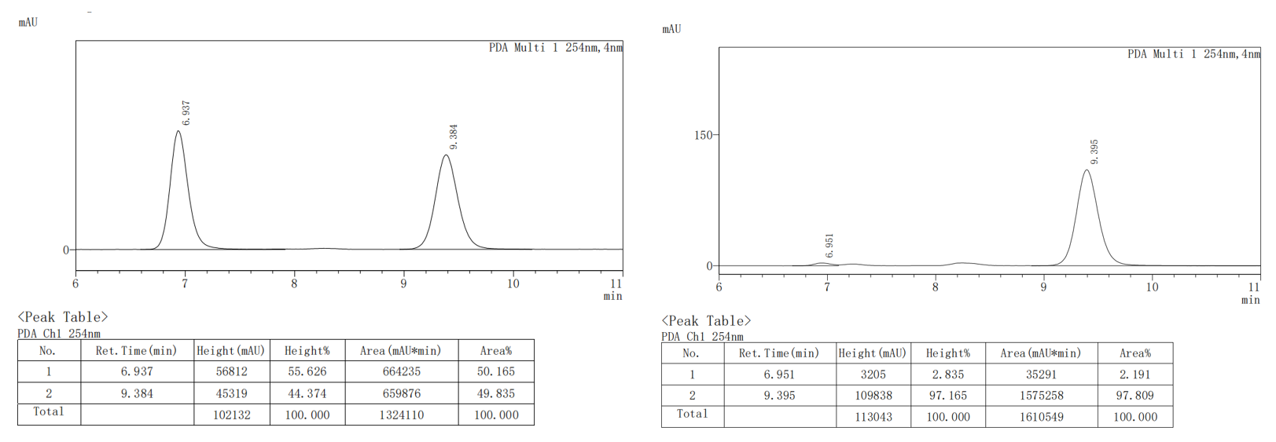
(4aR,9R,9aS)-6-methoxy-2-phenyl-3,4,4a,9a-tetrahydro-4'H-spiro[fluorene-9,1'-naphthalen]-4'-one (3ab).
The crude product was purified by column chromatography (petroleum ether/ethyl acetate = 50：1 to 30:1) to afford the product as white solid (95.8 mg, 79% yield).
¹H NMR (400 MHz, CDCl₃) δ 8.24 (dd, J = 7.8, 1.6 Hz, 1H), 7.50 (td, J = 7.7, 1.6 Hz, 1H), 7.41 (td, J = 7.5, 1.3 Hz, 1H), 7.34 – 7.16 (m, 6H), 6.97 (d, J = 2.5 Hz, 1H), 6.91 (d, J = 10.2 Hz, 1H), 6.73 (dd, J = 8.4, 2.5 Hz, 1H), 6.61 (d, J = 8.4 Hz, 1H), 6.36 (d, J = 10.2 Hz, 1H), 5.77 (dd, J = 4.1, 1.8 Hz, 1H), 3.84 (s, 3H), 3.75 (ddt, J = 8.0, 3.8, 1.8 Hz, 1H), 3.61 (ddd, J = 13.2, 8.5, 5.1 Hz, 1H), 2.58 (dtd, J = 9.3, 4.8, 4.4, 2.2 Hz, 2H), 2.40 – 2.29 (m, 1H), 1.70 (tdd, J = 13.0, 10.2, 6.1 Hz, 1H).
¹³C NMR (100 MHz, CDCl₃) δ 185.2, 160.1, 154.6, 149.5, 149.0, 141.6, 138.3, 137.3, 132.8, 132.2, 128.6, 128.3 (overlapped), 127.2, 127.0, 126.2, 126.1, 125.6, 125.2 (overlapped), 122.0, 114.0, 109.8, 57.6, 55.5, 55.4, 42.9, 29.0, 27.2.
HRMS (EI): m/z: [M]+ Calcd for, C₂₉H₂₄O₂, 404.1776, found: 404.1773.
M.P.: 160.3-163.2ºC.
[α]_{D}²⁰ = 59.4 (c = 0.2, CHCl₃)
HPLC conditions: Daicel Chiralpak IB column (90:10 n-Hexane: 2-Propanol, 0.5 mL/min, 254 nm); tr (minor) = 16.3 min, tr (major) = 14.6 min; 98% ee).
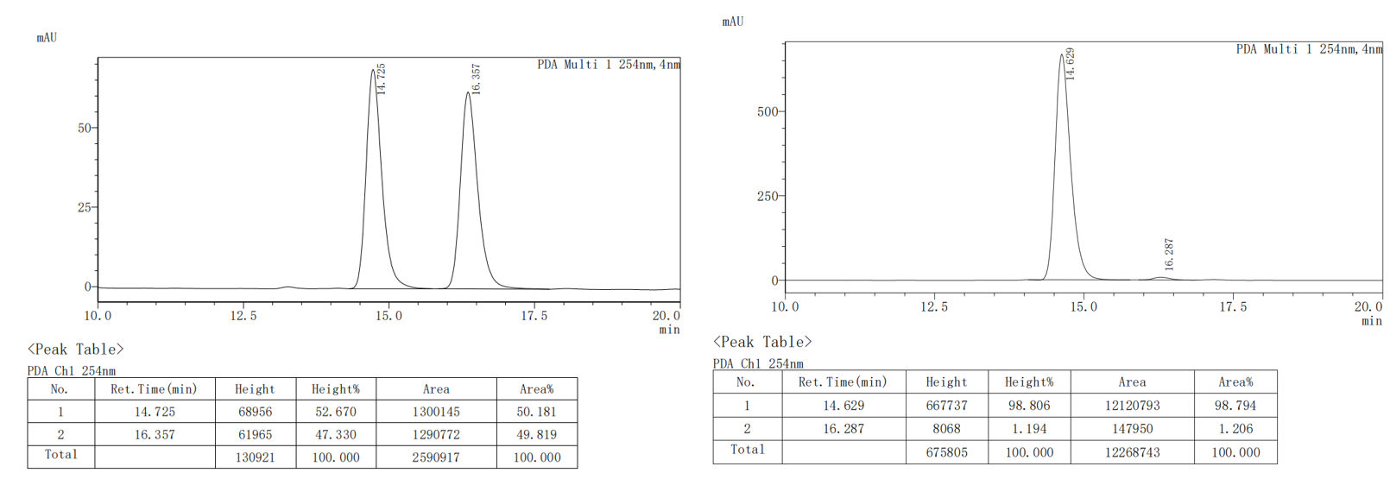
(4aR,9R,9aS)-2-phenyl-6-(trifluoromethoxy)-3,4,4a,9a-tetrahydro-4'H-spiro[fluorene-9,1'-naphthalen]-4'-one (3ac).
The crude product was purified by column chromatography (petroleum ether/ethyl acetate = 50：1 to 30:1) to afford the product as white solid (87.9 mg, 64% yield).
¹H NMR (400 MHz, CDCl₃) δ 8.26 (dd, J = 7.9, 1.6 Hz, 1H), 7.52 (td, J = 7.6, 1.6 Hz, 1H), 7.43 (td, J = 7.6, 1.2 Hz, 1H), 7.33 – 7.16 (m, 7H), 7.02 (dd, J = 8.4, 2.3 Hz, 1H), 6.88 (d, J = 10.2 Hz, 1H), 6.72 (d, J = 8.4 Hz, 1H), 6.39 (d, J = 10.2 Hz, 1H), 5.76 (d, J = 4.1 Hz, 1H), 3.78 (ddd, J = 8.9, 4.0, 2.2 Hz, 1H), 3.65 (ddd, J = 13.3, 8.5, 5.1 Hz, 1H), 2.61 (tdd, J = 9.8, 5.3, 2.6 Hz, 2H), 2.40 – 2.29 (m, 1H), 1.71 (tdd, J = 13.0, 10.2, 6.0 Hz, 1H).
¹³C NMR (100 MHz, CDCl₃) δ 184.8, 153.3, 149.3 (q, J = 2.0 Hz), 149.3, 148.5, 144.1, 141.4, 138.6, 133.0, 132.2, 128.5, 128.3 (overlapped), 127.3, 127.3, 126.7, 126.2, 126.1, 125.2 (overlapped), 121.4, 120.8, 120.4 (q, J = 257.5 Hz), 117.3, 57.6, 55.2, 42.7, 28.7, 27.0.
¹⁹F NMR (376 MHz, CDCl₃) δ -57.68.
HRMS (EI): m/z: [M]+ Calcd for, C₂₉H₂₁F₃O₂, 458.1494, found: 458.1488.
M.P.: 70.8-73.9 ºC.
[α]_{D}²⁰ = 79.6 (c = 0.2, CHCl₃).
HPLC conditions: Daicel Chiralpak IB (95:5 n-Hexane: 2-Propanol, 0.5 mL/min, 254 nm); tr (minor) = 18.2 min, tr (major) = 15.8 min; 91% ee).
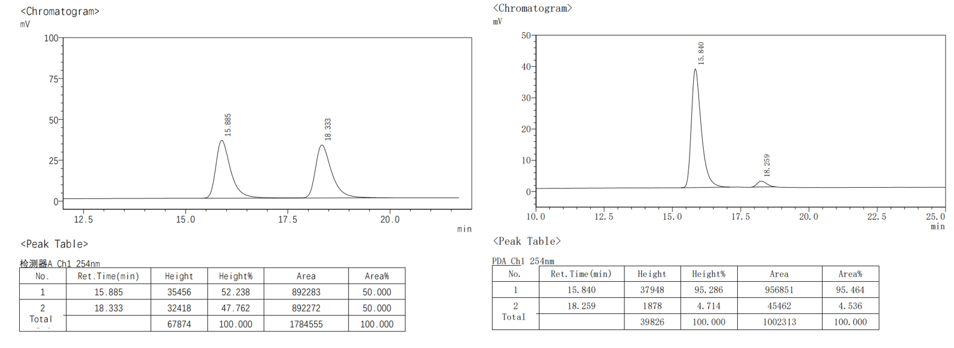
(4aR,9R,9aS)-2-phenyl-6-(trifluoromethyl)-3,4,4a,9a-tetrahydro-4'H-spiro[fluorene-9,1'-naphthalen]-4'-one (3ad).
The crude product was purified by column chromatography (petroleum ether/ethyl acetate = 50：1 to 30:1) to afford the product as white solid (88.8 mg, 67% yield).
¹H NMR (400 MHz, CDCl₃) δ 8.27 (dd, J = 7.8, 1.6 Hz, 1H), 7.72 (s, 1H), 7.53 (td, J = 7.5, 1.6 Hz, 1H), 7.49 – 7.41 (m, 2H), 7.30 (s, 2H), 7.27 (d, J = 11.1 Hz, 2H), 7.23 (td, J = 6.2, 5.7, 2.3 Hz, 1H), 7.16 (d, J = 7.9 Hz, 1H), 6.86 (dd, J = 18.2, 9.1 Hz, 2H), 6.42 (d, J = 10.2 Hz, 1H), 5.80 – 5.75 (m, 1H), 3.82 – 3.77 (m, 1H), 3.71 (ddd, J = 13.3, 8.5, 5.1 Hz, 1H), 2.70 – 2.53 (m, 2H), 2.40 (dq, J = 13.2, 4.3 Hz, 1H), 1.72 (tdd, J = 13.0, 9.9, 6.3 Hz, 1H).
¹³C NMR (100 MHz, CDCl₃) 184.8, 152.8, 149.7, 148.2, 148.1, 141.4, 138.8, 133.1, 132.2, 130.8 (q, J = 32.2 Hz), 128.5, 128.3 (overlapped), 127.5, 127.4, 126.4, 126.4, 126.0, 125.2 (overlapped), 125.1 (q, J = 4.0 Hz), 122.8, 121.9 (q, J = 4.0 Hz), 121.3, 77.0, 58.0, 54.9, 42.6, 28.8, 27.1.
¹⁹F NMR (376 MHz, CDCl₃) δ -62.17.
HRMS (EI): m/z: [M]+ Calcd for, C₂₉H₂₁F₃O, 442.1544, found: 442.1539.
M.P.: 75.1-77.2 ºC.
[α]_{D}²⁰ = 76.2 c = 0.2, CHCl₃).
HPLC conditions: Daicel Chiralpak IB column (95:5 n-Hexane: 2-Propanol, 0.5 mL/min, 254 nm); tr (minor) = 20.3 min, tr (major) = 17.0 min; 81% ee).
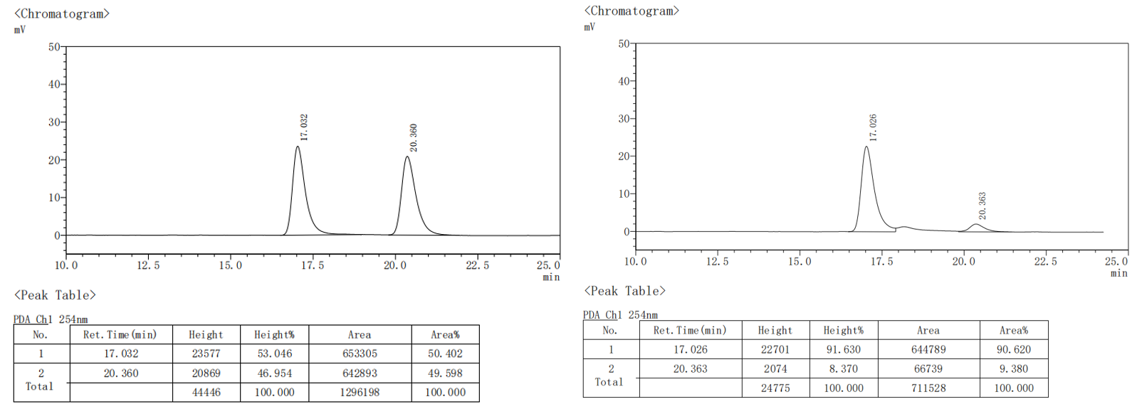
Methyl(4aR,9R,9aS)-4'-oxo-2-phenyl-3,4,4a,9a-tetrahydro-4'H-spiro[fluorene-9,1'-naphthalene]-6-carboxylate (3ae)
The crude product was purified by column chromatography (petroleum ether/ethyl acetate = 50：1 to 20:1) to afford the product as white solid (77.8 mg, 74% yield).
¹H NMR (400 MHz, CDCl₃) δ 8.27 (dd, J = 7.8, 1.6 Hz, 1H), 8.15 (d, J = 1.6 Hz, 1H), 7.86 (dd, J = 8.0, 1.6 Hz, 1H), 7.55 – 7.36 (m, 6H), 7.33 – 7.22 (m, 6H), 7.15 (dd, J = 8.0, 1.3 Hz, 1H), 6.93 (dd, J = 8.3, 1.9 Hz, 1H), 6.89 (d, J = 10.3 Hz, 1H), 6.78 (d, J = 8.0 Hz, 1H), 6.42 (d, J = 10.3 Hz, 1H), 5.77 (dd, J = 4.1, 1.7 Hz, 1H), 3.94 (s, 3H), 3.79 (ddt, J = 8.2, 3.9, 1.8 Hz, 1H), 3.69 (ddd, J = 13.2, 8.5, 5.1 Hz, 1H), 2.60 (qd, J = 4.3, 2.0 Hz, 2H), 2.46 – 2.37 (m, 1H), 1.71 (tdd, J = 12.9, 9.6, 6.5 Hz, 2H).
¹³C NMR (100 MHz, CDCl₃) 185.0, 166.9, 153.1, 150.8, 148.5, 147.8, 141.4, 138.7, 133.1, 132.2, 130.4, 129.5, 128.7, 128.5, 128.3, 127.4, 127.3, 126.7, 126.3, 126.3, 125.5, 125.2, 121.4, 115.7, 58.1, 55.0, 52.2, 42.5, 28.8, 27.0
HRMS (EI): m/z: [M]+ Calcd for, C₂₉H₂₄O₂, 432.1725, found: 432.1720.
M.P.: 71.5-72.7 ºC.
[α]_{D}²⁰ = -15.2 (c = 0.2, CHCl₃).
HPLC conditions: Daicel Chiralpak IB column (90:10 n-Hexane: 2-Propanol, 0.5 mL/min, 254 nm); tr (minor) = 14.4 min, tr (major) = 11.0 min; 96% ee).
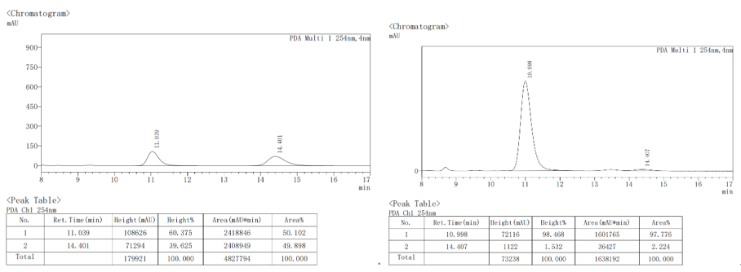
(4aR,9R,9aS)-7-methoxy-2-phenyl-3,4,4a,9a-tetrahydro-4'H-spiro [fluorene-9,1'-naphthalen]-4'-one (3af).
The crude product was purified by column chromatography (petroleum ether/ethyl acetate = 50：1 to 30:1) to afford the product as white solid (82.5 mg, 68% yield).
¹H NMR (400 MHz, CDCl₃) δ 8.25 (dd, J = 7.8, 1.6 Hz, 1H), 7.51 (td, J = 7.6, 1.6 Hz, 1H), 7.42 (td, J = 7.5, 1.3 Hz, 1H), 7.35 (d, J = 8.3 Hz, 1H), 7.31 – 7.18 (m, 6H), 6.92 (d, J = 10.3 Hz, 1H), 6.88 (dd, J = 8.4, 2.5 Hz, 1H), 6.38 (d, J = 10.3 Hz, 1H), 6.20 (d, J = 2.5 Hz, 1H), 5.79 – 5.74 (m, 1H), 3.75 (ddd, J = 8.6, 4.0, 2.2 Hz, 1H), 3.64 (s, 4H), 3.58 (ddd, J = 13.1, 8.4, 5.1 Hz, 1H), 2.60 – 2.52 (m, 2H), 2.37 – 2.26 (m, 1H), 1.73 – 1.58 (m, 1H).
¹³C NMR (100 MHz, CDCl₃) 185.1, 159.7, 154.2, 149.0, 146.8, 141.6, 139.5, 138.5, 132.9, 132.2, 128.7, 128.3 (overlapped), 127.1, 127.1, 126.1, 125.9, 125.4, 125.2 (overlapped), 122.0, 115.0, 109.8, 58.4, 55.5, 55.4, 42.0, 29.3, 27.1
HRMS (EI): m/z: [M]+ Calcd for, C₂₉H₂₄O₂, 404.1776, found: 404.1773.
M.P.: 80.7-82.6 ºC.
[α]_{D}²⁰ = 75.0 (c = 0.2, CHCl₃).
HPLC conditions: Daicel Chiralpak IB column (95:5 n-Hexane: 2-Propanol, 0.5 mL/min, 254 nm); tr (minor) = 19.1 min, tr (major) = 17.8 min; 90% ee).
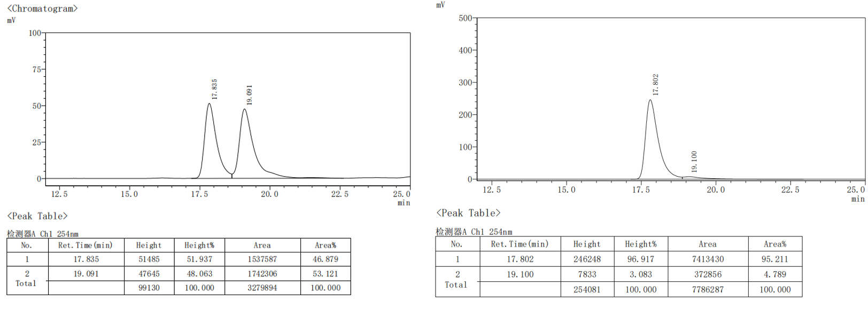(4aR,9R,9aS)-7-fluoro-2-phenyl-3,4,4a,9a-tetrahydro-4'H-spiro [fluorene-9,1'-naphthalen]-4'-one (3ag).
The crude product was purified by column chromatography (petroleum ether/ethyl acetate = 50：1 to 30:1) to afford the product as white solid (77.6 mg, 66% yield).
¹H NMR (400 MHz, CDCl₃) δ 8.25 (dd, J = 7.9, 1.5 Hz, 1H), 7.51 (td, J = 7.6, 1.6 Hz, 1H), 7.42 (td, J = 7.5, 1.1 Hz, 1H), 7.34 – 7.16 (m, 7H), 6.88 (d, J = 10.3 Hz, 1H), 6.82 (t, J = 8.8 Hz, 1H), 6.45 (d, J = 10.2 Hz, 1H), 5.74 (s, 1H), 3.73 (dt, J = 6.7, 2.4 Hz, 1H), 3.66 (ddd, J = 13.2, 8.4, 4.9 Hz, 1H), 2.57 (ddt, J = 9.8, 4.8, 2.2 Hz, 2H), 2.39 – 2.20 (m, 1H), 1.67 (tdd, J = 12.8, 10.2, 6.0 Hz, 1H).
¹³C NMR (100 MHz, CDCl₃) δ 184.9, 159.2 (d, J = 252.1 Hz), 151.7, 150.7 (d, J = 3.9 Hz), 148.3, 141.4, 138.6, 132.9, 131.6, 131.4, 131.3, 130.6, 130.6, 128.9, 128.3 (overlapped), 127.3 (d, J = 8.9 Hz), 127.1, 126.9, 126.3, 125.2 (overlapped), 121.1, 120.5 (d, J = 3.6 Hz), 114.6 (d, J = 19.7 Hz), 56.0 (d, J = 1.8 Hz), 55.4, 43.3, 29.0, 27.1.
¹⁹F NMR (376 MHz, CDCl₃) δ -116.72.
HRMS (EI): m/z: [M]+ Calcd for, C₂₈H₂₁FO, 392.1576, found: 392.1571.
M.P.: 80.3-81.7 ºC.
[α]_{D}²⁰ = 100.2 (c = 0.2, CHCl₃).
HPLC conditions: Daicel Chiralpak IB column (95:5 n-Hexane: 2-Propanol, 0.5 mL/min, 254 nm); tr (minor) = 22.8 min, tr (major) = 21.3 min; 87% ee).
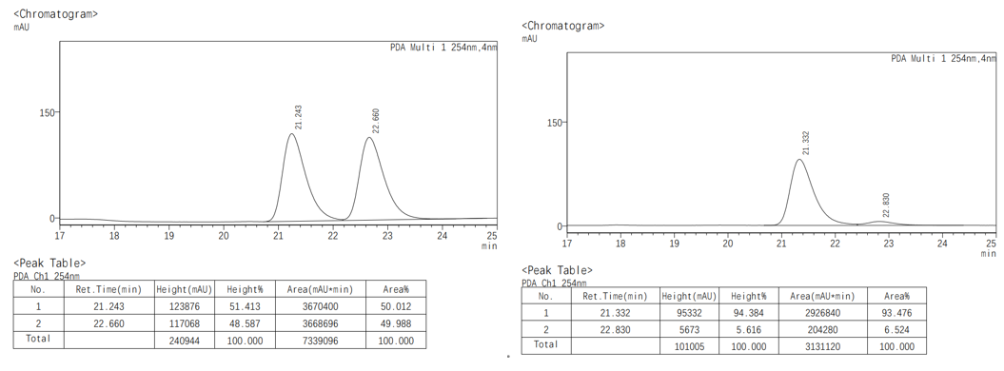
(4aR,9S,9aS)-8-fluoro-2-phenyl-3,4,4a,9a-tetrahydro-4'H-spiro [fluorene-9,1'-naphthalen]-4'-one (3ah).
The crude product was purified by column chromatography (petroleum ether/ethyl acetate = 50：1 to 30:1) to afford the product as white solid (74.1 mg, 63% yield).
¹H NMR (400 MHz, CDCl₃) δ 8.25 (dd, J = 7.9, 1.6 Hz, 1H), 7.53 (td, J = 7.6, 1.6 Hz, 1H), 7.45 (dd, J = 7.7, 1.2 Hz, 1H), 7.43 – 7.35 (m, 1H), 7.32 – 7.26 (m, 4H), 7.24 – 7.16 (m, 2H), 7.02 (td, J = 8.6, 2.5 Hz, 1H), 6.89 (d, J = 10.3 Hz, 1H), 6.44 – 6.36 (m, 2H), 5.78 – 5.72 (m, 1H), 3.81 – 3.73 (m, 1H), 3.60 (ddd, J = 13.3, 8.5, 5.1 Hz, 1H), 2.65 – 2.49 (m, 1H), 2.33 (ddd, J = 13.1, 9.0, 3.7 Hz, 1H), 1.75 – 1.60 (m, 1H).
¹³C NMR (100 MHz, CDCl₃) δ184.9, 162.8 (d, J = 245.7 Hz), 153.4, 148.5, 147.6 (d, J = 7.3 Hz), 143.0, 141.6, 138.7, 133.1, 132.2, 128.6, 128.4 (overlapped), 127.3 (d, J = 7.4 Hz), 126.3, 126.2, 126.0, 125.9, 125.2 (overlapped), 121.7, 115.7 (d, J = 22.7 Hz), 112.3 (d, J = 22.3 Hz), 58.2, 55.5, 42.1, 29.2, 27.2.
¹⁹F NMR (376 MHz,) δ -116.72.
HRMS (EI): m/z: [M]+ Calcd for C₂₈H₂₁FO, 392.1576, found: 392.1573.
M.P.: 144.7-147.9 ºC.
[α]D²⁰ = 90.4 (c = 0.2, CHCl₃).
HPLC conditions: Daicel Chiralpak ID column (95:5 n-Hexane: 2-Propanol, 0.5 mL/min, 254 nm); tr (minor) = 19.1 min, tr (major) = 17.3 min; 93% ee).
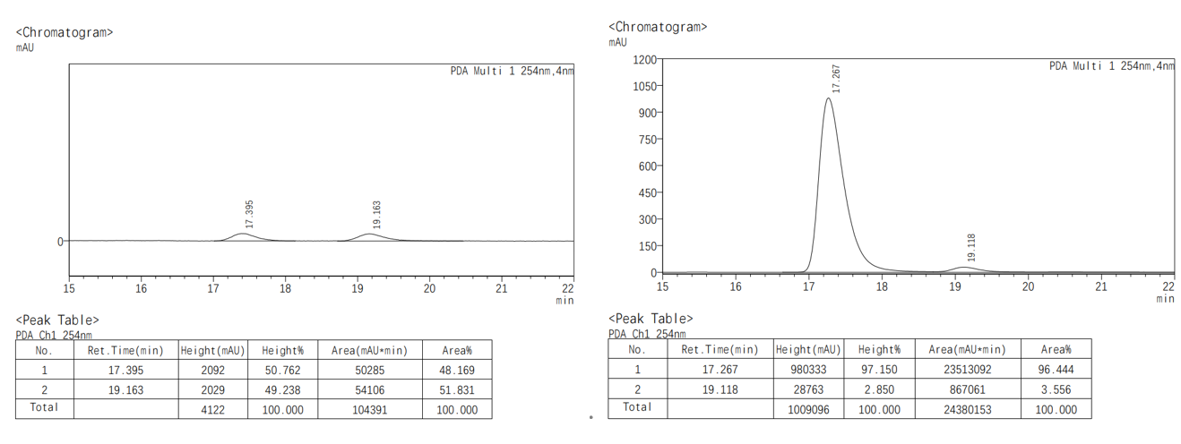
(4aR,9R,9aS)-6,7-difluoro-2-phenyl-3,4,4a,9a-tetrahydro-4'H-spiro[fluorene-9,1'-naphthalen]-4'-one. (3ai)
The crude product was purified by column chromatography (petroleum ether/ethyl acetate = 50：1 to 30:1) to afford the product as white solid (82.4 mg, 67% yield).
¹H NMR (400 MHz, CDCl₃) δ 8.25 (dd, J = 7.8, 1.6 Hz, 1H), 7.54 (td, J = 7.6, 1.6 Hz, 1H), 7.45 (td, J = 7.5, 1.3 Hz, 1H), 7.30 – 7.17 (m, 7H), 6.86 (d, J = 10.3 Hz, 1H), 6.51 (dd, J = 9.8, 7.4 Hz, 1H), 6.40 (d, J = 10.2 Hz, 1H), 5.73 (dd, J = 4.1, 2.0 Hz, 1H), 3.80 – 3.73 (m, 1H), 3.60 (ddd, J = 13.3, 8.5, 5.1 Hz, 1H), 2.66 – 2.49 (m, 2H), 2.31 (dtd, J = 13.1, 4.8, 3.2 Hz, 1H), 1.68 (tdd, J = 13.0, 10.6, 5.7 Hz, 1H).
¹³C NMR (100 MHz, CDCl₃) δ 184.7, 153.0, 148.1, 141.4, 138.7, 133.1, 132.1, 128.4, 128.3, 127.5, 127.3, 126.3, 125.2, 121.3, 114.1, 113.9, 113.3, 113.1, 57.8, 55.4, 42.4, 28.9, 27.0.
¹⁹F NMR (376 MHz, CDCl₃) δ -137.18 (d, J = 20.1 Hz), -137.53 (d, J = 20.1 Hz).
HRMS (EI): m/z: [M]+ Calcd for C₂₈H₂₀F₂O, 410.1482, found: 410.1478.
M.P.: 83.7-84.6 ºC.
[α]_{D}²⁰ = 121.5 (c = 0.2, CHCl₃).
HPLC conditions: Daicel Chiralpak ID column (95:5 n-Hexane: 2-Propanol, 0.5 mL/min, 254 nm); tr (minor) = 22.1 min, tr (major) = 18.6 min; 92% ee).
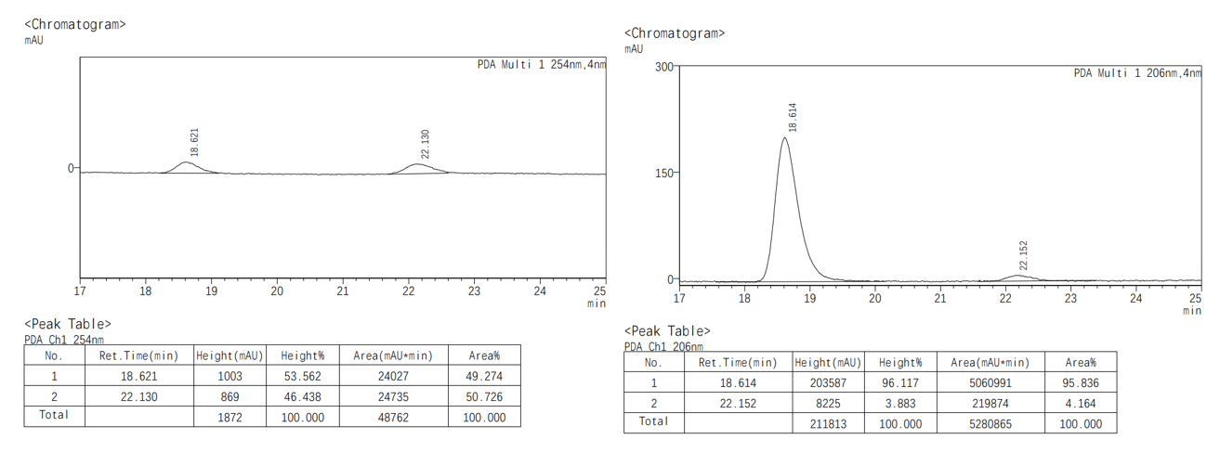
(4aR,9R,9aS)-6-fluoro-2-(m-tolyl)-3,4,4a,9a-tetrahydro-4'H-spiro [fluorene-9,1' -naphthalen]-4'-one (3aj).
The crude product was purified by column chromatography (petroleum ether/ethyl acetate = 50：1 to 30:1) to afford the product as white solid (76.8 mg, 63% yield).
¹H NMR (400 MHz, CDCl₃) δ 8.25 (dd, J = 7.8, 1.6 Hz, 1H), 7.52 (td, J = 7.5, 1.6 Hz, 1H), 7.43 (td, J = 7.5, 1.3 Hz, 1H), 7.22 – 7.08 (m, 5H), 7.04 (d, J = 7.4 Hz, 1H), 6.94 – 6.81 (m, 2H), 6.65 (dd, J = 8.5, 5.1 Hz, 1H), 6.38 (d, J = 10.2 Hz, 1H), 5.75 (dd, J = 4.2, 2.2 Hz, 1H), 3.78 (dt, J = 7.5, 3.4 Hz, 1H), 3.62 (ddd, J = 13.3, 8.5, 5.1 Hz, 1H), 2.66 – 2.45 (m, 2H), 2.37 – 2.33 (m, 1H), 2.32 (s, 3H), 1.70 (tdd, J = 13.0, 11.1, 5.2 Hz, 1H).
¹³C NMR (100 MHz, CDCl₃) δ 1 185.0, 163.0 (d, J = 246.3 Hz), 153.9, 149.6 (d, J = 7.7 Hz), 149.0, 141.4, 141.0, 141.0, 138.6, 137.8, 132.9, 132.2, 128.5, 128.2, 128.0, 127.2, 126.8 (d, J = 9.1 Hz), 126.2, 125.9 (d, J = 4.3 Hz), 122.4, 121.4, 115.2 (d, J = 22.9 Hz), 111.6 (d, J = 21.9 Hz), 57.5, 55.4, 42.8 (d, J = 2.1 Hz), 28.8, 27.1, 21.5.
HRMS (EI): m/z: [M]+ Calcd for, C₂₉H₂₃FO, 406.1733, found: 406.1727.
M.P.: 61.9-63.5 ºC.
[α]_{D}²⁰ = 77.9 (c = 0.2, CHCl₃).
HPLC conditions: Daicel Chiralpak IB column (97:3 n-Hexane: 2-Propanol, 0.5 mL/min, 254 nm); tr (minor) = 18.3 min, tr (major) = 16.1 min; 94% ee).
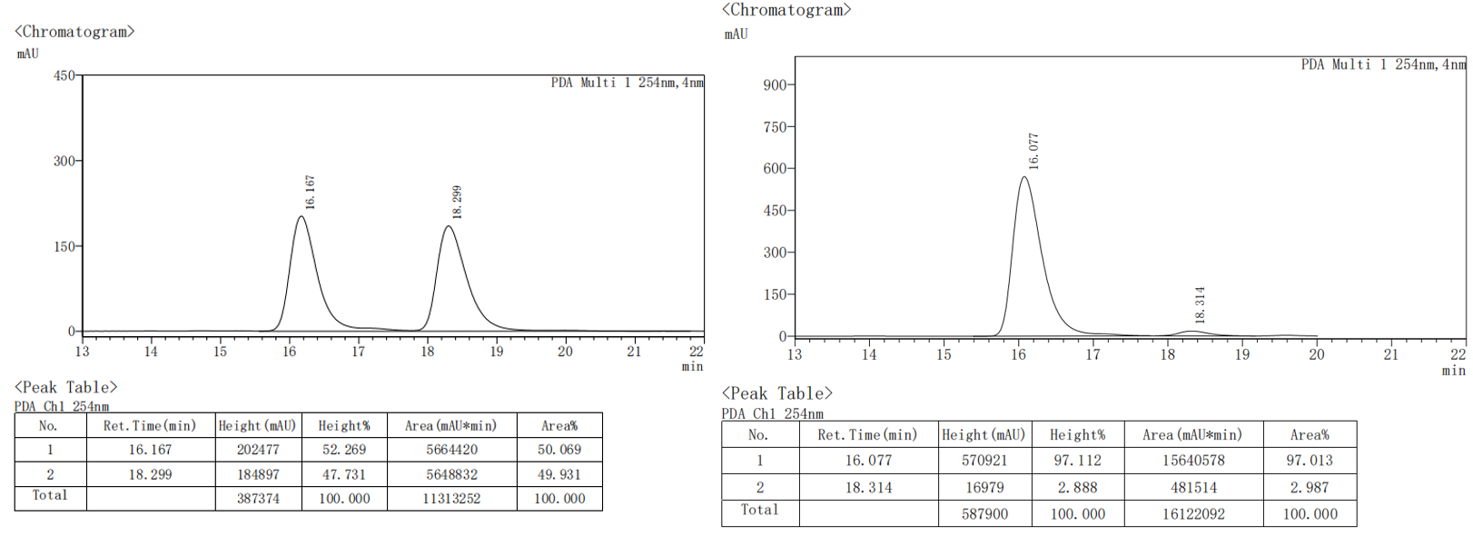
(4aR,9R,9aS)-6-chloro-2-(m-tolyl)-3,4,4a,9a-tetrahydro-4'H-spiro [fluorene-9,1'-naphthalen]-4'-one (3ak).
The crude product was purified by column chromatography (petroleum ether/ethyl acetate = 50：1 to 30:1) to afford the product as white solid (78.5 mg, 62% yield).
¹H NMR (400 MHz, CDCl₃) δ 8.25 (dd, J = 7.8, 1.6 Hz, 1H), 7.51 (td, J = 7.5, 1.6 Hz, 1H), 7.46 – 7.37 (m, 2H), 7.22 – 7.07 (m, 5H), 7.03 (d, J = 7.4 Hz, 1H), 6.87 (d, J = 10.3 Hz, 1H), 6.63 (d, J = 8.2 Hz, 1H), 6.38 (d, J = 10.3 Hz, 1H), 5.74 (dd, J = 4.3, 2.1 Hz, 1H), 3.92 – 3.72 (m, 1H), 3.62 (ddd, J = 13.2, 8.5, 5.1 Hz, 1H), 2.69 – 2.48 (m, 2H), 2.37 – 2.33 (m, 1H), 2.31 (s, 3H), 1.77 – 1.62 (m, 1H).
¹³C NMR (100 MHz, CDCl₃) δ 184.9, 153.4, 149.2, 148.6, 144.1, 141.4, 138.7, 137.8, 134.1, 132.9, 132.2, 128.5, 128.2, 128.2, 128.0, 127.2, 126.7, 126.2, 126.1, 125.9, 125.0, 122.3, 121.2, 57.6, 55.1, 42.7, 28.8, 27.1, 21.4.
HRMS (EI): m/z: [M]+ Calcd for, C₂₉H₂₃ClO, 422.1437, found: 422.1431.
M.P.: 82.3-91.4 ºC.
[α]_{D}²⁰ = 48.5 (c = 0.2, CHCl₃).
HPLC conditions: Daicel Chiralpak IB (97:3 n-Hexane: 2-Propanol, 0.5 mL/min, 254 nm); tr (minor) = 19.1 min, tr (major) = 15.9 min; 90% ee).
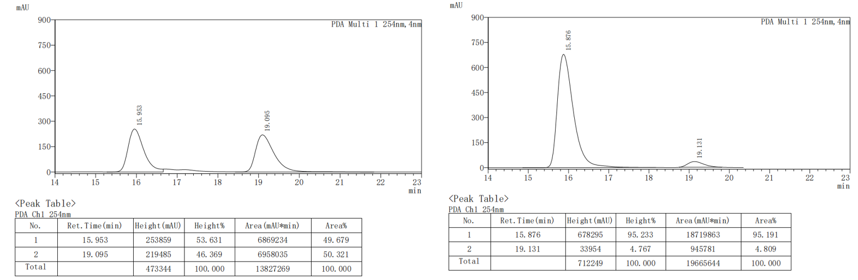
(4aR,9R,9aS)-6-methyl-2-(m-tolyl)-3,4,4a,9a-tetrahydro-4'H-spiro[fluorene-9,1'-naphthalen]-4'-one (3al).
The crude product was purified by column chromatography (petroleum ether/ethyl acetate = 50：1 to 30:1) to afford the product as white solid (82.0 mg, 68% yield).
¹H NMR (400 MHz, CDCl₃) δ 8.25 (dd, 1H), 7.48 (t, J = 7.6 Hz, 1H), 7.40 (t, J = 7.5 Hz, 1H), 7.23 (dd, J = 12.2, 9.4 Hz, 2H), 7.16 (t, J = 7.6 Hz, 1H), 7.10 (d, J = 7.2 Hz, 2H), 7.02 (d, J = 7.4 Hz, 1H), 6.97 (d, J = 7.8 Hz, 1H), 6.91 (dd, J = 10.2, 1.5 Hz, 1H), 6.58 (d, J = 7.7 Hz, 1H), 6.36 (dd, J = 10.2, 1.8 Hz, 1H), 5.77 (dd, J = 4.0, 2.2 Hz, 1H), 3.74 (dt, J = 7.2, 3.2 Hz, 1H), 3.59 (ddd, J = 13.3, 8.3, 5.2 Hz, 1H), 2.65 – 2.44 (m, 2H), 2.38 (s, 3H), 2.36 – 2.33 (m, 1H), 2.31 (s, 3H), 1.68 (qd, J = 12.4, 5.1 Hz, 1H).
¹³C NMR (100 MHz, CDCl₃) δ 185.2, 154.4, 149.4, 147.5, 142.5, 141.6, 138.4, 138.1, 137.7, 132.7, 132.2, 128.8, 128.6, 128.1, 127.9, 126.9, 126.0, 125.9, 125.5, 125.3, 125.1, 122.3, 121.8, 57.9, 55.1, 42.7, 29.1, 27.2, 21.4, 21.3.
HRMS (EI): m/z: [M]+ Calcd for, C₃₀H₂₆O, 402.1984, found: 402.1978.
M.P.: 104.7-105.9 ºC.
[α]_{D}²⁰ = 64.2 (c = 0.2, CHCl₃).
HPLC conditions: Daicel Chiralpak IB column (97:3 n-Hexane: 2-Propanol, 0.5 mL/min, 254 nm); tr (minor) = 14.9 min, tr (major) = 13.8 min; 87% ee).
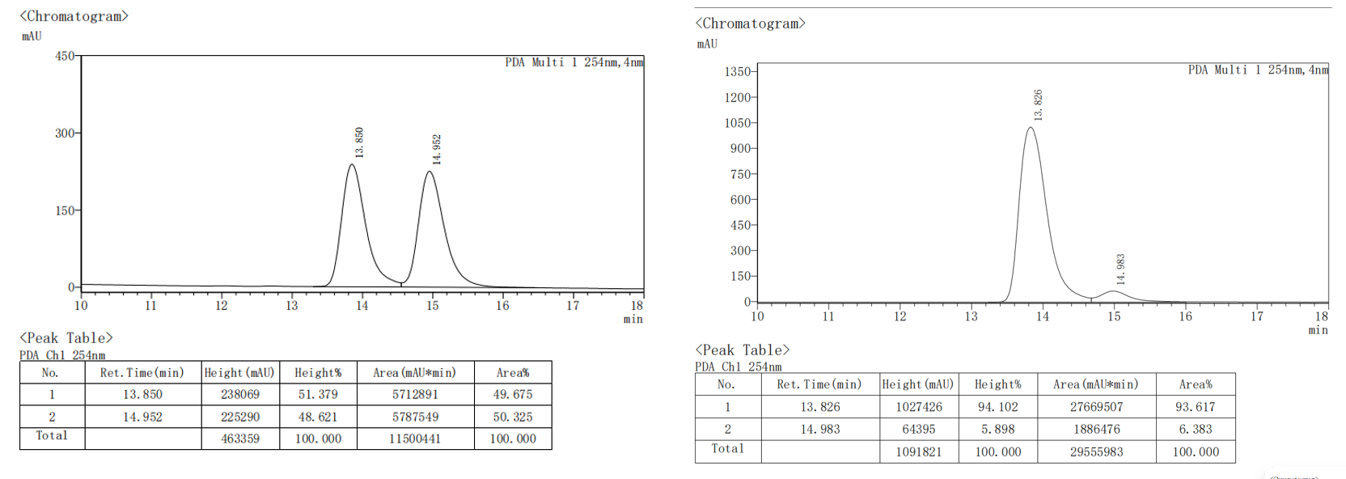
(4aR,9R,9aS)-6-fluoro-2-(m-tolyl)-3,4,4a,9a-tetrahydro-4'H-spiro[fluorene-9,1'-naphthalen]-4'-one (3am)
The crude product was purified by column chromatography (petroleum ether/ethyl acetate = 50：1 to 30:1) to afford the product as white solid (84.0 mg, 69% yield).;
¹H NMR (400 MHz, CDCl₃) δ 8.25 (dd, J = 7.9, 1.5 Hz, 1H), 7.57 – 7.48 (m, 0H), 7.44 (t, J = 7.6 Hz, 1H), 7.39 (dd, J = 8.4, 5.1 Hz, 1H), 7.23 – 7.14 (m, 1H), 7.12 – 7.07 (m, 2H), 7.05 – 6.97 (m, 1H), 6.89 (d, J = 10.2 Hz, 1H), 5.74 (dd, J = 4.3, 2.1 Hz, 1H), 3.77 (dt, J = 7.4, 3.3 Hz, 1H), 3.59 (ddd, J = 13.2, 8.4, 5.1 Hz, 1H), 2.66 – 2.47 (m, 1H), 2.36 – 2.32 (m, 1H), 2.31 (s, 3H), 1.77 – 1.60 (m, 1H).
¹³C NMR (100 MHz, CDCl₃) δ 184.9, 162.7 (d, J = 245.7 Hz), 153.3, 148.4, 147.5 (d, J = 7.3 Hz), 142.9, 142.9, 141.5, 138.7, 137.8, 133.0, 132.2, 128.5, 128.2, 128.0, 127.3, 126.2 (d, J = 8.2 Hz), 125.9, 125.8, 122.4, 121.3, 115.6 (d, J = 22.5 Hz), 112.2 (d, J = 22.3 Hz), 58.1, 55.4, 42.1, 29.2, 27.1, 21.4.
¹⁹F NMR (376 MHz, CDCl₃) δ -114.32.
HRMS (EI): m/z: [M]+ Calcd for C₂₉H₂₃FO, 406.1733, found: 406.1727.
M.P.: 75.0-76.8 ºC.
[α]_{D}²⁰ = 97.2 (c = 0.2, CHCl₃).
HPLC conditions: Daicel Chiralpak IB column (97:3 n-Hexane: 2-Propanol, 0.5 mL/min, 254 nm); tr (minor) = 17.7 min, tr (major) = 15.9 min; 91% ee).
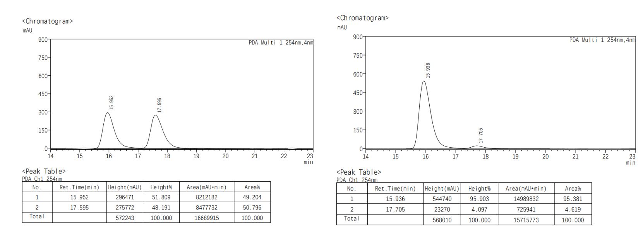
(4aR,9R,9aS)-7-methyl-2-(m-tolyl)-3,4,4a,9a-tetrahydro-4'H-spiro[fluorene-9,1'-naphthalen]-4'-one (3an).
The crude product was purified by column chromatography (petroleum ether/ethyl acetate = 50：1 to 30:1) to afford the product as white solid (85.6 mg, 71% yield).
¹H NMR (400 MHz, CDCl₃) δ 8.26 (d, J = 7.9 Hz, 1H), 7.51 (t, J = 7.6 Hz, 1H), 7.42 (t, J = 7.5 Hz, 1H), 7.33 (d, J = 7.7 Hz, 1H), 7.27 – 7.20 (m, 2H), 7.18 – 7.06 (m, 4H), 7.03 (d, J = 7.4 Hz, 1H), 6.92 (d, J = 10.3 Hz, 1H), 6.49 (s, 1H), 6.37 (d, J = 10.2 Hz, 1H), 5.77 (s, 1H), 3.83 – 3.70 (m, 1H), 3.66 – 3.56 (m, 1H), 2.70 – 2.47 (m, 2H), 2.31 (m, 4H), 2.22 (s, 3H), 1.75 – 1.55 (m, 1H).
¹³C NMR (100 MHz, CDCl₃) δ 185.2, 154.4, 149.3, 145.5, 144.5, 141.6, 138.5, 137.7, 137.6, 132.8, 132.2, 129.2, 128.7, 128.1, 127.9, 126.9, 126.0, 125.9, 125.8, 125.6, 124.5, 122.3, 121.8, 58.2, 55.1, 42.4, 29.1, 27.2, 21.4, 21.1.
HRMS (EI): m/z: [M]+ Calcd for, C₃₀H₂₆O, 402.1984, found: 402.1978.
M.P.: 70.3-71.3 ºC.
[α]_{D}²⁰ = 88.5 (c = 0.2, CHCl₃).
HPLC conditions: Daicel Chiralpak IB (99:1 n-Hexane: 2-Propanol, 0.5 mL/min, 254 nm); tr (minor) = 24.4 min, tr (major) = 25.7 min; 90% ee).
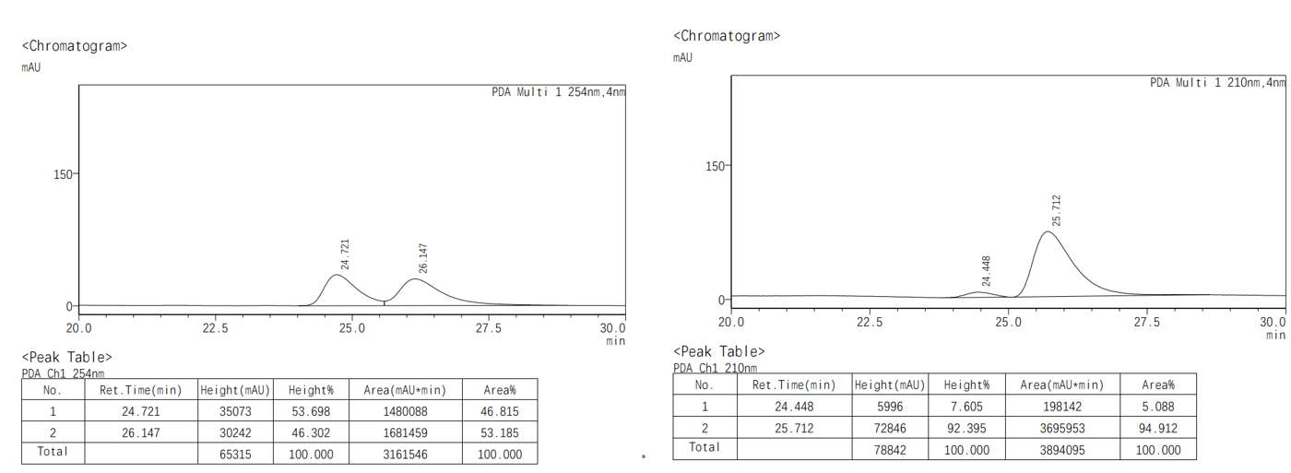
(4aR,9R,9aS)-2-(4-fluorophenyl)-6-methoxy-3,4,4a,9a-tetrahydro-4'H-spiro [fluorene-9,1'-naphthalen]-4'-one (3ba)
The crude product was purified by column chromatography (petroleum ether/ethyl acetate = 50：1 to 30:1) to afford the product as white solid (84.8 mg, 67% yield).
¹H NMR (400 MHz, CDCl₃) δ 8.25 (dd, J = 7.9, 1.5 Hz, 1H), 7.55 – 7.47 (m, 1H), 7.46 – 7.38 (m, 1H), 7.25 (qd, J = 6.7, 3.3 Hz, 4H), 7.04 – 6.93 (m, 3H), 6.90 (d, J = 10.3 Hz, 1H), 6.73 (dd, J = 8.4, 2.5 Hz, 1H), 6.62 (d, J = 8.4 Hz, 1H), 6.36 (d, J = 10.3 Hz, 1H), 5.71 (dd, J = 3.7, 1.9 Hz, 1H), 3.84 (s, 3H), 3.74 (ddt, J = 8.5, 4.1, 1.9 Hz, 1H), 3.60 (ddd, J = 13.2, 8.5, 5.0 Hz, 1H), 2.64 – 2.49 (m, 2H), 2.40 – 2.30 (m, 2H), 1.77 – 1.62 (m, 1H).
¹³C NMR (100 MHz, CDCl₃) δ 185.2, 162.0 (d, J = 247.4 Hz), 160.1, 154.5, 149.4, 148.8, 137.7, 137.4, 137.2, 132.8, 132.2, 128.6, 127.0, 126.8, 126.7, 126.1, 126.1, 125.5, 121.9, 115.1, 114.9, 114.0, 109.8, 57.5, 55.4, 55.4, 42.7, 28.9, 27.3
¹⁹F NMR (376 MHz, CDCl₃) δ -115.40.
HRMS (EI): m/z: [M]+ Calcd for, C₂₉H₂₃FO₂, 422.1682, found: 422.1679.
M.P.: 73.7-77.0 ºC.
[α]_{D}²⁰ = 31.1 (c = 0.2, CHCl₃).
HPLC conditions: Daicel Chiralpak IB column (95:5 n-Hexane: 2-Propanol, 0.5 mL/min, 254 nm); tr (minor) = 20.3 min, tr (major) = 18.8 min; 96% ee).
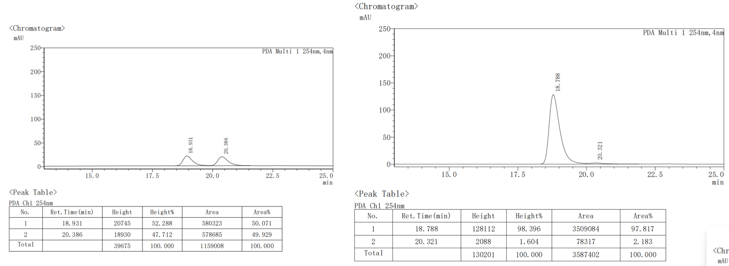
(4aR,9R,9aS)-2-(3-fluorophenyl)-6-methoxy-3,4,4a,9a-tetrahydro-4'H-spiro[flu-orene-9,1'-naphthalen]-4'-one (3bb).
The crude product was purified by column chromatography (petroleum ether/ethyl acetate = 50：1 to 30:1) to afford the product as white solid (99.6 mg, 78% yield).
¹H NMR (400 MHz, CDCl₃) δ 8.24 (d, J = 7.7 Hz, 1H), 7.50 (t, J = 7.6 Hz, 1H), 7.41 (t, J = 7.6 Hz, 1H), 7.27 – 7.20 (m, 2H), 7.07 (d, J = 7.8 Hz, 1H), 6.98 (td, J = 5.7, 5.1, 2.7 Hz, 2H), 6.94 – 6.85 (m, 2H), 6.73 (d, J = 8.5 Hz, 1H), 6.60 (d, J = 8.4 Hz, 0H), 6.36 (d, J = 8.5 Hz, 1H), 5.82 – 5.77 (m, 1H), 3.83 (d, J = 1.8 Hz, 3H), 3.76 – 3.72 (m, 1H), 3.67 – 3.54 (m, 1H), 2.58 – 2.54 (m, 2H), 2.35 (dt, J = 13.8, 4.4 Hz, 1H), 1.77 – 1.65 (m, 1H).
¹³C NMR (100 MHz, CDCl₃) δ 185.1, 162.8 (d, J = 245.3 Hz), 160.1, 154.3, 149.3, 148.7, 143.9 (d, J = 7.5 Hz), 137.4, 137.2, 132.8, 132.2, 129.7 (d, J = 8.4 Hz), 128.6, 127.0, 126.1 (d, J = 3.3 Hz), 125.6, 123.2, 120.8, 120.8, 114.1, 113.8 (d, J = 21.4 Hz), 112.1 (d, J = 21.9 Hz), 109.8, 57.5, 55.4, 55.3, 42.8, 28.8, 27.0.
¹⁹F NMR (376 MHz, CDCl₃) δ -113.36.
HRMS (EI): m/z: [M]+ Calcd for, C₂₉H₂₃FO₂, 422.1682, found: 422.1677.
M.P.: 94.3-97.5 ºC.
[α]_{D}²⁰ = 41.3 (c = 0.2, CHCl₃).
HPLC conditions: Daicel Chiralpak IB column (90:10 n-Hexane: 2-Propanol, 0.5 mL/min, 254 nm); tr (minor) = 18.2 min, tr (major) = 16.1 min; 94% ee).
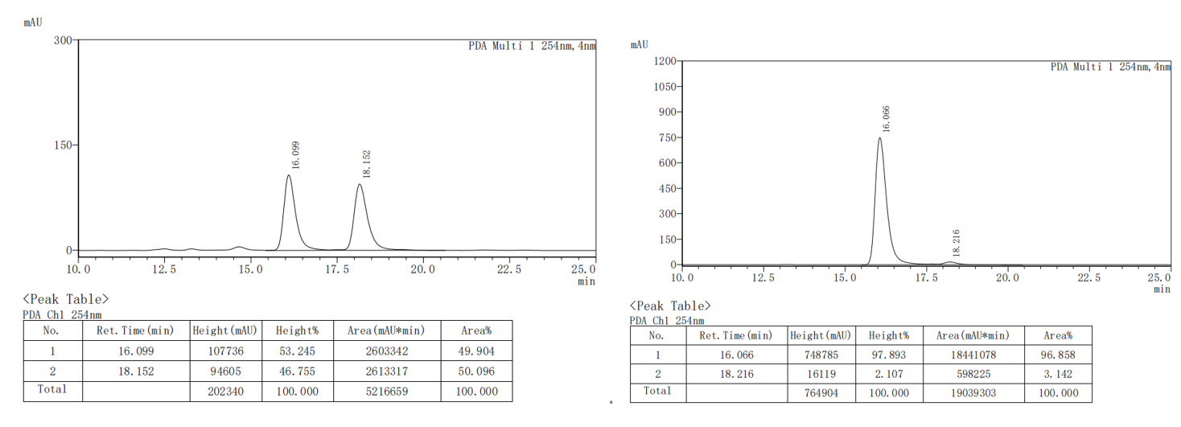
(4aR,9R,9aS)-2-(4-chlorophenyl)-6-methoxy-3,4,4a,9a-tetrahydro-4'H-spiro [fluorene-9,1'-naphthalen]-4'-one (3bc).
The crude product was purified by column chromatography (petroleum ether/ethyl acetate = 50：1 to 30:1) to afford the product as white solid (88.0 mg, 67% yield).
¹H NMR (400 MHz, CDCl₃) δ 8.24 (d, J = 7.8 Hz, 1H), 7.50 (t, J = 7.7 Hz, 1H), 7.41 (t, J = 7.5 Hz, 1H), 7.23 (d, J = 7.0 Hz, 5H), 6.97 (s, 1H), 6.89 (d, J = 8.5 Hz, 1H), 6.72 (d, J = 2.2 Hz, 1H), 6.62 (s, 1H), 6.35 (d, J = 8.4 Hz, 1H), 5.95 – 5.57 (m, 1H), 3.84 (s, 3H), 3.78 – 3.69 (m, 1H), 3.65 – 3.54 (m, 1H), 2.61 – 2.46 (m, 2H), 2.40 – 2.19 (m, 1H), 1.76 – 1.60 (m, 1H).
¹³C NMR (100 MHz, CDCl₃) δ 185.1, 160.1, 154.5, 149.3, 148.8, 140.0, 137.3, 137.2, 132.9, 132.2, 128.6, 128.4 (overlapped), 127.0, 126.5 (overlapped), 126.2, 126.1, 125.6, 122.6, 114.1, 109.8, 57.5, 55.4, 55.4, 42.7, 28.9, 27.1.
HRMS (EI): m/z: [M]+ Calcd for, C₂₉H₂₃ClO₂, 438.1387, found: 438.1381.
M.P.: 115.8-116.6 ºC.
[α]_{D}²⁰ = 48.5 (c = 0.2, CHCl₃).
HPLC conditions: Daicel Chiralpak IB column (95:5 n-Hexane: 2-Propanol, 0.5 mL/min, 254 nm); tr (minor) = 22.7 min, tr (major) = 20.6 min; 93% ee).
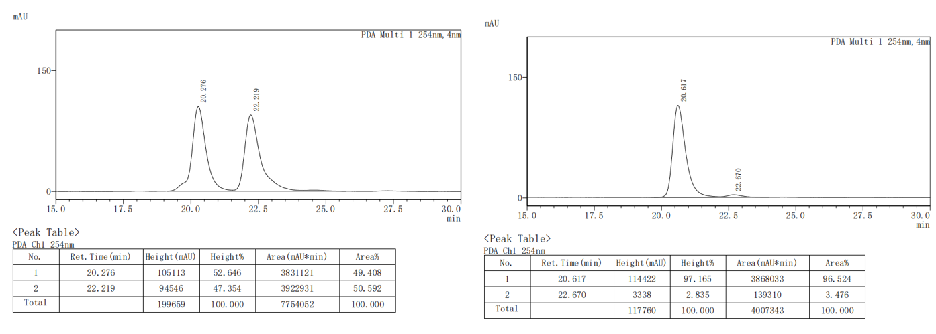
(4aR,9R,9aS)-6-methoxy-2-(p-tolyl)-3,4,4a,9a-tetrahydro-4'H-spiro[fluor-ene-9,1'-naphthalen]-4'-one (3bd).
The crude product was purified by column chromatography (petroleum ether/ethyl acetate = 50：1 to 30:1) to afford the product as white solid (83.6 mg, 66% yield).
¹H NMR (400 MHz, CDCl₃) δ 8.24 (d, J = 7.8 Hz, 1H), 7.50 (t, J = 7.5 Hz, 1H), 7.41 (t, J = 7.5 Hz, 1H), 7.21 (dd, J = 11.9, 7.8 Hz, 3H), 7.08 (d, J = 7.8 Hz, 2H), 6.97 (d, J = 2.4 Hz, 1H), 6.90 (d, J = 10.2 Hz, 1H), 6.71 (dd, J = 8.5, 2.1 Hz, 1H), 6.60 (d, J = 8.4 Hz, 1H), 6.35 (d, J = 10.1 Hz, 1H), 5.90 – 5.68 (m, 1H), 3.83 (s, 3H), 3.79 – 3.69 (m, 1H), 3.59 (ddd, J = 13.3, 8.4, 5.1 Hz, 1H), 2.56 (tdd, J = 16.8, 13.3, 3.2 Hz, 2H), 2.36 – 2.33 (m, 1H), 2.31 (s, 3H), 1.69 (dd, J = 12.7, 5.7 Hz, 1H).
¹³C NMR (100 MHz, CDCl₃) δ 185.2, 160.0, 154.7, 149.5, 149.0, 138.7, 138.1, 137.3, 136.9, 132.8, 132.2, 128.9 (overlapped), 128.6, 126.9, 126.2, 126.1, 125.5, 125.1 (overlapped), 121.1, 114.0, 109.8, 57.6, 55.5 (overlapped), 42.9, 29.0, 27.1, 21.0.
HRMS (EI): m/z: [M]+ Calcd for C₃₀H₂₆O₂, 418.1933, found: 418.1927.
M.P.: 198.5-200.1 ºC.
[α]_{D}²⁰ = 31.2 (c = 0.2, CHCl₃).
HPLC conditions: Daicel Chiralpak ID column (90:10 n-Hexane: 2-Propanol, 0.5 mL/min, 254 nm); tr (minor) = 33.1 min, tr (major) = 31.0 min; 97% ee).
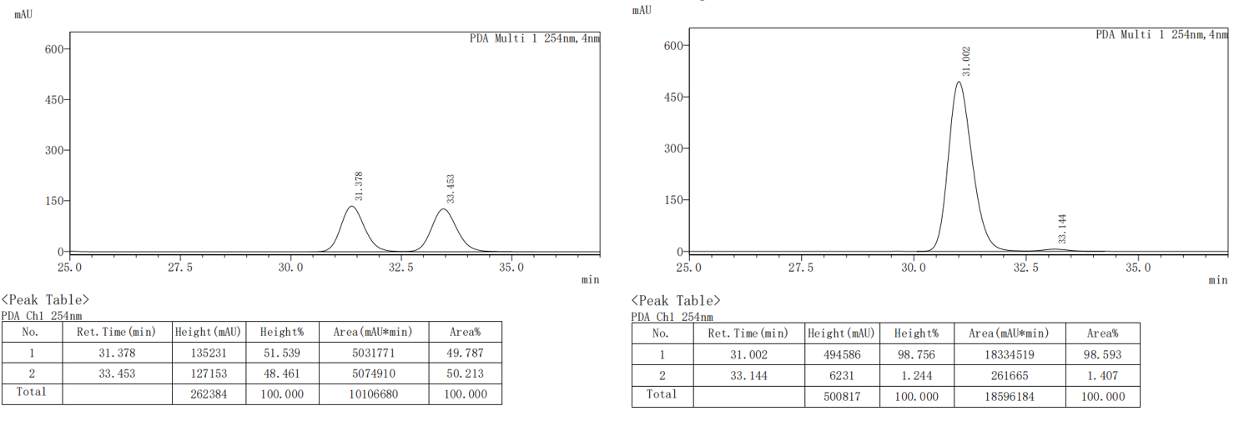
(4aR,9R,9aS)-6-methoxy-2-(m-tolyl)-3,4,4a,9a-tetrahydro-4'H-spiro[fluor-ene-9,1'-naphthalen]-4'-one (3be).
The crude product was purified by column chromatography (petroleum ether/ethyl acetate = 50：1 to 30:1) to afford the product as white solid (106.6 mg, 85% yield).
¹H NMR (400 MHz, CDCl₃) δ 8.24 (dd, J = 7.9, 1.6 Hz, 1H), 7.50 (td, J = 7.5, 1.6 Hz, 1H), 7.41 (td, J = 7.5, 1.3 Hz, 1H), 7.25 – 7.20 (m, 1H), 7.17 (dd, J = 8.4, 7.3 Hz, 1H), 7.17 – 7.07 (m, 2H), 7.03 (d, J = 7.4 Hz, 1H), 6.97 (d, J = 2.5 Hz, 1H), 6.91 (d, J = 10.2 Hz, 1H), 6.72 (dd, J = 8.4, 2.5 Hz, 1H), 6.60 (d, J = 8.4 Hz, 1H), 6.35 (d, J = 10.2 Hz, 1H), 5.76 (dd, J = 4.3, 2.2 Hz, 1H), 3.83 (s, 3H), 3.75 (dt, J = 7.5, 3.3 Hz, 1H), 3.60 (ddd, J = 13.2, 8.5, 5.1 Hz, 1H), 2.66 – 2.52 (m, 2H), 2.35 (q, J = 3.2, 1.8 Hz, 1H), 2.31 (s, 3H), 1.70 (tdd, J = 12.9, 11.1, 5.2 Hz, 1H).
¹³C NMR (100 MHz, CDCl₃) δ 185.2, 160.1, 154.6, 149.5, 149.0, 141.6, 138.5, 137.8, 137.3, 132.8, 132.2, 128.6, 128.2, 127.9, 126.9, 126.2, 126.1, 125.9, 125.5, 122.4, 121.8, 114.0, 109.8, 57.5, 55.4, 55.4, 42.9, 29.0, 27.2, 21.5.
HRMS (EI): m/z: [M]+ Calcd for C₃₀H₂₆O₂, 418.1933, found: 418.1927.
M.P.: 65.4-66.3 ºC.
[α]_{D}²⁰ = 29.7 (c = 0.2, CHCl₃).
HPLC conditions: Daicel Chiralpak IB column (90:10 n-Hexane: 2-Propanol, 0.5 mL/min, 254 nm); tr (minor) = 13.6 min, tr (major) = 12.7 min; 95% ee).
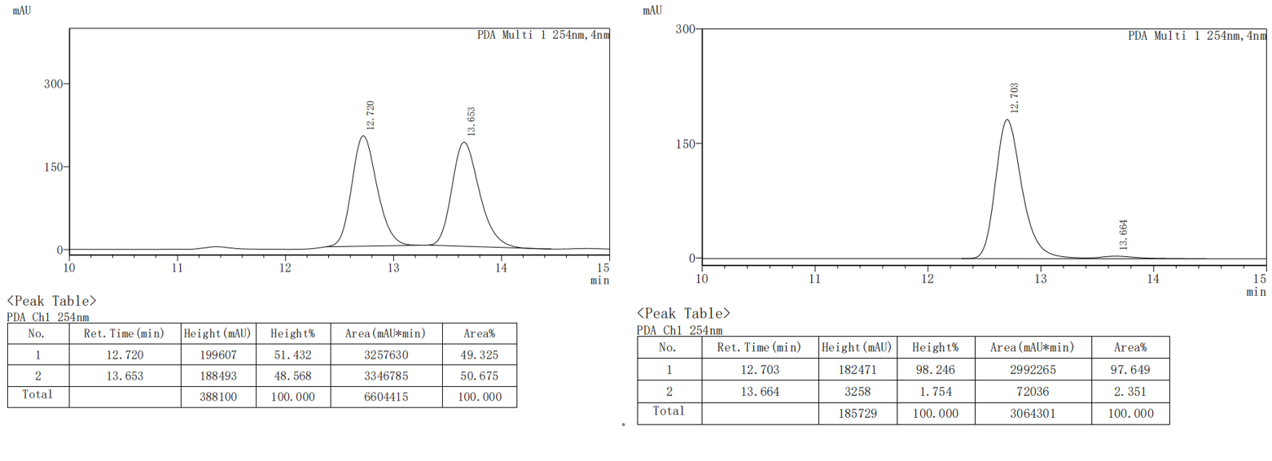
(4aR,9R,9aS)-6-methoxy-2-(o-tolyl)-3,4,4a,9a-tetrahydro-4'H-spiro[fluorene-9,1'-naphthalen]-4'-one (3bf).
The crude product was purified by column chromatography (petroleum ether/ethyl acetate = 50：1 to 30:1) to afford the product as white solid (86.7 mg, 69% yield).
¹H NMR (400 MHz, CDCl₃) δ 7.99 (dd, J = 8.0, 1.5 Hz, 1H), 7.29 (td, J = 7.5, 1.5 Hz, 1H), 7.18 (td, J = 7.5, 1.3 Hz, 1H), 7.04 (d, J = 8.1 Hz, 1H), 7.00 – 6.84 (m, 3H), 6.84 – 6.74 (m, 3H), 6.54 (dd, J = 8.5, 2.5 Hz, 1H), 6.43 (d, J = 8.4 Hz, 1H), 6.16 (d, J = 10.3 Hz, 1H), 5.13 (dd, J = 3.9, 2.4 Hz, 1H), 3.65 (s, 3H), 3.54 (dt, J = 8.7, 3.4 Hz, 1H), 3.42 (ddd, J = 13.2, 8.4, 4.8 Hz, 1H), 2.28 (dddd, J = 19.9, 11.3, 4.9, 2.5 Hz, 1H), 2.15 – 2.07 (m, 2H), 2.03 (s, 3H), 1.61 – 1.47 (m, 1H).
¹³C NMR (100 MHz, CDCl₃) 185.1, 160.1, 154.6, 149.4, 149.1, 143.5, 140.7, 137.4, 134.6, 132.7, 132.2, 130.0, 128.6, 127.9, 126.9, 126.8, 126.2, 126.0, 125.6, 125.6, 123.3, 114.0, 109.9, 57.4, 55.5, 55.2, 42.8, 29.6, 29.0, 20.0.
HRMS (EI): m/z: [M]+ Calcd for C₃₀H₂₆O₂, 418.1933, found: 418.1927.
M.P.: 78.0-83.0 ºC.
[α]_{D}²⁰ = 85.3 (c = 0.2, CHCl₃).
HPLC conditions: Daicel Chiralpak IF column (90:10 n-Hexane: 2-Propanol, 0.5 mL/min, 254 nm); tr (minor) = 27.8 min, tr (major) = 29.1 min; 99% ee).
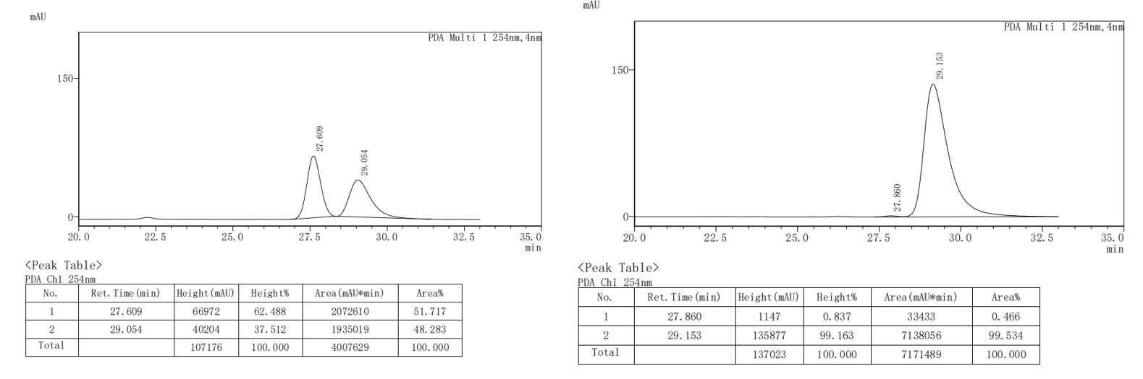
(4aR,9R,9aS)-2-(3,5-dimethylphenyl)-3,4,4a,9a-tetrahydro-4'H-spiro[fluorene-9,1'-naphthalen]-4'-one (3bg).
The crude product was purified by column chromatography (petroleum ether/ethyl acetate = 50：1 to 30:1) to afford the product as white solid (89.2 mg, 74% yield).
¹H NMR (400 MHz, CDCl₃) δ 8.26 (dd, J = 7.8, 1.6 Hz, 1H), 7.53 – 7.37 (m, 3H), 7.31 (t, J = 7.5 Hz, 1H), 7.14 (t, J = 7.5 Hz, 1H), 6.95 – 6.88 (m, 3H), 6.86 (s, 1H), 6.68 (d, J = 7.7 Hz, 1H), 6.37 (d, J = 10.2 Hz, 1H), 5.75 (dd, J = 4.2, 2.2 Hz, 1H), 3.75 (dt, J = 7.5, 3.4 Hz, 1H), 3.63 (ddd, J = 13.3, 8.5, 5.0 Hz, 1H), 2.73 – 2.48 (m, 2H), 2.38 – 2.30 (m, 1H), 2.27 (s, 6H), 1.76 – 1.61 (m, 1H).
¹³C NMR (100 MHz, CDCl₃) δ 185.1, 154.1, 149.3, 147.4, 145.5, 141.6, 138.6, 137.7, 132.8, 132.2, 128.8, 128.7, 128.2, 127.8, 127.0, 126.1, 125.7, 125.4, 124.8, 123.1 (overlapped), 121.5, 58.2, 54.9, 42.9, 29.1, 27.3, 21.3 (overlapped).
HRMS (EI): m/z: [M]+ Calcd for, C₃₀H₂₆O, 402.1984, found: 402.1978.
M.P.: 91.8-94.5 ºC.
[α]_{D}²⁰ = 104.1 (c = 0.2, CHCl₃).
HPLC conditions: Daicel Chiralpak IB column (95:5 n-Hexane: 2-Propanol, 0.5 mL/min, 254 nm); tr (minor) = 32.6 min, tr (major) = 29.8 min; 96% ee).
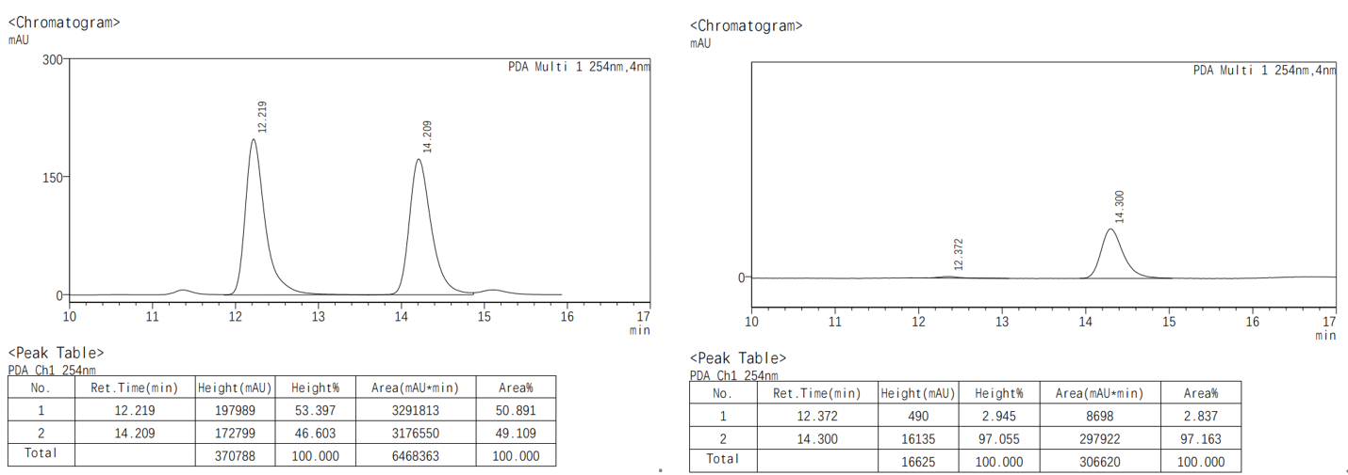
(4aR,9R,9aS)-2-([1,1'-biphenyl]-4-yl)-6-methoxy-3,4,4a,9a-tetrahydro-4'H-spiro[fluorene-9,1'-naphthalen]-4'-one (3bh).
The crude product was purified by column chromatography (petroleum ether/ethyl acetate = 50：1 to 30:1) to afford the product as white solid (108.1 mg, 75% yield).
¹H NMR (400 MHz, CDCl₃) δ 8.25 (d, J = 7.8 Hz, 1H), 7.56 (d, J = 7.7 Hz, 2H), 7.51 (d, J = 7.8 Hz, 3H), 7.45 – 7.33 (m, 5H), 7.31 (t, J = 7.3 Hz, 1H), 7.23 (d, J = 7.6 Hz, 1H), 6.98 (s, 1H), 6.93 (s, 1H), 6.72 (d, J = 8.5 Hz, 1H), 6.61 (d, J = 8.4 Hz, 1H), 6.37 (d, J = 10.2 Hz, 1H), 6.00 – 5.66 (m, 1H), 3.83 (s, 3H), 3.79 – 3.70 (m, 1H), 3.60 (qd, J = 8.1, 5.4 Hz, 1H), 2.74 – 2.48 (m, 2H), 2.42 – 2.29 (m, 1H), 1.71 (qd, J = 12.4, 5.2 Hz, 1H).
¹³C NMR (100 MHz, CDCl₃) 185.2, 160.1, 154.6, 149.4, 148.9, 140.6, 140.4, 139.9, 137.8, 137.2, 132.8, 132.2, 128.7 (overlapped), 128.6, 127.2, 127.0, 126.9 (overlapped), 126.9 (overlapped), 126.1, 126.1, 125.5 (overlapped), 122.1, 114.0, 109.8, 57.6, 55.5, 55.4, 42.8, 28.9, 27.0.
HRMS (EI): m/z: [M]+ Calcd for, C₃₅H₂₈O₂, 480.2089, found: 480.2084.
M.P.: 224.6-225.8 ºC.
[α]_{D}²⁰ = 117.6 (c = 0.2, CHCl₃).
HPLC conditions: Daicel Chiralpak IB column (90:10 n-Hexane: 2-Propanol, 0.5 mL/min, 254 nm); tr (minor) = 25.0 min, tr (major) = 20.7 min; 93% ee).
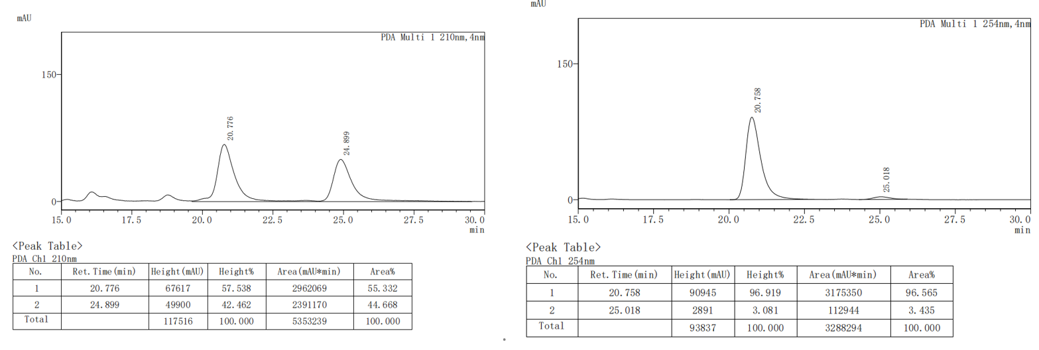(4aR,9R,9aS)-6-methoxy-2-(2-methoxyphenyl)-3,4,4a,9a-tetrahydro-4'H-spiro[fluor-ene-9,1'-naphthalen]-4'-one (3bi)
The crude product was purified by column chromatography (petroleum ether/ethyl acetate = 50：1 to 30:1) to afford the product as white solid (86.0 mg, 66% yield).
¹H NMR (400 MHz, CDCl₃) δ 8.20 (dd, J = 7.9, 1.6 Hz, 1H), 7.47 (td, J = 7.7, 1.6 Hz, 1H), 7.37 (td, J = 7.6, 1.2 Hz, 1H), 7.26 – 7.11 (m, 2H), 7.04 (dd, J = 7.4, 1.8 Hz, 1H), 7.01 – 6.94 (m, 2H), 6.84 (ddd, J = 19.0, 7.8, 1.1 Hz, 2H), 6.72 (dd, J = 8.5, 2.5 Hz, 1H), 6.60 (d, J = 8.4 Hz, 1H), 6.39 (d, J = 10.2 Hz, 1H), 5.53 (dd, J = 3.9, 2.4 Hz, 1H), 3.83 (s, 3H), 3.76 (s, 3H), 3.75 – 3.69 (m, 1H), 3.61 (ddd, J = 13.0, 8.4, 5.0 Hz, 1H), 2.66 (dddd, J = 14.7, 12.0, 4.8, 2.5 Hz, 1H), 2.40 (dt, J = 16.3, 3.6 Hz, 1H), 2.33 – 2.18 (m, 1H), 1.66 (qd, J = 12.6, 4.3 Hz, 1H).
¹³C NMR (100 MHz, CDCl₃) δ 185.2, 160.0, 156.5, 154.8, 149.5, 149.3, 138.4, 137.3, 132.7, 132.6, 132.2, 128.9, 128.6, 128.1, 126.8, 126.1, 126.0, 125.4, 123.8, 120.6, 113.9, 110.8, 109.8, 57.6, 55.4, 55.3, 55.2, 42.9, 29.0, 28.7.
HRMS (EI): m/z: [M]+ Calcd for C₃₀H₂₆O₃, 434.1882, found: 434.1876.
M.P.: 185.7-186.6 ºC.
[α]_{D}²⁰ = 73.7 (c = 0.2, CHCl₃).
HPLC conditions: Daicel Chiralpak ID column (90:10 n-Hexane: 2-Propanol, 0.5 mL/min, 254 nm); tr (minor) = 41.9 min, tr (major) = 45.1 min; 98% ee).
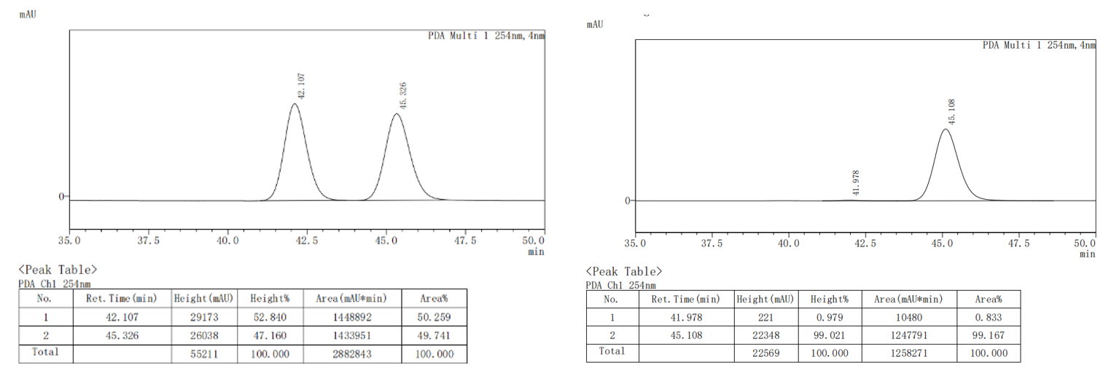
(4aR,9R,9aS)-6-methoxy-2-(3-methoxyphenyl)-3,4,4a,9a-tetrahydro-4'H-spiro[fluorene-9,1'-naphthalen]-4'-one (3bj).
The crude product was purified by column chromatography (petroleum ether/ethyl acetate = 50：1 to 30:1) to afford the product as white solid (86.2 mg, 66% yield)
¹H NMR (400 MHz, CDCl₃) δ 8.23 (dd, J = 7.8, 1.6 Hz, 1H), 7.50 (td, J = 7.5, 1.6 Hz, 1H), 7.41 (td, J = 7.5, 1.2 Hz, 1H), 7.27 – 7.14 (m, 1H), 6.97 (d, J = 2.5 Hz, 1H), 6.94 – 6.87 (m, 2H), 6.83 (t, J = 2.1 Hz, 1H), 6.81 – 6.68 (m, 2H), 6.61 (d, J = 8.4 Hz, 1H), 6.35 (d, J = 10.2 Hz, 1H), 5.77 (dd, J = 4.3, 2.0 Hz, 1H), 3.83 (s, 3H), 3.78 (s, 3H), 3.76 – 3.71 (m, 1H), 3.60 (ddd, J = 13.1, 8.5, 5.0 Hz, 1H), 2.66 – 2.45 (m, 2H), 2.41 – 2.21 (m, 1H), 1.83 – 1.44 (m, 1H).
¹³C NMR (100 MHz, CDCl₃) δ 185.1, 160.1, 159.5, 154.5, 149.4, 148.9, 143.2, 138.3, 137.3, 132.8, 132.2, 129.2, 128.6, 127.0, 126.1, 126.1, 125.6, 122.3, 117.8, 114.0, 112.3, 111.2, 109.8, 57.5, 55.4, 55.4, 55.2, 42.9, 28.9, 27.2.
HRMS (EI): m/z: [M]+ Calcd for C₃₀H₂₆O₃, 434.1882, found: 434.1876.
M.P.: 135.2-137.9 ºC.
[α]_{D}²⁰ = 44.9 (c = 0.2, CHCl₃).
HPLC conditions: Daicel Chiralpak IB column (90:10 n-Hexane: 2-Propanol, 0.5 mL/min, 254 nm); tr (minor) = 24.3 min, tr (major) = 20.3 min; 96% ee).
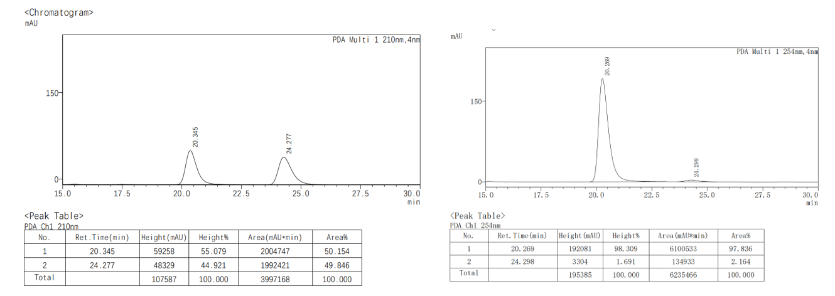
(4aR,9R,9aS)-6-methoxy-2-(4-methoxyphenyl)-3,4,4a,9a-tetrahydro-4'H-spiro[fluorene-9,1'-naphthalen]-4'-one (3bk).
The crude product was purified by column chromatography (petroleum ether/ethyl acetate = 50：1 to 30:1) to afford the product as white solid (102.3 mg, 78% yield)
¹H NMR (400 MHz, CDCl₃) δ 8.24 (d, J = 7.9 Hz, 1H), 7.50 (t, J = 7.6 Hz, 1H), 7.41 (t, J = 7.6 Hz, 1H), 7.24 (d, J = 8.0 Hz, 3H), 6.97 (s, 1H), 6.90 (d, J = 10.2 Hz, 1H), 6.81 (d, J = 7.0 Hz, 2H), 6.72 (d, J = 8.5 Hz, 1H), 6.60 (d, J = 8.4 Hz, 1H), 6.35 (d, J = 8.4 Hz, 1H), 5.71 – 5.66 (m, 1H), 3.83 (d, J = 1.7 Hz, 3H), 3.78 (d, J = 1.8 Hz, 3H), 3.76 – 3.72 (m, 1H), 3.59 (p, J = 6.8, 6.3 Hz, 1H), 2.62 – 2.46 (m, 2H), 2.37 – 2.29 (m, 1H), 1.76 – 1.61 (m, 1H).
¹³C NMR (100 MHz, CDCl₃) δ 185.2, 160.0, 158.9, 154.7, 149.5, 149.0, 137.6, 137.3, 134.2, 132.8, 132.2, 128.6, 126.9, 126.3 (overlapped), 126.1, 126.0, 125.5, 120.3, 114.0, 113.6 (overlapped), 109.8, 57.6, 55.5, 55.4, 55.2, 42.9, 29.0, 27.1.
HRMS (EI): m/z: [M]+ Calcd for C₃₀H₂₆O₃, 434.1882, found: 434.1876.
M.P.: 179.8-181.9 ºC.
[α]_{D}²⁰ = 70.8 (c = 0.2, CHCl₃).
HPLC conditions: Daicel Chiralpak IB column (97:3 n-Hexane: 2-Propanol, 0.4 mL/min, 254 nm); tr (minor) = 31.0 min, tr (major) = 28.9 min; 90% ee).
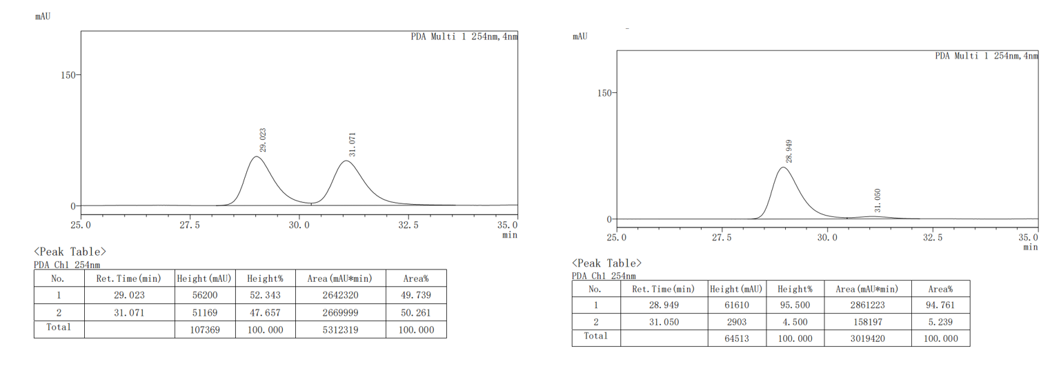
(4aR,9R,9aS)-6-methoxy-2-(4-(methylthio)phenyl)-3,4,4a,9a-tetrahydro-4'H -spiro[fluorene-9,1'-naphthalen]-4'-one (3bl).
The crude product was purified by column chromatography (petroleum ether/ethyl acetate = 50：1 to 30:1) to afford the product as white solid (87.8 mg, 65% yield).
¹H NMR (400 MHz, CDCl₃) δ 8.24 (dd, J = 7.8, 1.5 Hz, 1H), 7.50 (td, J = 7.5, 1.5 Hz, 1H), 7.46 – 7.37 (m, 1H), 7.22 (d, J = 8.5 Hz, 3H), 7.16 (d, J = 8.4 Hz, 2H), 6.97 (d, J = 2.5 Hz, 1H), 6.89 (d, J = 10.2 Hz, 1H), 6.72 (dd, J = 8.4, 2.5 Hz, 1H), 6.60 (d, J = 8.4 Hz, 1H), 6.34 (d, J = 10.3 Hz, 1H), 5.75 (dd, J = 4.3, 2.0 Hz, 1H), 3.83 (s, 3H), 3.74 (dt, J = 7.2, 3.0 Hz, 1H), 3.59 (ddd, J = 13.3, 8.4, 5.1 Hz, 1H), 2.62 – 2.50 (m, 2H), 2.45 (s, 3H), 2.33 (dq, J = 13.1, 4.2 Hz, 1H), 1.68 (tdd, J = 12.9, 10.7, 5.6 Hz, 1H).
¹³C NMR (100 MHz, CDCl₃) δ 185.1, 160.0, 154.6, 149.4, 148.9, 138.4, 137.6, 137.2, 132.8, 132.2, 128.6, 126.9, 126.5 (overlapped), 126.1, 126.0, 125.5 (overlapped), 125.5, 121.5, 114.0, 109.8, 57.5, 55.4 (overlapped), 42.8, 28.9, 26.9, 15.9.
HRMS (EI): m/z: [M]+ Calcd for, C₃₀H₂₆O₂S, 450.1654, found: 450.1648.
M.P.: 82.7-84.0 ºC.
[α]_{D}²⁰ = 75.7 (c = 0.2, CHCl₃).
HPLC conditions: Daicel Chiralpak IB column (90:10 n-Hexane: 2-Propanol, 0.5 mL/min, 254 nm); tr (minor) = 23.2 min, tr (major) = 20.0 min; 84% ee).
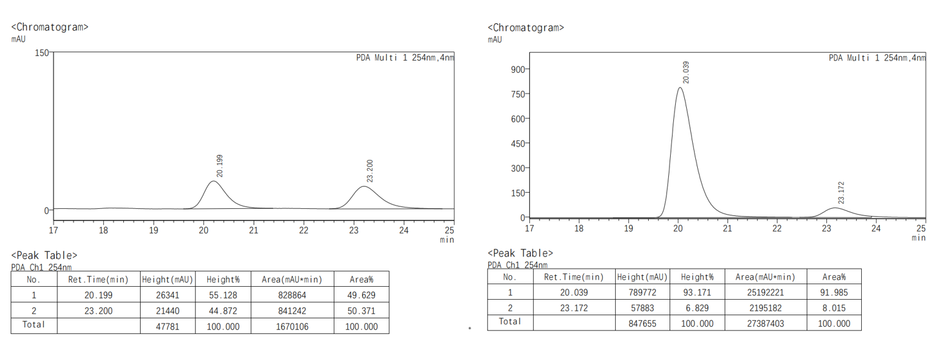
(4aR,9R,9aS)-6-methoxy-2-(4-(trimethylsilyl)phenyl)-3,4,4a,9a-tetrahydro-4'H-spiro[fluorene-9,1'-naphthalen]-4'-one (3bm).
The crude product was purified by column chromatography (petroleum ether/ethyl acetate = 50：1 to 30:1) to afford the product as white solid (98.4 mg, 69% yield).
¹H NMR (400 MHz, CDCl₃) δ 8.24 (d, J = 7.8 Hz, 1H), 7.49 (t, J = 7.6 Hz, 1H), 7.46 – 7.36 (m, 3H), 7.29 (d, J = 7.6 Hz, 2H), 7.22 (d, J = 7.3 Hz, 1H), 6.97 (d, J = 2.6 Hz, 1H), 6.89 (d, J = 10.2 Hz, 1H), 6.71 (d, J = 8.3 Hz, 1H), 6.60 (d, J = 8.4 Hz, 1H), 6.34 (d, J = 10.2 Hz, 1H), 5.79 (s, 1H), 3.82 (s, 2H), 3.74 (t, J = 5.9 Hz, 1H), 3.66 – 3.48 (m, 1H), 2.73 – 2.42 (m, 2H), 2.34 (dt, J = 13.5, 4.4 Hz, 1H), 1.70 (tt, J = 12.4, 6.0 Hz, 1H), 0.24 (s, 9H).
¹³C NMR (100 MHz, CDCl₃) δ 185.1, 160.0, 154.5, 149.4, 148.9, 141.9, 139.2, 138.2, 137.2, 133.3 (overlapped), 132.8, 132.2, 128.6, 126.9, 126.1, 126.0, 125.5, 124.5 (overlapped), 122.2, 114.0, 109.8, 57.5, 55.4, 55.4, 42.8, 28.9, 26.9, -1.2 (overlapped).
HRMS (EI): m/z: [M]+ Calcd for, C₃₂H₃₂O₂Si, 476.2172, found: 476.2166.
M.P.: 94.1-112.7 ºC.
[α]_{D}²⁰ = 62.3 (c = 0.2, CHCl₃).
HPLC conditions: Daicel Chiralpak IB column (95:5 n-Hexane: 2-Propanol, 0.5 mL/min, 254 nm); tr (minor) = 14.6 min, tr (major) = 13.4 min; 94% ee).
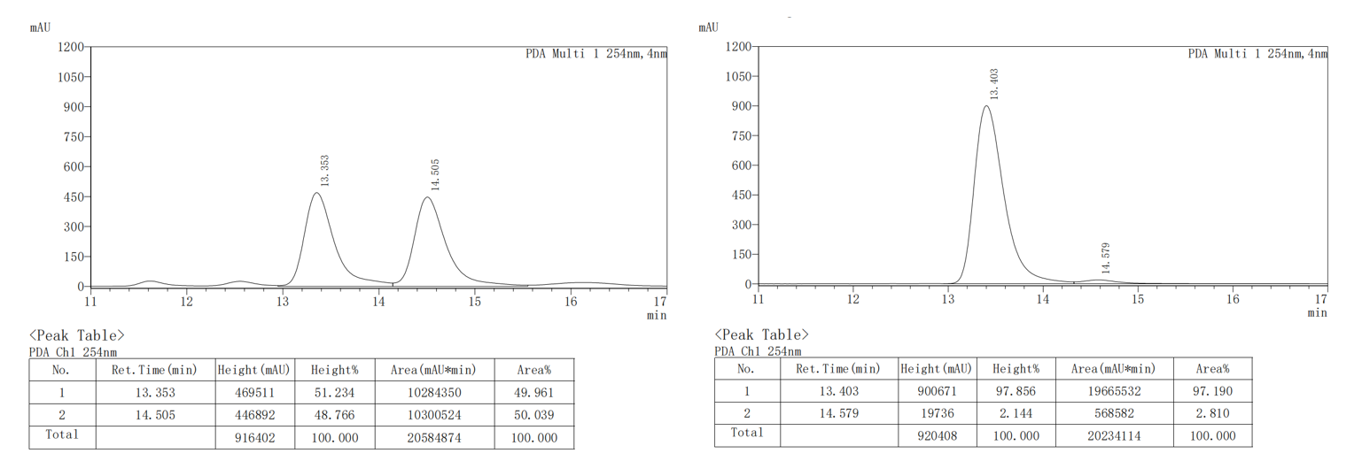
(4aR,9R,9aS)-6-methoxy-2-(4-(trifluoromethoxy)phenyl)-3,4,4a,9a-tetra-hydro-4'H-spiro[fluorene-9,1'-naphthalen]-4'-one (3bn).
The crude product was purified by column chromatography (petroleum ether/ethyl acetate = 50：1 to 30:1) to afford the product as white solid (95.9 mg, 65% yield).
¹H NMR (400 MHz, CDCl₃) δ 8.24 (dd, J = 7.9, 1.5 Hz, 1H), 7.50 (td, J = 7.6, 1.6 Hz, 1H), 7.41 (td, J = 7.5, 1.2 Hz, 1H), 7.34 – 7.27 (m, 2H), 7.27 – 7.18 (m, 1H), 7.11 (d, J = 8.1 Hz, 2H), 6.98 (d, J = 2.5 Hz, 1H), 6.89 (d, J = 10.2 Hz, 1H), 6.73 (dd, J = 8.4, 2.5 Hz, 1H), 6.61 (d, J = 8.4 Hz, 1H), 6.35 (d, J = 10.2 Hz, 1H), 5.78 – 5.73 (m, 1H), 3.83 (s, 3H), 3.74 (ddt, J = 8.3, 3.9, 1.8 Hz, 1H), 3.60 (ddd, J = 13.2, 8.4, 5.1 Hz, 1H), 2.56 (dp, J = 6.8, 2.4 Hz, 2H), 2.35 (dq, J = 13.1, 4.2 Hz, 1H), 1.69 (tdd, J = 13.1, 9.2, 7.2 Hz, 1H).
¹³C NMR (100 MHz, CDCl₃) δ 185.1, 160.1, 154.4, 149.3, 148.7, 148.2, 140.3, 137.2, 137.1, 132.8, 132.2, 128.6, 127.0, 126.5 (overlapped), 126.1, 126.1, 125.6, 122.9, 120.7 (overlapped), 120.4 (q, J = 257.6), 114.1, 109.8, 57.5, 55.4, 55.3, 42.7, 28.8, 27.1.
¹⁹F NMR (376 MHz, CDCl₃) δ -57.86.
HRMS (EI): m/z: [M]+ Calcd for, C₃₀H₂₃F₃O₃, 488.1599, found: 488.1594.
M.P.: 80.4-86.3 ºC.
[α]_{D}²⁰ = 20.1 (c = 0.2, CHCl₃).
HPLC conditions: Daicel Chiralpak IB column (95:5 n-Hexane: 2-Propanol, 0.5 mL/min, 254 nm); tr (minor) = 16.9 min, tr (major) = 15.5 min; 95% ee).
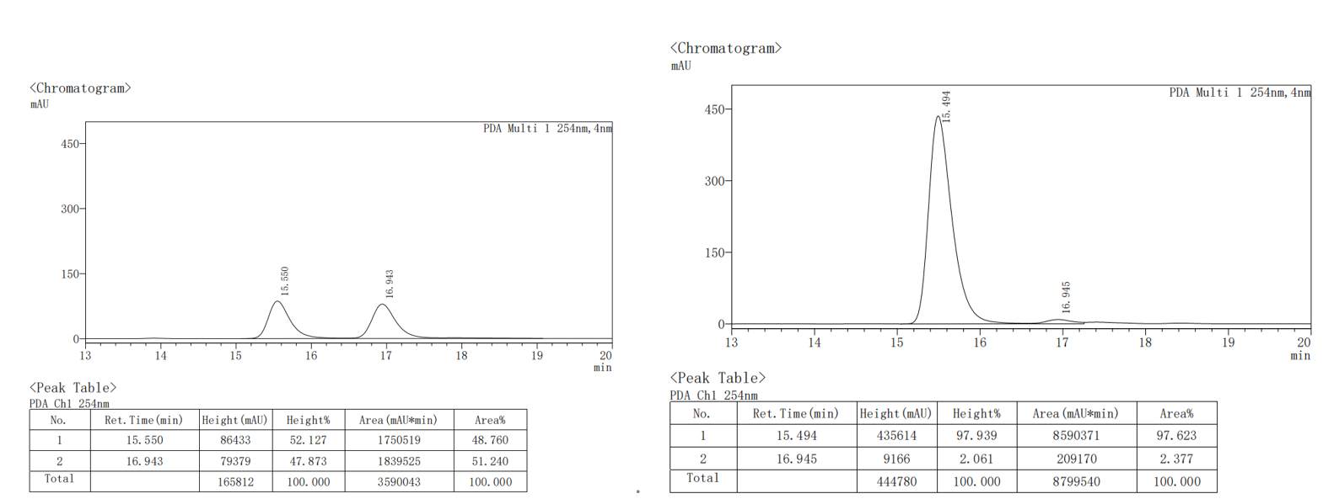
(4aR,9R,9aS)-6-methoxy-2-(4-(trifluoromethyl)phenyl)-3,4,4a,9a-tetrahydro-4'H-spiro[fluorene-9,1'-naphthalen]-4'-one (3bo).
The crude product was purified by column chromatography (petroleum ether/ethyl acetate = 50：1 to 30:1) to afford the product as white solid (85.6 mg, 60% yield).
¹H NMR (400 MHz, CDCl₃) δ 8.24 (d, J = 7.8 Hz, 1H), 7.51 (d, J = 7.9 Hz, 3H), 7.46 – 7.33 (m, 3H), 7.24 (d, J = 8.8 Hz, 1H), 6.99 (t, J = 1.9 Hz, 1H), 6.89 (d, J = 10.2 Hz, 1H), 6.73 (dt, J = 8.4, 1.8 Hz, 1H), 6.61 (d, J = 8.4 Hz, 1H), 6.36 (d, J = 10.2 Hz, 1H), 5.84 (d, J = 4.1 Hz, 1H), 3.83 (s, 3H), 3.78 – 3.72 (m, 1H), 3.61 (ddd, J = 13.3, 8.5, 5.2 Hz, 1H), 2.63 – 2.49 (m, 2H), 2.42 – 2.29 (m, 1H), 1.70 (tt, J = 13.0, 8.0 Hz, 1H).
¹³C NMR (100 MHz, CDCl₃) δ 185.0, 160.1, 154.3, 149.2, 148.6, 145.0, 137.4, 137.0, 132.9, 132.2, 129.0 (q, J = 32.3 Hz), 128.6, 127.0, 126.1, 126.1, 125.6, 125.5, 125.4, 125.2 (q, J = 3.8 Hz), 124.3, 122.8, 114.1, 109.8, 57.4, 55.4, 55.3, 42.6, 28.7, 27.0.
¹⁹F NMR (376 MHz, CDCl₃) δ -62.39.
HRMS (EI): m/z: [M]+ Calcd for, C₃₀H₂₃F₃O₂, 472.1650, found: 472.1645.
M.P.: 102.7-105.8 ºC.
[α]_{D}²⁰ = 40.9 (c = 0.2, CHCl₃).
HPLC conditions: Daicel Chiralpak IB column (90:10 n-Hexane: 2-Propanol, 0.5 mL/min, 254 nm); tr (minor) = 16.7 min, tr (major) = 15.3 min; 95% ee).
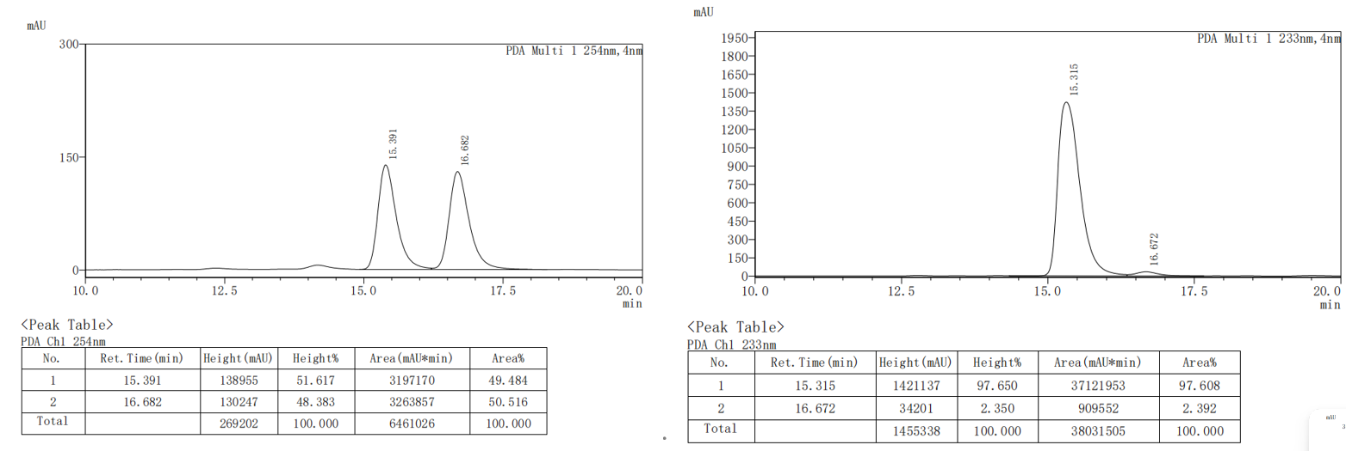
(4aR,9R,9aS)-6-methoxy-2-(naphthalen-2-yl)-3,4,4a,9a-tetrahydro-4'H-spiro [fluorene-9,1'-naphthalen]-4'-one (3bp).
The crude product was purified by column chromatography (petroleum ether/ethyl acetate = 50：1 to 30:1) to afford the product as white solid (104.1mg, 76% yield).
¹H NMR (400 MHz, CDCl₃) δ 8.26 (d, J = 7.8 Hz, 1H), 7.81 – 7.69 (m, 4H), 7.60 – 7.36 (m, 5H), 7.25 (d, J = 7.2 Hz, 2H), 7.01 – 6.91 (m, 2H), 6.73 (d, J = 5.9 Hz, 1H), 6.61 (d, J = 8.4 Hz, 1H), 6.38 (d, J = 8.8 Hz, 0H), 5.93 (s, 1H), 3.84 (s, 2H), 3.82 – 3.77 (m, 1H), 3.64 (td, J = 10.7, 8.3, 5.5 Hz, 1H), 2.71 (dtd, J = 27.0, 17.3, 15.0, 9.8 Hz, 2H), 2.39 (dt, J = 13.7, 4.2 Hz, 1H), 1.75 (qd, J = 12.5, 4.8 Hz, 1H).
¹³C NMR (100 MHz, CDCl₃) 185.2, 160.1, 154.6, 149.5, 148.9, 138.7, 138.2, 137.3, 133.3, 132.8, 132.6, 132.2, 128.6, 128.0, 127.8, 127.5, 127.0, 126.2, 126.1, 126.1, 125.7, 125.6, 123.7, 123.6, 122.7, 114.1, 109.8, 57.6, 55.5, 55.5, 42.9, 29.0, 27.1.
HRMS (EI): m/z: [M]+ Calcd for, C₃₃H₂₆O₂, 454.1933, found: 454.1927.
M.P.: 100.4-102.5 ºC.
[α]_{D}²⁰ = 100.5 (c = 0.2, CHCl₃).
HPLC conditions: Daicel Chiralpak IB column (95:5 n-Hexane: 2-Propanol, 0.5 mL/min, 254 nm); tr (minor) = 25.1 min, tr (major) = 19.5 min; 96% ee).
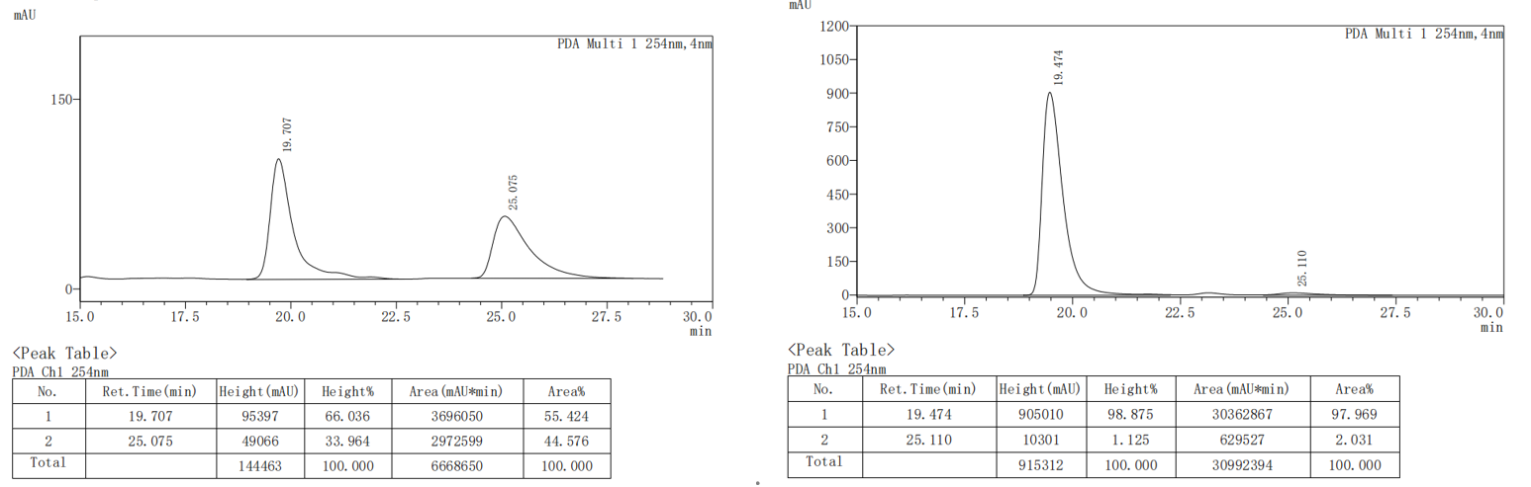

(4aR,9R,9aS)-2-(benzo[d][1,3]dioxol-5-yl)-6-methoxy-3,4,4a,9a-tetrahydro-4'H-spiro[fluorene -9,1'-naphthalen]-4'-one (3bq).
The crude product was purified by column chromatography (petroleum ether/ethyl acetate = 50：1 to 30:1) to afford the product as white solid (101.9 mg, 75% yield).
¹H NMR (400 MHz, CDCl₃) δ 7.49 (td, 1H), 7.41 (t, J = 7.5 Hz, 1H), 7.22 (d, J = 8.0 Hz, 1H), 6.96 (d, J = 2.5 Hz, 1H), 6.89 (d, J = 10.3 Hz, 1H), 6.78 (dd, J = 6.3, 2.0 Hz, 2H), 6.75 – 6.68 (m, 2H), 6.60 (d, J = 8.4 Hz, 1H), 6.35 (d, J = 10.2 Hz, 1H), 5.91 (s, 2H), 5.66 (dd, J = 4.6, 1.9 Hz, 1H), 3.83 (s, 3H), 3.73 (dt, J = 6.8, 2.9 Hz, 1H), 3.58 (ddd, J = 13.2, 8.5, 5.0 Hz, 1H), 2.53 (t, J = 4.3 Hz, 2H), 2.32 (dq, J = 13.2, 4.3 Hz, 1H), 1.69 (tdd, J = 12.9, 8.8, 5.0 Hz, 1H).
¹³C NMR (100 MHz, CDCl₃) δ 185.2, 160.0, 154.6, 149.5, 148.9, 147.7, 146.7, 137.9, 137.3, 136.1, 132.8, 132.2, 128.6, 127.0, 126.2, 126.1, 125.5, 121.0, 118.7, 114.0, 109.8, 108.0, 105.8, 101.0, 57.5, 55.4 (overlapped), 42.8, 29.0, 27.4.
HRMS (EI): m/z: [M]+ Calcd for, C₃₀H₂₄O₄, 448.1675, found: 448.1669.
M.P.: 76.4-78.6 ºC.
[α]_{D}²⁰ = 30.9 (c = 0.2, CHCl₃).
HPLC conditions: Daicel Chiralpak IB column (95:5 n-Hexane: 2-Propanol, 0.5 mL/min, 254 nm); tr (minor) = 32.6 min, tr (major) = 29.8 min; 96% ee).
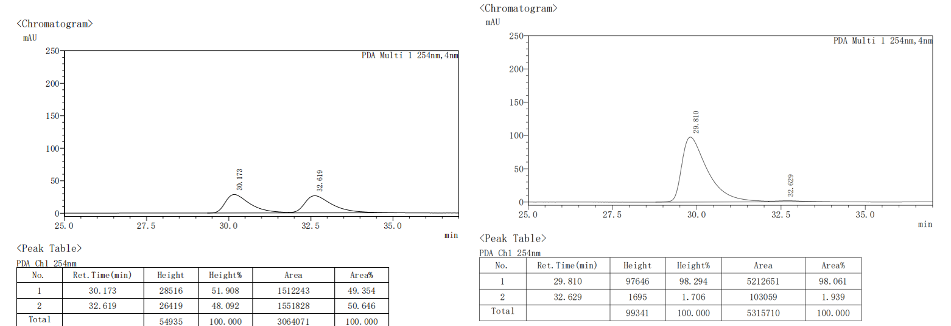
(4aR,9R,9aS)-2-(benzofuran-6-yl)-6-methoxy-3,4,4a,9a-tetrahydro-4'H-spiro [fluorene-9,1'-naphthalen]-4'-one (3br).
The crude product was purified by column chromatography (petroleum ether/ethyl acetate = 50：1 to 30:1) to afford the product as white solid (88.6 mg, 66% yield).
¹H NMR (400 MHz, CDCl₃) δ 8.25 (d, J = 7.9 Hz, 1H), 7.56 (s, 1H), 7.49 (d, J = 8.9 Hz, 2H), 7.40 (dd, J = 14.4, 7.9 Hz, 2H), 7.24 (d, J = 8.2 Hz, 2H), 6.96 (dd, J = 18.8, 6.5 Hz, 2H), 6.72 (d, J = 7.5 Hz, 2H), 6.61 (d, J = 6.7 Hz, 1H), 6.38 (d, J = 8.5 Hz, 1H), 3.83 (s, 1H), 3.80 – 3.71 (m, 3H), 3.66 – 3.48 (m, 1H), 2.74 – 2.57 (m, 2H), 2.50 – 2.28 (m, 1H), 1.73 (dt, J = 20.8, 6.5 Hz, 1H).
¹³C NMR (100 MHz, CDCl₃) δ 185.2, 160.0, 154.7, 154.3, 149.5, 149.0, 145.3, 138.5, 137.3, 137.0, 132.8, 132.2, 128.6, 127.4, 126.9, 126.1, 126.0, 125.5, 122.0, 121.5, 117.6, 114.0, 110.9, 109.8, 106.7, 57.6, 55.5, 55.4, 42.8, 29.0, 27.8.
HRMS (EI): m/z: [M]+ Calcd for, C₃₁H₂₄O₃, 444.1725, found: 444.1724.
M.P.: 141.8-156.3 ºC.
[α]_{D}²⁰ = 70.0 (c = 0.2, CHCl₃).
HPLC conditions: Daicel Chiralpak IB column (90:10 n-Hexane: 2-Propanol, 0.5 mL/min, 254 nm); tr (minor) = 19.5 min, tr (major) = 17.9 min; 91% ee).
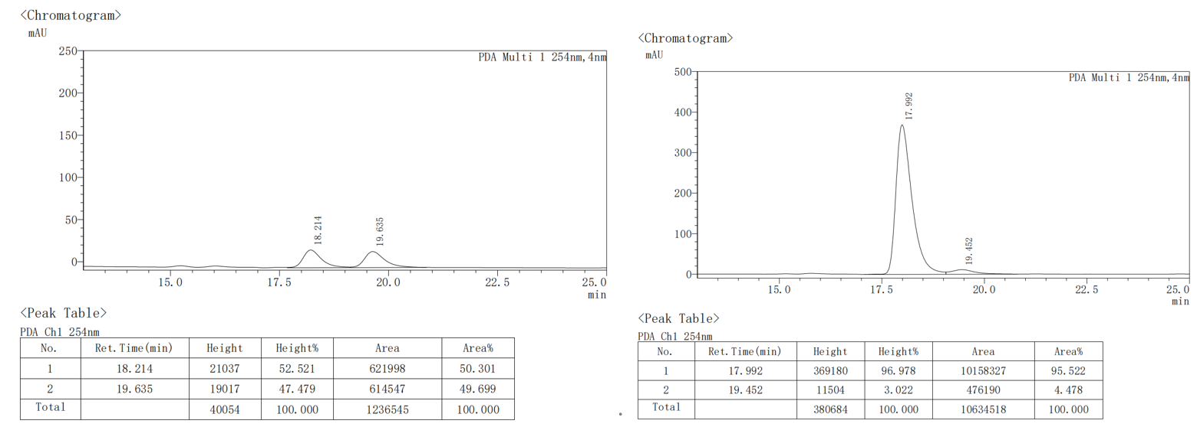
(4aR,9R,9aS)-2-(benzo[b]thiophen-6-yl)-6-methoxy-3,4,4a,9a-tetrahydro-4'H-spiro[fluorene-9,1'-naphthalen]-4'-one (3bs).
The crude product was purified by column chromatography (petroleum ether/ethyl acetate = 50：1 to 30:1) to afford the product as white solid (95.8 mg, 69% yield).
¹H NMR (400 MHz, CDCl₃) δ 8.25 (d, J = 7.8 Hz, 1H), 7.82 – 7.69 (m, 2H), 7.50 (t, J = 7.6 Hz, 1H), 7.44 – 7.36 (m, 2H), 7.33 – 7.19 (m, 3H), 6.98 (s, 1H), 6.93 (d, J = 12.0 Hz, 1H), 6.71 (d, J = 2.2 Hz, 1H), 6.60 (d, J = 6.7 Hz, 1H), 6.38 (d, J = 8.5 Hz, 1H), 5.82 (s, 1H), 3.83 (s, 3H), 3.80 – 3.75 (m, 1H), 3.62 (dt, J = 13.3, 6.5 Hz, 1H), 2.64 (dt, J = 10.0, 3.1 Hz, 2H), 2.37 (dt, J = 13.7, 4.3 Hz, 1H), 1.73 (qd, J = 12.7, 12.3, 5.8 Hz, 1H).
¹³C NMR (100 MHz, CDCl₃) δ 185.2, 160.0, 154.7, 149.5, 148.9, 139.7, 138.5, 138.3, 138.1, 137.3, 132.8, 132.2, 128.6, 127.0, 126.7, 126.1, 126.1, 125.5, 124.0, 122.1, 122.0, 122.0, 119.9, 114.0, 109.8, 57.5, 55.5, 55.4, 42.9, 29.0, 27.5.
HRMS (EI): m/z: [M]+ Calcd for, C₃₁H₂₄O₂S, 460.1497, found: 460.1492.
M.P.: 102.2-105.7ºC.
[α]_{D}²⁰ = 79.0 (c = 0.2, CHCl₃).
HPLC conditions: Daicel Chiralpak IB column (90:10 n-Hexane: 2-Propanol, 0.5 mL/min, 254 nm); tr (minor) = 23.8 min, tr (major) = 20.8 min; 94% ee).
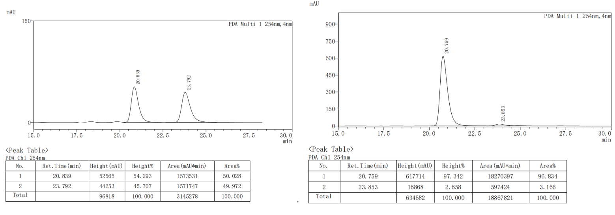
(4aR,9R,9aS)-6-methoxy-2-(thiophen-3-yl)-3,4,4a,9a-tetrahydro-4'H-spiro[fluor-ene-9,1'-naphthalen]-4'-one (3bt).
The crude product was purified by column chromatography (petroleum ether/ethyl acetate = 50：1 to 30:1) to afford the product as white solid (80.1 mg, 65% yield).
¹H NMR (400 MHz, CDCl₃) δ 8.24 (dd, J = 7.8, 1.5 Hz, 1H), 7.50 (td, J = 7.5, 1.5 Hz, 1H), 7.42 (td, 1H), 7.24 – 7.17 (m, 2H), 7.14 – 7.08 (m, 2H), 6.96 (d, J = 2.5 Hz, 1H), 6.89 (d, J = 10.2 Hz, 1H), 6.71 (dd, J = 8.4, 2.5 Hz, 1H), 6.59 (d, J = 8.4 Hz, 1H), 6.32 (d, J = 10.1 Hz, 1H), 5.81 (dd, J = 4.3, 2.2 Hz, 1H), 3.83 (s, 3H), 3.74 (dt, J = 7.6, 3.4 Hz, 1H), 3.59 (ddd, J = 13.2, 8.4, 5.1 Hz, 1H), 2.64 (dt, J = 16.6, 3.9 Hz, 1H), 2.49 (dddd, J = 16.2, 13.9, 4.9, 2.5 Hz, 1H), 2.32 (dp, J = 12.7, 4.3, 3.5 Hz, 1H), 1.77 – 1.65 (m, 2H).
¹³C NMR (100 MHz, CDCl₃) δ 185.1, 160.0, 154.5, 149.4, 148.9, 142.8, 137.2, 133.3, 132.8, 132.2, 128.6, 126.9, 126.1, 126.0, 125.5 (overlapped), 124.8, 120.7, 119.3, 114.0, 109.8, 57.4, 55.4, 55.3, 42.9, 28.7, 26.8.
HRMS (EI): m/z: [M]+ Calcd for, C₂₇H₂₂O₂S, 410.1341, found: 410.1338.
M.P.: 180.5-181.4 ºC.
[α]_{D}²⁰ = 71.7 (c = 0.2, CHCl₃).
HPLC conditions: Daicel Chiralpak IB column (95:5 n-Hexane: 2-Propanol, 0.5 mL/min, 254 nm); tr (minor) = 25.4 min, tr (major) = 21.4 min; 95% ee).
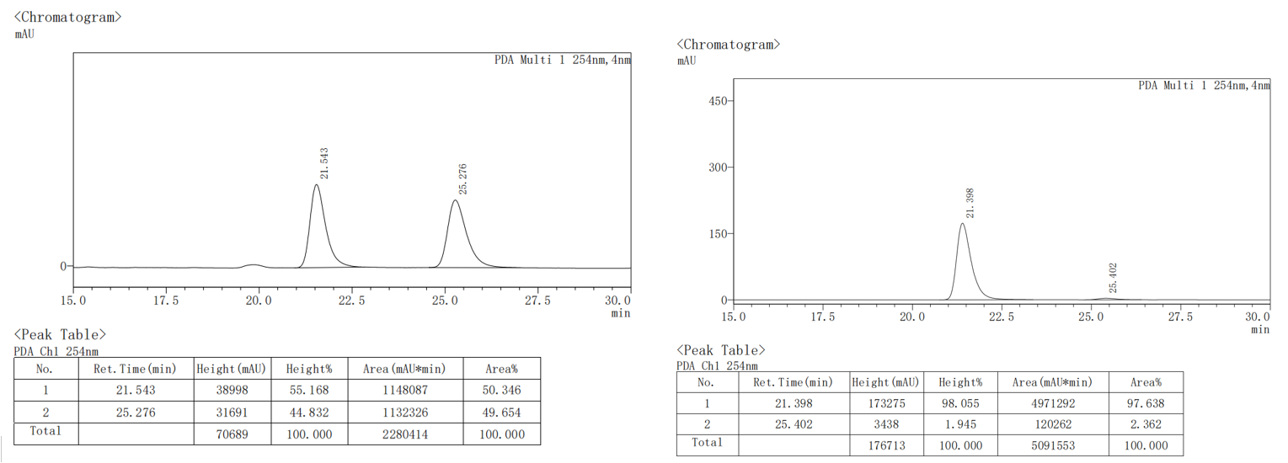
(4aR,9R,9aS)-2-benzyl-6-methoxy-3,4,4a,9a-tetrahydro-4'H-spiro[fluorene-9,1'-naphthalen]-4'-one (3bu).
The crude product was purified by column chromatography (petroleum ether/ethyl acetate = 50：1 to 30:1) to afford the product as white solid (85.3 mg, 68% yield).
¹H NMR (400 MHz, CDCl₃) δ 8.22 (dd, J = 7.8, 1.5 Hz, 1H), 7.47 (td, J = 7.5, 1.6 Hz, 1H), 7.39 (td, J = 7.5, 1.2 Hz, 1H), 7.23 (d, J = 7.3 Hz, 2H), 7.18 (t, J = 6.9 Hz, 2H), 7.13 – 7.08 (m, 2H), 6.93 – 6.84 (m, 2H), 6.69 (dd, J = 8.4, 2.5 Hz, 1H), 6.57 (d, J = 8.4 Hz, 1H), 6.37 (d, J = 10.2 Hz, 1H), 5.26 (d, J = 3.9 Hz, 1H), 3.80 (s, 3H), 3.67 – 3.53 (m, 1H), 3.45 (ddd, J = 13.2, 8.4, 5.0 Hz, 1H), 3.35 – 3.14 (m, 2H), 2.17 – 2.07 (m, 1H), 2.06 – 1.86 (m, 2H), 1.48 (tdd, J = 12.4, 10.1, 6.0 Hz, 1H).
¹³C NMR (100 MHz, CDCl₃) δ 185.2, 159.9, 154.9, 149.5, 149.2, 139.5, 138.9, 137.3, 132.7, 132.2, 128.7 (overlapped), 128.6, 128.2 (overlapped), 126.8, 126.1 (overlapped), 126.0, 125.4, 120.7, 113.9, 109.7, 57.4, 55.4, 55.2, 44.4, 42.8, 28.8, 27.2.
HRMS (EI): m/z: [M]+ Calcd for, C₃₀H₂₆O₂, 418.1933, found: 418.1932.
M.P.: 98.5-99.3 ºC.
[α]_{D}²⁰ = 80.9 (c = 0.2, CHCl₃).
HPLC conditions: Daicel Chiralpak IB column (95:5 n-Hexane: 2-Propanol, 0.5 mL/min, 254 nm); tr (minor) = 18.0 min, tr (major) = 17.2 min; 97% ee).
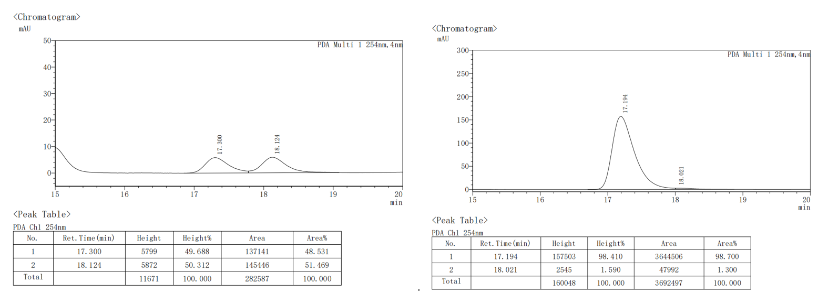
(4aR,9R,9aS)-2-butyl-6-methoxy-3,4,4a,9a-tetrahydro-4'H-spiro[fluorene-9,1'-naphthalen]-4'-one (3bv).
The crude product was purified by column chromatography (petroleum ether/ethyl acetate = 50：1 to 30:1) to afford the product as yellow oil (69.2 mg, 60% yield).
¹H NMR (400 MHz, CDCl₃) δ 8.21 (dd, J = 7.8, 1.6 Hz, 1H), 7.47 (td, 1H), 7.39 (td, 1H), 7.18 (d, J = 6.7 Hz, 1H), 6.92 (d, J = 2.5 Hz, 1H), 6.84 (d, J = 10.2 Hz, 1H), 6.69 (dd, J = 8.4, 2.5 Hz, 1H), 6.57 (d, J = 8.4 Hz, 1H), 6.31 (d, J = 10.2 Hz, 1H), 5.10 (s, 1H), 3.82 (s, 3H), 3.56 – 3.52 (m, 1H), 3.46 (ddd, J = 13.3, 8.4, 4.8 Hz, 1H), 2.26 – 2.13 (m, 1H), 2.13 – 2.01 (m, 2H), 1.95 (t, J = 7.4 Hz, 2H), 1.60 – 1.46 (m, 1H), 1.36 – 1.27 (m, 1H), 1.23 (dd, J = 14.9, 7.8 Hz, 2H), 0.85 (t, J = 7.2 Hz, 3H).
¹³C NMR (100 MHz, CDCl₃) δ 185.4, 160.0, 155.0, 149.8, 149.4, 140.0, 137.6, 132.7, 132.3, 128.7, 126.8, 126.2, 126.0, 125.3, 118.5, 113.8, 109.8, 57.4, 55.5, 55.2, 43.2, 37.6, 29.8, 29.0, 27.8, 22.3, 13.9.
HRMS (EI): m/z: [M]+ Calcd for, C₂₇H₂₈O₂, 384.2089, found: 384.2058.
[α]_{D}²⁰ = -15.9 (c = 0.2, CHCl₃).
HPLC conditions: Daicel Chiralpak IB column (99:1 n-Hexane: 2-Propanol, 0.5 mL/min, 254 nm); tr (minor) = 18.3 min, tr (major) = 19.0 min; 91% ee).
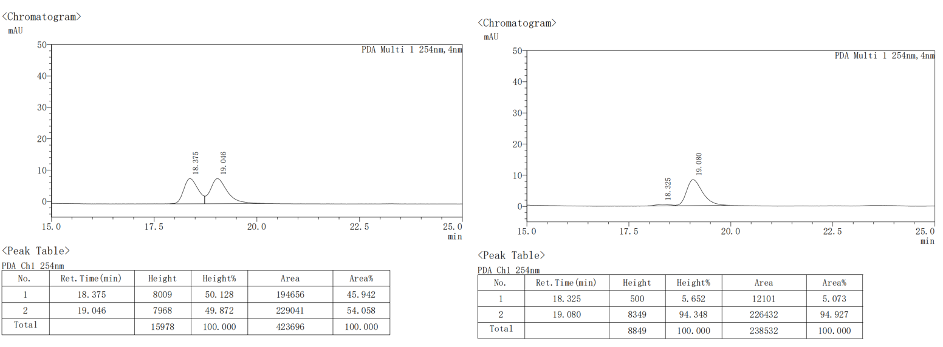
(4aR,9R,9aS)-2-cyclohexyl-6-methoxy-3,4,4a,9a-tetrahydro-4'H-spiro[fluorene-9,1'-naphthalen]-4'-one (3bw).
The crude product was purified by column chromatography (petroleum ether/ethyl acetate = 50：1 to 30:1) to afford the product as white solid (76.3 mg, 62% yield).
¹H NMR (400 MHz, CDCl₃) δ 8.21 (dd, J = 7.8, 1.6 Hz, 1H), 7.47 (td, J = 7.5, 1.6 Hz, 1H), 7.38 (td, J = 7.5, 1.3 Hz, 1H), 7.19 (dd, J = 8.0, 1.3 Hz, 1H), 6.92 (d, J = 2.5 Hz, 1H), 6.81 (d, J = 10.2 Hz, 1H), 6.69 (dd, J = 8.4, 2.5 Hz, 1H), 6.57 (d, J = 8.4 Hz, 1H), 6.30 (d, J = 10.2 Hz, 1H), 5.20 – 4.95 (m, 1H), 3.82 (s, 3H), 3.65 – 3.51 (m, 1H), 3.47 (ddd, J = 13.4, 8.5, 4.8 Hz, 1H), 2.29 – 2.14 (m, 1H), 2.14 – 2.04 (m, 2H), 1.85 – 1.73 (m, 1H), 1.70 (dt, J = 9.2, 3.0 Hz, 2H), 1.62 (d, J = 8.8 Hz, 3H), 1.49 (tdd, J = 14.1, 10.8, 6.9 Hz, 1H), 1.28 – 1.16 (m, 2H), 1.08 (tdd, J = 12.0, 7.0, 3.2 Hz, 2H), 0.96 – 0.84 (m, 1H).
¹³C NMR (100 MHz, CDCl₃) δ 185.4, 160.0, 155.1, 149.8, 149.5, 144.9, 137.5, 132.7, 132.3, 128.7, 126.8, 126.1, 126.0, 125.2, 116.6, 113.8, 109.8, 57.5, 55.4, 55.0, 45.9, 43.5, 32.1, 31.3, 29.2, 26.7, 26.6, 26.5, 26.3.
HRMS (EI): m/z: [M]+ Calcd for, C₂₉H₃₀O₂, 410.2246, found: 410.2243.
M.P.: 59.4-60.9 ºC.
[α]_{D}²⁰ = -18.9 (c = 0.2, CHCl₃).
HPLC conditions: Daicel Chiralpak IB and IA column (97:3 n-Hexane: 2-Propanol, 0.5 mL/min, 254 nm); tr (minor) = 29.9 min, tr (major) = 30.8 min; 97% ee).
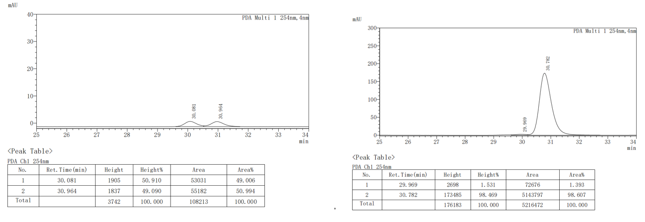
(4aR,9R,9aS)-6-methoxy-3,4,4a,9a-tetrahydro-4'H-spiro[fluorene-9,1'-naphthalen]-4'-one (3bx).
The crude product was purified by column chromatography (petroleum ether/ethyl acetate = 50：1 to 30:1) to afford the product as white solid (75.7 mg, 66% yield).
¹H NMR (400 MHz, CDCl₃) δ 8.20 (d, J = 7.8 Hz, 1H), 7.47 (t, J = 7.5 Hz, 1H), 7.38 (t, J = 7.6 Hz, 1H), 7.19 (d, J = 7.9 Hz, 1H), 6.93 (s, 1H), 6.87 (d, J = 10.2 Hz, 1H), 6.70 (d, J = 5.9 Hz, 1H), 6.58 (d, J = 8.4 Hz, 1H), 6.33 (d, J = 8.5 Hz, 1H), 5.85 (ddd, J = 10.4, 5.1, 2.5 Hz, 1H), 5.41 (d, J = 10.2 Hz, 1H), 3.82 (s, 3H), 3.53 (m, J = 4.6 Hz, 2H), 2.16 (m, J = 10.5, 5.3 Hz, 3H), 1.53 (dt, J = 12.1, 6.9 Hz, 1H).
¹³C NMR (100 MHz, CDCl₃) δ 185.1, 159.9, 154.6, 149.4, 149.3, 137.3, 132.7, 132.2, 128.6, 128.3, 126.8, 126.1, 126.0, 125.4, 124.9, 113.8, 109.7, 57.0, 55.4, 54.3, 43.2, 28.3, 24.2.
HRMS (EI): m/z: [M]+ Calcd for, C₂₃H₂₀O, 328.1463, found: 328.1462.
M.P.: 100.5-101.7 ºC.
[α]_{D}²⁰ = 74.1 (c = 0.2, CHCl₃).
HPLC conditions: Daicel Chiralpak IB column (99:1 n-Hexane: 2-Propanol, 0.3 mL/min, 254 nm); tr (minor) = 42.2 min, tr (major) = 39.6 min; 92% ee).
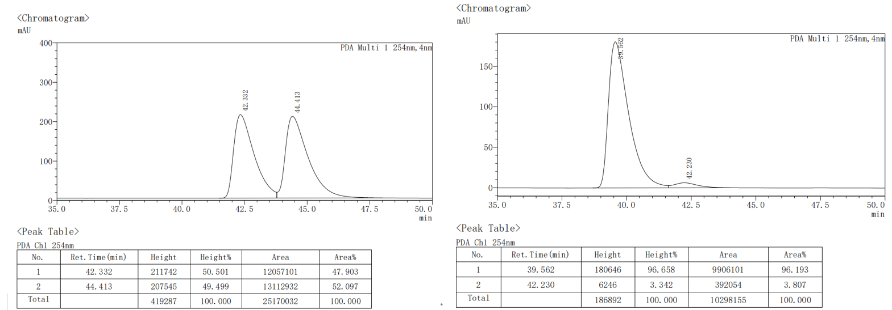
(1R,2S)-2-((E)-styryl)-2,3-dihydro-4'H-spiro[indene-1,1'-naphthalen]-4'-one (3by).
The crude product was purified by column chromatography (petroleum ether/ethyl acetate = 50：1 to 30:1) to afford the product as white solid (54.0 mg, 52% yield).
¹H NMR (400 MHz, CDCl₃) δ 8.23 (dd, J = 7.9, 1.5 Hz, 1H), 7.55 (td, J = 7.6, 1.5 Hz, 1H), 7.48 – 7.36 (m, 2H), 7.35 – 7.10 (m, 9H), 6.92 (d, J = 10.2 Hz, 1H), 6.66 (d, J = 7.6 Hz, 1H), 6.42 (d, J = 10.2 Hz, 1H), 6.20 (dd, J = 15.8, 1.1 Hz, 1H), 6.05 (dd, J = 15.8, 7.2 Hz, 1H), 3.81 (dt, J = 11.3, 6.9 Hz, 1H), 3.58 – 3.15 (m, 2H).
¹³C NMR (100 MHz, CDCl₃) δ 184.9, 149.6, 147.0, 146.3, 142.7, 136.6, 133.1, 132.7, 131.9, 128.5, 128.2, 128.0, 127.5, 127.5, 127.3, 127.2, 127.0, 126.3, 126.2, 125.1, 124.9, 77.0, 59.7, 58.5, 36.6.
HRMS (EI): m/z: [M]+ Calcd for, C₂₆H₂₀O, 348.1514, found: 348.1521.
[α]_{D}²⁰ = 3.8 (c = 0.2, CHCl₃).
HPLC conditions: Daicel Chiralpak IB column (85:15 n-Hexane: 2-Propanol, 0.5 mL/min, 254 nm); tr (minor) = 15.4 min, tr (major) = 17.2 min; 33% ee).
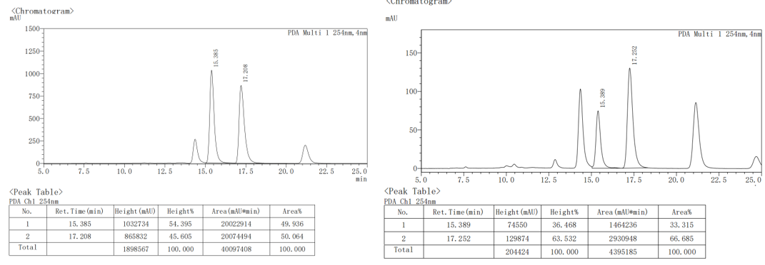

(4aR,9R,9aS)-2-(4-(((2R)-2-isopropyl-5-methylcyclohexyl)oxy) phenyl)-3,4, 4a,9a-tetrahydro-4'H-spiro [fluorene-9,1'-naphthalen]-4'-one (4a).
The crude product was purified by column chromatography (petroleum ether/ethyl acetate = 50：1 to 30:1) to afford the product as white solid (98.1 mg, 62% yield).
¹H NMR (400 MHz, CDCl₃) δ 8.25 (d, J = 7.8 Hz, 1H), 7.43 (ddd, J = 19.0, 13.5, 7.5 Hz, 3H), 7.30 (t, J = 7.5 Hz, 1H), 7.21 – 7.11 (m, 3H), 6.90 (d, J = 10.2 Hz, 1H), 6.81 (d, J = 8.2 Hz, 2H), 6.69 (d, J = 7.6 Hz, 1H), 5.74 – 5.62 (m, 1H), 4.00 (td, J = 10.6, 4.1 Hz, 1H), 3.72 (dt, J = 7.4, 3.1 Hz, 1H), 3.61 (td, J = 10.7, 8.5, 5.2 Hz, 1H), 2.65 – 2.42 (m, 2H), 2.32 (dq, J = 13.2, 4.3 Hz, 1H), 2.24 – 2.07 (m, 2H), 1.74 – 1.66 (m, 3H), 1.54 – 1.44 (m, 2H), 1.15 – 1.05 (m, 1H), 1.05 – 0.94 (m, 2H), 0.90 (t, J = 6.6 Hz, 7H), 0.76 (d, J = 6.9 Hz, 3H).
¹³C NMR (100 MHz, CDCl₃) δ 185.1, 157.6, 154.2, 149.2, 147.5, 145.5, 137.7, 133.8, 132.7, 132.2, 128.6, 128.2, 127.8, 126.9, 126.2 (overlapped), 126.0, 125.6, 125.4, 124.7, 120.0, 115.5 (overlapped), 58.3, 55.0, 47.9, 42.7, 40.2, 34.4, 31.3, 29.0, 27.1, 26.0, 23.6, 22.1, 20.7, 16.5.
HRMS (EI): m/z: [M]+ Calcd for, C₃₈H₄₀O₂, 528.3028, found: 528.3025
M.P.: 91.5-93.2 ºC.
[α]_{D}²⁰ = 14.8 (c = 0.2, CHCl₃).

(4aR,9R,9aS)-2-(4-(((1R,2R,4R)-1,7,7-trimethylbicyclo[2.2.1] eptan-2-yl)oxy)phenyl)-3,4,4a,9a-tetrahydro-4'H-spiro[fluorene-9,1'-naphthalen]-4'-one (4b)
The crude product was purified by column chromatography (petroleum ether/ethyl acetate = 50：1 to 30:1) to afford the product as white solid (72.6mg, 46% yield).
¹H NMR (400 MHz, CDCl₃) δ 8.25 (dd, J = 7.8, 1.6 Hz, 1H), 7.53 – 7.37 (m, 3H), 7.29 (td, J = 7.5, 1.2 Hz, 1H), 7.23 – 7.16 (m, 3H), 7.16 – 7.09 (m, 1H), 6.90 (d, J = 10.2 Hz, 1H), 6.78 – 6.72 (m, 2H), 6.68 (d, J = 7.6 Hz, 1H), 6.35 (d, J = 10.2 Hz, 1H), 5.67 (dd, J = 4.3, 2.0 Hz, 1H), 4.01 (dd, J = 6.4, 4.2 Hz, 1H), 3.72 (dt, J = 7.1, 3.1 Hz, 1H), 3.61 (ddd, J = 13.2, 8.5, 5.0 Hz, 1H), 2.61 – 2.44 (m, 2H), 2.36 – 2.24 (m, 1H), 1.85 – 1.48 (m, 6H), 1.10 (s, 2H), 1.04 (s, 3H), 0.96 (s, 3H), 0.85 (s, 3H).
¹³C NMR (100 MHz, CDCl₃) δ 185.1, 157.2, 157.2, 154.2, 149.3, 147.5, 145.5, 137.7, 137.7, 133.4, 133.4, 132.7, 132.2, 128.6, 128.1, 127.8, 126.9, 126.1 (overlapped), 126.0, 125.6, 125.4, 124.7, 119.8, 119.8, 115.1 (overlapped), 84.4, 58.3, 55.0, 49.1, 46.9, 45.2, 42.7, 39.4, 39.3, 34.1, 29.0, 27.3, 27.1, 27.1, 20.3, 20.1, 11.7.
HRMS (EI): m/z: [M]+ Calcd for, C₃₈H₃₈O₂, 526.2872, found: 526.2869.
M.P.: 98.7-100.5 ºC.
[α]_{D}²⁰= 65.5 (c = 0.2, CHCl₃).

(4aR,9R,9aS)-6-methoxy-2-(4-(((S)-4-(prop-1-en-2-yl) cyclohex-1-en-1-yl)methoxy)phenyl)-3,4,4a,9a-tetrahydro-4'H-spiro[fluorene-9,1'-naphthalen]-4'-one (4c).
The crude product was purified by column chromatography (petroleum ether/ethyl acetate = 50：1 to 30:1) to afford the product as white solid (66.9 mg, 54% yield).
¹H NMR (400 MHz, CDCl₃) δ 8.24 (d, J = 7.8, 1.6 Hz, 1H), 7.50 (t, J = 7.5, 1.6 Hz, 1H), 7.41 (t, 1H), 7.22 (d, J = 8.8 Hz, 3H), 6.97 (d, J = 2.5 Hz, 1H), 6.90 (d, J = 10.2 Hz, 1H), 6.82 (d, J = 8.7 Hz, 2H), 6.72 (dd, J = 8.4, 2.5 Hz, 1H), 6.60 (d, J = 8.4 Hz, 1H), 6.35 (d, J = 10.1 Hz, 1H), 5.81 (dd, J = 4.7, 2.5 Hz, 1H), 5.68 (dd, J = 4.4, 2.0 Hz, 1H), 4.72 (d, J = 4.3, 2.8 Hz, 2H), 4.36 (s, 2H), 3.83 (s, 3H), 3.77 – 3.70 (m, 1H), 3.62 – 3.52 (m, 1H), 2.64 – 2.45 (m, 2H), 2.37 – 2.26 (m, 1H), 2.17 (d, J = 11.9, 10.6, 4.4 Hz, 3H), 2.03 – 1.93 (m, 1H), 1.86 (ddq, J = 12.5, 5.0, 2.3 Hz, 1H), 1.73 (s, 3H), 1.71 – 1.60 (m, 2H), 1.51 (dtd, J = 12.5, 10.5, 6.4 Hz, 1H).
¹³C NMR (100 MHz, CDCl₃) δ 185.3, 160.1, 158.4, 154.8, 149.7, 149.6, 149.1, 137.7, 137.4, 134.1, 133.5, 132.8, 132.3, 128.7, 127.0, 126.2 (overlapped), 126.1, 125.5, 125.1, 120.3, 114.6 (overlapped), 114.0, 109.9, 108.8, 72.3, 57.7, 55.6, 55.5, 42.9, 41.0, 30.5, 29.1, 27.4, 27.2, 26.3, 20.8.
HRMS (EI): m/z: [M]+ Calcd for, C₃₉H₃₈O₃, 554.2821, found: 554.2817.
M.P.: 118.0-119.9 ºC.
[α]_{D}²⁰ = 42.4 (c = 0.2, CHCl₃).

- Gram-scale synthesis.
To a sealed tube was added Pd₂(dba)₃ (229 mg, 5 mol%), (Sc,Rs)-PC10 (20 mol%, 783.47 mg) and K₂HPO₄ (2.0 equiv., 1.74 g), the flask was evacuated and refilled with argon. Then 25 mL mestiylene was added to the tube under nitrogen atmosphere, and stirred at room temperature for 1 h. Then 1a (5 mmol, 975 mg) and 1,3-diene 2a (3.0 equiv, 1.40 g)was added in the condition of nitrogen flow, and the tube was allowed to stirr at 60 °C for 96 h. After the reaction was complete (monitored by TLC), diluted with 50 mL saturated salt water and 20 mL EtOAc, then extracted with 20 mL EtOAc (× 2), dried over anhydrous Na₂SO₄, the solvent was removed under reduced pressure. The crude product was purified by column chromatography (PE/EtOAc/DCM = 100:1:1 to PE/EtOAc/DCM = 50:1:1) to give 3aa (63% yield, 1.17 g, 96% ee), as a white solid.
- Synthetic applications of the products.
Compound 5⁵: To a solution of 3aa (96% ee, 0.2 mmol, 74.8 mg) in MeOH (2 mL) at room temperature was added CeCl₃·7H₂O (74.5 mg, 0.2 mmol), and the suspension was stirred for 10 min. After the reaction was cooled down to 0 °C, NaBH₄ (75.6 mg, 2.0 mmol) was added to the reaction, and the reaction was stirred for 30 min, and then quenched with water. After a half of solvent was evaporated in vacuo, the mixture was diluted with EtOAc, washed with brine, and then dried over anhydrous Na₂SO₄. The organic layer was dried over Na₂SO₄ filtered, and concentrated on a rotary evaporator. The crude product was purified by column chromatography (PE/EtOAc = 7:1) to give 6 (52 % yield, 39.1 mg) as a white solid.; The absolute configuration of 6 was confirmed by COSY and NOESY spectra.
¹H NMR (400 MHz, CDCl₃) δ 7.71 (dt, J = 7.8, 1.1 Hz, 1H), 7.47 – 7.36 (m, 1H), 7.35 – 7.25 (m, 6H), 7.23 – 7.15 (m, 3H), 6.96 (dd, J = 7.9, 1.3 Hz, 1H), 6.82 (d, J = 7.6 Hz, 1H), 6.03 (dd, J = 10.2, 2.7 Hz, 1H), 5.91 – 5.63 (m, 2H), 5.36 – 4.92 (m, 1H), 3.49 (ddd, J = 12.3, 8.2, 4.9 Hz, 1H), 3.38 (ddt, J = 8.2, 4.1, 2.0 Hz, 1H), 2.52 (ddt, J = 8.7, 4.4, 2.0 Hz, 2H), 2.22 (dq, J = 13.3, 4.4 Hz, 1H), 1.98 (d, J = 8.7 Hz, 1H), 1.70 (ddt, J = 13.2, 11.8, 7.8 Hz, 1H).
¹³C NMR (100 MHz, CDCl₃) δ 149.2, 146.7, 142.2, 141.4, 138.1, 137.8, 135.1, 128.2 (overlapped), 128.1, 128.0, 127.6, 127.4, 127.0, 127.0, 126.8, 126.5, 125.7, 125.2 (overlapped), 124.1, 123.4, 77.0, 64.9, 56.9, 55.8, 42.2, 28.5, 26.9.
HRMS (EI): m/z: [M]+ Calcd for, C₂₈H₂₄O, 376.1827, found: 376.1822.
M.P.: 98.7-100.5 ºC.
[α]_{D}²⁰ = 40.9 (c = 0.2, CHCl₃).
HPLC conditions: Daicel Chiralpak IB column (90:10 n-Hexane: 2-Propanol, 0.5 mL/min, 254 nm); tr (minor) = 12.8 min, tr (major) = 11.4 min; 96% ee).
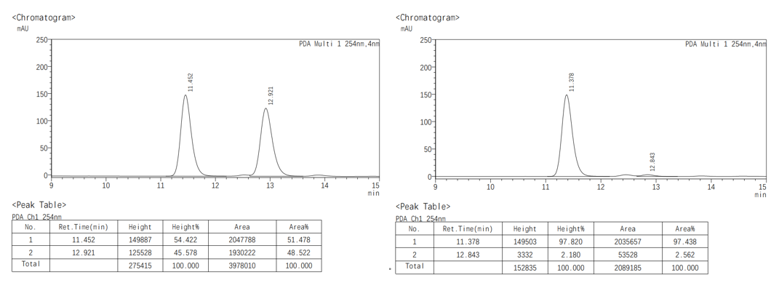
Compound 6:⁵ To a solution of 3aa (96% ee, 0.2 mmol, 74.8 mg) in MeOH (2 mL) at room temperature was added CeCl₃·7H₂O (74.5 mg, 0.2 mmol), and the suspension was stirred for 10 min. After the reaction was cooled down to 0 °C, NaBH₄ (75.6 mg, 2.0 mmol) was added to the reaction, and the reaction was stirred for 30 min, and then quenched with water. After a half of solvent was evaporated in vacuo, the mixture was diluted with EtOAc, washed with brine, and then dried over anhydrous Na₂SO₄. The organic layer was dried over Na₂SO₄ filtered, and concentrated on a rotary evaporator. After concentration in vacuo, the obtained residue was directly utilized for the next reaction. To a stirred solution of the crude product in CH₃CN (3.0 mL) at room temperature was added TsOH·H₂O (28.5 mg, 0.2 mmol). After being stirred for 30 min at room temperature, the reaction mixture was quenched with sat. aq. NaHCO₃ solution. Aqueous layer was extracted with EtOAc, and the combined organic layers were washed with brine. The crude product was purified by column chromatography (PE/EtOAc = 100:1) to give 7 (48 % yield, 35 mg) as a white solid.; The absolute configuration of 5 was confirmed by COSY and NOESY spectra of ent-5.
¹H NMR (400 MHz, CDCl₃) δ 8.54 (d, J = 8.1 Hz, 1H), 7.93 (d, J = 7.5, 1.7 Hz, 1H), 7.84 (d, J = 7.4, 2.0 Hz, 1H), 7.76 (d, J = 8.4 Hz, 1H), 7.54 (d, J = 8.4 Hz, 1H), 7.50 – 7.40 (m, 5H), 7.38 – 7.28 (m, 4H), 7.25 (d, J = 7.1 Hz, 1H), 6.62 (s, 1H), 3.89 (t, J = 5.6 Hz, 1H), 3.14 (dd, J = 10.1, 5.5 Hz, 1H), 2.58 (ddd, J = 15.8, 7.9, 2.1 Hz, 1H), 2.50 – 2.41 (m, 1H), 2.17 – 1.82 (m, 2H).
¹³C NMR (100 MHz, CDCl₃) δ 141.9, 138.2, 133.6, 133.0, 130.3, 129.8, 129.1, 128.4, 128.3 (overlapped), 127.8, 127.3, 127.1, 126.2, 126.0 (overlapped), 125.9, 125.4 (overlapped), 125.0, 124.8, 77.0, 23.7 (overlapped).
HRMS (EI): m/z: [M]+ Calcd for, C₂₈H₂₄O, 358.1722, found: 358.1716.
M.P.: 62.6-64.5 ºC.
[α]_{D}²⁰ = 112.2 (c = 0.2, CHCl₃).
HPLC conditions: Daicel Chiralpak IB column (98:2 n-Hexane: 2-Propanol, 0.5 mL/min, 254 nm); tr (minor) = 14.9 min, tr (major) = 13.0 min; 93% ee).
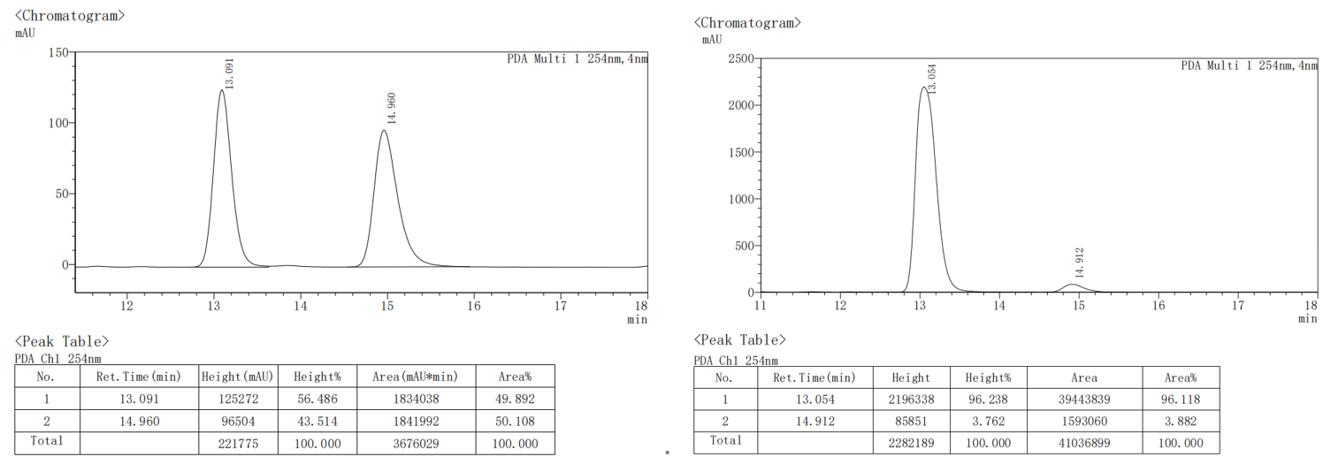
Compound 7¹: To a solution of 3aa (96% ee, 0.2 mmol, 74.8 mg) in DCM (4 mL) was sequentially added an aqueous solution of Na₂CO₃ (127.2 mg, 6.0 equiv.) and 3-chloroperoxybenzoic acid (m-CPBA, 138 mg, 4.0 eq., cas: 937-14-4) at room temperature. The reaction mixture was stirred for 2 h and poured into a saturated solution of aqueous NaHCO₃. The two layers were separated and the organic layer was washed with a saturated solution of aqueous NaHCO₃. The organic layer was dried over Na₂SO₄ filtered, and concentrated on a rotary evaporator. The crude product was purified by column chromatography (PE/EtOAc = 7:1) to give 6 (55 % yield, 42.9 mg) as a white solid.; The absolute configuration of 5 was confirmed by COSY and NOESY spectra.;
¹H NMR (400 MHz, CDCl₃) δ 8.18 (dd, J = 7.8, 1.5 Hz, 1H), 7.58 – 7.43 (m, 1H), 7.40 (dd, J = 7.7, 3.1 Hz, 2H), 7.39 – 7.21 (m, 6H), 7.17 (t, J = 7.4 Hz, 1H), 7.11 (d, J = 7.9 Hz, 1H), 6.97 (d, J = 10.3 Hz, 1H), 6.72 (d, J = 7.7 Hz, 1H), 6.38 (d, J = 10.3 Hz, 1H), 3.69 (td, J = 8.4, 5.2 Hz, 1H), 3.58 (d, J = 8.8 Hz, 1H), 2.94 (s, 1H), 2.42 (ddd, J = 14.7, 7.2, 4.7 Hz, 1H), 2.34 – 2.22 (m, 1H), 2.14 (ddd, J = 14.2, 8.6, 4.5 Hz, 1H), 1.91 – 1.78 (m, 1H).
¹³C NMR (100 MHz, CDCl₃) δ 184.6, 151.4, 149.2, 146.2, 145.4, 141.4, 133.2, 131.3, 128.6, 128.5 (overlapped), 128.3, 128.2, 127.7, 127.5, 127.3, 126.3, 125.1, 124.9 (overlapped), 124.7, 61.8, 60.7, 56.7, 52.9, 40.9, 27.0, 25.8.
HRMS (EI): m/z: [M]+ Calcd for, C₂₈H₂₂O₂, 390.1620, found: 390.1611.
M.P.: 194.3-197.3 ºC.
[α]_{D}²⁰ = 45.9 (c = 0.2, CHCl₃).
HPLC conditions: Daicel Chiralpak IB column (85:15 n-Hexane: 2-Propanol, 0.5 mL/min, 254 nm); tr (minor) = 15.3 min, tr (major) = 17.5 min; 96% ee).
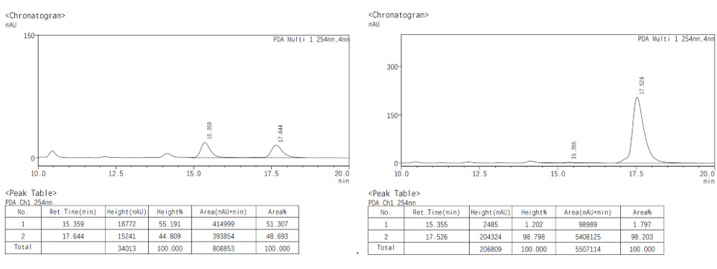

- NMR Spectra
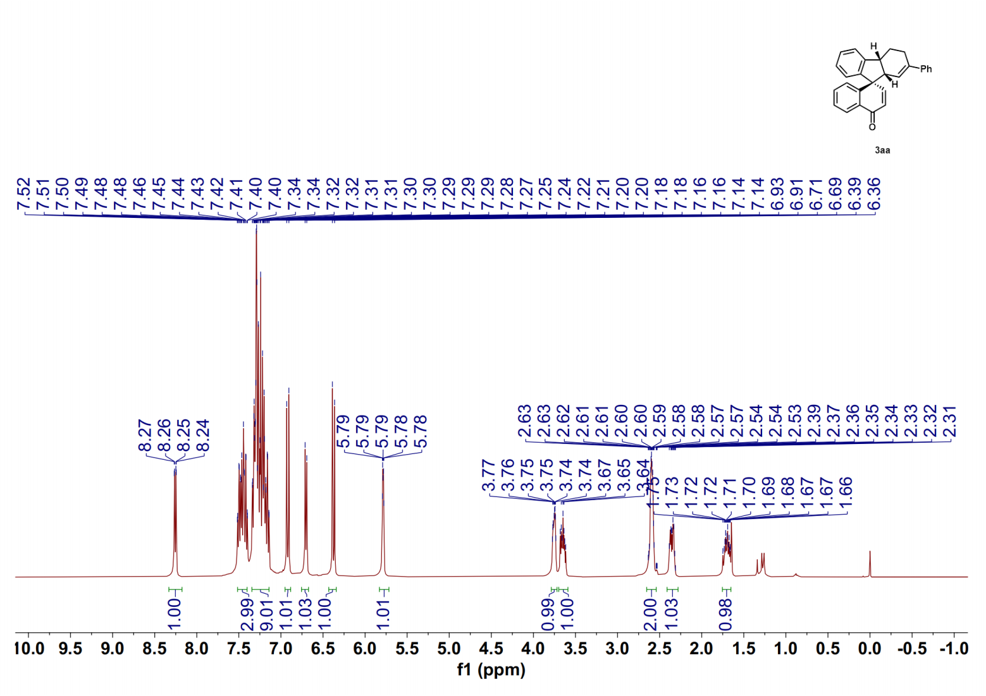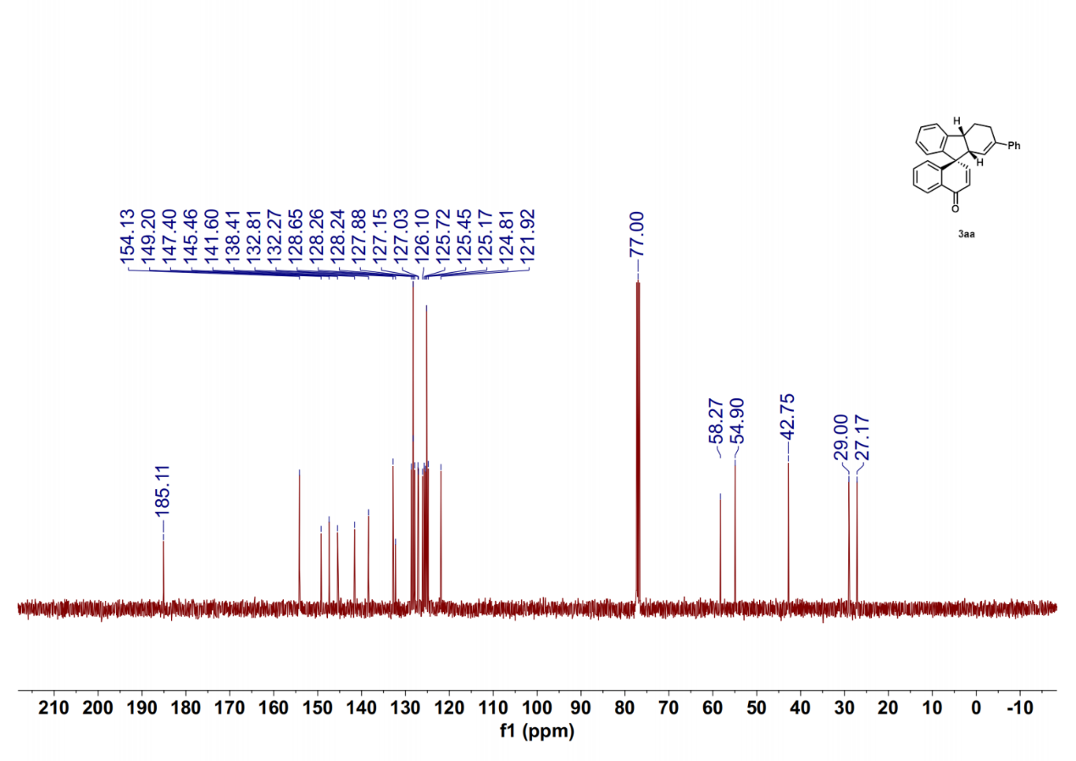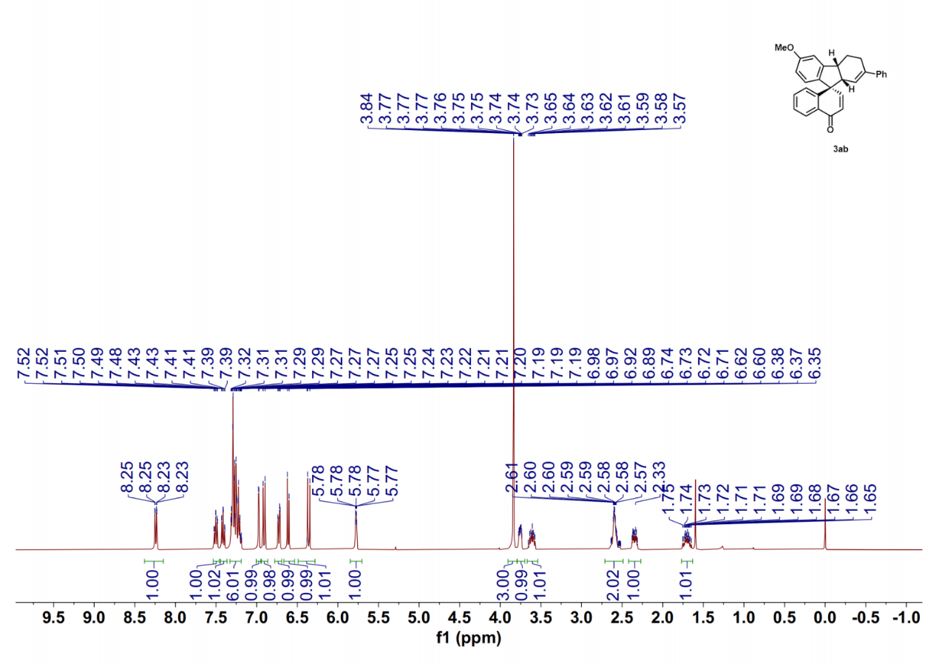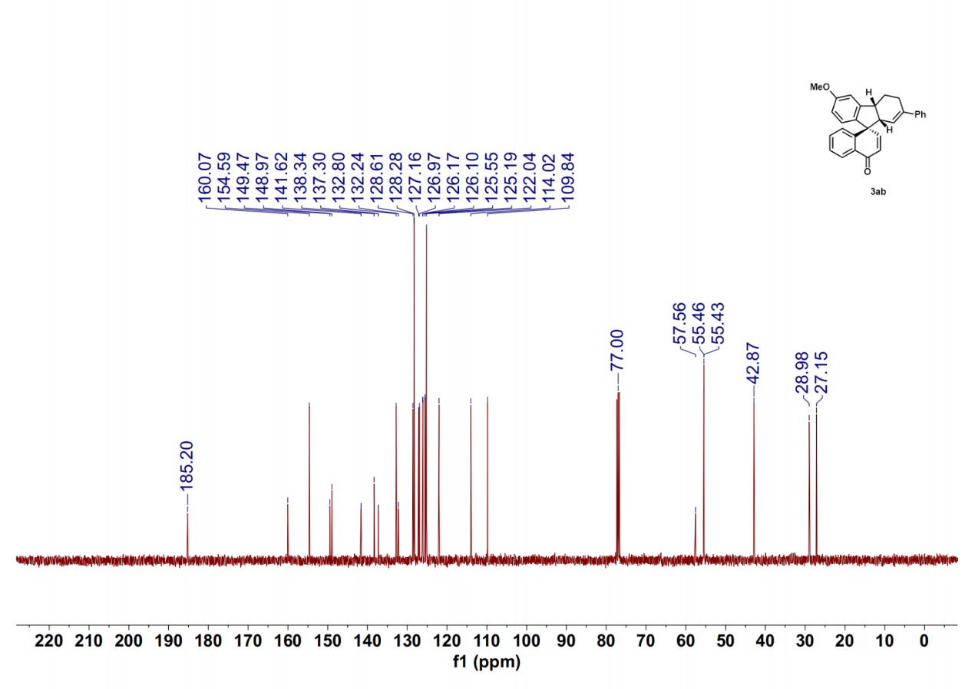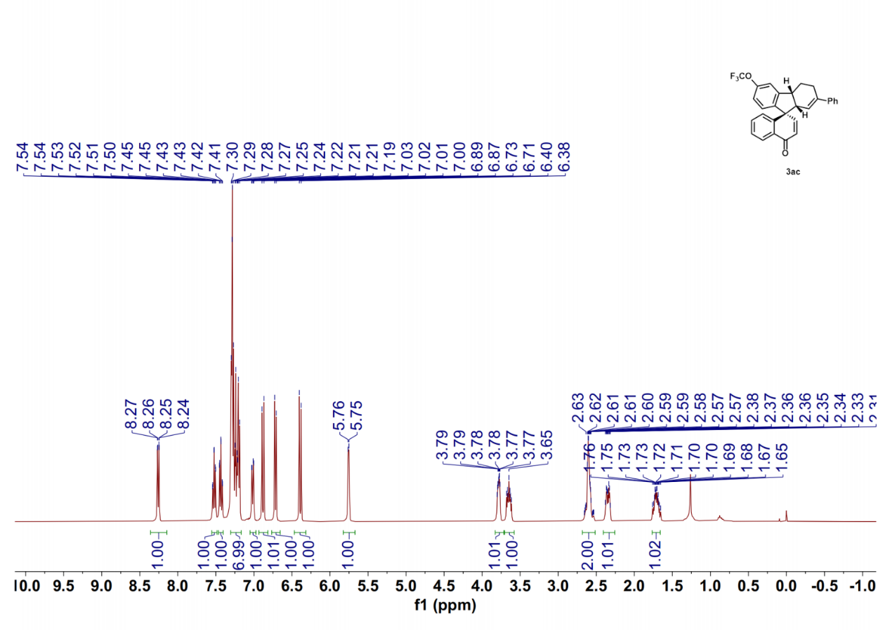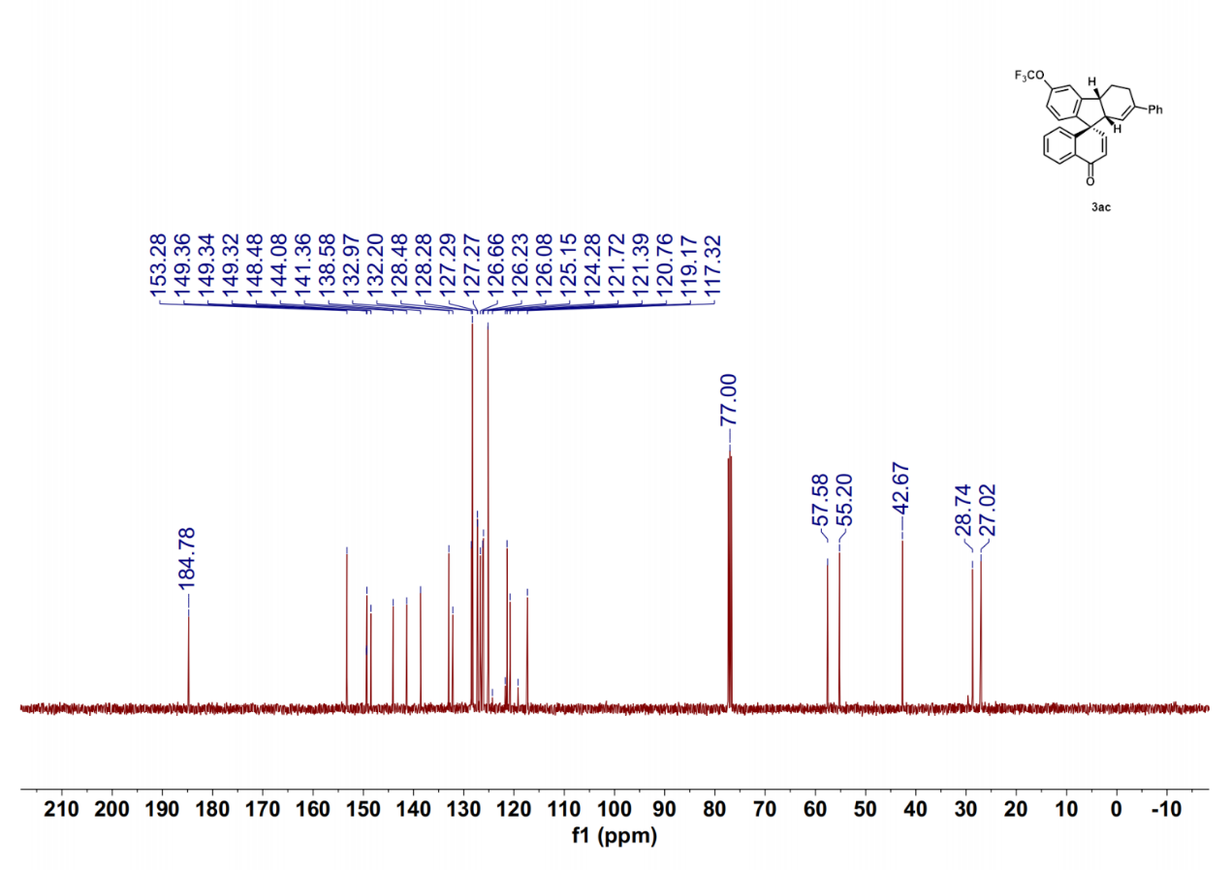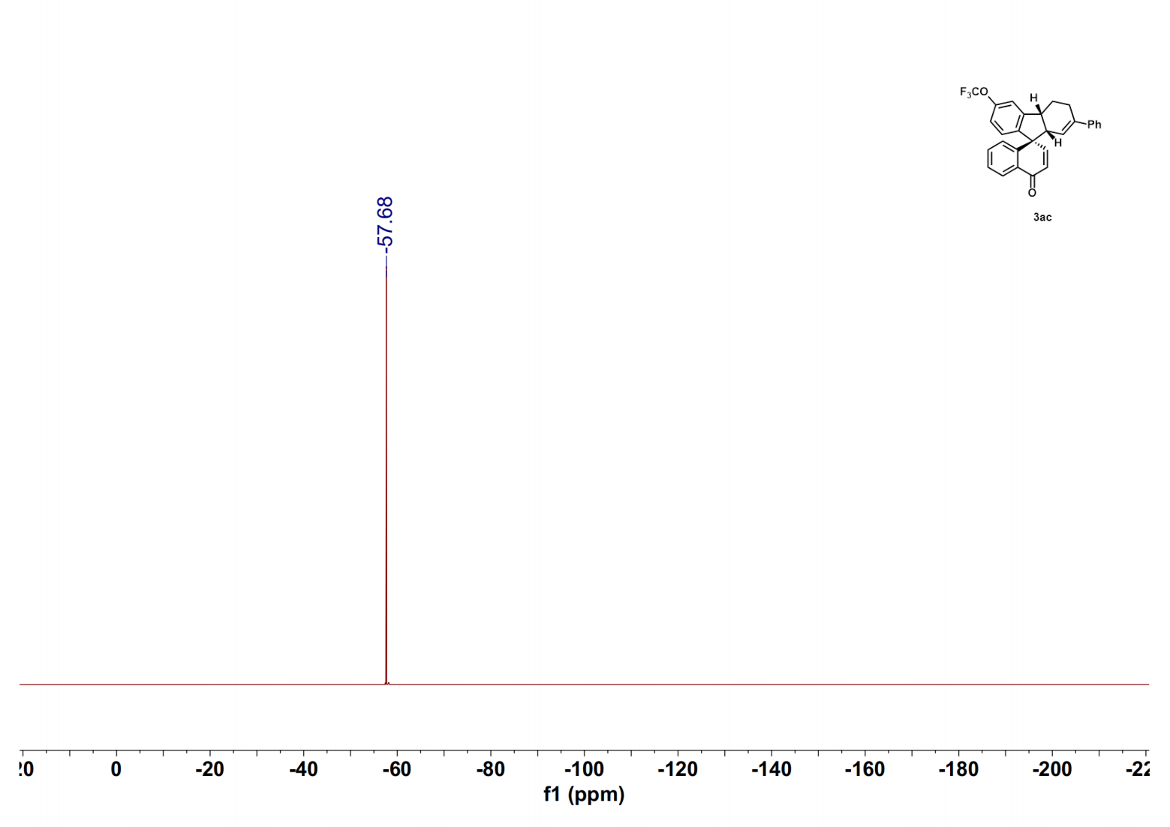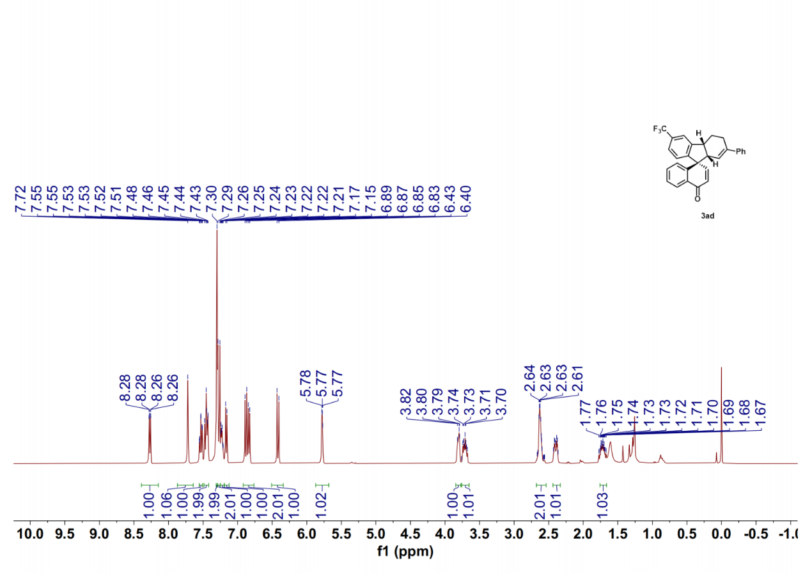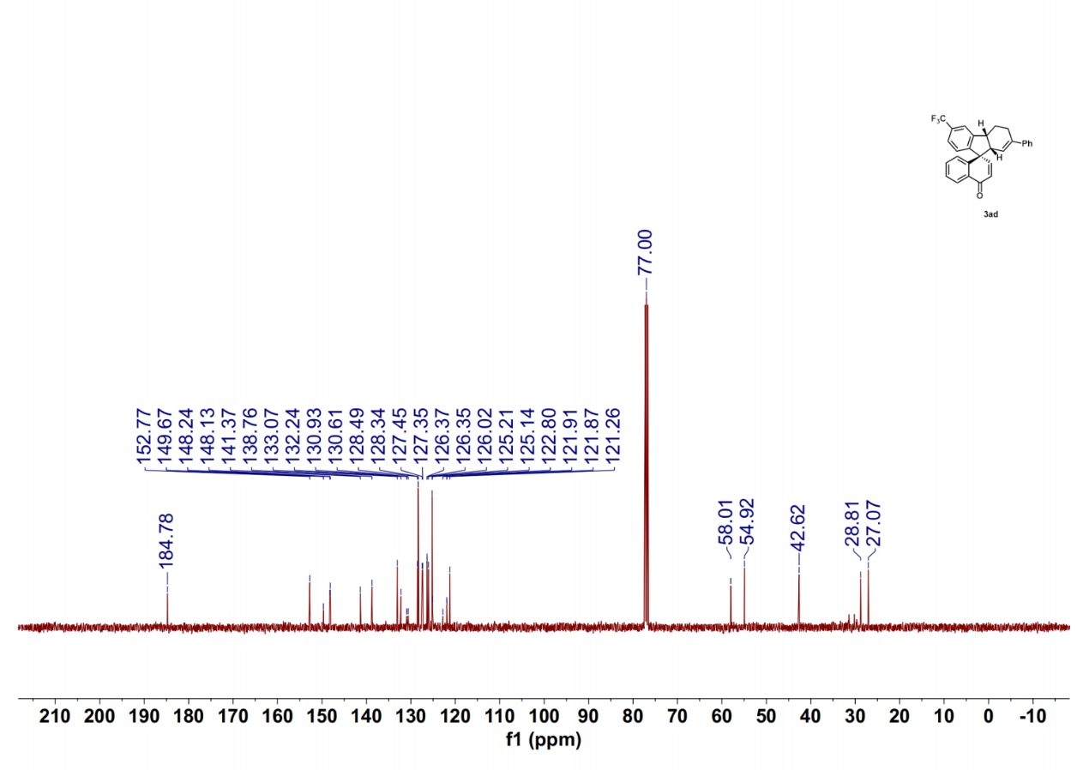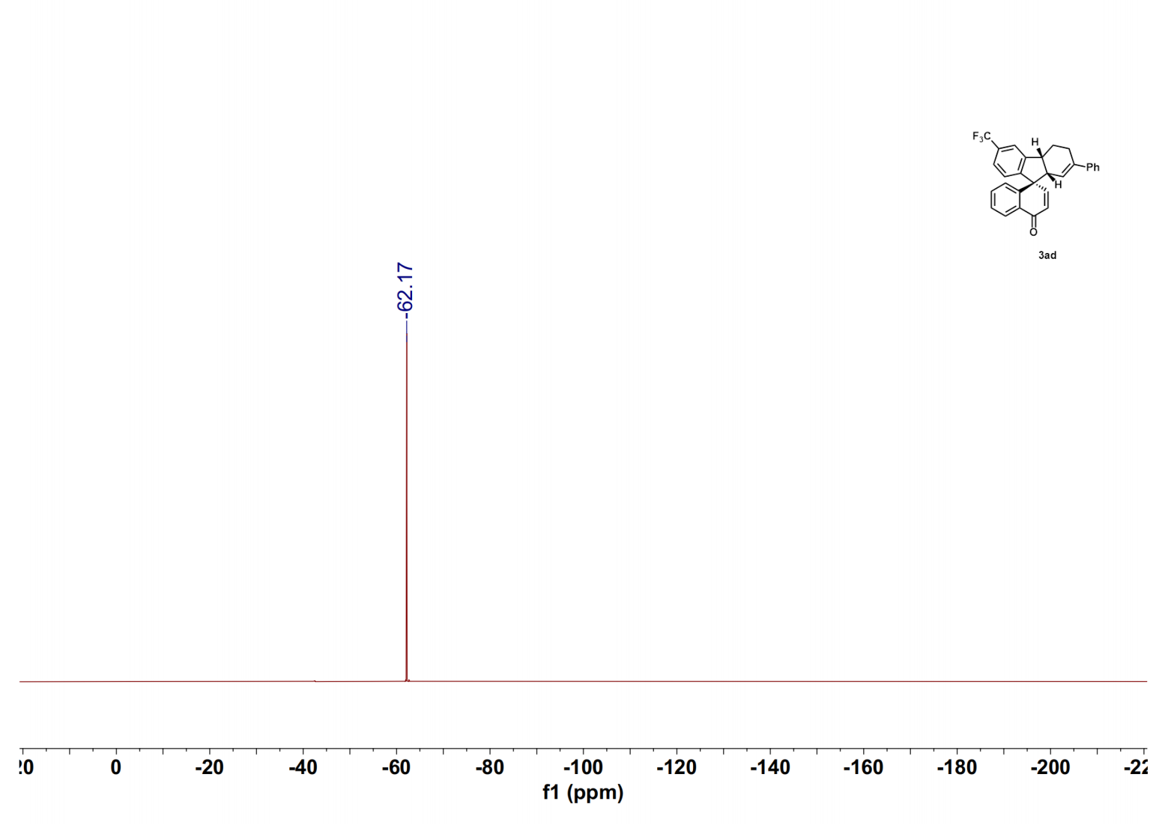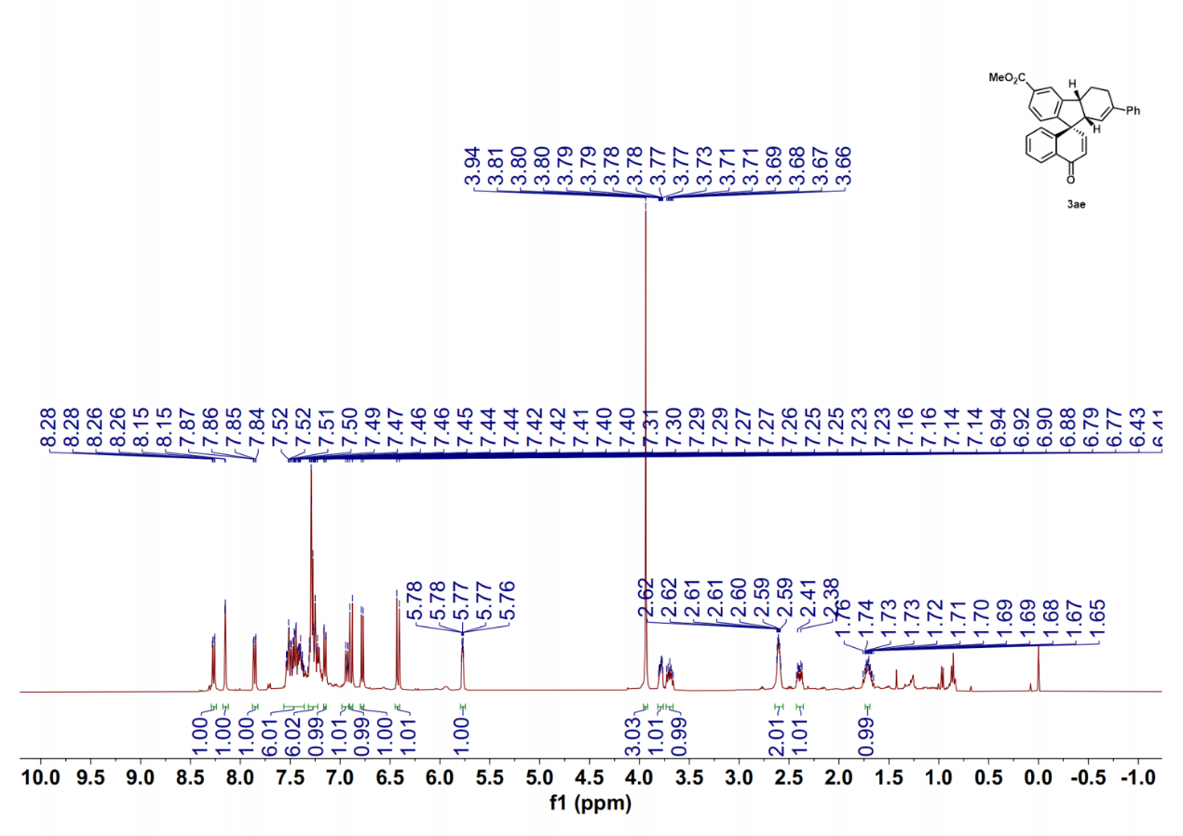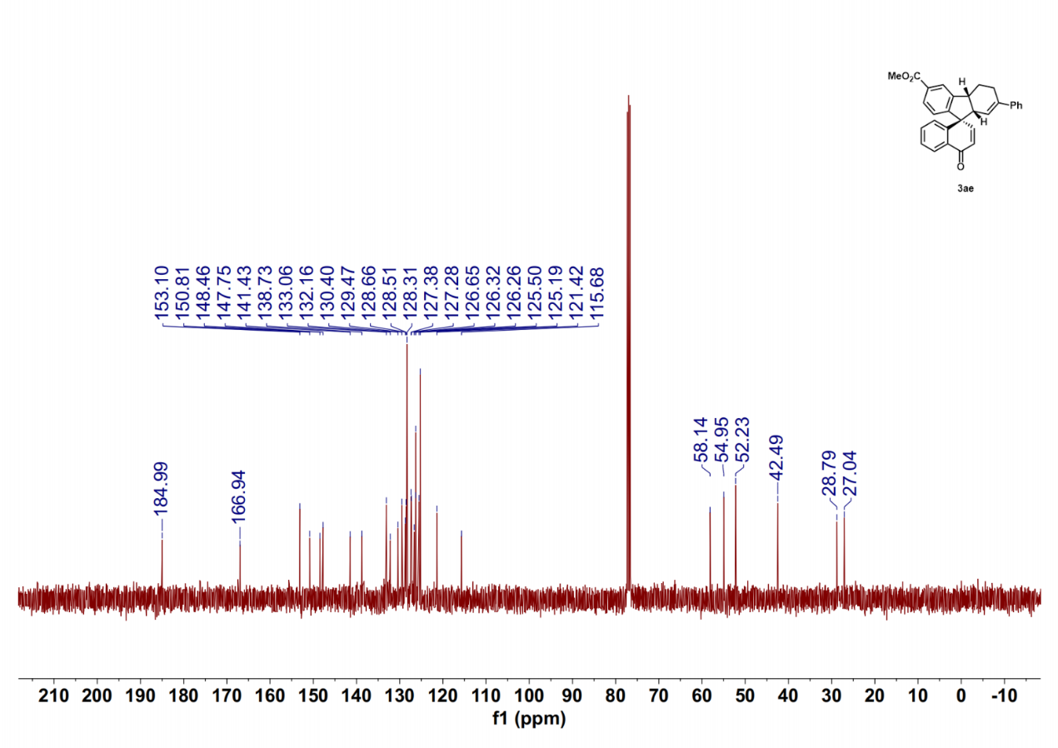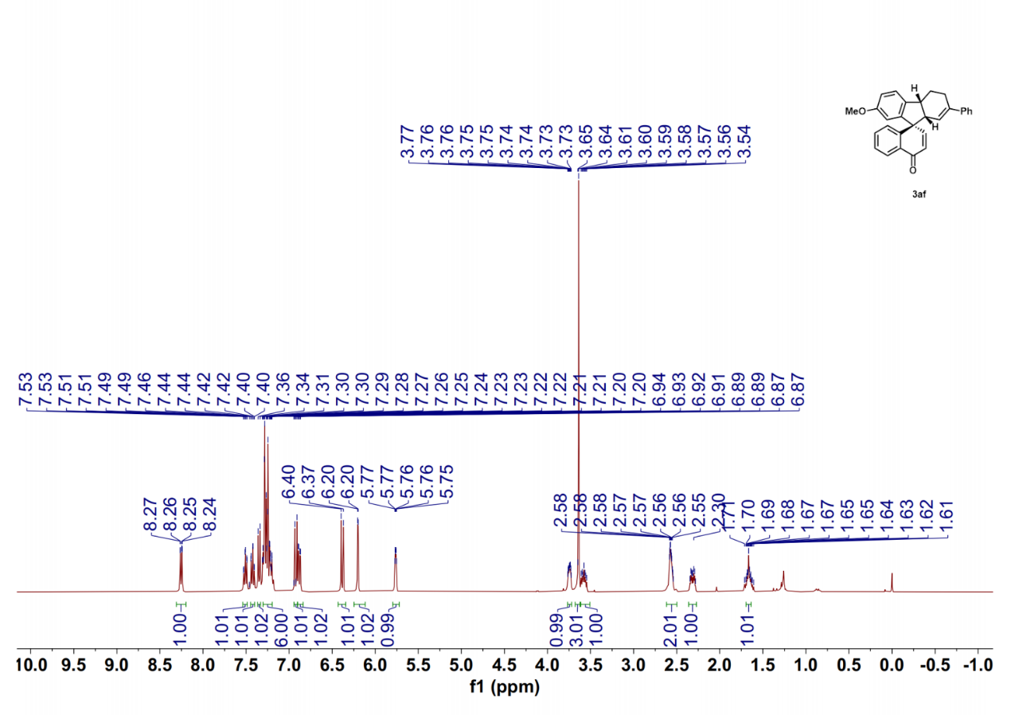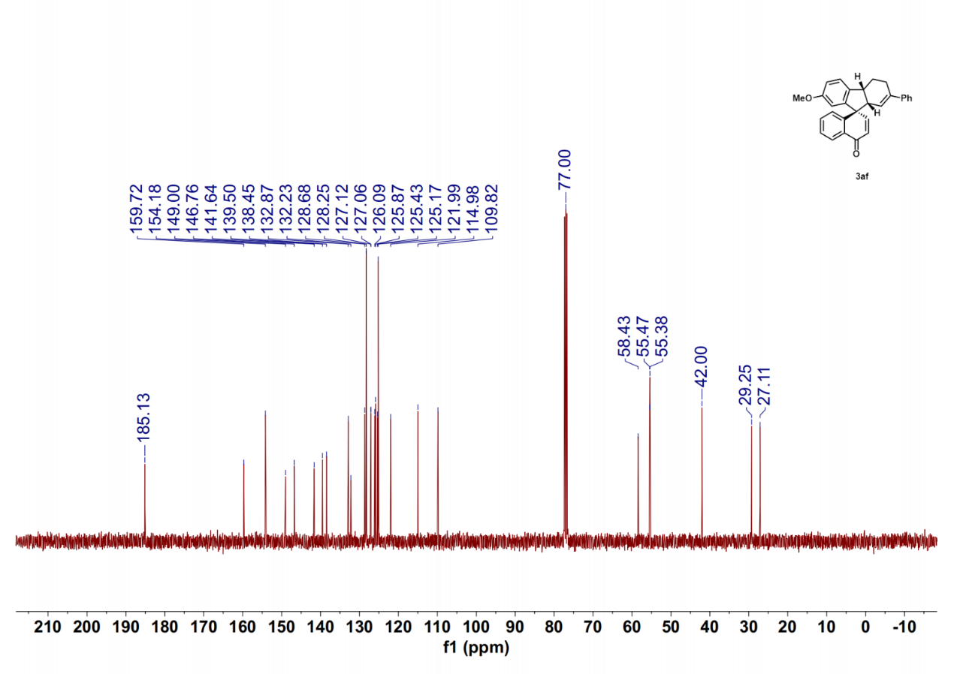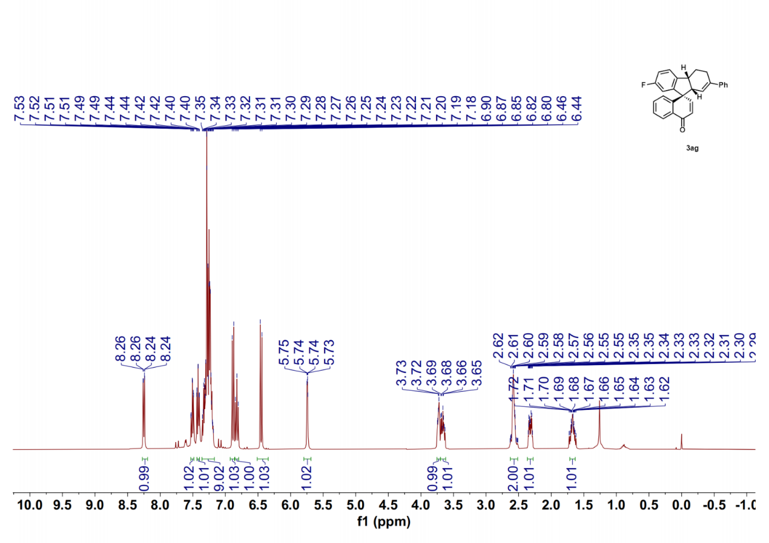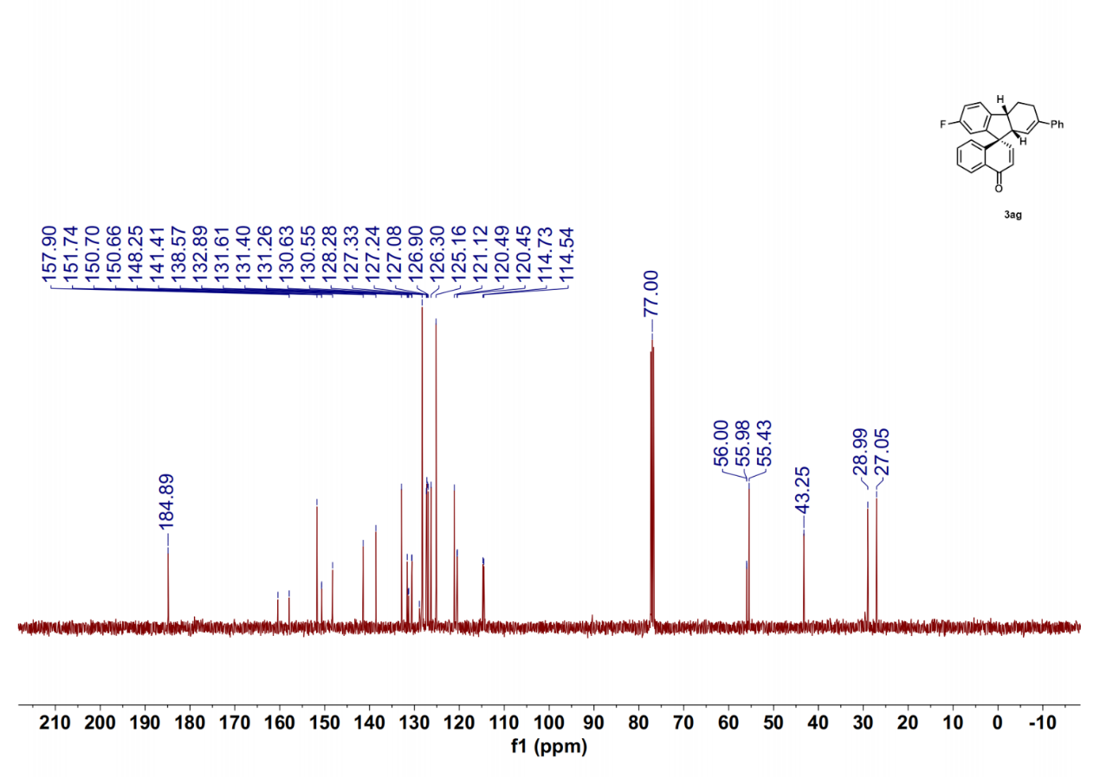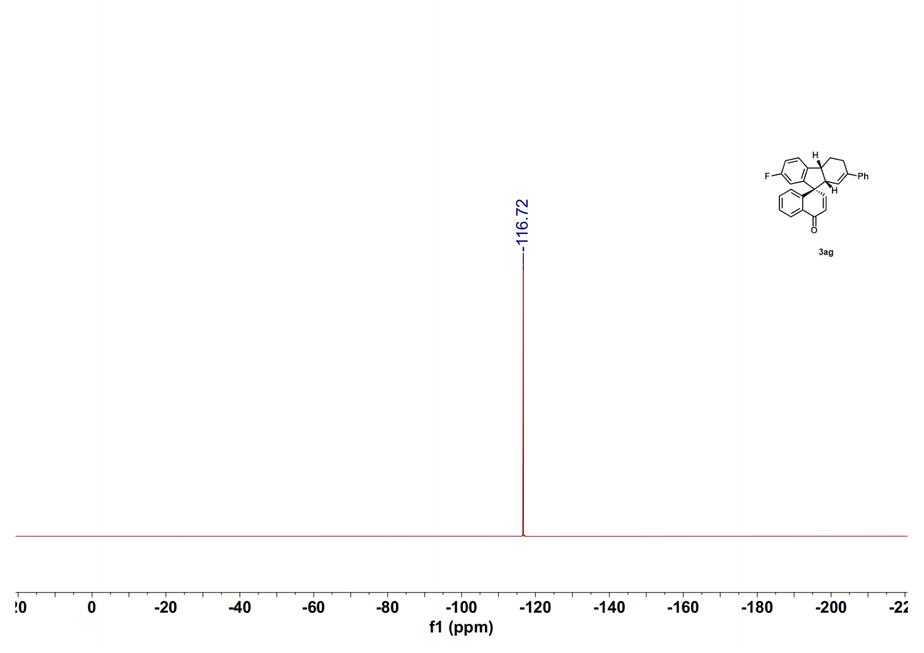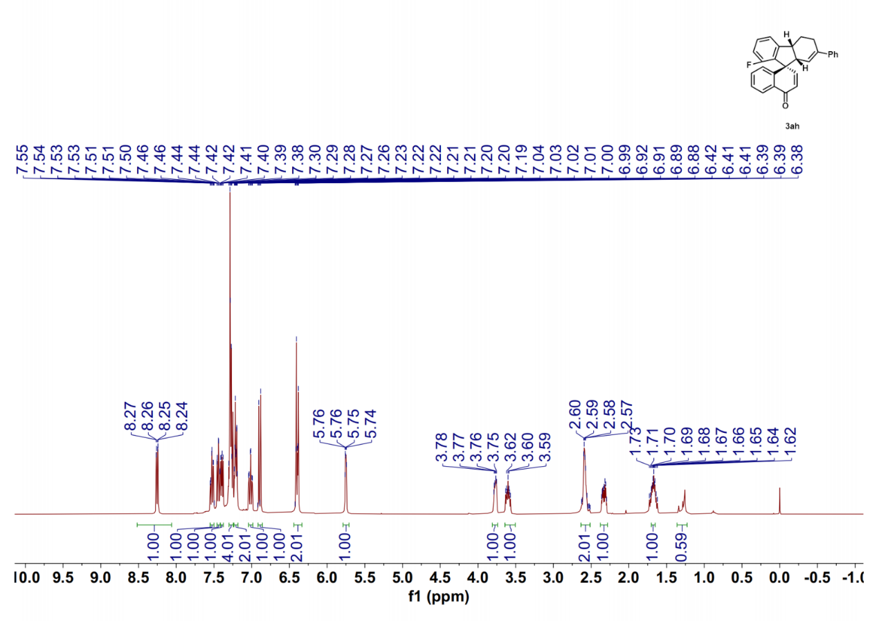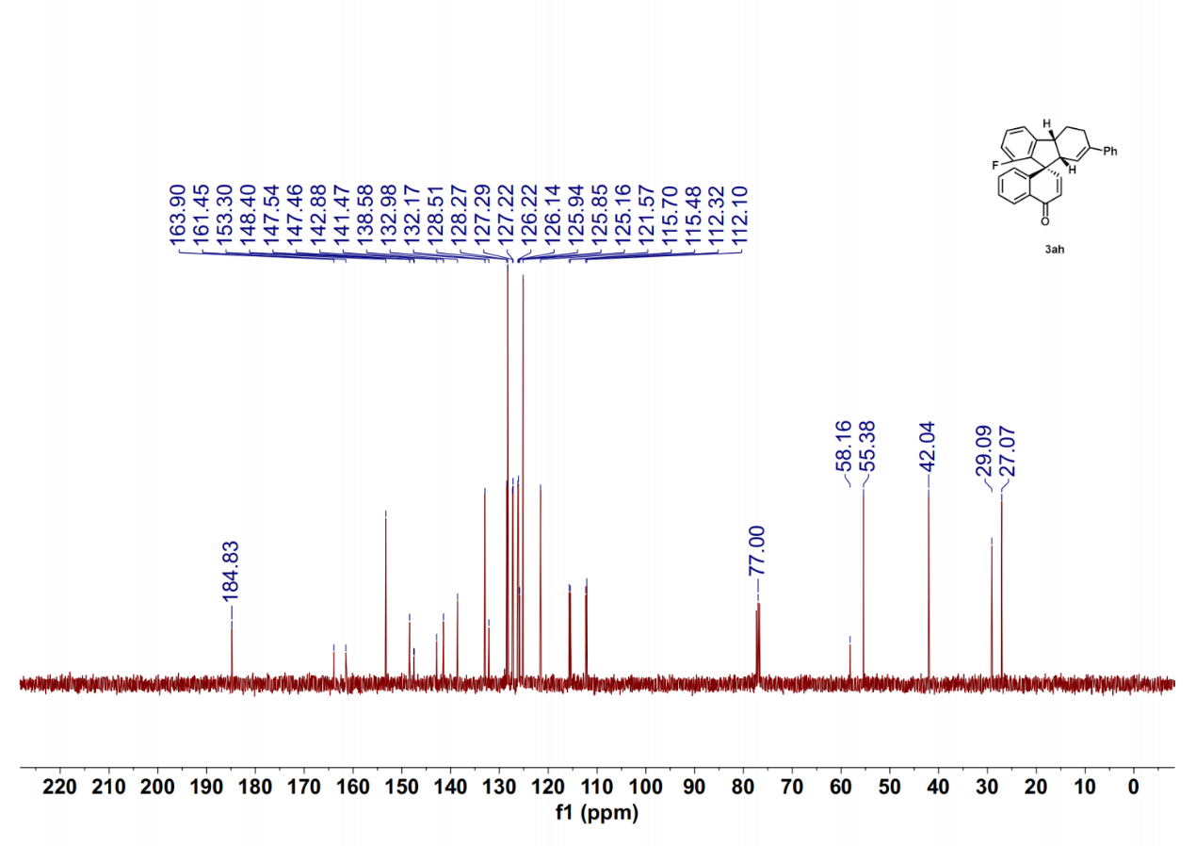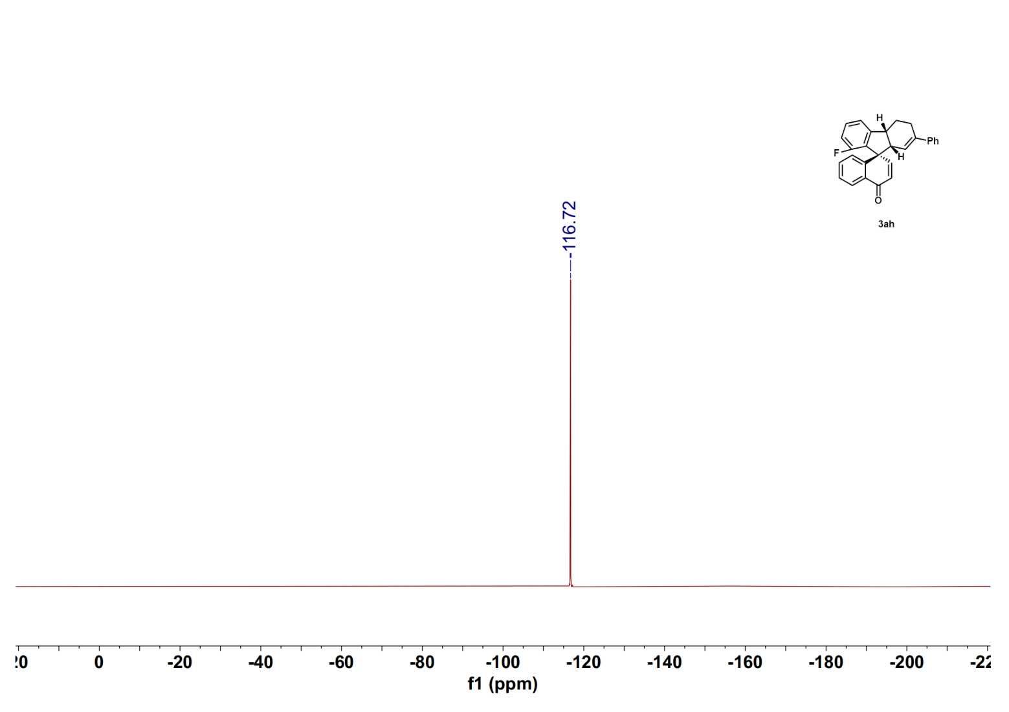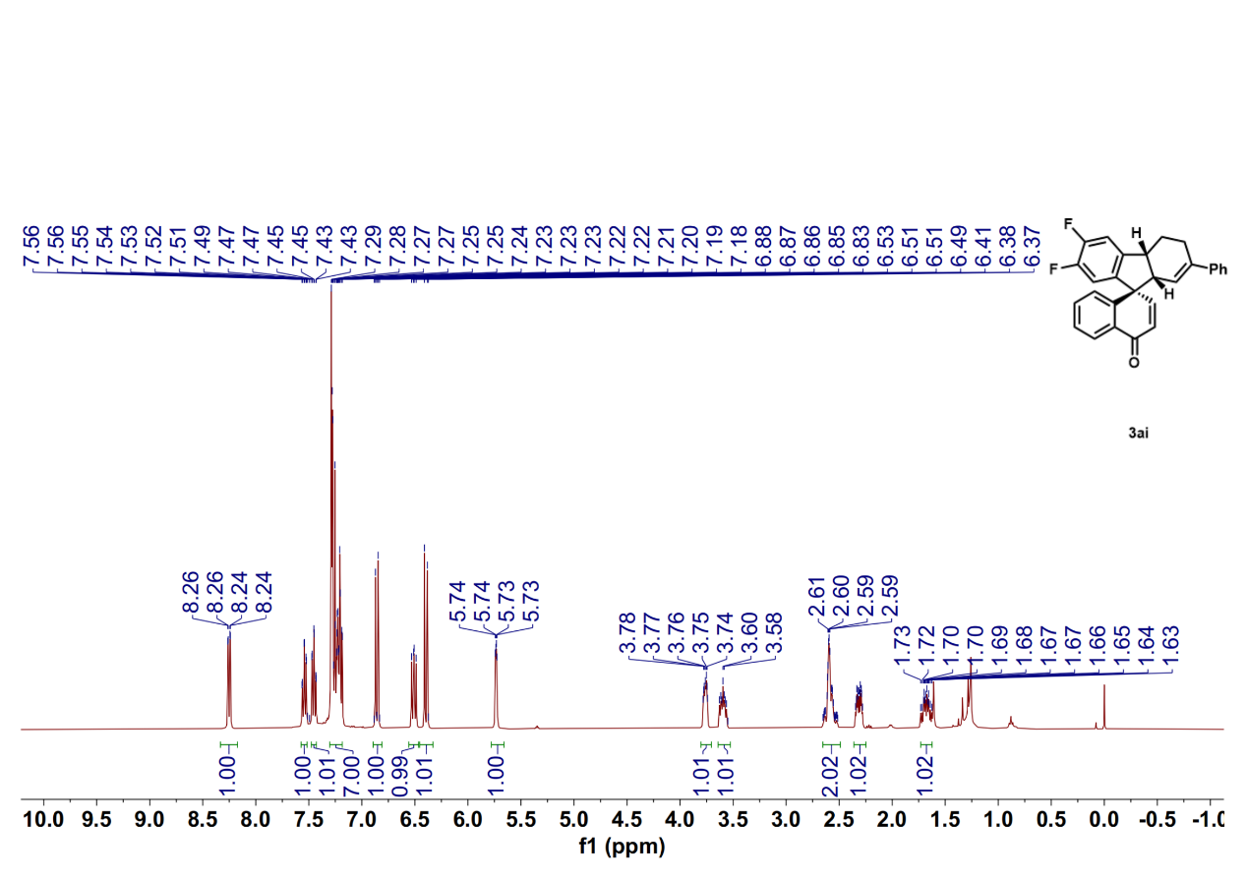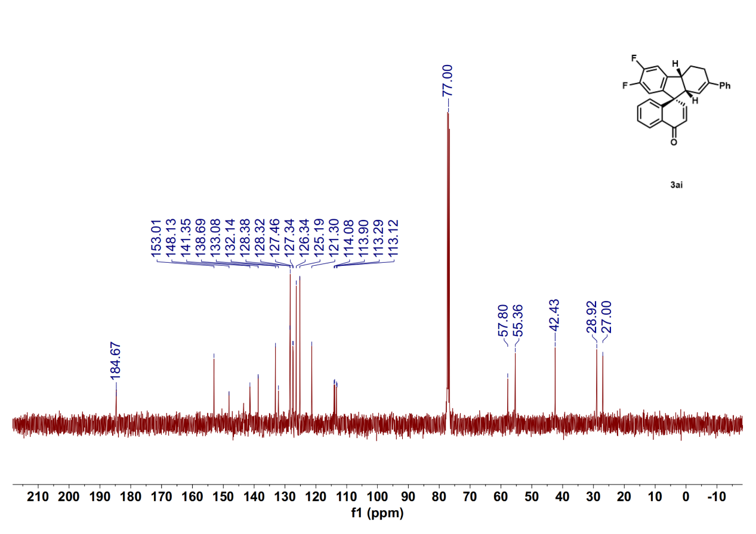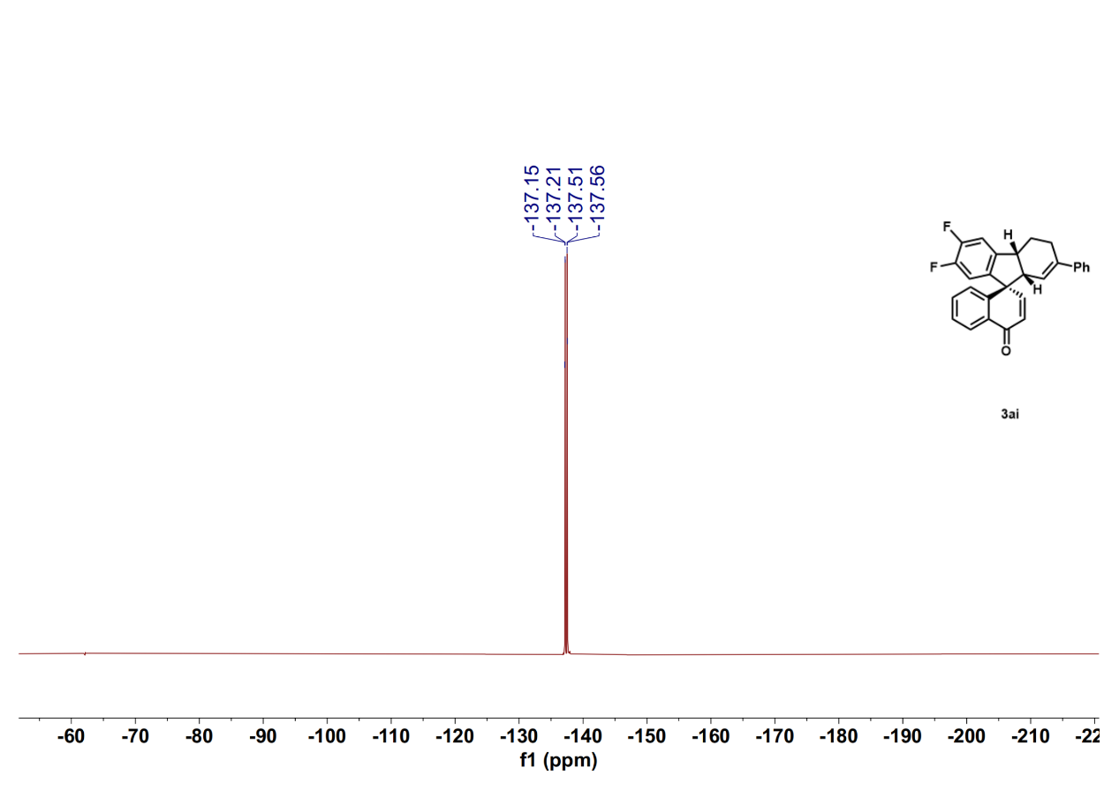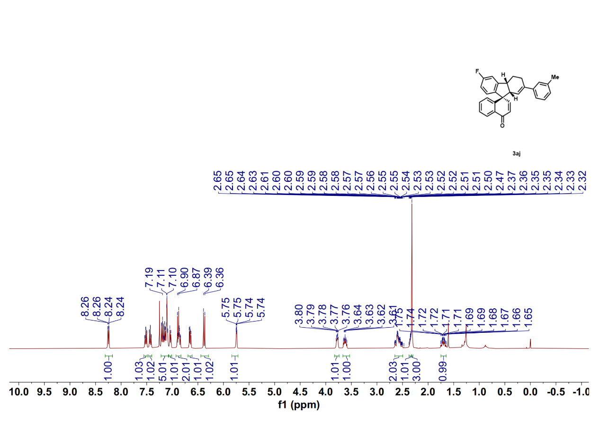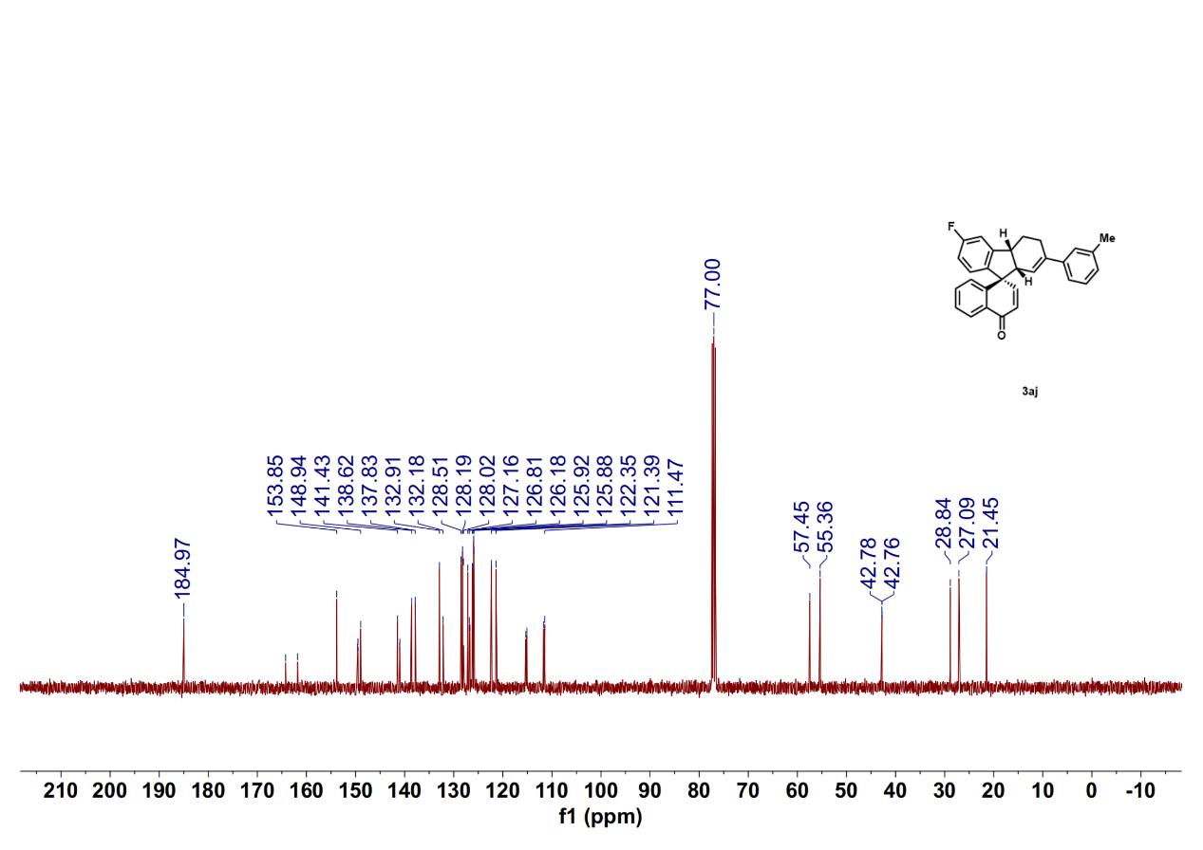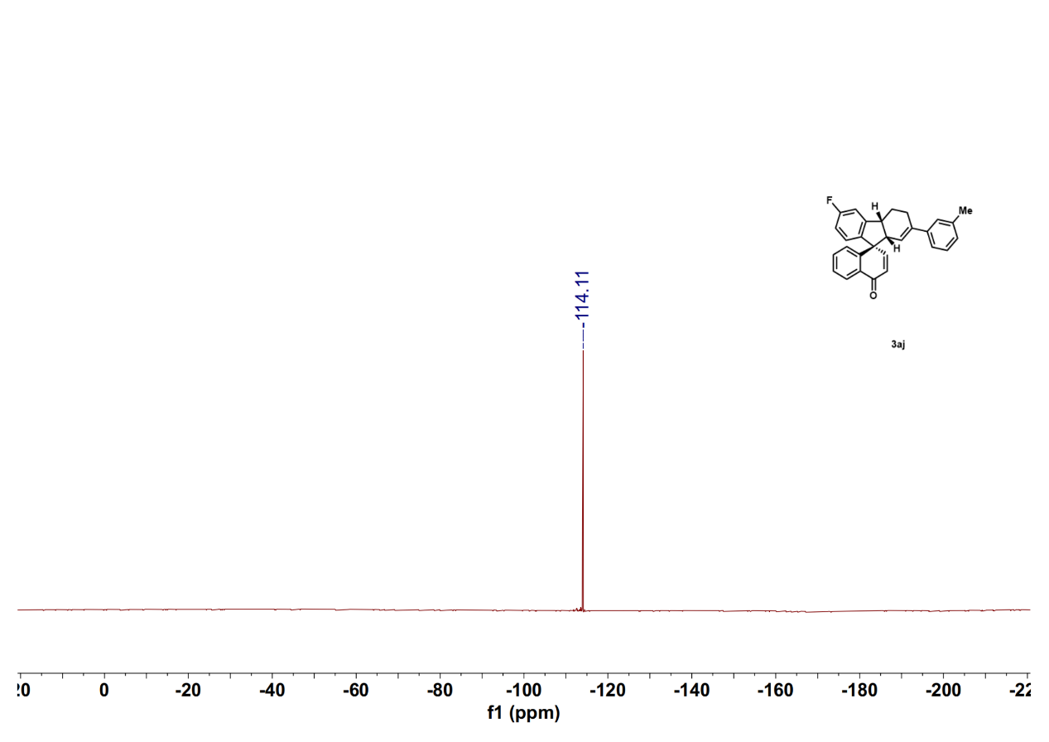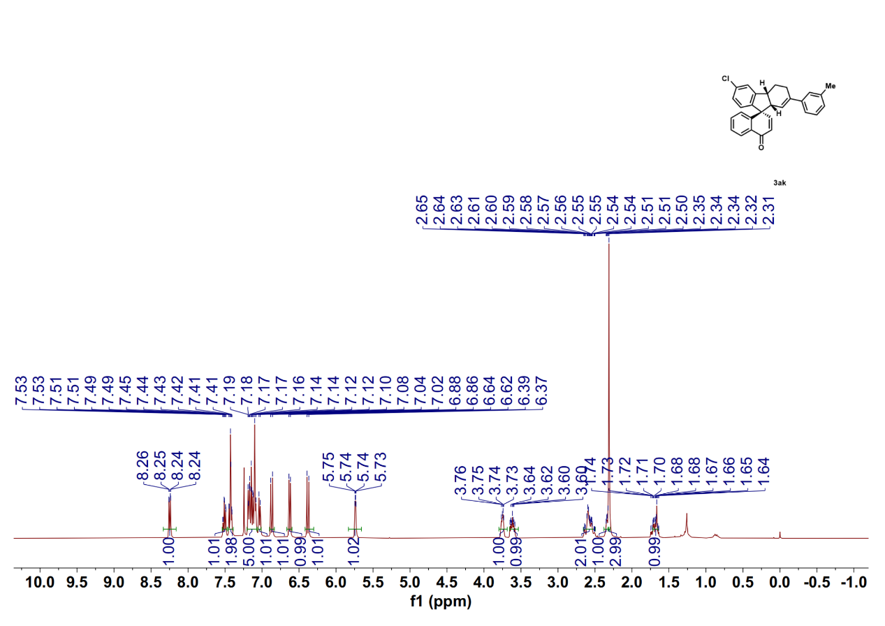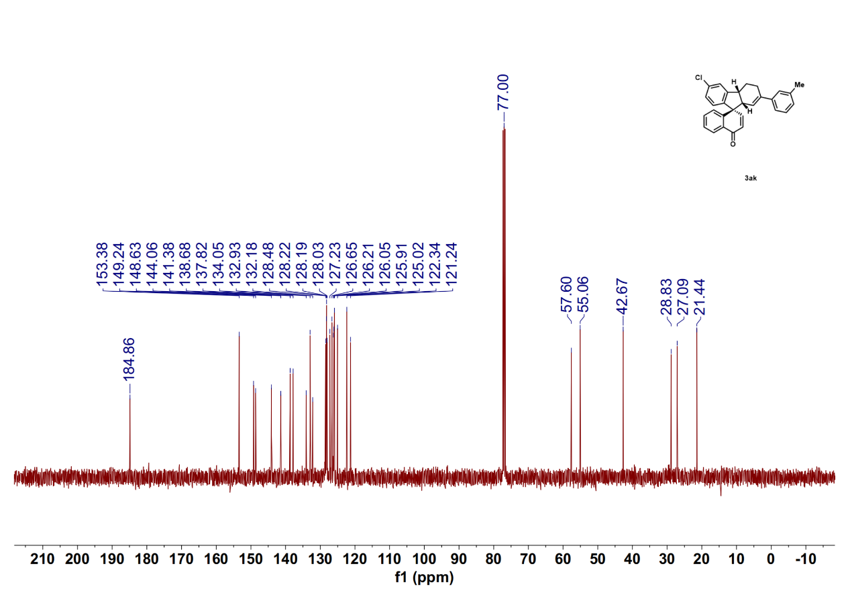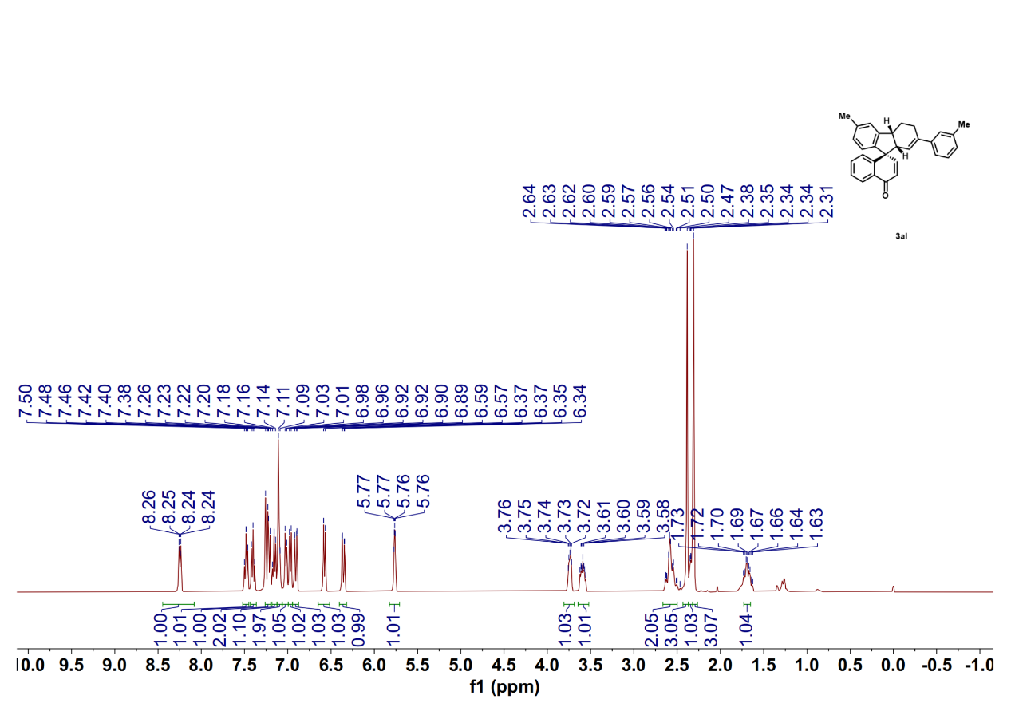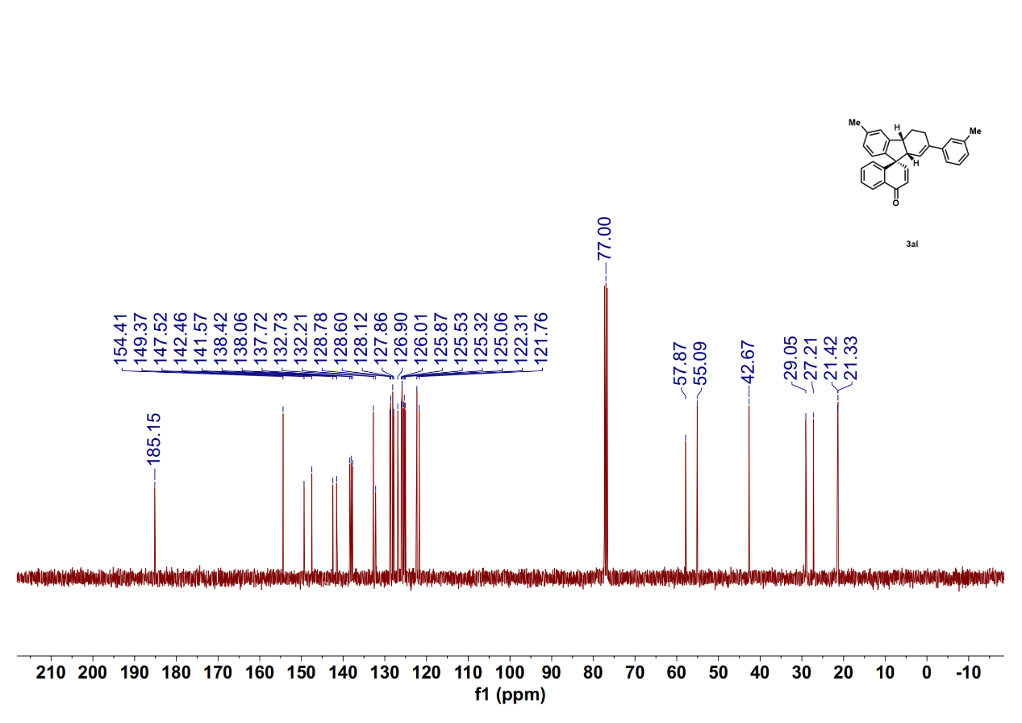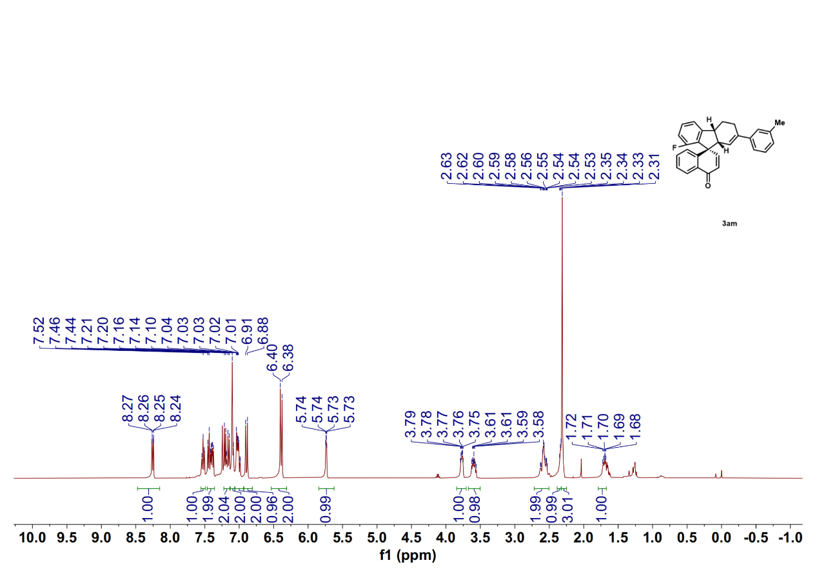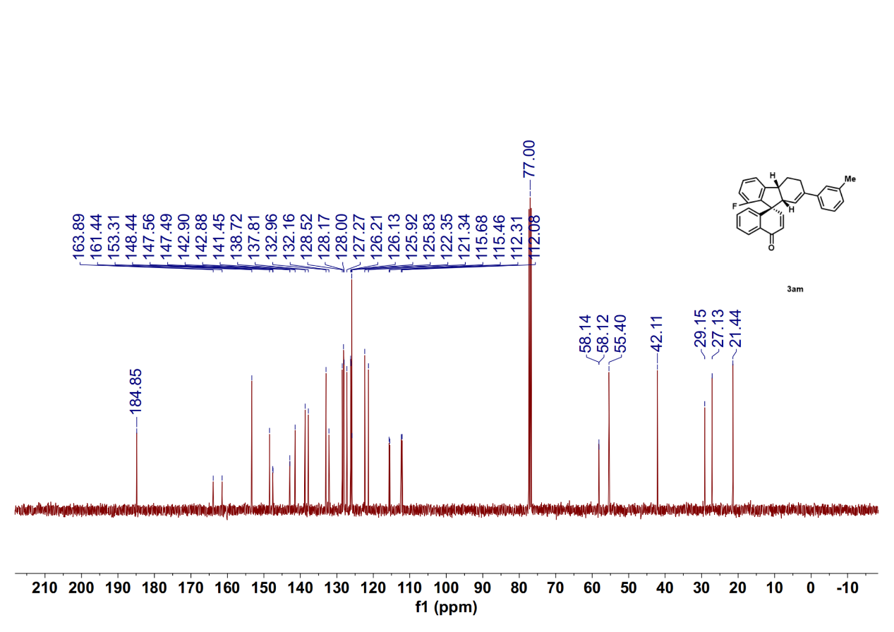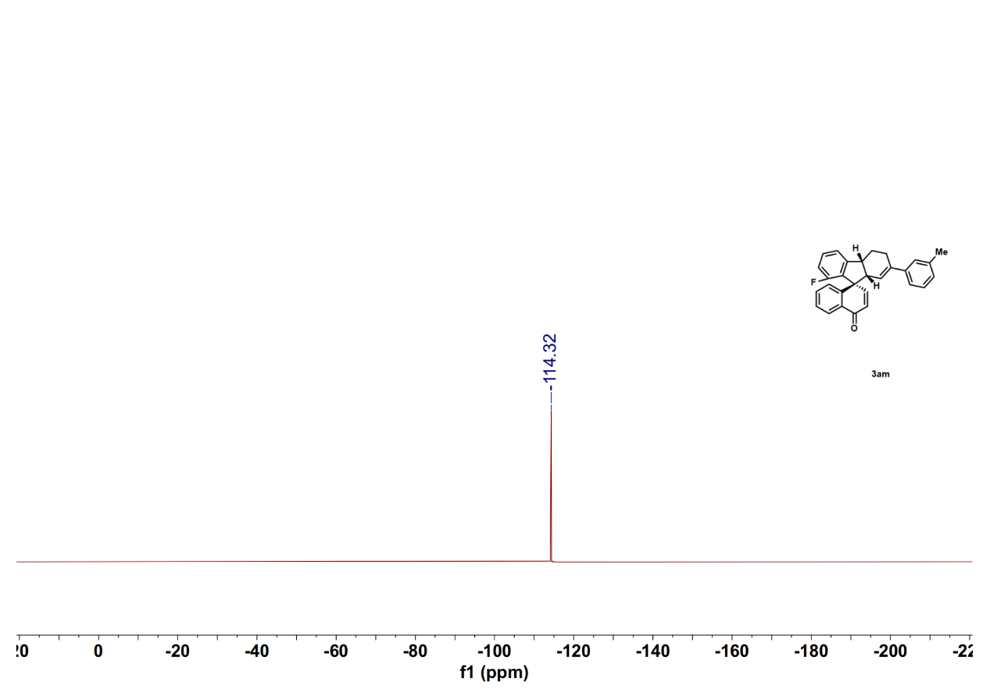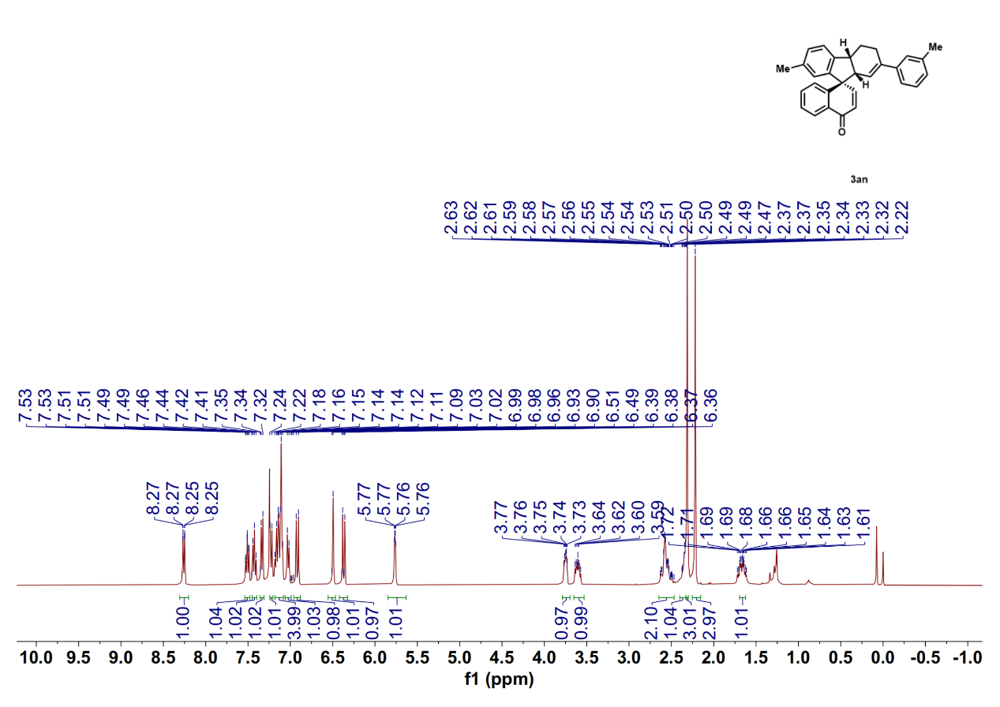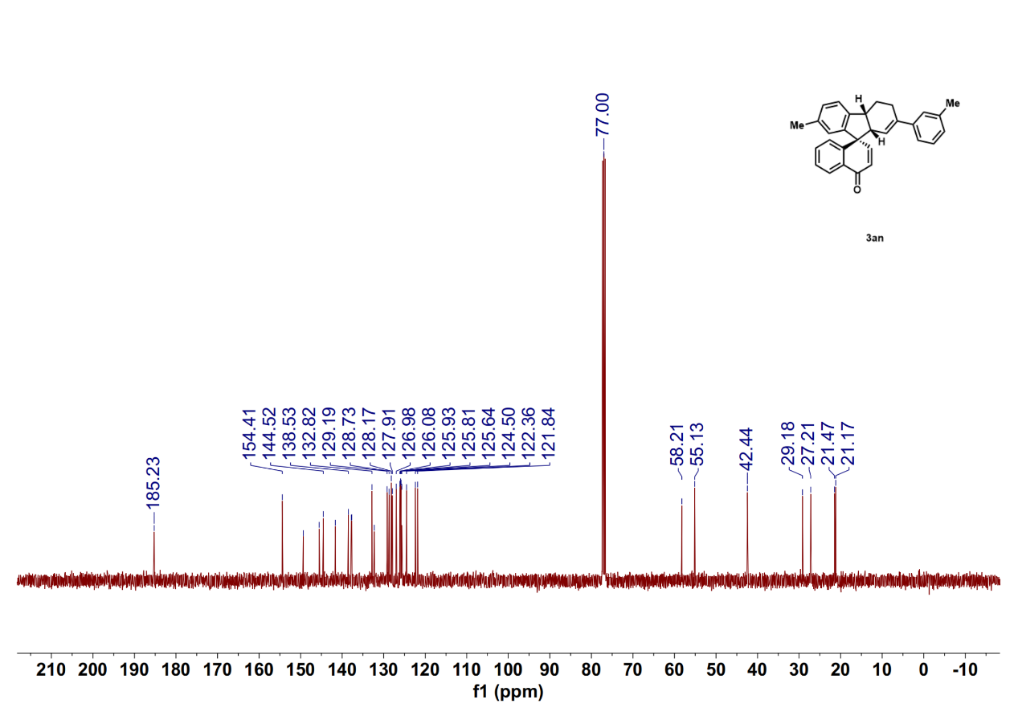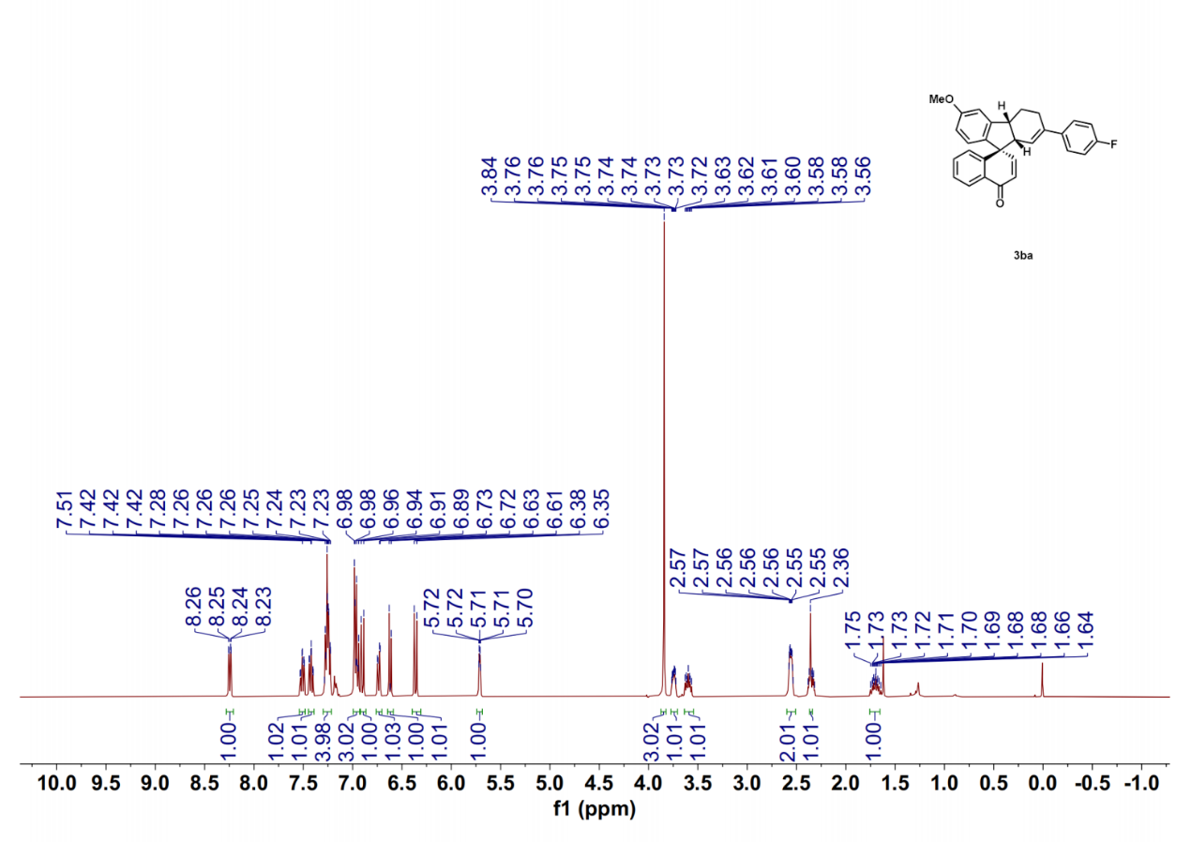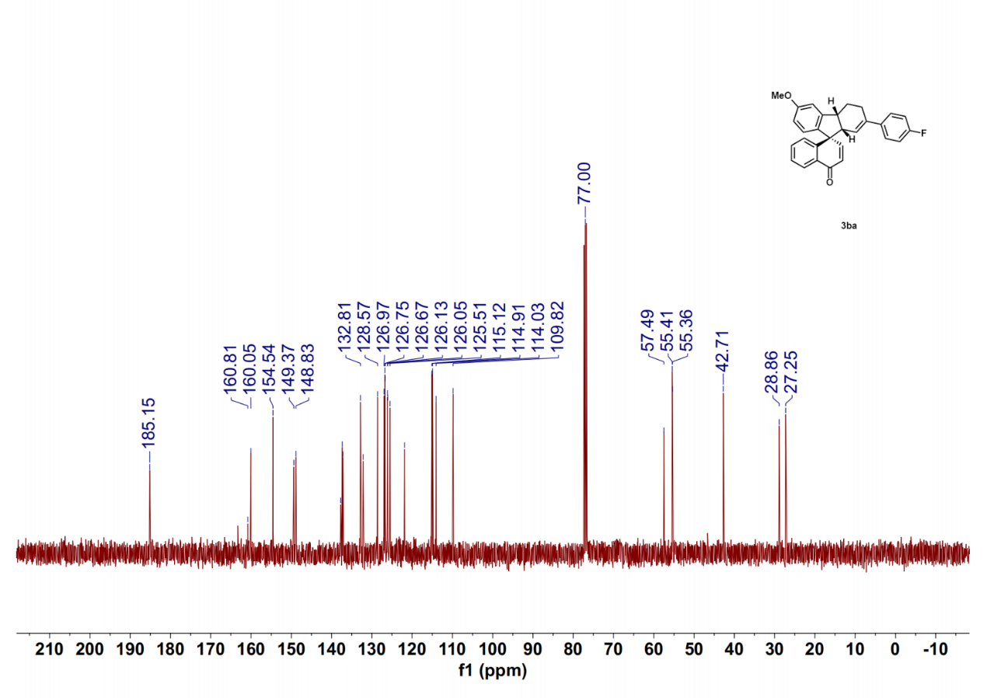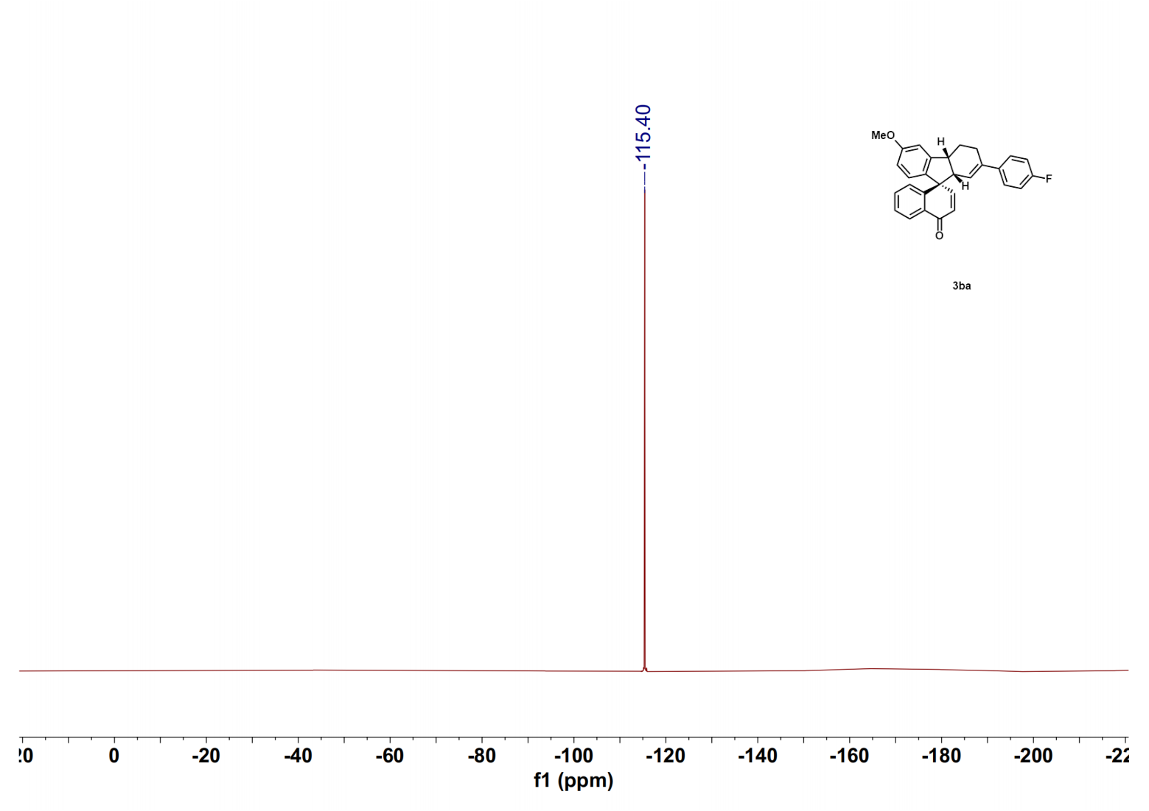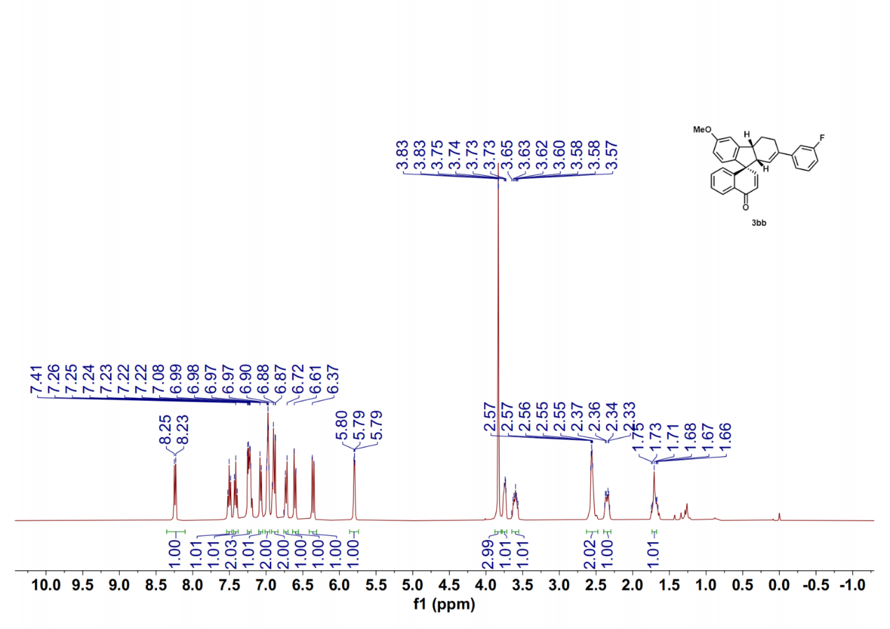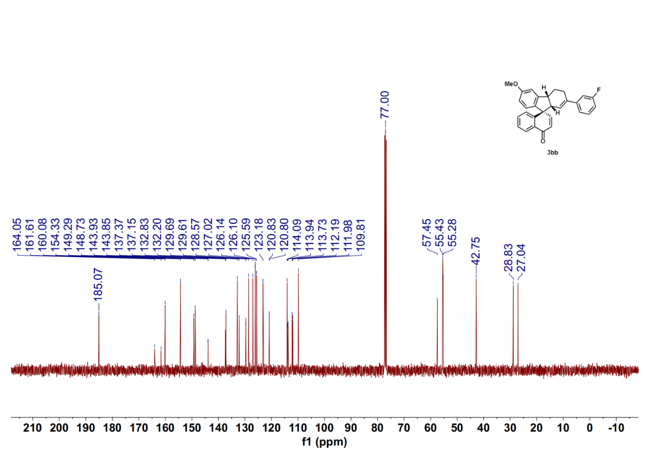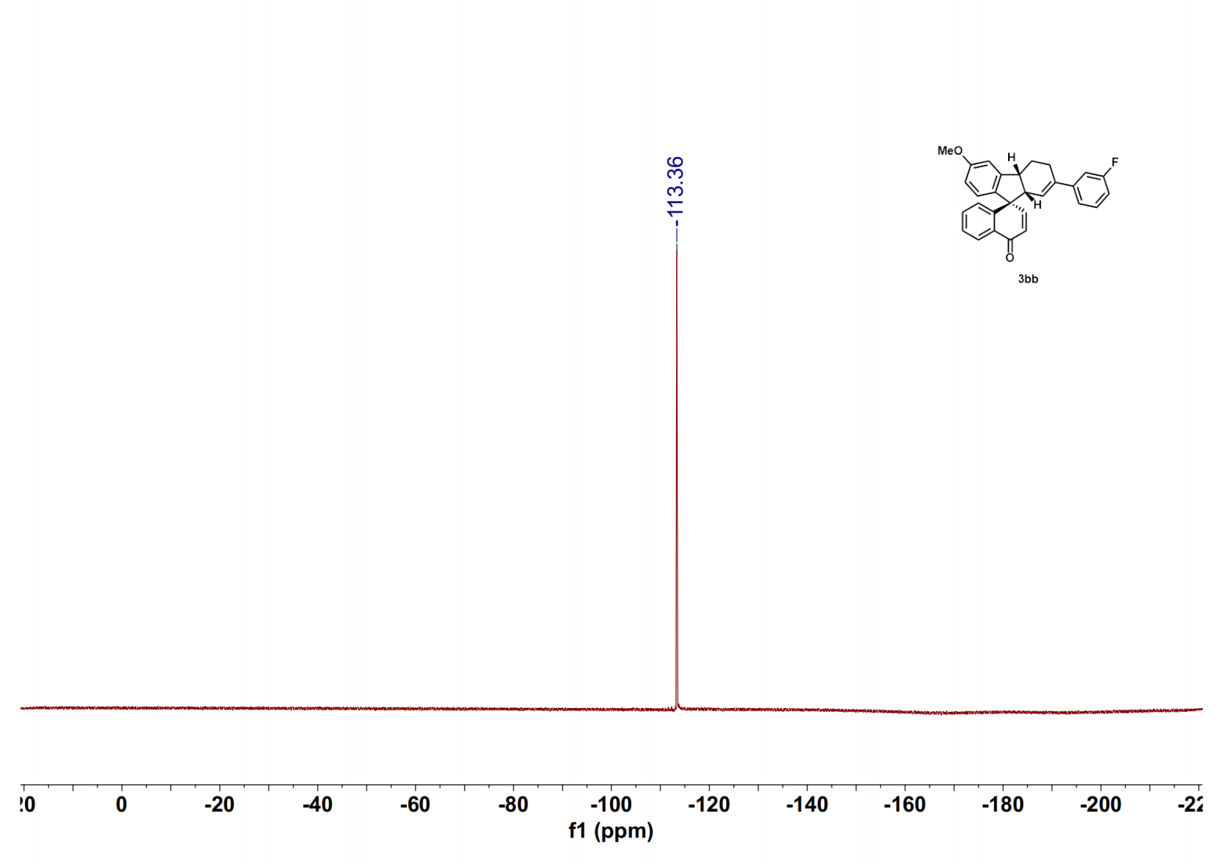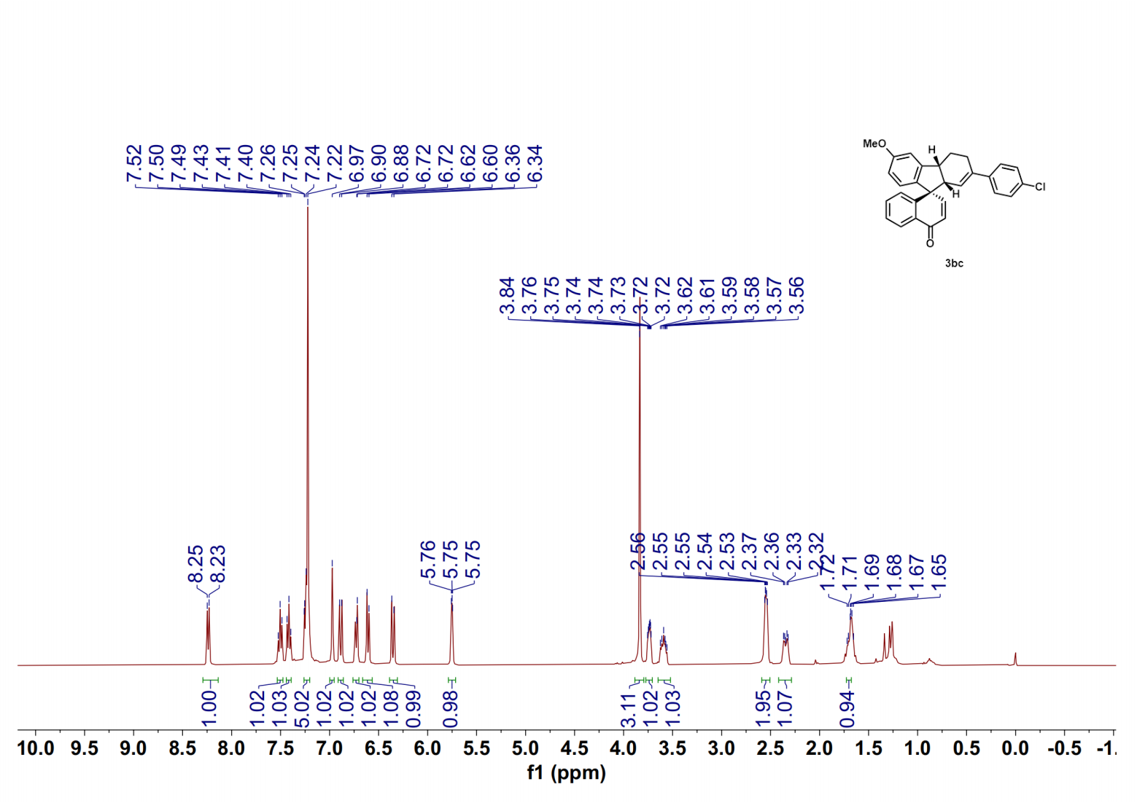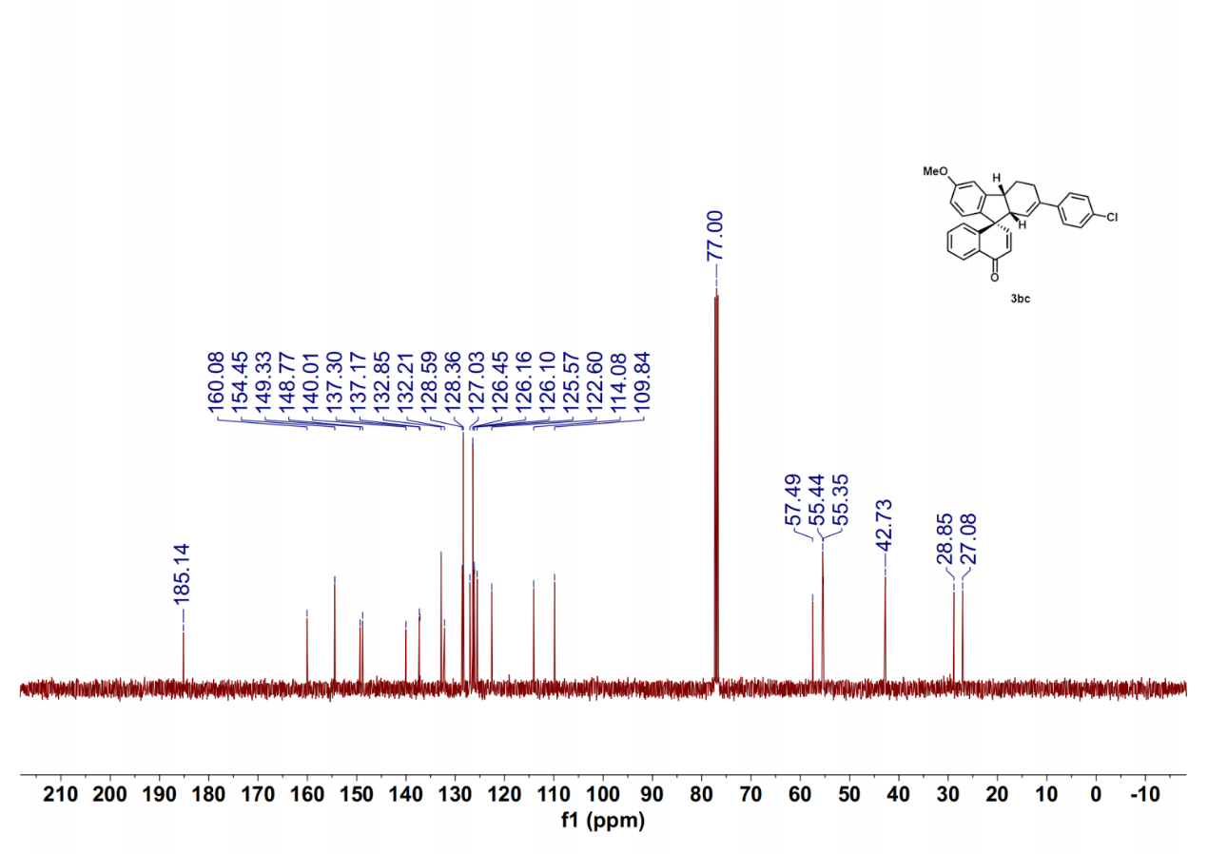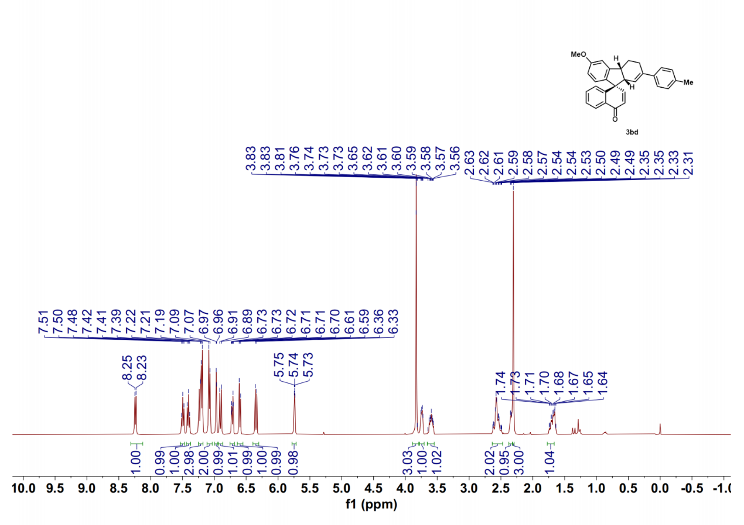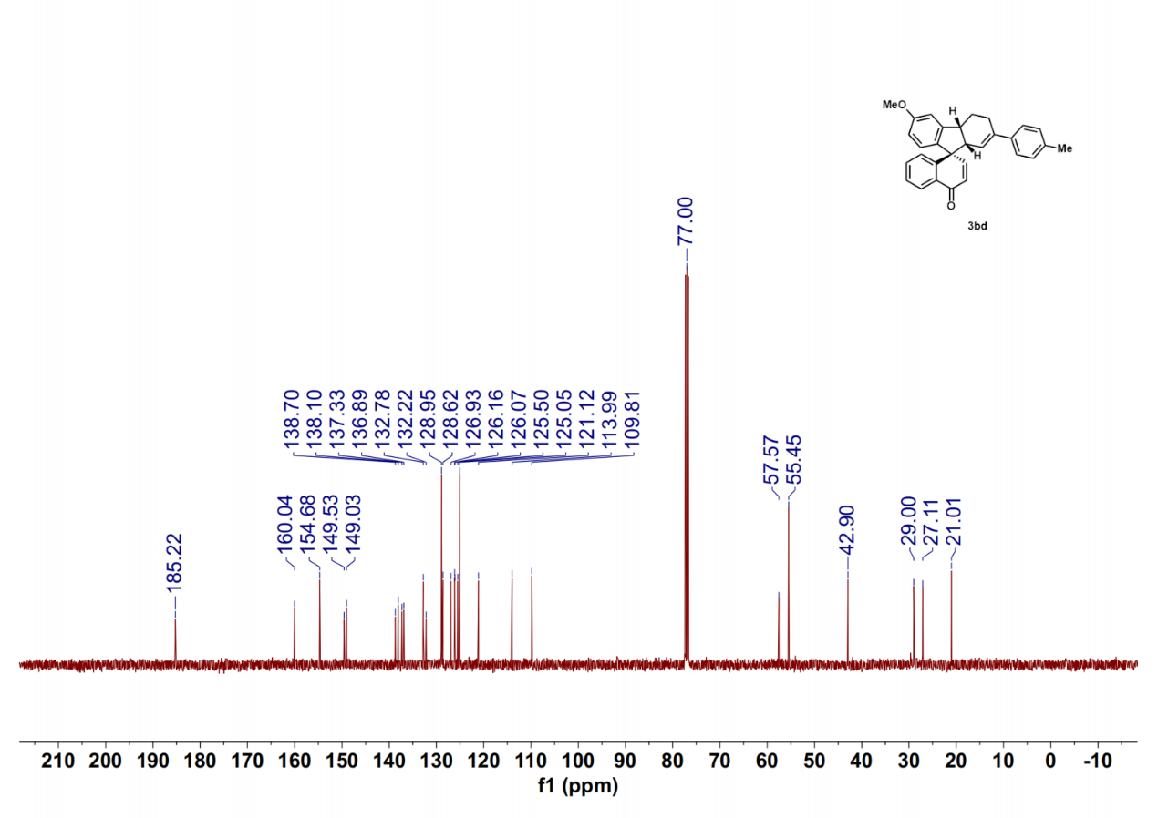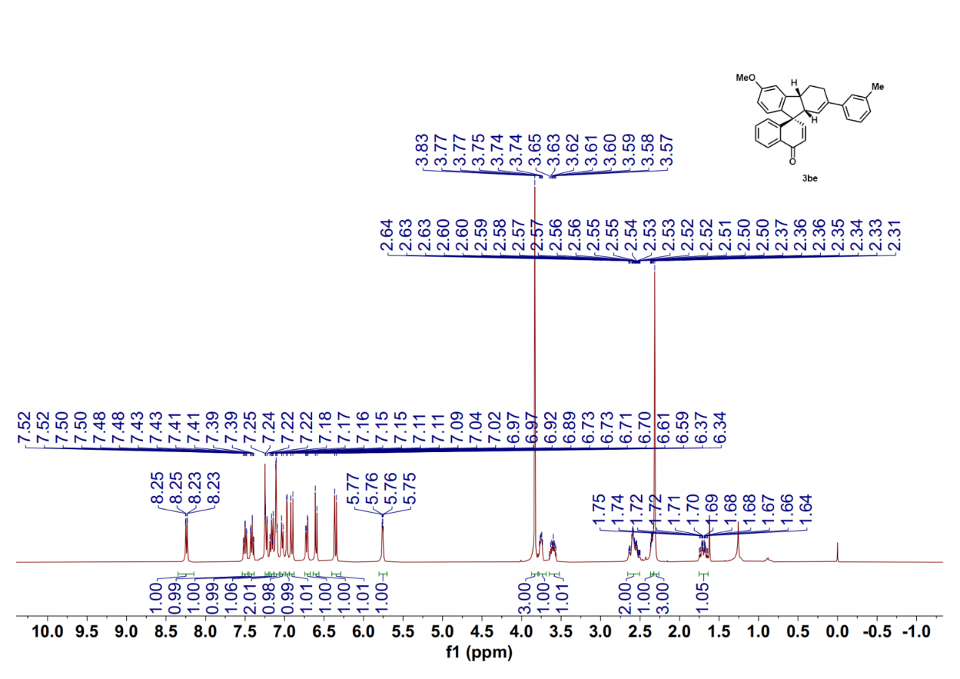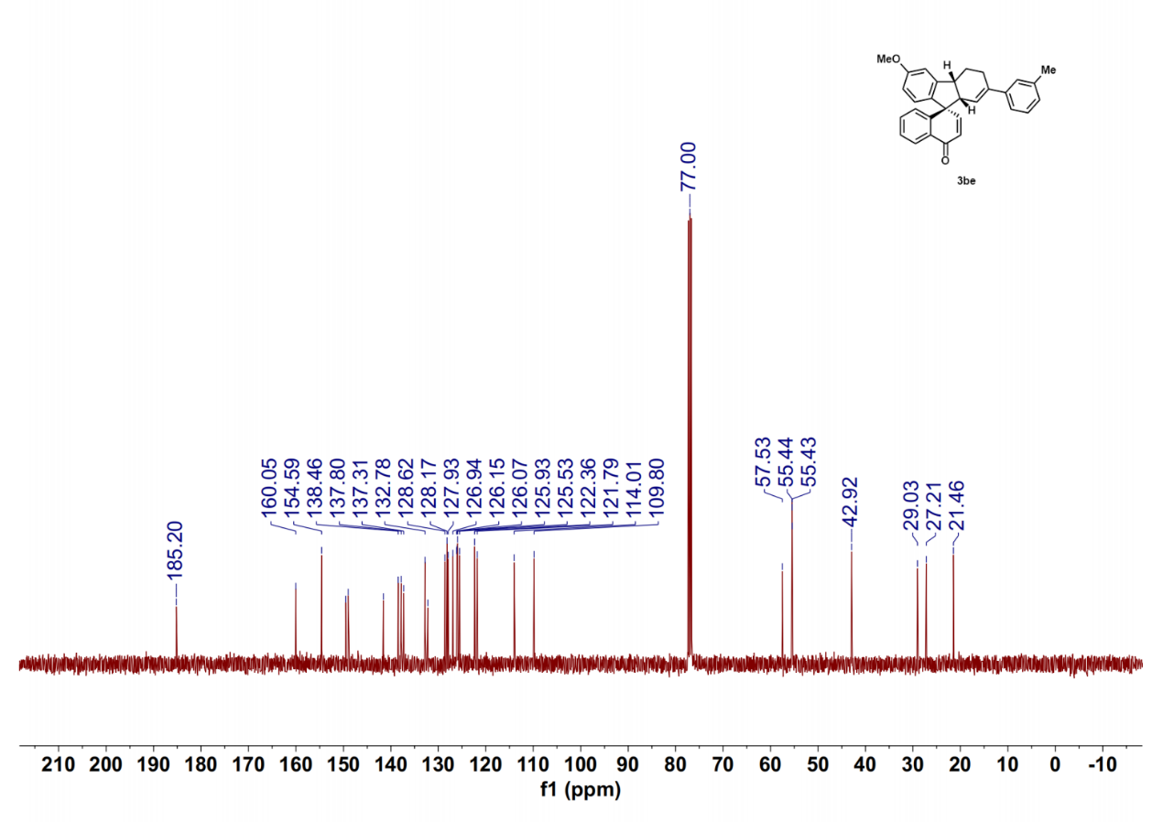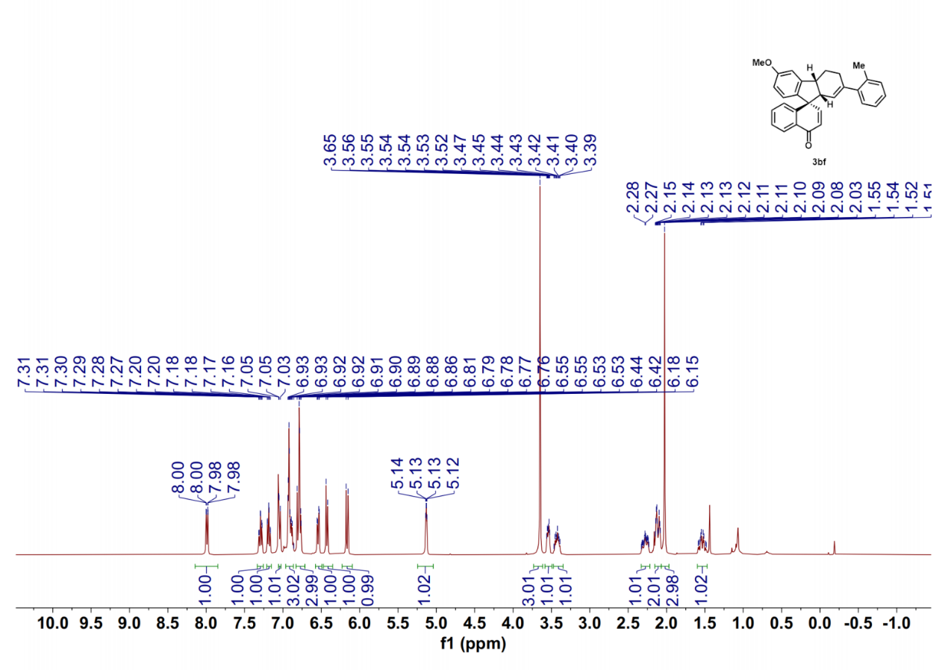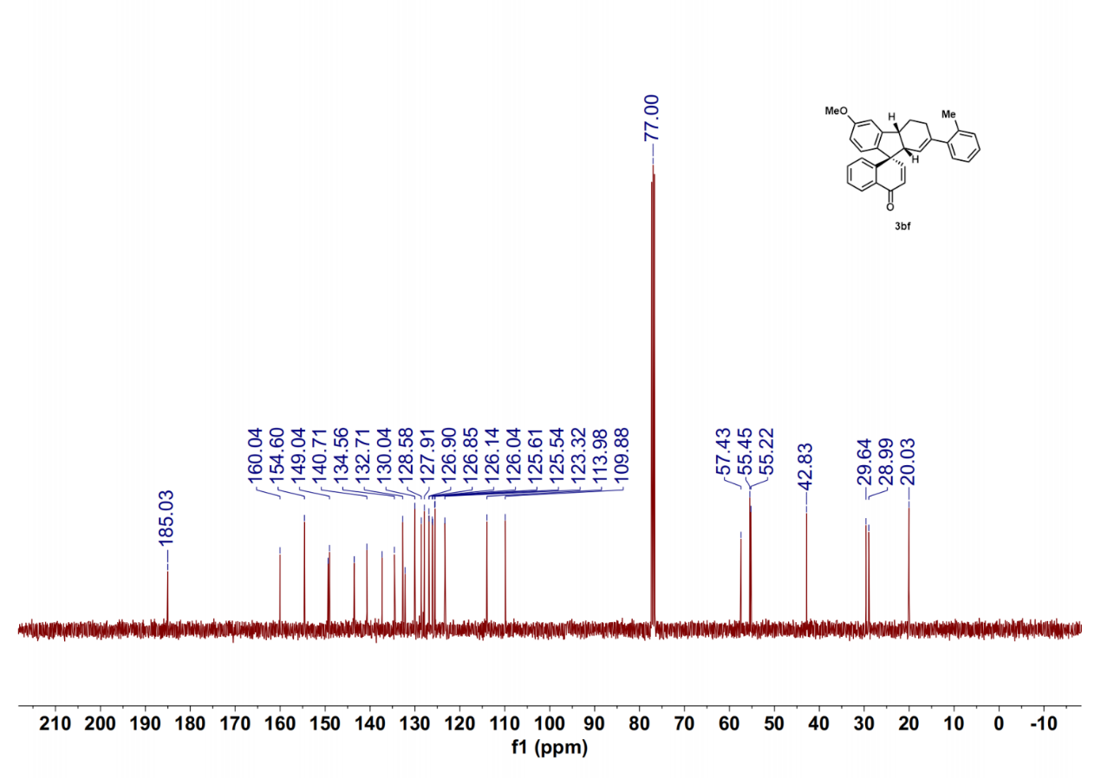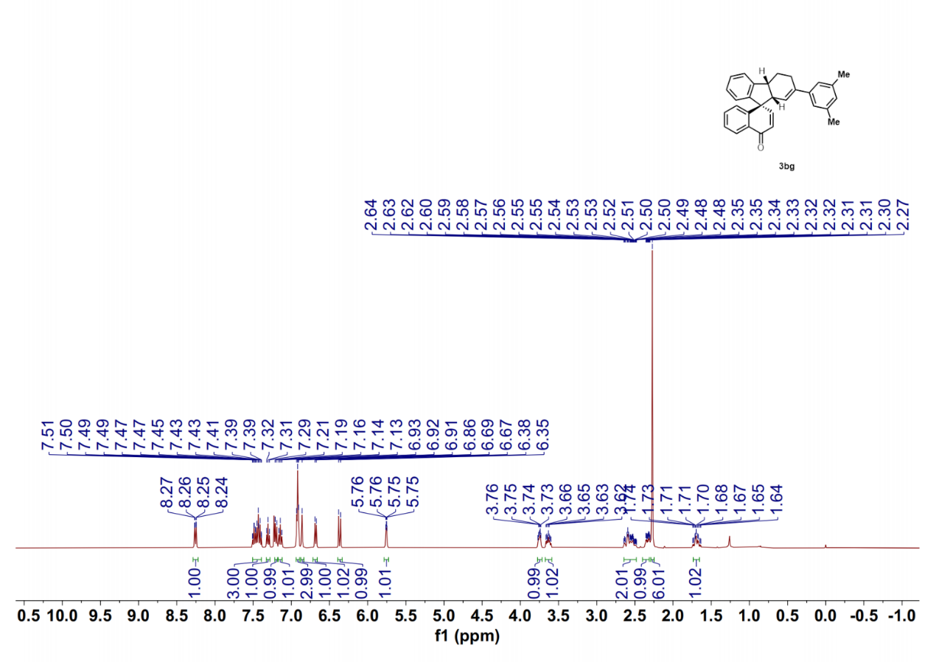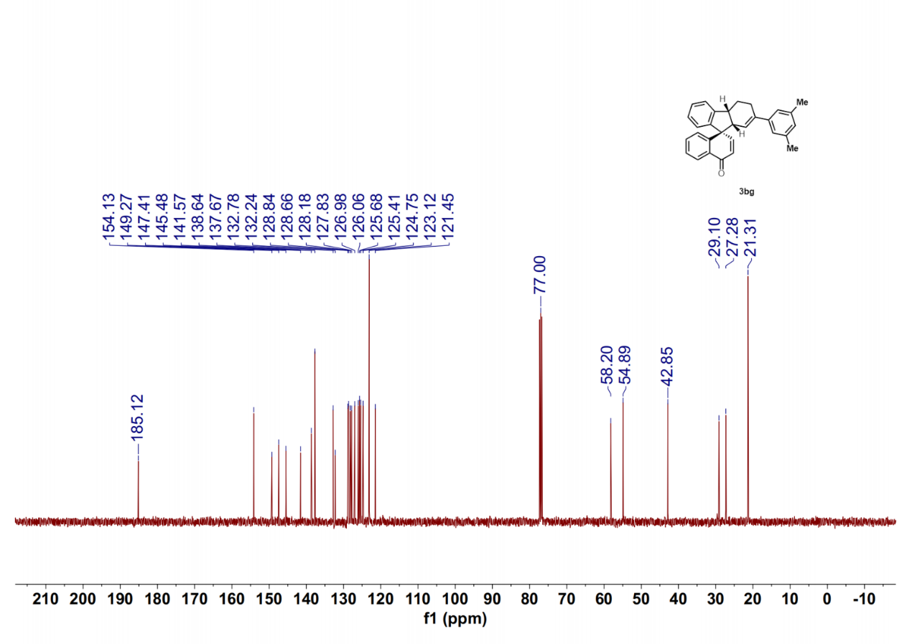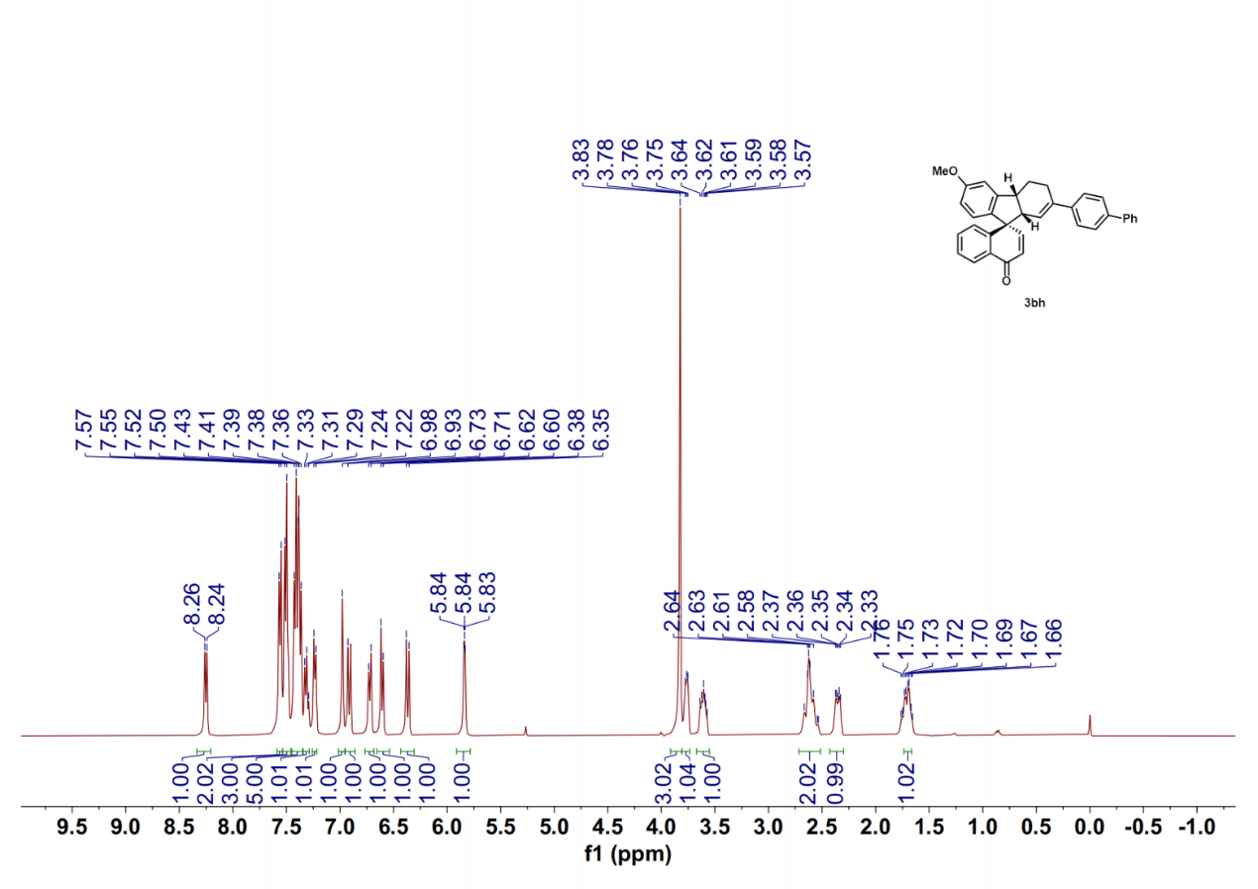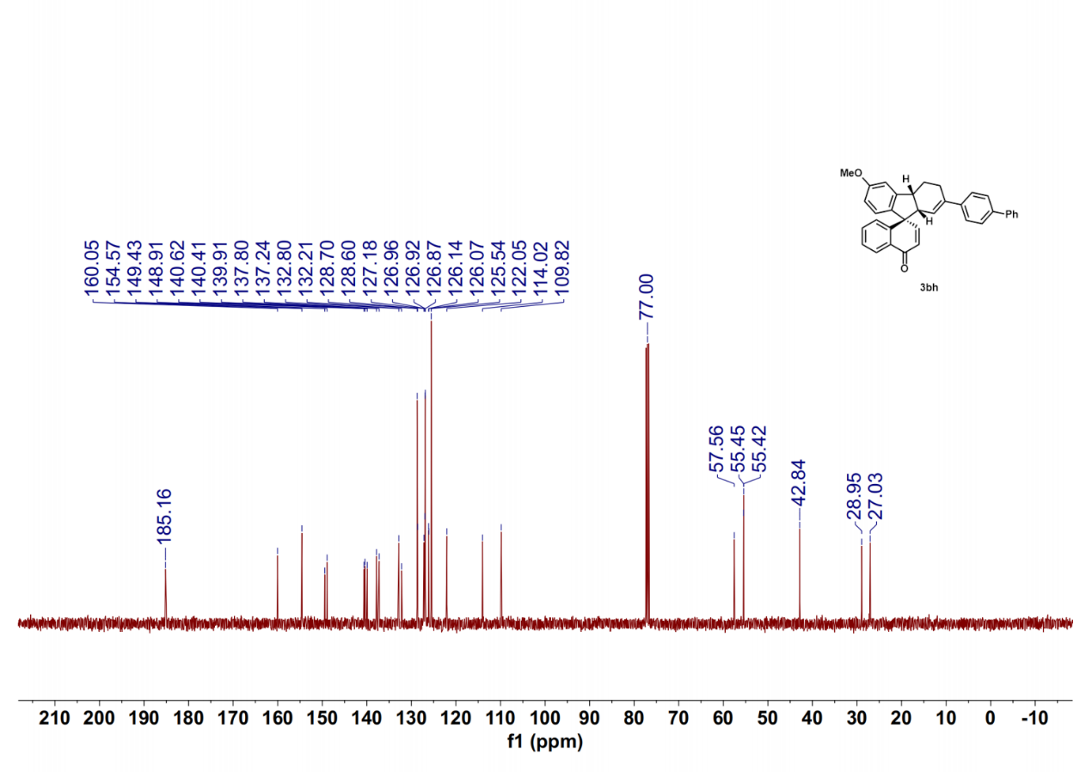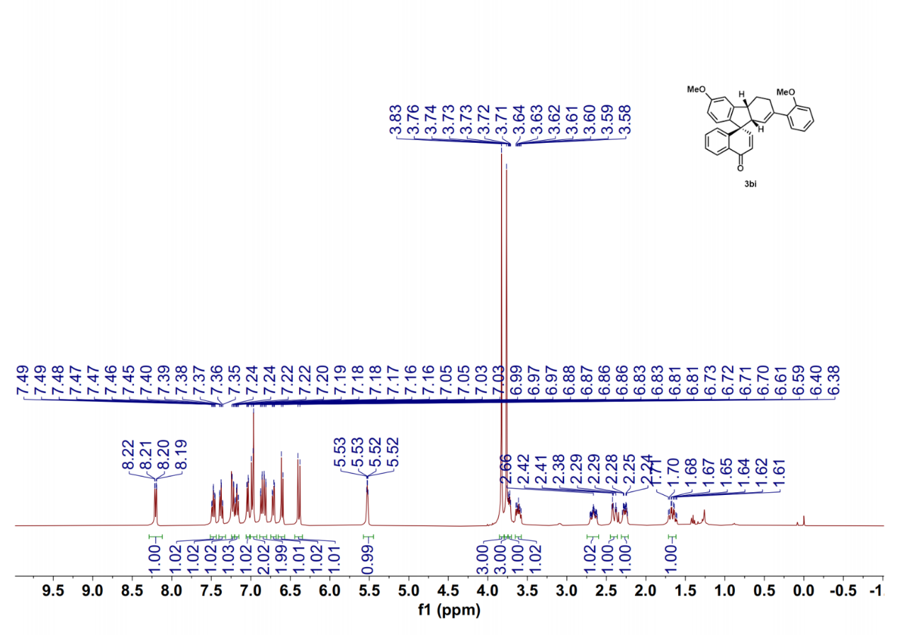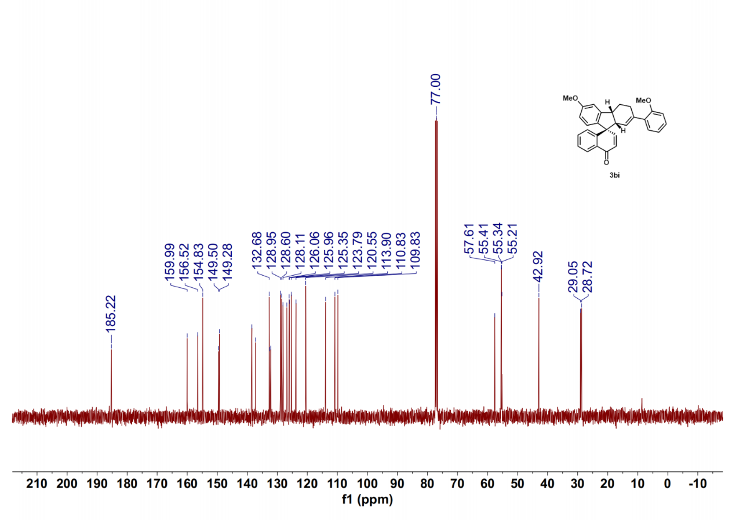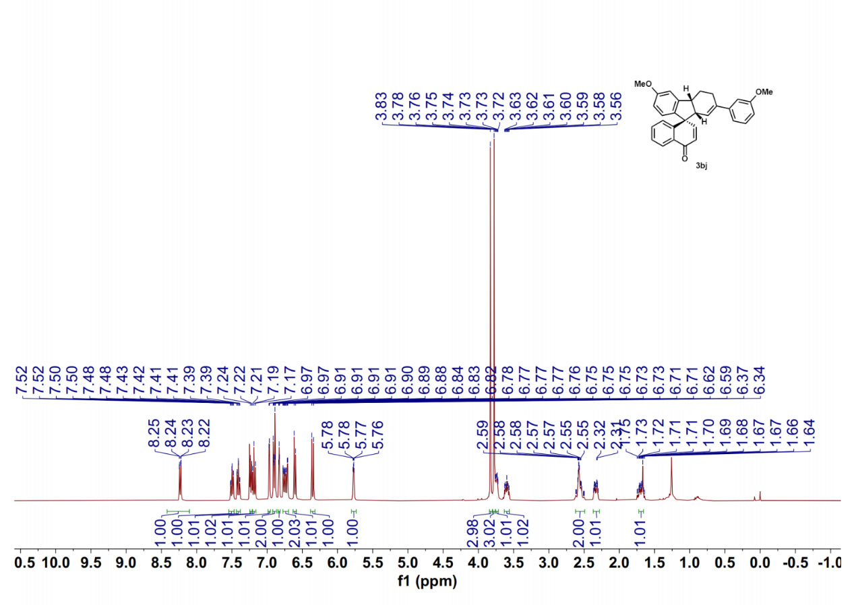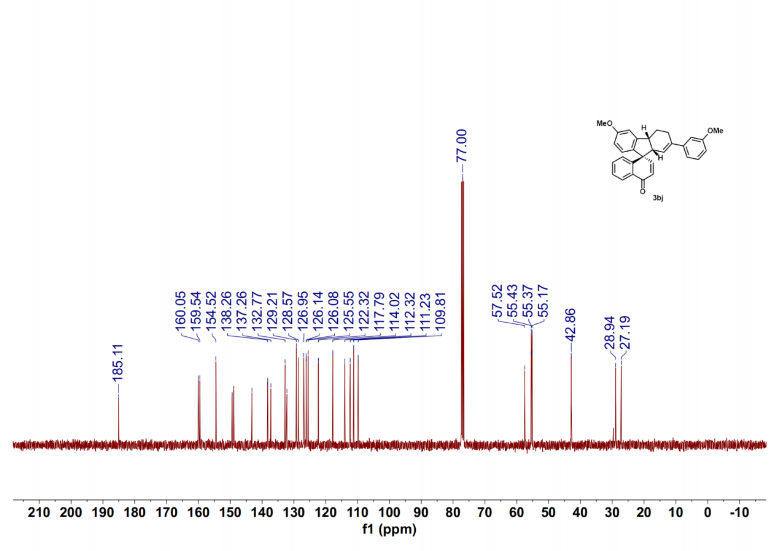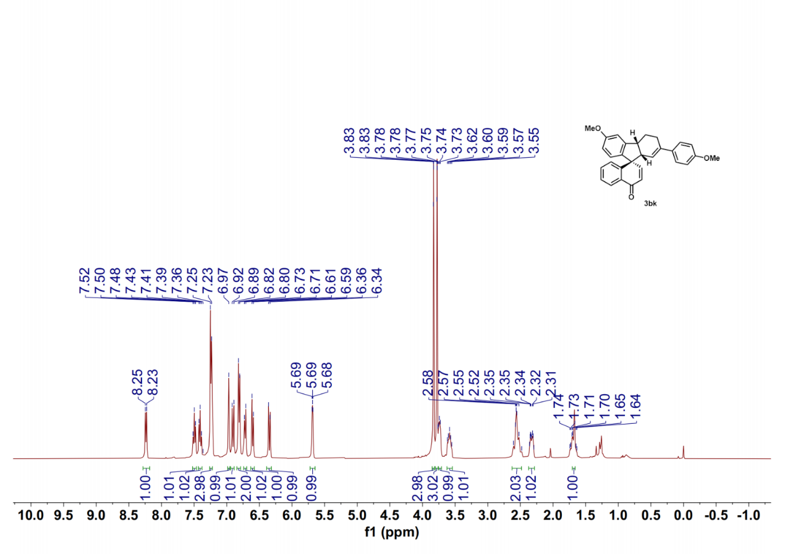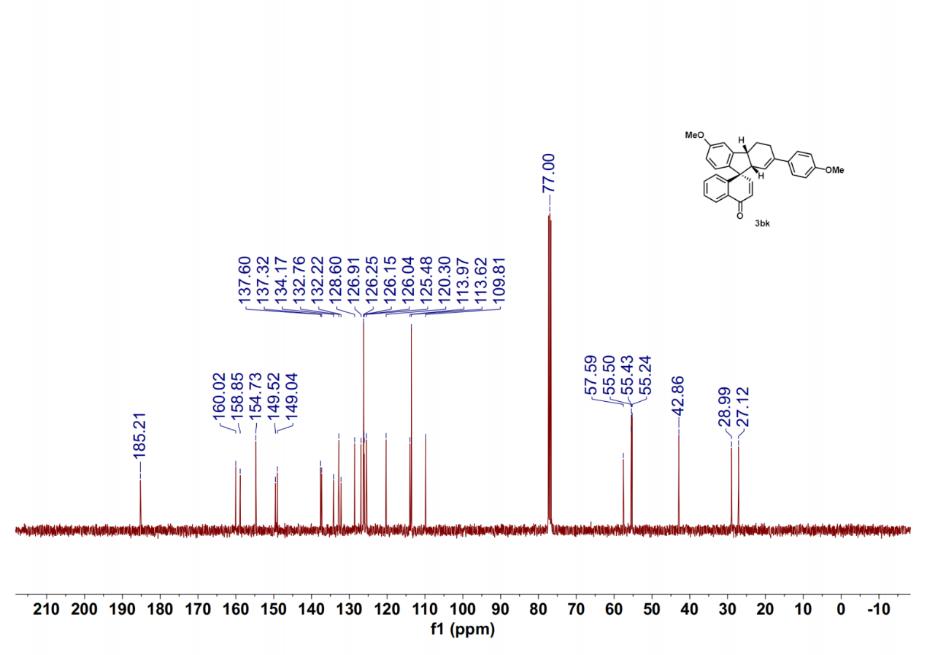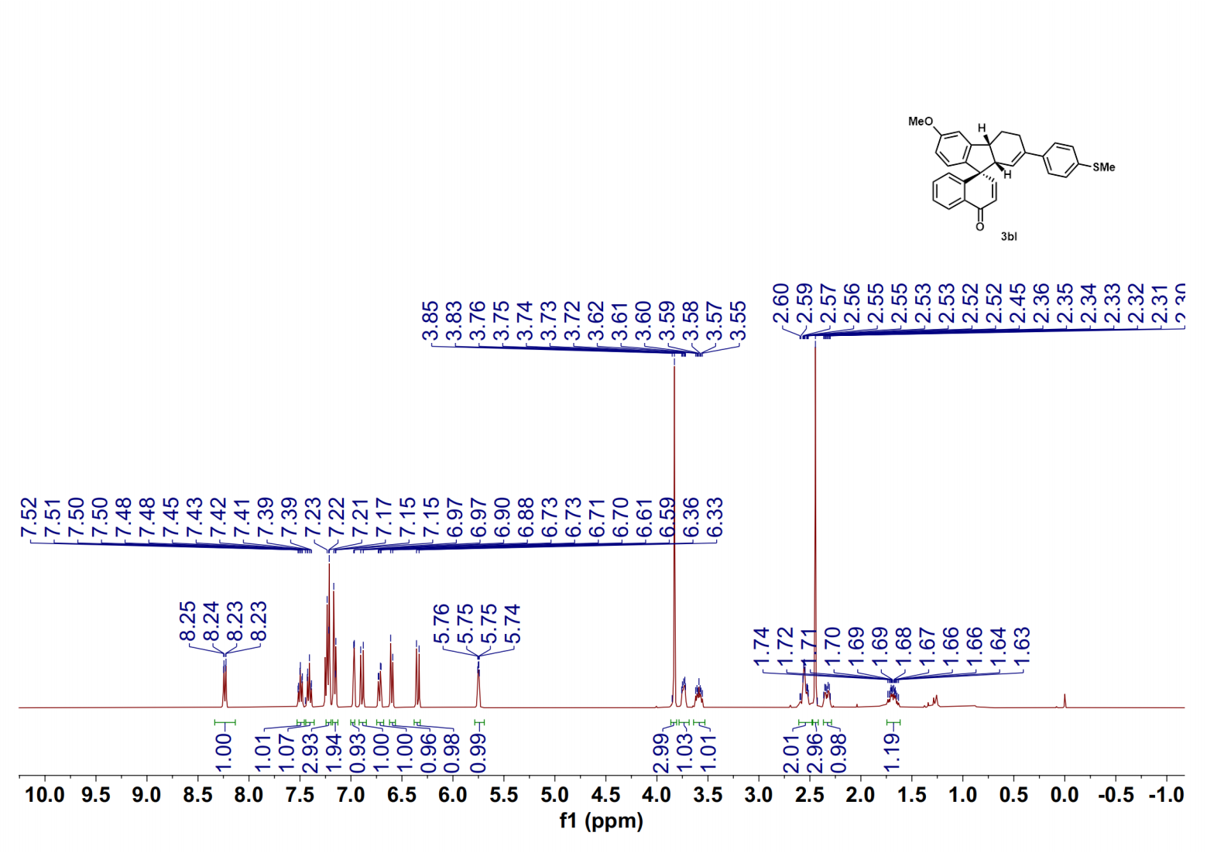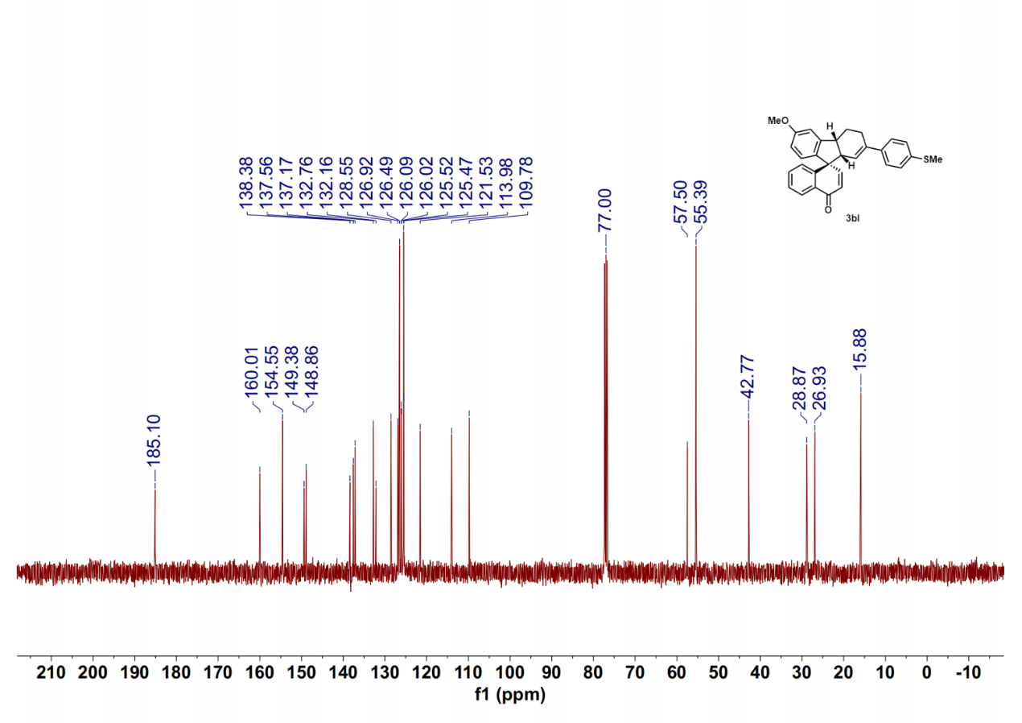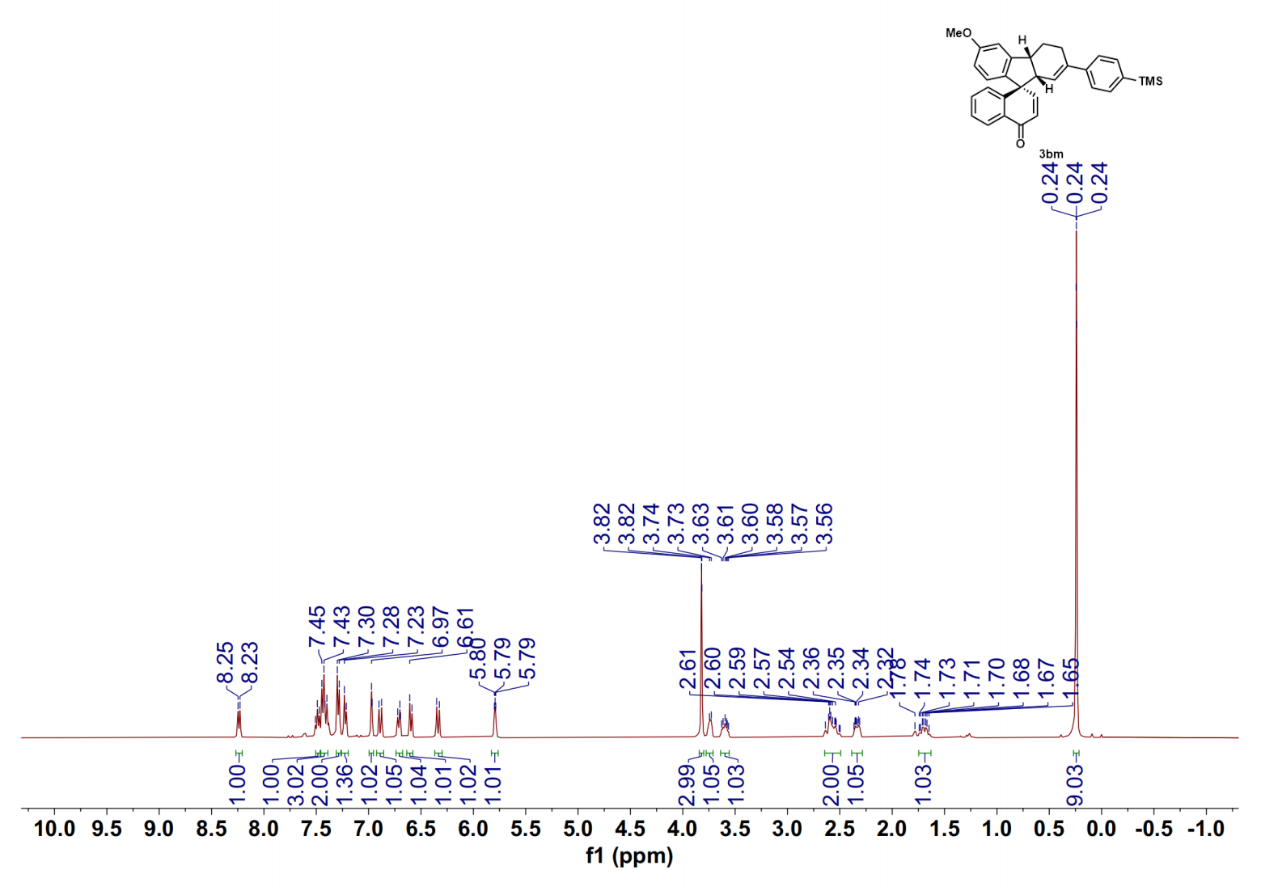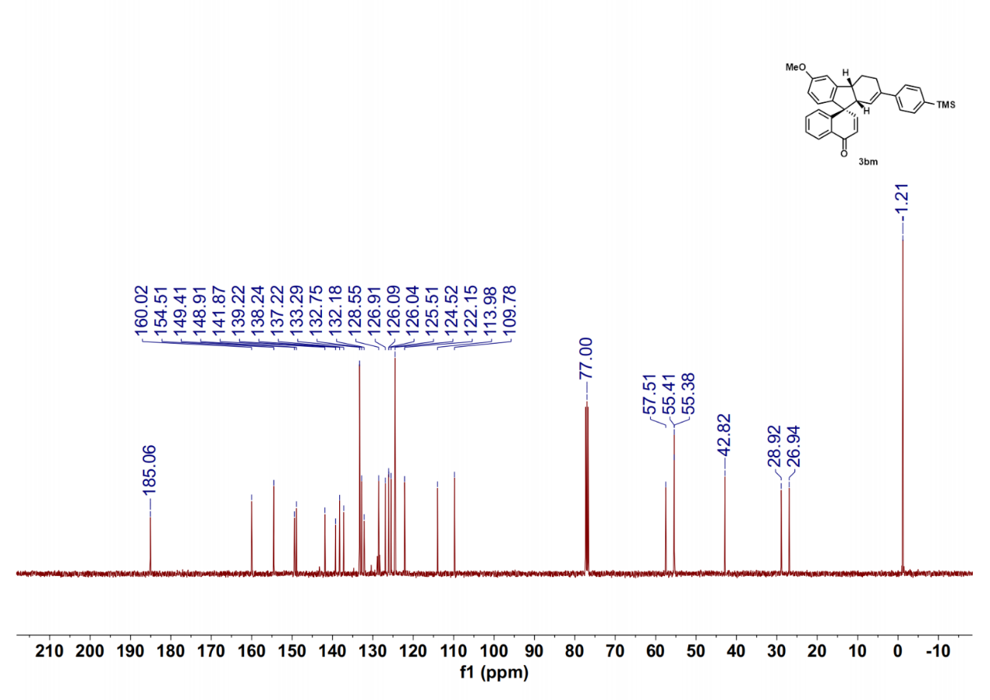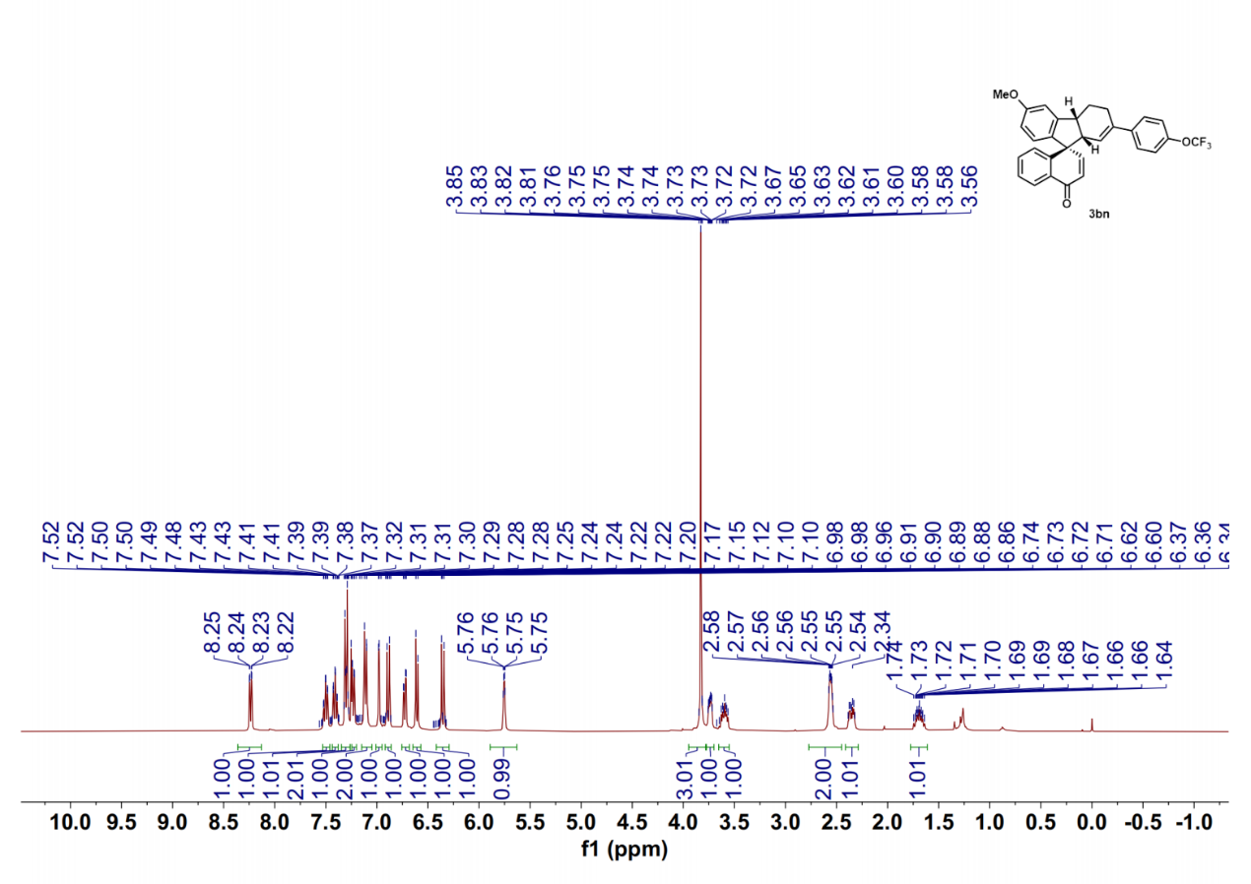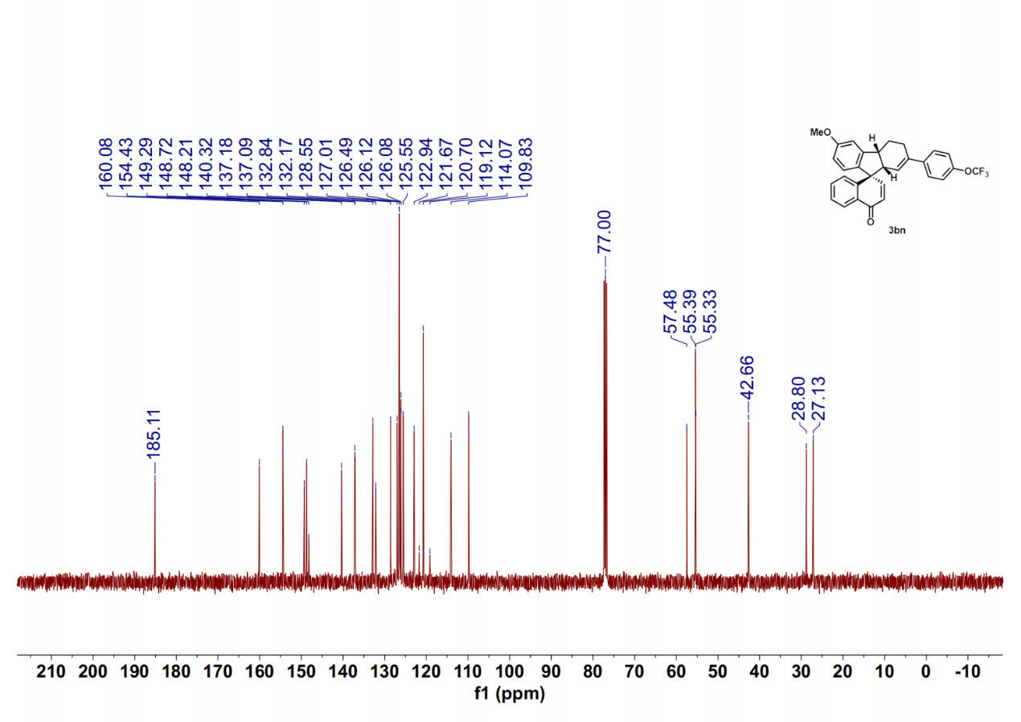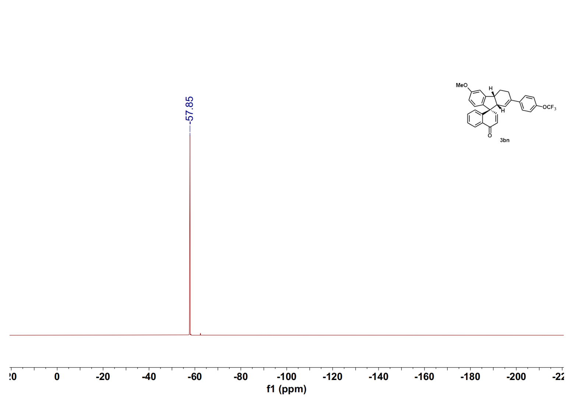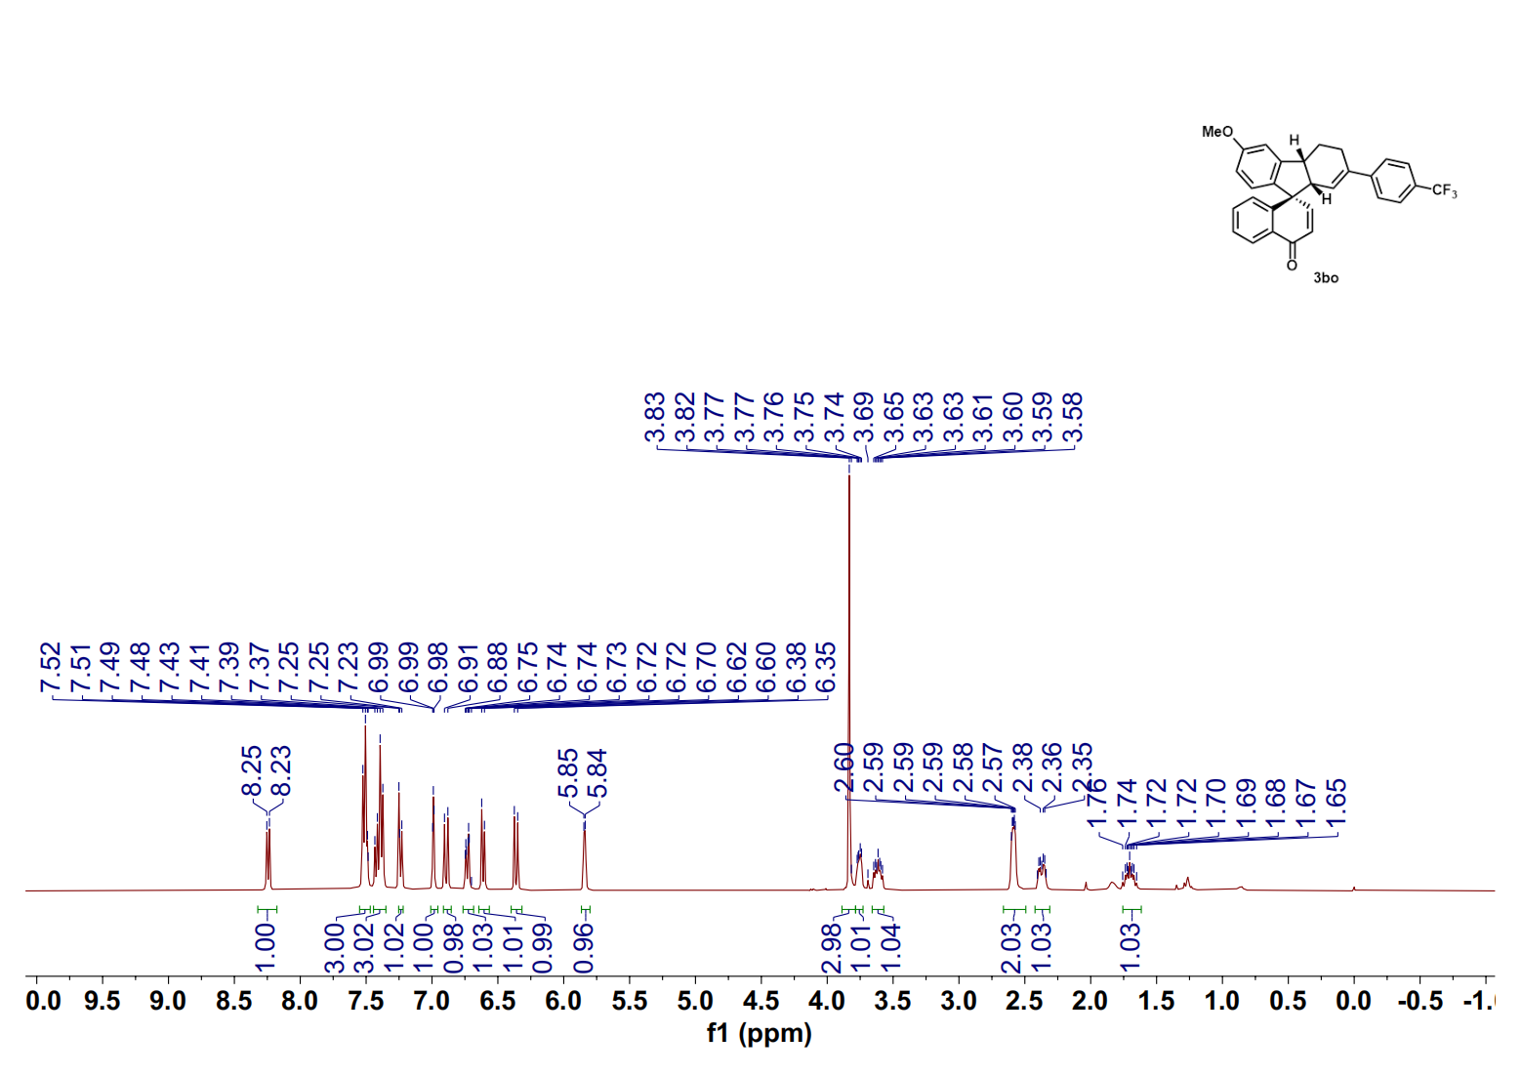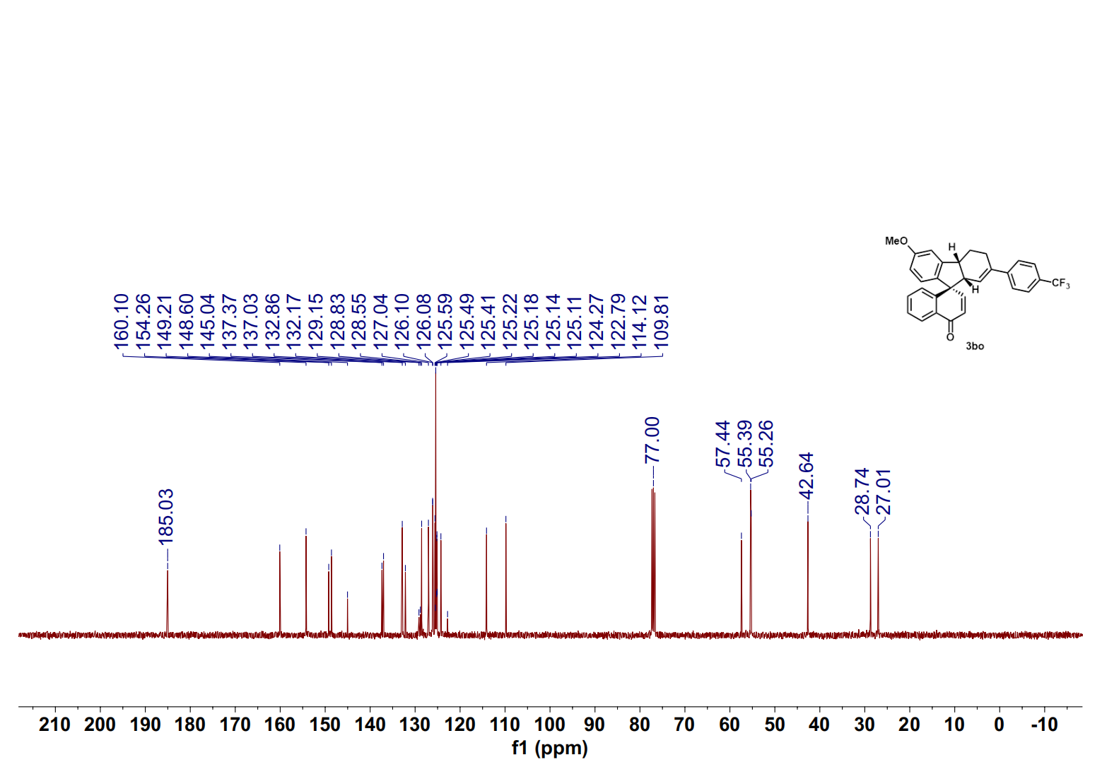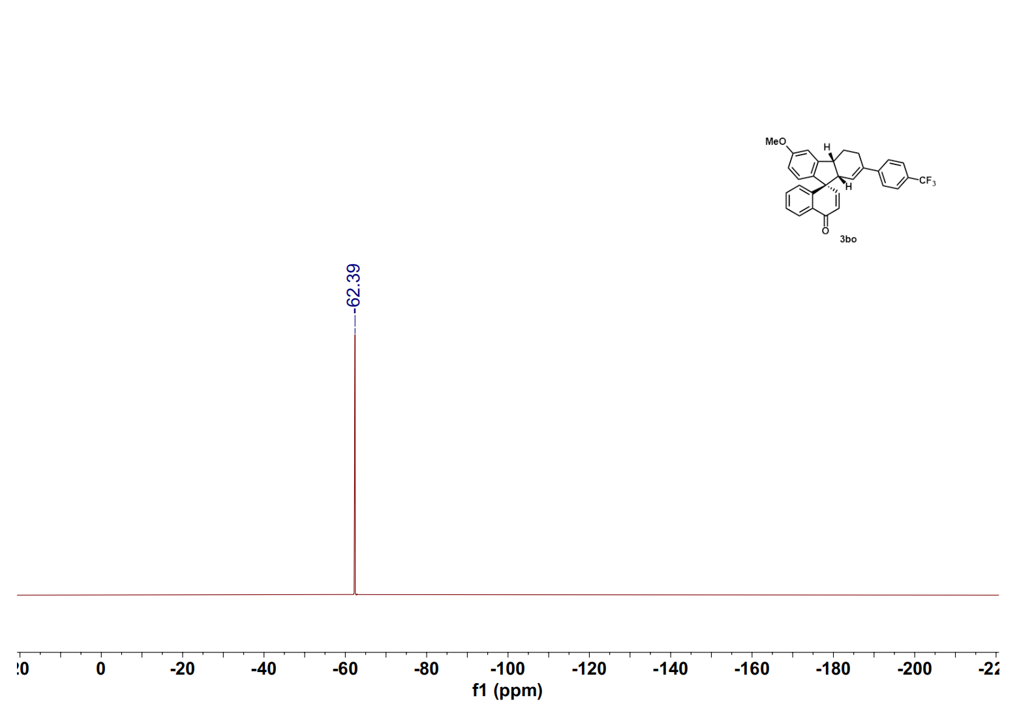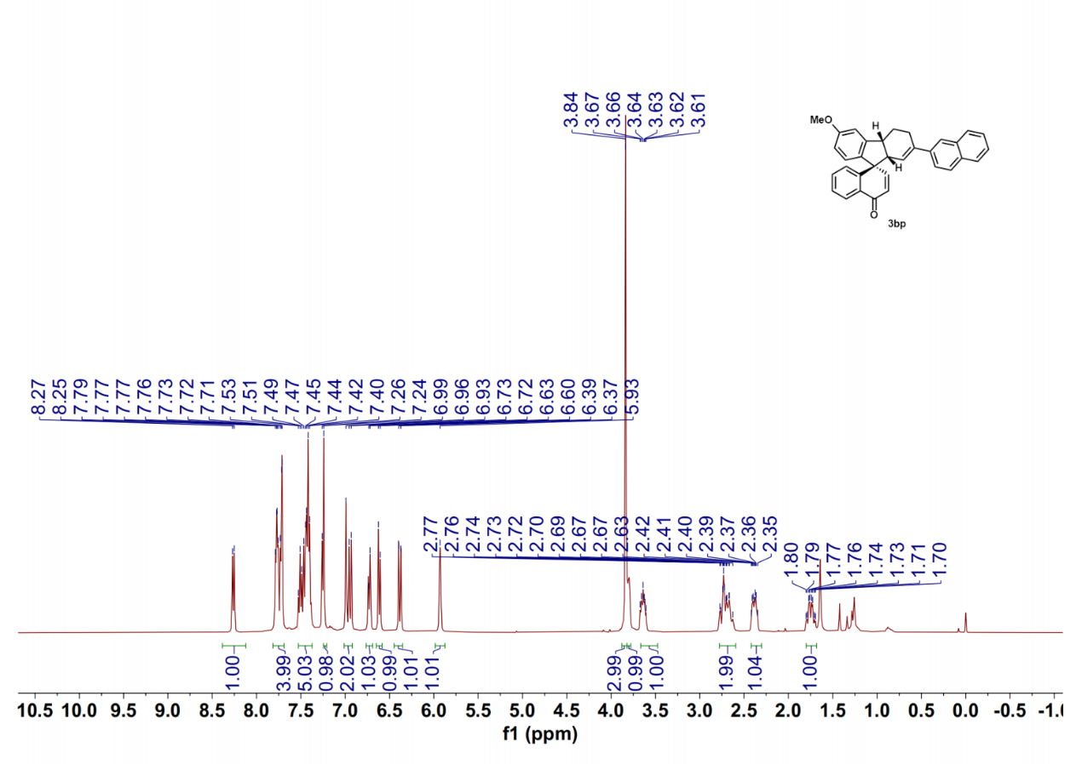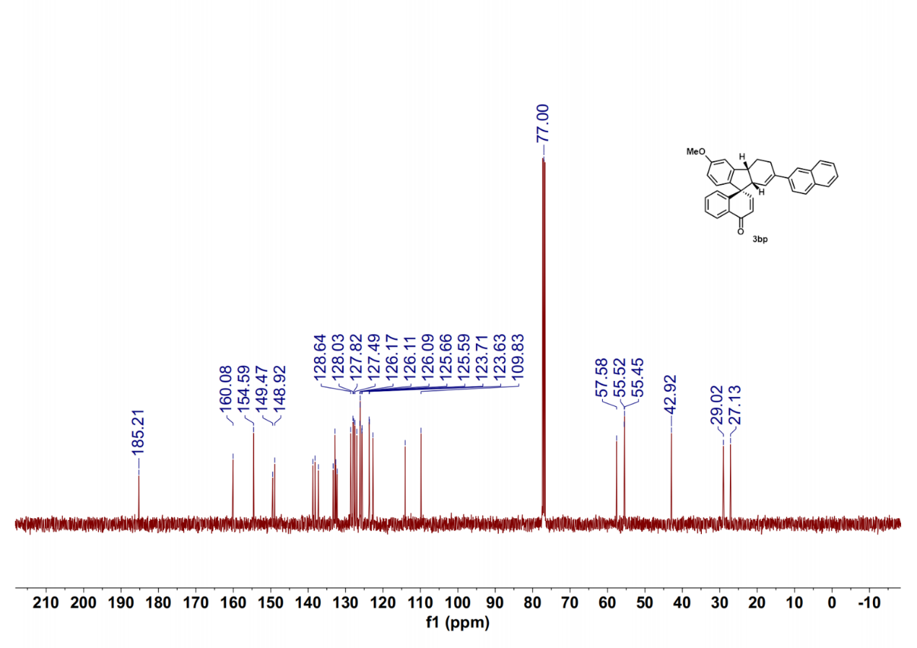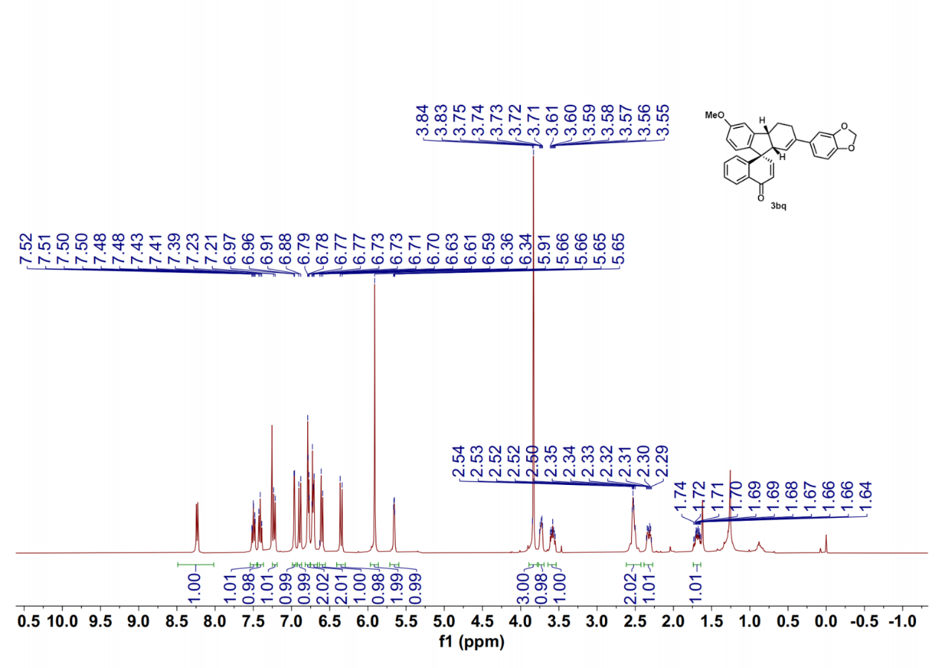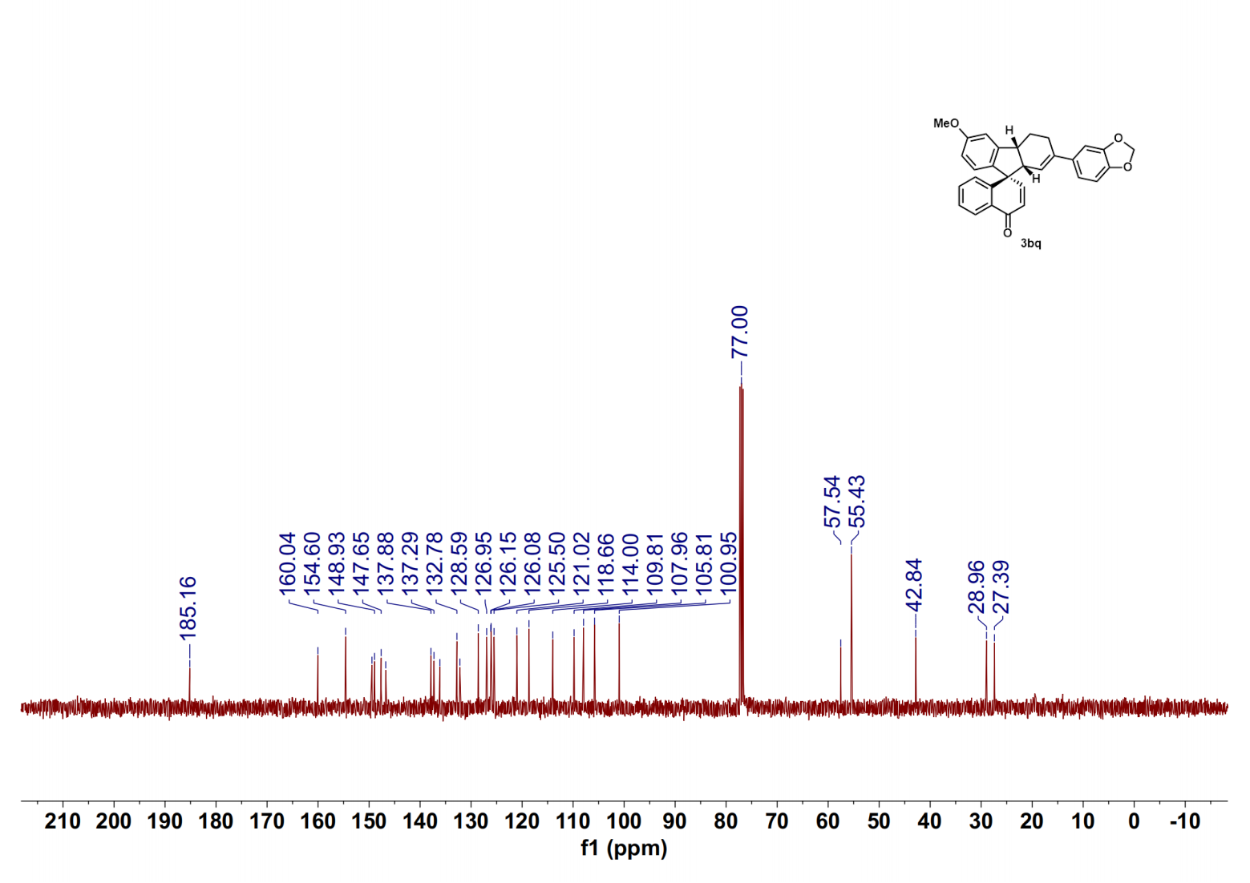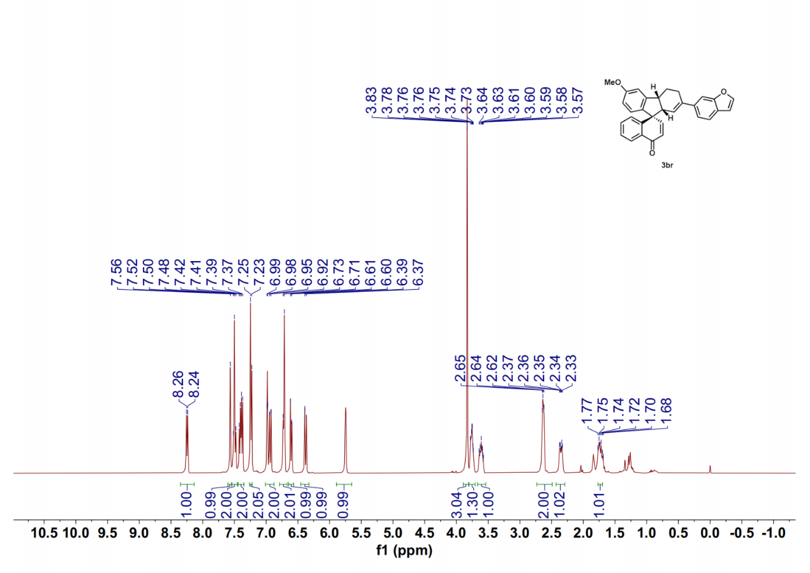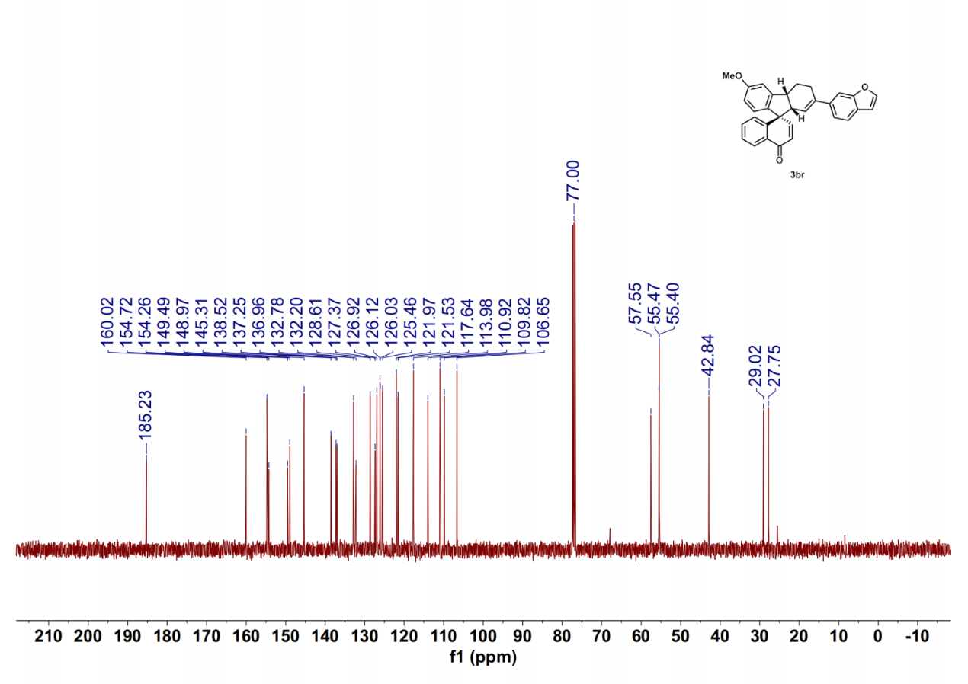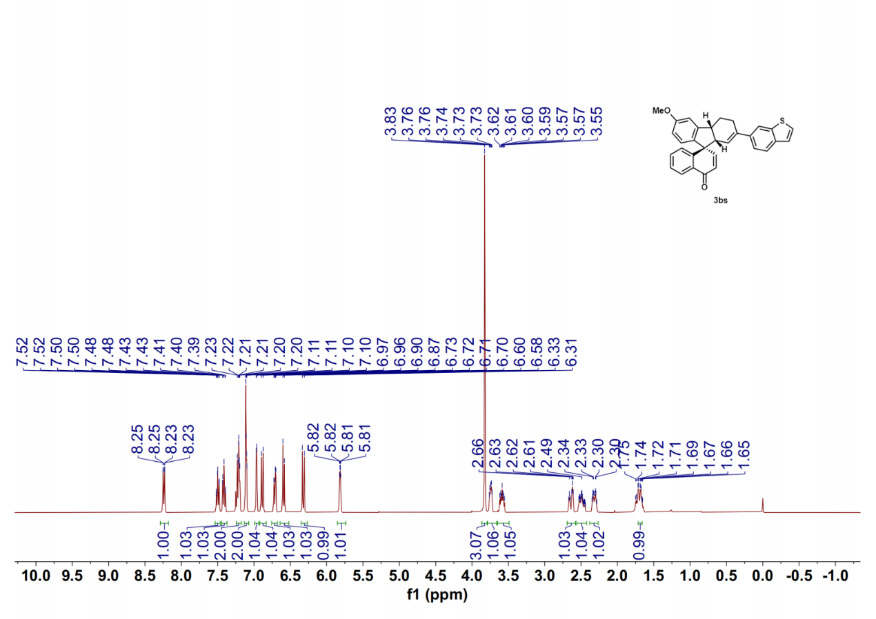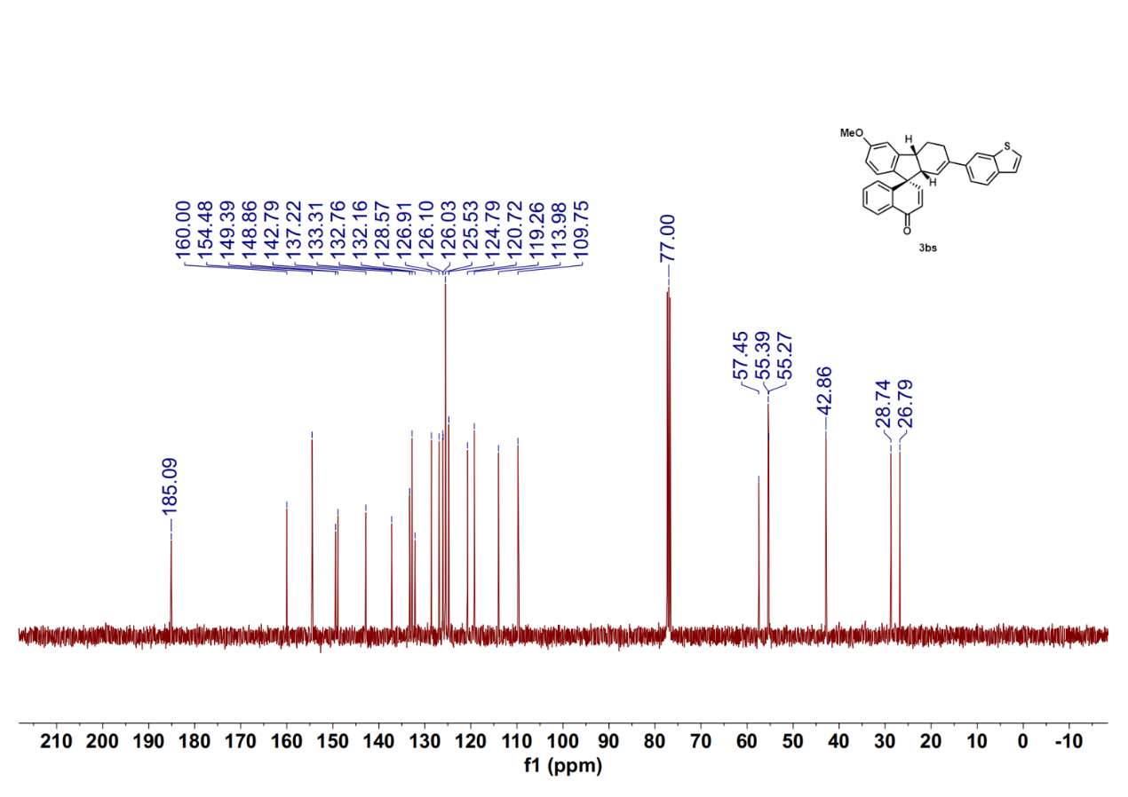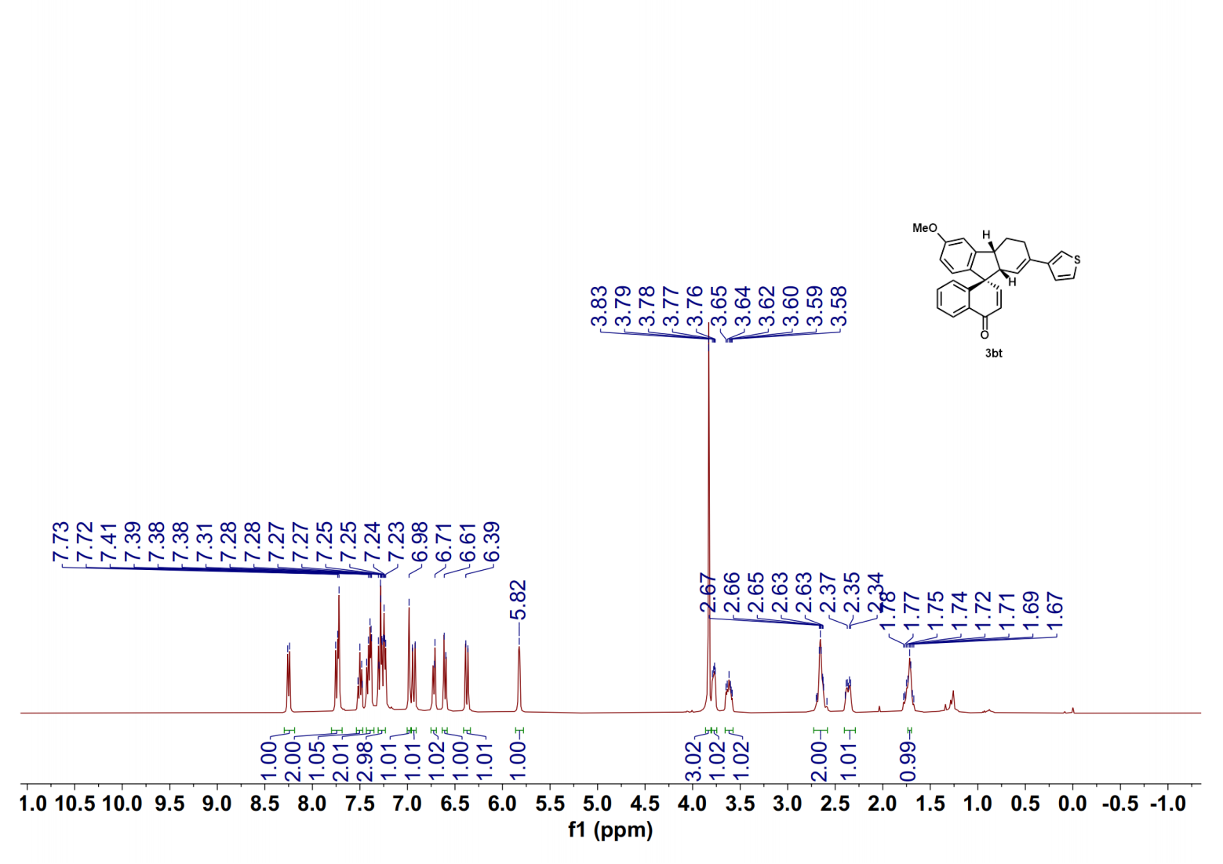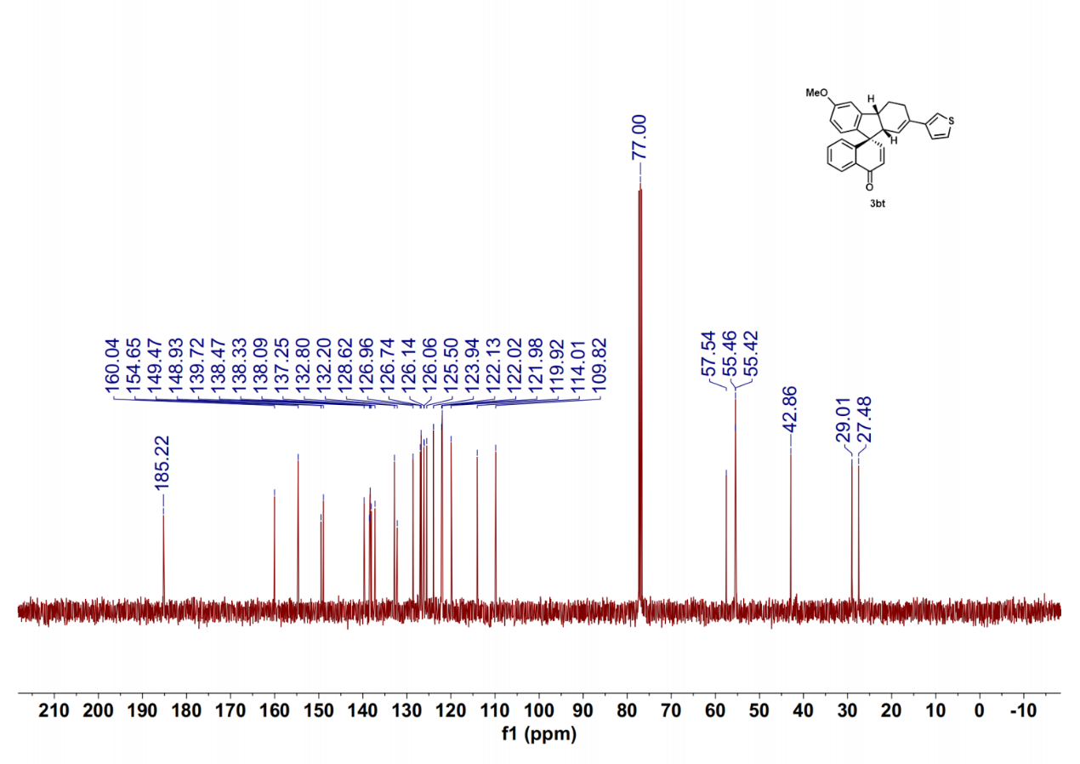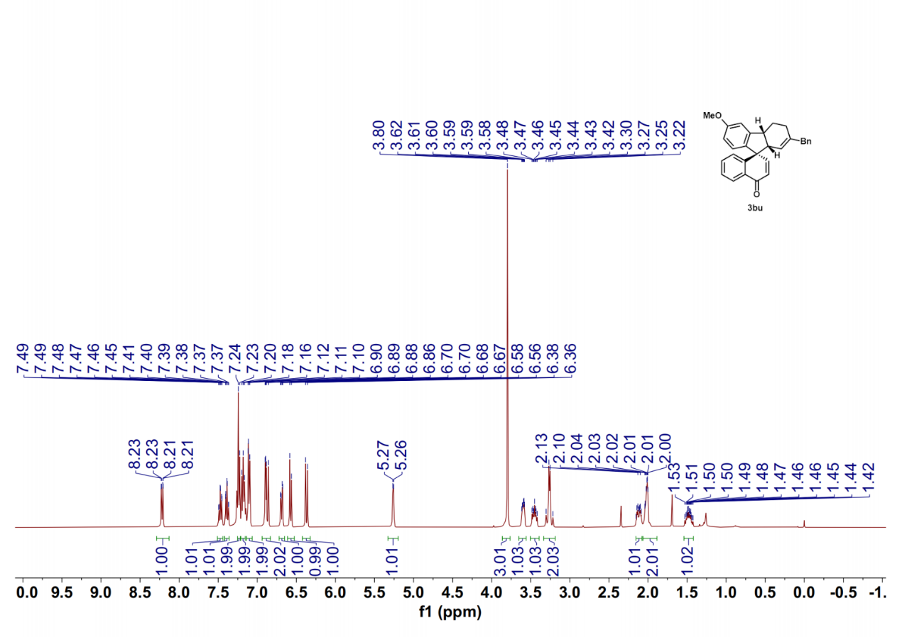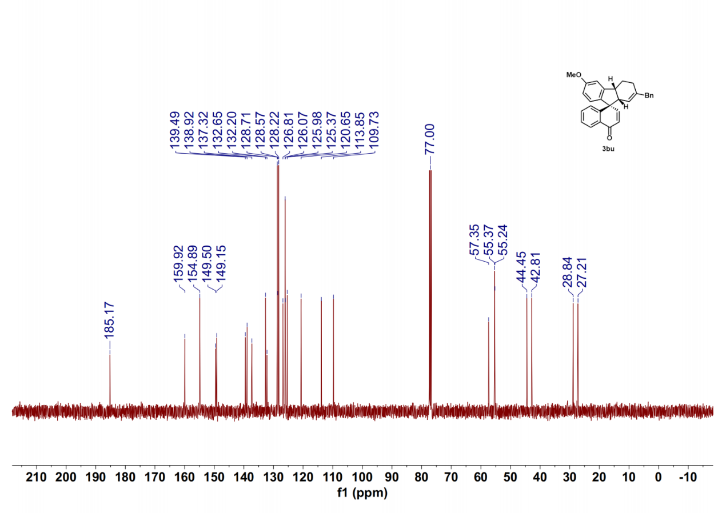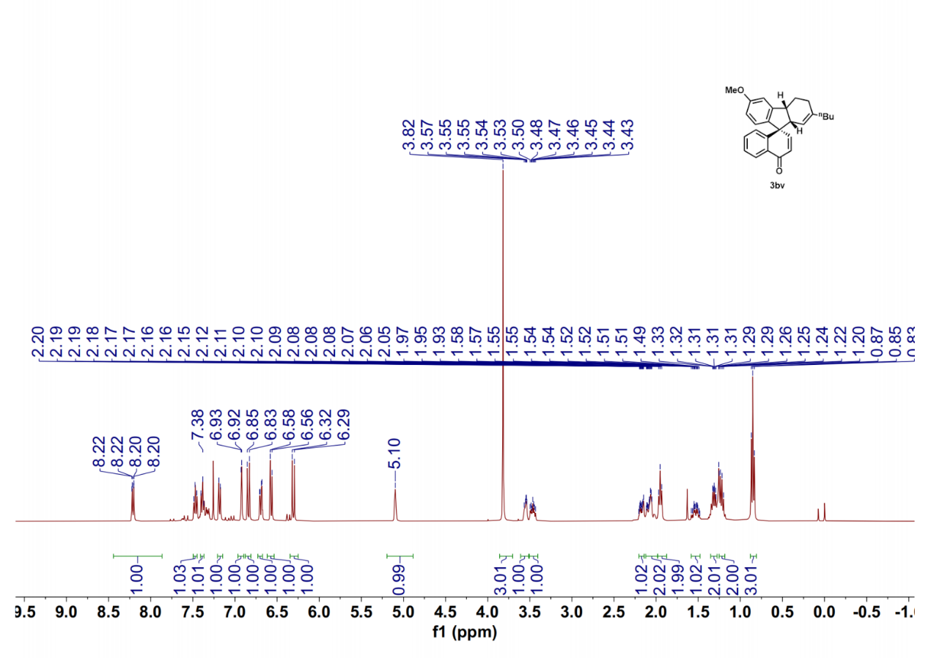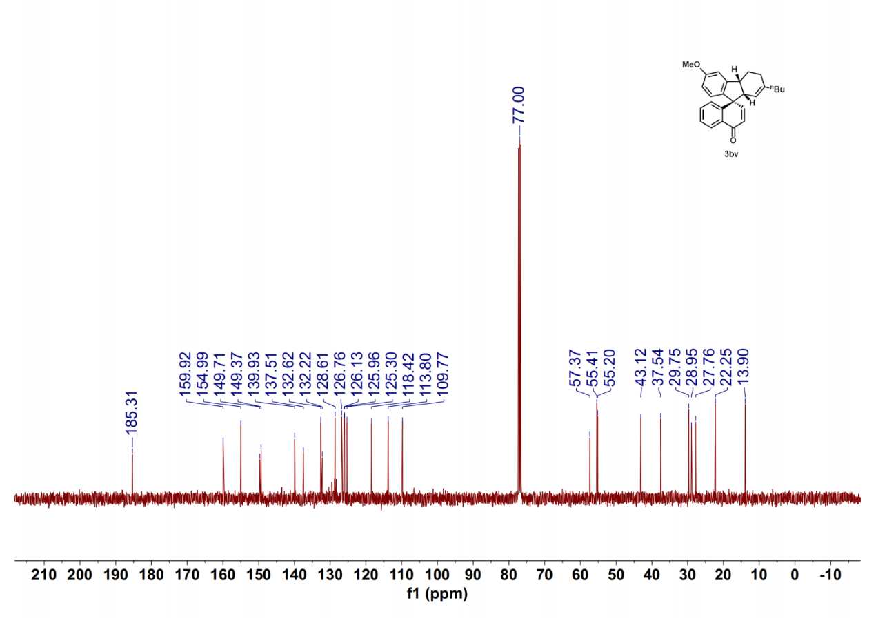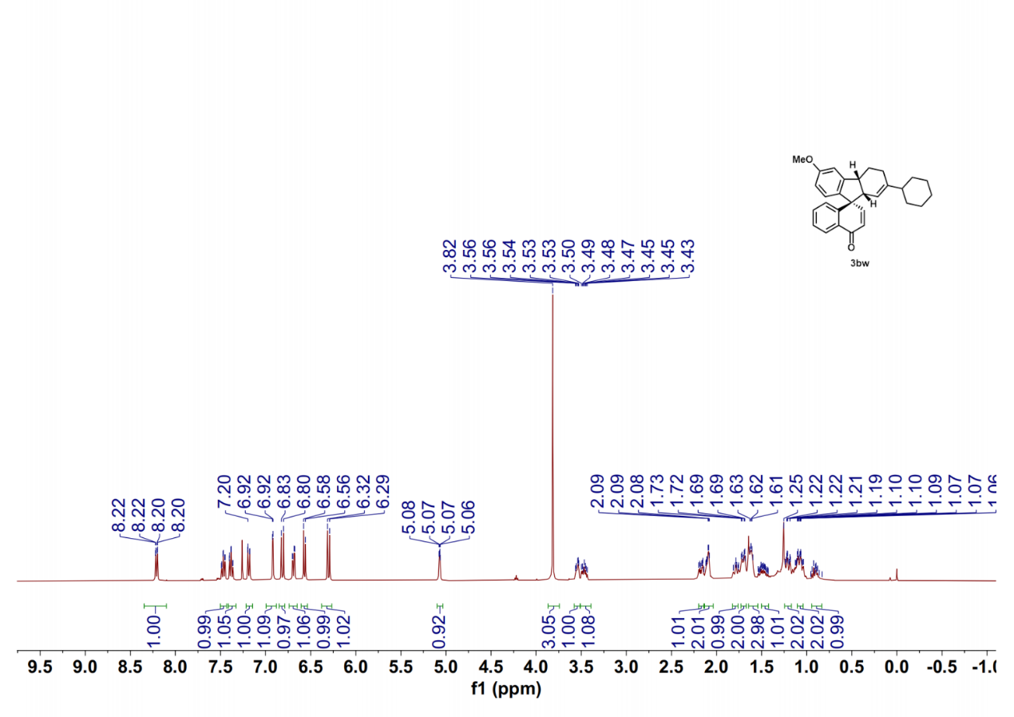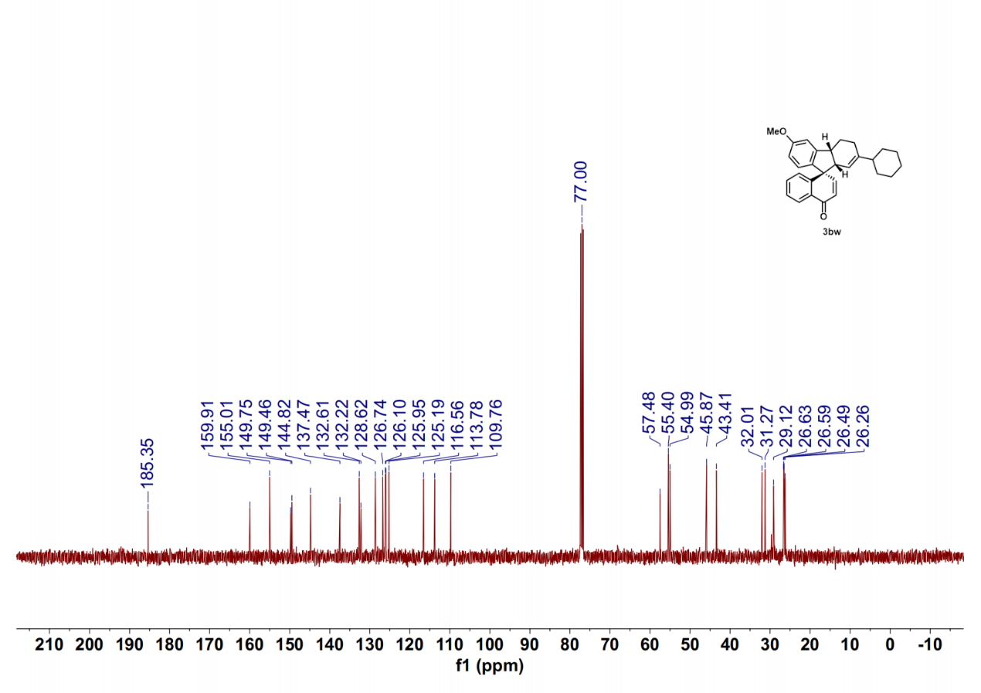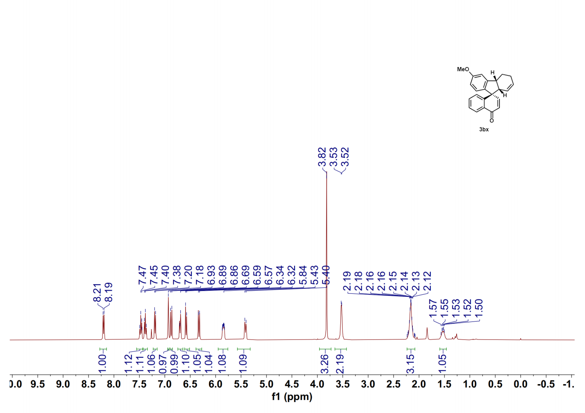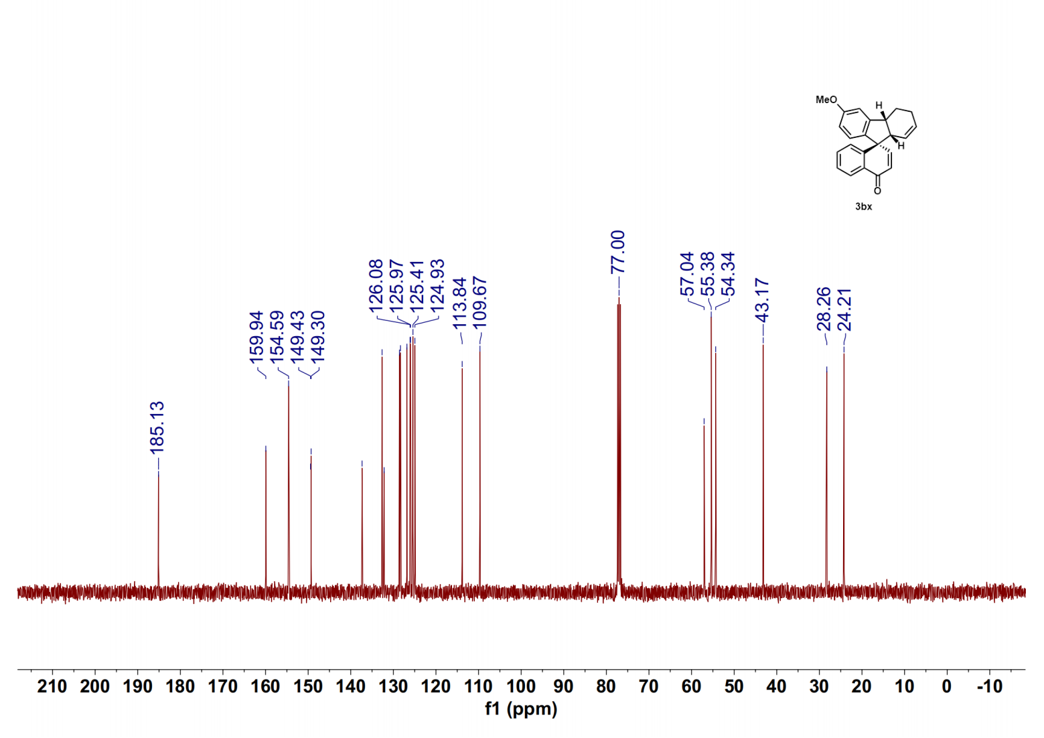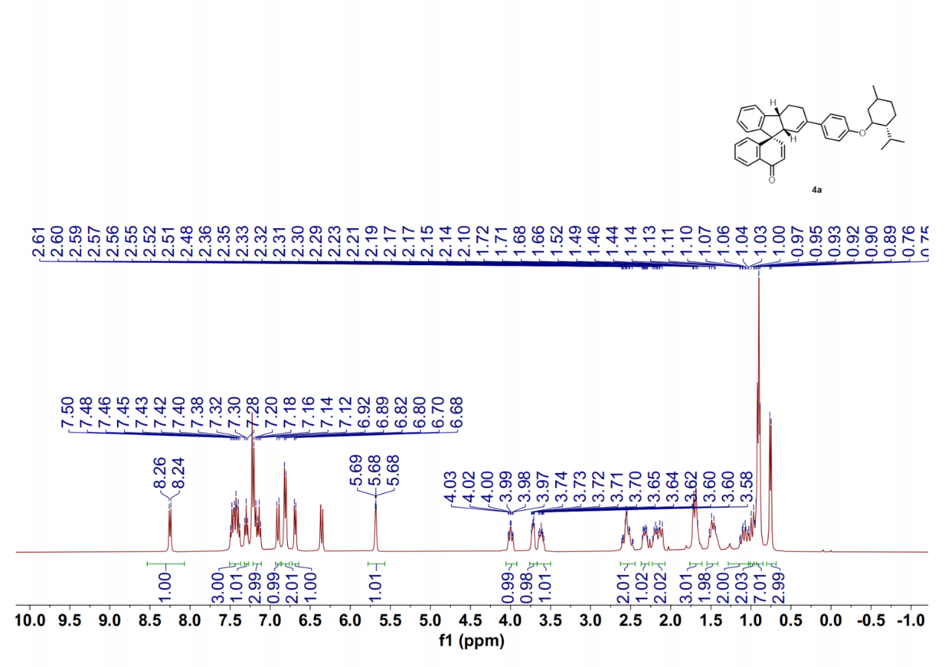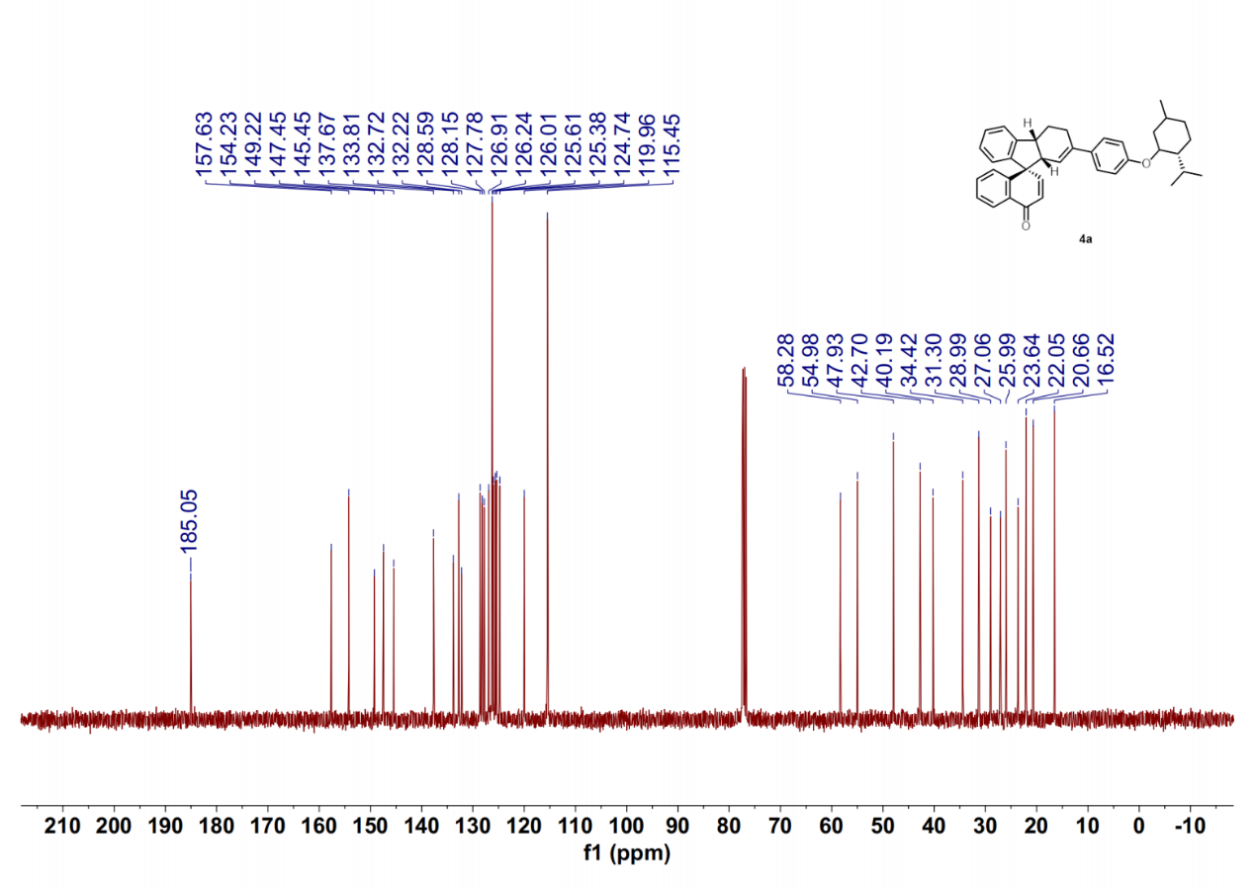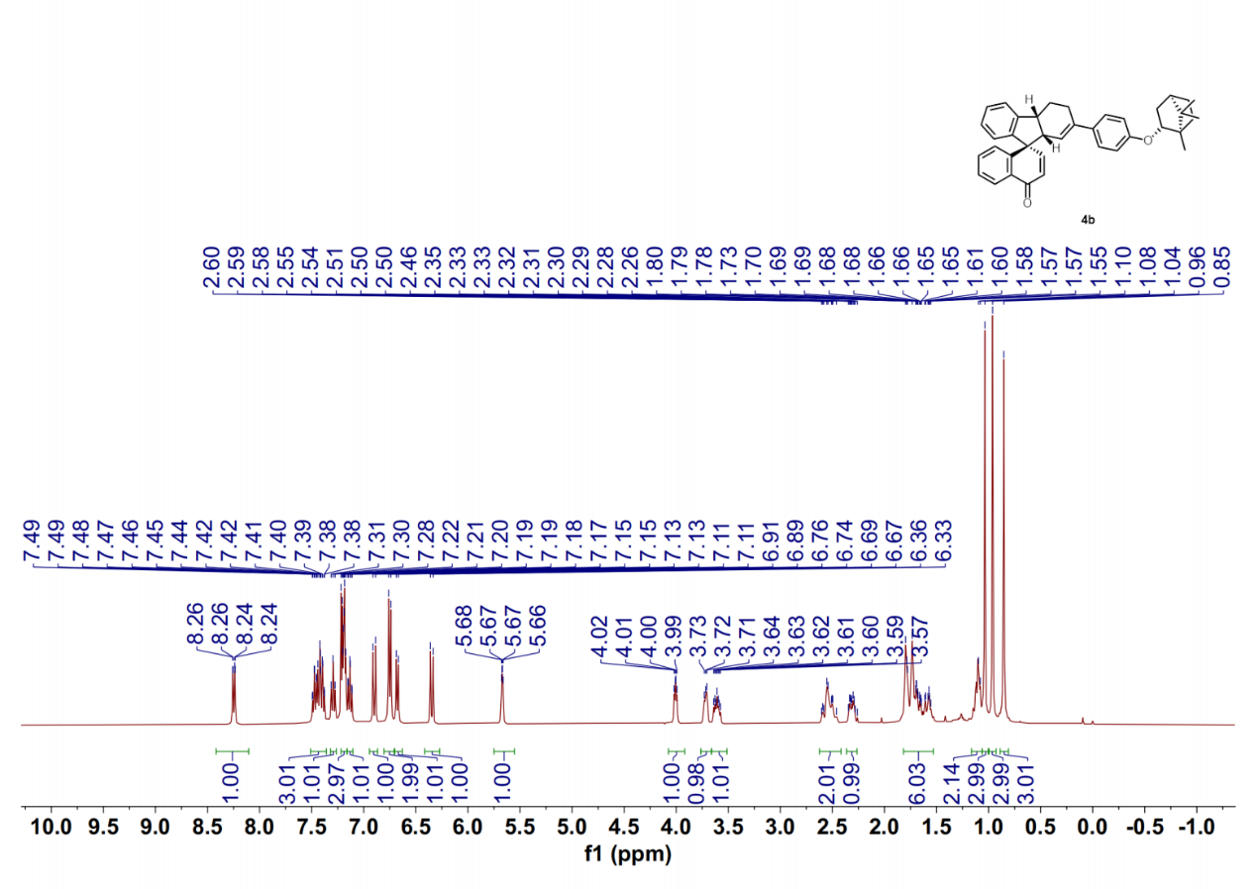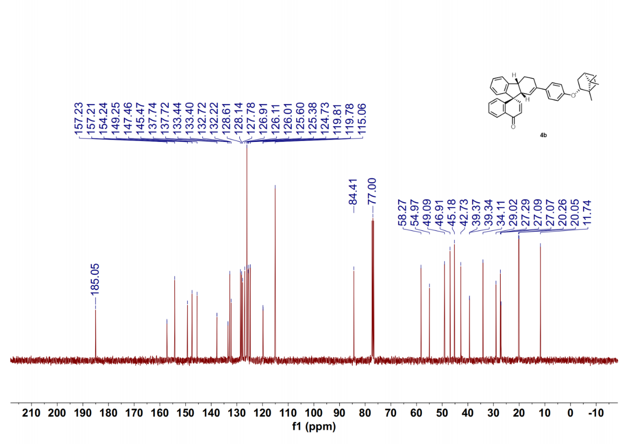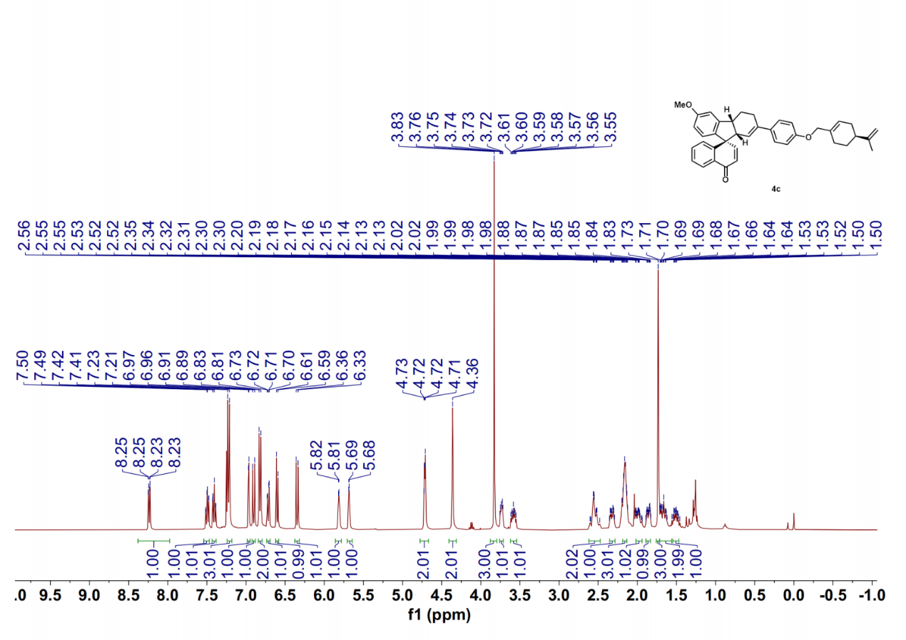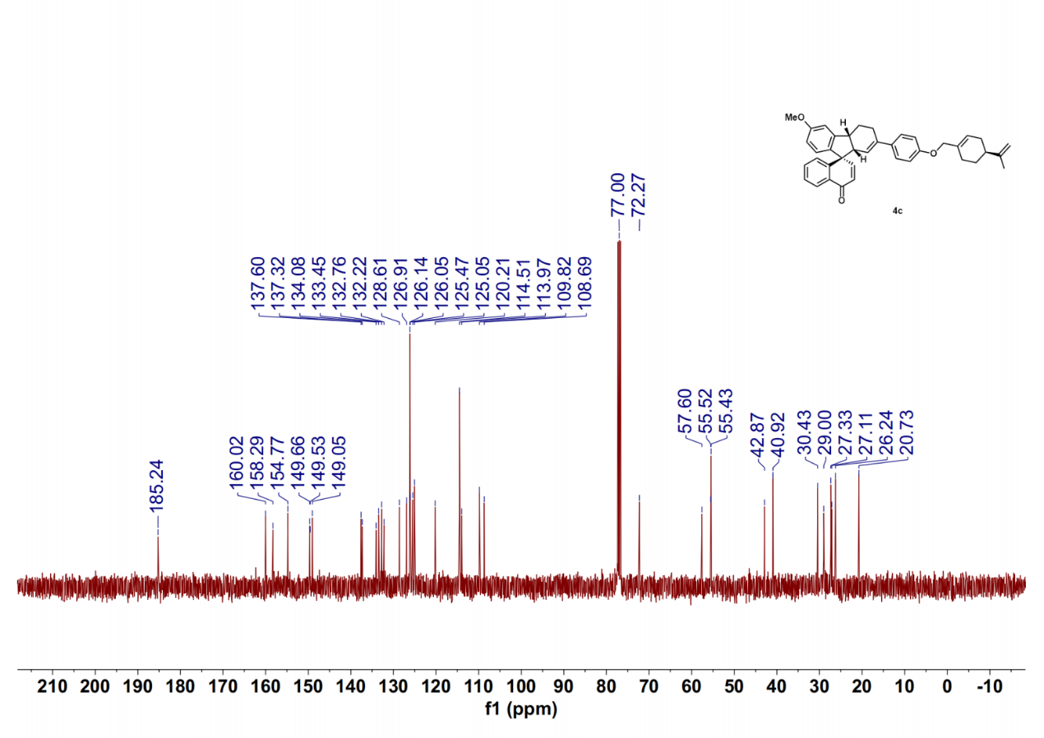
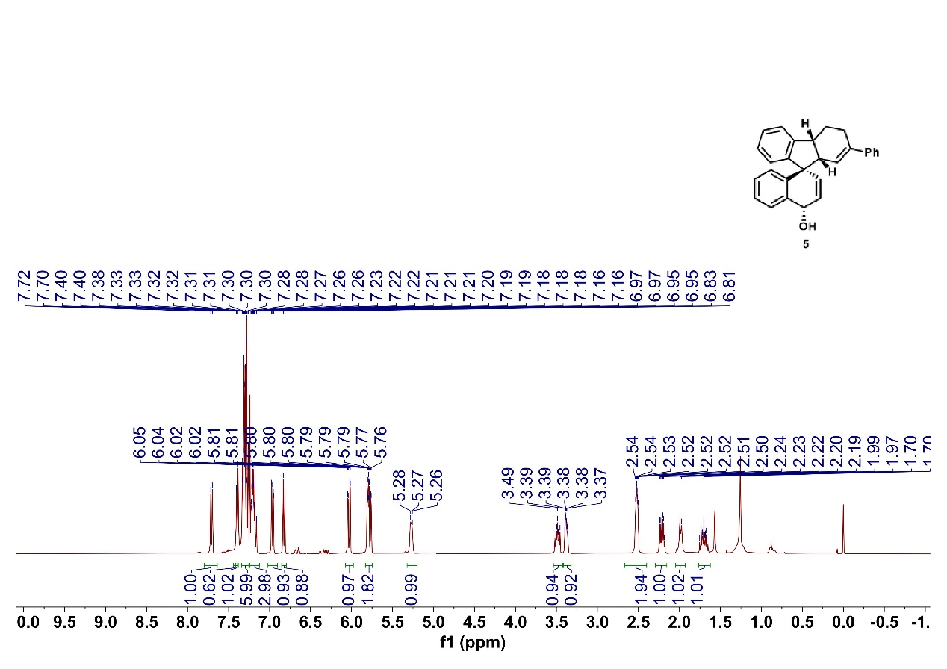
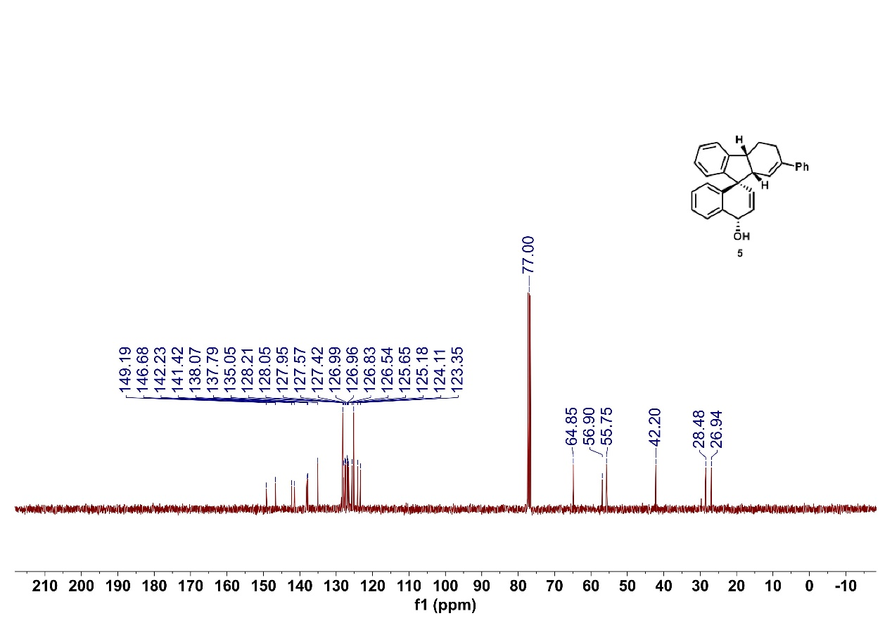
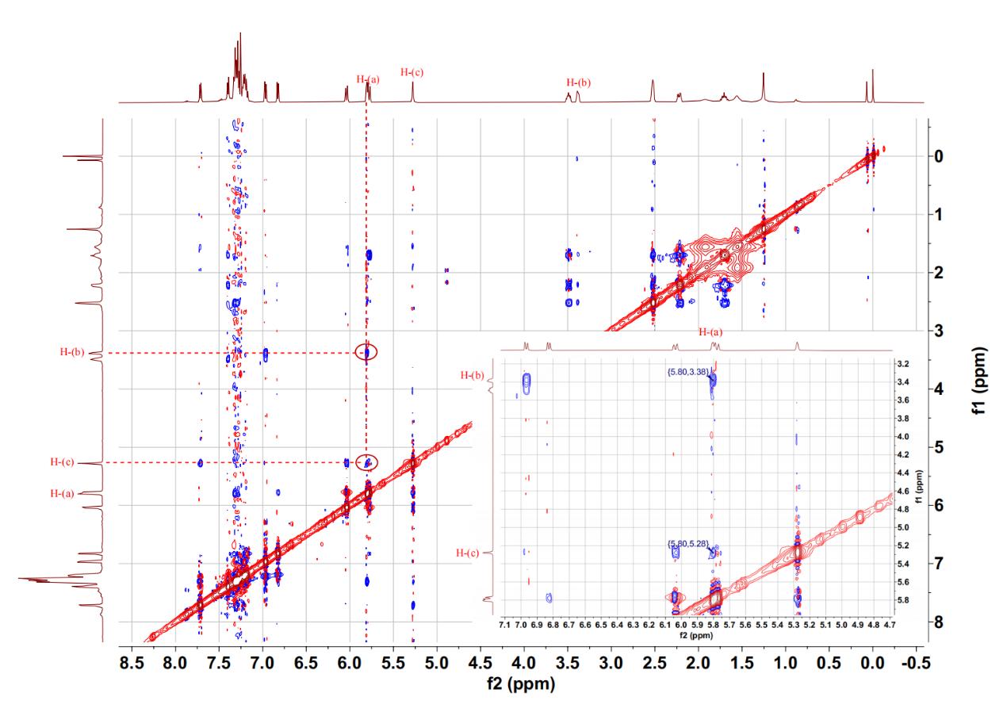
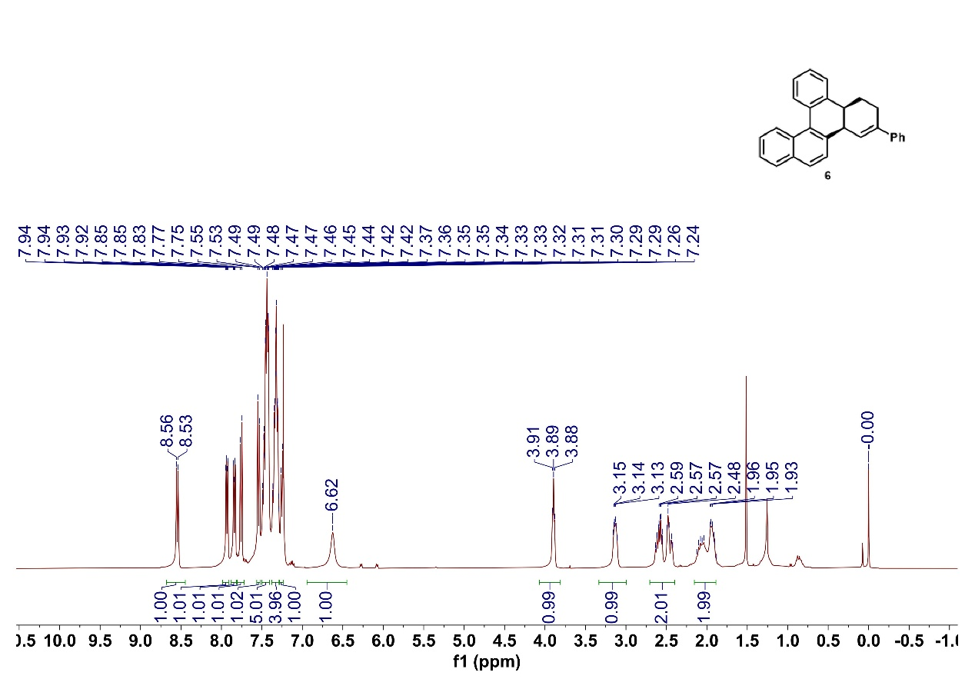
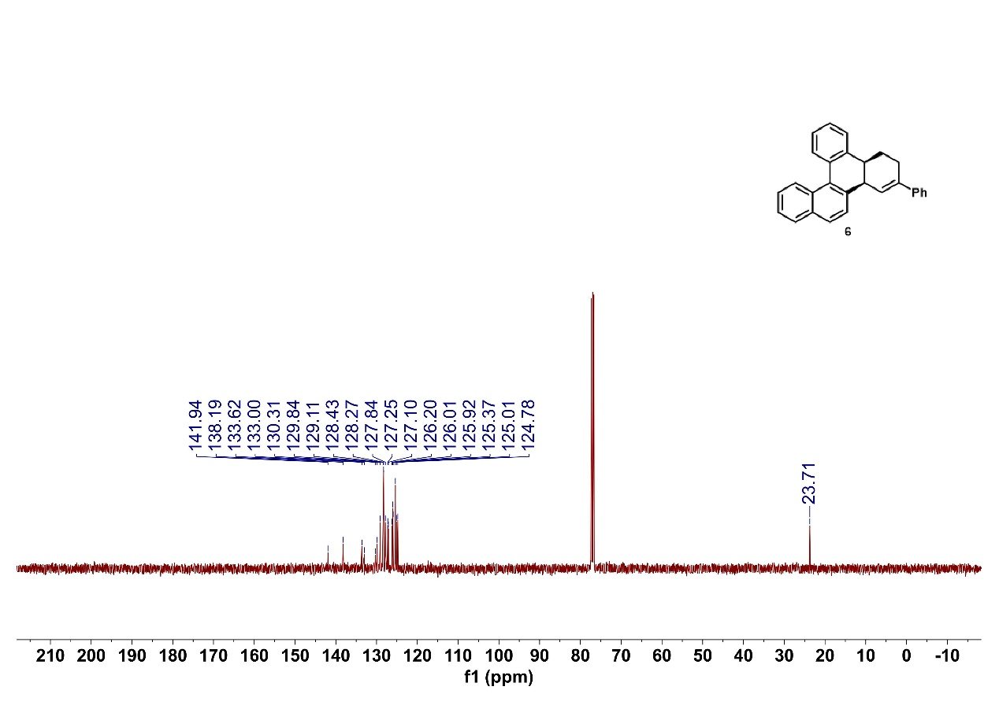
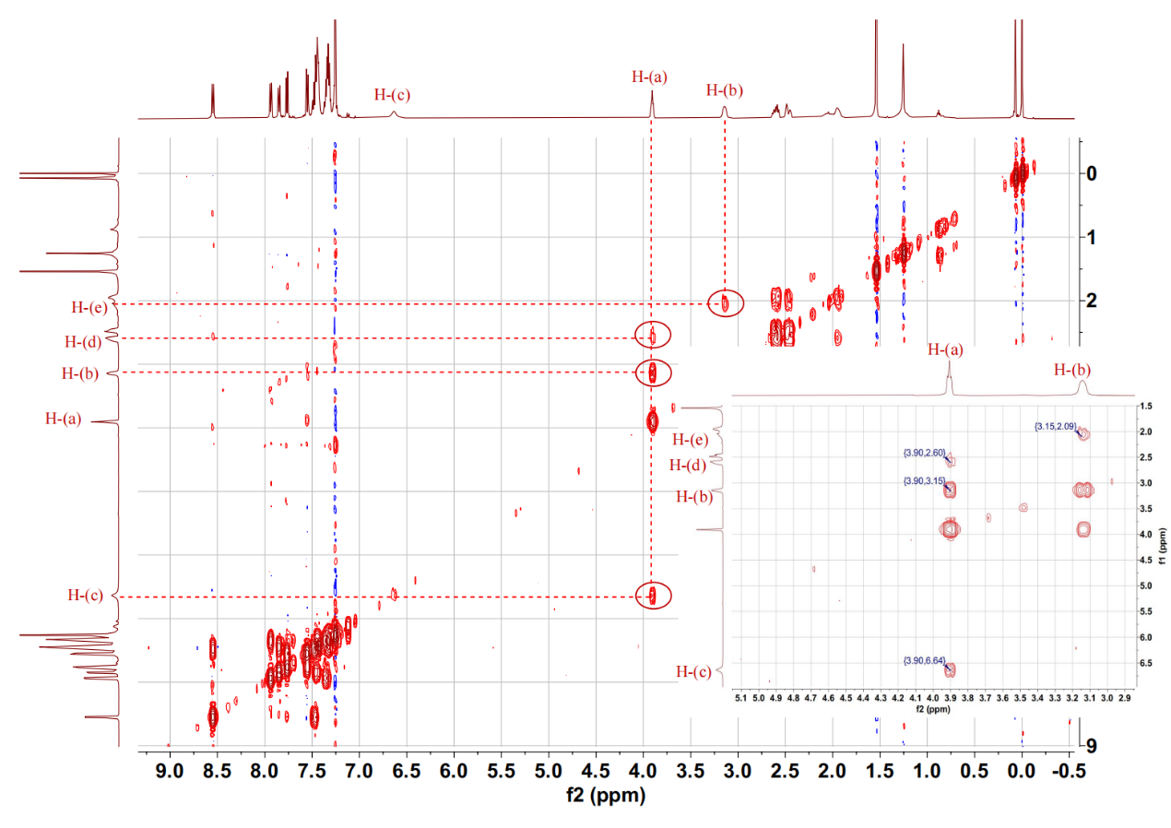

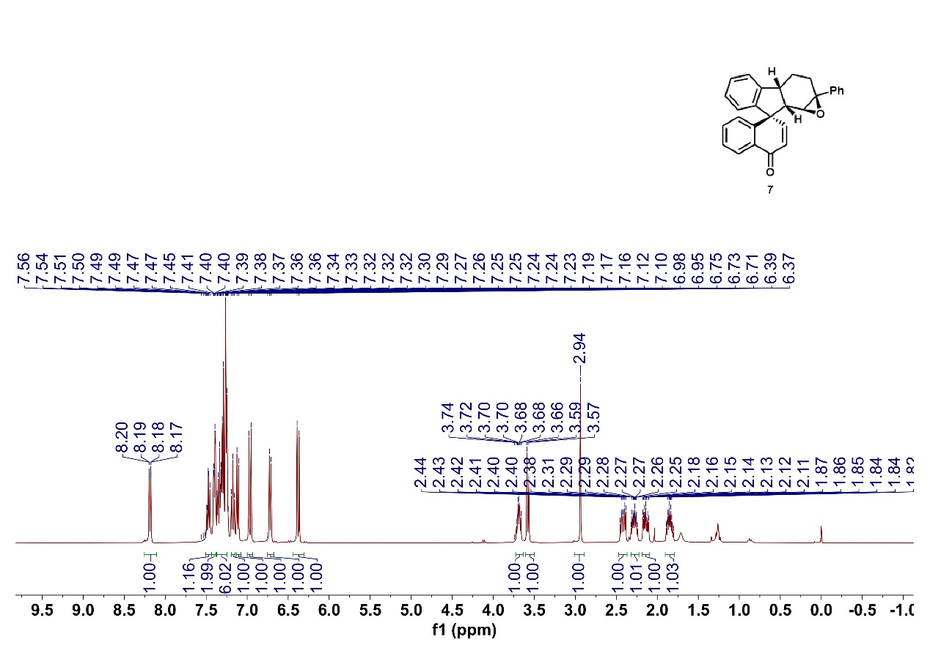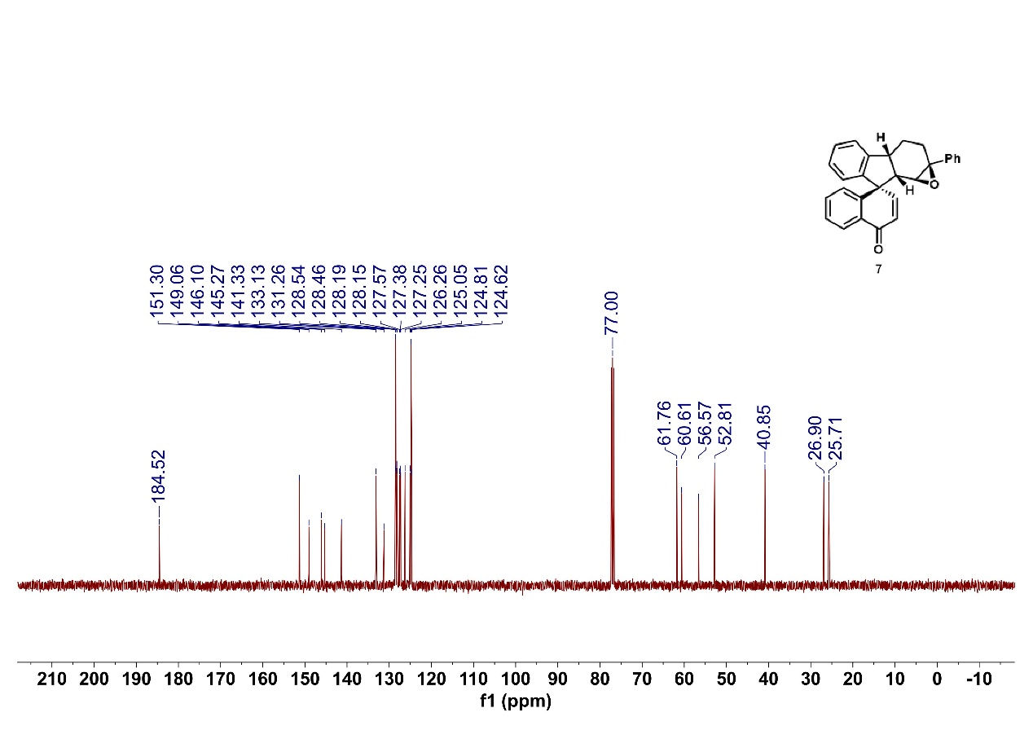
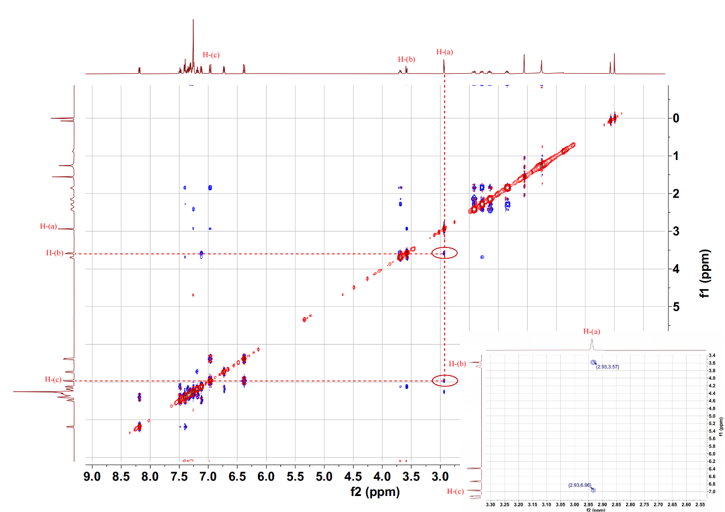

- References.
(1) Zhang, W.; Zhang, P.-C.; Li, Y.-L.; Wu, H.-H.; Zhang, J. PC-Phos Enabled Catalytic Palladium-heteroallyl Asymmetric Cycloaddition. J. Am. Chem. Soc. 2022, 144, 19627–19634.
(2) Yang, L.; Zheng, H.; Luo, L.; Nan, J.; Liu, J.; Wang, Y.; Luan, X. Palladium-Catalyzed Dynamic Kinetic Asymmetric Transformation of Racemic Biaryls: Axial-to-Central Chirality Transfer. J. Am. Chem. Soc. 2015, 137, 4876–4879.
(3) Li, Y.-L.; Zhang, P.-C.; Wu, H.-H.; Zhang, J. Palladium-Catalyzed Asymmetric Tandem Denitrogenative Heck/Tsuji–Trost of Benzotriazoles with 1,3-Dienes. J. Am. Chem. Soc. 2021, 143, 13010–13015.
(4) Trost, B. M.; Huang, Z.; Murhade, G. M. Catalytic palladium-oxyallyl cycloaddition. Science 2018, 362, 564–568.
(5) Fan, L.; Liu, J.; Bai, L.; Wang, Y.; Luan, X. Rapid Assembly of Diversely Functionalized Spiroindenes by a Three-Component Palladium-Catalyzed C−H Amination/Phenol Dearomatization Domino Reaction. Angew. Chem. Int. Ed. 2017, 56, 14257–14261.
(6) Wang, D.-M.; Shan, H.-M.; She, L.-Q.; He, Y.-Q.; Wu, Y.; Tang, Y.; Xu, L.-P.; Wang, P. Ligand-enabled Ni-catalysed dicarbofunctionalisation of alkenes with diverse native functional groups. Nat. Commun. 2024, 15, 10333.
(7) Schrader, M. L.; Schäfer, F. R.; Schäfers, F.; Glorius, F. Bridging the information gap in organic chemical reactions. Nat. Chem. 2024, 16, 491–498.

