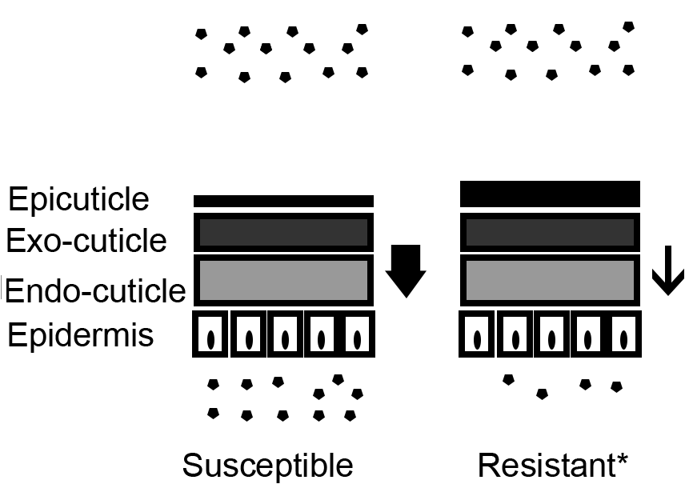
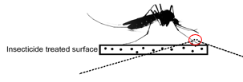
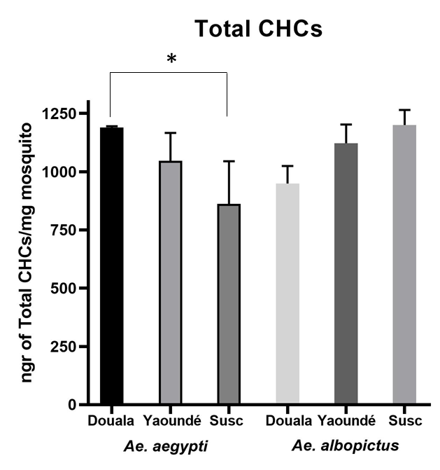
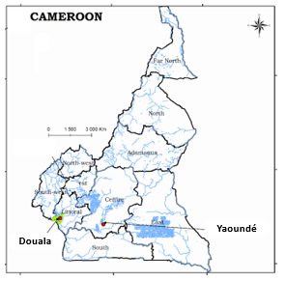
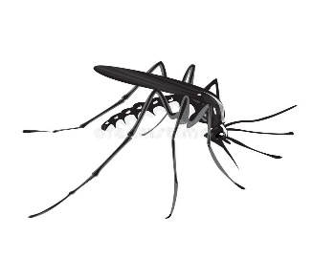
Extraction and Quantitation of CHC by GC-MS
High expression of CHCs in Aedes aegypti population from Douala
- Field collection and rearing of Aedes aegypti and Aedes albopictus larvae
- Quantitation of Cuticular Hydrocarbon Contents
METHODS
RESULTS

