Supplementary Information

Global population genomics of Salmonella enterica serotype Napoli, an emerging pathogen with an unusual epidemiologic pattern

Lise Frézal, Laura Villa, Guido Bloemberg, Laetitia Bonifait, Vincent Leclerc, Marie Accou-Demartin, Laetitia Fabre, Hilde Angermeier, Silvia Pino-Rosa, Sabrina Cadel-Six, Marianne Chemaly, Maria Pardos de la Gándara, Silvia Herrera-León, Roger Stephan, Alessandra Carattoli, and François-Xavier Weill

Supplementary Table 1. Composition of the 15 lineages of S. Napoli

Supplementary Table 2a: Polymorphism of the fliC gene encoding flagellin H1 (l,z13) in S. Napoli

Supplementary Table 2b: Polymorphism of the fljB gene encoding flagellin H2 (e,n,x) in S. Napoli

Supplementary Table 3: CRISPR-Cas system and spacer content convergence between cgMLST HC2600_104 lineages

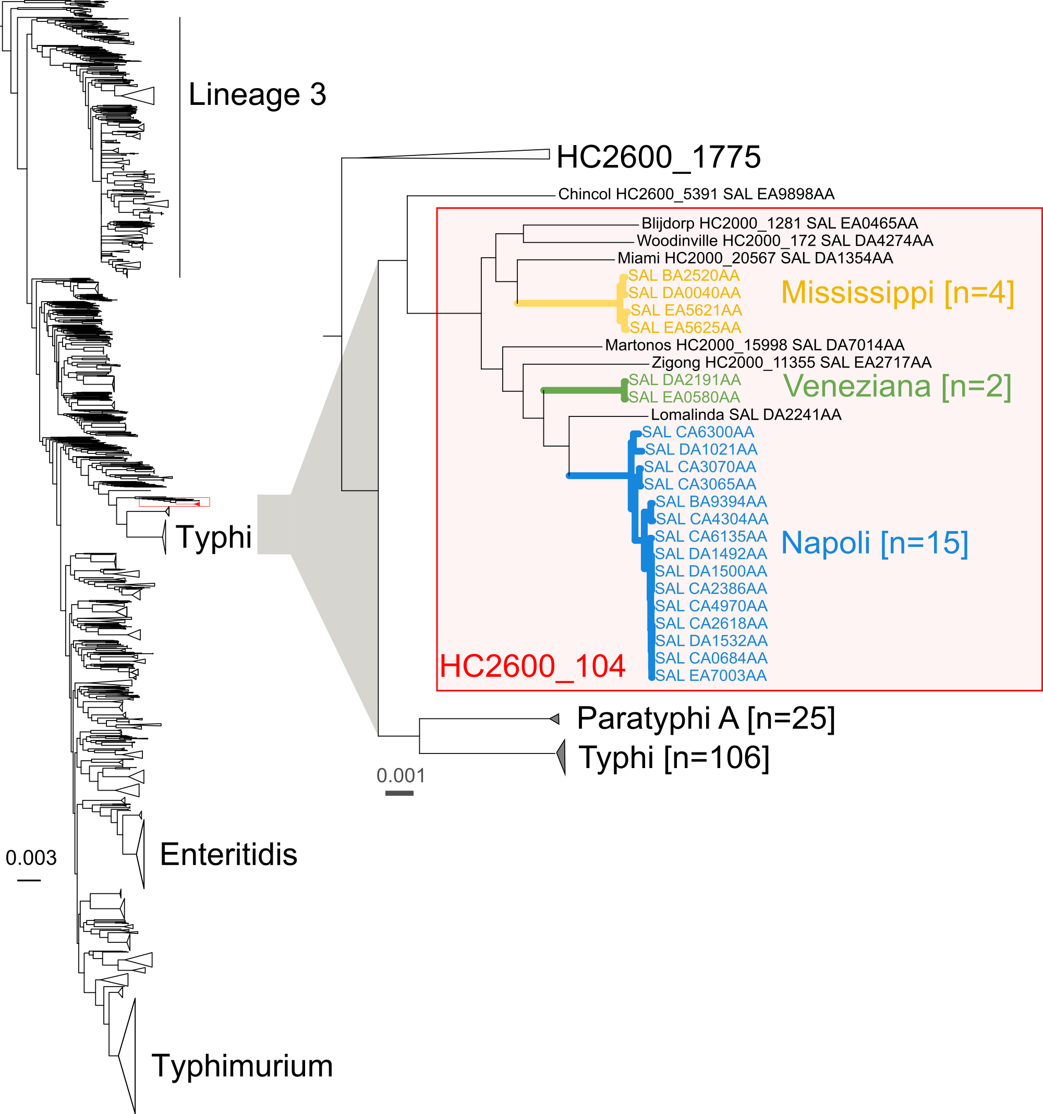
Supplementary Figure 1. Phylogenetic positioning of S. Napoli within S. enterica subsp. enterica. Left, maximum likelihood phylogeny established by Zhou and coworkers¹ from the concatenated alignment of 3,002 core-genome multilocus sequence typing (cgMLST) genes (https://enterobase.warwick.ac.uk/; scheme V2), from 2,964 representative genomes of S. enterica subsp. enterica. Right, a focus on the clade containing serovars Typhi, Paratyphi A and members of the cgMLST HC2600_104 cluster (red box), illustrating the phylogenetic proximity of S. Napoli to serovars Typhi and Paratyphi A. The scale bar indicates the number of nucleotide substitutions per site. EnteroBase genome identifiers (Barcode) are given as SAL_xxx.
Supplementary Figure 2. A NINJA neighbour-joining GrapeTree visualisation of the cgMLST allelic distances between 1,320 S. Napoli isolates (3,002 core genes of the Salmonella cgMLST scheme, see Fig. 3B). Tree nodes are colour-coded according to the (A) study of origin of the genomes investigated, (B) cgMLST HC400 and (C) cgMLST HC200 (see inset legend). Scale bars indicate the number of cgMLST allelic differences. Node size is proportional to the numbers of genomes (kurtosis = 30%).

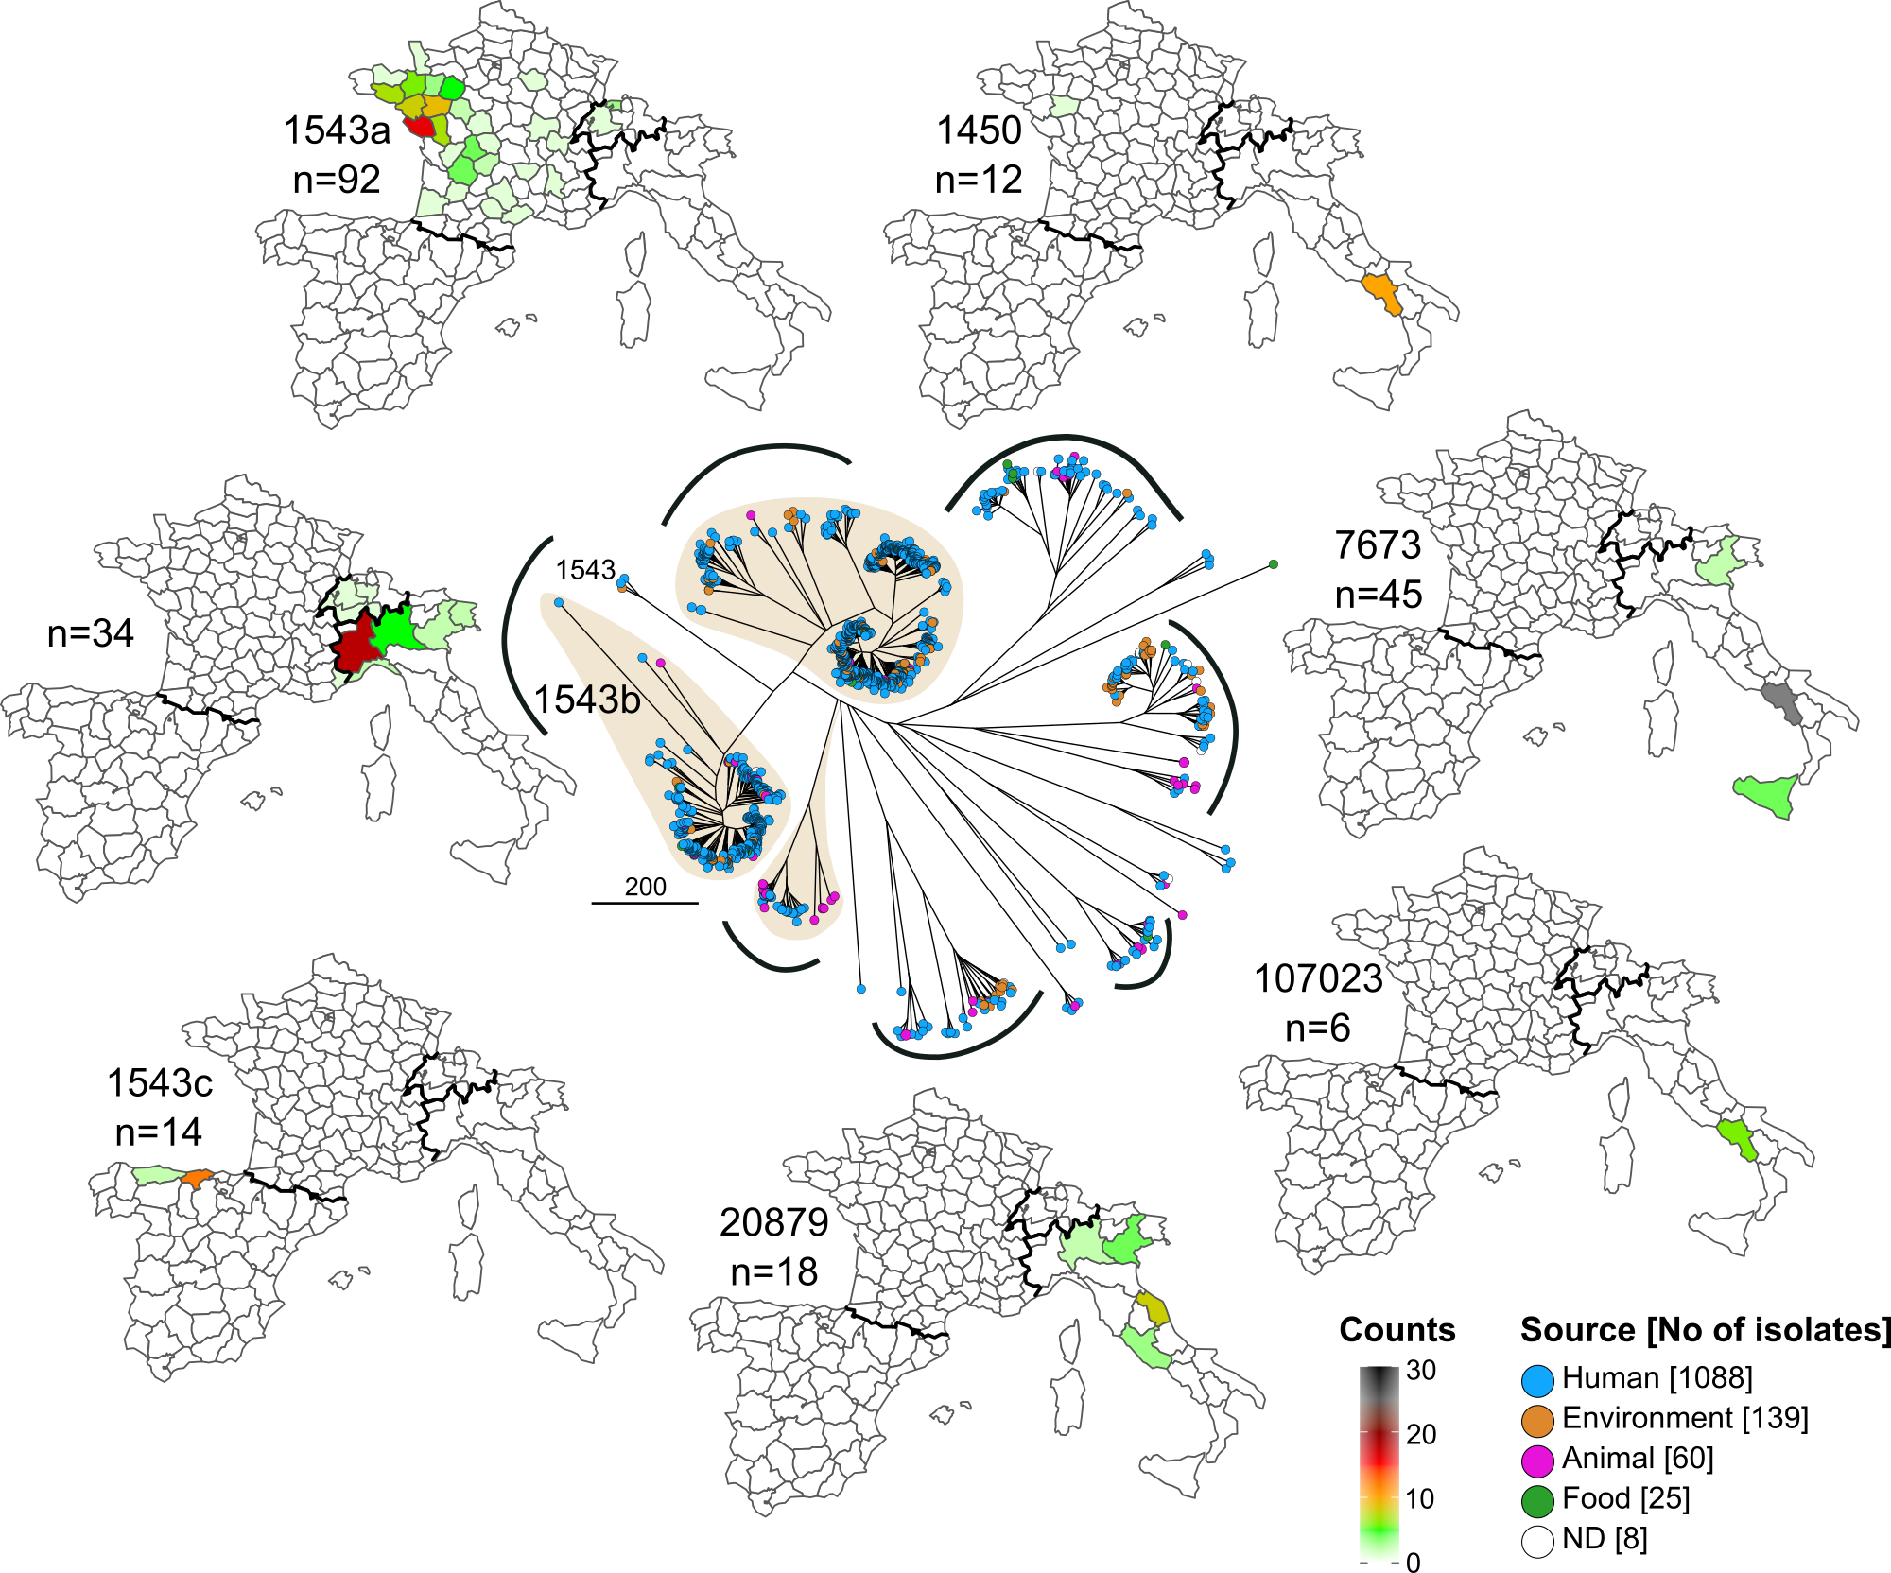
Supplementary Figure 3. The geographic distribution of non-human S. Napoli isolates. Centre, NINJA neighbour-joining GrapeTree visualisation of the cgMLST allelic differences between 1,320 S. Napoli isolates (see Fig. 3B) with nodes colour-coded by isolation source (see legend inset). The scale bar indicates the number of nucleotide differences. Node size is proportional to the number of genomes (kurtosis = 30 %). Periphery, choropleth maps depicting the geographic locations of 232 non-human isolates from the seven major cgMLST HC900 clusters across Italy, Switzerland, Spain and France. The number of isolates per area is colour-coded from white (0 isolates) to grey (30 isolates). ND: unknown.

Supplementary Figure 4. Phylogeography of the cgMLST HC900_1543a lineage of S. Napoli. Left, maximum likelihood phylogeny of all HC900_1543a isolates (magnification of Fig. 3A). Columns on the right of the phylogeny indicate, in order, the geographic origin (GEO), availability of postcode-level metadata (GPS = postcode centroid), and cgMLST cluster (HC400, HC200), see inset legend. Right, geographic maps illustrating (top) the spatial distribution of three most prevalent HC400 clusters and (bottom) the distribution of the three HC200 clusters nested within HC400_27729.

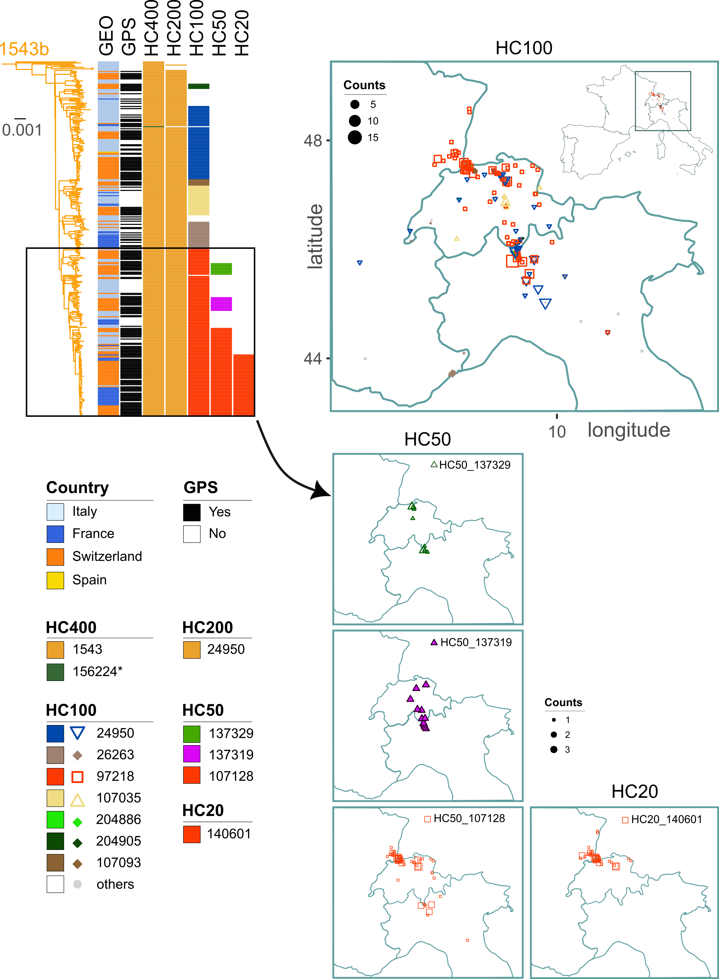
Supplementary Figure 5. Phylogeography of the cgMLST HC900_1543b lineage of S. Napoli. Left, maximum likelihood phylogeny of all HC900_1543b isolates (magnification of Fig. 3A). Columns to the right of the phylogeny indicate, in order, the geographic origin (GEO), availability of the postcode metadata (GPS), and cgMLST cluster (HC400, HC200, HC100, HC50, HC20), see inset legend. The scale bar indicates the number of nucleotide differences. Right, geographic maps illustrating (top) the spatial distribution of the most common HC100 clusters, and (bottom) the distribution of three HC50 clusters and one abundant HC20 cluster within HC100_97218. * The cgMLST assignment (HC400) of LC0541/17 is artefactual and due to an erroneous genome sequence (GCF_003296145.1 now removed from GenBank) deposited in EnteroBase.

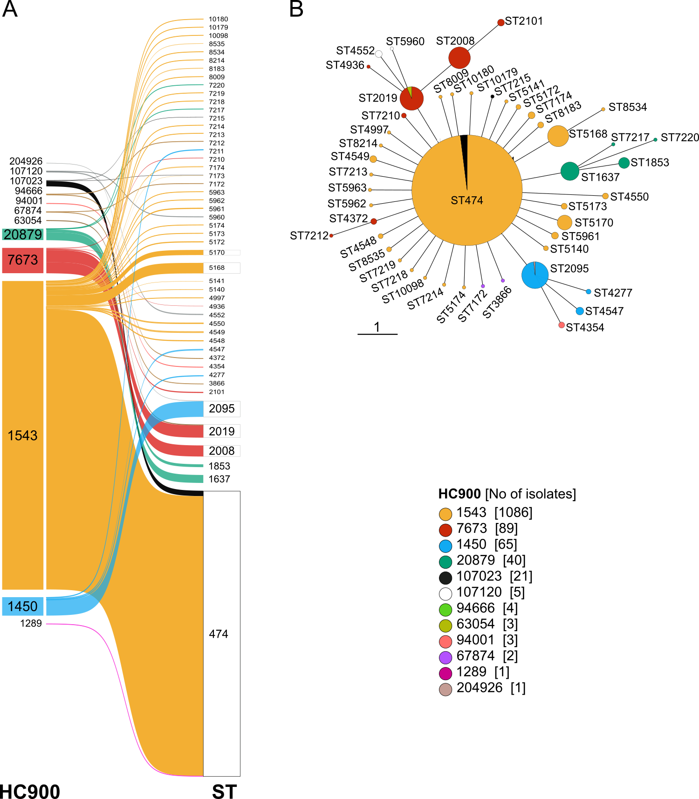
Supplementary Figure 6. Correlation between Achtman MLST7 ST and cgMLST in S. Napoli. (A) Distribution of the 50 different MLST7 STs across the 12 cgMLST HC900 clusters identified for S. Napoli. (B) Minimum-spanning tree (MST V2) for 1,320 S. Napoli genomes constructed from Achtman MLST7 profiles; nodes are colour-coded according to cgMLST HC900 cluster. Node size is proportional to the number of genomes, and the scale bar indicates the number of MLST allelic differences.

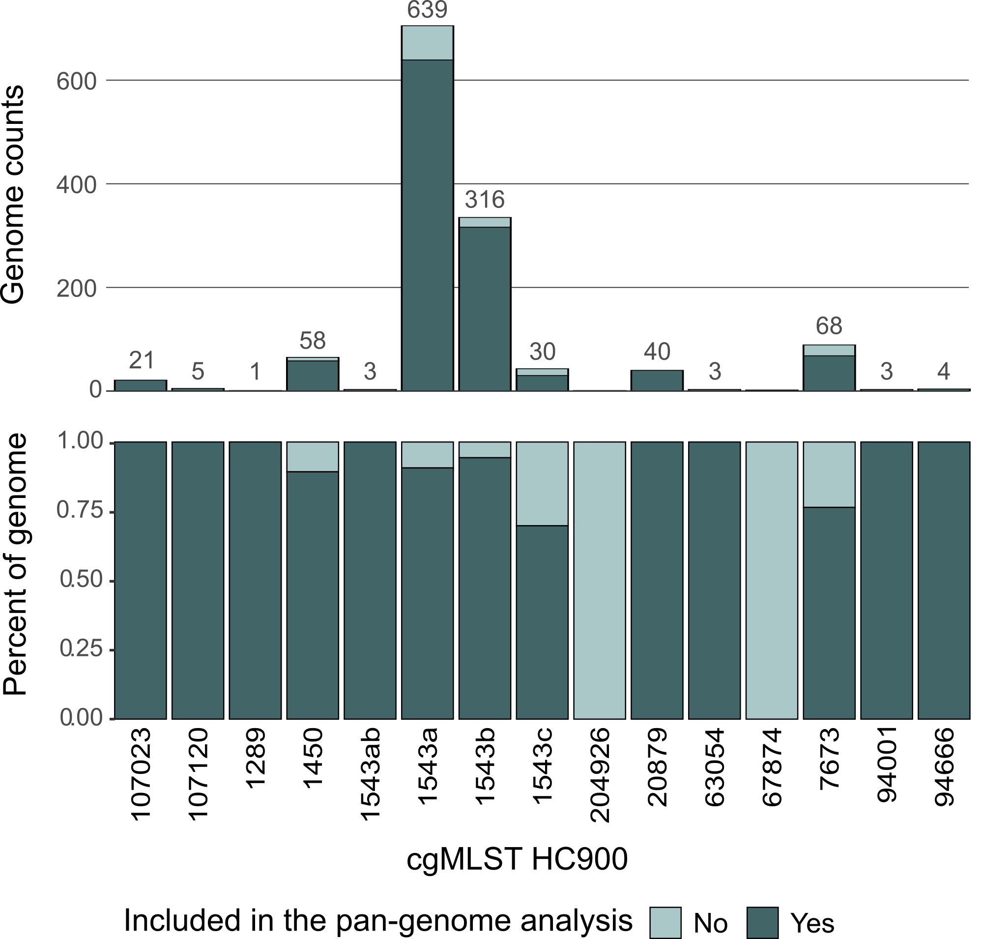

Supplementary Figure 7. Composition of the set of 1,191 S. Napoli genomes (i.e. de novo short read assemblies) included in the pan-genome analysis. The cgMLST HC900 and HC400 clusters are not uniformly distributed, the HC900_1543a and HC900_1543b lineages being the most abundant. In light green, the genomes excluded from the pan-genome analysis, in dark green, those that were included. For each lineage, the number of genomes included in the analysis is indicated above the corresponding bars.

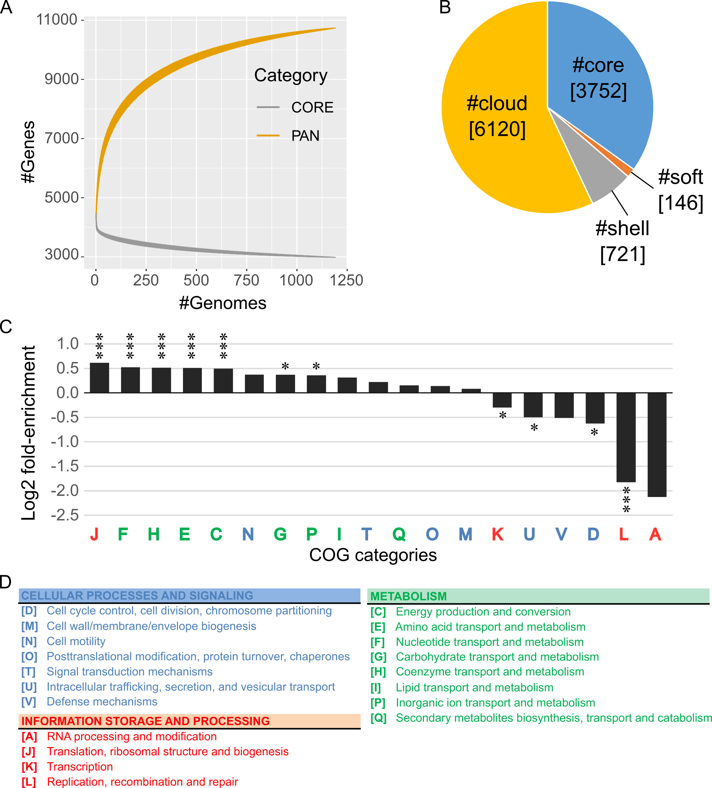
Supplementary Figure 8. Characteristics of the core and accessory genomes of S. Napoli. The pan-genome analysis was performed on 1,191 genome assemblies representing 13 lineages (see Supplementary Fig. 7). (A) Rarefaction curves depicting the cumulative number of genes in the pan genome (light orange) and the core genome (grey) as additional genomes were sampled. Estimates were obtained with PanGP² from the binary presence/absence matrix, by fully random sampling with 10 replicates per point. (B) Bar-pie chart displaying the relative proportions of the core (blue, genes present in ≥99% of isolates), soft-core (orange, 95–99%), shell (grey, 15–95%) and cloud (dark yellow, <15%) genes. Absolute gene counts are given in brackets. (C) Log₂ fold-enrichment of core (core + soft) genes across COG functional categories. A positive value for the enrichment index implies that the core genome contains more genes of this COG functional category than expected. The significance of enrichment for each COG category was assessed in two-tailed Fisher’s exact tests (* for p < 0.005; *** for p < 0.001). (D) Definition of COG functional categories.
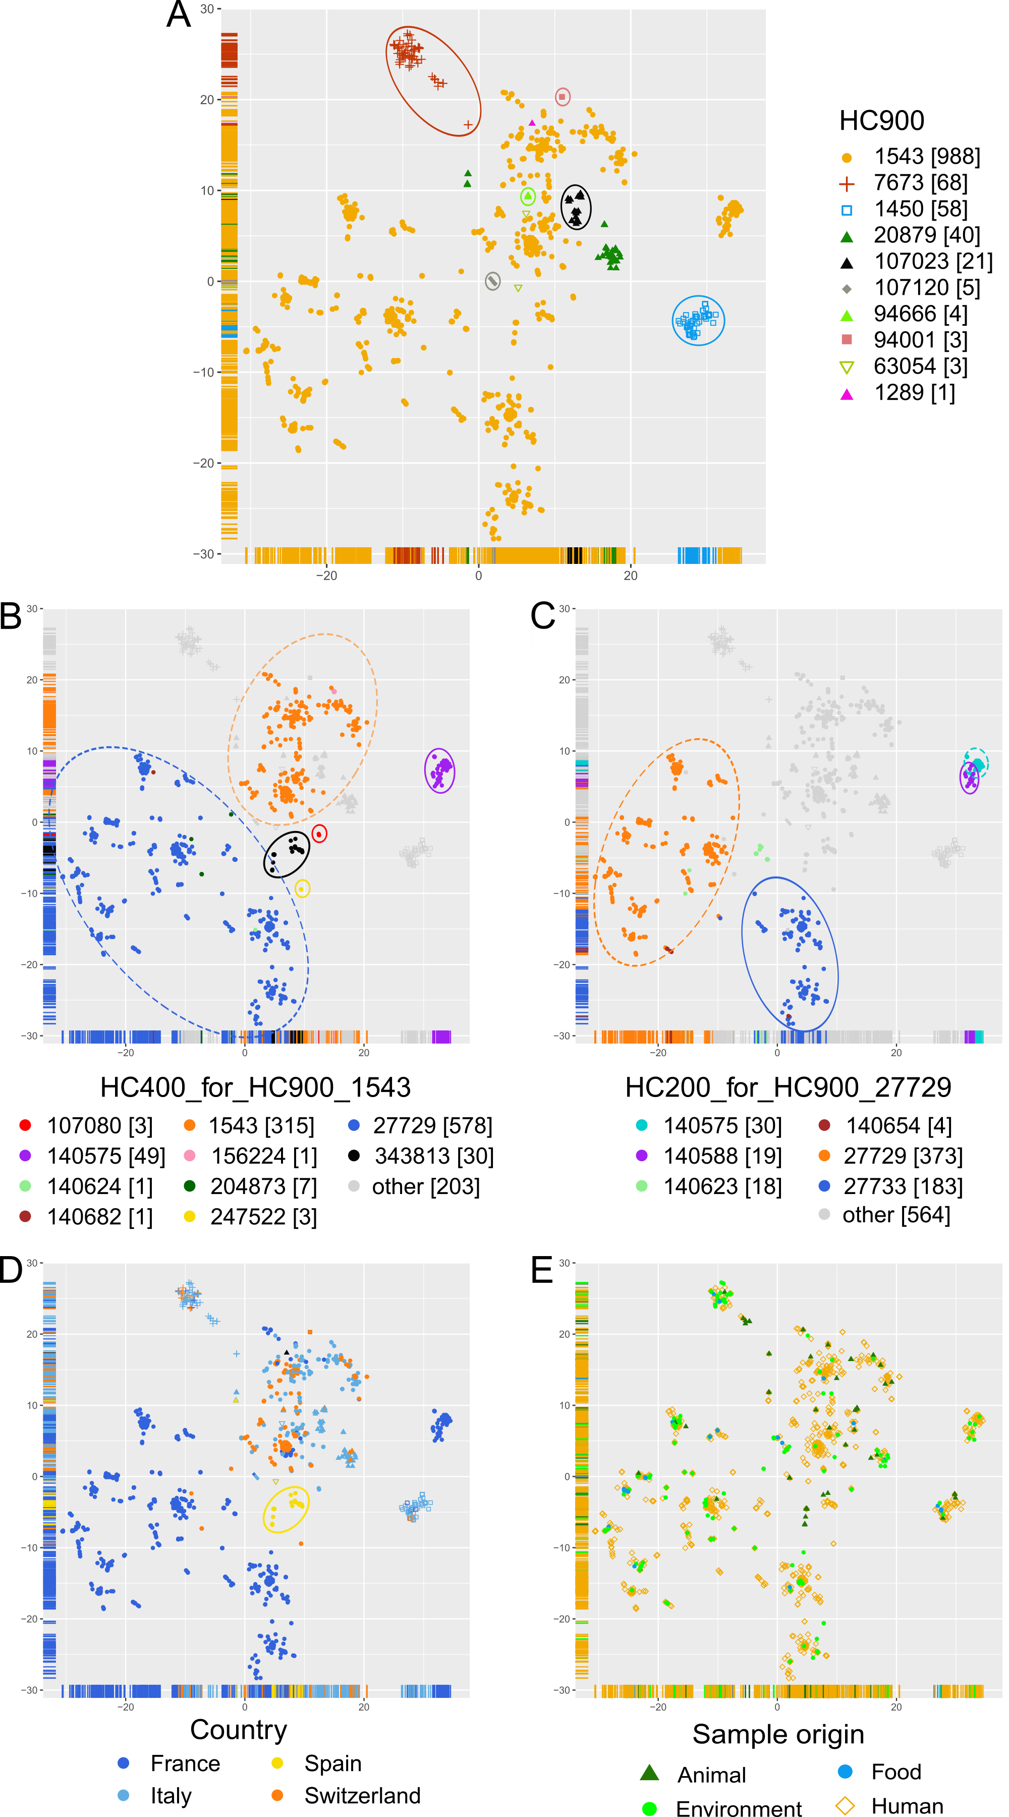
Supplementary Figure 9. PANINI³ pan-genome-based neighbour network for the S. Napoli population. Pairwise pan-genome distances between 1,191 S. Napoli genome assemblies were calculated with PANINI³ and projected with Barnes–Hut t-SNE (gradient accuracy = 0.5). Each node corresponds to a single isolate; shapes correspond to the cgMLST HC900 cluster; colours indicate: (A) cgMLST HC900 clusters; (B) cgMLST HC400 clusters within HC900_1543; (C) cgMLST HC200 clusters within HC400_27729; (D) country of isolation, and (E) sample source. In panels A–C, the principal clusters identified by PANINI³ are outlined manually.

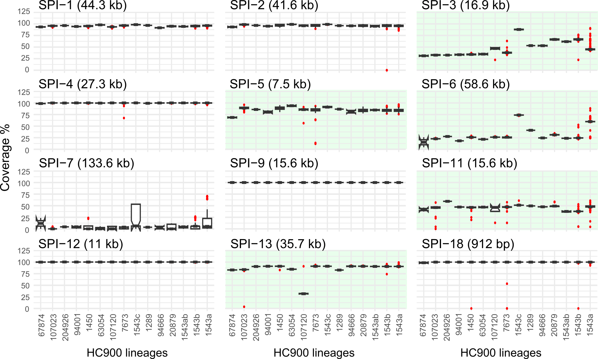

Supplementary Figure 10. Variable presence of Salmonella pathogenicity islands (SPI) in S. Napoli. SPI (PAIDB⁴; SPI-13 GenBank accession no. CP163475: 3,592,799-3,628,491; SPI-18 GenBank accession no. CP163475: 1,455,055–1,456,801) coverage was determined for 1,320 isolates (Illumina paired-end reads; KMA⁵ v1.4.14). Coverage data per cgMLST HC900 lineages are shown for SPIs detected in ≥ 3 isolates with ≥50% template coverage and ≥70% nucleic-acid sequence identity. Red dots: outlying points. Highlighted in green, SPI with variable coverage across lineages.

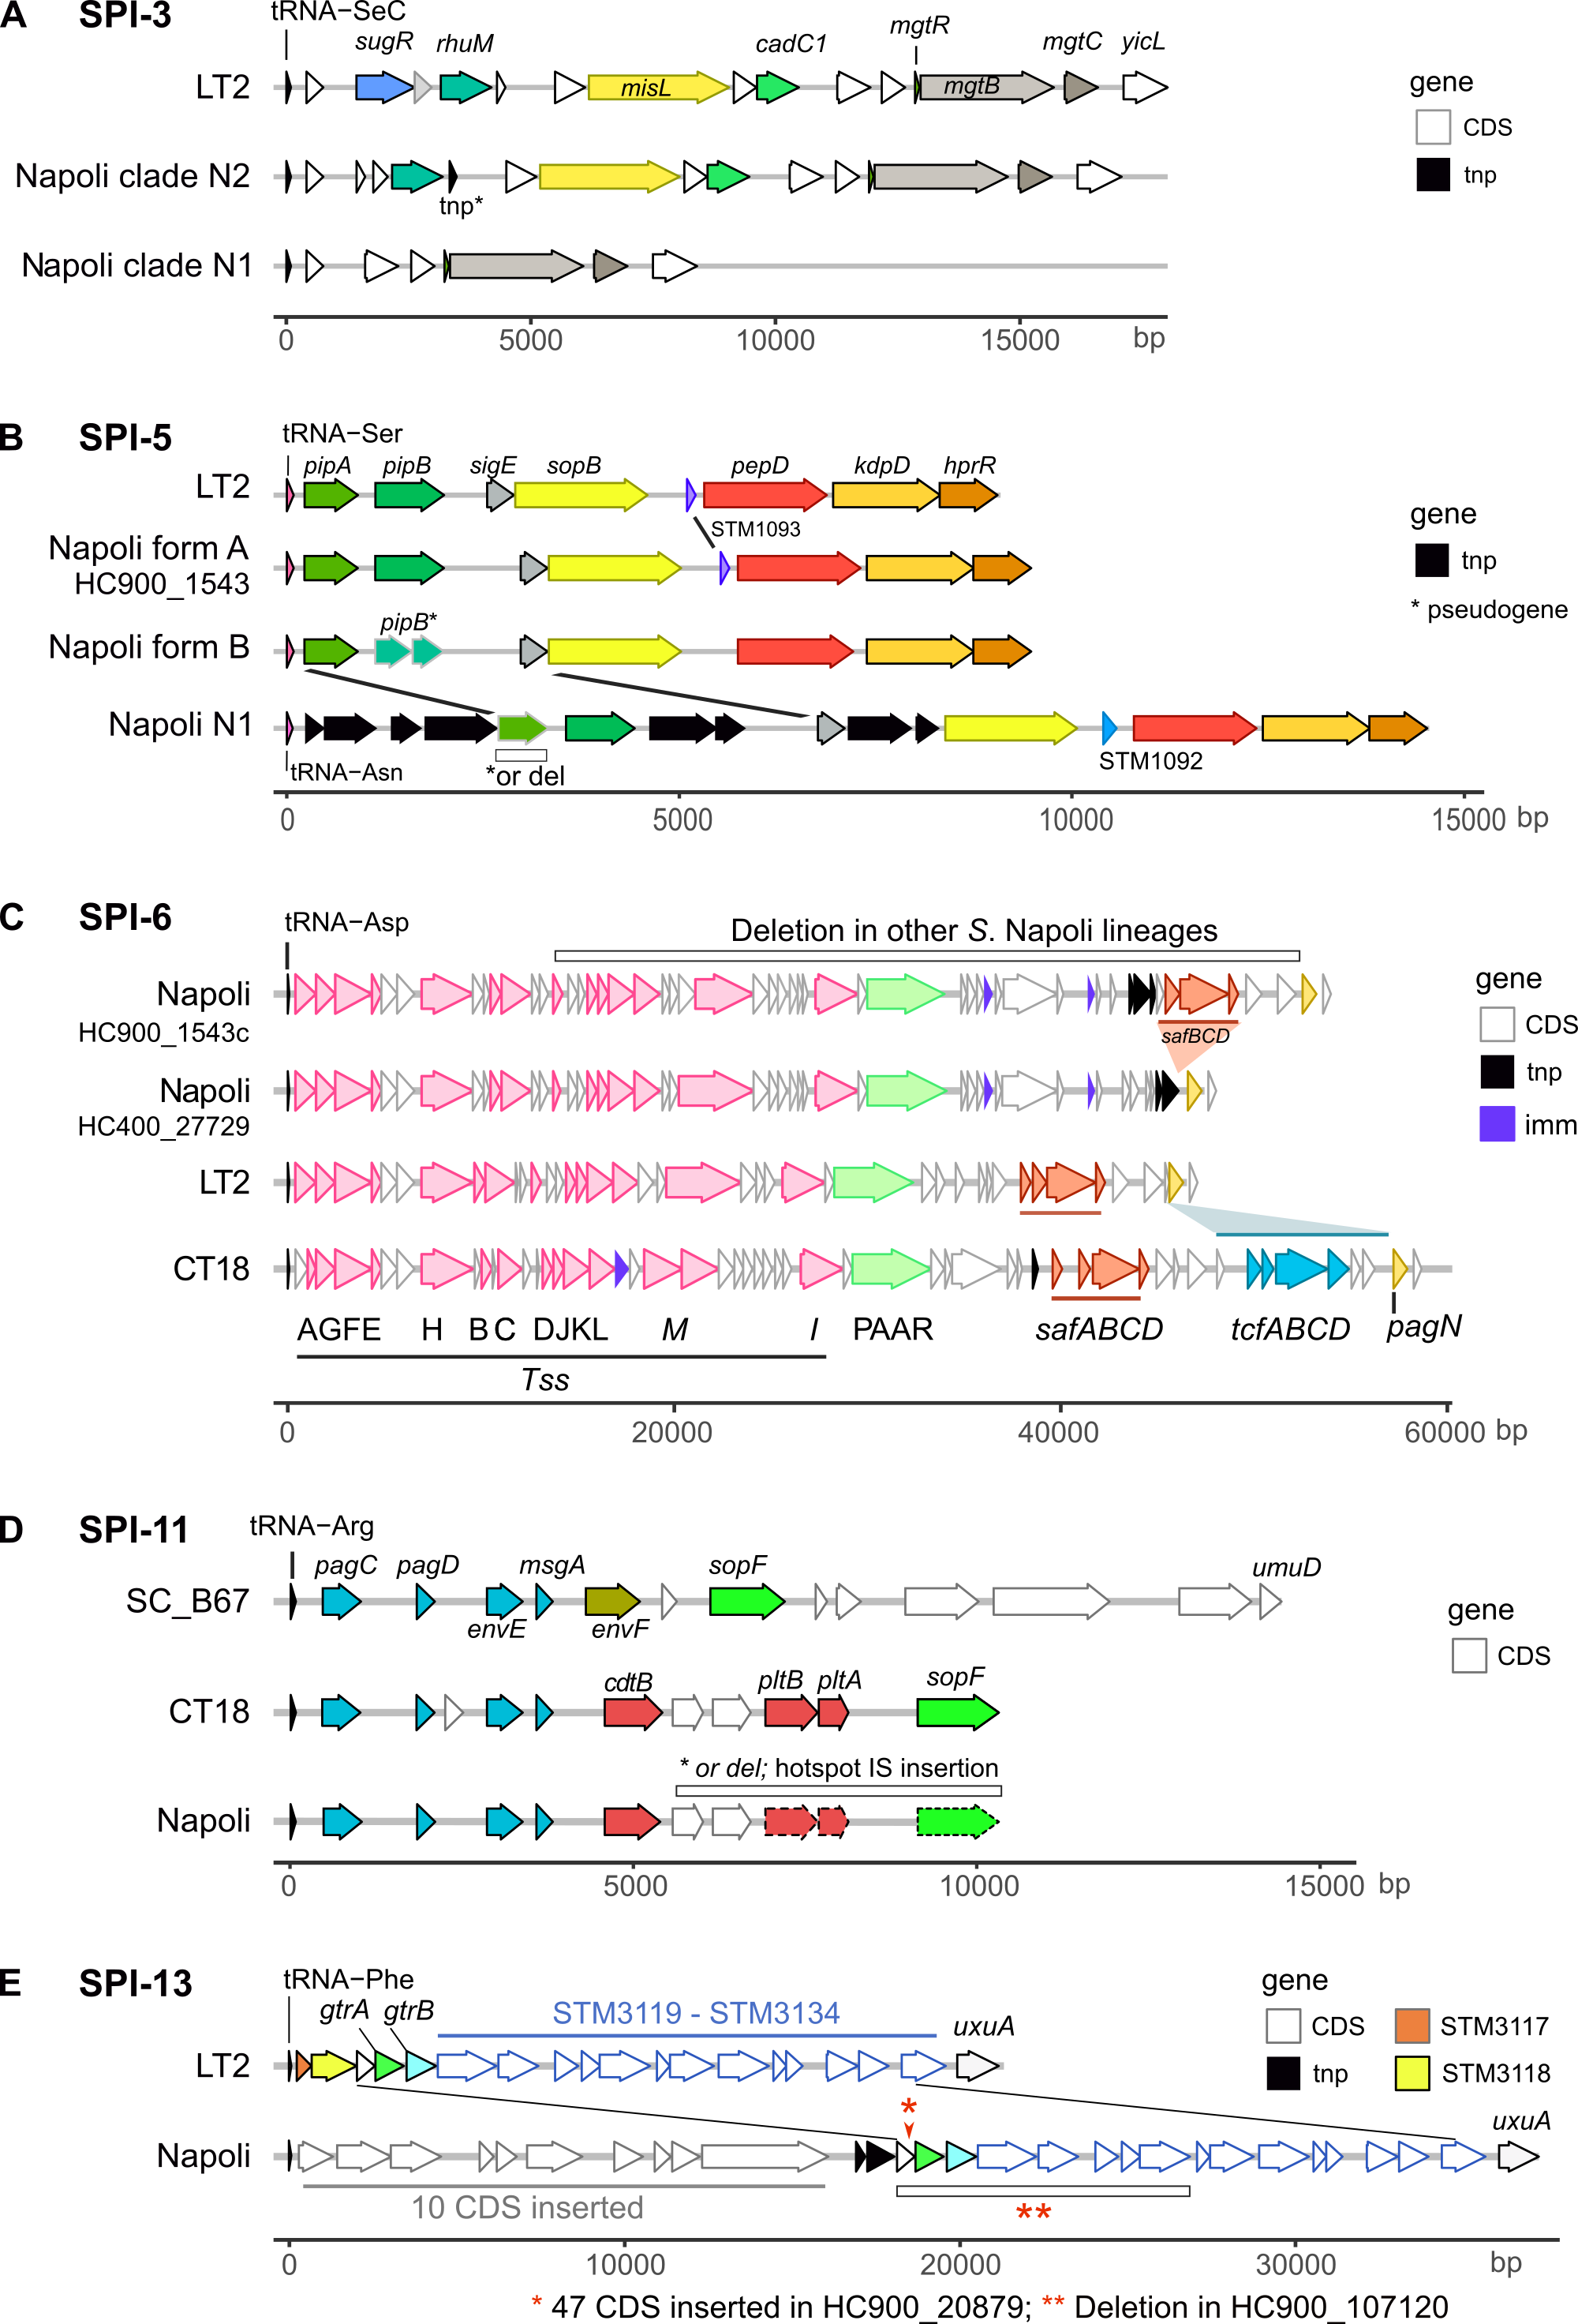
Supplementary Figure 11. Genomic architecture of Salmonella pathogenicity islands (SPI) with variable/incomplete gene content in S. Napoli. S. enterica serotypes Typhimurium strain LT2 (GenBank accession no. NC_003197.2), Choleraesuis strain SC_B67 (GenBank accession no. NC_006905.1), and Typhi strain CT18 (GenBank accession no. AL513382.1).
Supplementary Figure 12. Genomic regions showing evidence of recombination in S. Napoli. Left, maximum likelihood phylogeny constructed (RAxML) from 1,317 S. Napoli genomes using the Nap72-2 reference genome (GenBank no CP163475; 4,828,561 bp), with recombining segments masked before construction. Right, segments of high single-nucleotide polymorphism (SNP) density detected by Gubbins⁶ and visualised with Phandango⁷ (https://github.com/jameshadfield/phandango). Three major recombining regions are highlighted in red, and their chromosomal positions (bp) are indicated beneath each block. Presence/absence profiles of virulence genes were determined during the pan-genome analysis (see dedicated section).

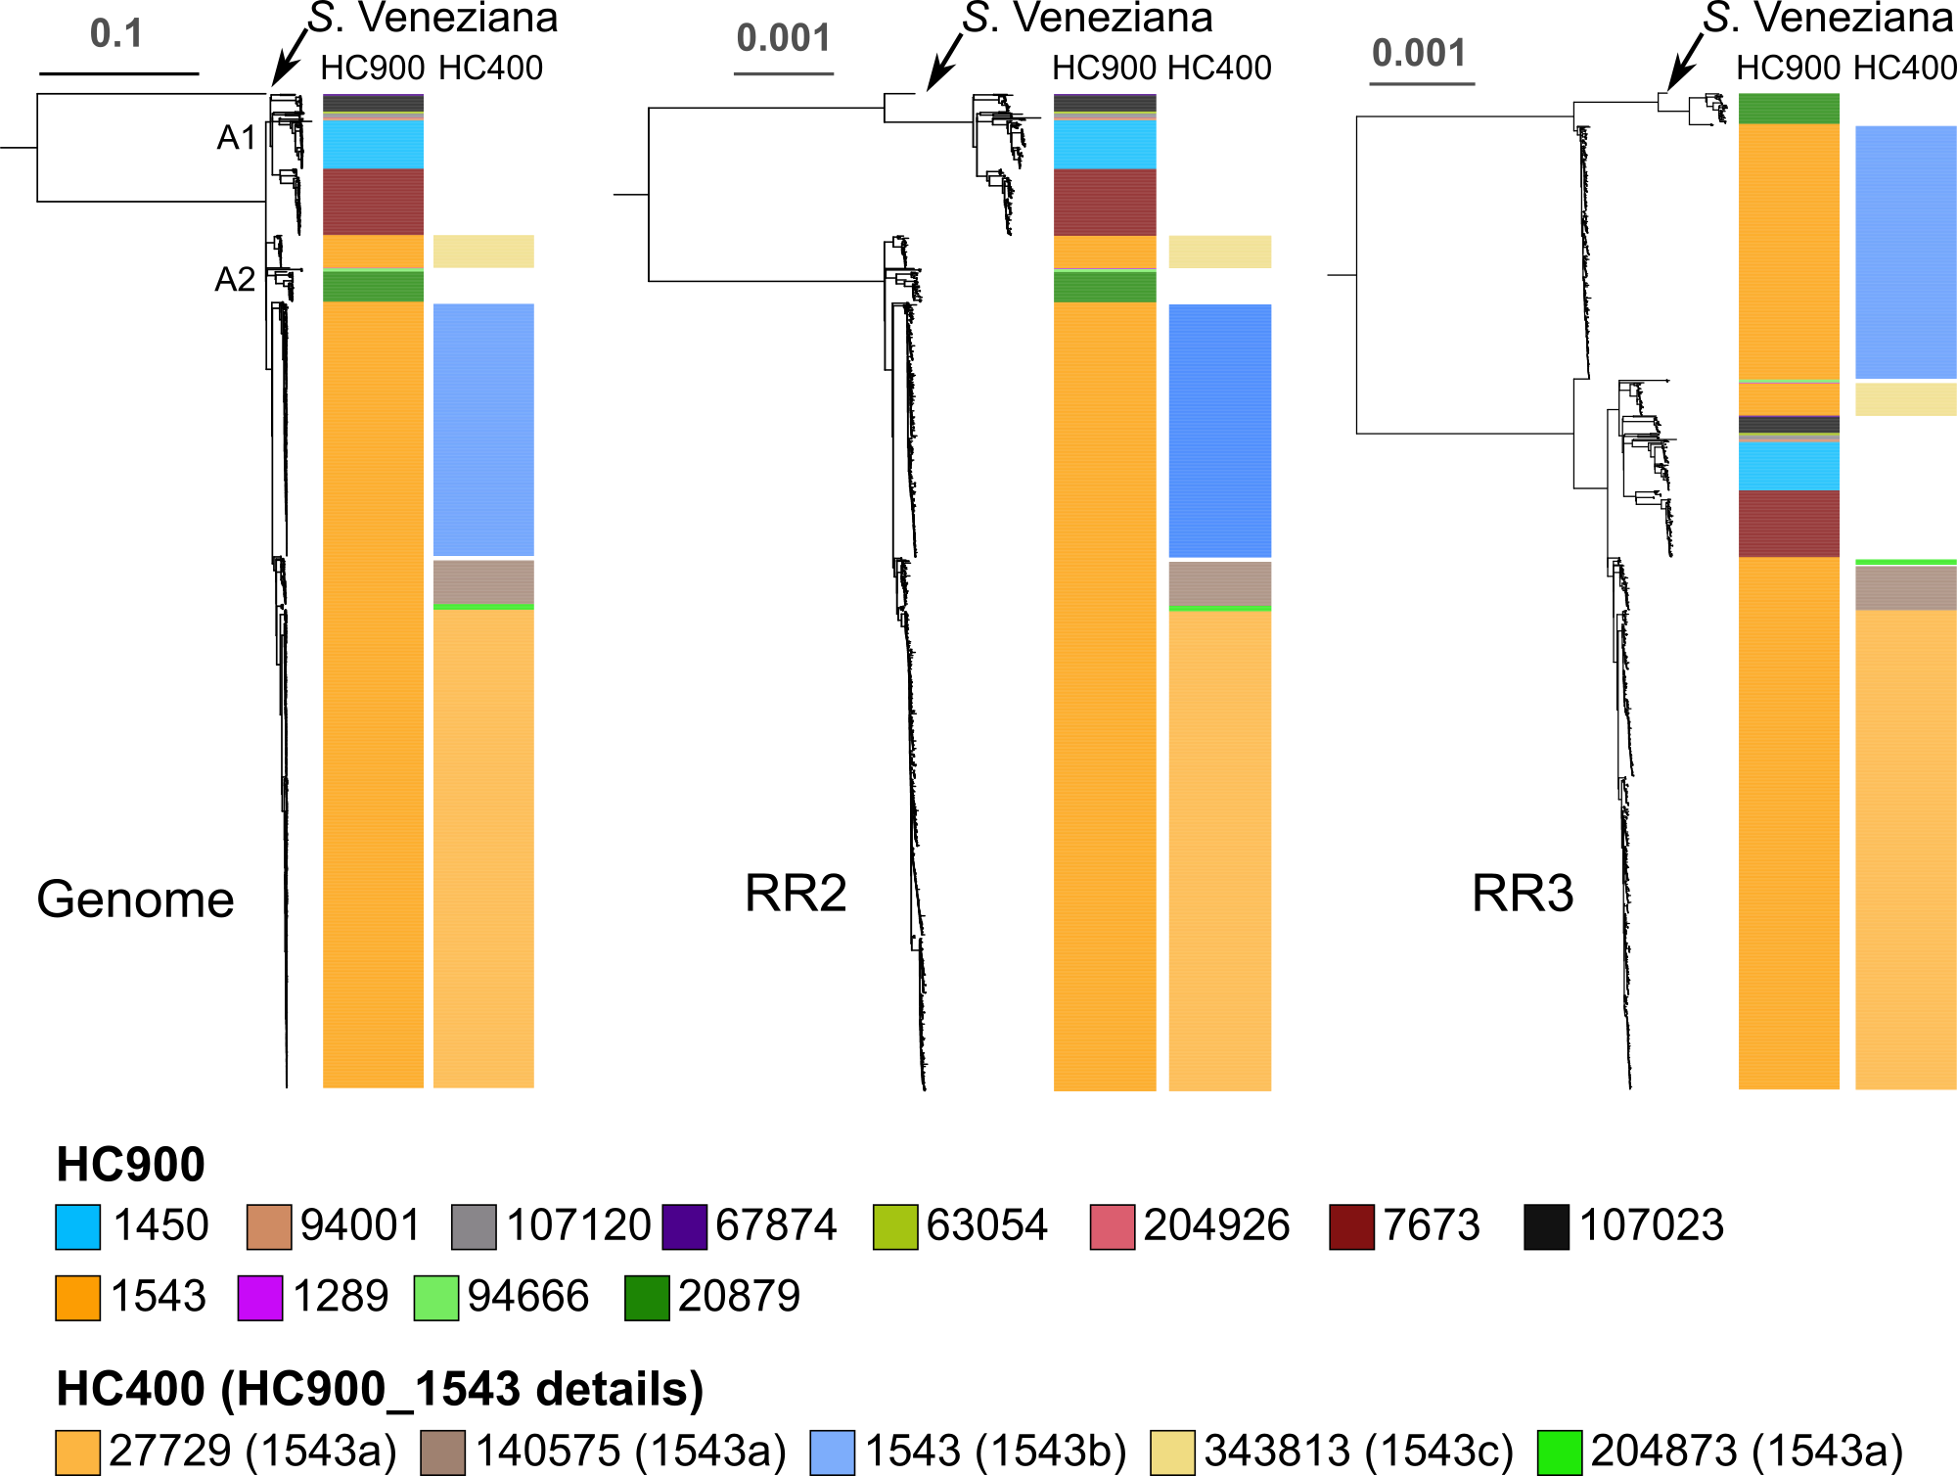

Supplementary Figure 13. Phylogenetic analysis of the S. Napoli population with S. Veneziana as the reference. Maximum likelihood trees were built with RAxML-NG and Illumina reads of 1,317 S. Napoli isolates mapped onto the S. Veneziana reference genome (strain 164K, GenBank accession no. CP163496). Left, genome-wide phylogeny. Centre, the phylogeny based on recombinant region 2 (RR2) (CP163496 coordinates: 2,752,761-2,965,480]). Right, tree based on recombinant region 3 (RR3), CRISPR/SPI-1 region (CP163496 co-ordinates: 884,613-1,094,400). Topological differences between the three trees reveal the impact of horizontal transfer in regions 2 and 3 (see Supplementary Figs. 11 and 12).

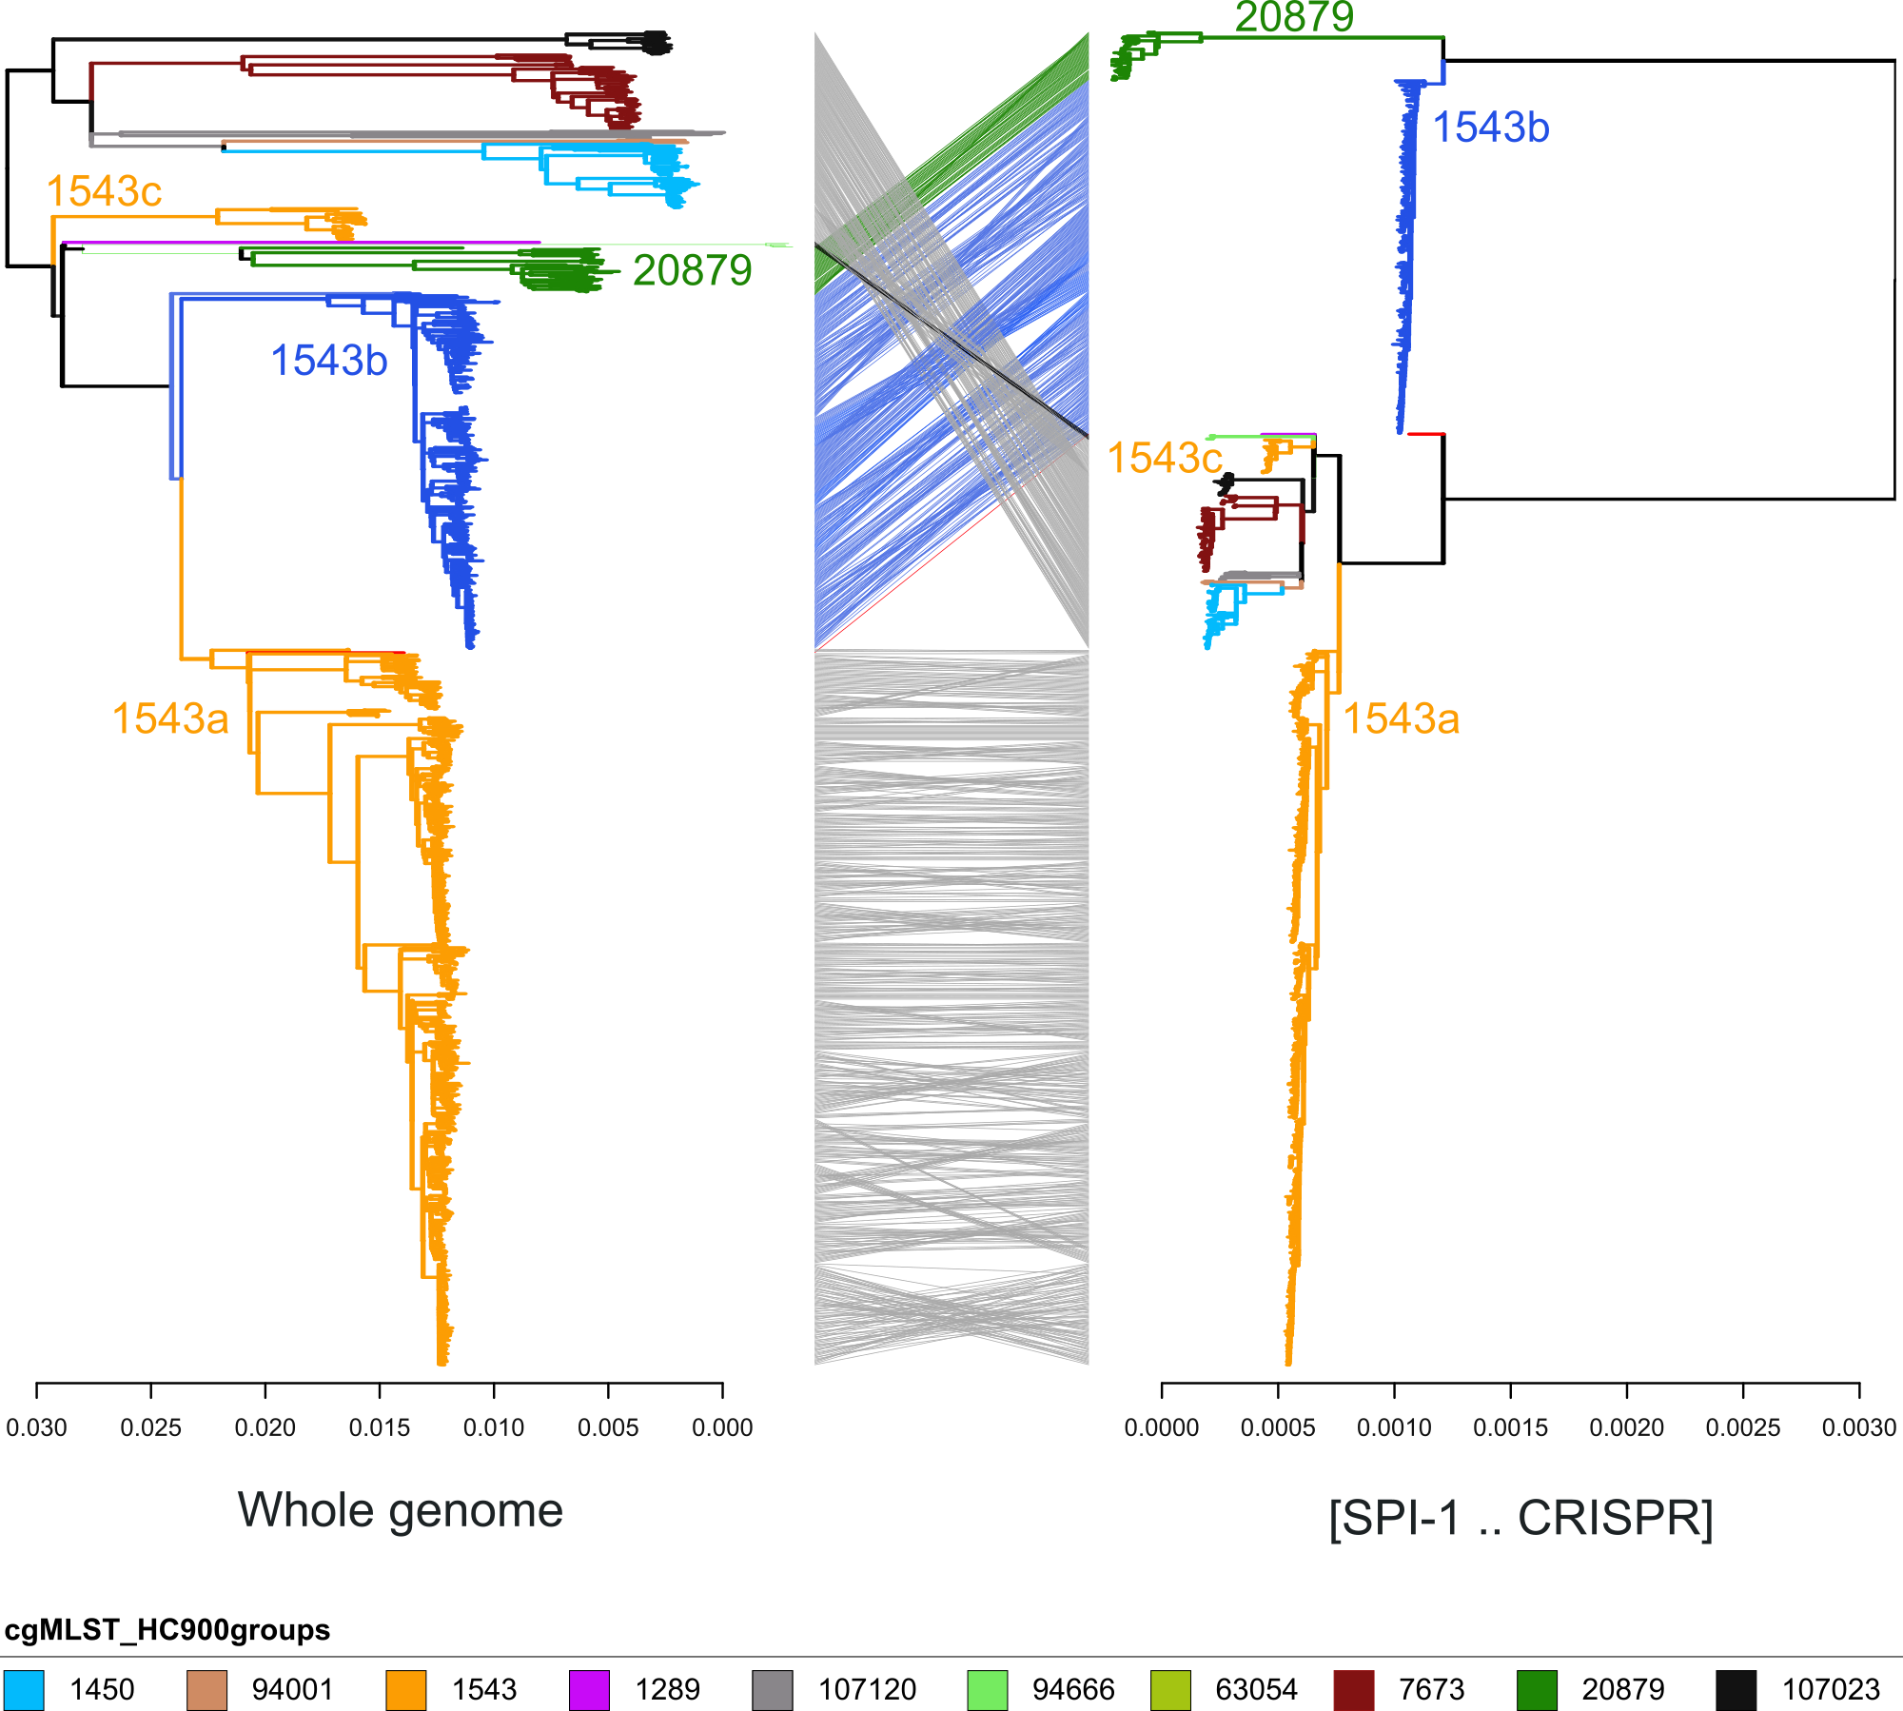
Supplementary Figure 14. Introgression signals in the genomic region spanning the SPI-1 pathogenicity island and the CRISPR locus. A tanglegram comparing two maximum likelihood phylogenies of 1,191 S. Napoli genomes (pan-genome analysis set) mapped onto the S. Napoli genome, Nap72-2 (GenBank accession no. CP163475). Left, tree built from the whole-genome alignment after the removal of recombinant segments. Right, tree built from recombinant region 3 (GenBank accession no. CP163475 coordinates: 3,264,793–3,483,701) identified by Gubbins⁶. The discordant topologies of the two trees suggest introgression affecting the SPI-1/CRISPR region.

Supplementary References

1. Zhou, Z. et al. Pan-genome Analysis of Ancient and Modern Salmonella enterica Demonstrates Genomic Stability of the Invasive Para C Lineage for Millennia. Current Biology 28, 2420-2428.e10 (2018).
2. Zhao, Y. et al. PanGP: A tool for quickly analyzing bacterial pan-genome profile. Bioinformatics 30, 1297–1299 (2014).
3. Abudahab, K. et al. PANINI: Pangenome Neighbour Identification for Bacterial Populations. Microbial Genomics 5, (2019).
4. Yoon, S. H., Park, Y.-K. & Kim, J. F. PAIDB v2.0: exploration and analysis of pathogenicity and resistance islands. Nucleic Acids Research 43, D624–D630 (2015).
5. Clausen, P. T. L. C., Aarestrup, F. M. & Lund, O. Rapid and precise alignment of raw reads against redundant databases with KMA. BMC Bioinformatics 19, 307 (2018).
6. Croucher, N. J. et al. Rapid phylogenetic analysis of large samples of recombinant bacterial whole genome sequences using Gubbins. Nucleic Acids Research 43, e15–e15 (2015).
7. Hadfield, J. et al. Phandango: an interactive viewer for bacterial population genomics. Bioinformatics 34, 292–293 (2018).

