Highly transparent and tunable antenna window using saltwater for UHF band applications
Duy Tung Phan¹, Tien Dat Nguyen¹, and Chang Won Jung^{1, *}
¹Graduate School of Nano IT Design Fusion, Seoul National University of Science and Technology, Seoul, 01811, South Korea
*changwoj@seoultech.ac.kr
Abstract
This paper presents a highly optical transparent and tunable liquid antenna for applications on the UHF band. The antenna has high transparency (> 91%), which is achieved through its use of salty water as a conductive medium held within a clear and hollow acrylic rectangular prism, allowing its use as an optical window. To achieve frequency- and beam-tunable characteristics, two advanced configurations of the antenna using dual-port feeding are proposed. The antenna’s performance is simulated and then verified through experiments. Measurement results show that for a basic configuration using single-port feeding, the antenna has a −6 dB bandwidth ranging from 350 to 675 MHz and efficient radiation efficiency (> 60%) over the band. For advanced configurations, a tunable frequency and directional radiation pattern can be achieved with enhancing gain compared to the basic configuration. These results demonstrate the proposed antenna can be used as a bi-functional device, i.e., as a tunable antenna and optical window.
Introduction
Currently, broadcasting applications have become very popular and play an important role in delivering multimedia services to users through mobile or handheld devices [1]. Most broadcasting applications such as television now operate on the ultra-high-frequency (UHF) band. However, the UHF band is one of the most challenging bands for antenna design because antennas that operate on this band are normally large, which therefore limits their practical applications [1-2]. To overcome this problem, our idea is to design a highly optical transparency (OT) external antenna using saltwater as a transparent liquid conductor. Due to the high transparency of the saltwater, the proposed antenna can overcome the size issue that affects conventional UHF antennas without many conformity or esthetic problems while also serving as an observation window in the construction industry at the same time.
Historically, many types of solid transparent antennas have been extensively studied using a solid transparent thin film such as indium tin oxide [2], graphene [3], multilayer film [4], or a metal mesh [5]. However, the metal mesh and multilayer film have relatively low average transparency (< 80%) in the visible band from 400 to 700 nm, whereas the graphene has high sheet resistance and indium tin oxide is expensive due to the cost of the rare-earth indium component [2-5]. Due to the low transparency, most previous transparent antennas are designed to work at a high frequency to reduce the size to fit specific applications, such as their installation onto the windshields of vehicles [4]. Due to its great optical transparency (OT) (> 95% at a salinity level of 40 ppt), low cost, and ready availability, saltwater has recently been explored as a potential candidate for developing a new class of high-transparent antennas [6]. For transparent antennas, saltwater as the conductive part conducts electric charges in the form of ions. So far, many different types of salt-water antennas have been reported [6-11]. In one study [6], a basic broadband water monopole was demonstrated, and the performance of the antenna was investigated by dissolving salt in pure water. In order to improve the performance of the antenna in [6], one study in [7] introduces a feeding probe loaded with a nut and washer. Another sea-water monopole [8] [9] utilized the insertion of a dielectric base between the water and ground plane to maximize the bandwidth. In other work [10], a high-efficiency seawater monopole with an average radiation efficiency above 60% is proposed for maritime wireless communications from 40 to 200 MHz. However, Saltwater, on the other hand, has a low conductivity; therefore, most existing salt-water antennas use a cylindrical structure to reduce the ohmic loss and improve radiation efficiency. It should be noted that by using the cylindrical structure, the light arrives at the antenna not only at a normal but also at an oblique incidence angle; therefore, the transparency of the antenna is significantly reduced due to strong reflection and refraction occur. To overcome this problem, in previous work [11] we presented a planar saltwater dipole antenna with very high optical transparency. However, a dipole antenna with a feeding point between two arms is not feasible as a window because the connectors are not transparent.
In this paper, we present a highly optical transparent liquid antenna for applications on the UHF band. The high transparency of the antenna is achieved using salty water held within a clear and hollow acrylic rectangular prism as a conductive medium. With this planar structure, the antenna can also be used as an optical window in the construction industry. Two advanced configurations of the antenna with two feeding ports are also proposed to achieve frequency- and beam-tunable characteristics and to enhance the gain of the antenna. The measured results demonstrate that the proposed antenna can be used as a bi-functional device, i.e., as a UHF-tunable antenna and an optical window. To the best of our knowledge, this work develops for the first time such a bi-functional device with flexible performance.

Concept and Schematic

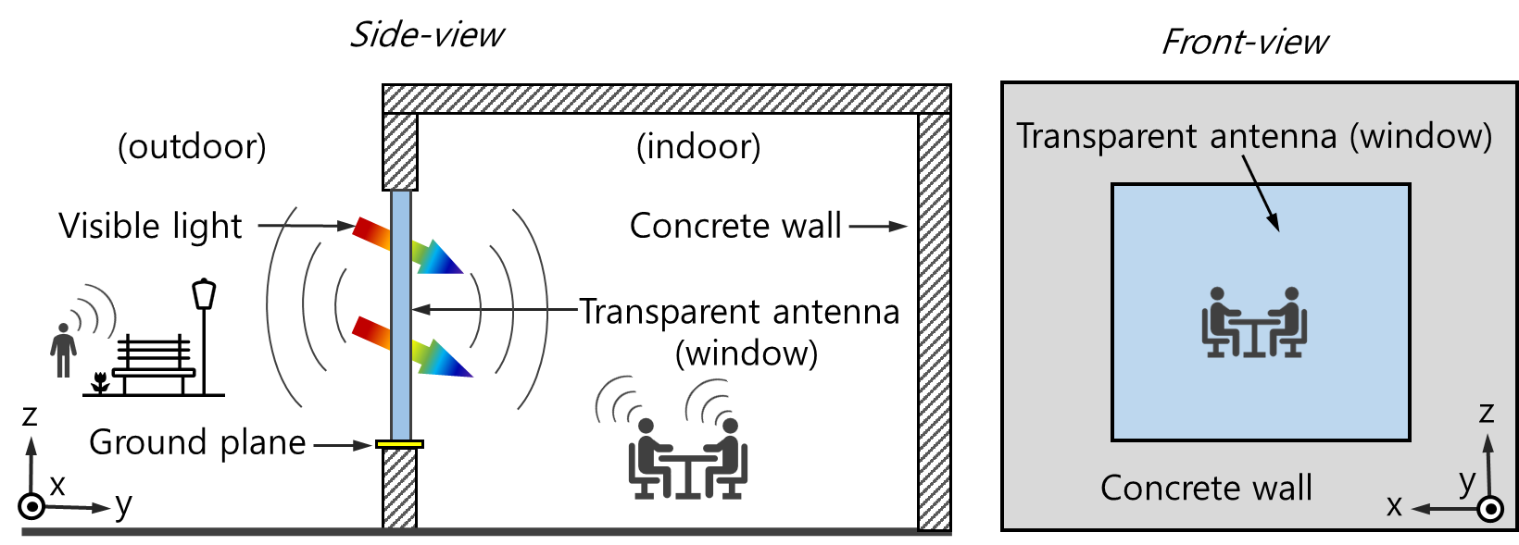
(a) (b)
Figure 1. Conceptual illustration of the transparent liquid antenna functioning as an optical window: (a) side-view, (b) front view
Fig. 1 illustrates the concept of the transparent liquid antenna, which can also be used as an optical window. Due to its high optical transparency, the antenna allows visible light to pass through unchanged; therefore, it can alternate as a conventional window. On the other hand, the antenna can be used to transmit/receive RF waves for wireless communication applications such as broadcast television and WLAN, among others. This approach is not only simple but also meets aesthetical requirements and is therefore feasible for use in many practical applications.
A schematic of the transparent liquid antenna with different configurations is shown in Figs. 2(a)-(c). In the basic configuration, as shown in Fig. 2(a), the transparent liquid antenna is fed by a single port and a thin metal strip on the top of the feeding probe for better excitation. However, the single-port configuration usually shows a low gain and cannot easily achieve tunable characteristics. Therefore, we propose advanced configurations using dual-port feeding, as shown in Figs. 2(b) and (c). As shown in Fig. 2(b), two ports are arranged opposite each other along the z-axis. In this way, two ground planes can be hidden in the upper and lower edges of the window frame without any effect on the transparency.
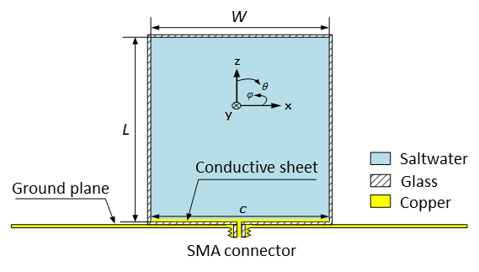
(a)
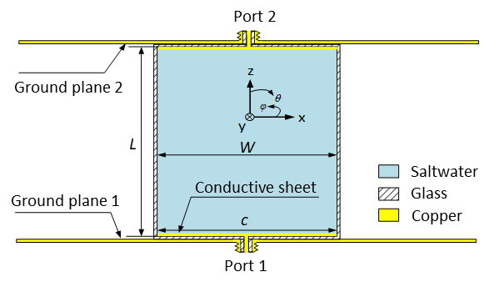
(b)
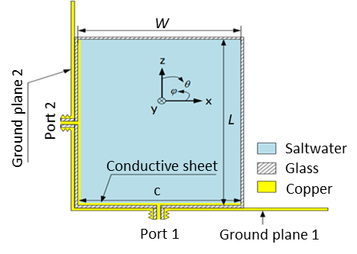
(c)
Figure 2. Schematic of the transparent liquid antenna under different configurations: (a) single feeding port, (b) dual opposite feeding ports, and (c) dual orthogonal feeding ports

Table 1. Optimized Dimensions of the Transparent Liquid Antenna
Parameter | W | L | c
Value (cm) | 15 | 15 | 15
By changing the phases of two these ports, we can control the current distribution on the antenna; therefore, we expect to achieve frequency-tunable characteristic and an omnidirectional radiation pattern for broadcasting applications such as TV or WLAN. We also propose another advanced configuration with ports 1 and 2 arranged along the z-axis and x-axis, respectively. As shown in Fig. 2(c), two ground planes also exist on the left side and lower edge of the window frame and do not cause any aesthetic problems. With this proposed configuration, we expect to achieve a directional radiation pattern for certain applications such as satellite communications. The optimum dimensions of the transparent were also determined.
Normally, a saltwater antenna shows relatively low radiation efficiency due to the high ohmic loss of the saltwater. Therefore, in the next sections, first we investigate the optical and electrical performance capabilities of saltwater with different salinity levels. Secondly, we conduct a parametric study to optimize the performance of the basic configuration by means of port feeding. Thirdly, the performance outcomes of the advanced configurations of the antenna are investigated. Finally, measurements are carried out to validate the simulation findings.
Results and discussion
Optical and electrical analysis of saltwater. Figure 3 depicts the measured conductivity and optical transparency of saltwater at various salinity levels ranging from 35 to 200 parts per thousand (ppt). The measured conductivity is carried out using a portable electrical conductivity meter, while a UV/VIS spectrophotometer connected to a computer is used to measure the optical transparency. It should be noted that optical transparency in Fig. 3 is the average value in the visible band.
As illustrated in Fig. 3, when the salinity rises, the conductivity rises rapidly while the optical transparency falls slightly. At room temperature, the maximum salinity level is 263 ppt. With salinity of 200 ppt, saltwater has efficient conductivity of 20 S/m and very high optical transparency of 91.5%. Therefore, to reduce the ohmic loss of the antenna, we use saltwater with salinity of 200 ppt in the antenna design.

Figure 3. Measured optical transparency (black squares) and conductivity (red circles) of saltwater corresponding to different salinity levels at room temperature

Single feeding port transparent liquid antenna. A transparent liquid antenna usually has low radiation efficiency compared to a typical metal antenna due to its higher ohmic loss. Therefore, it is important to understand the mechanism and optimize the radiation efficiency of the liquid antenna. The radiation of an antenna can be defined as Eq. (1).

$η=\frac{R_{rad}}{R_{rad}+R_{loss}}$, | (1)

where $R_{rad}$ and $R_{loss}$ are correspondingly the radiation resistance and loss resistance of the antenna. Because the antenna is a monopole type, $R_{rad}=73 Ω$ [10]. The loss resistance can be determined from the conductivity of saltwater ($σ$) and from the dimension of the antenna, as expressed by Eq. (2).

$R_{loss}=\frac{L}{σWt}$, | (2)

where $L, W, and t$ are the length, width, and thickness of the antenna, respectively.
(a)
(b)
Figure 4 (a) Reflection coefficient and (b) radiation efficiency of the proposed antenna with different widths of the metal sheet
Eqs. (1) and (2) show that the radiation efficiency of the saltwater antenna can be enhanced when the conductivity of the saltwater is increased. As reported in a previous study by the authors [6], under certain temperature and pressure conditions, the conductivity of saltwater increases with an increase in the salinity level. However, the salinity of saltwater at a certain point reaches its saturation limit, meaning that the conductivity of saltwater is limited. Under ambient conditions, the maximum salinity of saltwater at 263 parts per thousand (ppt) corresponds to conductivity of 25 S/m. To prevent the saltwater from becoming saturated, we use saltwater at 200 ppt for our antenna design. This salinity level ensures that conductivity of the saltwater remains as high as 20 S/m. The efficiency of the antenna can also be improved by optimizing the antenna’s dimensions, such as the length of the metal strip (c) and the width of the antenna (W), as presented in the next sections.
(a)
(b)
Figure 5 (a) Reflection coefficient and (b) radiation efficiency of the proposed antenna with different widths of the antenna and metal sheet
In order to improve the radiation efficiency of the liquid antenna, a metal strip is loaded on the top of the feeding probe (see Fig. 2) [6]. In this case, the metal strip is very thin (thickness 0.05 mm) and therefore does not affect the transparency of the antenna. Fig. 4 shows the reflection coefficient and radiation efficiency of the single-port transparent liquid antenna when the length of the metal strip varies from 5 to 15 cm. As shown in Fig. 4(a), when c increases, the resonant characteristics of the antenna do not have much of an effect and the impedance matching level is slightly poorer. However, the radiation efficiency of the antenna is significantly improved when c increases from 5 to 15 cm, as shown in Fig. 4(b). This occurs because the metal strip acts as a radiator, which contributes to an increase in the total radiation efficiency of the proposed liquid antenna. Therefore, the length of the metal strip is kept as long as the width (W) of the saltwater antenna to maximize its efficiency.
Fig. 5 shows the resonant characteristics and radiation efficiency of the liquid antenna when its width varies from 5 to 15 cm. We can observe from Fig. 5(a) that the resonant frequency of the antenna does not change much, whereas the impedance matching level is significantly improved when W increases. On the other hand, when W increases from 5 to 15 cm, the radiation efficiency of the antenna also increases significantly (Fig. 5(b)) despite the fact that the impedance matching becomes poorer with an increase in W. This likely stems from the ohmic loss of the antenna, which decreases when W increases. However, we can also observe from Fig. 4(b) that the total radiation efficiency of the antenna increases rapidly with W below 10 cm and that it increases slowly when W exceeds 10 cm. Therefore, in this study, we chose $W=c=15 cm$ as the optimum dimensions of the antenna. The optimum dimensions of the antenna are listed in Table 1. It should be noted that the thicknesses of the saltwater and glass layers (not shown in Fig. 2) are 10 mm and 2 mm, respectively.
Dual-port feeding transparent liquid antenna. Fig. 6 shows the reflection coefficient of the antenna in the advanced configurations. Figs. 6(a) and (b) correspond to the configuration with two ports arranged opposite to each other along the z-axis (see Fig. 2(b)) and arranged orthogonally along the z-axis and x-axis (see Fig. 2(c)), respectively. For each configuration, two ports are fed in a co-phase and reserve-phase configuration relative to each other in an effort to investigate their resonant characteristics.

(a)
(b)
Figure 6. Reflection coefficient of the transparent liquid antenna with dual co-phase port feeding and dual reserve-phase port feeding: (a) two ports opposite, and (b) two ports orthogonal

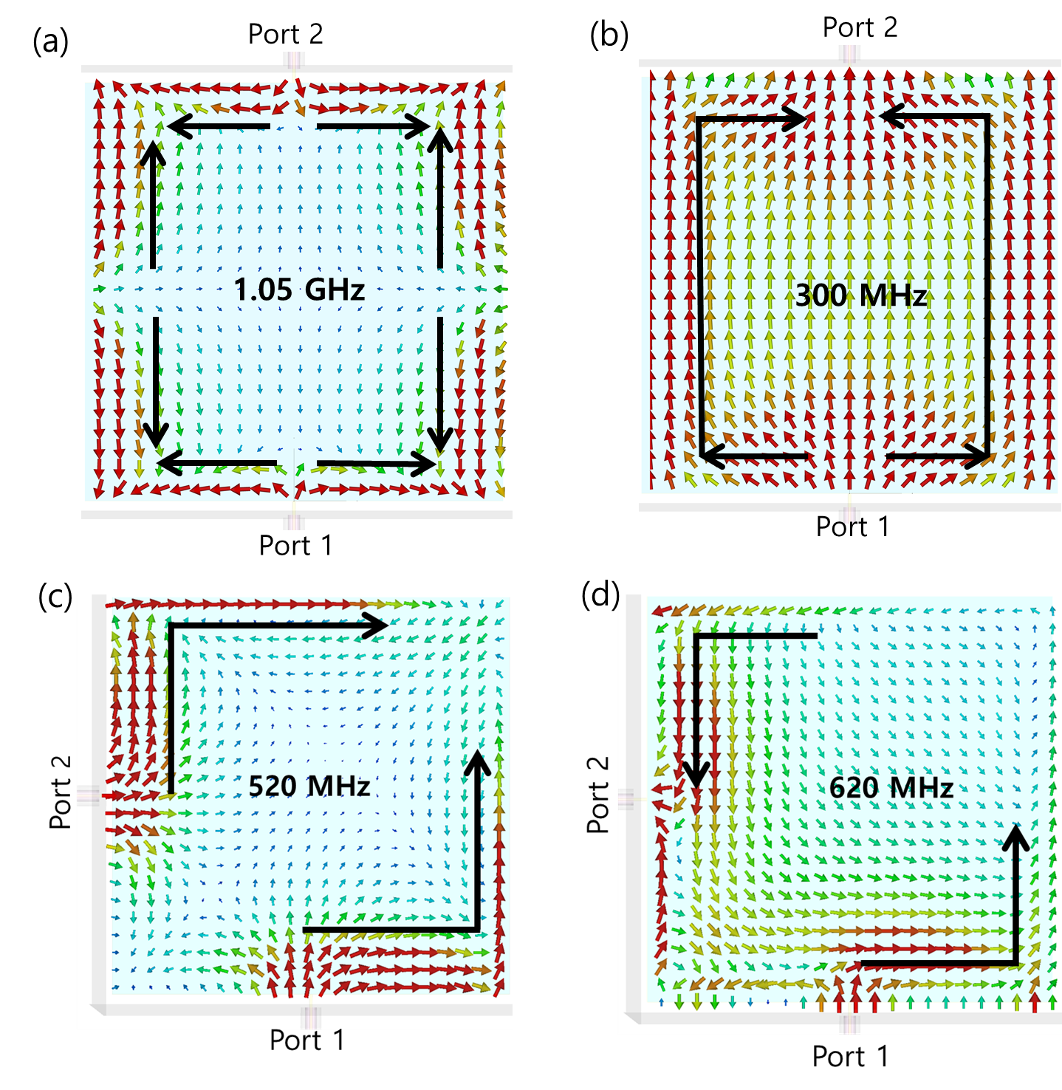
Figure 7. Surface current distribution at the resonant frequencies of the transparent liquid antenna: (a) opposite ports, co-phase feeding; (c) opposite ports, reserve-phase; (d) two orthogonal ports, co-phase; and (e) two orthogonal ports, reserve-phase
As shown in Fig. 6(a), when we change from the co-phase feeding mode to the reserve-phase feeding mode, the resonant frequency of the antenna moves from the higher band to the lower band. However, in the configurations where the two ports are arranged orthogonally, we can observe a reserve trend because the resonant frequency of the antenna moves from a lower to a higher band when we change from reserve-phase feeding to co-phase feeding. Therefore, both configurations demonstrate that a tunable frequency can be realized by the interchange between co-phase feeding to reserve-phase feeding. However, the configuration with opposite ports shows a much wider frequency-tunable range compared to the configuration with orthogonal ports, making it a more suitable configuration for frequency-tunable purposes.
In order to understand the mechanism associated with the resonant characteristics of the two advanced configurations, the current distributions at the resonant frequencies of the configurations are assessed at the resonant frequencies, as shown in Fig. 6. In each case, two ports are also fed in the co-phase and reserve-phase configurations relative to each other. As shown in Fig. 7(a), the current is distributed into different short segments with different directions, demonstrating that the antenna is working at a higher resonance level. When the two ports are fed in the reserve-phase configuration, as shown in Fig. 7(b), the current is uniformly distributed along with the antenna from port 1 forward to port 2. This type of current distribution indicates that the antenna is working in the fundamental resonance condition. Therefore, the resonant frequency in this case is much lower than that of co-phase feeding in Fig. 7(a).
Figs. 7(c) and (d) show the current distribution of the configuration with orthogonal feeding ports when ports 1 and 2 are fed in the co-phase and reserve-phase conditions, respectively. We find that the current distribution in these cases is quite similar, indicating that both cases are operating at the fundamental resonance. The length of the current in Fig. 7(c) is slightly longer than that in Fig. 7(d), resulting in the resonant frequency of co-phase feeding being slightly lower than in reserve-phase feeding, as shown in Fig. 7(b).

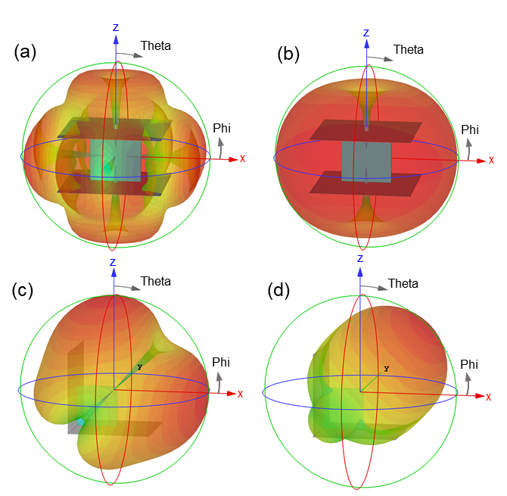
Figure 8. 3D radiation pattern of the transparent liquid antenna with (a) opposite ports, co-phase feeding; (b) opposite ports, reserve-phase feeding; (c) orthogonal ports, co-phase feeding; and (d) orthogonal ports, reserve-phase feeding
Fig. 8 shows the simulated 3D radiation pattern of the transparent liquid antenna with different advanced configurations and feeding phases. By using opposite feeding ports, the antenna acts as an omnidirectional antenna (Figs. 8(a) and (b), whereas it shows directional radiation characteristics when two feeding ports are arranged orthogonally to each other, as shown in Figs. 8(c) and (d). This result shows that the configuration with opposite feeding ports can be used for broadcasting applications such as television while the configuration with orthogonal feeding ports is more suitable for applications that require a high-directivity antenna, such as satellite communications.
Measurement results and discussion. Fig. 9 shows the measurement setup of the proposed antenna in an anechoic chamber. The inset image in Fig. 9 depicts the fabricated transparent liquid antenna (advanced configuration), where the two feeding ports are orthogonally arranged along the x- and z-axis. We find that the fabricated antenna retains its very good transparency.

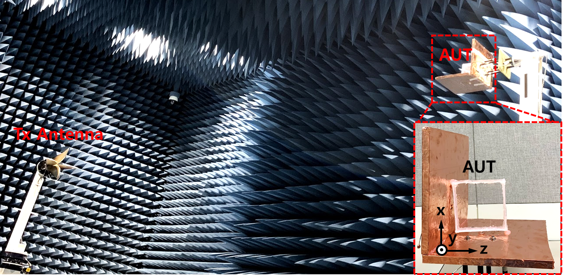
Figure 9. Measurement setup of the transparent liquid antenna in an anechoic chamber (the inset shows a closer look of the antenna under test (AUT)).

Figs. 10 shows the simulated and measured reflection coefficients ($S_{11}$) of the transparent liquid antenna with different feeding configurations. The measured S₁₁ is assessed using a network analyzer E5071B, with the findings in good agreement with the simulation results. As shown in Fig. 10(a), the transparent liquid antenna with single-port feeding (see Fig. 2(a)) shows a very wide -6 dB bandwidth ranging from 350 to 680 MHz (of 330 MHz; 64%). This frequency nearly covers the band for ultra-high-definition TV (UHD TV) applications. The reflection coefficient of the antenna with feeding using two opposite ports (see Fig. 2(b)) is shown in Fig. 10(b). As expected, the resonant frequency of the antenna moves significantly to a higher band when we change from the reserve-phase feeding to the co-phase feeding configuration. It was observed that the antenna in the reserve-phase configuration shows a wide -6 dB bandwidth ranging from 260 to 750 MHz (490 MHz; 97%), while the resonant band of the co-phase configuration is much higher, from 1.03 to 1.32 GHz (290 MHz; 24.6%). This result demonstrates that frequency-tunable characteristics of the transparent liquid antenna can be achieved by feeding a different phase between two opposite ports. Fig. 10(c) presents the simulated and measured reflection coefficients of an antenna with a feeding configuration of two orthogonal ports (see Fig. 2(c)). For the configuration with orthogonal ports, the antenna shows a small left-shift of the resonant frequency from 600 to 550 MHz when we change from reserve-phase to co-phase feeding. The -6dB bandwidths of the antenna in the reserve-phase and co-phase configurations are 330 MHz (500 to 830 MHz; 49.6%) and 240 MHz (460 to 700 MHz; 41.3%), respectively.
(a)
(b)
(c)
Figure 10. Measured reflection coefficients of the transparent liquid antenna in comparison with the simulation: (a) single feeding port, (b) opposite feeding ports, and (c) orthogonal feeding ports

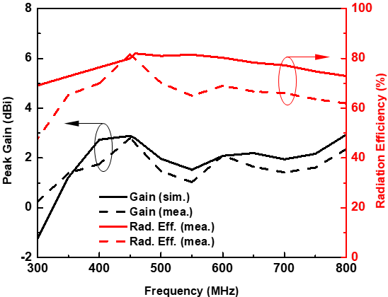
(a)
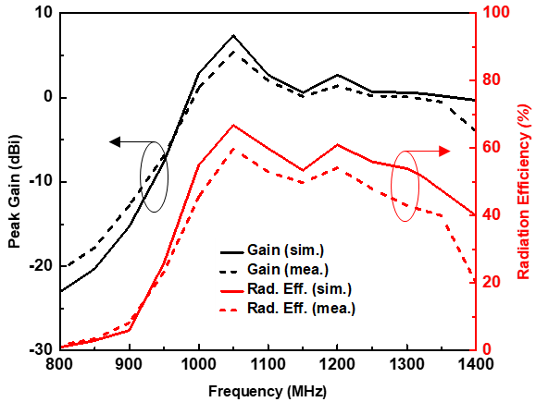
(b)
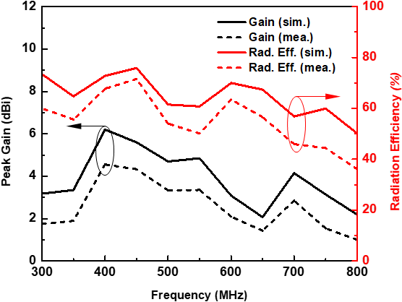
(c)
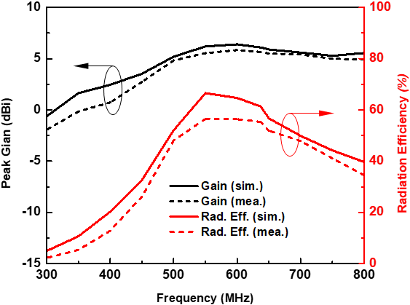
(d)
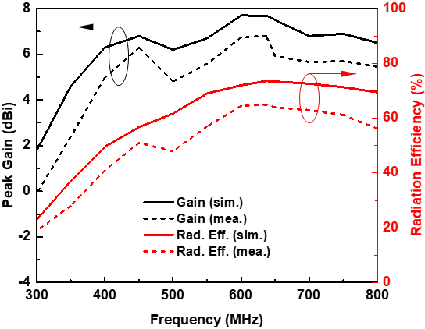
(e)
Figure 11. Measured gain and radiation efficiency of the transparent liquid antennas: (a) single port feeding; (b) opposite ports, co-phase feeding; (c) opposite ports, reserve-phase feeding; (d) orthogonal ports, co-phase feeding; and (e) orthogonal ports, reserve-phase feeding

Fig. 11 depicts the simulated and measured gain and the radiation efficiency of the transparent liquid antenna. The antenna in the basic configuration with a single port shows typical performance outcomes with the average gain and radiation efficiency on the UHF band being 1.73 dBi and 69%, respectively (Fig. 11(a)). As shown in Figs. 11 (b), the antenna in the advanced configuration with two opposite co-phase ports feeding shows an efficiency rate as high as 63% with an average value of 58.8% and gain up to 5.4 dBi on the resonant band from 1.03 to 1.32 GHz. Meanwhile, as shown in Fig. 11(c), the feeding configuration with the two opposite reserve-phase ports exhibits higher efficiency up to 71% and lower gain levels up to 4.5 dBi compared to the co-phase feeding configuration. This can be explained by the radiation characteristic of the antenna in the co-phase feeding configuration, which is more directive than that of the reserve-phase configuration, as shown in Figs. 8(a) and (b). Figs. 11(d) and (e) show the gain and efficiency of the antenna when two ports are arranged orthogonally. We find that the co-phase and reserve-phase feeding configurations exhibit similar average gain and efficiency outcomes over the resonant bands. The average gains of the co-phase and reserve-phase configurations are 5.8 and 6.8 dBi, respectively, whereas the corresponding average efficiency rates are 56% and 60%.

(a)
(b)
(b)
(c)

(d)
(e)
Figure 12. Measured radiation pattern of the transparent liquid antennas on the xoy- and xoz-planes: (a) single port feeding; (b) opposite ports, co-phase feeding; (c) opposite ports, reserve-phase feeding; (d) orthogonal ports, co-phase feeding; and (e) orthogonal ports, reserve-phase feeding

The simulated and measured radiation patterns of the proposed antenna with different feeding configurations are depicted in Fig. 12. We observed good agreement between the simulation and measurement outcomes. As shown in Fig. 12(a), the antenna shows an omnidirectional radiation pattern on the xoy-plane, while it acts as a directional antenna on the xoz-plane. The radiation pattern of the proposed antenna is similar to that of a conventional metal monopole. Figs. 12 (b) and (c) show the radiation pattern of the antenna with two opposite co-phase and reserve-phase feeding ports at their resonant frequencies, respectively. Both configurations exhibit omnidirectional radiation characteristics. However, we find that the co-phase configuration is operating at a higher resonance level while the reserve-phase configuration acts as a typical dipole at the fundamental resonance level. On the other hand, the antenna using two orthogonal feeding ports shows directional radiation patterns, as presented in Figs. 12 (d) and (e). This result demonstrates that a tunable radiation pattern can be achieved by changing from the configurations with single and two opposite feeding ports to that with orthogonal feeding ports.

Conclusion
This paper presented a highly optical transparent and tunable liquid antenna window for applications on the UHF band. The antenna has high transparency (> 91%) achieved due to the use of salty water as its conductive medium, which is held within a clear and hollow acrylic rectangular prism, allowing it to be used as an optical window. To improve the radiation efficiency of the antenna, a thin metal strip was loaded into a feeding probe to achieve greater excitation. Advanced configurations of the antenna with two feeding ports are also proposed to achieve frequency-tunable characteristics and to enhance the gain of the antenna. The antenna is simulated and its performance is verified through experimentally. Measurement results show that for the basic configuration with a single feeding port, the antenna has a −6 dB bandwidth from 350 to 680 MHz and efficient radiation efficiency (> 60%) over the band. For advanced configurations, tunable characteristics or a directional radiation pattern can be achieved with an enhanced gain compared to that of the basic configuration. These results demonstrate that the proposed antenna can be used as a bi-functional device, i.e., as an antenna and an optical window.
Methods
Materials. In this study, the saltwater is made by directly dissolving salt to pure water at room temperature. The amount of salt ($m_{s}$), pure water ($m_{w}$) are controlled to achieve desire salinity (S) using relationship between them as $S=m_{s}/m_{w}$. It should be noted that $m_{s}$ and $m_{w}$ are in grams whereas S in parts per thousand (ppt).
Simulation and Measurement. In this study, the antenna is analyzed in both aspects of electrical and optical characteristics. About the simulation result, we use Ansys HFSS (High Frequency Structure Simulator) R2019.1 to simulate the performance of the antenna. Regarding to the measurements, the optical transparency of the antenna is carried out using a model T60 ultraviolet-visible spectrophotometer whereas the conductivity was measured using a model HI8633 portable electrical conductivity meter. Meanwhile, the measured antenna’s reflection coefficient was assessed using a model E8364C vector network analyzer. The experimental far-field performance of antenna including gain, efficiency, and radiation pattern, were measured in a microwave anechoic chamber, as shown in Fig. 9.

References
- Wang, C. J. and Lee, Y. L. A compact dipole antenna for DTV applications by utilizing L-shaped stub and coupling strip. IEEE Trans. Antennas Propag. 62(12) 6515-6519 (2014).
- Phan, D. T. and Jung, C. W. Optically Transparent Wideband Dipole and Patch External Antennas Using Metal Mesh for UHD TV Applications. IEEE Trans. Antennas Propag. 68(3) 1907-1917 (2020).
- Kosuga, S., Nagata,S., Kuromatsu,S., Suga, R., Watanabe, T., Hashimoto, O. and Koh, S. Optically transparent antenna based on carrier-doped three-layer stacked graphene. AIP Adv. 11(3) 035136 (2021).
- Kim, Y., Hong, S., Lee, C., Kim Y. and Jung, C. W. Design of transparent multilayer film antenna for wireless communication. Electron. Lett. 51(1) 12-14 (2015).
- Inomata, M. Transparent Glass Antenna for 28 GHz and its Signal Reception Characteristics in Urban Environment. IEEE Conf. Proc. (EuCAP) 2020 1-5 (2020).
- Phan, D. T. and Jung, C. W. Optically transparent sea-water monopole antenna with high radiation efficiency for WLAN applications. Electron. Lett. 55(24) 1269-1271 (2019)
- Fayad, H. and Record, P. Broadband liquid antenna. Electron. Lett. 42(3) 177-178 (2006).
- Paraschakis, E., Fayad, H. and P. Record, P. Ionic liquid antenna. Proc. IWAT. IEEE Int. Workshop Antenna Technol. Small Antennas Novel Metamater. 552-554 (2005).
- Xing, L., Huang, Y., Aljaafreh, S. and Boyes, S. J. A monopole water antenna. Proc. Loughborough Antennas Propag. Conf. (LAPC). 1-4 (2012).
- Hua, C., Shen, Z. and Lu, J. High-efficiency sea-water monopole antenna for maritime wireless communications. IEEE Trans. Antennas Propag., 62(12) 5968-5973 (2014).
- Phan, D. T. and Jung, C. W. Highly Transparent Planar Dipole Using Liquid Ionized Salt Water Under Surface Tension Condition for UHD TV Applications. IEEE Trans. Antennas Propag. 69(1) 35-42 (2021).
- Luebbers, R., Chen, L., Uno, T. and Adachi, S. FDTD calculation of radiation patterns, impedance, and gain for a monopole antenna on a conducting box. IEEE Trans. Antennas Propag. 40(12) 1577-1583 (1992).

Competing interests (mandatory)
The authors declare no competing interests.

Acknowledgements
This work was supported by a grant from the National Research Foundation (NRF) of Korea funded by the Korean government (no. 2016R1D1A1B02012957).

Author contributions
Methodology, D.T. Phan, T.D. Nguyen and C.W. Jung; T.D. Nguyen conducted the simulations and experiments. D.T. Phan analyzed the results; D.T. Phan and T.D. Nguyen wrote the original draft; C.W. Jung reviewed and edited the draft. Supervision, C.W. Jung. All authors reviewed the manuscript.

