SUPPLEMENTAL INFORMATION

Continuous-wave room-temperature lasing from Bloch surface plasmon polaritons
Peng Sun^{1, #}, Pei-Wei Si^{2, #}, Yao Yang¹, Sen Yan³, Yi-Cheng Xu¹, Jin-Kun Li¹, Zhi-Peng Dong¹, Bowen Liu^{2,} *, and Jun Yi^{1,} *

¹ School of Electronic Science and Engineering, State Key Laboratory of Physical Chemistry of Solid Surfaces, Fujian Key Laboratory of Ultrafast Laser Technology and Applications, Chemistry, College of Chemistry and Chemical Engineering, Xiamen University, Xiamen 361005, P. R. China
² College of Chemistry and Chemical Engineering, Lanzhou University, Lanzhou 730000, China
# These authors contribute equally to this work
* Correspondence to: junyi@xmu.edu.cn (J. Yi); lbw@lzu.edu.cn (B. Liu)

This supplementary information includes:
Supplementary Note 1 - 9
Supplementary Fig. 1 - 17

Table of Contents

Supplementary Note 1: Sample fabrication and characterization 3
Supplementary Note 2: Measurement of angle-resolved spectra 10
Supplementary Note 3: Measurement of threshold of emitted laser 14
Supplementary Note 4: First-order temporal coherence 17
Supplementary Note 5: Theoretical formulation of Surface Plasmon Lattice Resonances 20
Supplementary Note 6: Band structure of the Bloch SPP modes 23
Supplementary Note 7: Dispersion characteristics of the lasing emission 26
Supplementary Note 8: Far-field radiation patterns and diffraction orders 29
Supplementary Note 9: Azimuthal dependence and spatial multiplexing 32

Supplementary Note 1: Sample fabrication and characterization
As shown in Supplementary Fig. 1, the periodic silver plasmonic arrays were fabricated using a custom-built ultraviolet holographic lithography (UV-HL) system. Glass substrates ($25×25$ mm²) were sequentially cleaned by ultrasonication in acetone and anhydrous ethanol for 25 min each, followed by immersion in a freshly prepared piranha solution (1:3 volume ratio mixture of 30% H₂O₂ and 98% H₂SO₄) to remove organic residues. The substrates were then rinsed extensively with ultrapure water (Milli-Q), dried under a nitrogen stream, and baked in an oven at ${120}^{∘}$C for 30 min. A 500 nm-thick layer of positive-tone photoresist (ALLRESIST) was spin-coated onto the prepared substrates. The resist was then patterned using the UV-HL method under 266 nm laser illumination, creating a two-dimensional periodic interference pattern. Following development, a periodic photoresist template was formed on the glass surface.
To create the metallic lattice, a 100 nm-thick silver layer, supported by a 3 nm-thick chromium adhesion layer, was deposited via thermal evaporation (Vnano, VZZ-300) at a base pressure of $<5 × {10}^{-4}$ Pa. The sample surfaces were then subjected to a brief oxygen plasma treatment to enhance surface energy. Finally, a template-stripping process was employed to transfer the metal films: the silver surface was coated with a small amount of UV-curable optical adhesive (Norland, NOA 81) and covered with a clean glass coverslip. After curing under 365 nm UV illumination, mechanical peeling transferred the metal layer to the coverslip, yielding an ultra-smooth, inverted silver nanoarray.
We characterized the topography of the fabricated arrays using Atomic Force Microscopy (AFM). The large-area scan (Supplementary Fig. 2a) reveals a high-quality lattice with long-range order and smooth surface morphology, free from significant defects or roughness. Cross-sectional analysis along a continuous lattice row (Supplementary Fig. 2b) confirms the uniformity of the structure, showing a periodicity of ~415 nm and an average modulation height of ~30 nm. Statistical analysis of the height distribution (Supplementary Fig. 2c) indicates that while the modulation depth ranges from 20 nm to 45 nm, the distribution is strongly centered around 33 nm (~50% of the population). Furthermore, the height profile of a single nanostructure (Supplementary Fig. 2d) is well-described by a Gaussian fit, indicating a continuous, gradient profile typical of interference lithography. These results confirm that the fabrication process yields structures with excellent surface quality and geometric uniformity, providing a robust foundation for minimizing scattering losses in the nano-laser.
We employed oil-soluble CdSe/ZnS core-shell quantum dots (QDs) as the gain medium. These QDs exhibit a photoluminescence (PL) peak at $610±5$ nm, a full-width at half-maximum (FWHM) of ~35 nm, and a quantum yield exceeding 80%. Notably, the QDs possess a broad absorption spectrum with $>$95% absorption efficiency at 405 nm, which was selected as the pump wavelength to minimize the lasing threshold (see Supplementary Fig. 3).
To deposit the gain layer, a solution of QDs in hexane was diluted to 1 mg mL⁻¹. A 30 $μ$L volume was dispensed onto the center of the sample, followed by spin-coating at 1500 rpm for 30 s. The samples were subsequently dried in a vacuum oven for over 8 hours to remove the solvent. During this process, the evaporation of hexane drives the QDs to conformally coat the lattice surface. A residual ultra-thin layer of solvent/ligands aids in the formation of a stable, adhesive interface between the QDs and the silver structure (see Supplementary Fig. 4).
To ensure that the gain layer does not introduce parasitic waveguide modes or alter the QD emission properties, we performed a series of control experiments. First, we compared the PL spectra of the QDs in the solution phase versus the spin-coated solid film on a planar glass substrate (Supplementary Fig. 5a). Both spectra show a consistent peak emission at ~610 nm with no significant spectral shift or broadening, indicating that the deposition process does not induce QD aggregation or defect formation. Second, we analyzed the influence of the gain layer on the plasmonic resonances by comparing the white-light reflectance spectra of the lattice before and after spin-coating (Supplementary Fig. 5b). The coating induces a slight redshift of the primary resonance dip from 606.6 nm to 610.9 nm ($Δλ≈4.3$ nm) accompanied by a minor reduction in modulation depth. This small shift confirms that the dielectric environment is only weakly perturbed. Crucially, no additional spectral features corresponding to dielectric waveguide modes were observed in the measurement range. This confirms that the gain layer is sufficiently thin to prevent the support of guided modes, ensuring that the subsequent lasing is driven purely by the Bloch SPP modes of the metallic lattice.
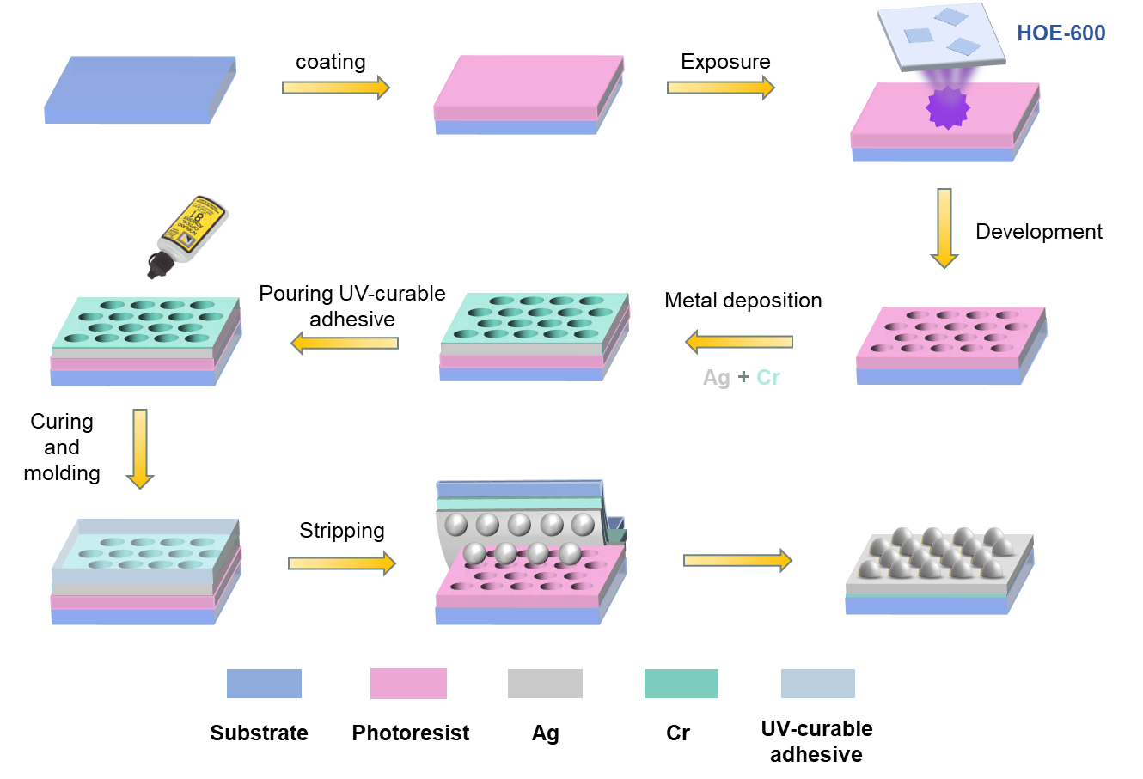
Supplementary Figure 1 | Schematic illustration of the sample fabrication process. The fabrication utilizes UV holographic lithography followed by a template-stripping procedure. A photoresist template is patterned via laser interference, metallized with Ag/Cr, and then transferred to a final glass support using a UV-curable adhesive. This method yields inverted silver lattices with superior surface smoothness compared to direct lift-off processes.

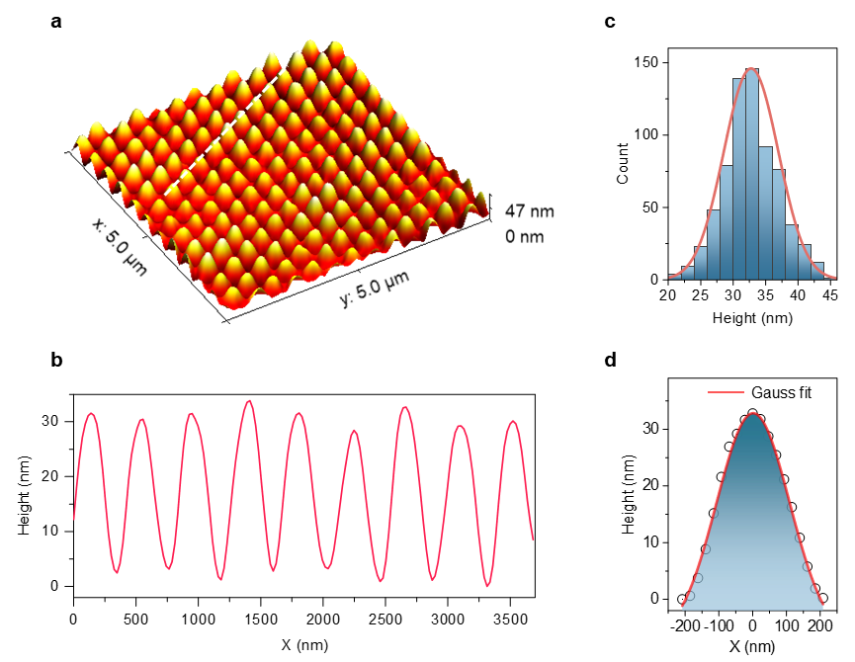
Supplementary Figure 2 | Morphological characterization of the plasmonic lattice. a, Large-area Atomic Force Microscopy (AFM) image of the fabricated silver nanoarray, showing high periodicity and surface quality. b, Height profile extracted along the white dashed line in a, demonstrating a uniform periodicity of ~415 nm and modulation height of ~30 nm. c, Statistical histogram of the modulation heights collected from the scanned area; the distribution is centered at 33 nm. d, Cross-sectional profile of a single lattice unit cell (black dots) fitted with a Gaussian function (red line), indicating a smooth, continuous surface profile.

Supplementary Figure 3 | Characteristics of quantum dots. The red solid line and the purple solid line represent the normalized absorption spectrum and the emission spectrum respectively. These QDs exhibit a photoluminescence (PL) peak at $610±5$ nm, a full-width at half-maximum of ~35 nm.

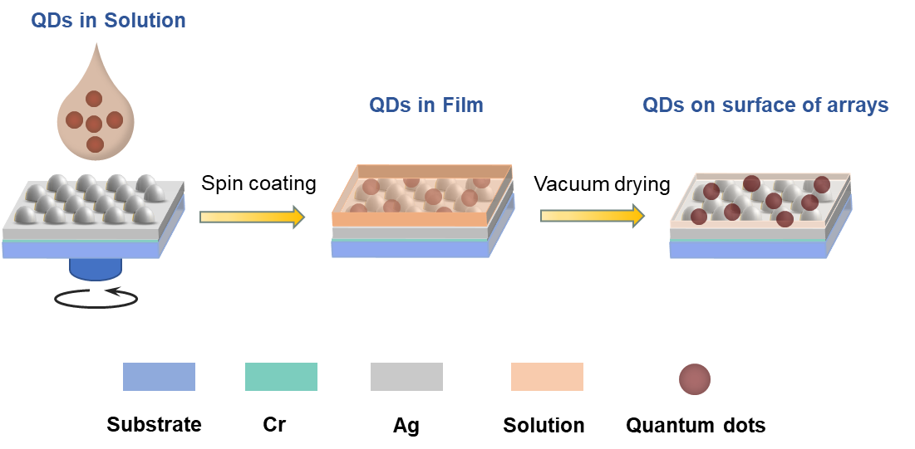
Supplementary Figure 4 | Fabrication of nano-laser. The quantum‑dots in hexane solution was spin‑coated onto the nanostructured array and subsequently dried in a vacuum oven to evaporate the solvent. This process drives the conformal coating of quantum dots over the lattice surface, while the residual solvent helps to firmly adhere the quantum dots to the interface.

Supplementary Figure 5 | Optical characterization of the quantum dot gain layer. a, Normalized photoluminescence (PL) spectra of the CdSe QDs in hexane solution (black) and as a spin-coated thin film (red). The identical peak positions (~610 nm) indicate that the film formation process preserves the intrinsic emission properties of the QDs. b, Reflectance spectra of the silver lattice before (black) and after (red) coating with the QD layer. The primary Bloch SPP resonance exhibits a minor redshift of 4.3 nm due to the change in refractive index, while the absence of new resonance dips confirms that the thin gain layer does not support parasitic waveguide modes.

Supplementary Note 2: Measurement of angle-resolved spectra
To systematically investigate the correlation between the lasing emission and the Bloch SPPs, we constructed a versatile custom-built angle-resolved spectroscopy system (Supplementary Fig. 6). This apparatus integrates multiple functionalities, allowing for the comprehensive measurement of angle-resolved reflection spectra, radiation emission spectra, excitation polarization/power dependence, emission polarization analysis, and temporal coherence.
The system comprises four primary modules: a light source selection unit, a polarization/power control unit, a spectral collection unit, and a Michelson interferometer module¹. The sample positioning and detection geometry are controlled by a nested goniometer configuration.
The sample is mounted on a motorized rotation stage (Stage 3) to control the azimuthal angle ($φ$, in the $x$-$y$ plane). Stage 3 is vertically mounted onto a second rotation stage (Stage 2), which tilts the sample to define the incident polar angle ($θ_{\text{in}}$, in the $x$-$z$ plane). A larger, outer coaxial rotation stage (Stage 1) carries the detection modules. Rotating Stage 1 allows the detection unit to sweep the viewing angle ($θ_{\text{out}}$) independently of the sample orientation. This configuration enables full hemispherical mapping of the optical response, defined by the parameters $\left(λ,I∝θ_{\text{in}},φ,θ_{\text{out}}\right)$.
For passive band structure mapping, a collimated halogen light source (HL100, Idea Optics) illuminates the sample (Supplementary Fig. 7b). The incident polarization (TE or TM) is selected via a linear polarizer (LP2; GT10, JCOPTIX). To measure specular reflectance, the angular motion is synchronized such that the detection angle tracks the reflection path: if the sample is rotated by an angle $α$ ($θ_{\text{in}}=α$), Stage 1 is rotated by $2α$ ($θ_{\text{out}}=θ_{\text{in}}+θ_{\text{r}}$). The reflected light is coupled into a multimode fiber via the spectral collection module and analyzed by a spectrometer (LEDPRO-50, Ocean Optics).
For active measurements, the source is switched to a continuous-wave (CW) 405 nm semiconductor laser (GNL-S405, CIOMP) (Supplementary Fig. 7c). The excitation power is continuously tunable using a half-wave plate (HWP; TWP20H-405P, JCOPTIX) in combination with the fixed polarizer LP2. The incident geometry ($θ_{\text{in}},φ$) is set by Stages 2 and 3, while the emission spectrum is collected at arbitrary angles $θ_{\text{out}}$ by rotating Stage 1. To analyze the polarization state of the emission, a rotatable linear polarizer (LP3; GT10, JCOPTIX) is inserted into the collection path. To verify excitation polarization dependence, LP3 is removed, and the HWP is rotated to vary the pump polarization while maintaining constant power.
To measure the coherence length ($l_{c}$), the spectral collection module on Stage 1 is replaced by the Michelson interferometer module (Supplementary Fig. 7d). The excitation geometry remains identical to the emission setup. By translating mirror M2 via a high-precision linear actuator to introduce a path length difference between the two interferometer arms, interference fringes are generated and recorded by a CMOS camera (E3ISPM20000KPA, ToupTek).
For all measurements involving the pump laser, a long-pass edge filter (VLP01-532-12.5, Semrock) is installed at the entrance of the detection modules (both spectral and interferometric). This filter effectively blocks scattered 405 nm pump light, ensuring signal purity and protecting the detectors.

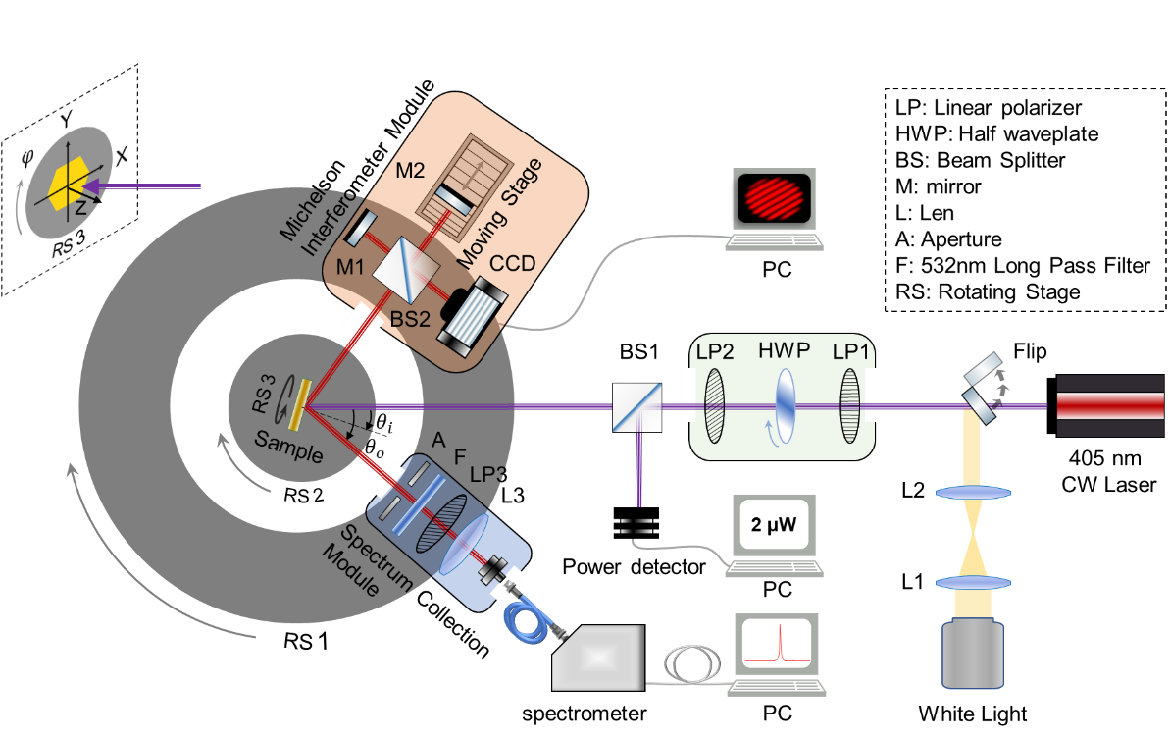
Supplementary Figure 6 | Multifunctional angle-resolved spectral measurement system. The schematic illustrates the custom-built setup comprising four primary functional modules: the light source selection unit, the polarization and power control unit (green box), the spectral collection unit (blue box), and the Michelson interferometer¹ unit (pink box).

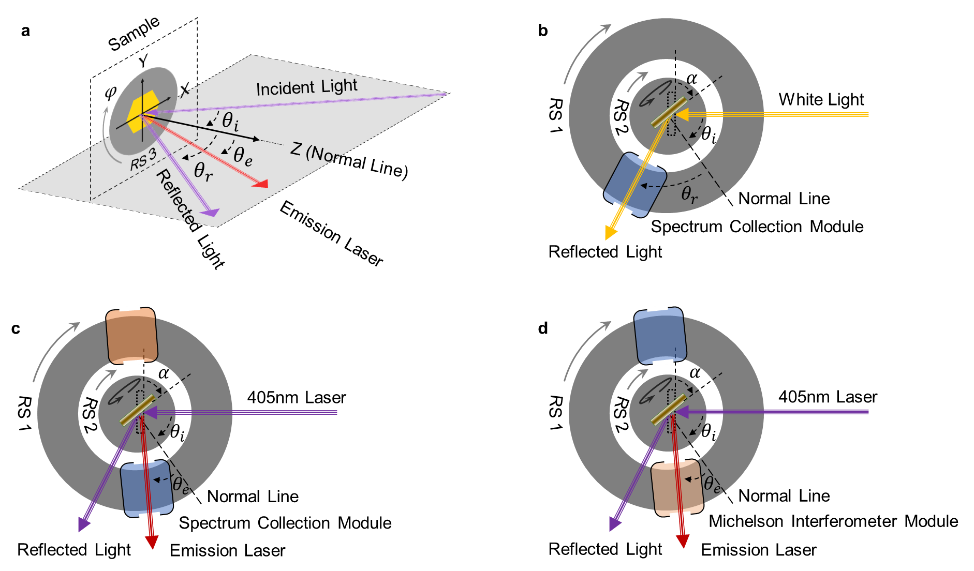
Supplementary Figure 7 | Optical path and measurement geometry. a, Definition of the coordinate system. The plane of incidence is defined as the $xz$-plane, with the $z$-axis normal to the sample surface. The incident angle ($θ_{\text{in}}$), reflection angle ($θ_{\text{r}}$), and emission angle ($θ_{\text{out}}$) are all defined relative to the surface normal. b, Configuration for angle-resolved reflectance. Collimated white light illuminates the sample. The incident angle is set by rotating the sample stage ($θ_{\text{in}}=α$), while the detection arm (Stage 1) is rotated to the specular reflection angle to collect the signal. c, Configuration for lasing emission characterization. The sample is pumped by a 405 nm CW laser. The incident polar angle ($θ_{\text{in}}$) and azimuthal angle ($ϕ$) are set by the sample goniometer (Stages 2 and 3). The detection arm (Stage 1) scans independently to map the radiation pattern at various emission angles ($θ_{\text{out}}$). d, Configuration for temporal coherence measurement. The geometry is identical to c, but the spectral collection module is replaced by the Michelson interferometer module to record interference patterns.

Supplementary Note 3: Measurement of threshold of emitted laser
To ensure accurate determination of the lasing threshold, precise characterization of the pump beam is essential. As shown in the setup diagram (Supplementary Fig. 6 and Supplementary Fig. 7c), a 50:50 non-polarizing beamsplitter was inserted after the polarization/power control module. This diverted half of the excitation beam to a calibrated power meter (Model 2936-R, Newport) for real-time monitoring of the equivalent power incident on the sample.
To quantify the power density, the power meter was temporarily replaced by a beam profiler (BP209-VIS, Thorlabs). The resulting spatial profile (Supplementary Fig. 8) reveals a near-circular Gaussian distribution. Using the elliptical area formula $S=πab$, and the measured major axis $2a≈282.7$ μm and minor axis $2b≈273.8$ μm, we calculated the effective spot area to be $S=6.079×{10}^{-4}{\text{ cm}}^{2}$. This value was used to convert the measured pump power into power density (${mW/cm}^{2}$) for all threshold calculations.
For the input-output ($L$-$L$) characterization, the linear polarizer (LP2) was fixed to the TM orientation. The excitation power was then swept by rotating the preceding half-wave plate (HWP), ensuring that the polarization state on the sample remained strictly TM-polarized while the intensity varied. We systematically investigated the emission intensity as a function of pump power at various detection angles $θ_{\text{out}}$ to clearly distinguish between directional lasing and isotropic spontaneous fluorescence (Supplementary Fig. 9).
Under vertical pumping, the emitted energy is not concentrated near the optical axis ($θ_{\text{out}}={10}^{∘}$) nor at large angles characteristic of planar interface emission ($θ_{\text{out}}={60}^{∘}$). At these angles, the response is linear and broad, typical of spontaneous fluorescence. In contrast, the emission is efficiently funneled into specific directional channels defined by the Bloch surface plasmon polaritons. In these resonant directions, the signal intensity is orders of magnitude higher than the fluorescence background, accompanied by significant spectral narrowing.

Supplementary Figure 8 | Beam profile of the excitation source. The 405 nm CW semiconductor laser operates in the fundamental transverse mode (${\text{TEM}}_{00}$). The measured spot shape is quasi-circular with a Gaussian intensity distribution, ensuring uniform excitation quality.

Supplementary Figure 9 | Emission spectra of power densities at different detection angles under normal excitation. Left panels: Input-output ($L$-$L$) curves plotting the integrated emission intensity versus pump power density. Both axes are plotted on a ${log⁡}_{2}$ scale to clearly visualize the transition from spontaneous emission to lasing and to compare the threshold behaviors across different angles. Right panels: Normalized emission spectra measured at the maximum pump power density for each respective detection angle. The comparison highlights the spectral narrowing and intensity dominance of the resonant lasing mode ($θ_{\text{out}}≈{36}^{∘}$) compared to the broad background fluorescence observed at off-resonance angles ($θ_{\text{out}}≈{10}^{∘}$ and ${60}^{∘}$).

Supplementary Note 4: First-order temporal coherence
The experimental setup is shown in Supplementary Fig. 6. The experiment involved splitting the emission beam into two paths and introducing a controllable path length difference ($Δx$) by translating mirror M2. By strictly translating M2 along the optical axis with a step size of $Δx=5$ $μ$m, we acquired a series of interference fringe patterns at varying path delays (see Supplementary Fig. 10).
The first-order temporal coherence function, $g^{\left(1\right)}$, is the normalized mutual coherence function that quantifies the correlation between the optical fields. In an interferometric measurement, the modulus $∣g^{\left(1\right)}∣$ is directly related to the fringe visibility $V(Δx)$, defined as $\left(I_{max}-I_{min})/(I_{max}+I_{min}\right)$. The decay of fringe visibility with increasing displacement reflects the loss of coherence. The experimental data follows an exponential decay profile, consistent with a Lorentzian spectral lineshape².
$∣g^{\left(1\right)}(Δx)∣=e^{-∣Δx∣/l_{c}}$ (S1)
where $l_{c}$ represents the coherence length, defined as the displacement at which the coherence degree decays to $1/e≈0.368$ of its initial value. By fitting the visibility curve with this function, the full-width at half-maximum (FWHM) can be related to the coherence length via:
$FWHM=2×\left(ln2·l_{c}\right)≈1.386·l_{c}$ (S2)
To ensure sufficient signal intensity for clear fringe recording by the industrial CMOS camera, the pump power was set to the milliwatt level ($P=10.73$ mW), which is well above the lasing threshold ($∼μ$W range). The extracted $|g^{\left(1\right)}\left(Δx\right)|$ curve is presented in Fig. 2f of the main text. A fit to the experimental data yields an FWHM of approximately 24.98 $μ$m, corresponding to a coherence length of $l_{c}≈18.02$ $μ$m.
We further verified the stability of the coherence properties by systematically varying the pump power (Supplementary Fig. 11). The results indicate that the coherence length remains robust at approximately 18 $μ$m across the measured power range. This value is in excellent agreement with the theoretical coherence length estimated from the spectral properties of the laser (center wavelength $λ≈612$ nm, linewidth $Δλ≈5.8$ nm), confirming the validity of the interferometric characterization.
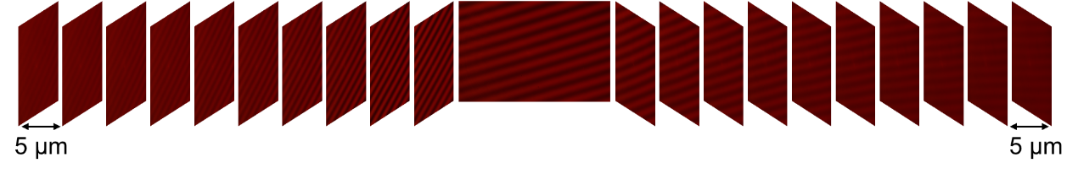Supplementary Figure 10 | Evolution of interference fringes. Representative interference patterns recorded by the camera at selected path length differences ($Δx$). High-contrast fringes are observed near zero path difference ($Δx=0$), with visibility gradually decreasing as $Δx$ increases, indicative of the finite coherence length of the lasing mode.

Supplementary Figure 11 | Coherence length of different power. Extracted coherence length ($l_{c}$) plotted as a function of pump power. The coherence length remains stable at $∼$18 $μ$m (dashed line), consistent with the spectral linewidth limits, indicating that the temporal coherence of the device is maintained even at high pump powers.

Supplementary Note 5: Theoretical formulation of Surface Plasmon Lattice Resonances
Surface Lattice Resonances (SLRs) are typically defined as collective optical modes arising in periodic arrays of discrete metal nanoparticles, where the Localized Surface Plasmon Resonance (LSPR) of individual particles couples radiatively with the diffraction orders of the array (Rayleigh anomaly). This coupling leads to spectral features with significantly narrower linewidths than individual LSPRs.
However, when the system transitions to a continuous metallic film with periodic modulation (as in this work), the optical response is dominated by the coupling between propagating SPPs and the lattice diffraction. While physically analogous to SLRs in terms of band formation, this phenomenon is more accurately described as Bloch SPPs. Here, the lattice acts as a grating coupler that folds the dispersion of the propagating SPPs into the first Brillouin zone, creating leaky modes inside the light cone that can couple to free-space radiation (see Supplementary Fig. 12).
The dispersion relation of an SPP propagating at a flat interface between a metal (permittivity $ε_{m}$) and a dielectric (permittivity $ε_{d}$) is given by:
$\left|k_{spp}\right|=\frac{2π}{λ}·{\left(\frac{1}{ε_{1}}+\frac{1}{ε_{2}}\right)}^{1/2}$ (S3)
where $λ$ is the vacuum wavelength. In a system with two-dimensional periodicity, the lattice momentum allows the SPP to couple to free-space light. The resonance condition is satisfied when the momentum matching equation is met³:
$k_{spp}=k_{||}+G$ (S4)
Here, $k_{∥}$ is the in-plane wavevector component of the incident (or emitted) light, and $G$ is a reciprocal lattice vector.
For a plane wave incident at a polar angle $θ$ and azimuthal angle $ϕ$ (see schematic in Supplementary Fig. 12a), the in-plane wavevector is:
$k_{||}=\frac{2πn}{λ}sinθ∙\left(cosφ,sinφ\right)$ (S5)
where $n$ is the refractive index of the surrounding medium.
For the triangular lattice structure used in this work, the reciprocal lattice is hexagonal. The reciprocal lattice vectors $G$ are defined as:
$G=\frac{2π}{P}K$，$K=mb_{1}+nb_{2}$ (S6)
where $m,n$ are integers representing the diffraction order, and $b_{1},b_{2}$ are the primitive reciprocal lattice vectors. The magnitude of the primitive vectors is $|b|=4π/(\sqrt{3}P)$, where $P$ is the lattice constant. The geometric relationship between the lattice basis, reciprocal vectors, and wavevectors is illustrated in Fig. 4g of the main text.
To map the isofrequency contours in momentum space, we consider the vector components in a Cartesian coordinate system. The momentum conservation law (Eq. S4) dictates that a resonant mode exists when the magnitude of the diffracted wavevector equals the SPP wavenumber. Decomposing this into components allows us to solve for the resonant angles:
$k_{||}: \left\{\begin{aligned}k_{x}=\frac{2πn}{λ}sinθ∙cosφ \\ k_{y}=\frac{2πn}{λ}sinθ∙sinφ\end{aligned}\right.$ (S7)
$G: \left\{\begin{aligned}G_{x}=\frac{2π}{P}\left(mb_{1}+nb_{2}\right)·cosφ \\ G_{y}=\frac{2π}{P}\left(mb_{1}+nb_{2}\right)·sinφ\end{aligned}\right.$ (S8)
Finally, the out-of-plane component of the free-space wavevector, which determines the radiative decay into the far field, is given by:
$k_{z}=\sqrt{{\left(\frac{2πn}{λ}\right)}^{2}-∣k_{∥}∣^{2}} =\frac{2πn}{λ}\cos{θ}$ (S9)
These equations (S3–S8) form the basis for the theoretical isofrequency contours presented in Fig. 4 of the main text. They confirm that for a given lattice constant $P$ and diffraction order $\left(m , n\right)$, there is a deterministic relationship between the resonant wavelength $λ$, the emission angle $θ$, and the azimuth $φ$.

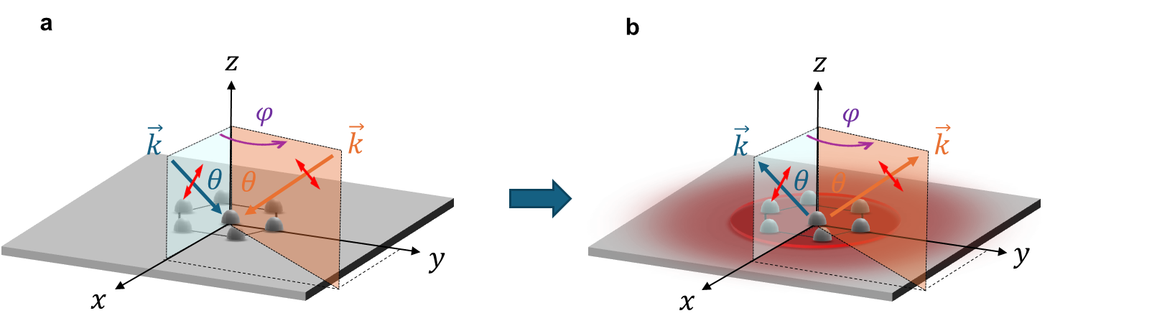
Supplementary Figure 12 | Principle of reciprocity in plasmonic lattices. a, Schematic of the “receiving mode”: An incident plane wave couples to the lattice resonance, creating a dip in reflectance. b, Schematic of the “transmitting mode”: An internal dipole source couples to the lattice mode, which then radiates into the far field with the same directionality as the receiving mode.

Supplementary Note 6: Band structure of the Bloch SPP modes
To reconstruct the photonic band structure of the experimental system (triangular silver lattice, period $P≈415$ nm), we utilized the angle-resolved spectroscopy module described in Supplementary Note 2 (see Supplementary Fig. 7b). By scanning the detection angle across the full hemispherical space, we measured the reflectance $R(λ,θ,ϕ)$. Using the geometric relations derived in Supplementary Note 5 (Eq. S7-S9), these real-space reflectance maps were transformed into momentum space ($k$-space). Supplementary Fig. 13b displays the resulting dispersion diagram, plotting photon energy $E$ versus the in-plane wavevector $k_{∥}$ along the high-symmetry path of the first irreducible Brillouin zone ($Γ→M→K→Γ$).
The theoretical dispersion curves (overlaid as black dotted lines in Supplementary Fig. 13b were calculated using the empty-lattice approximation and the momentum matching framework established in Supplementary Note 5. For the dielectric function of silver, $ε(ω)$, we employed the Drude-Lorentz model⁴:
$ε\left(ω\right)=ε_{∞}-\frac{Ω_{p}^{2}}{ω^{2}+iΓ_{0}ω}+\sum_{j=1}^{k}{\frac{{f_{j}ω}_{p}^{2}}{{(ω_{j}^{2}-ω}^{2})-i{ωΓ}_{j}}}$ (S10)
The parameters for the Drude term (plasma frequency $Ω_{p}$, damping $Γ_{0}$) and the Lorentz oscillators (strength $f_{j}$, resonance $ω_{j}$, damping $Γ_{j}$) were taken from Rakić et al. [Ref: Rakic 1998, Appl. Opt. 37, 5271] ⁴. The refractive index of the dielectric environment was set to match the effective index of the gain-coated interface.
The agreement between experiment and theory is excellent, particularly in the lower energy bands. In the high-frequency region, the experimental signal-to-noise ratio is limited by the lower spectral irradiance of the halogen light source. However, in the crucial spectral window relevant to the gain medium (570–650 nm, indicated by the yellow shading), the dispersion features are resolved with high clarity.
Throughout the measured Brillouin zone, the experimental spectra reveal a single, well-defined resonance branch without parasitic splitting or scatter-induced background. This confirms the high spatial uniformity of the fabricated lattice. Along the $M→K$ path, the experiment clearly reproduces the theoretical band evolution, including the mode merging and splitting characteristic of the hexagonal symmetry.
Notably, along the $Γ→M$ direction (corresponding to Fig. 1f in the main text), a single sharp resonant mode intersects the gain bandwidth. Crucially, our design does not rely on aligning the gain peak with high-symmetry points (critical points like $Γ$, $M$, or $K$) where the group velocity is zero. For instance, the $K$-point resonance ($∼$665 nm) lies slightly outside the primary QD emission range ($∼$650 nm cutoff). The successful lasing observed in this work demonstrates that Bloch SPP feedback is efficient enough to sustain oscillation along the dispersive slopes of the band structure, not just at band-edge singularities. This flexibility significantly relaxes fabrication tolerances and offers a new paradigm for designing tunable nanolasers.
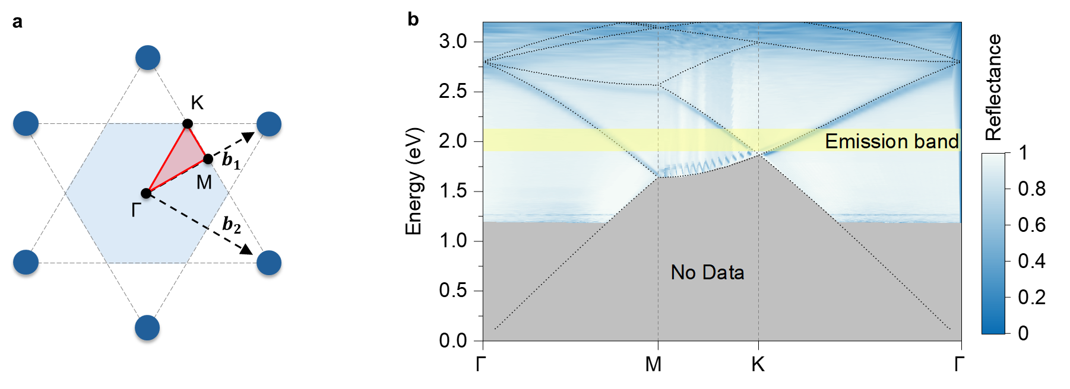
Supplementary Figure 13 | Photonic band structure of triangular lattice. a, Photonic band structure analysis. a, Schematic of the first Brillouin zone for a hexagonal lattice, defining the high-symmetry points $Γ$, $M$, and $K$. b, Projected energy-momentum dispersion diagram along the path $Γ→M→K→Γ$. The color map represents the experimental angle-resolved reflectance (darker blue indicates the resonance dip), while the overlaid black dotted lines represent the theoretical Bloch SPP dispersion calculated using the Drude-Lorentz model⁴. The yellow shaded region indicates the spectral bandwidth of the quantum dot gain medium. The excellent agreement confirms that the optical response is governed by the predicted lattice modes.

Supplementary Note 7: Dispersion characteristics of the lasing emission
The theoretical analysis in Supplementary Note 5 establishes the conditions for resonant coupling: when a plane wave is incident on the lattice at a specific angle and polarization, it can couple efficiently to a Bloch SPP mode, resulting in a sharp dip in reflectance. This describes the “receiving mode” of the lattice (schematic in Supplementary Fig. 12a). By the principle of optical reciprocity, if the lattice is integrated with an active medium (QDs), the system acts as a source⁵. The isotropic spontaneous emission from the QDs couples into the lattice modes, receives feedback, and is then out-coupled into free space via first-order Bragg diffraction. This out-coupled radiation is not isotropic but follows the exact same angular and polarization constraints as the receiving mode, constituting the “transmitting mode” (Supplementary Fig. 12b).
To visualize the spatial distribution of this emission, we solved the momentum matching equations (Eq. S7 in Supplementary Note 5) for the entire gain bandwidth. For a fixed wavelength $λ$, the allowed solutions lie on the intersection of the light cone (a sphere of radius $∣k∣=2πn/λ$) and the reciprocal lattice planes. The resulting isofrequency contours exhibit the characteristic six-fold symmetry of the triangular lattice (Supplementary Fig. 14a). As the wavevector component $k_{z}$ decreases (moving from the $Γ$-point center towards the Brillouin zone edges), the distribution of solutions changes. Near the $K$-points (vertices of the hexagon), multiple diffraction orders intersect. This leads to a high density of states where modes of different indices and wavelengths overlap significantly in momentum space (Supplementary Fig. 14b, $k_{x}$-$k_{y}$ projection).
While the momentum-space representation separates modes by wavevector, in real-space experiments (far-field projection), these modes overlap on the detector plane. The projection of these solutions reveals two distinct regimes: Along the $Γ→K$ direction, the dispersion bands cross and degenerate. While this provides a high density of states, it leads to spectral crowding where multiple wavelengths can be emitted at the same angle, or conversely, a single wavelength can be emitted into multiple degenerate angles. This mode mixing complicates the isolation of a clean, single-mode lasing signal. While for the edge-center along the $Γ→M$ direction (Supplementary Fig. 14c, d), the dispersion branches are widely separated and non-degenerate. In this direction, there is a strict one-to-one mapping between the emission polar angle $θ$ and the resonant wavelength $λ$. Specifically, for a fixed azimuthal orientation ($ϕ=0^{∘}$ or equivalent), $\sin{θ}$ scales linearly with $λ$ over small angular ranges.
This analysis underpins our experimental design. By aligning our detection optics along the $Γ→M$ direction, we exploit this linear dispersion to achieve the continuous, mode-hop-free tunability demonstrated in Fig. 5d of the main text. This avoids the spectral cross-talk inherent to the $K$-point degeneracies and ensures a clean, single-wavelength output for every selected angle.

 | 3D | 2D
SPP mapping in k-space | $$a_{}$$ | $$b_{}$$
Far-field pattern in real-space | $$c_{}$$ | $${\begin{aligned}d \\ \\ \\ \end{aligned}}_{\begin{aligned} \\ \\ \\ \end{aligned}}$$
Supplementary Figure 14 | Theoretical emission topology. a, Calculated isofrequency contours in 3D momentum space for the Bloch SPP modes within the gain bandwidth. The surfaces represent the allowed $k$-vectors for emission. b, Projection of the contours onto the 2D $\left(k_{x} , k_{y}\right)$ plane. The crossing of lines near the corners of the hexagon corresponds to the $K$-points, indicating mode degeneracy. c, d, Real-space projection of the emission patterns. The dashed lines highlight the $Γ→M$ direction (used for experimental detection) and the $Γ→K$ direction. The $Γ→M$ path shows a clear, monotonic shift of the resonance ring with wavelength, enabling the linear angle-wavelength tuning strategy.

Supplementary Note 8: Far-field radiation patterns and diffraction orders
The far-field emission characteristics of the nanolaser are fundamentally governed by the interplay between the lattice’s spatial symmetry and the conservation of photon momentum. A complete analysis of the radiation distribution in both real and momentum space provides the critical physical insight into the lasing mechanism. As established in the theoretical framework (Supplementary Note 5), the emission direction is a function not only of wavelength $λ$, polar angle $θ$, and azimuth $ϕ$, but is strictly indexed by the Bragg diffraction orders $\left(m , n\right)$ corresponding to the reciprocal lattice vectors.
To map the available radiative channels, we systematically solved the momentum matching conditions for all relevant diffraction orders. Supplementary Fig. 15 visualizes these solutions, identifying the specific locations of radiation in momentum space.
The calculations reveal six distinct radiation branches (color-coded in Supplementary Fig. 15), corresponding to the six-fold rotational symmetry ($C_{6}$) of the reciprocal lattice. When projected onto the 2D observation plane (Supplementary Fig. 15 column d and Fig. 4i of the main text), these branches form the edges of a hexagon, directly mapping the triangular lattice symmetry into the far field. Each branch is associated with a specific pair of integers $\left(m , n\right)$ corresponding to the reciprocal lattice vector $G={2π}/P∙(mb_{1}+nb_{2})$ involved in the scattering process. This precise indexing allows for the deterministic design of emission directionality.
We then discuss the momentum coupling mechanism. Consider the specific case where the observation is aligned along the lattice $x$-axis (azimuth $ϕ=0^{∘}$, corresponding to the $Γ→M$ direction). For any given in-plane wavevector $k_{∥}$ (determined by the emission angle $θ$), the condition for first-order Bragg diffraction is satisfied by two symmetric lattice modes propagating at oblique angles to the $x$-axis. The coupling mechanism is illustrated in Fig. 4g of the main text. The resonant surface plasmon wavevector ($k_{\text{SPP}}$, yellow arrow) is scattered by a reciprocal lattice vector ($G$, green arrow) such that the resulting wavevector matches the in-plane component of the free-space radiation ($k_{∥}$, red arrow). Mathematically, this vector sum $k_{\text{SPP}}=k_{∥}+G$ closes the momentum triangle, enabling the non-radiative SPP mode to couple radiatively to the far field. This coherent scattering process forms the physical basis for the directional lasing output observed in our experiments.
Crucially, along high-symmetry trajectories (such as the $Γ→M$ direction), pairs of surface plasmon modes satisfy the Bragg condition simultaneously. For instance, the $\left(-1,0\right)$ and $\left(1,0\right)$ diffraction orders become degenerate along the $M$-direction (see Fig. 1f in the main text). The coherent coupling of these modes leads to the formation of degenerate standing waves characterized by significantly sharpened resonance linewidths and a substantial, delocalized enhancement of the electromagnetic field across the lattice plane.
Both theoretical calculations and experimental measurements confirm that deviating the azimuthal angle $φ$ away from these high-symmetry axes lifts the degeneracy, causing the single resonance band to split into two discrete, detuned branches. This azimuthal evolution is the fundamental physical origin of the hexagonal far-field radiation pattern observed in Fig. 4i. It underscores that the spatial emission characteristics are strictly dictated by the rotational symmetry of the lattice.
Furthermore, the distribution of emission polar angles $θ$ exhibits a distinct non-uniformity. The density of radiative solutions is maximal near the $M$-symmetry directions (which correspond to the minimum emission angle for a given spectral band) and becomes increasingly sparse as $θ$ approaches grazing emergence ($∼{90}^{∘}$). This trend is clearly verified in the comparison between the experimental far-field data (Fig. 4a-e) and the theoretical simulations (Supplementary Fig. 15, column c). Notably, while the emission is concentrated at lower angles, the existence of solutions extending toward large polar angles suggests that this platform retains the potential for wide-angle beam steering applications.

λ | SPP mapping in  3D k-space | SPP mapping onto  2D plane | Far-field pattern in  3D real-space | Far-field patternonto 2D plane
 | a | b | c | d
570 nm | 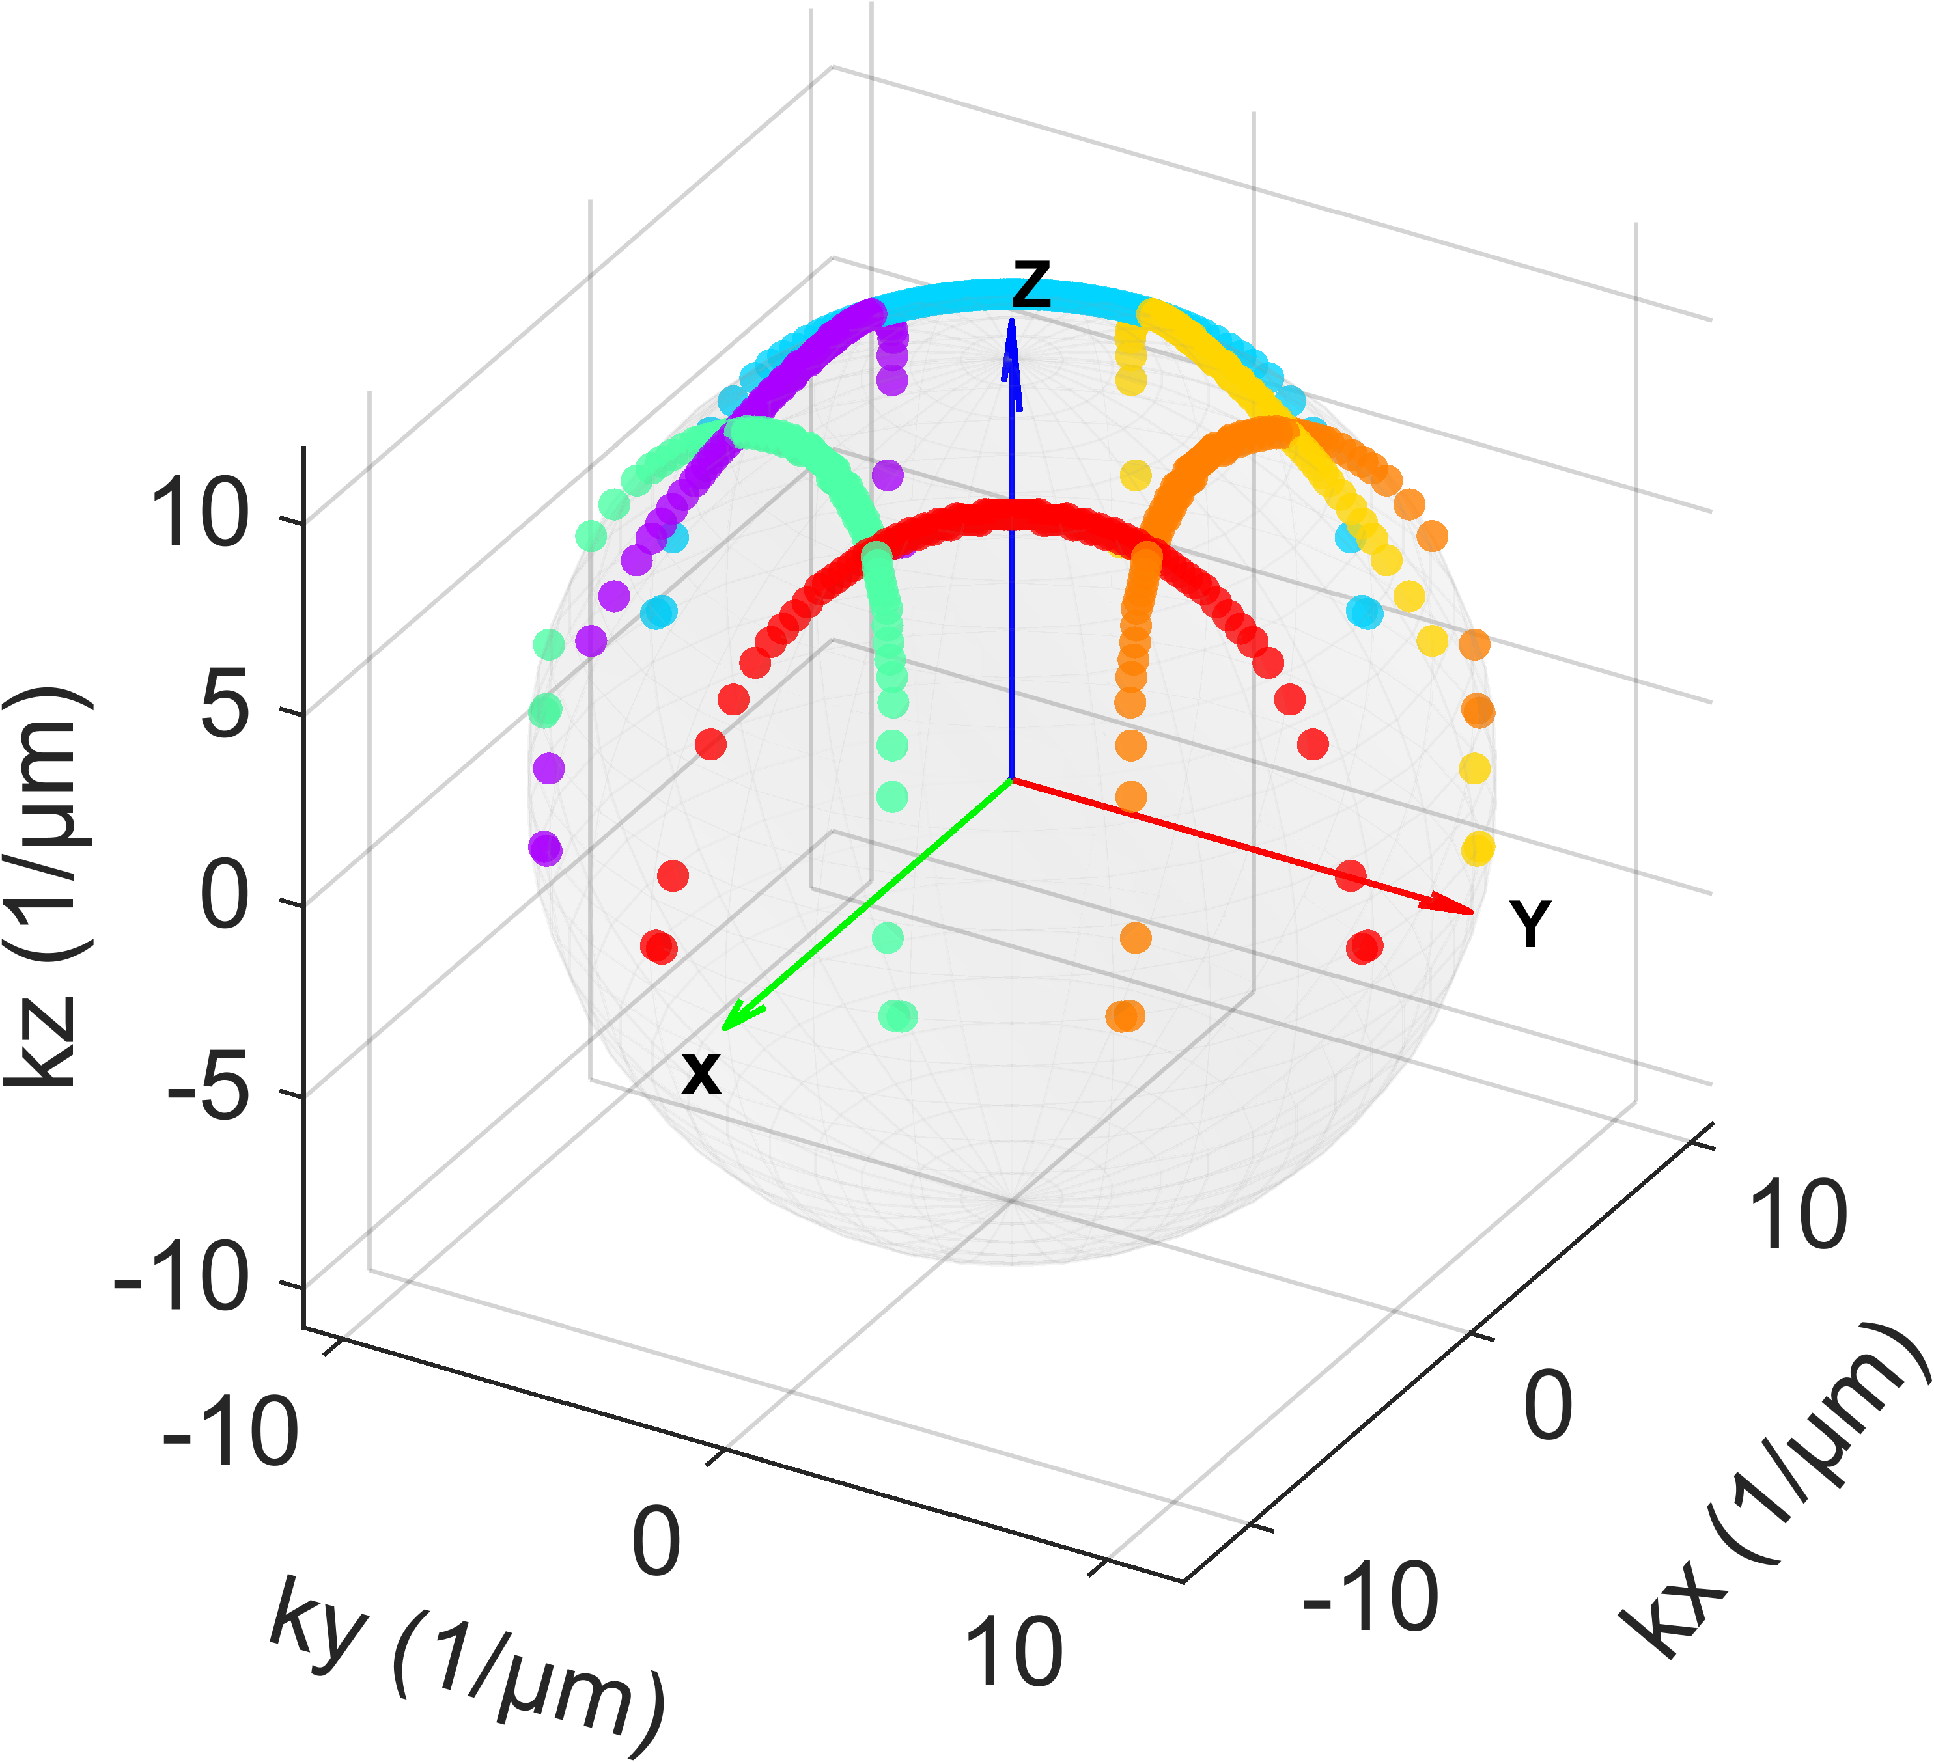 | 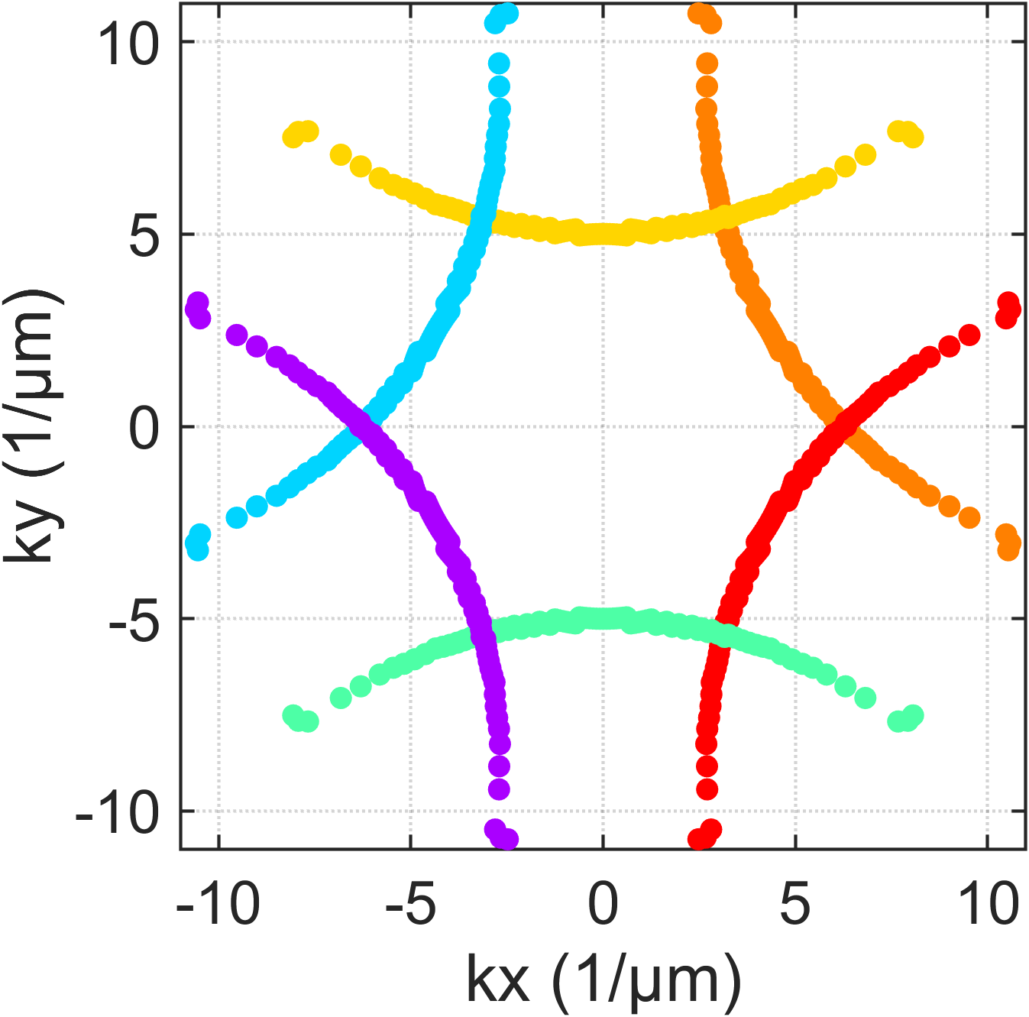 | 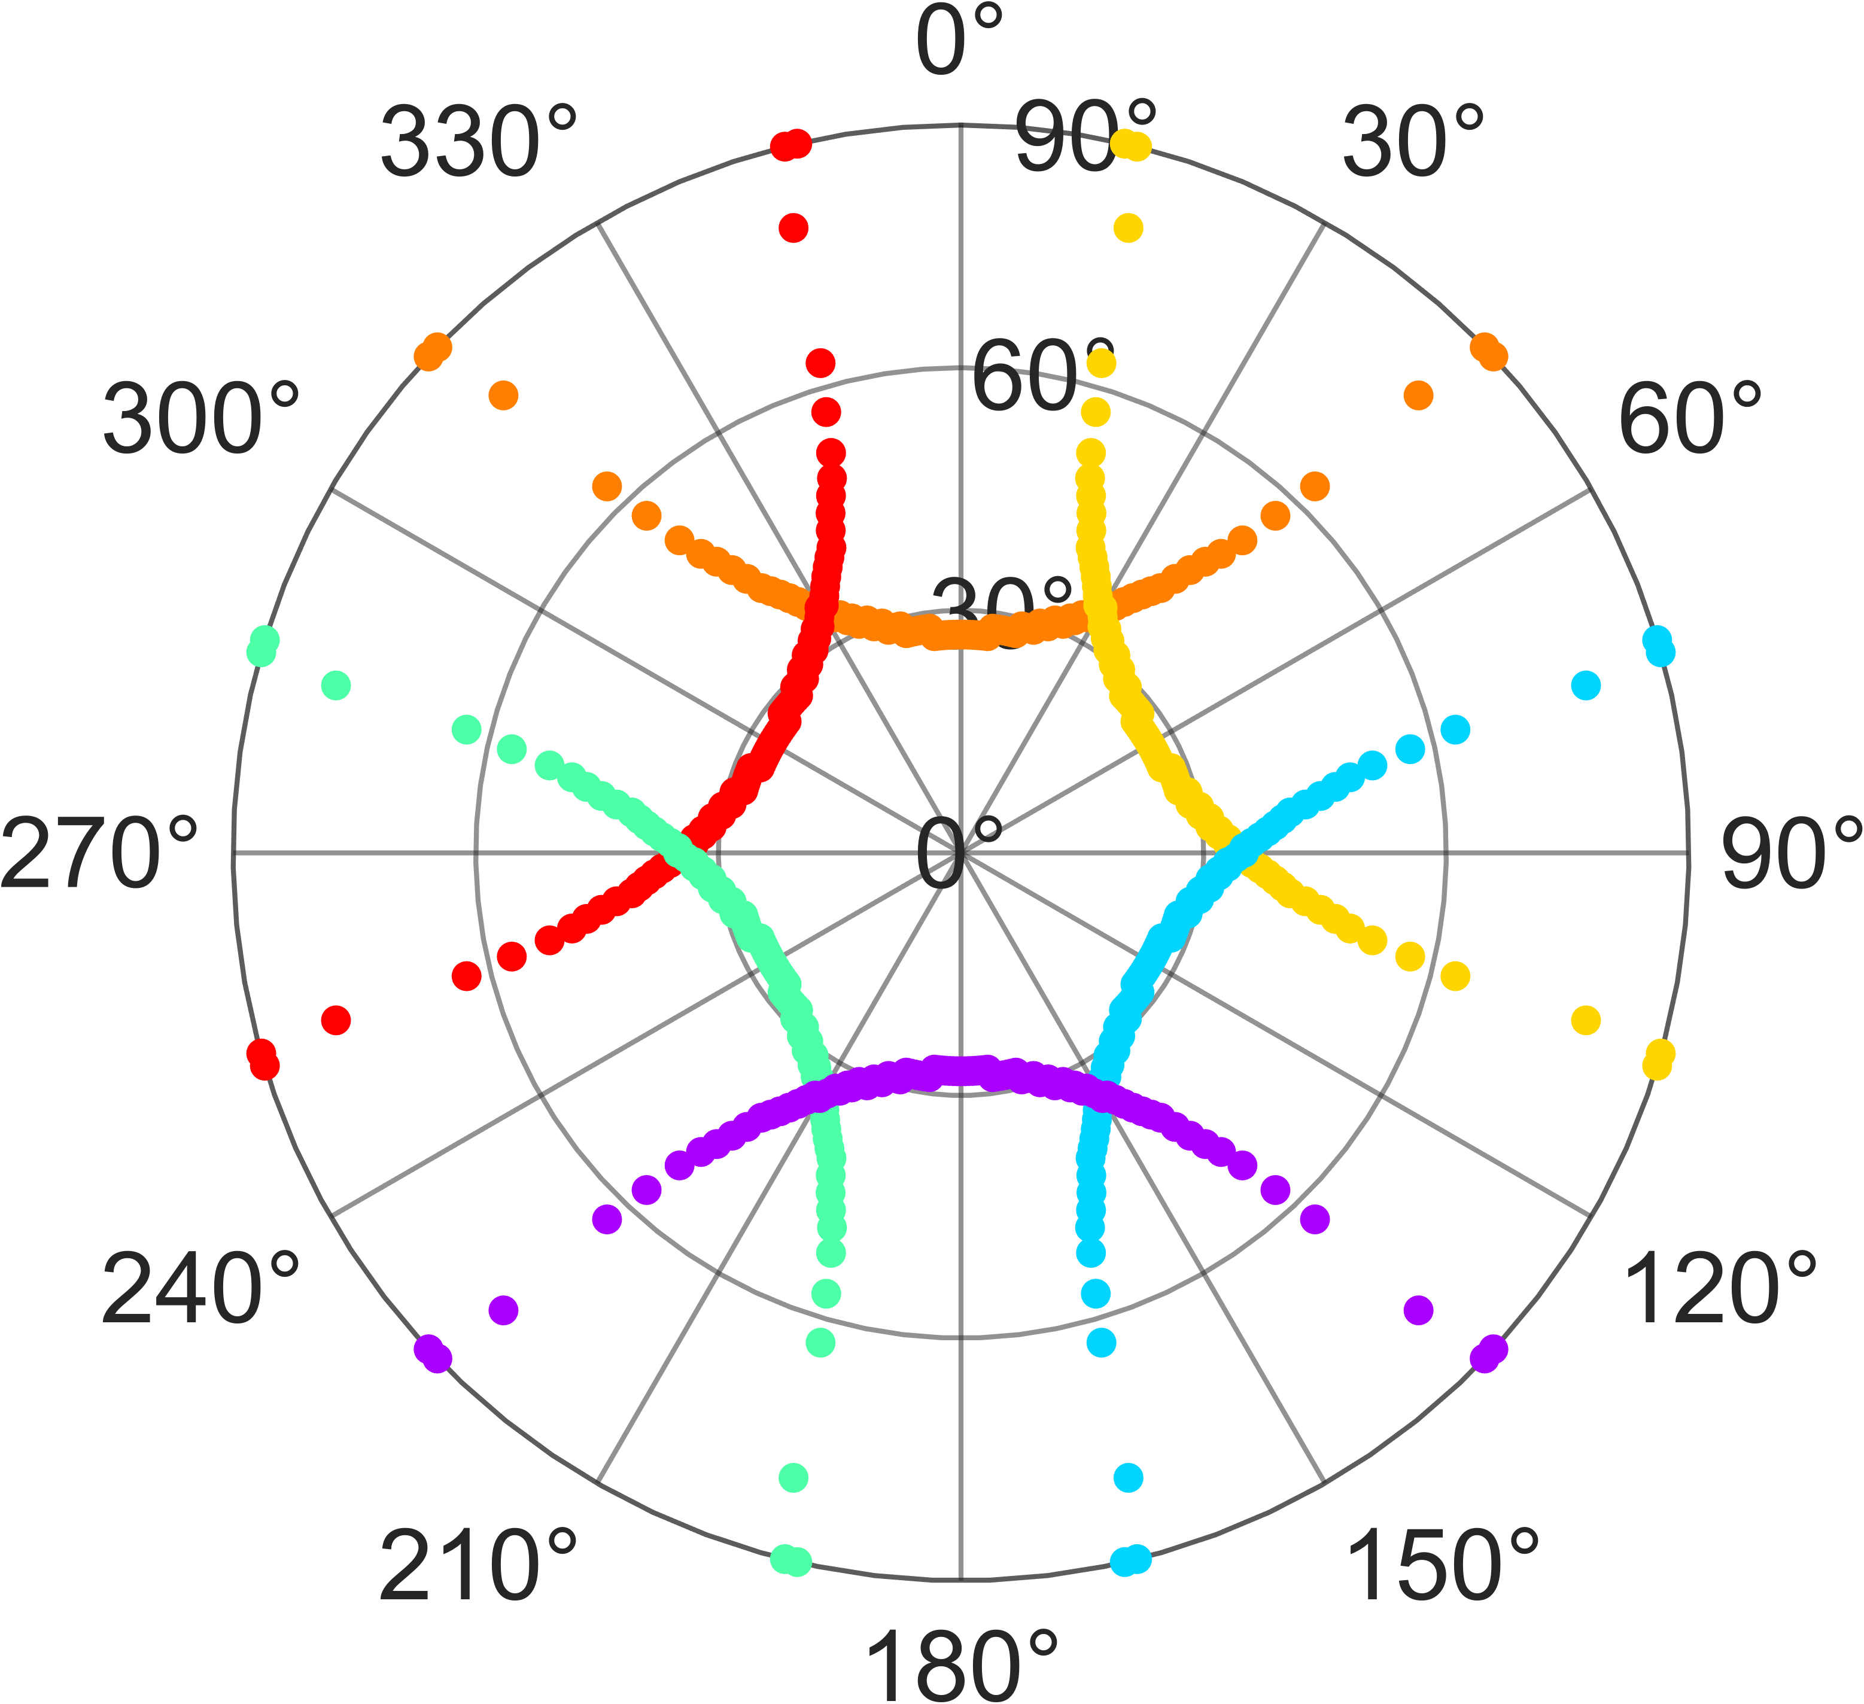 | 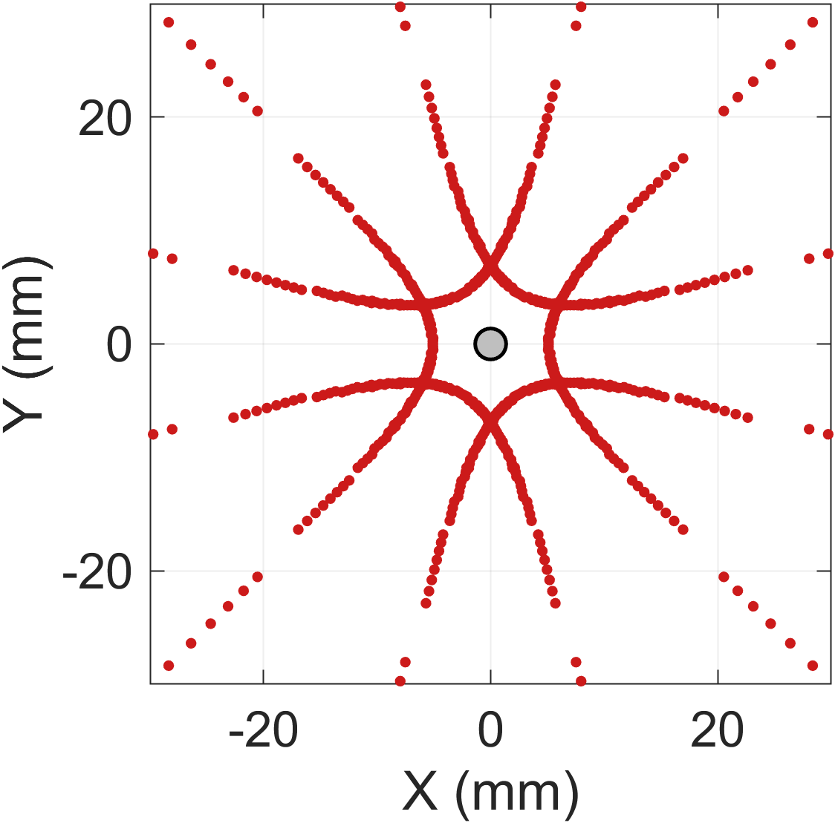
590 nm | 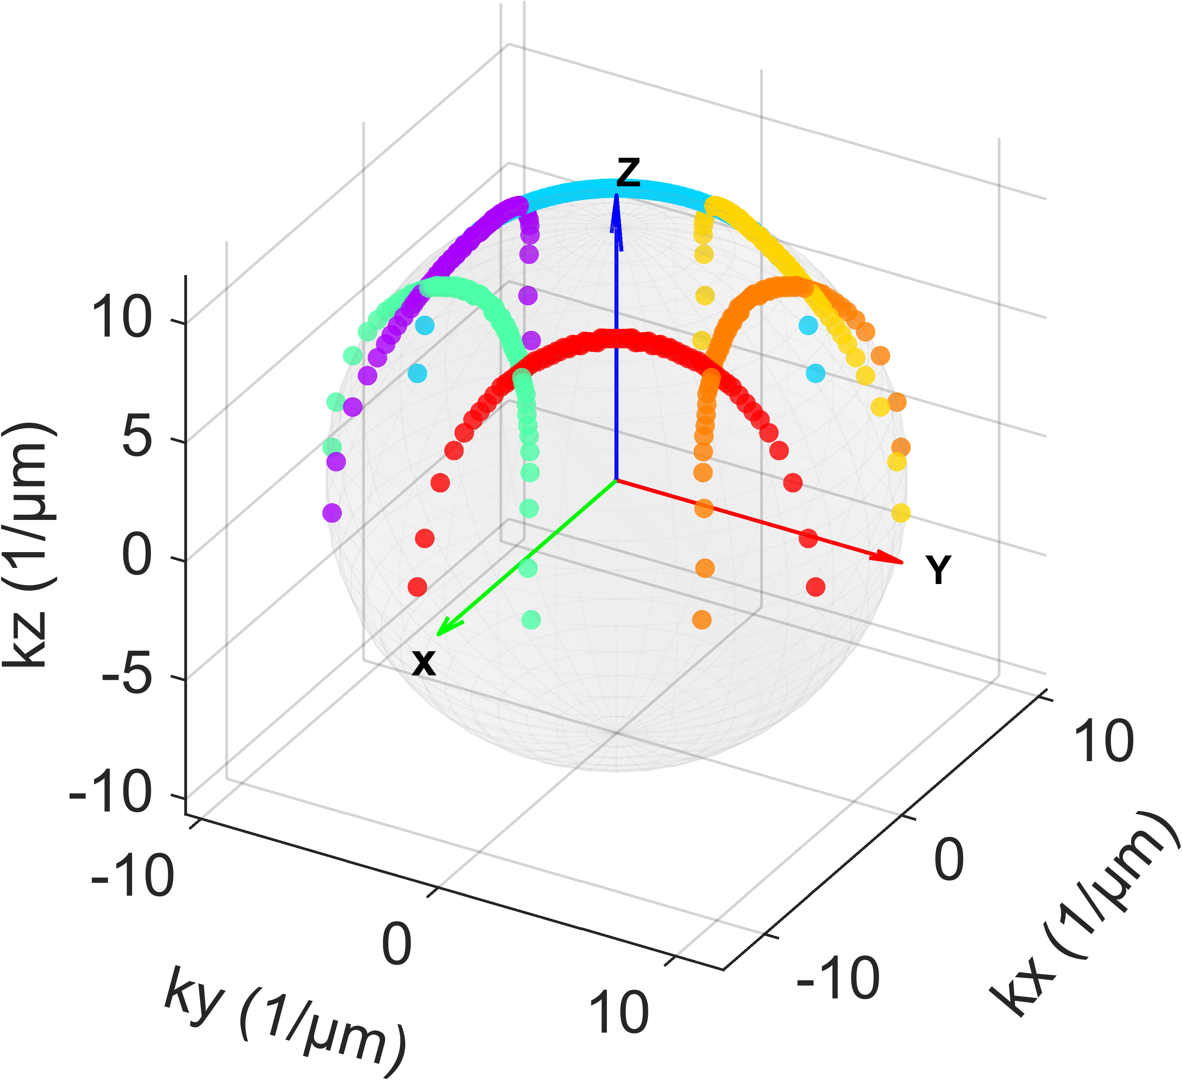 | 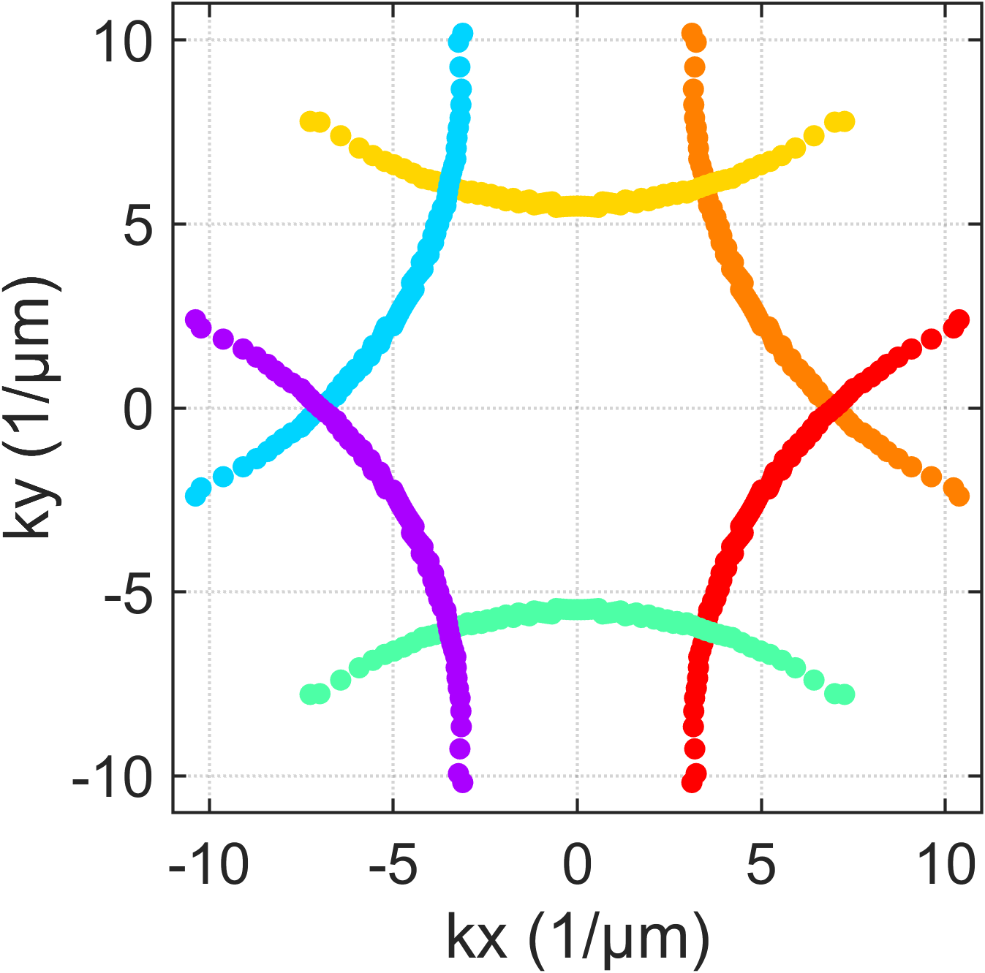 | 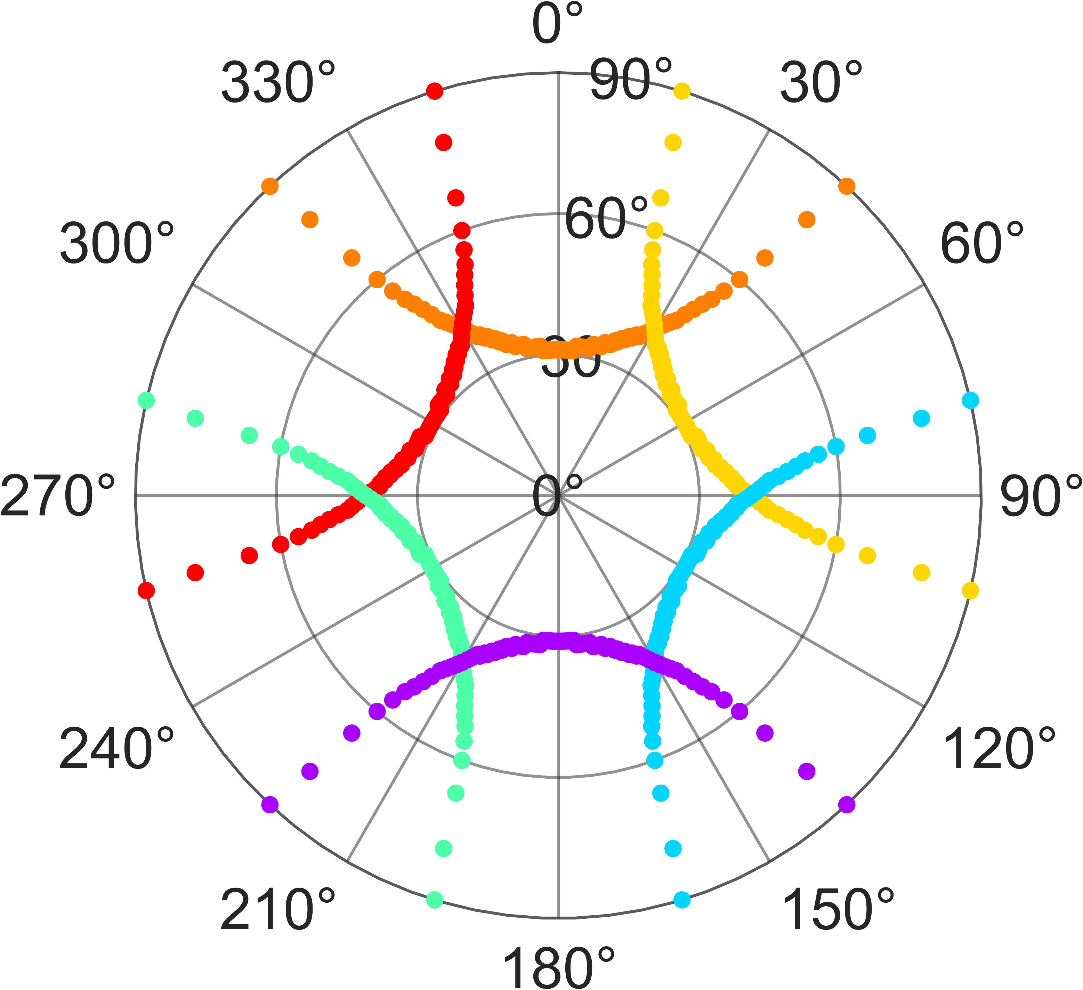 | 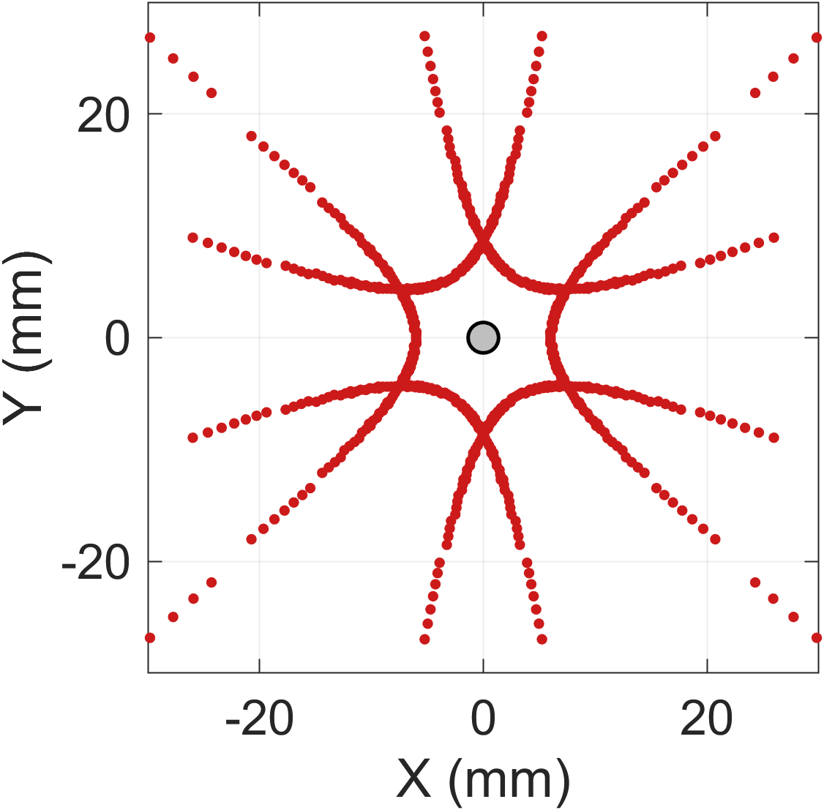
610 nm | 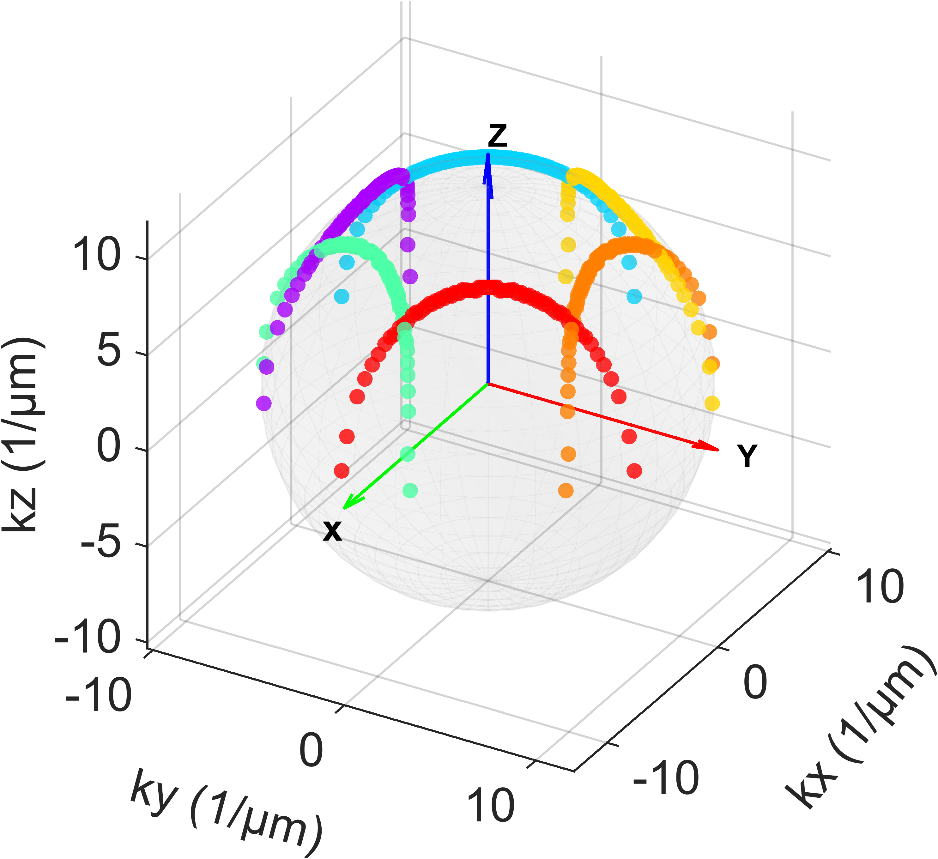 | 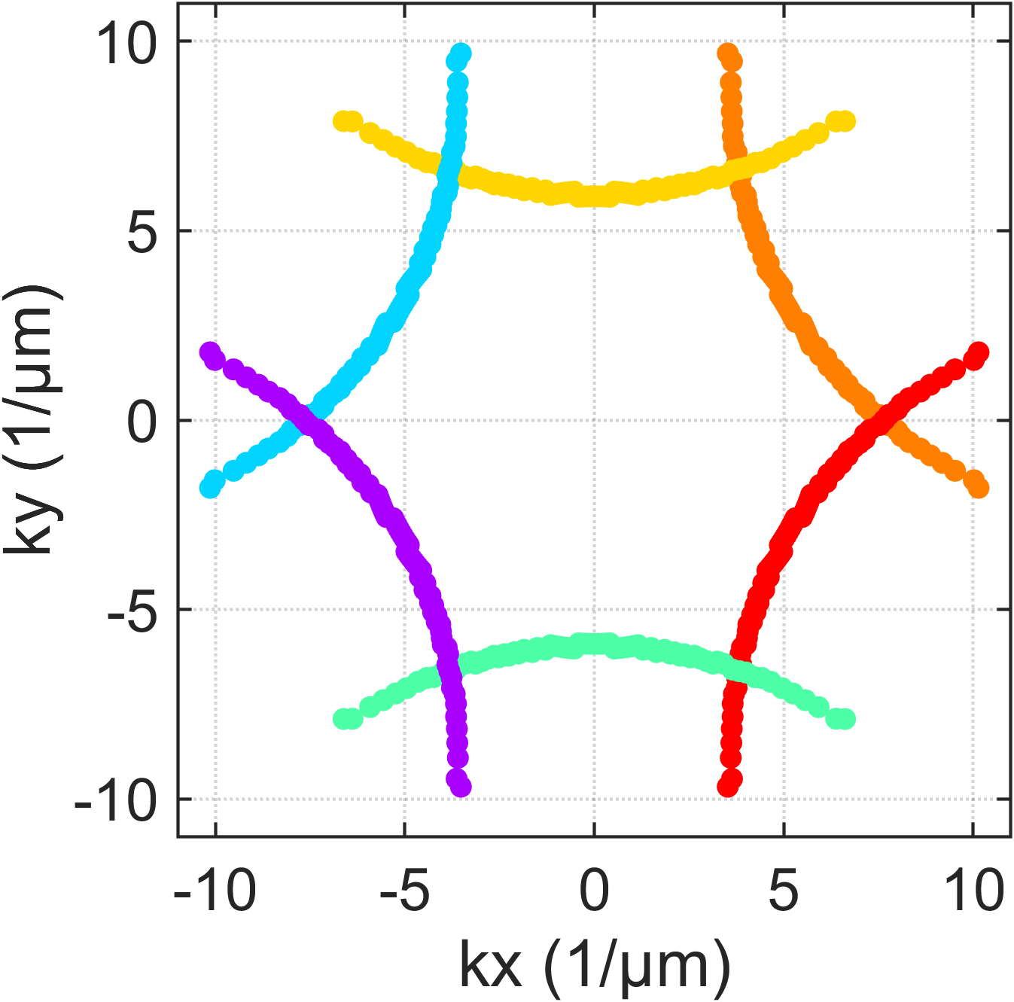 | 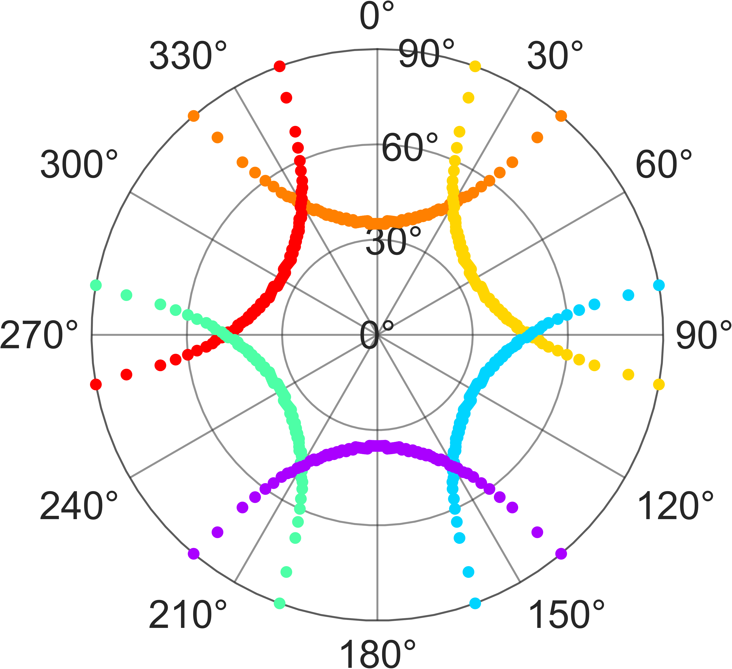 | 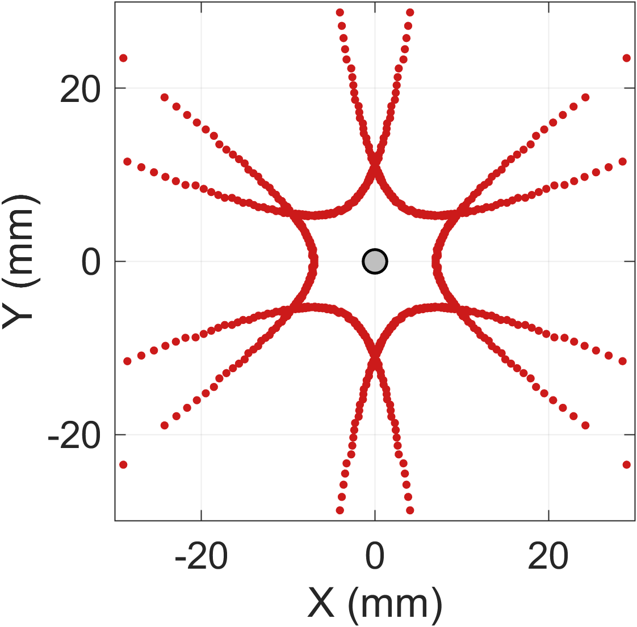
630 nm | 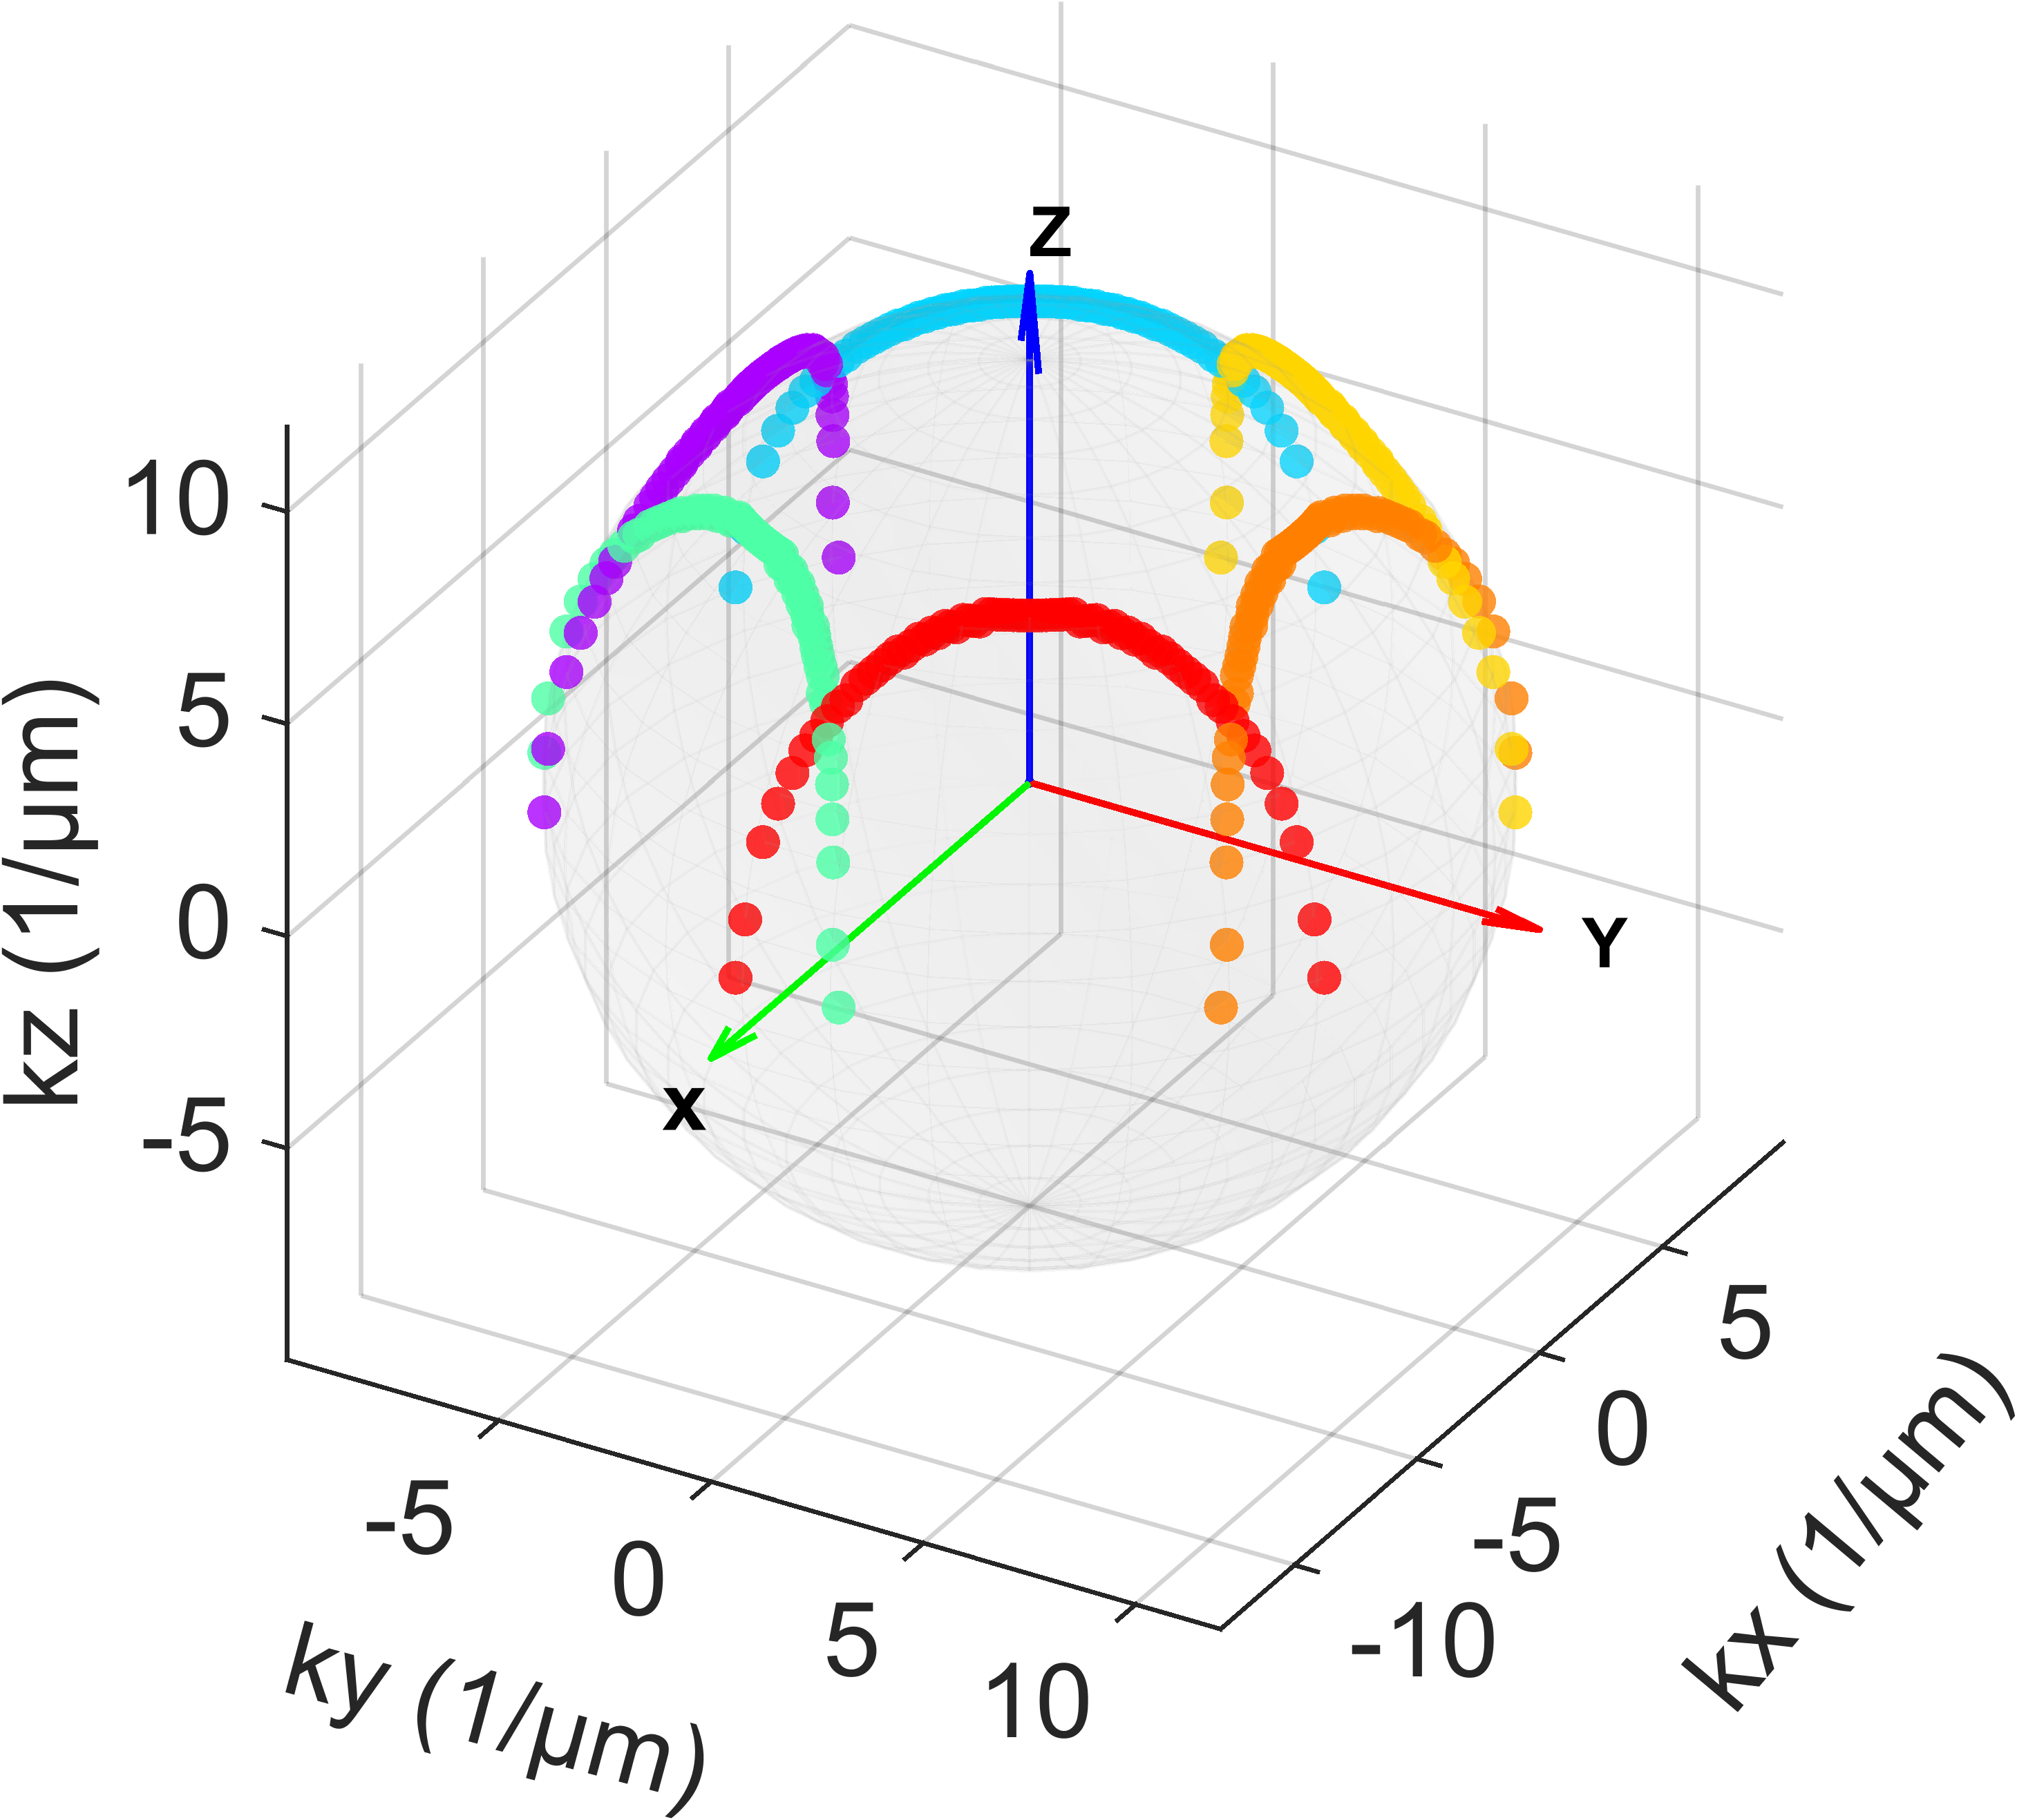 | 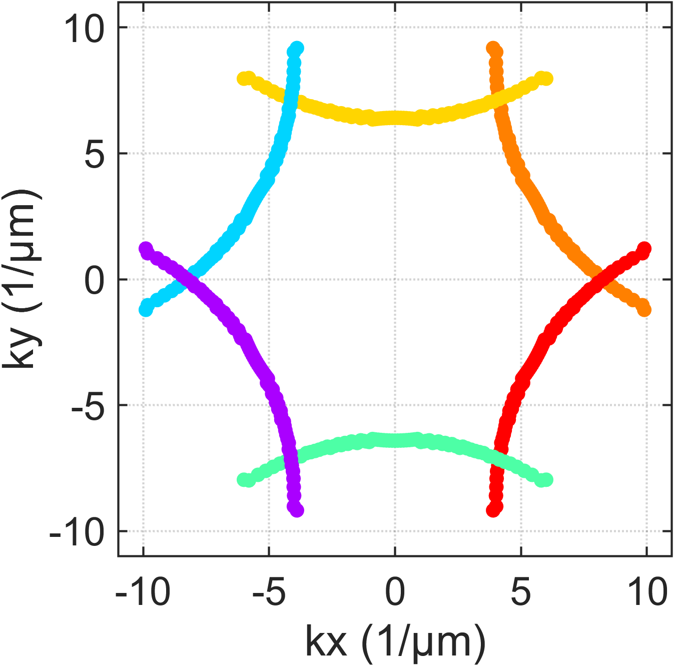 | 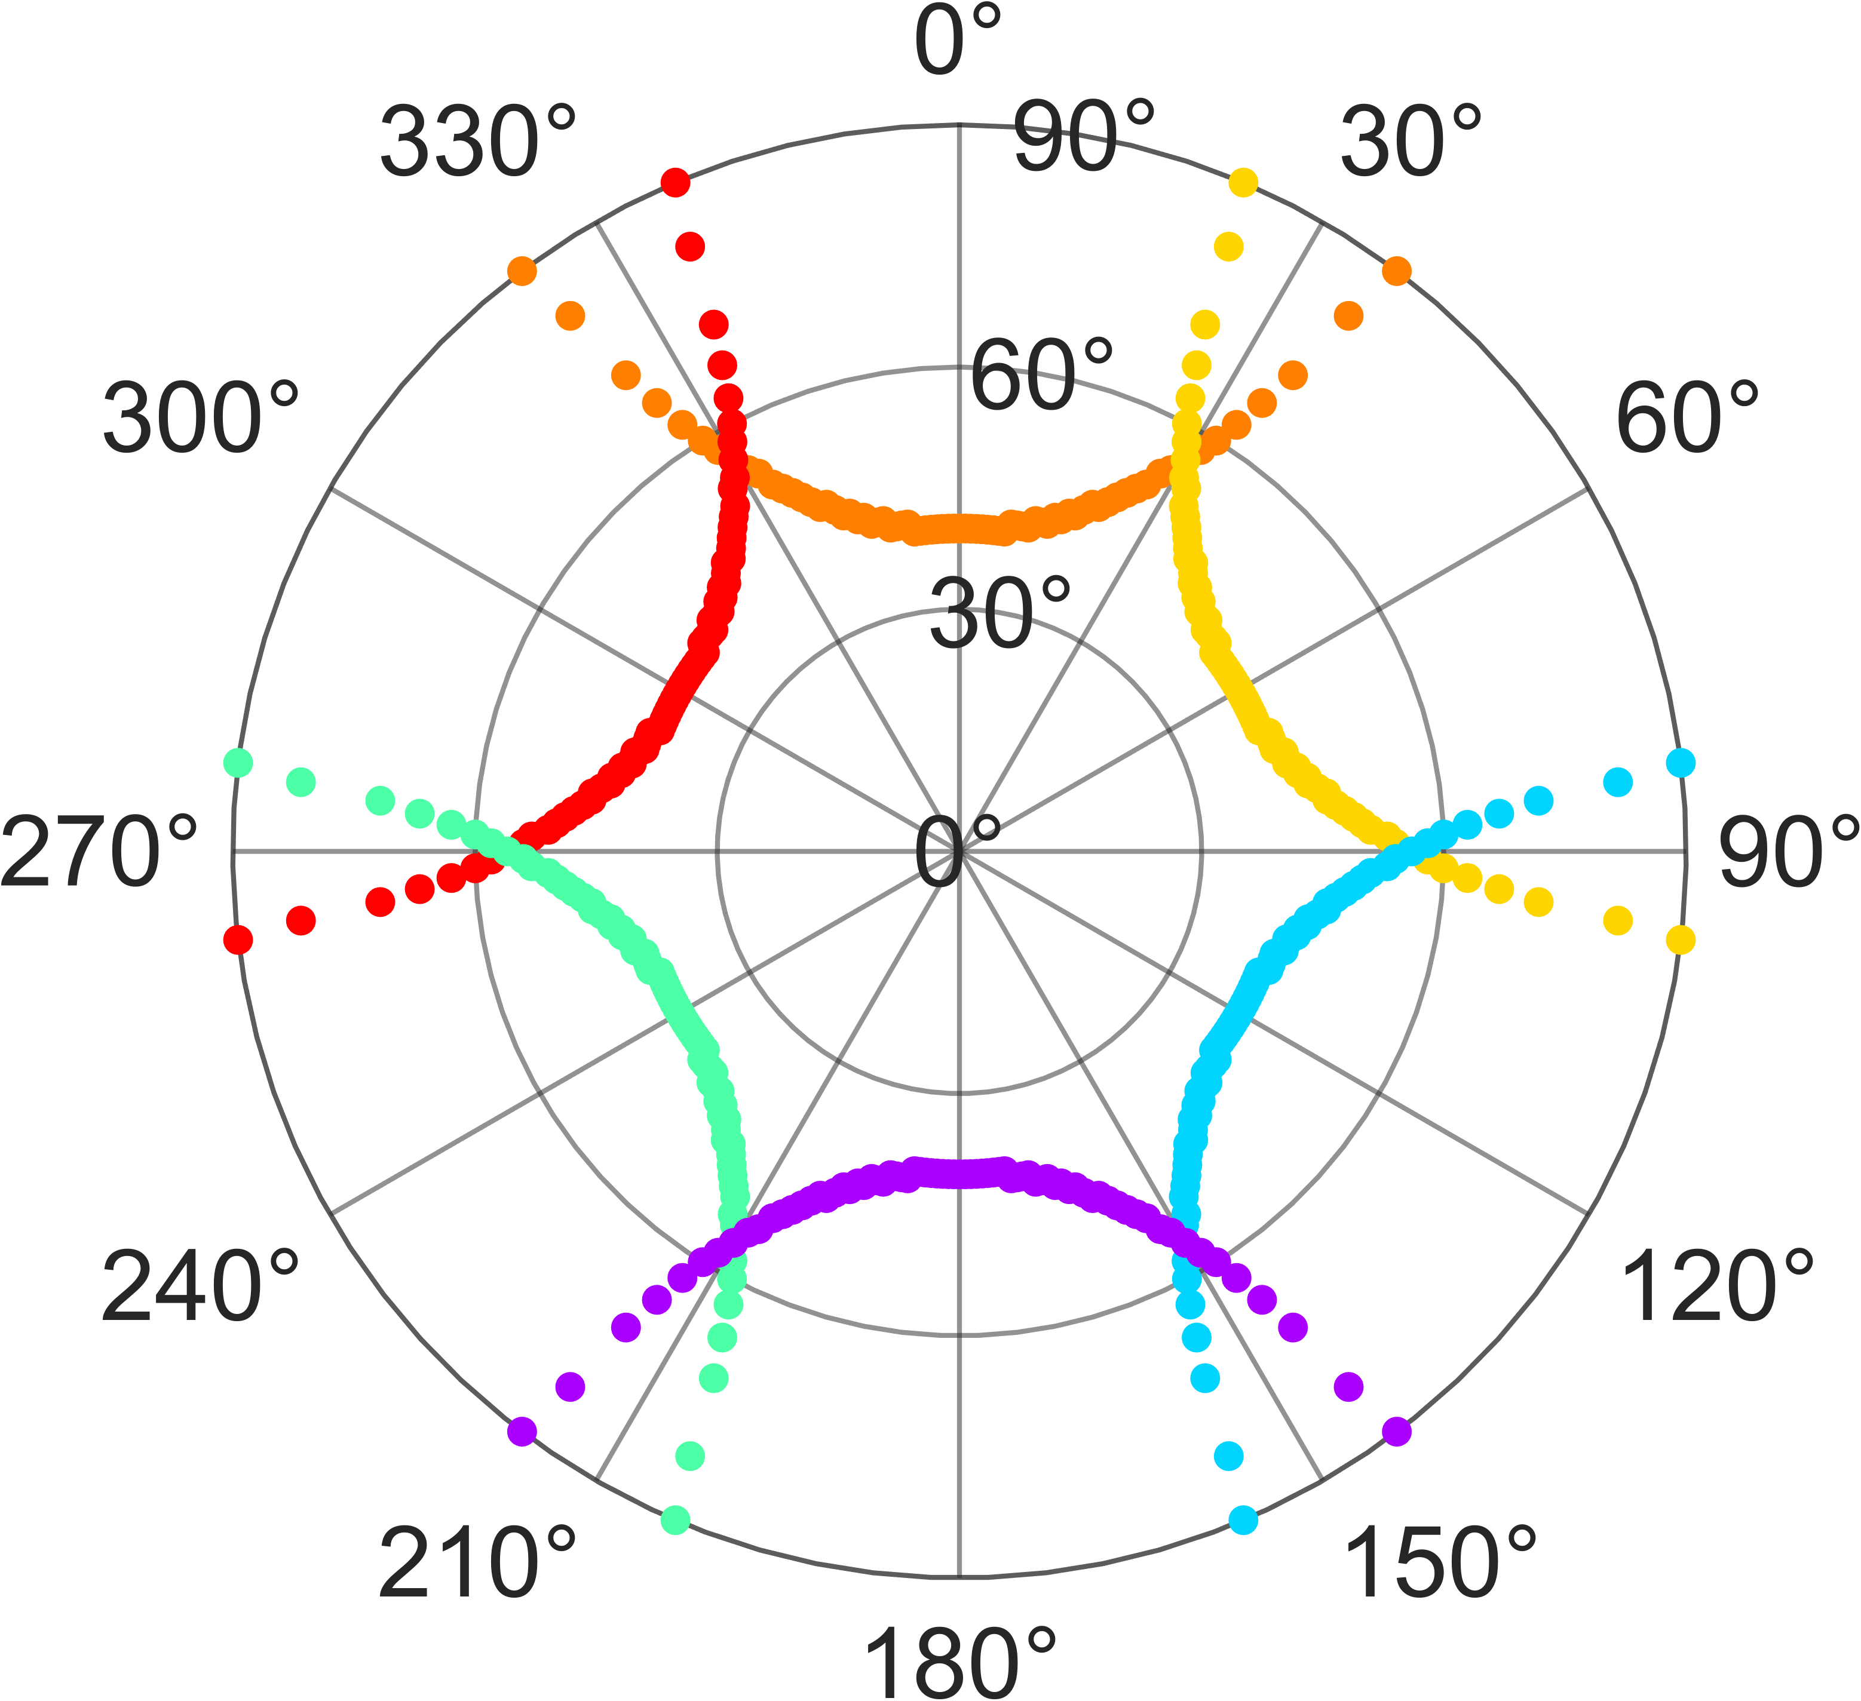 | 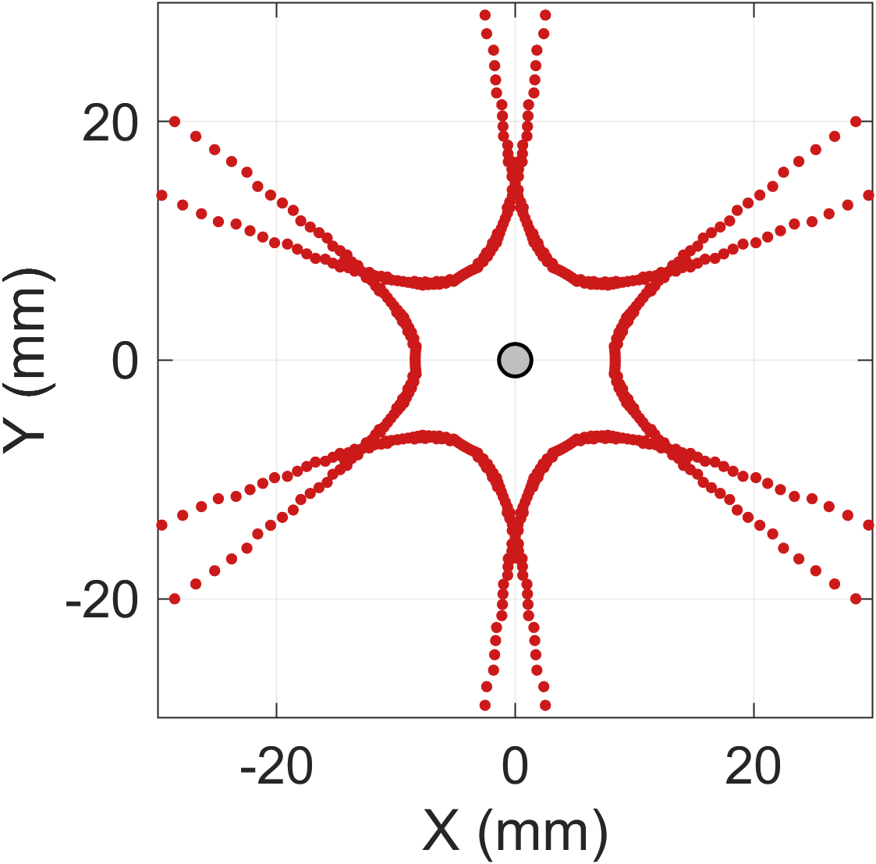
650 nm | 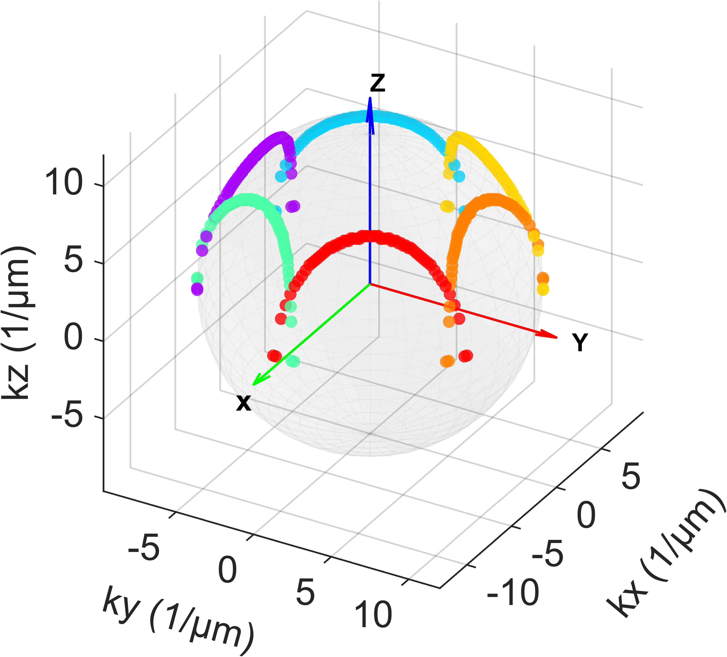 | 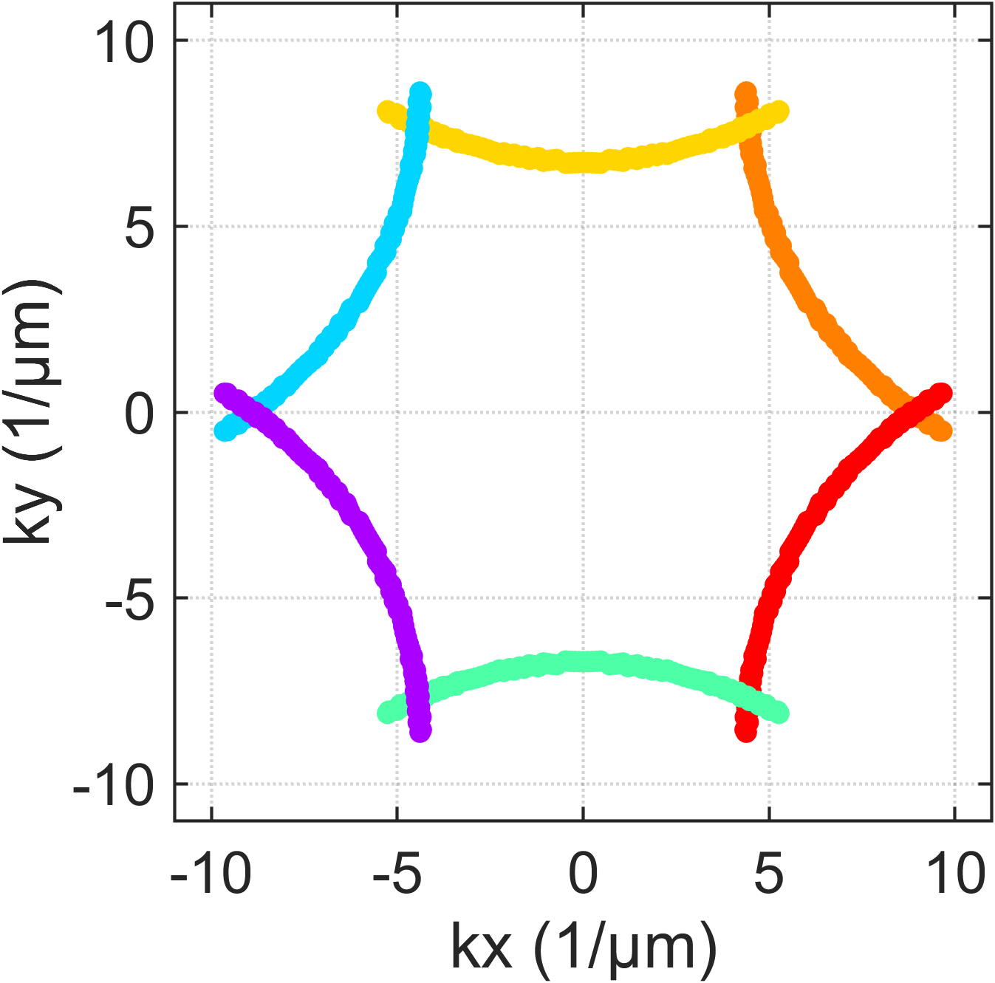 | 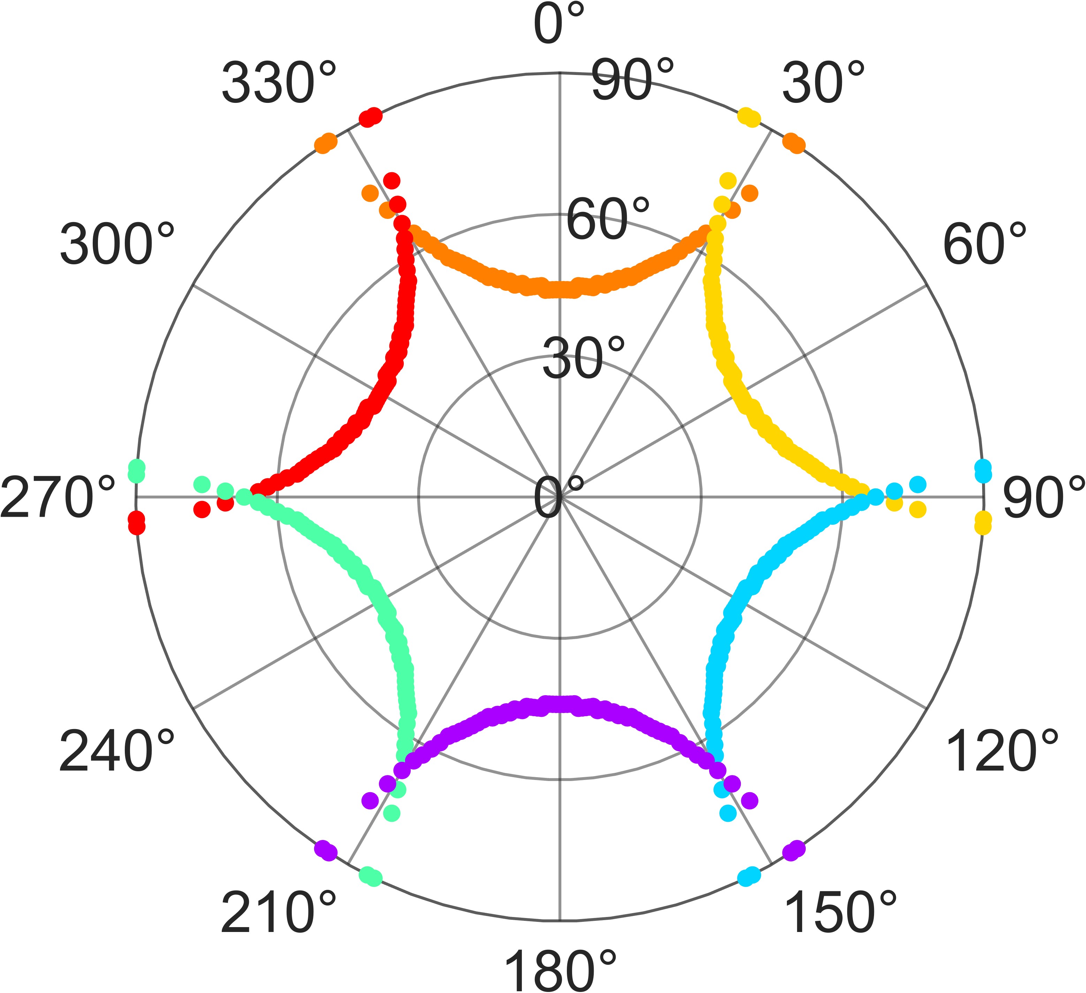 | 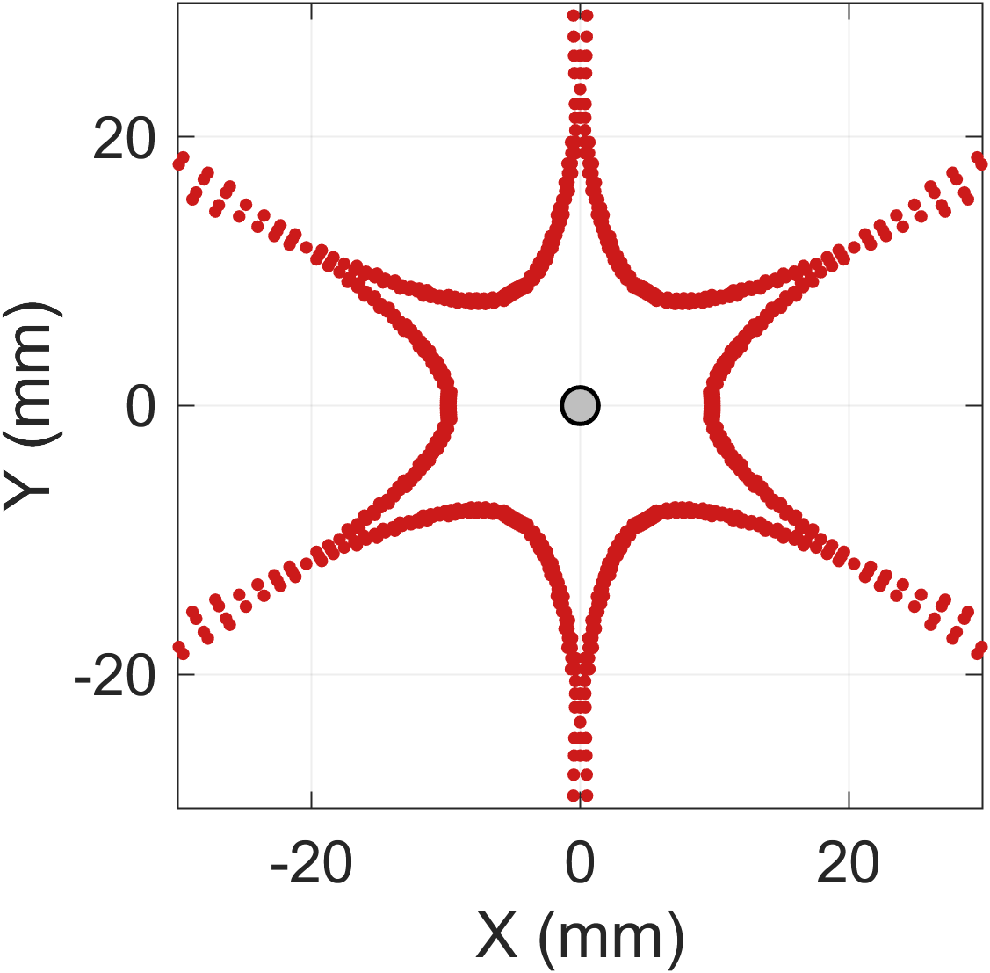
Supplementary Figure 15 | Analysis of diffraction orders and far-field symmetry. a–c, Theoretical momentum-space maps of the allowed emission modes for selected wavelengths within the gain bandwidth. The different colors correspond to the six distinct first-order Bragg diffraction channels. d, Composite projection of the emission patterns onto the 2D plane ($k_{x},k_{y}$). The hexagonal arrangement of the emission lobes reflects the intrinsic $C_{6}$ symmetry of the reciprocal lattice. The precise agreement between these calculated loci and the experimental beam patterns (see Fig. 4i in main text) confirms that lasing is driven by specific, identifiable lattice diffraction orders.

Supplementary Note 9: Azimuthal dependence and spatial multiplexing
The lasing wavelength of the device is determined by the specific intersection of the diffraction conditions with the gain bandwidth. As discussed in Supplementary Note 6, for a fixed azimuthal angle $φ$ (specifically along the $M$-direction), the wavelength $λ$ exhibits a linear dependence on the sine of the polar angle $θ$. This provides a straightforward mechanism for continuous tunability. Conversely, if the polar angle $θ$ is fixed, the resonant wavelength varies as a function of the azimuthal angle $ϕ$ due to the warping of the isofrequency contours. This azimuthal dependence enables spatially multiplexed lasing, where different emission wavelengths can be accessed simultaneously by collecting light from different azimuthal directions.
Supplementary Fig. 16 illustrates the emission characteristics at a fixed polar angle of $θ={36}^{∘}$. The theoretical dispersion map (Supplementary Fig. 16a) reveals a periodic recurrence of the resonance every ${60}^{∘}$, consistent with the six-fold rotational symmetry of the triangular lattice. For the M-direction ($φ=n×{60}^{∘}$), the dispersion band reaches a local extremum (turning point). Crucially, the mode here is non-degenerate and spectrally isolated, ensuring high spectral purity. In contrast, for the K-direction ($φ={30}^{∘}+n×{60}^{∘}$), while the pattern also suggests a single mode at these intermediate angles, this feature is physically formed by the degeneracy (crossing) of two adjacent diffraction orders. Even a minor angular misalignment breaks this degeneracy, splitting the mode into two distinct peaks.
Because the $M$-point mode offers superior spectral stability and resistance to mode splitting compared to the $K$-point degeneracy, we selected the $M$-direction for the quantitative threshold characterizations presented in the main text.
We compared the passive white-light reflectance (Supplementary Fig. 16b) and the active lasing emission spectra (Supplementary Fig. 16c) as a function of azimuth. Both measurements reproduce the theoretical dispersion bands with high fidelity. The effective lasing range is observed between 550 nm and 650 nm, strictly defined by the fluorescence bandwidth of the quantum dots (peak at $∼$610 nm, see Supplementary Fig. 3).
To elucidate the spatial structure of the beam, Supplementary Fig. 17a presents a high-resolution view of the lasing dispersion, while Supplementary Fig. 17b displays the polar radiation patterns extracted at specific wavelengths.
At M-point resonance ($λ=612$ nm), The radiation is confined to six discrete spots aligned with the high-symmetry $M$-axes. The emission intensity is maximal here, and the angular divergence is small ($∼3^{∘}$), limited primarily by lattice fabrication imperfections. As the wavelength decreases, the condition for resonance shifts away from the $M$-point extremum. The single lobe splits into two symmetric lobes. Consequently, the far-field pattern evolves from 6 spots to 12 distinct spots, reflecting the reduced symmetry of the generic wavevector $k_{∥}$ compared to the high-symmetry axes. While at K-point resonance ($λ=570$ nm), the 12 lobes re-merge into 6 spots, but the pattern is rotated by ${30}^{∘}$ relative to the 612 nm case. These spots align with the $K$-directions. Unlike the $M$-point emission, each of these lobes represents a superposition of two degenerate lattice modes. This evolution perfectly maps the intersection of the constant-$θ$ circle with the hexagonal plasmonic band structure.

Supplementary Figure 16 | Azimuthal dispersion characteristics at fixed polar angle ($θ={36}^{∘}$). a, Theoretical calculation of the resonant wavelength as a function of azimuthal angle $φ$. The pattern exhibits six-fold symmetry. The gray arrows indicate the $M$-directions ($ϕ=0^{∘},{60}^{∘},…$), where the mode is non-degenerate. The $K$-directions ($φ={30}^{∘},…$) correspond to mode crossing points. b, c, Experimental angle-resolved maps of b, white-light reflectance and c, lasing emission intensity. The experiments closely match the theoretical prediction. The spectral cutoff in c corresponds to the edges of the quantum dot gain profile (approx. 550–650 nm).

Supplementary Figure 17 | Evolution of the spatial radiation pattern. a, Zoom-in of the azimuthal lasing dispersion from Supplementary Fig. 14c. b, Polar plots representing the far-field beam profile at selected wavelengths.

Supplementary References
1 Shan, H. et al. Spatial coherence of room-temperature monolayer WSe2 exciton-polaritons in a trap. Nat Commun 12, (2021).
2 Luo, Y. et al. Manipulating nonlinear exciton polaritons in an atomically-thin semiconductor with artificial potential landscapes. Light Sci Appl 12, (2023).
Lubin, S. M., Hryn, A. J., Huntington, M. D., Engel, C. J. & Odom, T. W. Quasiperiodic Moiré Plasmonic Crystals. ACS Nano 7, 11035–11042 (2013).
4 Rakić, A. D., Djurišić, A. B., Elazar, J. M. & Majewski, M. L. Optical properties of metallic films for vertical-cavity optoelectronic devices. Appl. Opt. 37, 5271 (1998).
5 Rodríguez-Fortuño, F. J. et al. Near-Field Interference for the Unidirectional Excitation of Electromagnetic Guided Modes. Science 340, 328–330 (2013).

