Supplementary Materials
Determination of pathophysiological mechanisms of ALPPS in an animal model using molecular and functional imagings
Fig. S1. The H&E staining of FLR and tumor. (A) Liver VX2 tumors in the ALPPS and Sham group were stained by hematoxylin and eosin (H&E) (original magnification ×200). (B) FLR in both groups were stained by H&E (original magnification ×200).
Fig. S2. The SUV_{max} of ¹⁸F-FDG,¹⁸F-FCH,¹⁸F-FLT of tumor and FLR. (A) The normal liver tissue SUV_{max} of ¹⁸F-FDG, ¹⁸F-FCH, and ¹⁸F-FLT in VX2 tumor-bearing rabbit at day 7 (*P<0.05; **P<0.01; ***P<0.001; ****P<0.0001. N.S. was regarded as not statistically significant). (B)The tumor SUV_{max} of ¹⁸F-FDG, ¹⁸F-FCH, ¹⁸F-FLT in VX2 tumor-bearing rabbit. (C) ¹⁸F-FLT PET/CT uptake in FLR in the ALPPS group (without tumor) was negligible at all time points.

Fig. S3. Quantitative PET region-of-interest analysis of tumor or FLR uptake for ¹⁸F-FDG and ¹⁸F-FCH. (A) The ¹⁸F-FDG SUV_{max} of the FLR kept at the low level all the time in both groups. (B) The GLUT1 scores of tumor in both groups, the difference was statistically significant on day 7 (*P<0.05). (C) Correlation analysis between ¹⁸F-FDG SUV_{max} and GLUT1-positive scores. (Spearman r =0.4505, P<0.05). (D) The ¹⁸F-FCH SUV_{max} of the tumor remained at the baseline level in both groups.
Fig. S4. The correlation analysis between Ki67-positive rate and ¹⁸F-FCH SUV of FLR, correlation analysis between FLRV_{FCH} and FLRV_{water} or FLRV_{MRI}. (A) Correlation analysis between Ki67-positive rate of FLR and ¹⁸F-FCH SUV_{max} (Pearson r=0.8780, P<0.0001). (B) Correlation analysis between Ki67-positive rate of FLR and ¹⁸F-FCH SUV_{mean} (Pearson r=0.8655, P<0.0001). (C) Correlation analysis between FLRV_{FCH} and FLRV_{water} (Pearson r =0.9057, P<0.0001). (D) Correlation analysis between FLRV_{FCH} and FLRV_{MRI.} (Pearson r =0.9319, P<0.0001).
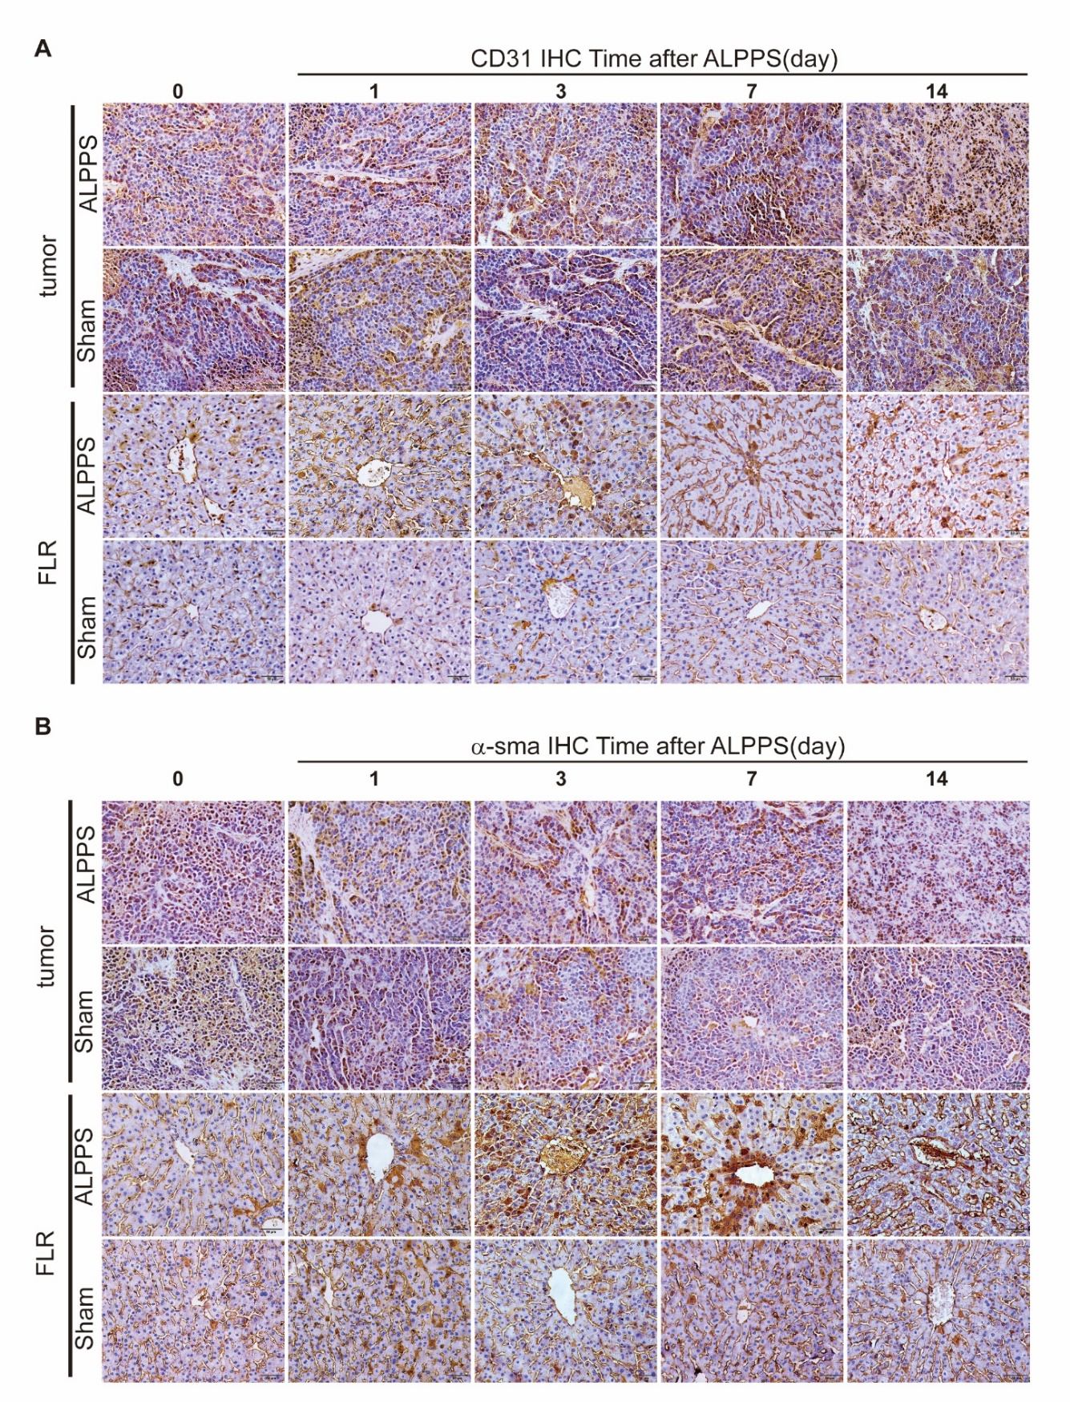
Fig. S5. The IHC of CD31 and α-sma (A) Angiogenesis of tumor and FLR were assessed by IHC of CD31 in the ALPPS and Sham group (original magnification ×200). (B) Vessel maturation of tumor and FLR were assessed by IHC of α-sma in both groups (original magnification ×200).
Fig. S6. The correlation analysis between K^{trans} value and CD31 MVD count,α-SMA-positive stained area (%). (A) Correlation analysis of tumor between K^{trans} and CD31 MVD count (Pearson r =0.8540, P<0.0001). (B) Correlation analysis of FLR between K^{trans} and CD31 MVD count (Pearson r =0.7734, P<0.0001). (C) Correlation analysis of tumor between K^{trans} and α-SMA-positive stained area (%) (Pearson r =0.7238, P<0.0001). (D) Correlation analysis of FLR between K^{trans} and  α-SMA-positive stained area (%). (Pearson r =0.8021, P<0.0001).

Table S1. The volume increase rate(%) of FLR measured by ¹⁸F-FCH PET/CT,MRI.
 | FLRV_{FCH}(%) |  | FLRV_{MRI}(%)
Time(d) | ALPPS | Sham | ALPPS | Sham
0 | 0 | 0 | 0 | 0
1 | 5.19±6.73* | -5.69±5.38 | 12.12±13.69 | 2.69±18.10
3  7  14 | 24.81±8.17*  60.55±1.99*  96.13±16.92* | -2.47±3.84  -4.03±1.39  6.45±0.68 | 28.03±7.18  65.66±33.31  103.39±38.00 | 5.30±18.50  4.69±7.10  10.24±25.34
*P<0.05. P<0.05 was regarded as statistically significant.

Table S2. The VVF and VVF increase rate (%) of FLR.
 | VVF |  | VVF increase rate (%)
Time(d) | ALPPS | Sham | ALPPS | Sham
0 | 66.49±10.39 | 67.65±16.18 | 0 | 0
1 | 104.17±7.78 | 56.16±21.88 | 60.42±36.35* | 2.85±55.59
3  7  14 | 195.32±31.77  289.72±89.56  190.21±63.66 | 55.93±1.73  56.86±6.95  66.81±10.14 | 200.83±82.23*  336.50±109.47*  202.79±89.67* | -8.52±32.65  -13.43±17.08  5.98±45.51
*P<0.05. P<0.05 was regarded as statistically significant.

