Supplementary Table S1. Univariable Analysis of Factors Associated With Hypothyroidism as an Immune-Related Adverse Event
MDV cohort
Variable | OR (95% CI) | P value
TSH | 1.68 (1.48–1.91) | < .001
Total protein | 1.31 (1.11–1.54) | < .001
Cholinesterase | 1.48 (1.15–1.91) | .002
Sodium | 1.31 (1.10–1.56) | .003
Albumin | 1.27 (1.07–1.50) | .007
Sex (0: Female, 1: Male) | 0.83 (0.71–0.96) | .01
Chemo combination therapy | 0.82 (0.67–0.95) | .01
Chloride | 1.23 (1.04–1.47) | .02
FT3 | 1.18 (1.02–1.37) | .02
PPI use | 0.82 (0.69–0.98) | .03
Emphysema | 0.82 (0.68–0.98) | .03
JMDC cohort
Variable | OR (95% CI) | P value
TSH | 1.63 (1.38–1.91) | < .001
Albumin | 1.40 (1.12–1.74) | .003
Sodium | 1.38 (1.10–1.73) | .005
Chloride | 1.32 (1.07–1.63) | .01
CRP | 0.71 (0.54–0.95) | .02
Glucose | 1.21 (1.02–1.45) | .03
Sex(0: Female, 1: Male) | 0.82 (0.68–0.99) | .04
Cholinesterase | 1.43 (1.01–2.02) | .04
Total protein | 1.24 (1.01–1.53) | .04
Data are from univariable logistic regression models in the MDV and JMDC cohorts.
Abbreviations: OR, odds ratio; CI, confidence interval; TSH, thyroid-stimulating hormone; CRP, C-reactive protein; FT3, free triiodothyronine; PPI, proton pump inhibitor; MDV, Medical Data Vision; JMDC, Japan Medical Data Center.

Supplementary Table S2. Univariable Cox Proportional Hazards Analysis for TTNT-D
MDV cohort
Variable | HR | P value
Albumin | 0.71 | <.001
LDH | 1.28 | <.001
ALP | 1.24 | <.001
CRP | 1.26 | <.001
AST | 1.20 | <.001
Chloride | 0.80 | <.001
Sodium | 0.82 | <.001
γ-GT | 1.17 | <.001
Hemoglobin | 0.83 | <.001
WBC count | 1.14 | <.001
Hematocrit | 0.84 | <.001
Acetaminophen use | 1.47 | <.001
Platelet count | 1.15 | <.001
ALT | 1.14 | <.001
NSAIDs use | 1.37 | .001
RBC count | 0.88 | .002
Potassium | 1.13 | .003
Steroid use | 1.58 | .003
Cholinesterase | 0.82 | .004
Total protein | 0.89 | .007
FT3 | 0.86 | .01
PPI use | 1.24 | .01
PT | 0.83 | .01
Inorganic Phosphorus | 1.16 | .03
JMDC cohort
Variable | HR | P value
Albumin | 0.66 | <.001
CRP | 1.37 | <.001
Sodium | 0.75 | <.001
WBC count | 1.29 | <.001
Total protein | 0.77 | <.001
Hematocrit | 0.78 | <.001
Hemoglobin | 0.78 | <.001
Chloride | 0.79 | <.001
LDH | 1.19 | <.001
RBC count | 0.83 | <.001
Antibiotics use | 1.45 | <.001
NSAIDs use | 1.49 | <.001
CK | 0.80 | <.001
ALP | 1.16 | <.001
γ-GT | 1.15 | <.001
PD-1 / PD-L1 | 1.62 | <.001
Acetaminophen use | 1.55 | <.001
PPI use | 1.33 | <.001
FT3 | 0.83 | .001
Tchol | 0.82 | .003
Potassium | 1.13 | .004
PT-INR | 0.86 | .005
AST | 1.11 | .008
Platelet count | 1.10 | .01
Amylase | 0.88 | .02
Calcium | 0.91 | .046
Data are from univariable Cox proportional hazards models in the MDV and JMDC cohorts.
Abbreviations: TTNT-D, time to next treatment or death; HR, hazard ratio; CI, confidence interval; LDH, lactate dehydrogenase; ALP, alkaline phosphatase; γ-GT, gamma-glutamyl transferase; AST, aspartate aminotransferase; ALT, alanine aminotransferase; WBC, white blood cell; RBC, red blood cell; FT3, free triiodothyronine; PT, prothrombin time; PT-INR, prothrombin time–international normalized ratio; eGFR, estimated glomerular filtration rate; CK, creatine kinase; MDV, Medical Data Vision; JMDC, Japan Medical Data Center.

Supplementary Table S3. Multivariable Cox Proportional Hazards Models for TTNT-D
Variable | HR (95% CI) | P value
Albumin | 0.75 (0.64–0.87) | <.001
LDH | 1.16 (1.07–1.26) | <.001
Potassium | 1.12 (1.01–1.23) | .03
Acetaminophen use | 1.29 (1.01–1.64) | .041
- MDV Cohort
- JMDC Cohort
Variable | HR (95% CI) | P value
Albumin | 0.79 (0.68–0.92) | .002
Platelet count | 0.87 (0.78–0.97) | .01
LDH | 1.15 (1.02–1.30) | .02
Total protein | 0.88 (0.79–0.98) | .03
PD-1 / PD-L1 | 1.33 (1.00–1.77) | .047
HRs and 95% CIs were obtained from multivariable Cox proportional hazards models including clinically relevant covariates. Abbreviations: TTNT-D, time to next treatment or death; HR, hazard ratio; CI, confidence interval; MDV, Medical Data Vision; JMDC, Japan Medical Data Center; LDH, lactate dehydrogenase.

Supplementary Figure S1
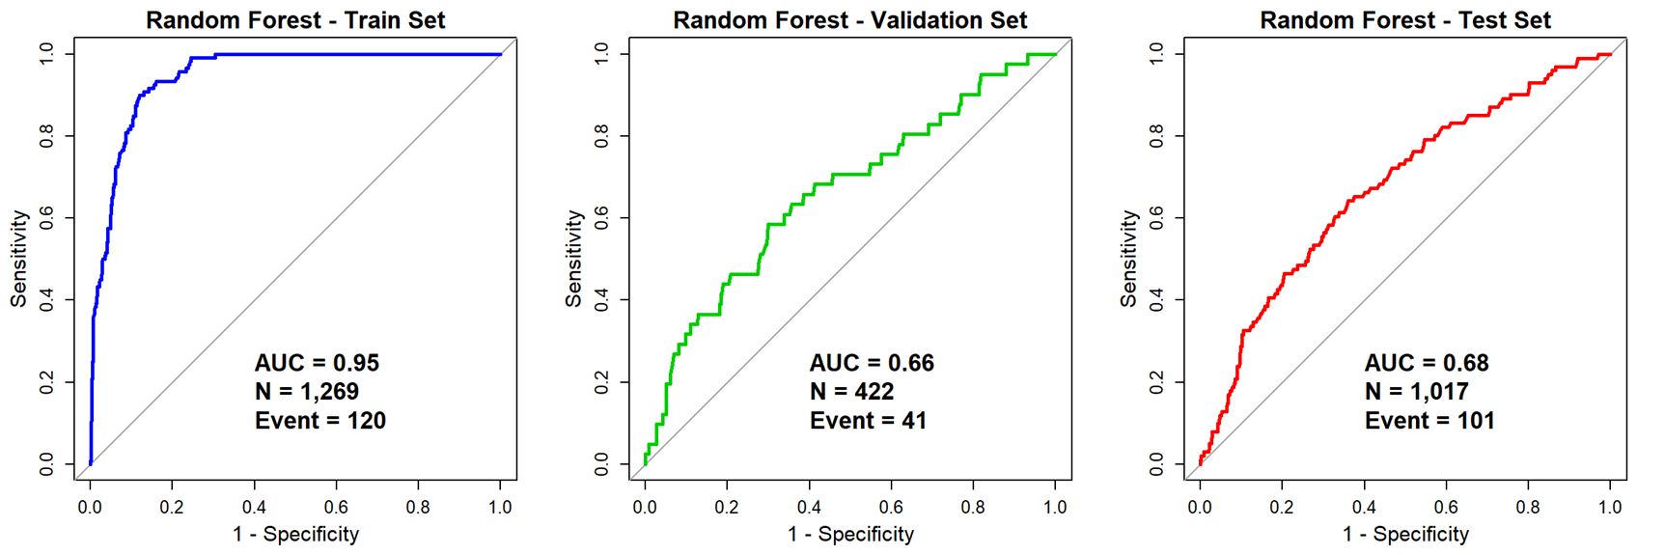

Supplementary Figure S2
