Fig. S1. The effect of R. solanacearum inoculation on the mycorrhizal colonization levels in tomato.
Tomato plants were cultivated in unsterilized soil and inoculated or mock-inoculated with the AMF strain R. intraradices (Ri). The control (CK) plants were inoculated with autoclaved inoculum. After four weeks of growth, part of the CK plants and the AMF-inoculated plants were further challenged with R. solanacearum (Rs) for additional two weeks. (a) No significant difference in the root length colonization levels was observed between the AMF-inoculated (AM) plants and the asymptomatic dual-inoculated plants (AM+Rs). (b) The AM-specific H⁺-ATPase gene SlHA8 was used as an AM marker gene to indicate the difference in mycorrhizal colonization level among different treatments. CK (mock-inoculated control), Rs (inoculation with R. solanacearum), AM (inoculation with AMF, R. intraradices), AM+Rs (dual inoculation with R. intraradices and R. solanacearum). Different letters indicate significant differences (P < 0.05), and ns denotes no significance.
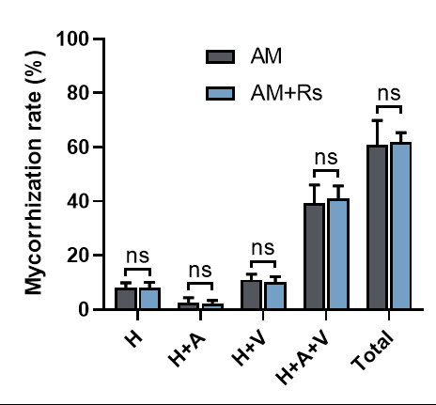
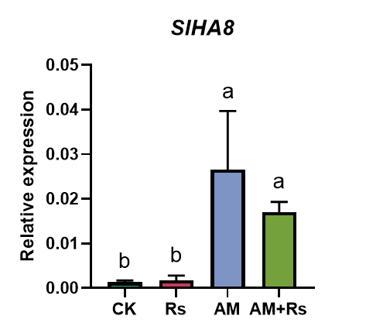
a
b

Fig. S2. The effects of AMF and/or R. solanacearum inoculation on the rhizospheric microbiota.
- Shannon diversity index of the bacterial community in rhizospheric soils of plants inoculated with AMF (AM), R. solanacearum (Rs), or both (AM+Rs), compared to mock-inoculated control plants (CK).
- Chao1 richness index of the bacterial community in rhizospheric soils of plants inoculated with AMF (AM), R. solanacearum (Rs), or both (AM+Rs), compared to mock-inoculated control plants (CK).

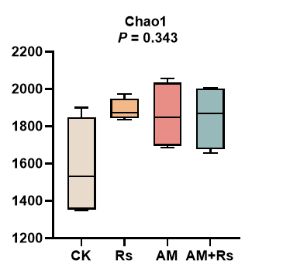
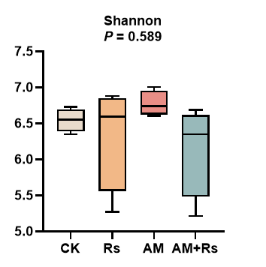
b.xz04【】
a.xz04【】

Fig. S3. A comparison of the relative abundances of several phylum-level bacterial species across different treatments. AM, inoculated alone with the AMF, R. intraradices; Rs, inoculated alone with R. solanacearum; AM+Rs, dual inoculation with R. intraradices and R. solanacearum. Different letters indicate significant differences (P < 0.05).
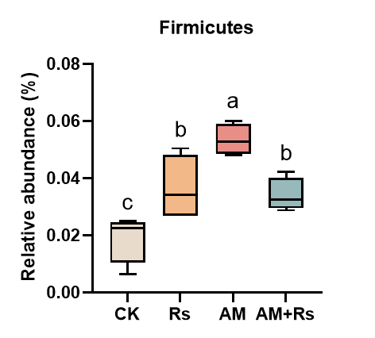
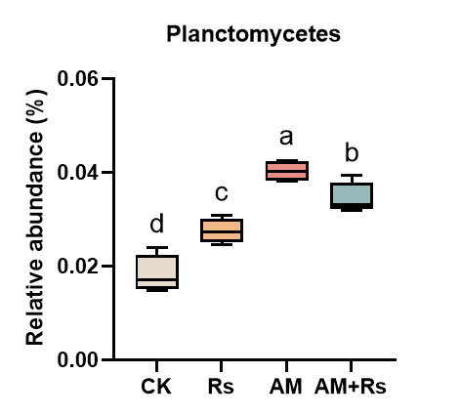
b.xz04【】
a.xz04【】

Fig. S4. A comparison of the relative abundances of several genus-level bacterial species across different treatments. AM, inoculated alone with the AMF, R. intraradices; Rs, inoculated alone with R. solanacearum; AM+Rs, dual inoculation with R. intraradices and R. solanacearum. Different letters indicate indicate significant differences (P < 0.05).
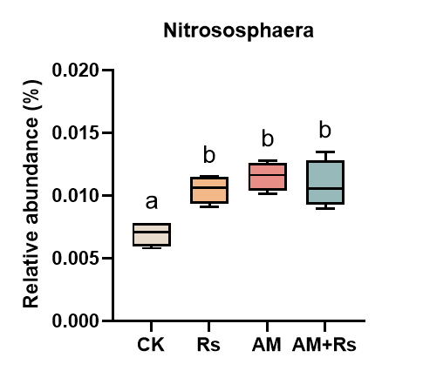
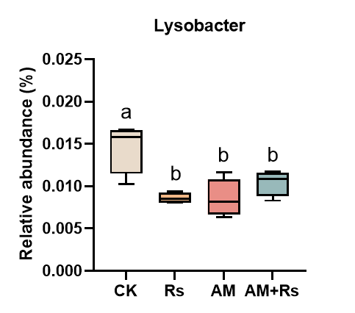
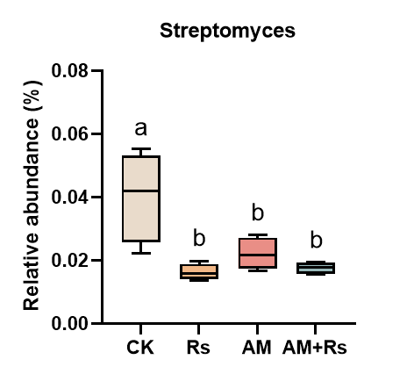
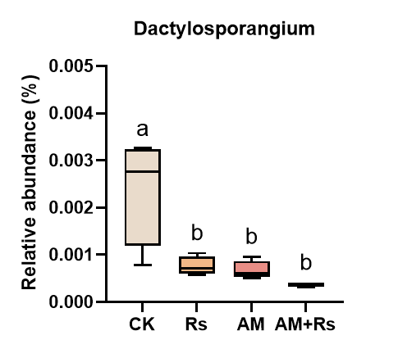
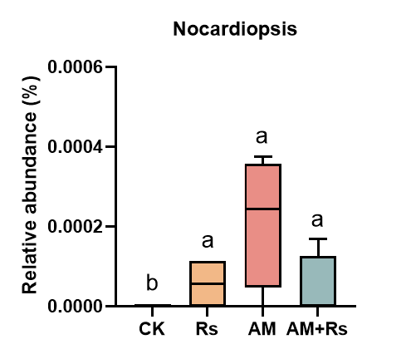
b.xz04【】
a.xz04【】
c.xz04【】
e.xz04【】
d.xz04【】

Fig. S5. Phylogenetic analysis of the 16S ribosomal RNA (rRNA) genes of the two isolates AQC296 and AQC211. Phylogenetic trees were constructed using the neighbor-joining method based on 16S rDNA sequences, with ten closely related reference strains selected for each isolate.
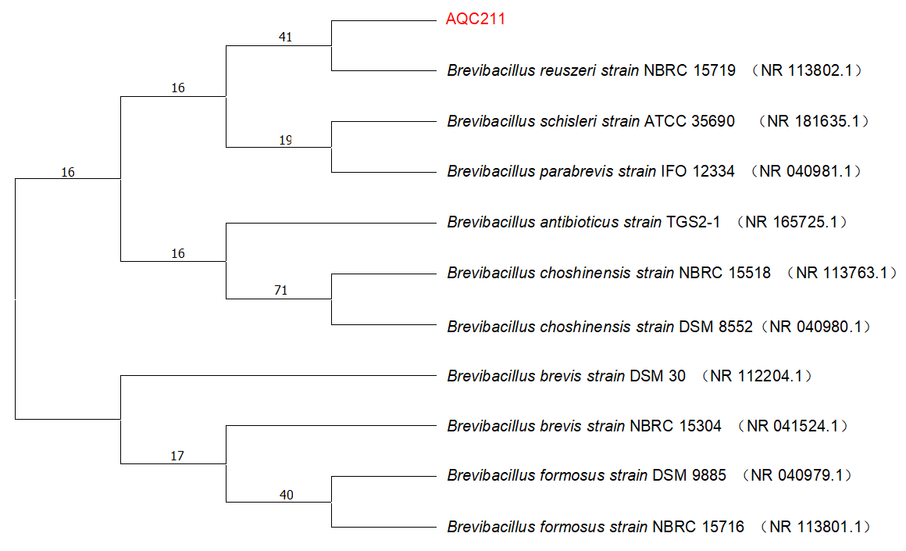
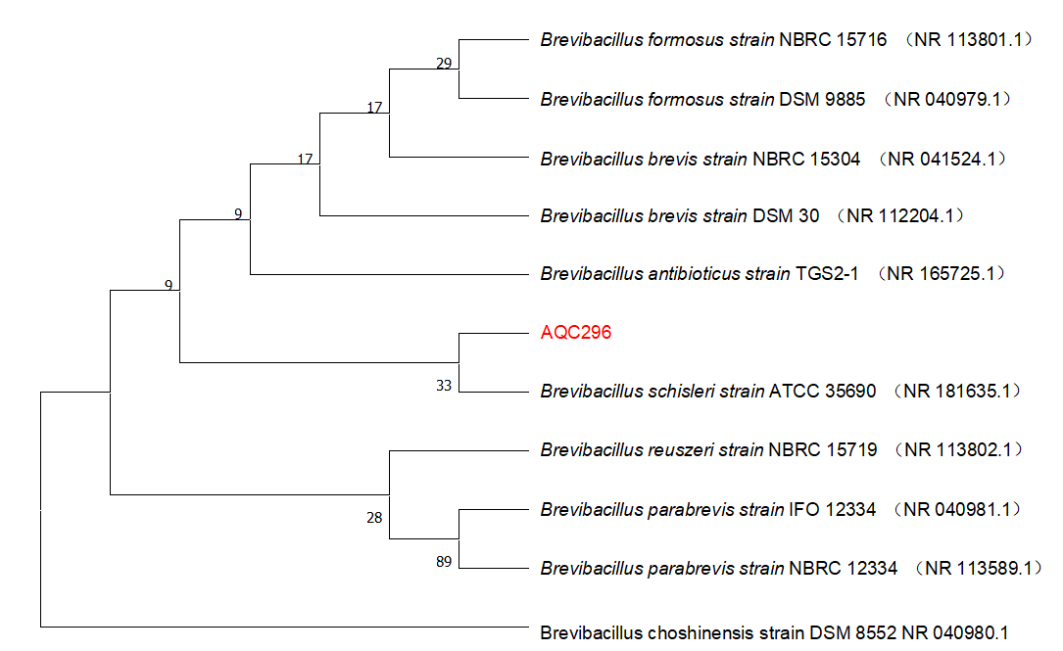
b.xz04【】
a.xz04【】

Fig. S6. Evaluation of the biocontrol efficacy of the two Brevibacillus strains, AQC211 and AQC296, against R. solanacearum in tomato plants. Two-week-old tomato seedlings grown in non-sterilized seedling substrate (peat moss/perlite/vermiculite, 3 : 1 : 1) were first inoculated with 50 ml suspension (OD600 at 1.0) containing either AQC211 or AQC296. The control plants were inoculated with equal mount of sterilized water. After one week of growth, these plants were further challenged with R. solanacearum for another two weeks.
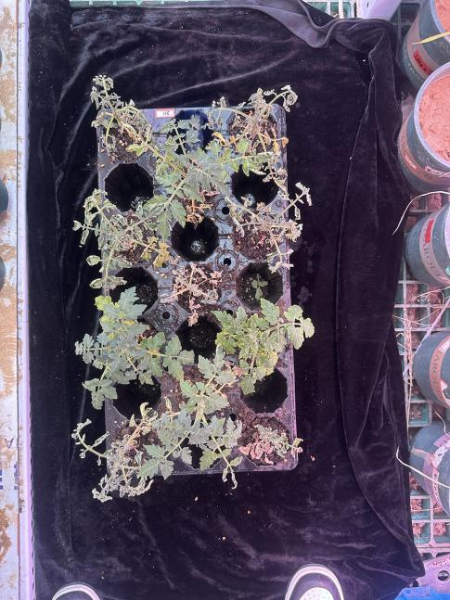
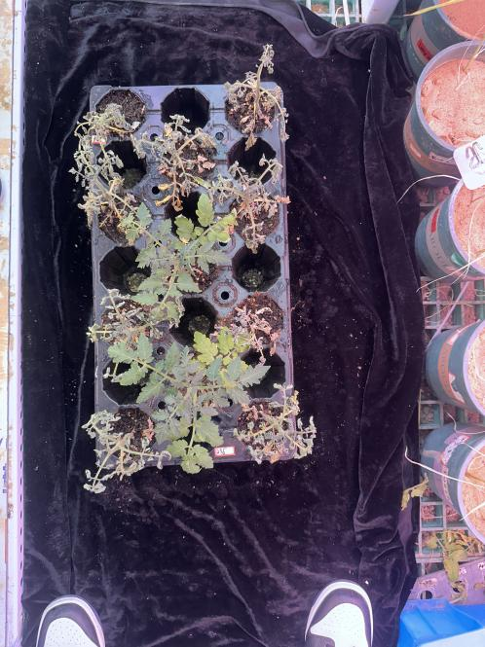
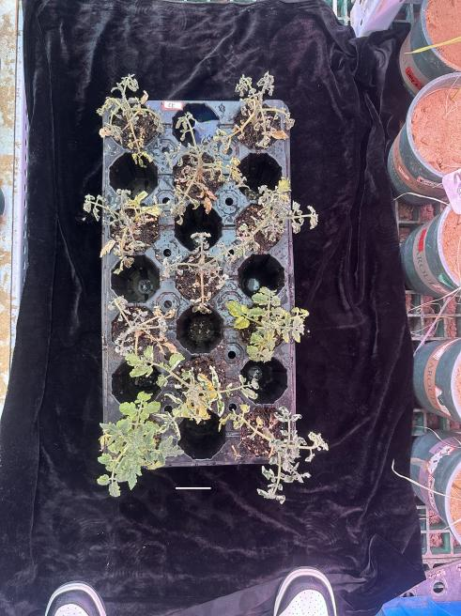
AQC296+Rs
AQC211+Rs
Rs

Table S1. Primers used for qRT-PCR analysis.

Gene | Forward primer(5’-3’) | Reverse primer(5’-3’)
SlActin | TTCCGTTGCCCAGAGGTCCT | TCGCCCTTTGAAATCCACATC
SlHA8 | AGCAAAAAGGCGCGCAGATAT | AAGGCGAAAAACTCCACAAATGA
SlPR1 | CTTAACGCTCACAATGCAGC | AGCGGCAGCTAGGTTTTCAC
SlPR2 | CTCAAGAGCGGGTGATTGTA | ATAGTCTGGCCTCTCGGACA
SlPR3 | TAGTCTGGCGCAACTCAGTC | TGCAAGAAATGAACCACCAT
SlPR4 | AGGTTGTGCTAGGGTTCGAT | CTTGGAATCAAAGTCCGGTT

