Supplemental Figures
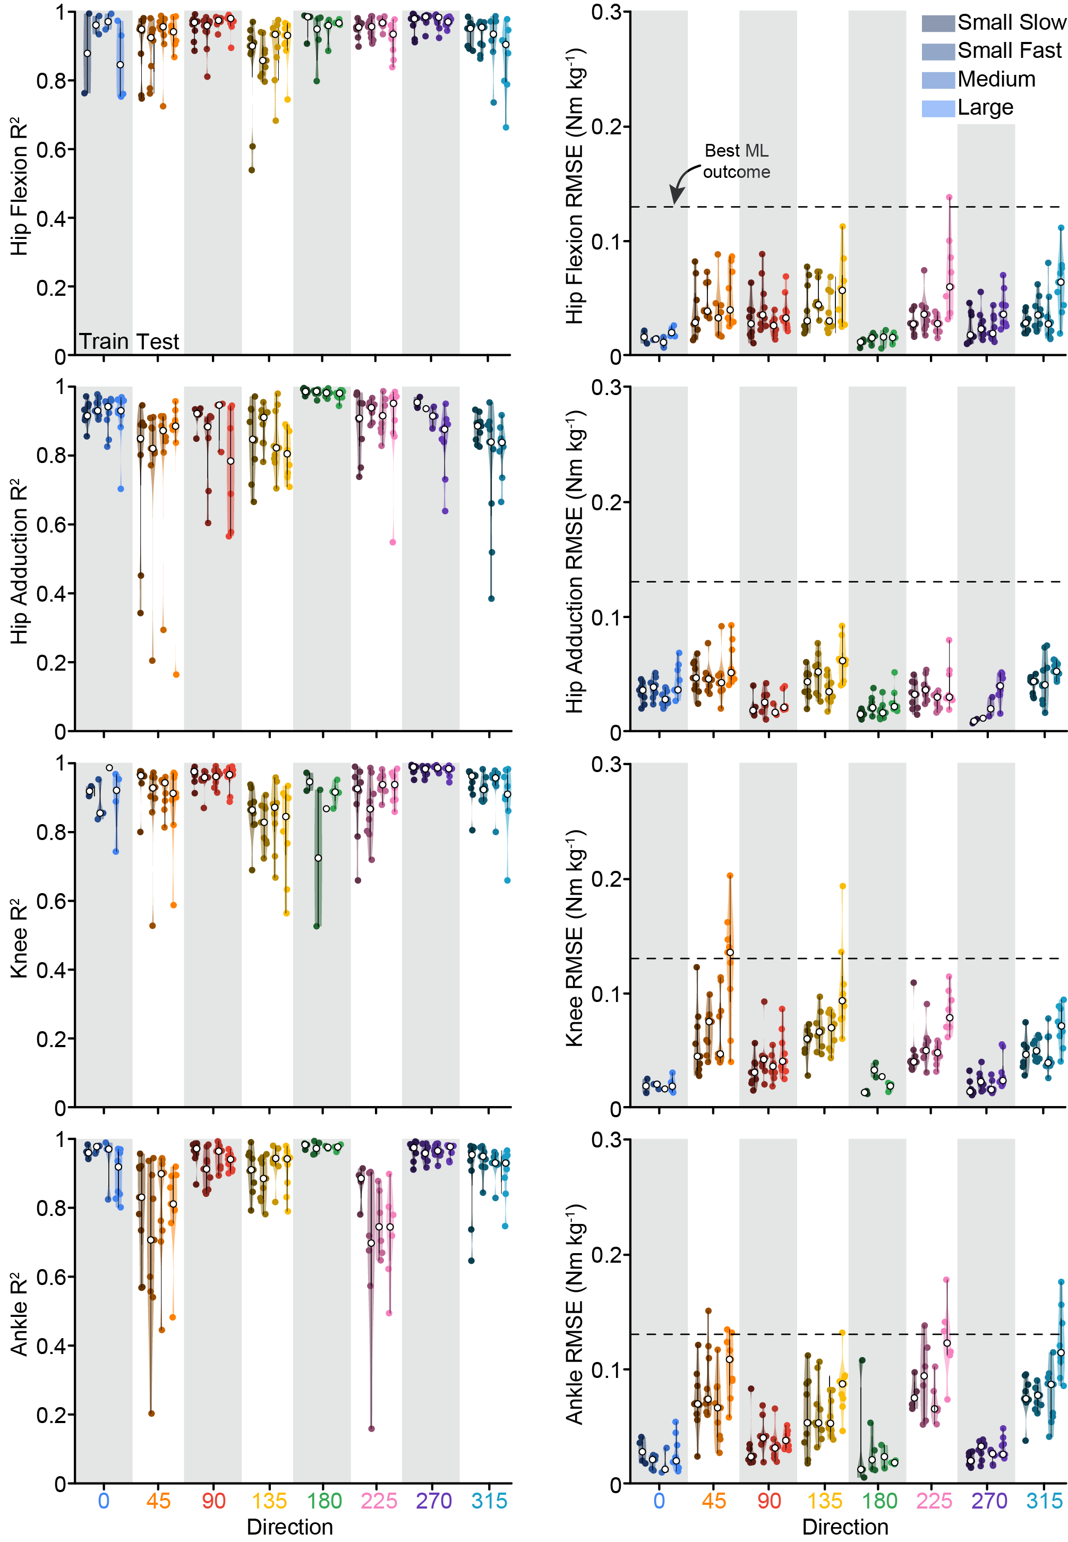
Supplemental Figure 1. Direction generalization group results. On average, the delayed CoM feedback model accurately reconstructed the balance-correcting torque response across all directions at the ankle, knee, and hip, with a high R² and low root mean squared error (RMSE). The CoM model was only trained in the cardinal directions (shaded - 0, 90, 180, and 270°). The different colors represent different perturbation directions, and different shades represent different perturbation magnitudes.
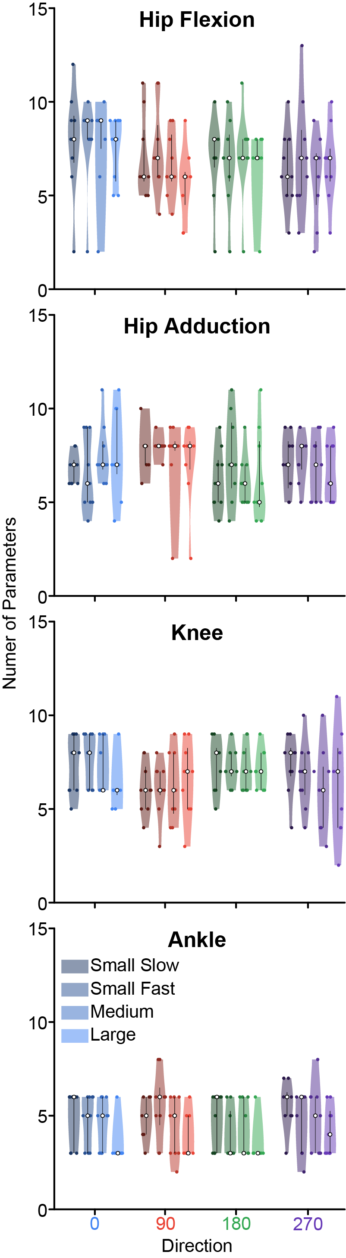
Supplemental Figure 2. Number of parameters across all joints, directions, and perturbation magnitude. The different colors represent different perturbation directions, and different shades represent different perturbation magnitudes.
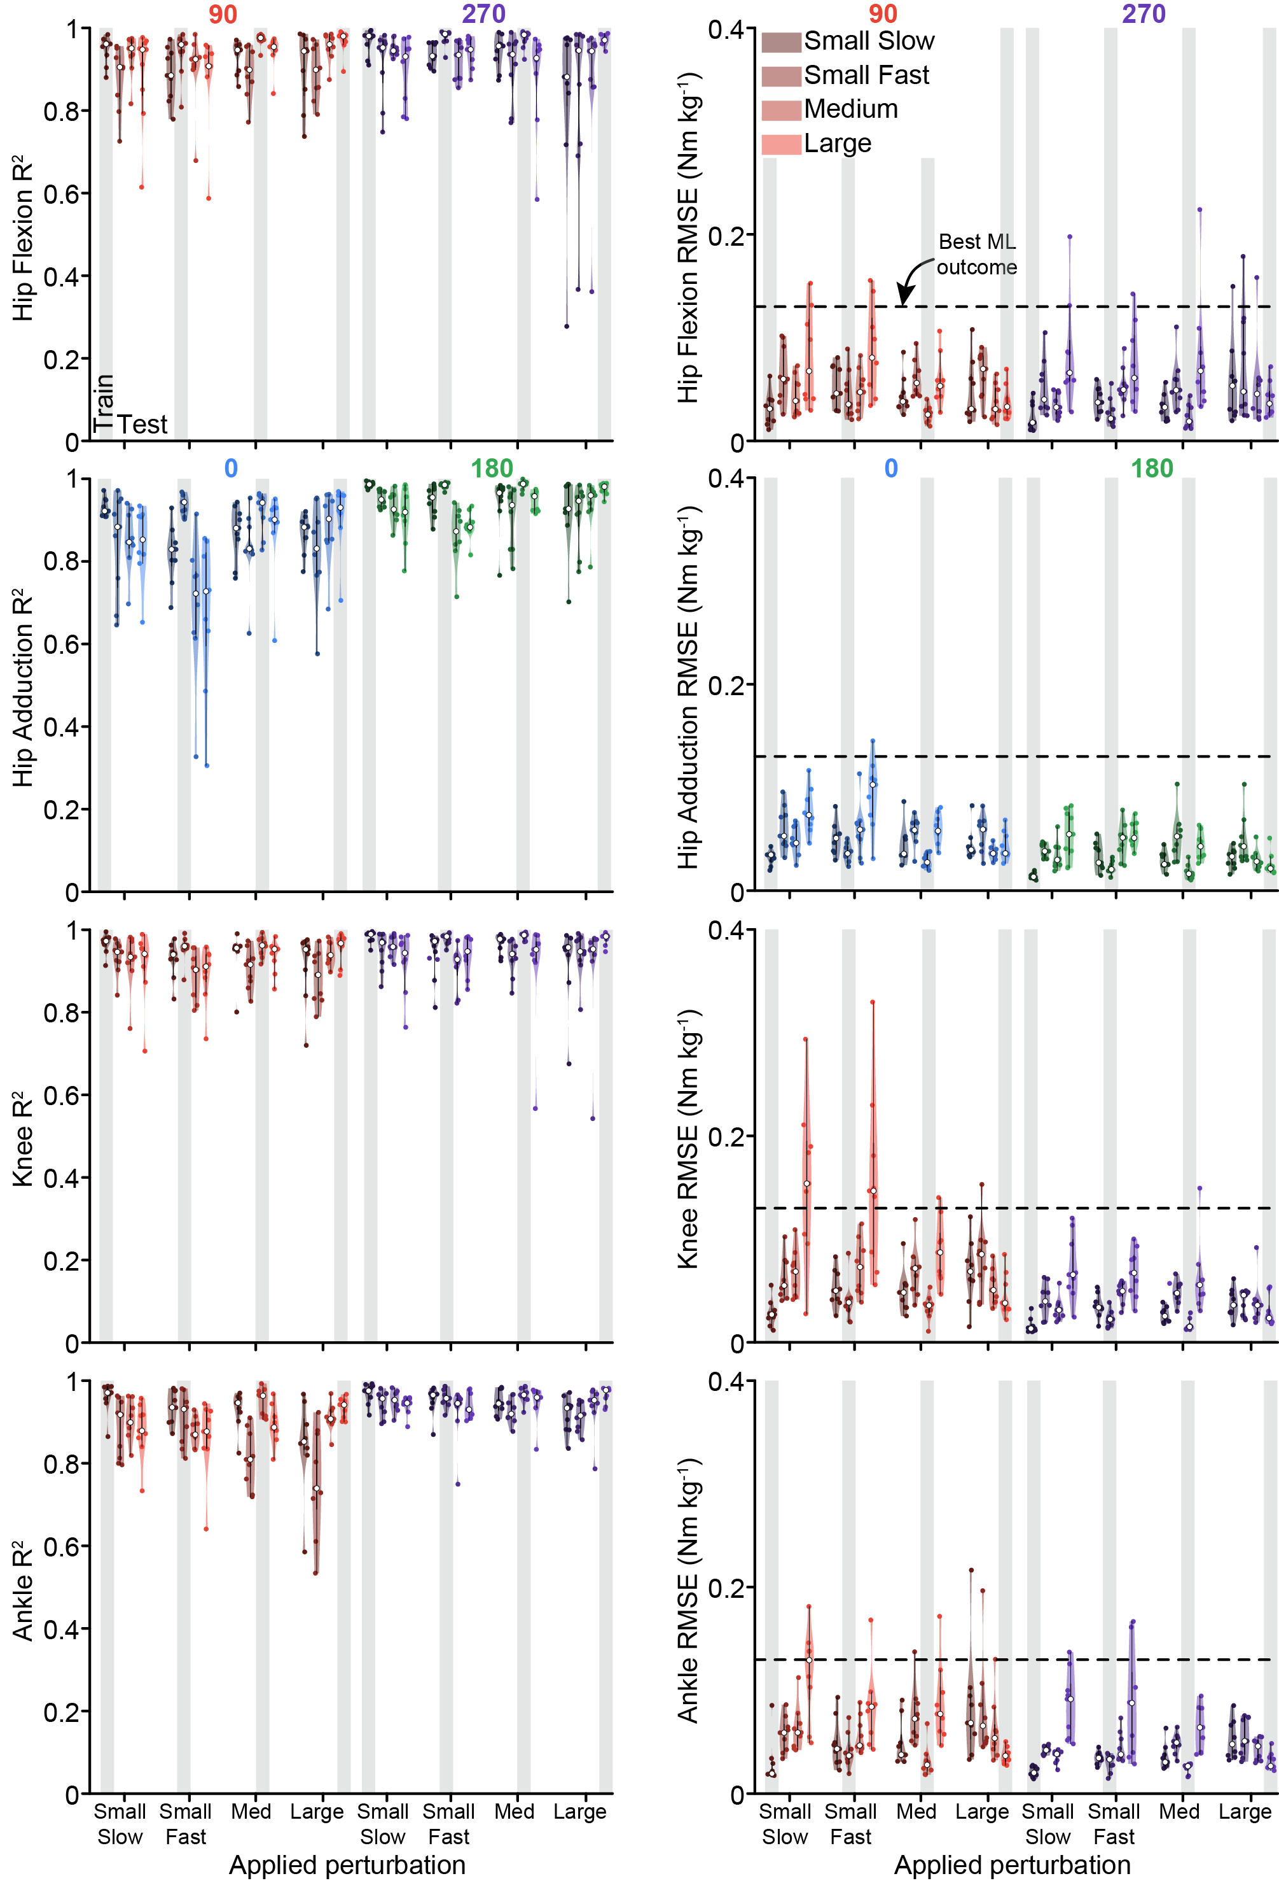
Supplemental Figure 3. Magnitude generalization group results. On average, the delayed CoM feedback model was able to generalize to other perturbation magnitudes at the ankle, knee, and hip, with high R² and low root mean squared error (RMSE). The CoM model was only trained at one perturbation magnitude (shaded) and then tested at different magnitudes. The different colors represent different perturbation directions, and different shades represent different perturbation magnitudes.
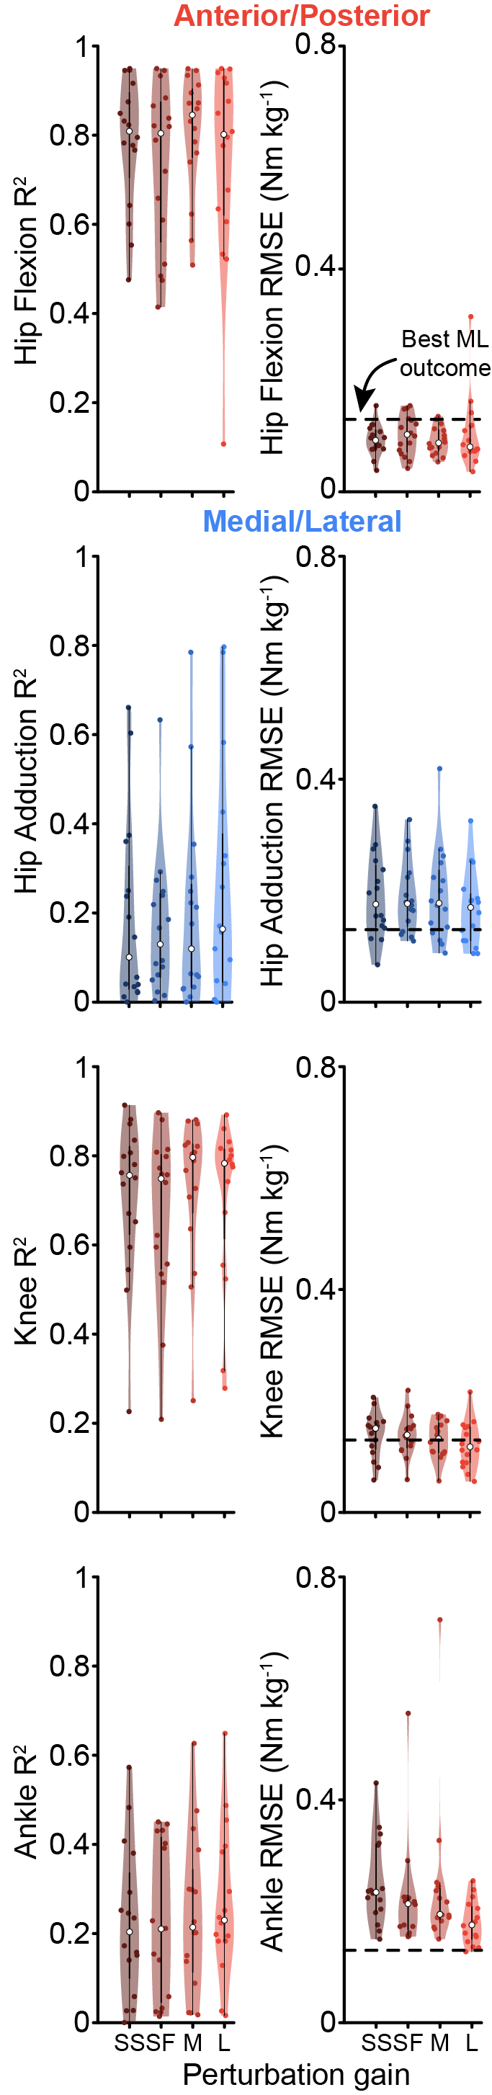
Supplemental Figure 4. Sinusoidal generalization group results. On average, the delayed CoM feedback model was able to generalize from ramp-and-hold perturbations to sinusoidal movements for the hip flexion and knee flexion torque responses, but not for hip adduction or ankle plantarflexion torque responses. The CoM model was only trained on ramp-and-hold perturbations of different magnitudes and then tested on the sinusoidal movement. The different colors represent different perturbation directions, and different shades represent different perturbation magnitudes. SS = small slow, SF = small fast, M = medium, L = large perturbation.
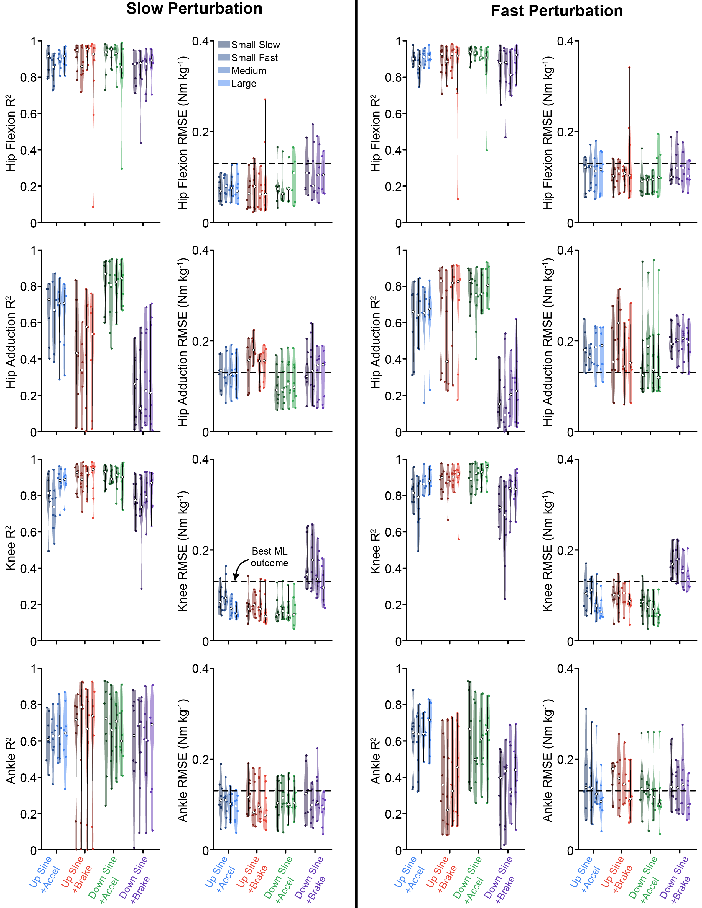
Supplemental Figure 5. Generalization from ramp-and-hold perturbations to perturbations superimposed on a sinusoidal movement group results. On average, the delayed CoM feedback model was able to generalize from ramp-and-hold perturbations to perturbations superimposed on the sinusoidal movements for the hip flexion and knee flexion torque responses, but not for hip adduction or ankle plantarflexion. The CoM model was only trained on ramp-and-hold perturbations of different magnitudes and then tested on the sinusoidal movement. The different colors represent different perturbation directions, and different shades represent different perturbation magnitudes.

