Supplementary Materials

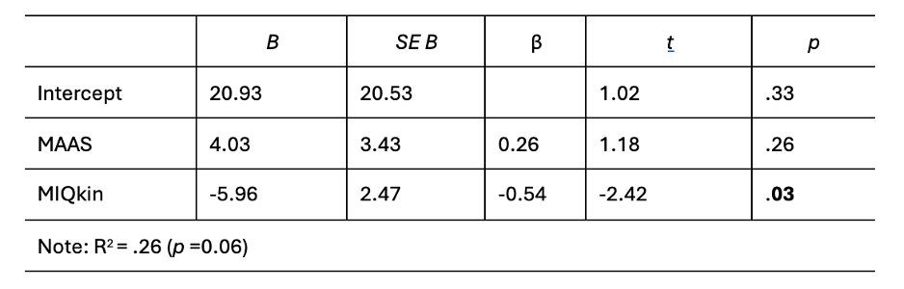
Supplementary Table 1. % Success linear regression output for control group.

Supplementary Table 2. MRE linear regression output for control group.
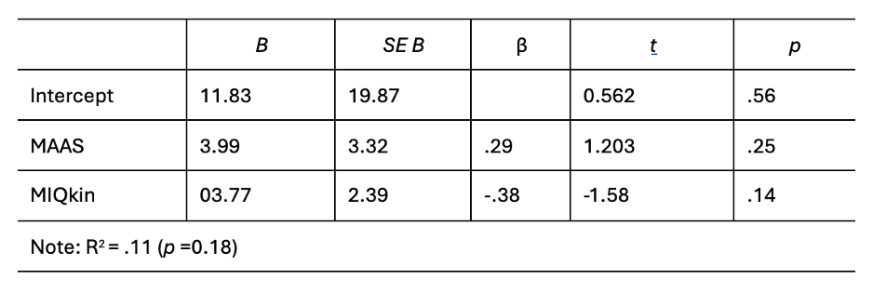
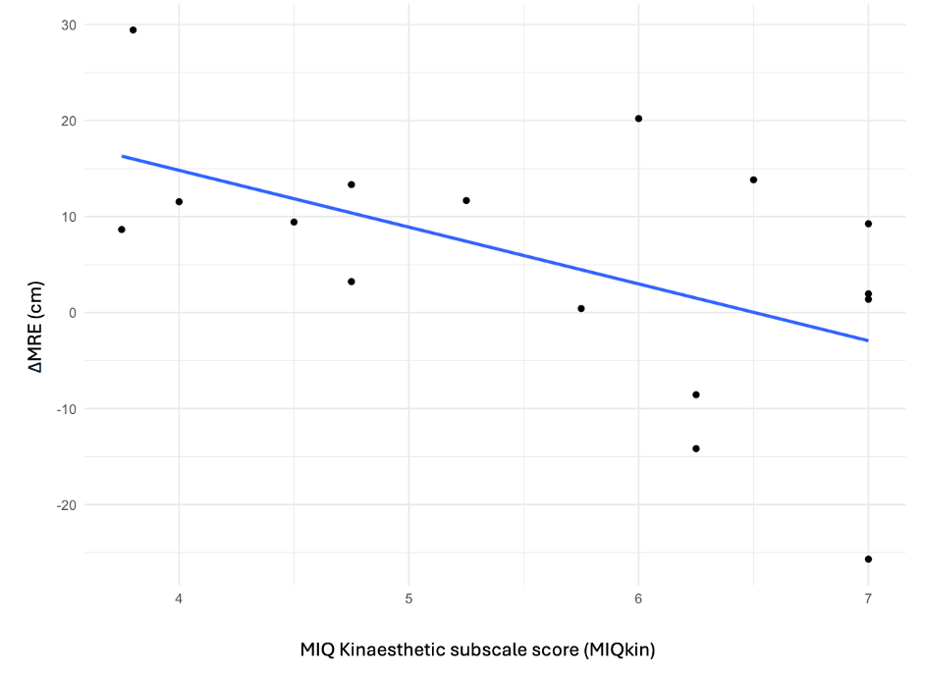
Supplementary Figure 1. Change in MRE correlation with MIQ kinaesthetic subscale scores for the control group.

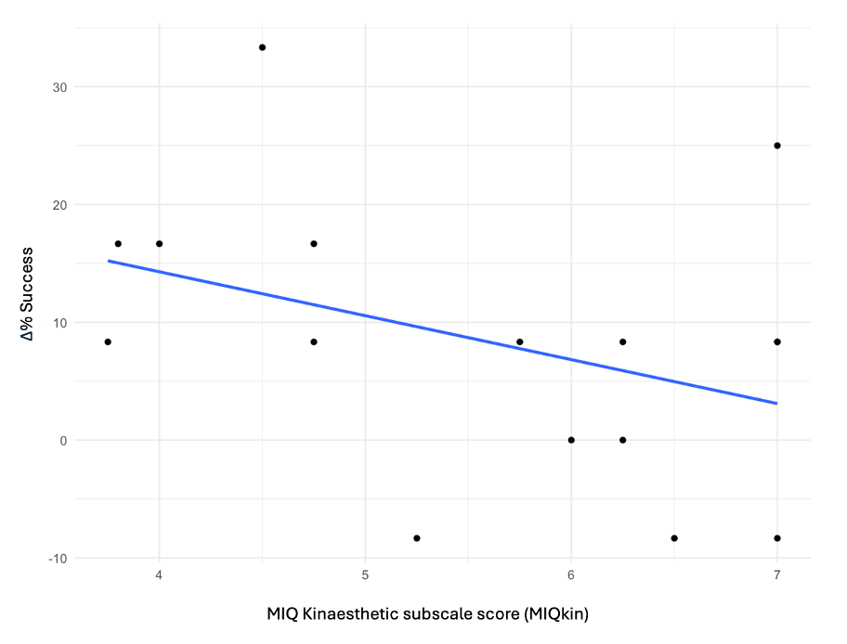
Supplementary Figure 2. Change in %Success correlation with MIQ kinaesthetic subscale scores for the control group.

