Supplementary Figure 1. Trial schema.
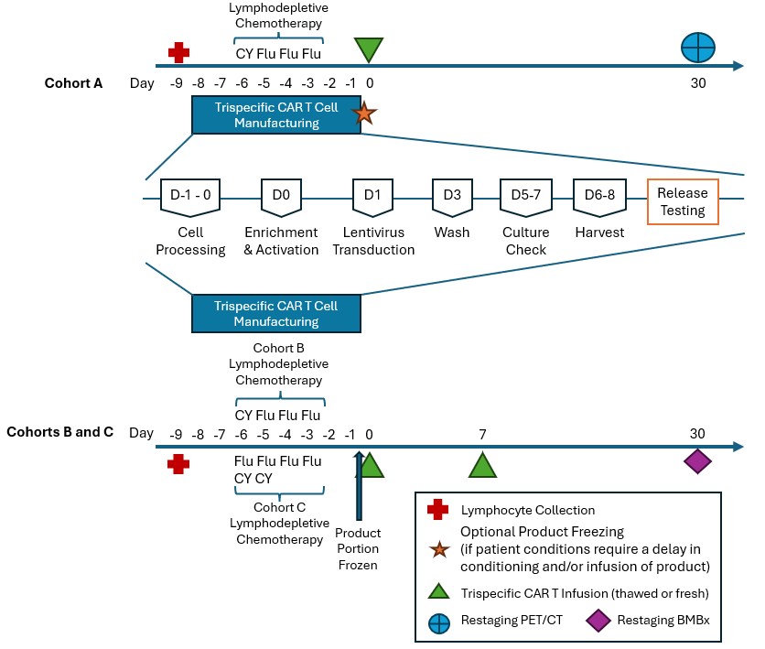
Supplementary Figure 1 Legend:
Trial schema. Treatment days shown are based on 8-day manufacturing schedule. CAR T infusion date was designated Day 0. Depending on the availability of the manufactured product, days between completion of chemotherapy and the infusion were adjusted.

Supplementary Table 1. CD19, CD20, and CD22 expression Pre- and Post- CD19/20/22 CAR T in Relapse Samples
Patient - Cohort - Dose Level | Diagnosis | Prior to CAR T |  |  |  | Post-CAR T (at relapse)
Patient - Cohort - Dose Level | Diagnosis | CD19 | CD20 | CD22 | CD19 |  | CD20 | CD22
001 - Cohort A - Dose Level 1 | B-PLL | + | +moderate | + | - |  | - | Not Available
002 -  Cohort A - Dose Level 1 | DLBCL | + | +dim to moderate | Not Available | + |  | +dim | Not Available
004 - Cohort A - Dose Level 2 | CLL | + | +dim | - | + |  | +dim to moderate | -
005 - Cohort A - Dose Level 2 | CLL | + | - | - | + |  | - | -
006 - Cohort A - Dose Level 2 | CLL | + | +dim | - | +dim |  | +markedly dim | -
001 - Cohort B - Dose Level 1 | Ph+ B-ALL | + | - | - | + |  | - | +
004 - Cohort B - Dose Level 1 | KMT2A B-ALL | - | - | +dim / partial | + |  | - | +
006 - Cohort B - Dose Level 2 | Richter's | + | +dim | - | + |  | - | +
007- Cohort B - Dose Level 2 | MCL | + | +moderate | + | + |  | - | -
012 - Cohort B - Dose Level 3 | Richter's | + | + | +moderate | Not Available |  | Not Available | Not Available
013 - Cohort B - Dose Level 3 | Ph+ B-ALL | + | + | - | + |  | + | -

Supplementary Figure 2. Statistical Analysis (Area Under the Curve) Trispecific CAR T Cell Persistence by PCR Data
A B
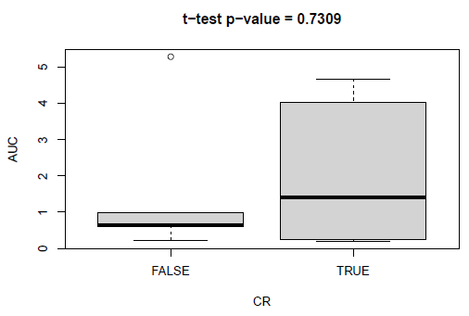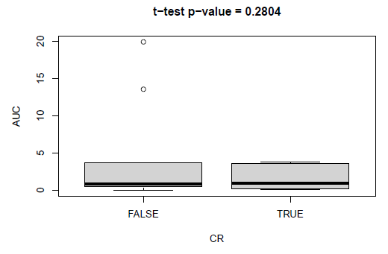
C
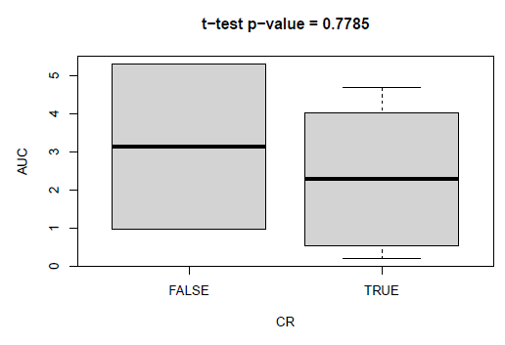
Supplementary Figure 2 Legend:
Area under the curve (AUC) of the log normalized trispecific CAR T Cell persistence (by PCR) data between day 0 and day 90 compared between complete responders (CR) and non-complete responders by two-sample t-test. Panel (A) shows data up to 90 days post-infusion and Panel (B) shows up to 30 days post-infusion for all patients. Panel (C) shows data up to 90 days post-infusion for lymphoma patients.
Supplementary Figure 3. Immunophenotypic and functional characteristics of CD4⁺ T cells in NTTs in CR and PD cohorts.
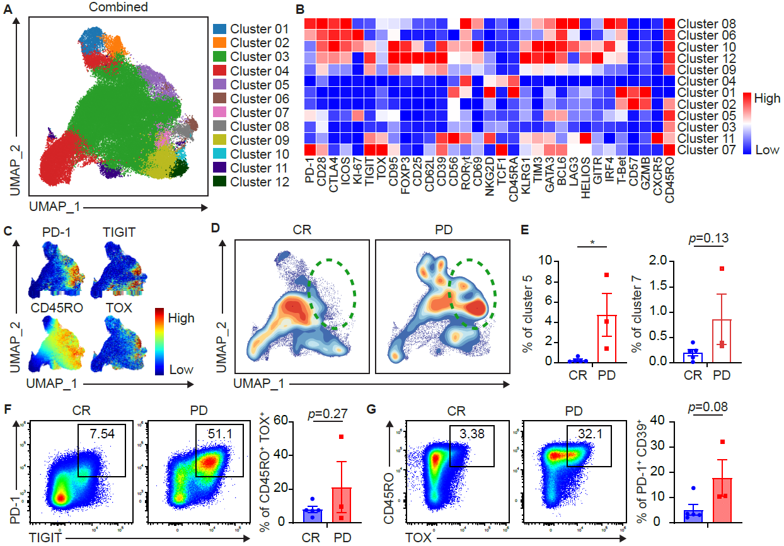
Supplementary Figure 3 Legend:
Samples from patient NTTs used to manufacture trispecific CAR T infusion product were analyzed via spectral flow cytometry. (A) UMAP dot plot of CAR⁺ CD4⁺ T cells from the total cohort (n=8). (B) Clustered heatmap showing key marker expressions on differentially abundant CAR⁺ CD4⁺ clusters. Color scale was determined by median normalization of each individual marker with blue representing low expression, white representing median expression and red representing high expression. (C) Expression plots of phenotypical markers present on CAR⁺ CD4⁺ T cells. (D) Contour UMAP plots of CAR⁺ CD4⁺ T cells in CR vs. PD cohorts. (E) Box plots showing clusters percentages of CAR⁺ CD4⁺ Cells in CR vs. PD cohorts. Left: Cluster 5. Right: Cluster 7. For (F) and (G), 2D flow plot analysis was performed on spectral flow cytometry data from all patient NTT samples. (F) Representative 2D flow cytometry plots showing individual patient PD-1 and TIGIT expression on NTTs and corresponding box plot quantification in CR vs. PD cohorts. (G) Representative 2D flow cytometry plots showing individual patient CD45RO and TOX expression on NTTs and corresponding box plot quantification in CR vs. PD cohorts. Box plots in (E), (F), and (G) show quartiles with bands at the median; whiskers indicate 1.5 interquartile range; all observations overlaid as dots. p values are from two sample t test. p < 0.05 = *. p < 0.01 = **.

Supplementary Figure 4. Immunophenotypic and functional characteristics CD4⁺ CAR⁺ T cell in Trispecific CAR T Infusion product.
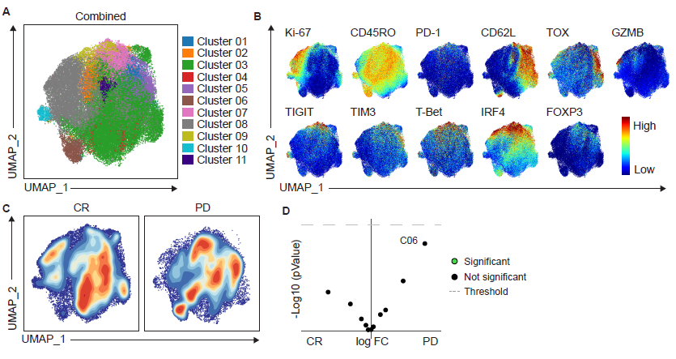
Supplementary Figure 4 Legend:
Patient’s trispecific CAR T infusion products were analyzed by spectral flow cytometry. (A) UMAP dot plot of CAR⁺ CD4⁺ T cells from the total cohort (n=8). (B) Expression plots of phenotypical and functional markers present on CAR⁺ CD4⁺ T cells. (C) Contour UMAP plots of CAR⁺ CD4⁺ T cells in CR vs. PD cohorts. (D) Volcano plot plots of all clusters differentially expressed in CR vs. PD cohorts. P value ≤ 0.05 was considered significant.

Supplementary Figure 5. Immunophenotypic and functional characteristics CD8⁺ CAR⁺ T cells in post-CAR T infusion PBMCs at Day 7.
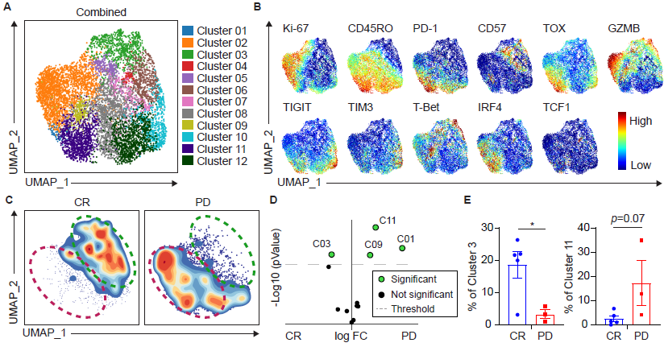

Supplementary Figure 5 Legend: PBMCs from the Day 7 post-CAR T timepoint were analyzed via spectral flow cytometry. (A) UMAP dot plot of CAR⁺ CD8⁺ T cells from the total cohort (n=8). (B) Expression plots of phenotypical and functional markers present on CAR⁺ CD8⁺ T cells. (C) Contour UMAP plots of CAR⁺ CD8⁺ T cells in CR vs. PD cohorts. (D) Volcano plot plots of all clusters differentially expressed in CR vs. PD cohorts. P value ≤ 0.05 was considered significant. (E) Box plots showing clusters percentages of CAR⁺ CD8⁺ Cells in CR vs. PD cohorts. Left: Cluster 3. Right: Cluster 11. Box plots show quartiles with bands at the median; whiskers indicate 1.5 interquartile range; all observations overlaid as dots. p values are from two sample t test. p < 0.05 = *.

Supplementary Figure 6. Immunophenotypic and functional characteristics of CD4⁺ CAR⁺ T cell in post-CAR T PBMCs at Day 7.
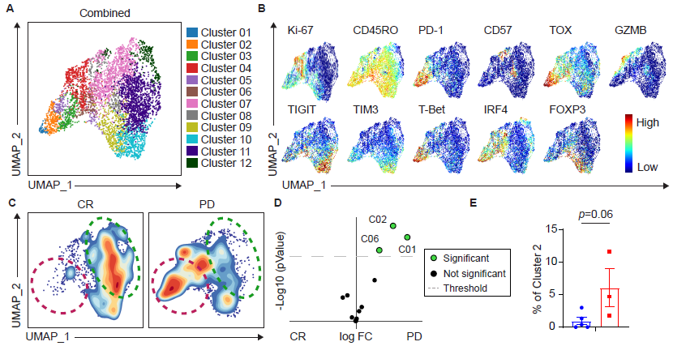
Supplementary Figure 6 Legend:
PBMCs from the Day 7 post-CAR T timepoint were analyzed via spectral flow cytometry. (A) UMAP dot plot of CAR⁺ CD4⁺ T cells from the total cohort (n=8). (B) Expression plots of phenotypical and functional markers present on CAR⁺ CD8⁺ T cells. (C) Contour UMAP plots of CAR⁺ CD4⁺ T cells in CR vs. PD cohorts. (D) Volcano plot plots of all clusters differentially expressed in CR vs. PD cohorts. P value ≤ 0.05 was considered significant. (E) Box plots showing cluster percentages of CAR⁺ CD4⁺ Cells in CR vs. PD cohorts for cluster 2. Box plot shows quartiles with bands at the median; whiskers indicate 1.5 interquartile range; all observations overlaid as dots. p values are from two sample t test.

Supplementary Figure 7: Immunophenotypic and functional characteristics CD8⁺ CAR⁺ T cells in Post-CAR T PBMCs at Day 14.
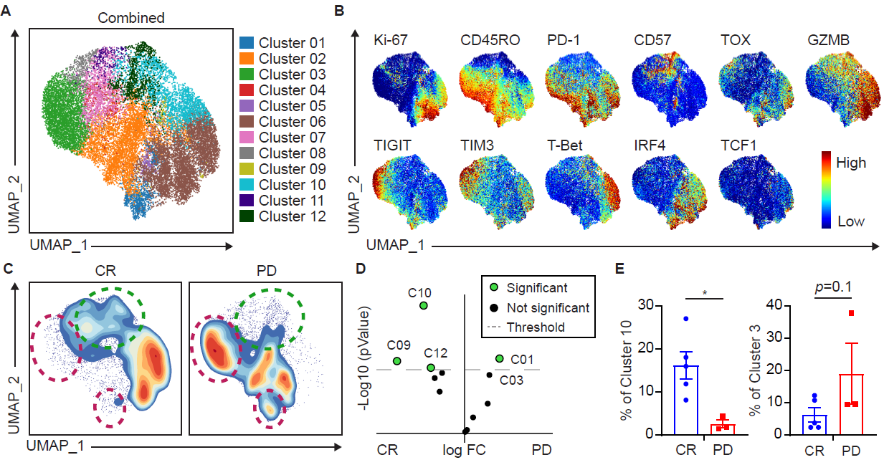

Supplementary Figure 7 Legend: PBMCs from the Day 14 post-CAR T timepoint were analyzed via spectral flow cytometry. (A) UMAP dot plot of CAR⁺ CD8⁺ T cells from the total cohort (n=8). (B) Expression plots of phenotypical and functional markers present on CAR⁺ CD8⁺ T cells. (C) Contour UMAP plots of CAR⁺ CD8⁺ T cells in CR vs. PD cohorts. (D) Volcano plot plots of all clusters differentially expressed in CR vs. PD cohorts. P value ≤ 0.05 was considered significant. (E) Box plots showing clusters percentages of CAR⁺ CD8⁺ Cells in CR vs. PD cohorts. Left: Cluster 10. Right: Cluster 3. Box plots show quartiles with bands at the median; whiskers indicate 1.5 interquartile range; all observations overlaid as dots. p values are from two sample t test. p < 0.05 = *.

Supplementary Figure 8. Immunophenotypic and functional characteristics of CD4⁺ CAR⁺ T cell clusters in post-CAR T PBMCs at Day 14.

Supplementary Figure 8 Legend:
PBMCs from the Day 14 post-CAR T timepoint were analyzed via spectral flow cytometry. (A) UMAP dot plot of CAR⁺ CD14⁺ T cells from the total cohort (n=8). (B) Expression plots of phenotypical and functional markers present on CAR⁺ CD14⁺ T cells. (C) Contour UMAP plots of CAR⁺ CD14⁺ T cells in CR vs. PD cohorts. (D) Volcano plot plots of all clusters differentially expressed in CR vs. PD cohorts. P value ≤ 0.05 was considered significant. (E) Box plots showing clusters percentages of CAR⁺ CD14⁺ Cells in CR vs. PD cohorts. Left: Cluster 3. Right: Cluster 11. Box plots show quartiles with bands at the median; whiskers indicate 1.5 interquartile range; all observations overlaid as dots. p values are from two sample t test. p < 0.05 = *.

Supplementary Table 2. 40 color spectral flow cytometry CAR T cell immunophenotyping panel.
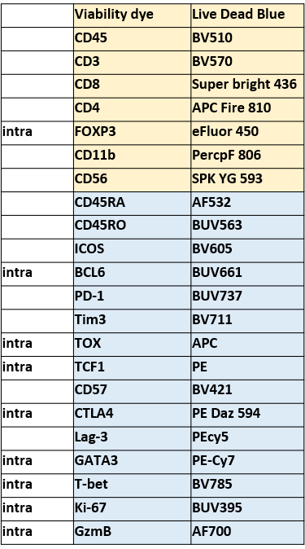
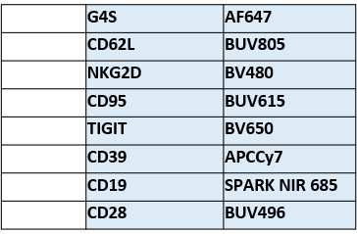

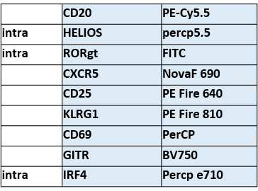

Supplementary Figure 9. Trispecific CAR⁺ T cell Gating Strategy for spectral flow cytometry.
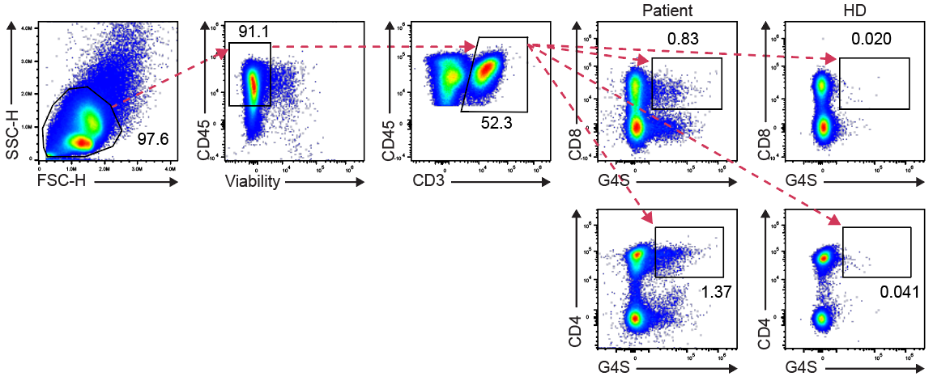
Supplementary Figure 9 Legend:
NTTs, trispecific CAR T infusion product, and PBMCs at post-CAR T timepoints were analyzed via spectral flow cytometry. G4S Linker antibody was used to identify CAR⁺ cells. Representative 2D flow cytometry plot showing gating strategy for CAR⁺ CD8⁺ and CAR⁺ CD4⁺ CAR T cells is shown here. Healthy donor (HD) samples were utilized as negative controls. Percentages of CAR⁺ CD8⁺ T cells, CAR⁺ CD4⁺ T cells in a representative patient and healthy donor control are shown.

