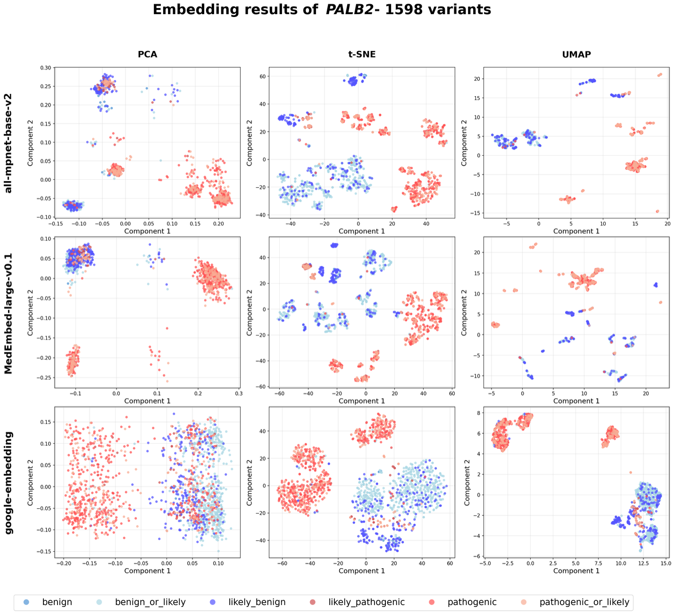
Supplementary Figure 1: Visualization of semantic embeddings for 1,598 PALB2 variants.

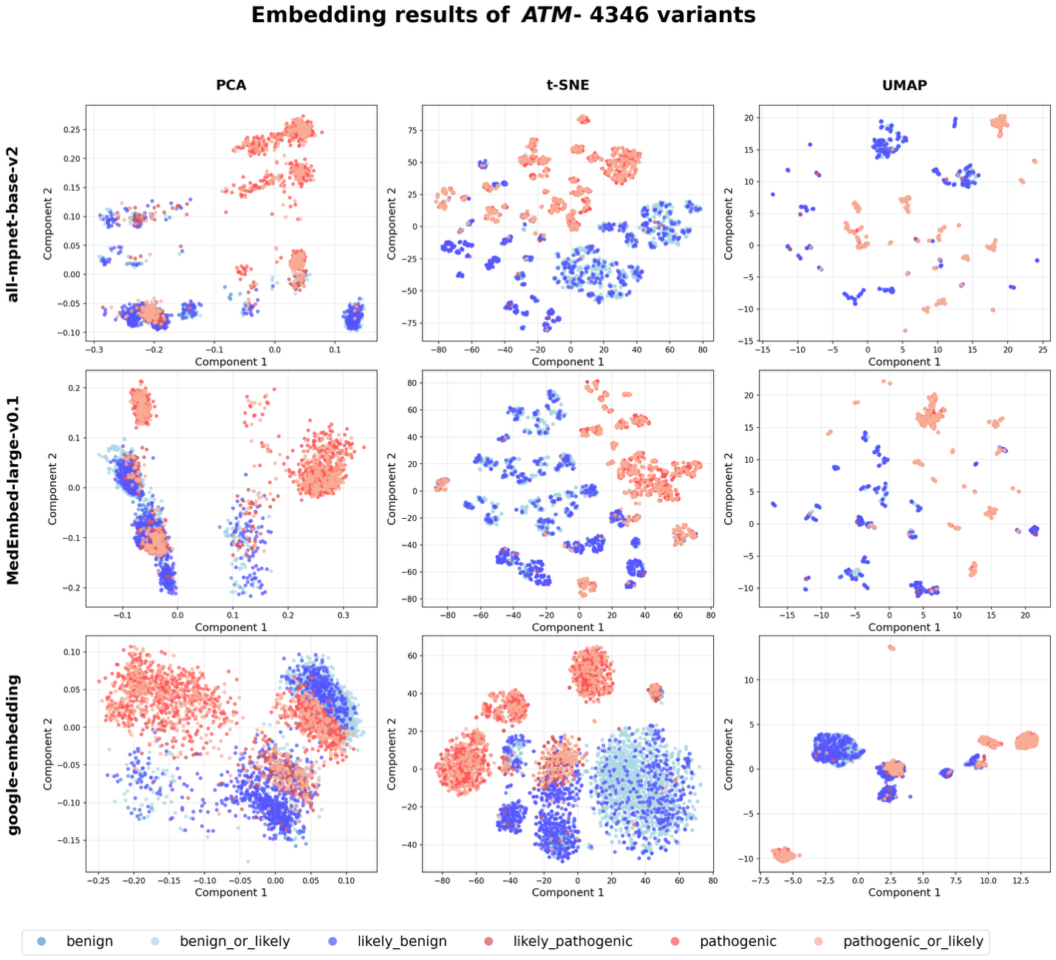
Supplementary Figure 2: Visualization of semantic embeddings for 4,346 ATM variants.

