Supplementary Information
This section supplies information supporting the description of the statistical tests adopted to validate the results of our work.
Table S1: Summary of the results obtained by the Weight of Evidence test.
a)
2D well-fault buffer distance (km) | Total  cells | Cells hosting productive  wells | % of total wells | Cells NOT hosting productive  wells | W+ | S²_{W-} | W- | S²_{W+} | C | C/S(C)
<2 | 18,827,023 | 14 | 2.9 | 18,827,009 | -0.313 | 0.071 | 0.011 | 0.002 | -0.325 | -1.197
2-5 | 21,451,808 | 3 | 0.6 | 21,451,805 | -1.984 | 0.333 | 0.041 | 0.002 | -2.025 | -3.496
5-10 | 39,929,503 | 48 | 10.1 | 39,929,455 | 0.167 | 0.021 | -0.017 | 0.002 | 0.184 | 1.209
10-20 | 85,400,755 | 125 | 26.3 | 85,400,630 | 0.364 | 0.021 | -0.103 | 0.002 | 0.467 | 4.484
20-30 | 63,252,541 | 119 | 25.1 | 63,252,422 | 0.615 | 0.021 | -0.143 | 0.002 | 0.758 | 7.155
30-40 | 52,505,078 | 82 | 17.3 | 52,504,996 | 0.429 | 0.021 | -0.070 | 0.002 | 0.499 | 4.109
40-50 | 43,392,493 | 55 | 11.6 | 43,392,438 | 0.220 | 0.018 | -0.026 | 0.002 | 0.245 | 1.711
> 50 | 142,165,247 | 29 | 6.1 | 14,2165,218 | -1.607 | 0.034 | 0.300 | 0.002 | -1.907 | -9.951
Grand total | 466,924,448 | 475 | 100.0
2D well-fault buffer distance (km) | Total  cells | Cells hosting sterile  wells | % of total wells | Cells NOT hosting sterile  wells | W+ | S²_{W-} | W- | S²_{W+} | C | C/S(C)
<2 | 18,827,023 | 62 | 12.6 | 188,26,961 | 1.142 | 0.016 | -0.094 | 0.002 | 1.235 | 9.093
2-5 | 21,451,808 | 31 | 6.3 | 21,451,777 | 0.318 | 0.032 | -0.018 | 0.002 | 0.336 | 1.811
5-10 | 39,929,503 | 52 | 10.6 | 39,929,451 | 0.214 | 0.019 | -0.023 | 0.002 | 0.236 | 1.612
10-20 | 85,400,755 | 150 | 30.5 | 85,400,605 | 0.513 | 0.019 | -0.163 | 0.002 | 0.676 | 6.895
20-30 | 63,252,541 | 91 | 18.5 | 63,252,450 | 0.313 | 0.019 | -0.059 | 0.002 | 0.373 | 3.210
30-40 | 52,505,078 | 45 | 9.2 | 52,505,033 | -0.205 | 0.019 | 0.023 | 0.002 | -0.228 | -1.456
40-50 | 43,392,493 | 23 | 4.7 | 43,392,470 | -0.685 | 0.043 | 0.050 | 0.002 | -0.735 | -3.440
> 50 | 142,165,247 | 37 | 7.5 | 14,2165,210 | -1.396 | 0.027 | 0.285 | 0.002 | -1.681 | -9.833
Grand total | 466,924,448 | 491 | 100.0

b)
3D well-fault distance (km) | Total  cells | Cells hosting productive  wells | % of total wells | Cells NOT hosting productive  wells | W+ | S²_{W-} | W- | S²_{W+} | C | C/S(C)
<4 | 8,840,000 | 10 | 2.1 | 8,839,990 | 0.106 | 0.100 | -0.002 | 0.002 | 0.108 | 0.34
4-6 | 20,330,000 | 7 | 1.5 | 20,329,993 | -1.083 | 0.143 | 0.030 | 0.002 | -1.113 | -2.92
6-10 | 40,000,000 | 25 | 5.3 | 39,999,975 | -0.487 | 0.040 | 0.035 | 0.002 | -0.523 | -2.544
10-20 | 92,830,000 | 142 | 29.9 | 92,829,858 | 0.408 | 0.040 | -0.134 | 0.002 | 0.541 | 5.402
20-30 | 67,170,000 | 120 | 25.3 | 67,169,880 | 0.563 | 0.040 | -0.136 | 0.002 | 0.699 | 6.620
30-40 | 54,260,000 | 86 | 18.1 | 54,259,914 | 0.443 | 0.040 | -0.076 | 0.002 | 0.520 | 4.361
40-50 | 44,190,000 | 57 | 12.0 | 44,189,943 | 0.237 | 0.018 | -0.028 | 0.002 | 0.266 | 1.883
>50 | 139,304,448 | 28 | 5.9 | 139,304,420 | -1.622 | 0.036 | 0.294 | 0.002 | -1.915 | -9.831
Grand total | 466,924,448 | 475 | 100.0
3D well-fault distance (km) | Total  cells | Cells hosting sterile  wells | % of total wells | Cells NOT hosting sterile  wells | W+ | S²_{W-} | W- | S²_{W+} | C | C/S(C)
<4 | 8,840,000 | 29 | 5.9 | 8,839,971 | 1.138 | 0.034 | -0.042 | 0.002 | 1.179 | 6.161
4-6 | 20,330,000 | 48 | 9.8 | 20,329,952 | 0.809 | 0.021 | -0.058 | 0.002 | 0.867 | 5.707
6-10 | 40,000,000 | 45 | 9.2 | 39,999,955 | 0.068 | 0.022 | -0.007 | 0.002 | 0.074 | 0.474
10-20 | 92,830,000 | 166 | 33.8 | 92,829,834 | 0.531 | 0.022 | -0.191 | 0.002 | 0.722 | 7.567
20-30 | 67,170,000 | 95 | 19.3 | 67,169,905 | 0.296 | 0.022 | -0.060 | 0.002 | 0.356 | 3.117
30-40 | 54,260,000 | 46 | 9.4 | 54,259,954 | -0.215 | 0.022 | 0.025 | 0.002 | -0.241 | -1.553
40-50 | 44,190,000 | 25 | 5.1 | 44,189,975 | -0.620 | 0.040 | 0.047 | 0.002 | -0.667 | -3.249
>50 | 139,304,448 | 37 | 7.5 | 139,304,411 | -1.376 | 0.027 | 0.276 | 0.002 | -1.652 | -9.663
Grand total | 466,924,448 | 491 | 100.0
The table summarizes the distribution of all our input data set of all results obtained by the Weight of Evidence test for 2D (a) and 3D distances (b), for both productive and sterile wells.
Figure S1: Distribution of productive and sterile wells in the eight bins selected for the 3D fault-well distance scheme.
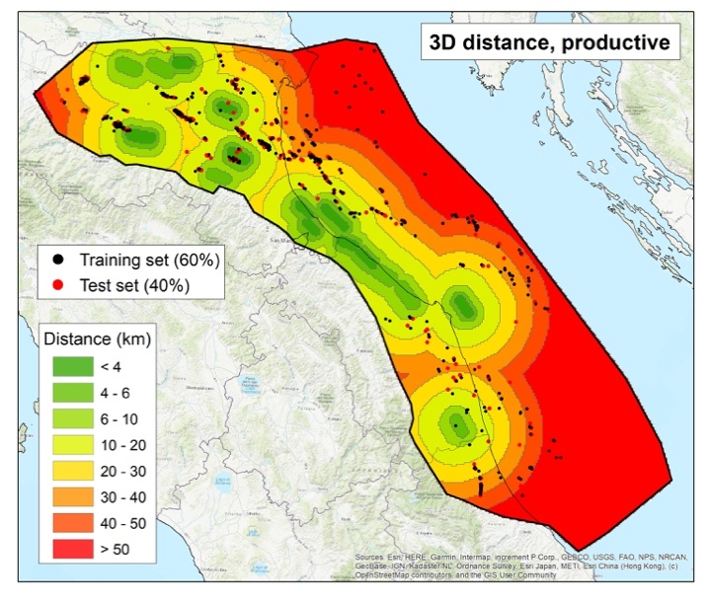 | 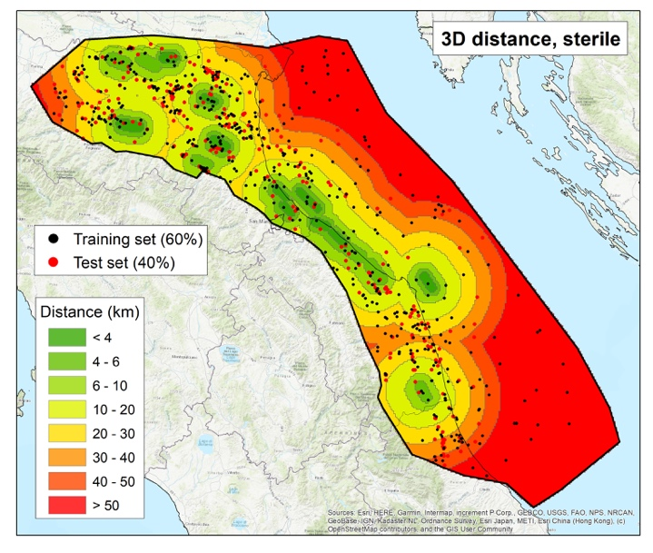
Geographical distribution of gas wells and of the different classes of pixels with respect to the binning scheme, shown for the 3D case only.

