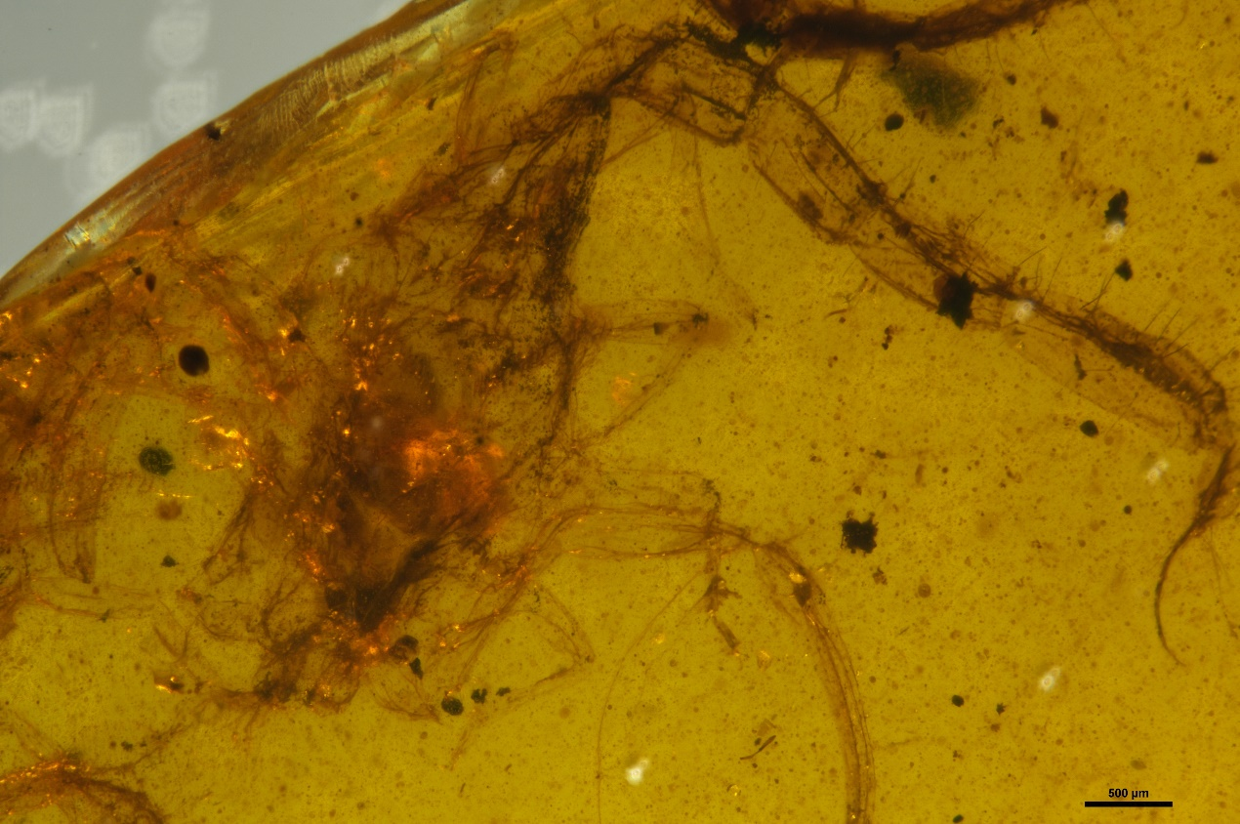

Fig 8. Optical microscope image of BMM 4772 specimen

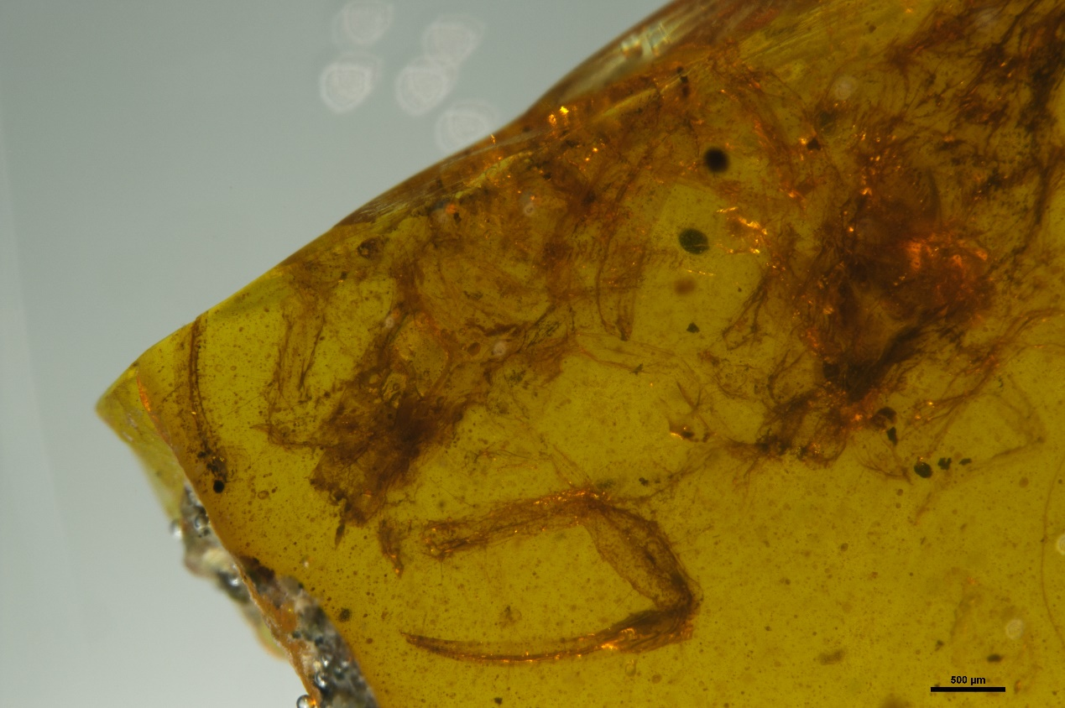
Fig 9：Optical microscope image of BMM 4772 specimen

