The RNA-binding protein ELAVL1 regulates hepatitis B virus replication and growth of hepatocellular carcinoma cells

Authors:
Hiroaki Kanzaki¹, Tetsuhiro Chiba^{1,} *, Tatsuya Kaneko¹, Junjie Ao¹, Na Qiang¹, Yaojia Ma¹, Takamasa Ishino¹, Keita Ogawa¹, Miyuki Nakagawa¹, Kisako Fujiwara¹, Hidemi Unozawa¹, Terunao Iwanaga¹, Motoyasu Kan¹, Takafumi Sakuma¹, Naoto Fujita¹, Keisuke Koroki¹, Yuko Kusakabe¹, Kazufumi Kobayashi¹, Naoya Kanogawa¹, Soichiro Kiyono¹, Masato Nakamura¹, Takayuki Kondo¹, Tomoko Saito¹, Ryo Nakagawa¹, Sadahisa Ogasawara¹, Ryosuke Muroyama², Shingo Nakamoto¹, Tatsuo Kanda³, Hitoshi Maruyama⁴, Jun Kato¹, Yoh Zen⁵, Ai Kotani⁶, Kazuma Sekiba⁷, Motoyuki Otsuka⁷, Masayuki Ohtsuka⁸, Naoya Kato¹

Institutions:
¹ Department of Gastroenterology, Graduate School of Medicine, Chiba University, 1-8-1 Inohana, Chuo-ku, Chiba 260-8670, Japan
² Department of Molecular Virology, Graduate School of Medicine, Chiba University, 1-8-1 Inohana, Chuo-ku, Chiba 260-8670, Japan
³ Department of Gastroenterology and Hepatology, Nihon University School of Medicine, 30-1 Oyaguchi-Kamicho, Itabashi-ku, Tokyo 173-8610, Japan
⁴ Department of Gastroenterology, Juntendo University School of Medicine, 2-1-1 Hongo, Bunkyo-ku, Tokyo 113-8421, Japan
⁵ Institute of Liver Studies, King's College Hospital, London, UK
⁶ Division of Hematological Malignancy, Institute of Medical Sciences, Tokai University, 143 Shimokasuya, Isehara, Kanagawa 259-1193, Japan.
⁷ Department of Gastroenterology, Graduate School of Medicine, The University of Tokyo, 7-3-1 Hongo, Bunkyo-ku, Tokyo, 113-8655, Japan.
⁸ Department of General Surgery, Graduate School of Medicine, Chiba University, 1-8-1 Inohana, Chuo-ku, Chiba, 260-8670, Japan

*Corresponding author:
Tetsuhiro Chiba, M.D., PhD.
Department of Gastroenterology, Graduate School of Medicine, Chiba University, 1-8-1 Inohana, Chuo-ku, Chiba 260-8670, Japan.
Telephone: +81-43-2262083, Fax: +81-43-2262088
E-mail: chibat@chiba-u.jp
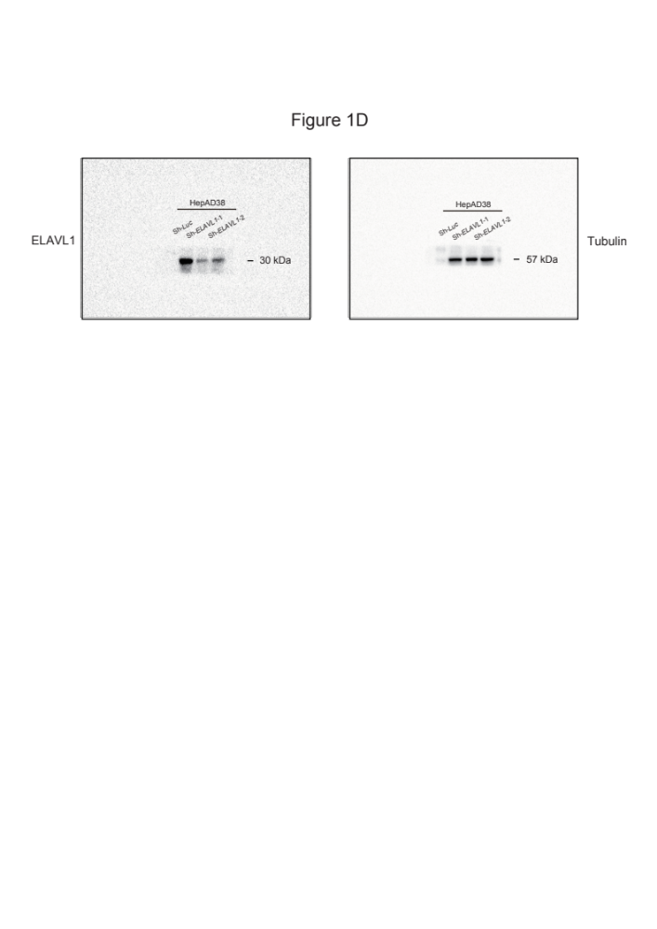
Supplementary Figure S1. Uncropped Western blot images of Figure 1D.
Figure 1D shows HepAD38 cells with stable knockdown of ELAVL1 were subjected to western blot analyses using anti-ELAVL1 and anti-tubulin antibody (loading control).

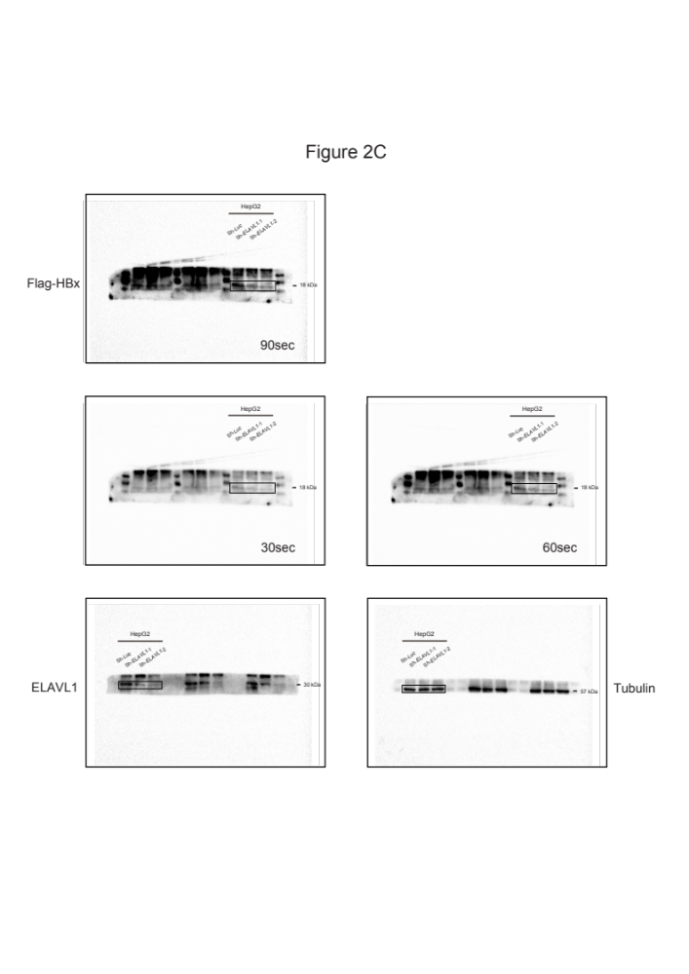

Supplementary Figure S2. Uncropped Western blot images of Figure 2C.
Figure 2C shows ELAVL1-knockdown HepG2 cells that constitutively express Flag-HBx protein were subjected to western blot analyses using anti-Flag, anti-ELAVL1, and anti-tubulin antibodies (loading control).

