PEDAGOGICAL GUIDELINES FOR FACILITATORS
AND
SIMULATED PARTICIPANTS

Course : Integrated Clinical Care
SIMULATION ZONE 2
GENERAL INFORMATION ON THE SCENARIO
Name: Differential Diagnosis in Physiotherapy
Scenario Synopsis (general scenario overview): Private physiotherapy service, a 39-year-old patient who consults for poor post-IQ recovery in June 20xx. It's the first day she came to the service after the referral of the traumatologist. She is currently attending the public service but wants a second opinion since she is not improving.
INFORMATION AND TRAINING PROGRAMME OBJECTIVES
Learning outcomes: At the end of the session, participants should be able to:
OBJ1. Establish a differential diagnosis in physiotherapy.
OBJ2. Assess the need to refer to another professional or to start your treatment plan according the findings.
Learner pre-simulation activities: (reading, studying, theory session, watching videos, following the module online, reviewing content, simulations...)
- Review complete anamnesis guidelines.
- Review doctor referrals.
- Prepare an interview and the examination with the patient.
MATERIALS AND CONFIGURATION
Setting/environment: Physiotherapy examination room (private or public consultation)
Setting the scene: the patient comes with a crutch.
Materials

- 1 sphygmomanometer and 1 stethoscope
- 1 pulse oximeter
- Goniometer
- Non-sterile gloves
- Glucometer
- Glucose test strips
- Elastic bands different resistance
- Balloons
- Diff. weights (1kg, 2kg, 5kg)
- 1 examination bed/bed
- 1 clock/timer
- Radio/telephone to call the laboratory or others (Photo)
- Computer
- Papers/block note
- Pens
Documentation in the room:
- Medicine referral
Staff (participants/actors/roles): 1 simulated participant (preferably a woman in her mid-30s).
It could be a second character acting as a family member (mother or friend)
Participants: 1 or 2 physiotherapy students
Additional notes on the installation/environment: ensure good visual for observers when examining the patient and especially when the patient enters the room.

BRIEFING
Follow the basic structure to create a safe learning environment.
- Welcome to the group.
- Create the conditions for a good conversation and establish a "simulation
contract": be respectful, confidential, non-judgmental and focus on the actions - mistakes are opportunities to learn.
- Review the pre-task and ask students how they have prepared themselves and which script they use for the interview and potential examination.
- Recall the objective and review the previous information with students.
- Present the scenario, including the room and equipment.
- Explain to learners that:
- Limitations may occur during the exploration (trust patients’ information. E.g.: end-feel when mobilizing)
- How the ending will happen.
SCENARIO INFORMATION FOR THE FACILITATOR AND THE SIMULATED PATIENT
SUMMARY
36-year-old patient consulting for poor recovery post IQ after 1year (Oct.23)
Medical diagnosis: Patella instability D, Genu valgo and Arthrosis.
(see medical report).

RHB post-IQ of a year of evolution that does not solve problems: it has been difficult to reduce inflammation, it has cost it to recover analytical mobility, and it has cost a lot to recover muscle strength. The patient is currently complaining that she/he cannot walk, she/he cannot make long journeys as she/he gets tired, and says that her leg “straightens her,” and she/he cannot walk. It has taken a lot of time to go up and down stairs, but with the help of a railing/crutches, she/he says that since the intervention, she/he has lost stability and that she/he does not feel sure to walk alone on the street.

INFORMATION ON THE INTERVENTION AND EVOLUTION OF THE CASE
Current situation: She/he is on sick leave and goes to the hospital three times a week for rehabilitation. Sitting in the shower requires personal hygiene, as it does not stand up (she/he has to hold on to the shower pole in order to get up).
Pathobiological mechanism: Patella instability D, Genu valgo, and Arthrosis.
Personal History: Former smoker of a daily package for half a year.
Family History: No interest.
Aggregating factors: Loading weights, walking a lot, weather changes, the days of heat and rain she/he feels weaker and with dizziness and vertigo.
Improvement factors: Being seated helps you feel more stable. Take frequent breaks.
Night Pattern: She/he has always presented problems reconciling sleep.
Daily Pattern: Chronic fatigue and tiredness. She/he is exhausted and finds it difficult to “start” falling asleep. If she/he wakes up in the middle of the night, she/he cannot conceal sleep again. It needs a lot of time to get ready and leave home (between 2-3 hours)

PATIENT PERSPECTIVES (Expectations and/or concerns)
The patient states that since the intervention she/he does not have her/his knee well, she/he does not feel safe, she/he is very unstable and cannot lead the life she/he had before. She/he feels she/he is limited because can't walk like before. She/he is not able to drive at the moment, “someday she/he lost control of his/her car” (JUST TELL IF THEY ARE REALLY WELL ORIENTED TO OTHER OPTIONS).

ACTIVITIES AND PARTICIPATION (work/personal, family/social and/or leisure situation)
She/he is currently on leave. She/he worked as a secretary in a company near the consultation center, where she/he handled the accounting.

DIAGNOSTIC STUDIES THAT ARE PROVIDED IMMEDIATELY (if requested)
Laboratory tests: None
Other (X-ray, ultrasound, electrocardiogram, etc.): None
OTHER INFORMATION (notes for the facilitator that participants should not know)
Medical referral (appendix 1)

SCRIPT AND SCENARIO DEVELOPMENT
Students expected interventions  Interventions expected according to the protocol | Patient Intervention  Provide, at the participant’s request, information on outcomes that the patient or standardised mannequin cannot show.
Anna, I'd like you to tell me what bring you here? | Well, look, I don't improve you... I was told that after the operation, it would take a year, but it would end up improving. And I've been almost a year and a half and that's not that I don't improve, but that's why I'm back. Even my mother tells me that this is not normal.
What's wrong with you, what do you feel? | I cannot walk and I am frankly tired of this situation. I'm getting tired right away. I walk 50-100 mts and I have to stop to rest. I can't go up or down stairs without helping me with a railing. I'm not strong, my leg doesn't give me. And I insist, they told me that after the operation it would improve. I am very stressed, and with stress I am even more nervous and more upset.
Do you have pain? | All day long
And could you tell me a little bit about this pain? | I feel tight, especially in tight (quadriceps) and calf (calf-muscles). I don’t know it is a little bit scary because I can't move correctly.  (Only if they give you examples of pain, try to specify a little... if the student says, but notes that it is a punching pain, tingling, burning...) In this case responds to the specific sensation (like cork or carton), if not be more vague “not sure how to describe it”.
And can you locate the pain? In other words, is there any specific point or is it general? | Rather general, like here (touching the area of the thigh and the calf with the hand).  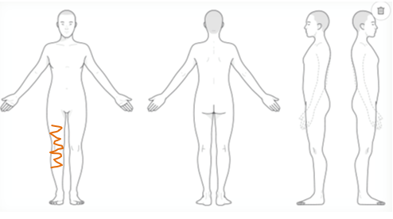
And on a scale from 0 to 10 being 10 the maximum pain you can withstand, like the score? Is it the same in each of the places you have indicated to me? | 8/10
And this pain is the same throughout the day? | Yeah, it doesn’t change that much.
And it prevents you from sleeping? | I fall asleep without problems, and I try to stay as long as possible awaken to be well tired, but... I'm going to sleep about 11 o'clock or so.  I don't know if it wakes me up or if I move it wakes me up...the thing is that in general, at some point I wake up...and then it's hard for me to get back to a comfortable position.
We will talk now a bit about the instability. When did it start? | About three years ago.
And what did it feel? | Talking about the start of the instability - Well, I started to notice a lack of stability when walking, not instability, but I started to feel a bit insecure, "clumsy". I also suffered some falls, due to balance losses. And my right foot was cramping up. I was wearing a lot of hills (if woman) and I noticed that my knee was being tampered...it didn't answer.
And at that time, did you have pain at that time? | Wow, I’m not sure when does the pain started. I don’t think so.
In the report, I see that there is a lack of strength? | Well, no, I don't know if it's a lack of strength, but that's what I'm telling you it's hard for me to go up and down stairs.
And what was/is more difficult to go up or down stairs? | Definitely down.
Other questions students can bring up (with some answers)  History of interest? Any illness and/or health situation? NON  Family History? At home, has anyone had problems with instability as well? NON  Personal/family situation: who helps you at home? have a husband/child? Not married either kid. Comment on this desire for autonomy... and that just after the intervention your mother helped you, but now, you prefer not to have too much of it.  How are the relationships at work, are you stressed? not working at the moment  What do you associate with being stressed?  Does stress affect your pathology/situation? yes, it makes it worse.  Can you tell me a little bit about your day to day? I wake up very tired and I need some time to get out of the house, charged muscles (quadriceps and twins) and little mobility. In the morning I am more active than in the afternoons, I need to rest continuously. | Other symptoms the patient has but it won’t tell unless addressed specifically (the patient doesn’t tell them because it is nothing related to instability for her)  The patient has worsened since the end of 2022 has more symptoms not linked to knee pathology, but he has never talked to the doctor since in a few days / weeks he recovered me except from constant exhaustion and rigidity (he was very tired at work and believed that it was stress):  - Blurred left eye view 2-3 times  - Loss of touch, strength and mobility and tingling feeling from time to time.  - Lack of concentration.  - Cramps in the arms and back  - Incontinence (e.g. in this specific case, I didn’t see any sense in explaining to trauma a topic such as incontinence).  - 1 day: felt like paralyzed on the ground, couldn’t move for about 20min.  - Sensitivity problems:  - difficulty working with the computer keyboard  - to put on contact lent  - TV remote control  - take the glass  - comb  - use of the mobile screen, etc.  - I find it hard to open and close my hand, to raise my arm.  - I can't write for months, I'm right-handed.  - Cognitive problems:  - Lack of attention and concentration ' I find it very difficult to read and to be able to follow the storyline.  - Visio-spatial Perception es Problems with space in car  - Problems with immediate memory  - Problems to process information.
EXPLORING
- Make HER walk through the room, with heels… regular WALK WITH AND WITHOUT CRUTCH.  - Carry out joint balance and muscle balance tests.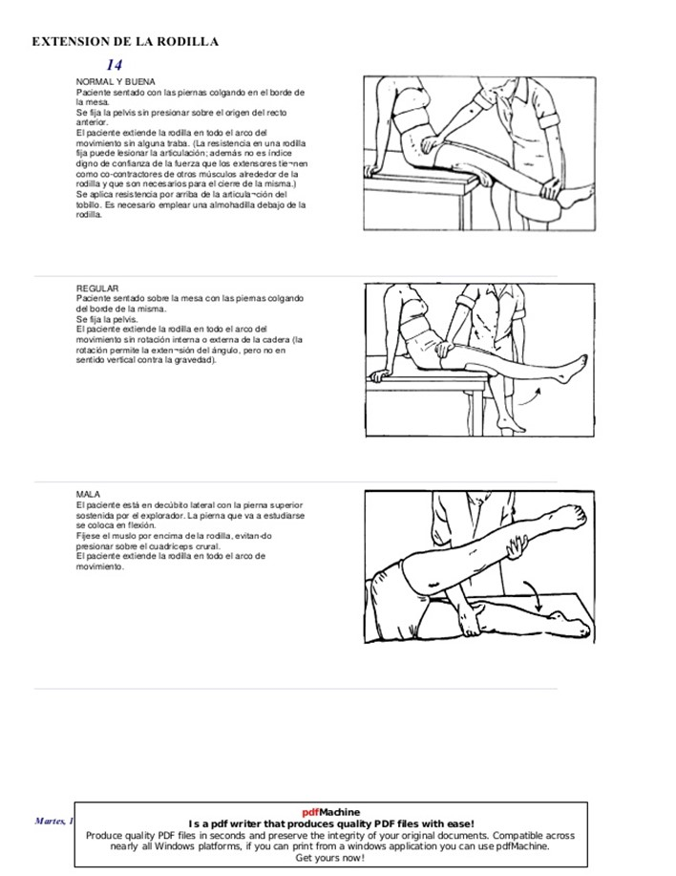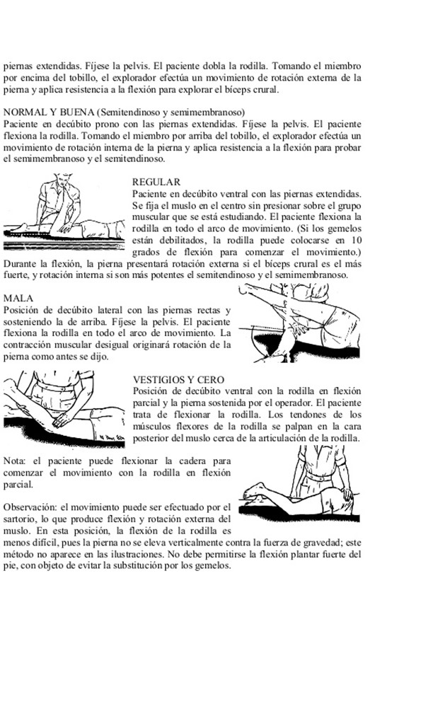  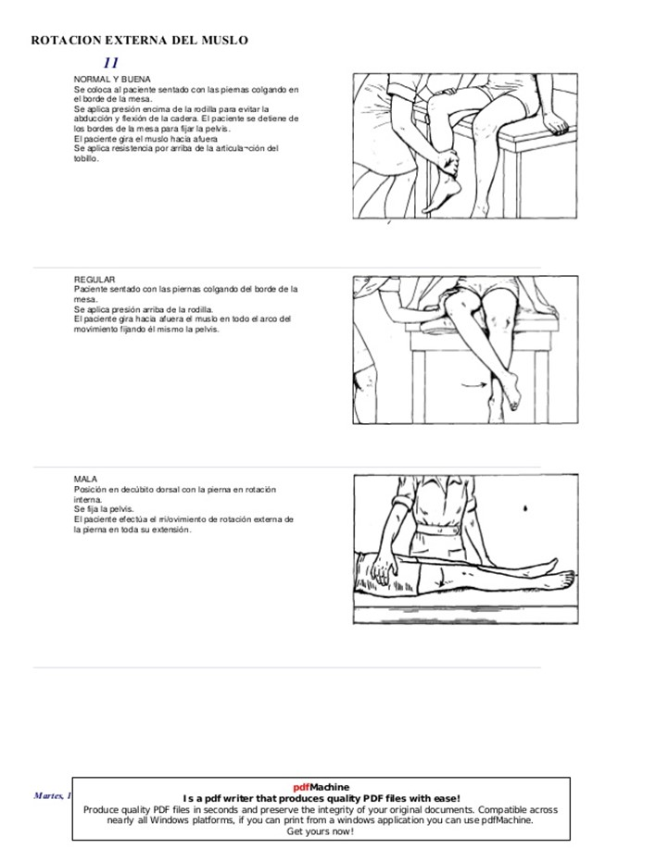  - Sensitivity tests  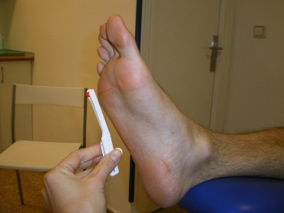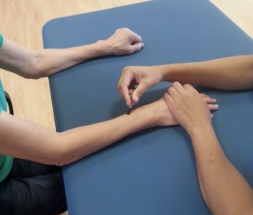 | Before starting the exploration, student should ask for undressing (patient will use only one hand to take shoes off)  - When walking https://www.youtube.com/watch?v=bAcLUOMTmYc (really without noticing, but the foot is not going up) without crutch the patient doesn’t feel safe. And she/he uses the wall, bad or chairs to supper her.  - Generalized diminished strength more evident in tibialis anterior (2/5), gluteus and hip stabilizers 4/5, peroneal mm. 2+/5; hamstring muscles 3+/5.  Patient should reinforce that knee is swollen a bit (you can see that there is this little swallow that it has never disappeared).  - Sensitivity test shows alteration. Patient could recognize that there is touch but not appropriate locations, and distally (in the foot) she/he would have difficulties sometimes to recognize if participants are touching or not. For the arm she/he do recognize the location and differences in temperature but it doesn’t feel the same in both sides (the affected is altered).

PEDAGOGICAL GUIDELINES FOR STUDENTS – CAS 4 Differential Diagnostic Course: Clinical Integration

STUDENTS INFORMATION CASE 1
GENERAL INFORMATION ON THE SCENARIO
Name: Differential Diagnosis in Physiotherapy
Expected duration of the simulation 2h in total
Briefing: 20 min
Scenario A: 15min interview + Debriefing: 30-40 min
Scenario B: 15 min exploration + Debriefing: 30-40min
Scenario Synopsis (general scenario overview): Private physiotherapy service, 39-year-old patient who consults for poor post-IQ recovery after 1 year (see medical report – appendix 1). It's the first day she/he comes to this private service. She/he has done physiotherapy before.
INFORMATION AND TRAINING PROGRAMME OBJECTIVES
Learning outcomes: At the end of the session, participants should be able to:
OBJ1. Establish a differential diagnosis in physiotherapy.
OBJ2. Assess need to referring to another professional, if needed.
Learner pre-simulation activities: (reading, studying, theory session, watching videos, following the module online, reviewing content, simulations...)
- Review complete anamnesis guidelines.
- Review Doctors referral.
- Prepare an interview and assessment with the patient.

Appendix 1:
PATIENT INFORMATION
NAME AND SURNAME Mia Polp
DATE OF BIRTH 25/12/xx (36yo) FEMALE SEX
OCCUPATION: Administrative assistant in the export department.
History of interest: non
CURRENT SITUATION
DIAGNOSIS and/or MEDICAL TTM Patella instability RIGTH, Genu valgo and Arthrosis.
SURGICAL TTM: October xxxx Surgery. Arthroscopy with locoregional anaesthesia shows Patellar chondroplasty of the 3rd lateral facet and lateral tibial plate. External subluxation of the RIGTH rotula. No other injuries
Procedure done:
Chondral shaving with minimal openings: LPFM plasty with semi-tendinous allograft, double papillar tunnel, and join Jugger Knot 2.9 femoral with TV control.
Sutures and compression after surgery, and follow-up from the nursery department and physiotherapy.
EVOLUTION
RHB is set from the time of the intervention to the present.
Slow evolution due to problems: difficulty recovering analytical mobility, muscle strength (significant lack of force), and persistent inflammation.
REASON FOR THE REPORT'
The patient says that since the intervention, she has lost stability and does not feel safe walking alone on the street. She complains that she can’t walk or make long journeys as she gets tired, and her leg “straightens her.” It has taken a lot to climb and go downstairs; she currently does it with the help of a railing and a cross.

