Conformationally restrained de novo Peptides to modulate Skp1-Skp2 Interaction of the SCF E3 Ligase
Simran Tolani¹, Nitesh Mani Tripathi *³, Himanshu Antil*¹, Sourav Ghosh¹, Anirban Banerjee¹, Sushil Kumar¹, Anupam Bandyopadhyay^{3#}, Ashutosh Kumar^{1,2#}
- Department of Biosciences and Bioengineering, Indian Institute of Technology, Bombay, Mumbai, India
- Wadhwani Innovation and Translation Centre, Indian Institute of Technology, Bombay, Mumbai, India
- Biomimetic Peptide Engineering Lab, Department of Chemistry, Indian Institute of Technology Ropar, Punjab, India
* Authors Contributed equally
#Correspondence: ashutoshk@iitb.ac.in and anupamba@iitrpr.ac.in
Supplementary Information

Table of Contents

Table S1: Docking Study of potential peptide inhibitors against Skp2 protein via HDOCK webserver. 2
Table S2: Oxidative disulfide assembly (SS) and hexafluorobenzene-mediated (HFB) cysteine stapling of P2, P3 and P4 peptides. 3
Table S3: Calculated and observed mass, isolated yields (%) of synthesized P1 linear, SS- mediated P2-P4 and HFB-mediated P2-P4 peptides. 3
Figure S1: Circular Dichroism of Peptides 4
Figure S2 : Intermolecular Protein-Ligand contacts and Per-residue interaction mapping 5
Figure S3: LC-MS and associated mass of P1 linear and disulfide (SS)-mediated P2-P4 peptides 14
Figure S4: LC-MS and associated mass of HFB-mediated P2-P4 peptides 17
Figure S5: Purification and Characterization of Skp1-Skp2 complex 18
References: 19

Table S1: Docking Study of potential peptide inhibitors against Skp2 protein via HDOCK webserver.
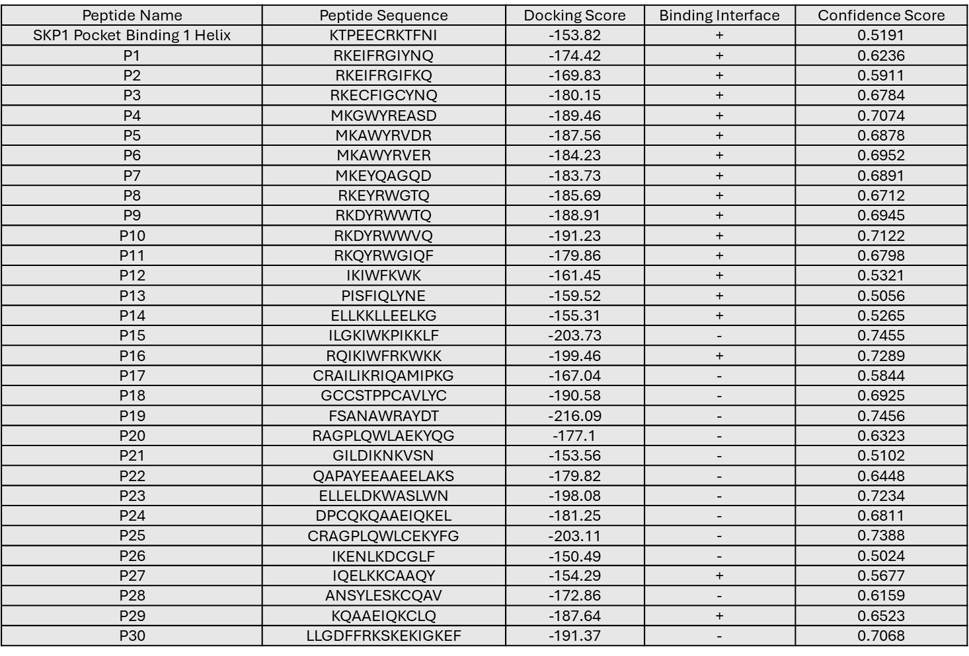
*Docking Score is a relative score to rank different binding poses for given protein-peptide complex (More negative docking score means a more possible model binding); Binding Interface means peptides binding to Skp2 Pocket 1, ‘+’ means binding and ‘-‘ means non-binding; and Confidence Score means docking score-dependent confidence score to indicate the binding likeliness of protein and peptide molecules.

Table S2: Oxidative disulfide assembly (SS) and hexafluorobenzene-mediated (HFB) cysteine stapling of P2, P3 and P4 peptides.
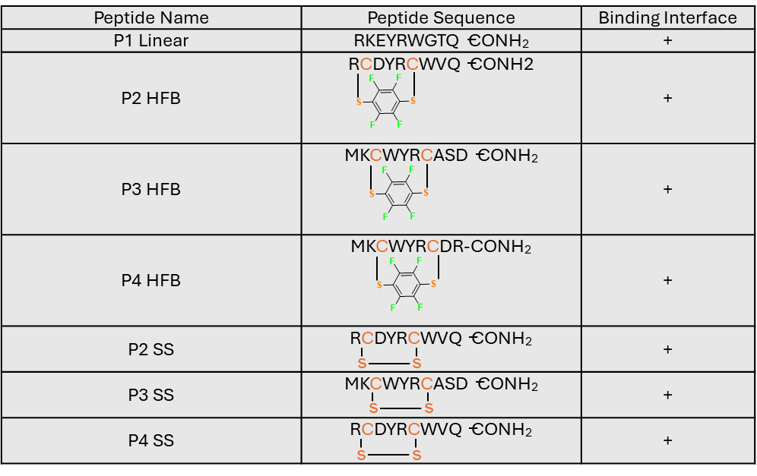

Table S3: Calculated and observed mass, isolated yields (%) of synthesized P1 linear, SS- mediated P2-P4 and HFB-mediated P2-P4 peptides.
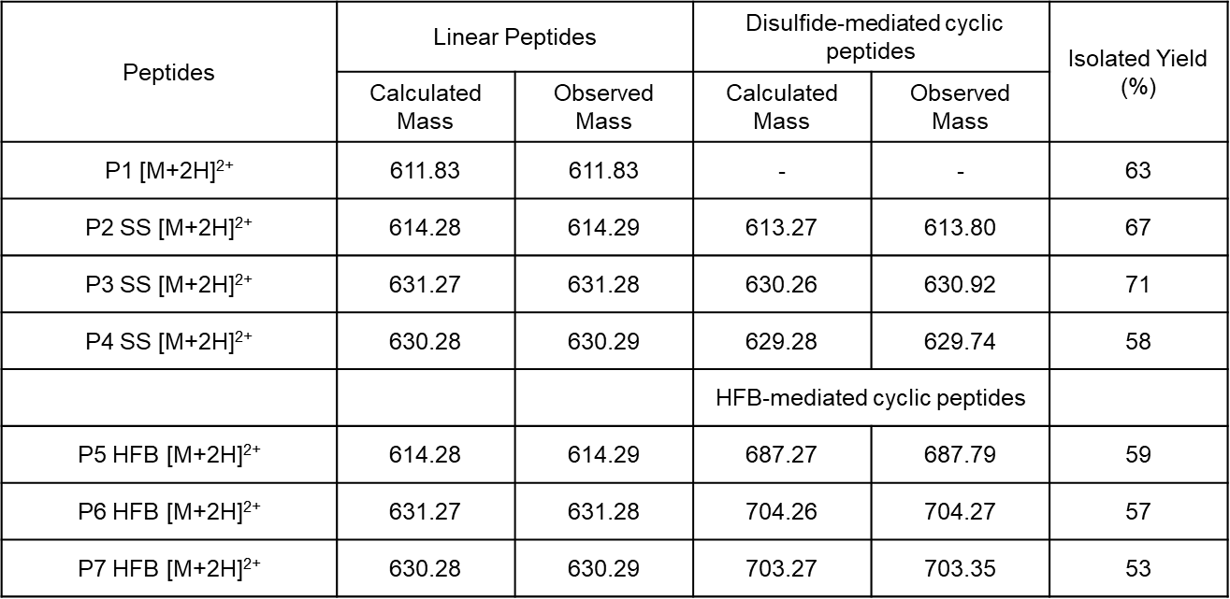

Figure S1: Circular Dichroism of Peptides

Figure S1: Circular Dichroism Spectra of stapled peptides indicating Polyproline I like conformations for P2HFB, P3HFB and P4HFB with positive around 220nm and negative peaks at 206nm. While a Polyproline II like conformations for P3SS and P4SS with positive peaks at 228nm at large negative peaks around 200nm. Whereas P2SS did not acquire a PPII conformation, however, based on its peak minima values at 218nm and 202nm, it could be said to have conformation resembling an extended β-sheet like structure. ^{1,2}

Figure S2 : Intermolecular Protein-Ligand contacts and Per-residue interaction mapping.
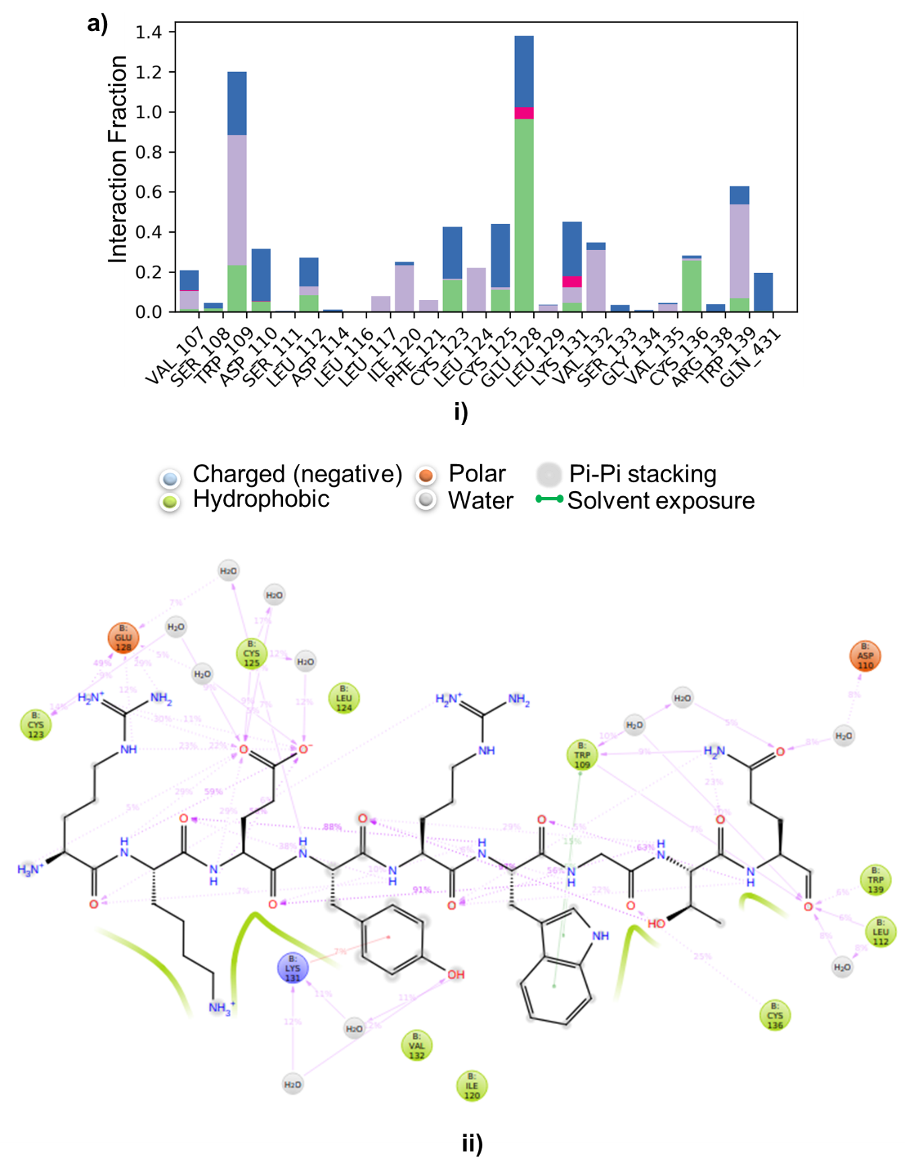

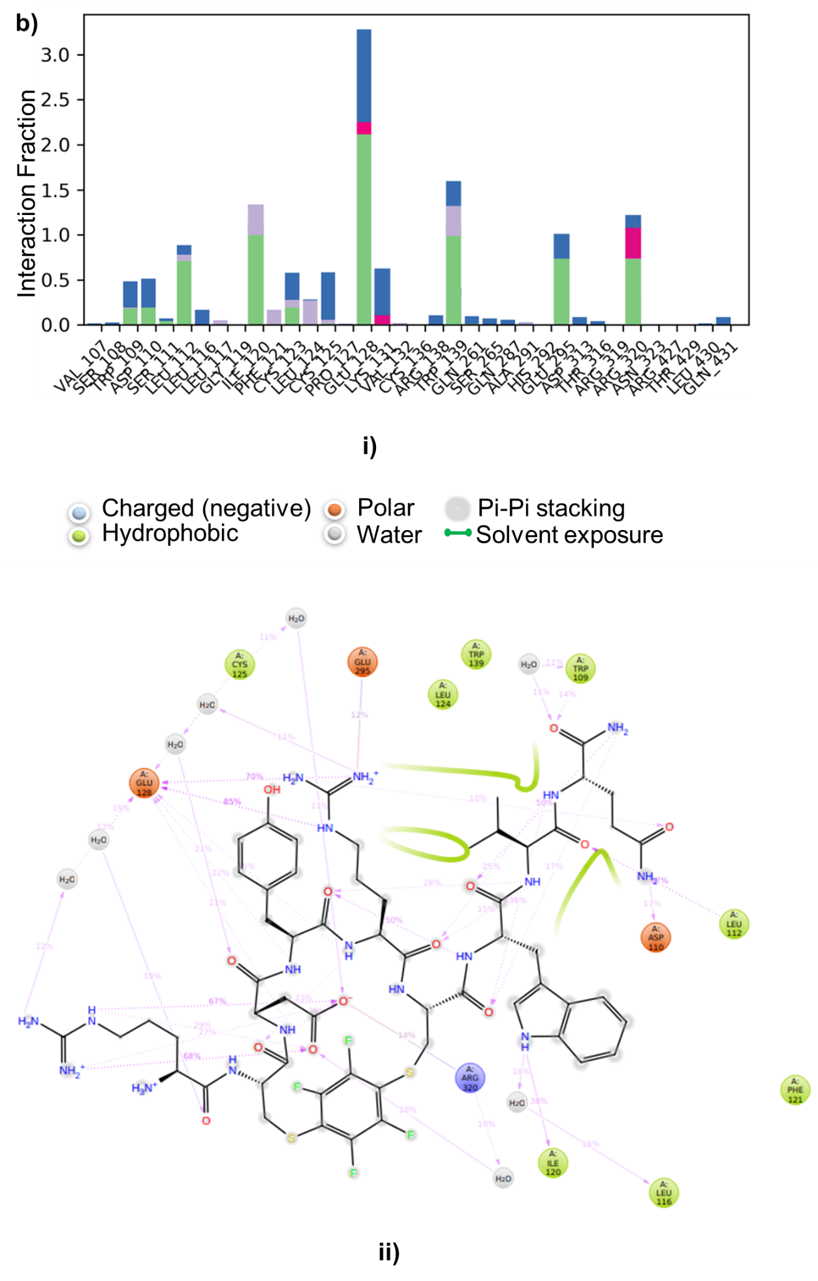

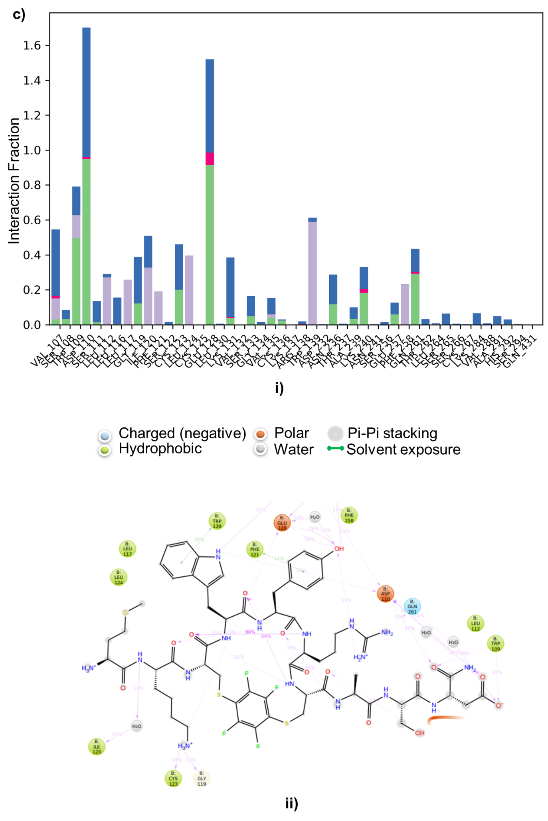

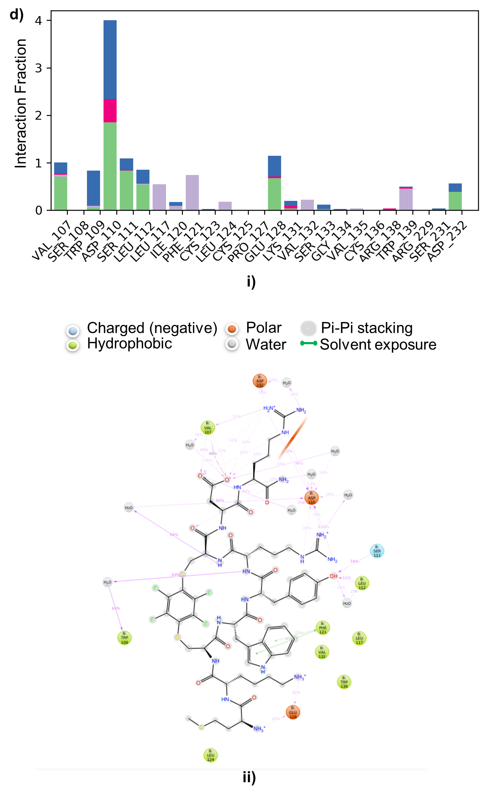
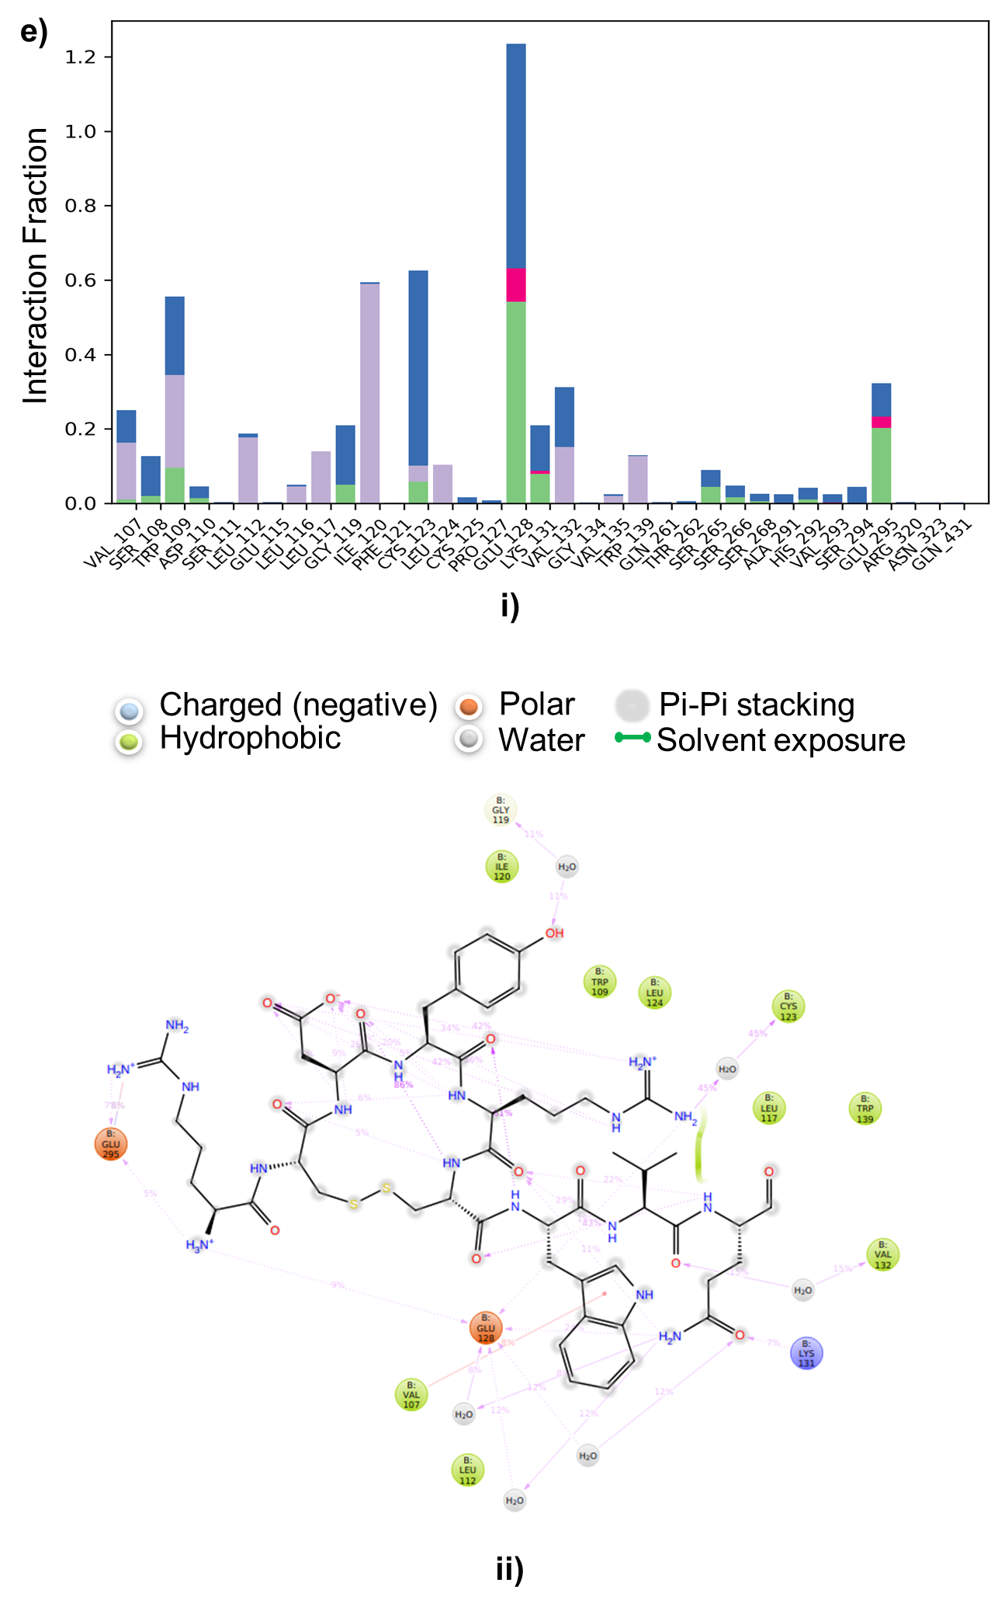
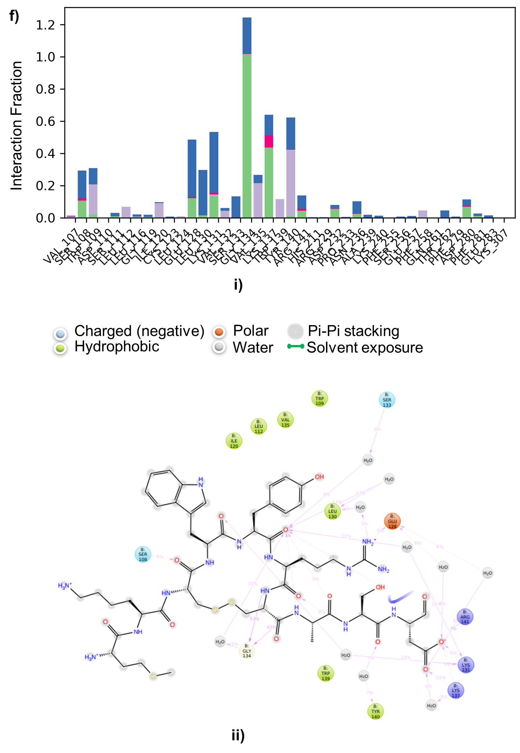

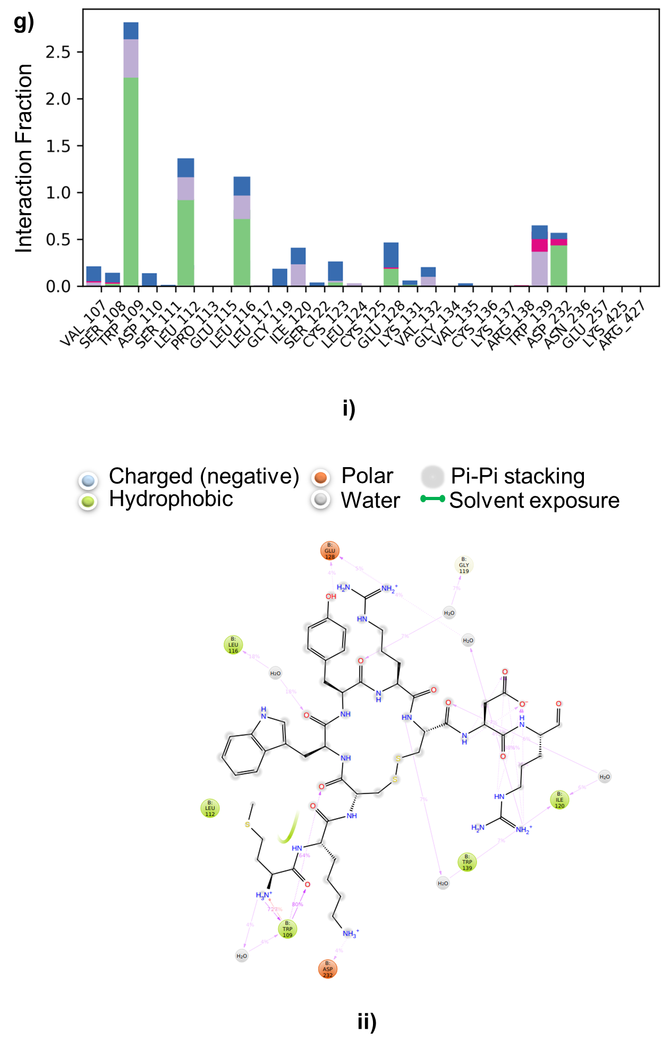
Figure S2: A schematic of detailed 2D Skp2- P1 linear and P2 HFB peptide ligand atom interaction and histogram depicting the per-residues analysis between the complexes throughout the 100 ns MD simulations. ai) Histogram showing per-residue contribution throughout simulation in Skp2-P1 linear peptide complex. aii) 2D view of P1 linear ligand atom interacts with Skp2 receptor; bi) Histogram showing per-residue contribution throughout simulation in Skp2-P2 HFB peptide complex. bii) 2D view of P2 HFB ligand atom interacts with Skp2 receptor. ci) Histogram showing per-residue contribution throughout simulation in Skp2-P3 HFB peptide complex. cii) 2D view of P3 HFB ligand atom interacts with Skp2 receptor; di) Histogram showing per-residue contribution throughout simulation in Skp2-P4 HFB peptide complex. dii) 2D view of P4 HFB ligand atom interacts with Skp2 receptor. ei) Histogram showing per-residue contribution throughout simulation in Skp2-P2 SS peptide complex. eii) 2D view of P2 SS ligand atom interacts with Skp2 receptor; fi) Histogram showing per-residue contribution throughout simulation in Skp2-P3 SS peptide complex. fii) 2D view of P3 SS ligand atom interacts with Skp2 receptor; gi) Histogram showing per-residue contribution throughout simulation in Skp2-P4 SS peptide complex. gii) 2D view of P4 SS ligand atom interacts with Skp2 receptor; In 2D interaction maps, hydrogen bond formation (pink arrows), hydrophobic (green), polar (blue), red (negative), violet (positive) and glycine (grey) interaction. Hydrogen bond, ionic, hydrophobic and water bridge interactions are illustrated by green, pink, purple and blue bars, respectively.

The intermolecular protein-ligand interactions are demonstrated during simulation time throughout the trajectory. There can be a possibility of having multiple contacts of the residue with the same ligand atom. Protein-ligand contacts through a per-residue interaction analysis, which is based on the average value of the interaction occupancies of the binding site residues and the results were described in the form of stacked bar plots, normalized over the course of the trajectory. In the case of P1 linear-Skp2 complex, the following interactions was noted for hydrophobic contacts were maintained with residues such as Val107, Asp110, Ile122, Leu126, Leu129, Leu193, and Trp195, which contribute to the core non-polar environment of the binding cavity. These residues showed sustained contact occupancy, suggesting their role in anchoring the hydrophobic moieties of the ligand. Polar interactions were observed with Ser108, Asp110, Glu128, and Lys131, which frequently engaged in hydrogen bonding with the ligand backbone and side-chain carbonyl groups. Among these, Glu128 and Asp110 displayed sustained hydrogen bond occupancy, indicating their importance in anchoring the peptide within the binding cleft. Negatively charged residues such as Asp110 and Glu128 played a crucial role in electrostatic stabilization, interacting with positively charged amino groups of the ligand. Cys123 and Cys125 contributed secondary interactions, most likely stabilizing the overall pocket structure. (Figure S2 ai). Residues Trp109, Lys131, and Trp139 were found to establish π–π stacking and cation–π interactions with the aromatic moieties of the peptide, enhancing the binding affinity. In addition, bridging water molecules mediated transient hydrogen bonding between the ligand and residues Cys125, Leu124, and Ile120, further improving the dynamic stability of the complex. A maximum interaction occupancy was observed for Trp109, Glu128, and Lys131, indicating persistent hydrogen bonding and hydrophobic stabilization during the simulation. Minor but consistent contacts from Leu112, Val132, and Cys136 also contributed to maintaining the peptide orientation within the active site throughout the simulation period. (Figure S2 aii). Overall, the complex exhibited a network of hydrophobic, hydrogen bonding, and electrostatic interactions. The persistence of Trp109, Glu128, and Lys131 interactions marks these residues as key hotspots for peptide stabilization in this P1linear-Skp2 complex.
Whereas P2 HFB-Skp2 complex, prominent interacting residues include Glu128, Phe121, Asp130, Arg320, and Thr329, which maintained consistent hydrogen bonding or hydrophobic interactions throughout the trajectory. Hydrophobic core primarily contributed by Leu112, Leu116, Leu120, Phe121, and Leu124, forming a nonpolar environment that stabilized the peptide backbone through van der Waals contacts. Phe121 showed a notable contribution with strong aromatic stacking interactions that likely improved peptide positioning within the pocket (Figure S2 bi)Polar and charged residues played a vital role in anchoring the peptide. Glu128 and Asp130 engaged in persistent hydrogen bonds and electrostatic interactions with the peptide’s amide and carbonyl groups, while Arg320 provided a strong positive electrostatic complementarity to the negatively charged regions of the peptide. Few residues such as Gln126, Thr329, and Ser279 participated intermittently in hydrogen bonding, with Glu128 and Asp130 showing the highest occupancy and persistence over the simulation. Water-mediated bridges were also evident, with multiple water molecules bridging Glu128, Arg320, and Thr329, maintaining the local hydrogen-bonding network and contributing to the stability of the peptide conformation. Overall, residues Glu128, Asp130, Arg320, and Phe121 emerged as critical interaction hotspots, forming a stable hydrogen-bonding and electrostatic network with hydrophobic core support from Leu112, Leu120, and Leu124. This combined pattern of electrostatic anchoring and hydrophobic enclosure suggests a strong and persistent binding mode for this peptide, consistent with its lower fluctuation and higher contact occupancy observed during the simulation trajectory (Figure S2 bii). Together these interactions span polar, hydrophobic, and solvent-mediated contacts indicate a well-distributed and stable peptide engagement pattern across the binding interface, potentially supporting the observed stability and binding affinity of the complex during molecular dynamics simulations.
P3 HFB-Skp2 complex exhibits a well-balanced interaction profile with contributions from hydrogen bonding, electrostatics, and hydrophobic contacts each crucial in retaining the peptide within the binding site and supporting complex stability across the simulation. The per-residue contact histogram (Figure S2 ci). indicated major interaction contributions from Asp110, Glu128, Gln261, and Phe121, showing sustained occupancy throughout the simulation trajectory.
Polar and charged residues, such as Asp110, Glu128, and Gln261, formed critical hydrogen-bonding and electrostatic interactions with the peptide backbone and side-chain amide groups. Asp110 engaged in strong hydrogen bonds with the terminal amide and hydroxyl groups of the peptide, while Glu128 maintained multiple bridging water-mediated hydrogen bonds that supports local electrostatic complementarity. Gln261 also exhibited stable polar contacts with the peptide carbonyl group, assisting in orientation and stabilization within the binding cleft. Furthermore, Cys123 and Gly119 contributed to minor stabilizing hydrogen bonds and van der Waals contacts, whereas Ile120 and Leu117 strengthened hydrophobic interactions around the central peptide scaffold. Several bridging water molecules were observed to mediate dynamic hydrogen bonds between Glu128, Gln261, and Phe258, supporting a persistent interaction network during the simulation period. Overall, the combination of strong hydrogen bonding with Asp110, Glu128, and Gln261, along with hydrophobic packing from Leu112, Phe121, Leu120, and Trp139, suggests a well-stabilized peptide-protein interface (Figure S2 cii). These residues together are key interaction hotspots that contribute to the structural persistence and high binding affinity of this peptide complex throughout the MD trajectory.
P4 HFB-Skp2 complex exhibited a collective interaction network comprising hydrogen bonding, π–π stacking, and hydrophobic contacts, which stabilized its binding conformation within the active pocket. The per-residue contact histogram (Figure S2 di). revealed that residues Asp110, Ser111, Glu124, Trp109, Phe121, and Trp139 contributed most prominently to the interaction profile throughout the MD trajectory. Hydrogen bonding and polar contacts were primarily contributed by Asp110, Ser111, and Glu124, forming stable hydrogen bonds with the peptide backbone and side-chain amide groups. Among these, Asp110 maintained strong direct and water-mediated hydrogen bonds for a significant fraction of the simulation time, while Ser111 formed transient polar interactions that assisted in stabilizing the ligand orientation. Glu124, located near the entrance of the pocket, participated in electrostatic attraction and maintained a network of bridging water-mediated hydrogen bonds that reinforced ligand anchoring. Hydrophobic and aromatic residues including Trp109, Phe121, Leu117, Leu124, and Val132, established extensive nonpolar contacts with the peptide’s aromatic rings and aliphatic regions. The π–π stacking interaction between Phe121 and the ligand’s aromatic core was particularly significant, sustaining through the majority of the simulation and providing conformational rigidity. Trp109 and Trp139 further contributed to hydrophobic and π–cloud interactions, promoting van der Waals complementarity across the binding interface. Additionally, Asp232 and Ser231 contributed intermittent hydrogen bonding at the solvent-exposed edge of the peptide-binding groove, aiding in peripheral stabilization. Several bridging water molecules mediated dynamic hydrogen bonds connecting Asp110, Glu124, and Trp109, which maintained the hydration shell stability across the simulation window (Figure S2 dii). Overall, the P4 HFB-Skp2 complex exhibited a balanced interaction network, with strong hydrogen bonding (Asp110, Ser111, Glu124), stable hydrophobic packing (Trp109, Phe121, Leu117), and π–π stacking (Phe121) as the major contributors. These residues acted as key binding determinants responsible for maintaining a stable and persistent peptide conformation during the entire MD trajectory.

Whereas P2 SS-Skp2 complex shows formed a diverse array of interactions, its binding appeared more polar-driven and solvent-mediated, potentially allowing more flexibility but possibly at the cost of tighter hydrophobic packing. The per-residue interaction histogram (Figure S2 ei). indicated that residues Trp108, Ile120, Cys123, Leu124, Glu128, Glu129, Lys131, Val132, and Glu295 exhibited higher contact occupancies throughout the MD trajectory, highlighting their consistent involvement in stabilizing the ligand. Among these, Glu128 and Glu295 showed the highest interaction persistence, dominated by hydrogen bonding and electrostatic attractions, which likely anchor the ligand in the pocket. From the 2D interaction diagram (Figure S2 eii). the peptide forms a well-defined interaction network. Notably, Glu128 and Glu295 act as major polar contact points forming multiple hydrogen bonds with backbone amide and side-chain groups of the ligand. These interactions are crucial for maintaining complex stability during the simulation. Hydrophobic residues including Trp109, Leu117, Cys123, Leu124, and Val132 participate in nonpolar contacts and π–alkyl interactions, forming a stabilizing hydrophobic core that complements the polar anchoring. Trp109 and Leu124 exhibit strong van der Waals engagement, providing shape complementarity around the peptide backbone. Additionally, Lys131 contributes a cation–π or hydrogen bonding interaction, depending on the side-chain orientation, enhancing electrostatic complementarity. Several water-mediated hydrogen bonds were observed, particularly involving Leu117, Cys123, and Glu129, which further extend the hydrogen bond network around the ligand interface. Overall, the complex demonstrates a balanced combination of polar (Glu128, Glu129, Glu295, Lys131) and hydrophobic (Trp109, Leu117, Cys123, Leu124, Val132) interactions that support strong peptide binding affinity. The persistence of Glu128 and Glu295 contacts, along with hydrophobic stabilization by Leu124 and Trp109, suggest this peptide maintains a stable and specific interaction profile over the simulation time, indicative of a potentially strong binder.
P3 SS-Skp2 complex demonstrates a tightly knit interaction profile, combining hydrophobic encapsulation, electrostatic anchoring, and polar bridging, all of which collectively stabilize the ligand in the binding site over the simulation time. From the per-residue interaction plot (Figure S2 fi). several residues displayed high contact frequency throughout the MD trajectory, indicating stable intermolecular engagement. These include Ser108, Leu130, Glu128, Gly134, Trp139, Arg141, Lys137, and Tyr140, which collectively constitute the major interaction hotspot region. Among them, Glu128 and Gly134 exhibited the highest contact occupancies, primarily due to persistent hydrogen bonding and water-mediated interactions maintained during the simulation. The 2D interaction map (Figure S2 fii). supports this observation, revealing that Glu128 forms a strong polar hydrogen bond network with the ligand backbone and side-chain donor groups, stabilizing the orientation of the peptide within the pocket. Gly134 and Ser108 also participate through direct or water-bridged hydrogen bonds, reinforcing the structural stability of the ligand. A significant contribution to hydrophobic stabilization arises from Leu112, Leu130, Trp109, Val135, and Trp139, which interact through van der Waals and π–alkyl contacts with aromatic and aliphatic regions of the ligand. These residues form a compact hydrophobic patch surrounding the peptide core, helping to maintain the correct conformational alignment throughout the simulation. Additionally, Ser133, Lys137, Arg141, and Tyr140 provide both electrostatic and polar interactions, occasionally engaging in water-mediated contacts that strengthen the hydrogen bond network around the binding interface. Notably, Arg141 and Lys137 display high contact persistence (>40%), suggesting their key role in charge complementarity and interaction specificity. Overall, the combination of strong polar contacts (Glu128, Gly134, Ser108) and hydrophobic stabilization (Leu130, Val135, Trp139), reinforced by charged interactions from Lys137 and Arg141, indicates a well-balanced and stable binding profile. The recurring occupancy of Glu128 and Gly134, in particular, suggests that these residues act as molecular anchors, maintaining interaction continuity and ensuring robust peptide-protein binding throughout the MD simulation.
Whereas P4 SS-Skp2 complex showed a cooperative network of hydrophobic encapsulation, stable polar or charged interactions, and water-bridged contacts. This combination contributed to the peptide’s persistent binding within the receptor throughout the simulated trajectory. From the 2D interaction mapping ((Figure S2 gii).), hydrophobic interactions predominantly contributed by Trp109, Leu112, Leu116, Ile120, and Trp139, which surround the peptide backbone and establish a hydrophobic cage around the aromatic and aliphatic side chains of the ligand. These residues are largely responsible for stabilizing the peptide through nonpolar contacts that persist over the MD trajectory. Key polar contacts are formed by Pro113, Glu128, Asp232, and Gly119, where both direct and water-mediated hydrogen bonds were observed. In particular, Glu128 maintains a stable hydrogen bond with the peptide backbone amide, while Asp232 participates in water-bridged interactions, reinforcing the overall binding geometry. Charged and electrostatic contacts include Asp232 (acidic) and Arg427 (basic) exhibit complementary charge-based interactions that likely contribute to the orientation and docking stability of the ligand within the binding cleft. Several interactions (notably with Trp109, Ile120, and Gly119) are mediated through bridging water molecules, suggesting a dynamic but persistent hydrogen-bond network that helps retain binding affinity during the simulation window. Residues Trp109, and Glu128 displayed the most sustained interaction occupancies throughout the trajectory, serving as anchor residues for the ligand. These were complemented by hydrophobic stabilization from Leu112, Leu116, and Trp139, which supported compact packing and conformational rigidity of the peptide within the receptor pocket. Collectively, the observed interaction profile highlights that the ligand is held firmly by a combination of electrostatic anchoring (Glu128, Asp232) and hydrophobic enclosure (Trp109, Leu116, Trp139), reflecting a strong and persistent binding interface consistent with stable molecular dynamics behaviour.

Figure S3: LC-MS and associated mass of P1 linear and disulfide (SS)-mediated P2-P4 peptides.
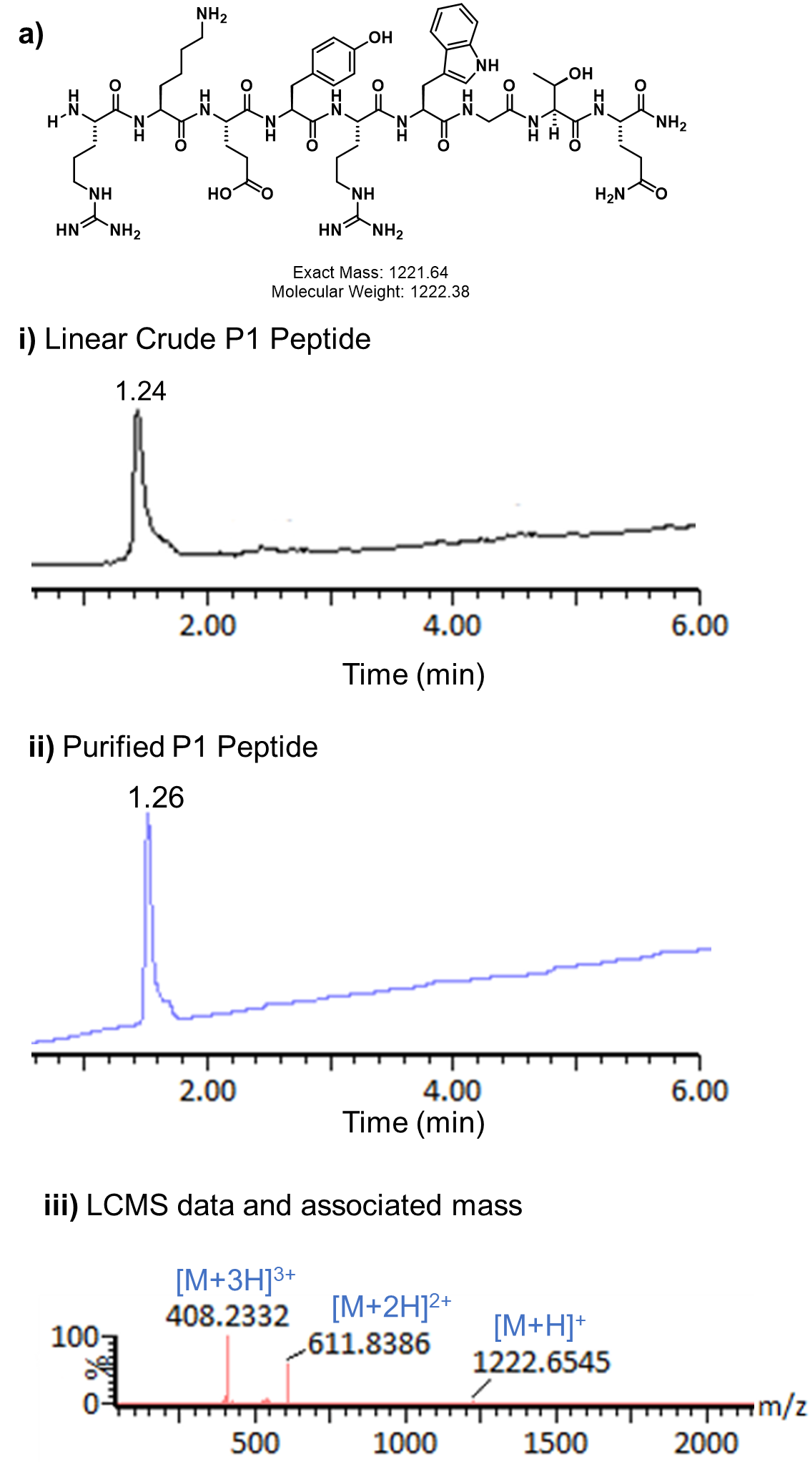
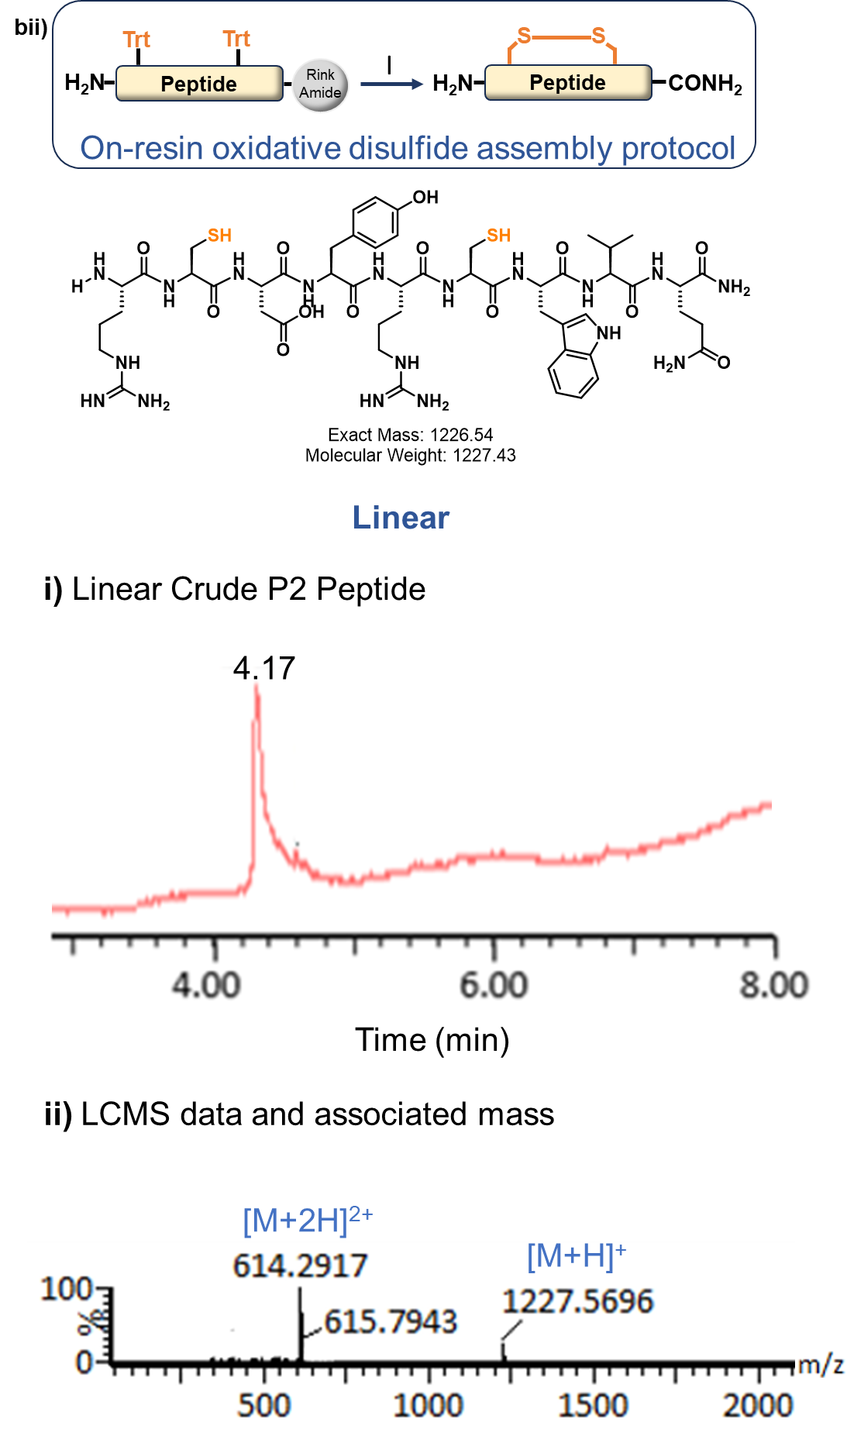
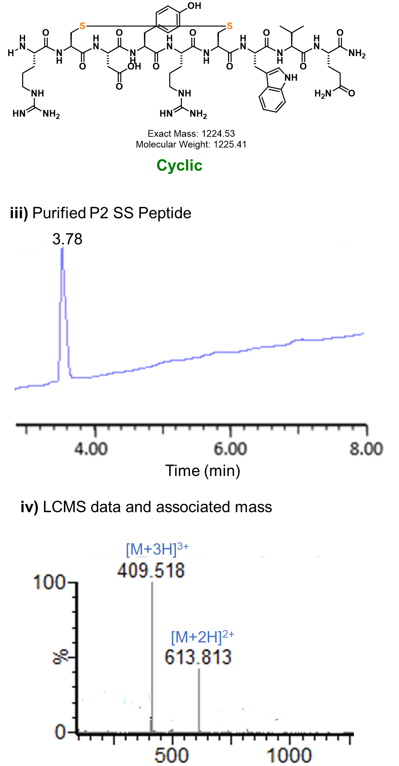

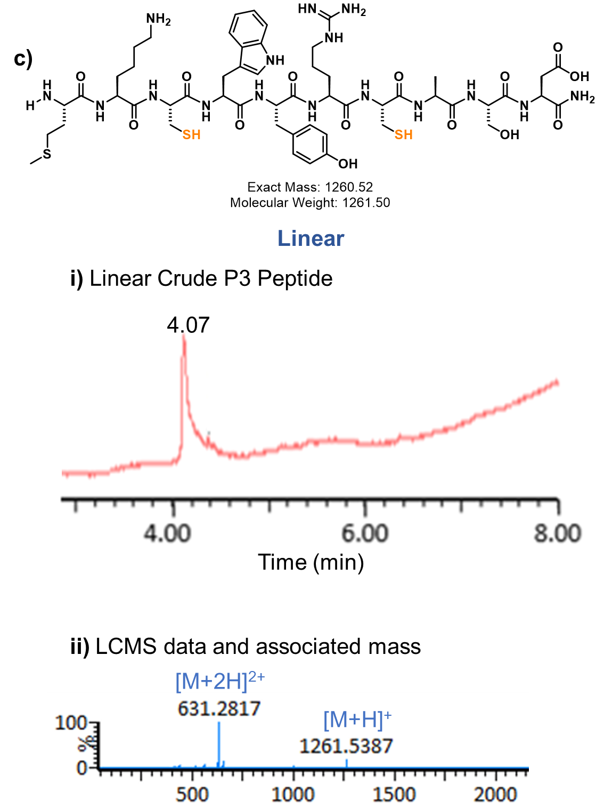

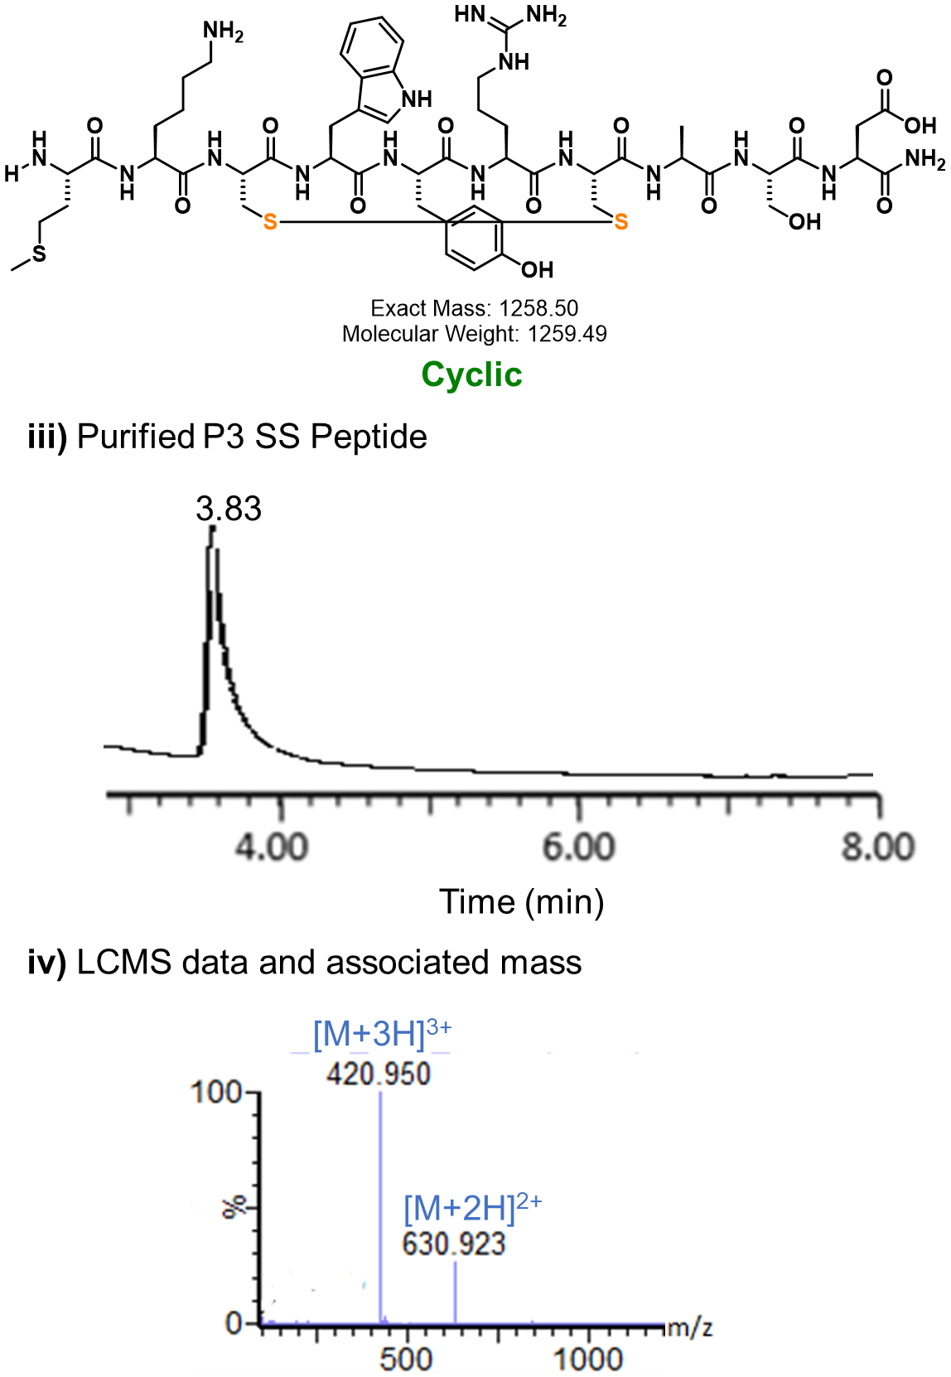

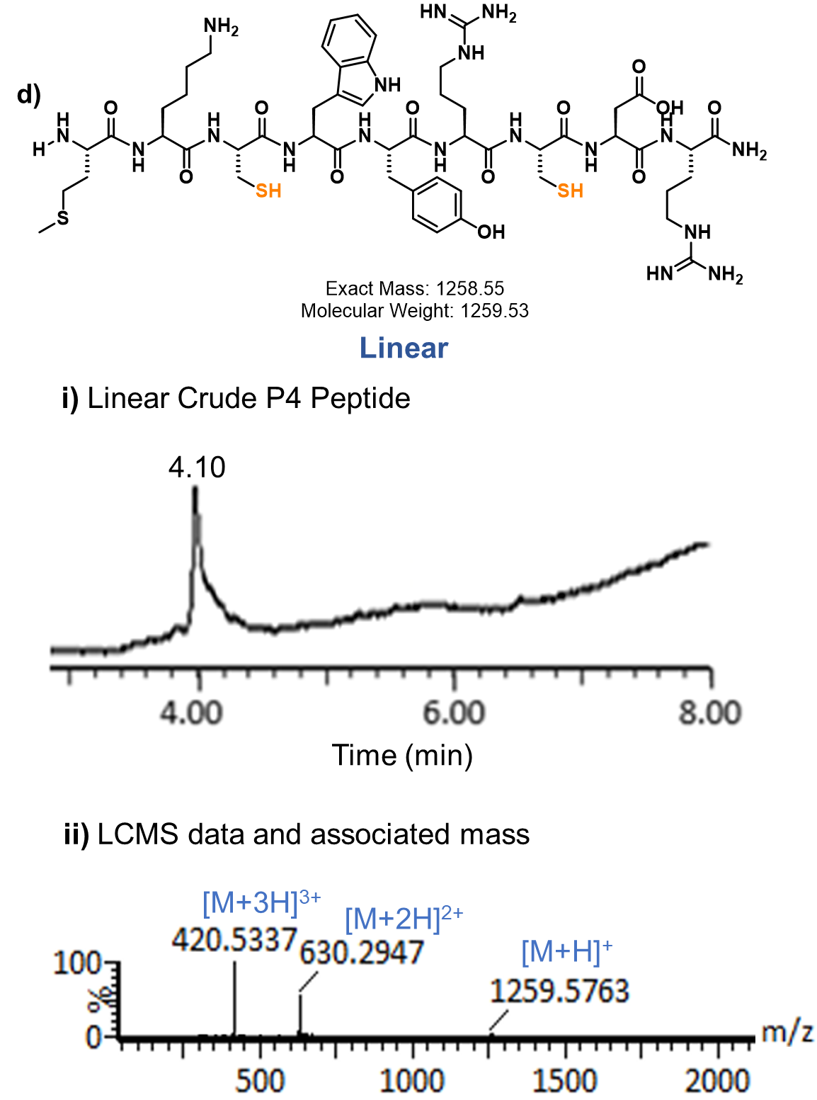

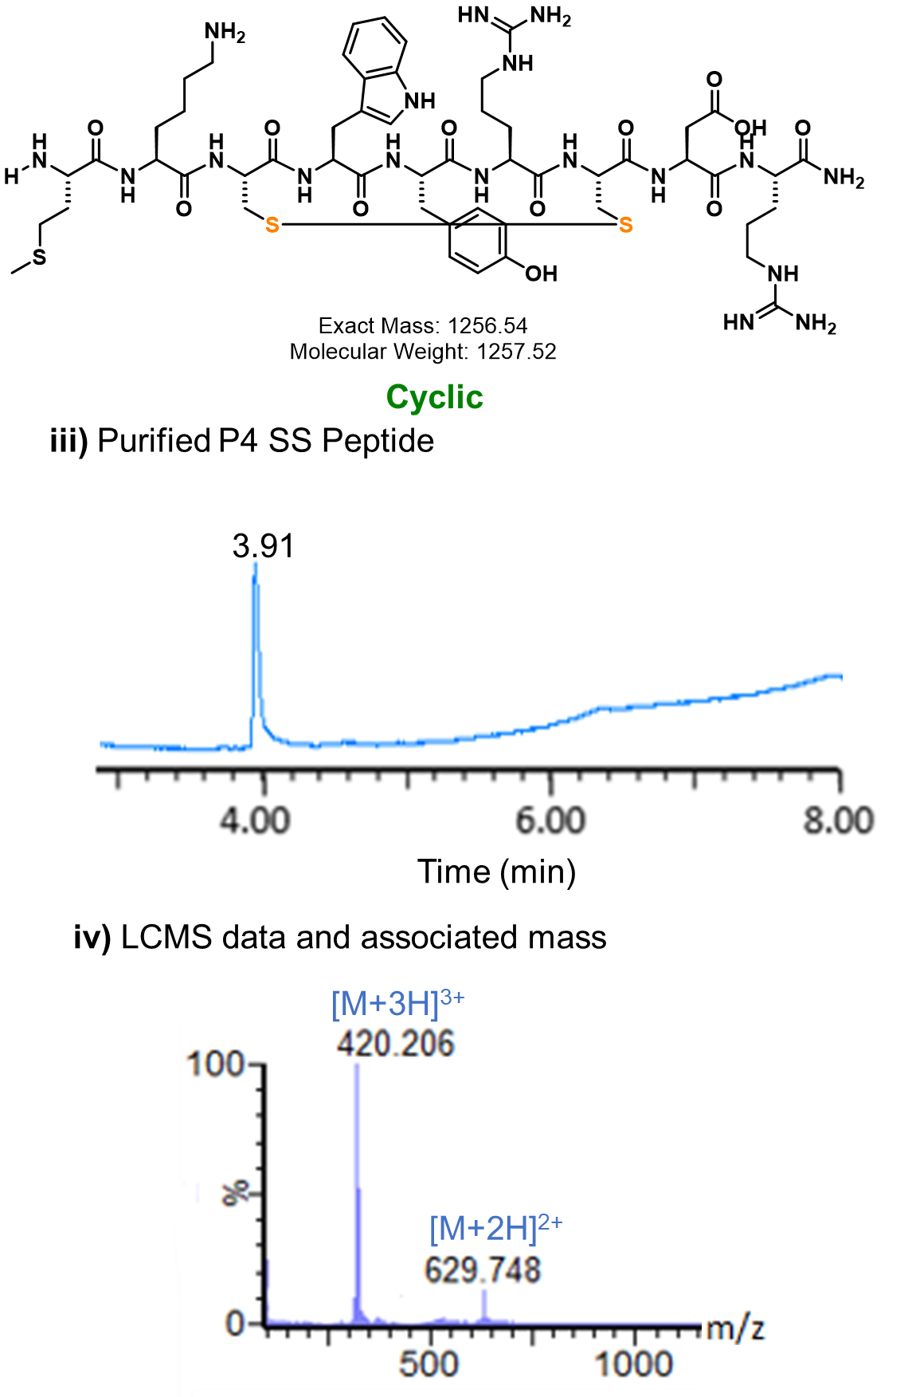

Figure S3: LC-MS and associated mass of P1 linear and disulfide (SS)-mediated P2-P4 peptides. a) LC-MS data of linear crude P1 peptide and its associated mass. bi) General on-resin oxidative disulfide assembly stapling protocol followed: Trityl (Trt)-protected cysteines were cross-linked by charging NCS (0.055 mmol, 2.2 equivalents) solution 306 (4 mL, 14 mM) in 2% TFA/DCM on the peptidyl-resin for 15min. The resin was washed with DMF (2 × 3 mL) and DCM (4× 3 mL). Air-dried peptidyl-resin was subjected to reagent K (0.75 mL) for 2 h for peptide cleavage and global deprotection³. bi-ii) LC-MS data of Crude linear P2 SS and biii-iv) LC-MS data of purified cyclic(right) P2 SS peptide; ci-ii) LC-MS data of Crude linear P3 SS and ciii-iv) LC-MS data of purified cyclic(right) P3 SS peptide; di-ii) LC-MS data of Crude linear P4 SS and diii-iv) LC-MS data of purified cyclic(right) P4 SS peptide.

Figure S4: LC-MS and associated mass of HFB-mediated P2-P4 peptides.
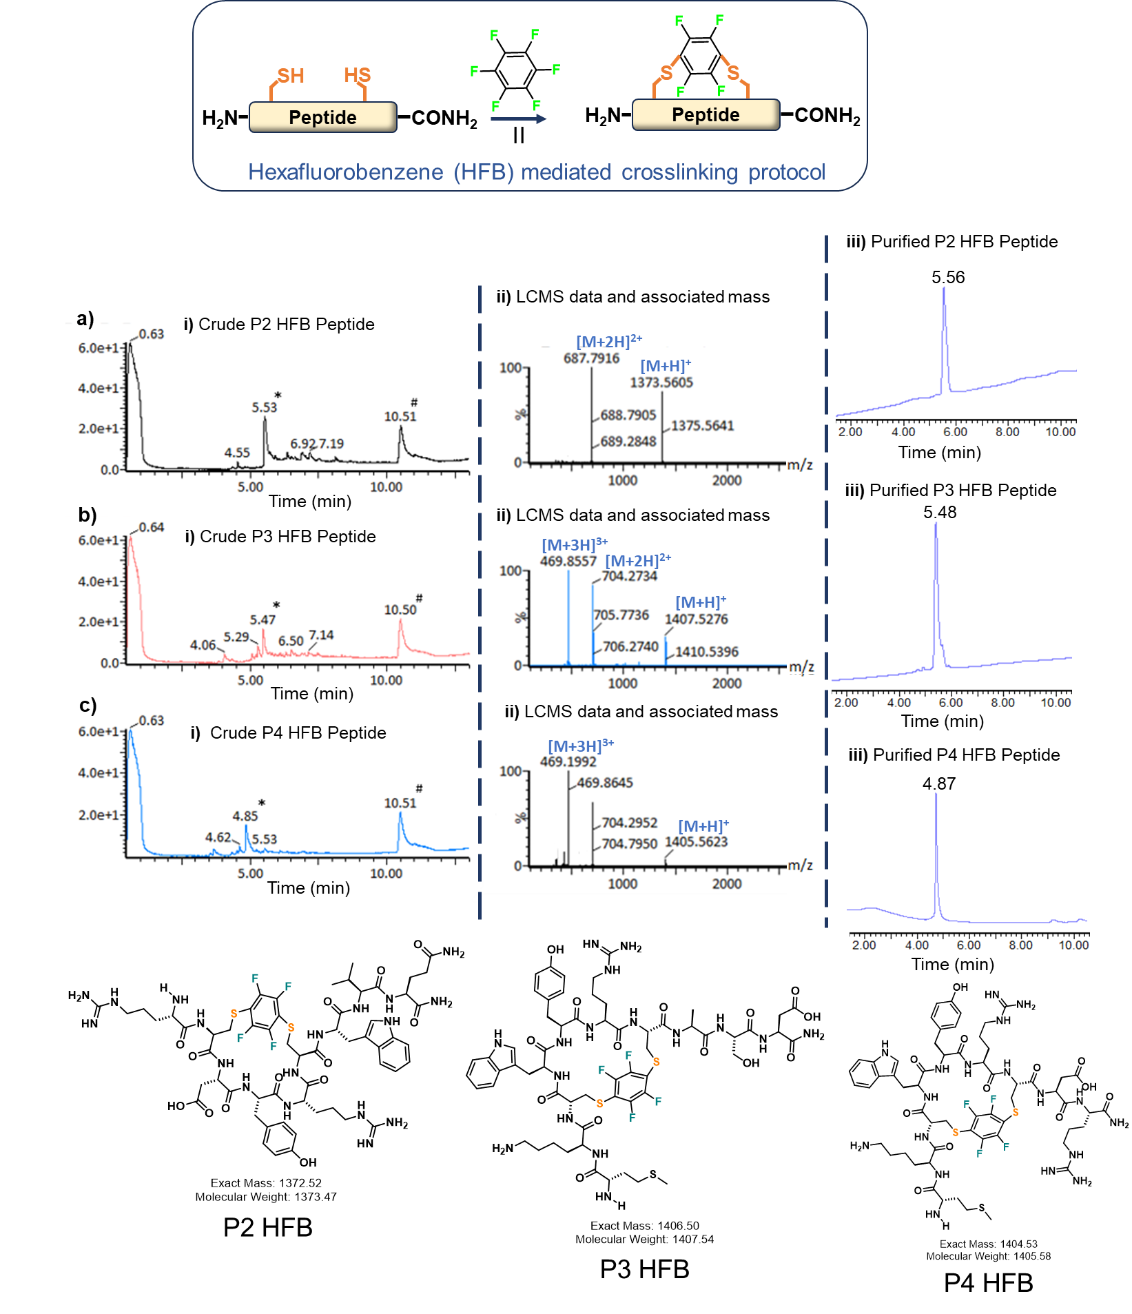
Figure S4: LC-MS and associated mass of HFB-mediated P2-P4 peptides. General Hexafluorobenzene (HFB)-mediated cysteine stapling protocol followed: A solid peptide sample (7.5 µmol) was taken in a plastic Eppendorf tube, followed by the addition of 1.9 mL of a 100 µM hexafluorobenzene solution in DMF (about 25 equivalents) and 1.5 mL of a 50 mM TRIS base solution in DMF. The mixture was shaken vigorously for 30 seconds and then left to react at room temperature for 4.5 hours⁴; ai) LC data of Crude P2 HFB peptide; aii) Associated mass data of P2 HFB peptide; aiii) Purified P2 HFB peptide. bi) LC data of Crude P3 HFB peptide; bii) Associated mass data of P3 HFB peptide; biii) Purified P3 HFB peptide. ci) LC data of Crude P4 HFB peptide; cii) Associated mass data of P4 HFB peptide; ciii) Purified P4 HFB peptide (* is crude peptide product; # is side product generated during reactions).

Figure S5: Purification and Characterization of Skp1-Skp2 complex.
Figure S5: Purification and Characterization of Skp1-Skp2 complex. A. Schematic of the protein complex. (Skp2 N-terminal+ FBD is predicted from alpha fold) B. SDS-Page Gel of the complex with the two bands corresponding to Skp1 at 19kDa and Skp2 at 18kDa. C. Circular Dichroism Spectra and D. MALDI-TOF graph to validate the secondary structure and molecular weight of the purified protein complex.

References:
(1) Lopes, J. L. S.; Miles, A. J.; Whitmore, L.; Wallace, B. A. Distinct Circular Dichroism Spectroscopic Signatures of Polyproline II and Unordered Secondary Structures: Applications in Secondary Structure Analyses. Protein Sci. 2014, 23 (12), 1765–1772.
(2) Luong, H. X.; Kim, Y.-W. Stabilization of Single Turn Polyproline II Helices via Macrocyclic Hydrocarbon Staples. Org. Lett. 2020, 22 (20), 7986–7990.
(3) Tripathi, N. M.; Das, B. K.; Chowdhury, A.; Gour, V.; Bandyopadhyay, A. Introducing Regioselective Disulfide Linkages in Peptides under Pseudodilute Conditions by Harnessing Bro̷nsted Acid-Activated N-Chlorosuccinimide. JACS Au 2025, 5 (2), 802–810. https://doi.org/10.1021/jacsau.4c01063.
(4) Spokoyny, A. M.; Zou, Y.; Ling, J. J.; Yu, H.; Lin, Y.-S.; Pentelute, B. L. A Perfluoroaryl-Cysteine SNAr Chemistry Approach to Unprotected Peptide Stapling. J. Am. Chem. Soc. 2013, 135 (16), 5946–5949.

