Supporting Information

Modulating amyloid-β 42 aggregation and neurotoxicity by Kunitz domains and their derived peptides

Maya Rabinovich, Shiran Lacham-Hartman, and Niv Papo

Avram and Stella Goldstein-Goren Department of Biotechnology Engineering and National Institute of Biotechnology in the Negev, Ben-Gurion University of the Negev, P.O. Box 653, Beer-Sheva 84105, Israel

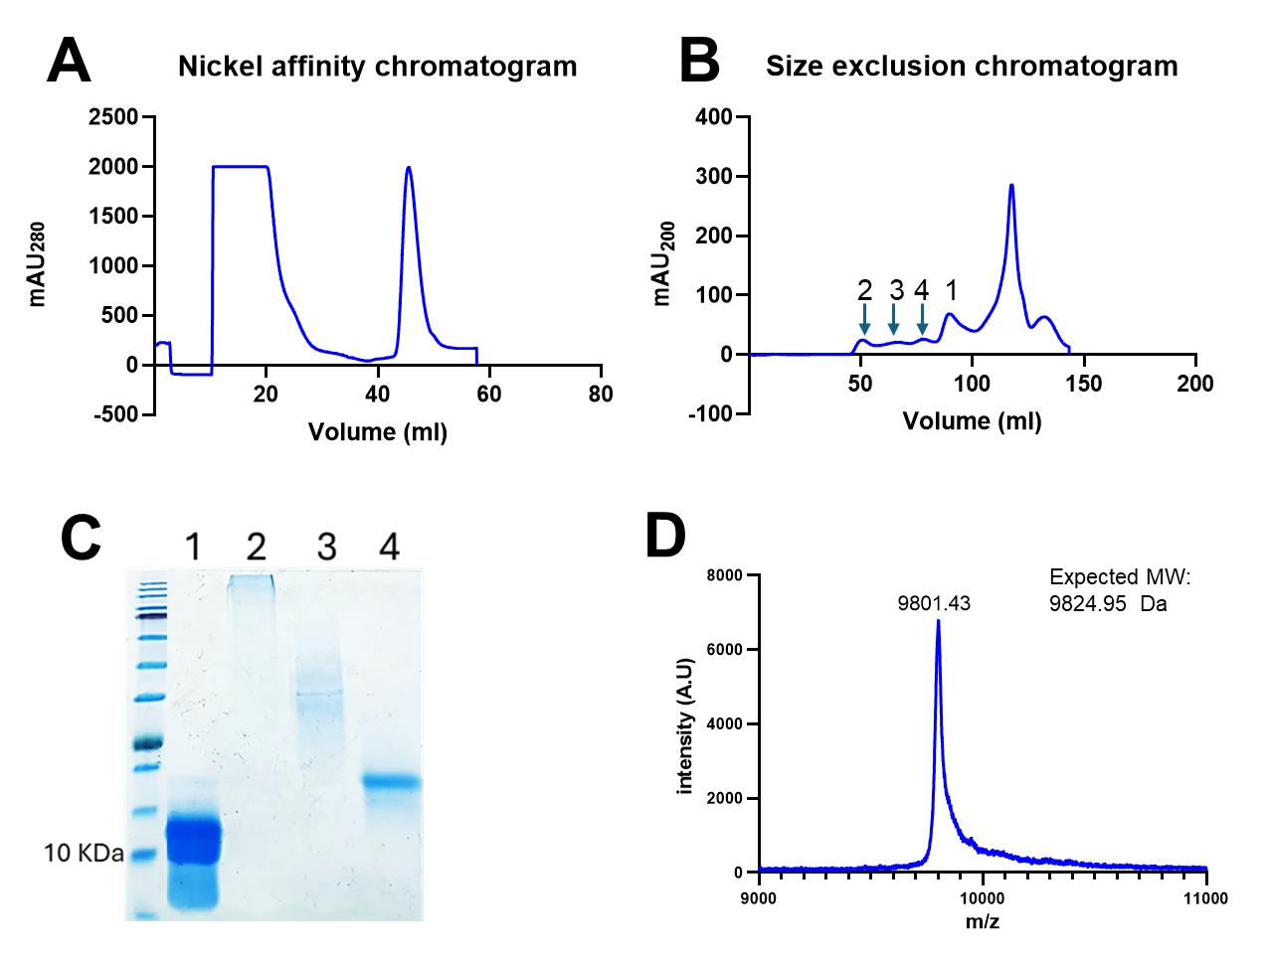
Figure S1. TFPI purification steps: (A) Nickel affinity chromatography purification of TFPI; (B) Size-exclusion chromatography (SEC); (C) 15% SDS-PAGE analysis under non-reducing conditions of peaks 1-4 eluted from SEC; and (D) MS analysis of purified TFPI derived from peak 1 of SEC.

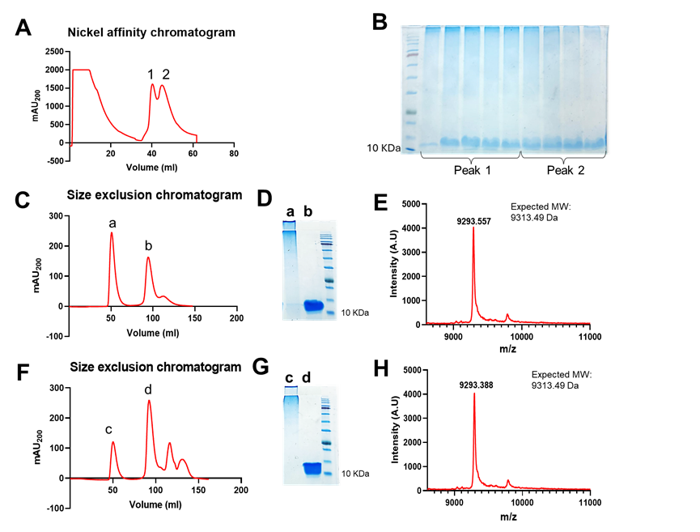
Figure S2. Bikunin purification steps: (A) Nickel affinity chromatography purification of bikunin produced two eluted peaks, designated peak 1 and peak 2. (B) Fractions 1 and 2 were loaded onto 15% SDS-PAGE under non-reducing conditions. (C) Size-exclusion chromatogram (SEC) of peak 1 (of nickel affinity chromatogram). (D) 15% SDS-PAGE analysis under non-reducing conditions of eluted peaks 'a' and 'b' (from the SEC). (E) MS analysis of purified bikunin obtained from peak 'b' (from the SEC). (F) SEC of peak 2 (of nickel affinity chromatogram). (G) 15% SDS-PAGE analysis under non-reducing conditions of eluted peaks 'c' and 'd' (from the SEC). (H) MS analysis of purified bikunin obtained from peak 'd' of the SEC.

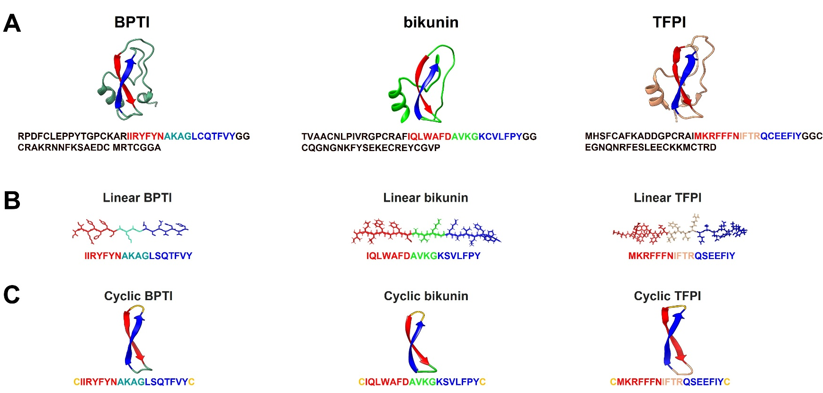
Figure S3. Linear and cyclic peptides derived from the scaffold of Kunitz-type proteins. (A) Cartoon representation of the crystal structures and one-letter code sequences of BPTI (PDB:4Y0Y), bikunin (PDB:4U30) and TFPI (PDB:6BX8). (B) Linear peptides harboring the two β strands that originate from the β-hairpin structure in the full-length BPTI, bikunin and TFPI scaffolds. (C) Cyclic peptides based on the amino acid sequence of the β-hairpin, as in (B), but with two cysteines (indicated in yellow) at the N- and C-termini of the sequence to create a disulfide bridge that closes the segment and forms the β-hairpin structure that is found in the full-length BPTI, bikunin and TFPI scaffolds.

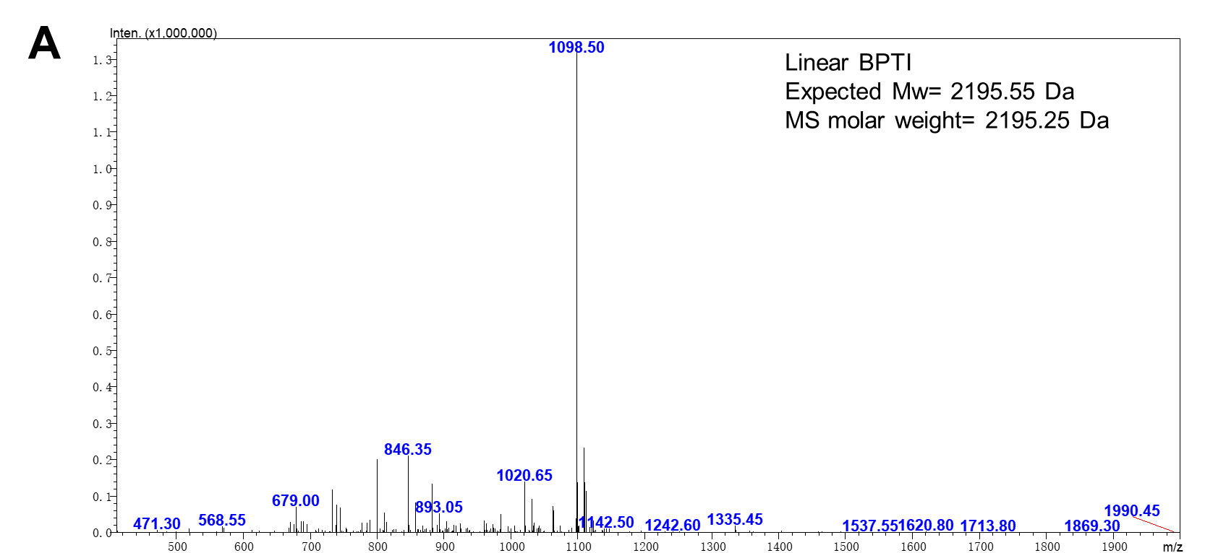
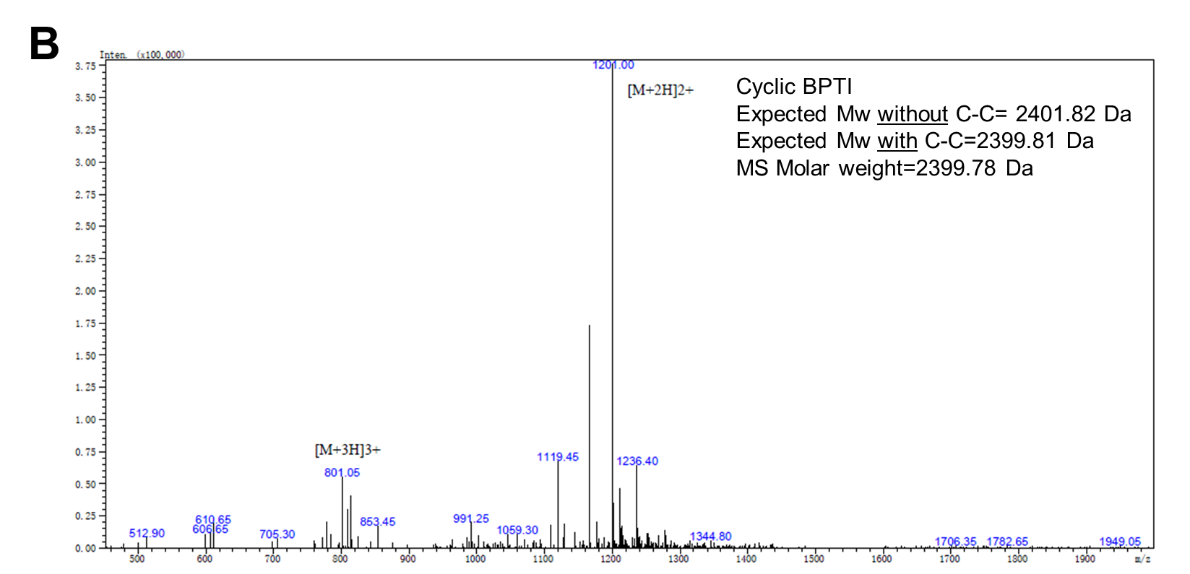

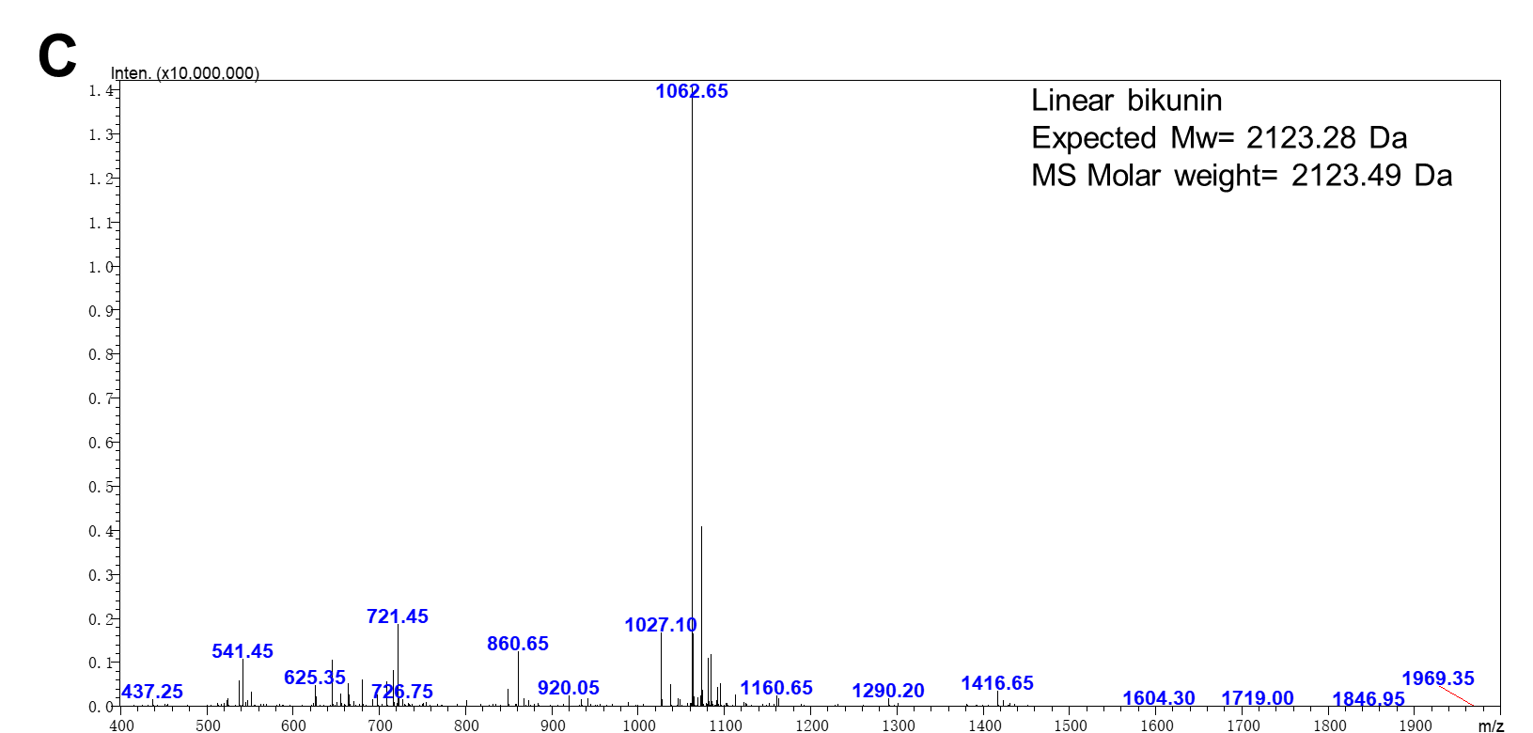
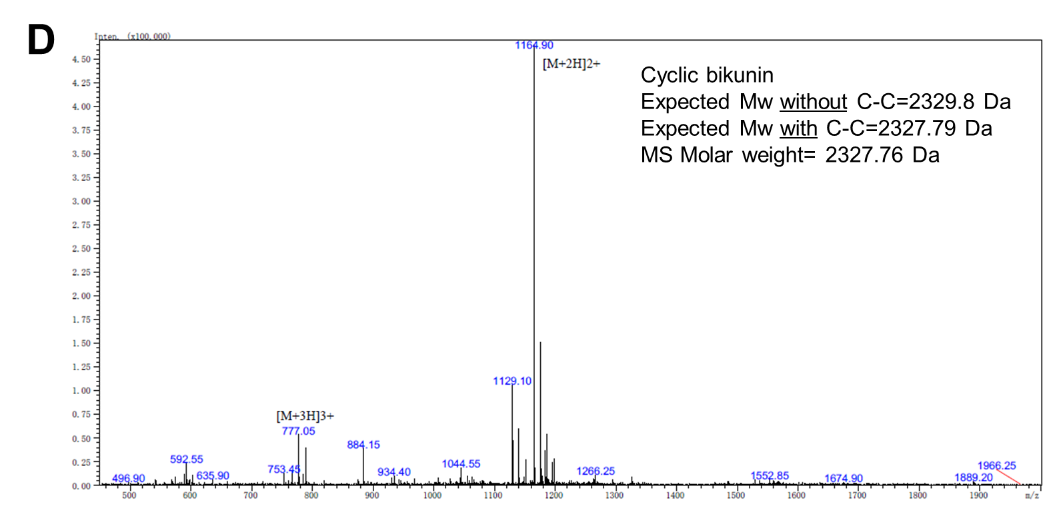

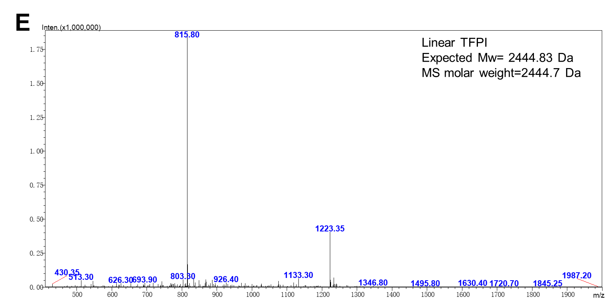
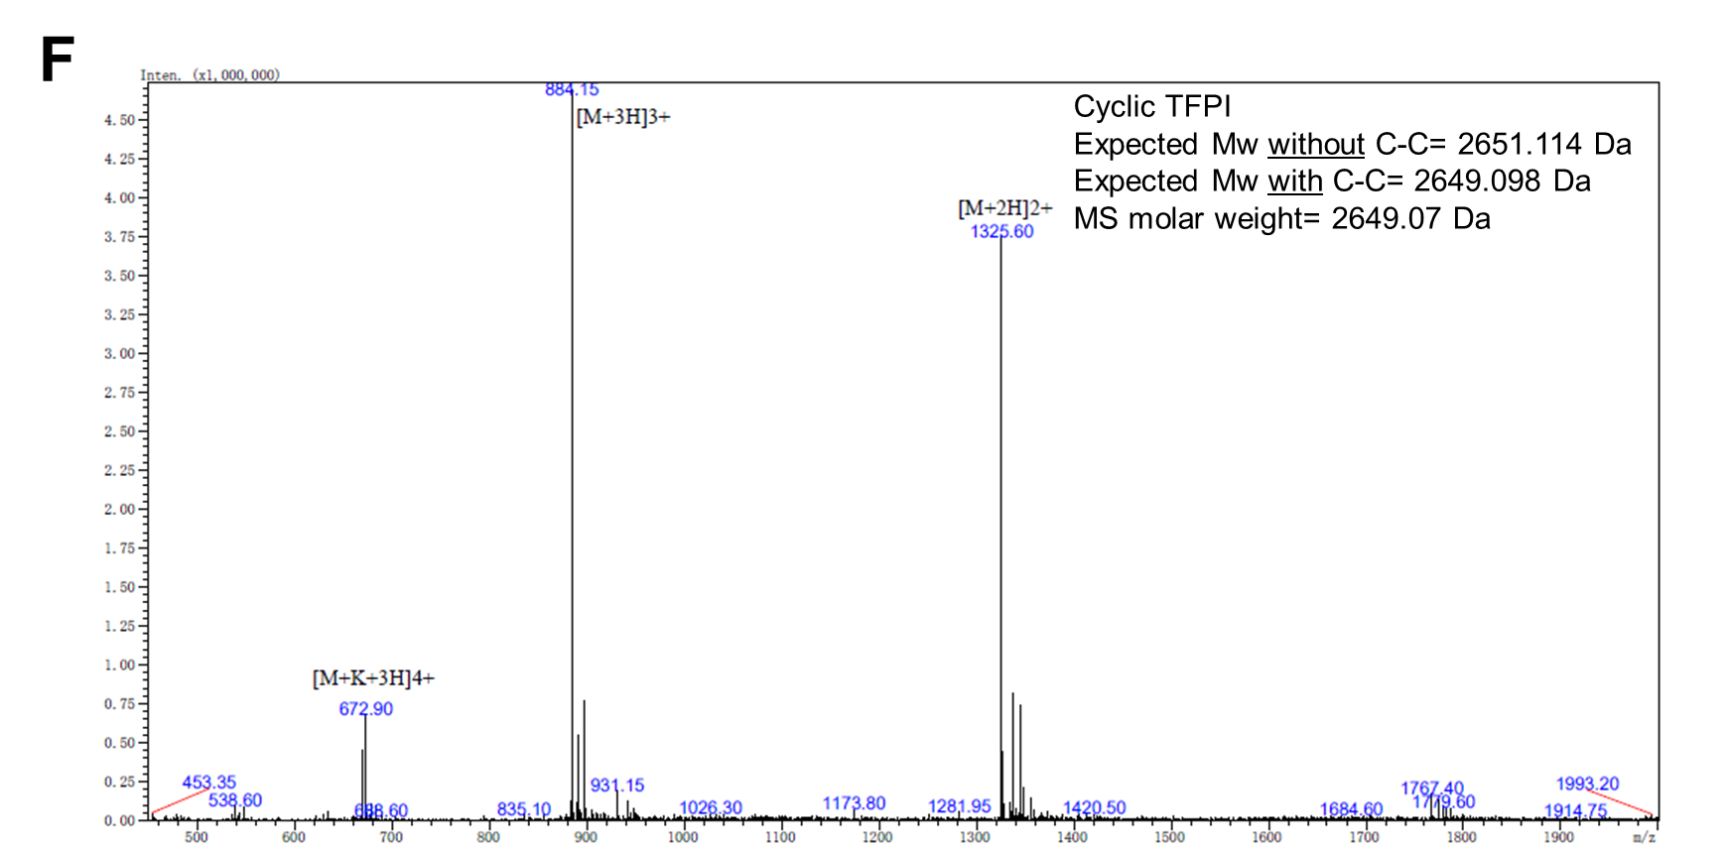

Figure S4. Mass spectroscopy of the synthetic peptides. (A) Linear BPTI, (B) cyclic BPTI, (C) linear bikunin, (D) cyclic bikunin, (E) linear TFPI, and (F) cyclic TFPI. The X-axis represents the separation of the ionized sample according to mass-to-charge (m/z) ratios. The Y-axis represents the signal intensity, with the scale given in arbitrary units (×100,000).
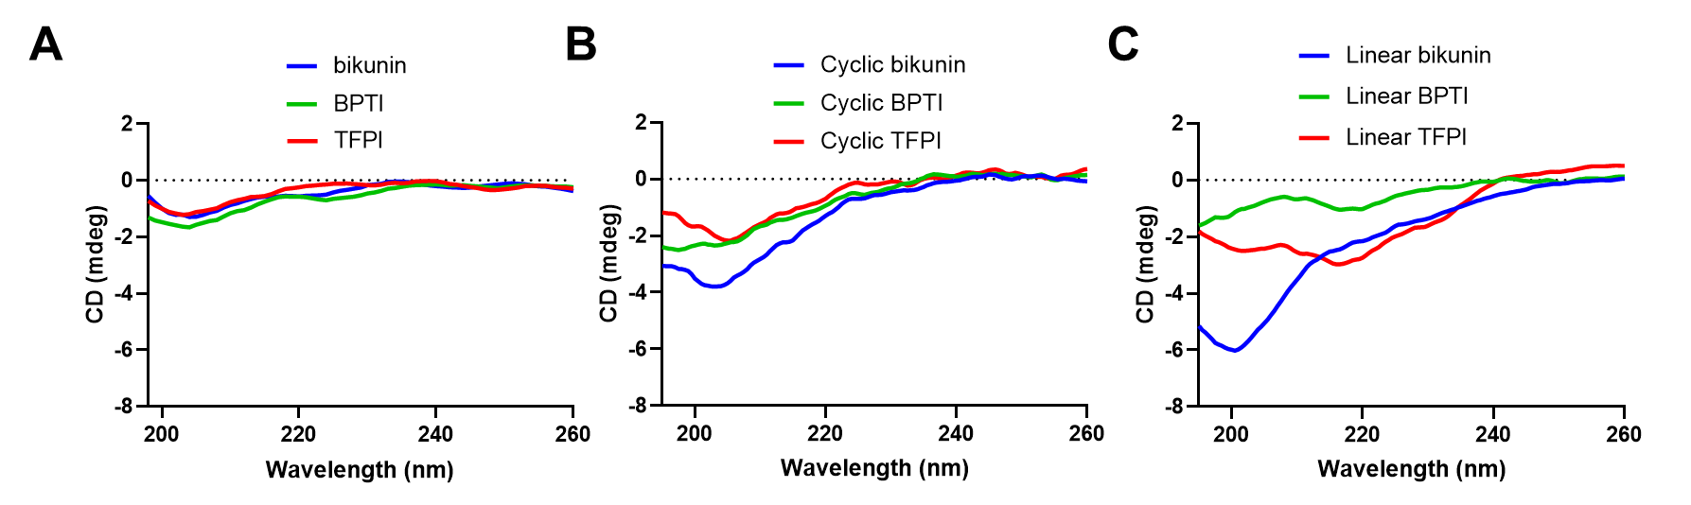
Figure S5. Circular dichroism (CD) spectra of Kunitz-type proteins and cyclic and linear peptides. Samples of (A) Kunitz-type proteins (781.25 nM), (B) cyclic peptides (100 µM) or (C) linear peptides (100 µM) were incubated for 18 h with diluted phosphate buffer (5 mM sodium phosphate, 37.5 mM NaCl, pH 7.4), and the spectra were measured over the range of 195-260 nm.

